Response to Schools Workforce Issues Paper

Dr Linda Darby, Lecturer, School of Education, RMIT University

Disclaimer: This response is personal and does not reflect the views of others within the School of Education, to RMIT University

I would like to respond to questions relating to current or future workforce shortages, and professional development needs of teachers. I refer to my research that has provided insights into the issues for teachers who are teaching outside their subject areas, or “out-of-field” (OOF), particularly at the junior secondary level, and particularly in maths or science. This issue is prevalent in many Australian schools and it has enormous implications for policy and practice around school governance, funding arrangements and structures associated with continued teacher development, and initial teacher education. In this submission I refer to only the teacher perspective, but this issue ultimately impacts on the quality of the education we provide students.

This response is structured in the following way:
- Incidence of OOF teaching in maths and science
- Key issues that arise, as represented in the literature
- Identity and professional learning of OOF teachers, arising from my research
- Key learnings

a) Who is teaching what?

In Australia the issue of teaching OOF is continuing to attract media attention due to various reports documenting the staffing profiles in different states and territories. Focusing on research relating to Maths and Science teachers, Table 1 summarises the incidences reported over past years:

Table 1.
Studies exploring issues surrounding teaching middle school science and/or maths OOF in Australia

Author | Scale | Summary of findings relevant to middle school science and/or mathematics
Department of Education Employment and Workplace Relations (2008)Staff in Australian Schools | National online survey of teachers and school leaders | - 5-13% of secondary teachers of Year 11 and 12 Maths, Physics, Chemistry did not have a 1 year tertiary qualification in these areas.  - 25% of junior maths teachers were not 1 year qualified  - 50% of junior maths teachers were not 3 year qualified
Ingvarson, Beavis & Kleinhenz (2004)  Teacher education courses in Victoria | Survey of Victorian graduate teachers | - 13-20% of graduate primary teachers felt unqualified to teach at the level they were teaching  - 15% of science teachers felt unqualified to teach  - 25-30% of other teachers felt unqualified
Harris et al (2005)  Who’s Teaching Science | Survey of 8.2% of Australian junior science teachers | - 16% of all science teachers and 28% of science teachers possessed no science-based degrees  - 8% of all science teachers and 22% of Year 7 and 8 science teachers did not complete any science subject s at university
Harris & Jensz (2006)  The preparation of mathematics teachers in Australia | Survey of mathematics teachers from 30% of Australian schools | - 20% of teachers of junior mathematics had not studied maths beyond first year  - 8% had no tertiary training in mathematics
Lyons, Cooksey, Panizzon, Parnell, & Pegg,(2006) The SiMERR National Survey | National survey | - Science ICT and maths teachers in provincial towns are twice as likely, and in remote towns three times as likely, than teachers in metropolitan centres to teach subjects which they were unqualified for
McConney & Price (2009)  An assessment of the phenomenon of "teaching OOF" in WA schools. | Western Australian survey of 535 primary and secondary schools | - 24% of teachers overall taught OOF in 2007 and 2008.  - 16% of maths teachers  - 18% of science teachers
Tas Audit Office (2010)  Science Education in public high schools, Tasmania. | Survey and interviews with Tasmanian science teachers | - 49% of sample had a science degree  - 26% Bachelor of Education degree with science specialisation  - 5% of teachers had no science component in their qualifications
Panizzon, Westell & Elliott (2011)  Profile of teachers of secondary science (SA) | Survey with South Australian science teachers | - 16% of general science teachers were unqualified

Other reports in the media reflect similar or higher proportions of teachers teaching outside their fields of expertise (Topsfield, 2007; Rodd, 2007; Dillon, 2011; White, 2011).

Recent international and Australian studies have drawn attention to this practice by citing limited support structures and processes as contributing factors, and describing effects on teachers, learners, colleagues, parents, governing bodies and school management (see, for example, Steyn & du Plessis, 2007). Data emerging from research into teacher supply and demand demonstrate how poor attraction and retention of teachers increases the extent and longevity of teaching OOF. Studies examining the Australian science and maths teaching workforce indicate that the incidence of teaching mathematics or science OOF is a constant reality (Department of Education Employment and Workplace Relations, 2008; Ingvarson, et al., 2004; 2009a; Tasmanian Audit Office, 2010). With her colleagues, Harris undertook Australian national surveys of the profile of science and mathematics teachers. They found that 16% of respondents teaching science lacked a minor in any university science discipline and 20% of teachers of junior mathematics had not studied mathematics beyond first year university (Harris & Jensz, 2006; Harris, et al., 2005), and eight percent had no tertiary education in mathematics or science. The most recent study reported that 16% of general science teachers in South Australian were not science-trained (Panizzon, Westall, & Elliott, 2010). More startling is that in Tasmania, only 49% of teachers of science surveyed had a science degree.

Ingersoll (2002) places at the heart of the issue, at least in US schools, not supply/demand imbalances and inadequate initial teacher education, but “the manner in which schools are organized and teachers are employed and utilized” (p. 24). Internationally, the OECD raise the equity issue, reporting that “Teacher shortage problems seem to be most acute in schools serving disadvantaged or isolated communities” (p.39). ). Ingersoll (2002) makes this point: “Unequal access to qualified teachers and, hence, to quality teaching is considered a primary factor in the stratification of educational resources, opportunities to learn, and, ultimately, educational outcomes” (p. 3). More locally in Australia, a report by the Victorian Department of Education and Early Childhood Development (2008) shows an increasing trend in the percentage of Government schools reporting difficulties in filling teacher vacancies, particularly in some rural or regional areas, and particularly in the learning areas of mathematics, science and technology. Teaching OOF is inevitable under such circumstances (Australian Education Union, 2009; Lyons, et al., 2006). In fact, Lyons et al. reported data that science, ICT and mathematics were two times more likely, and in remote towns three times more likely, to be taught by unqualified teachers than in metropolitan schools (see Table 1).

b) Key issues for OOF teachers

International studies highlight the significance of this issue as influencing the quality of educational outcomes, and teacher well-being (see, for example, Ingersoll, 1998, 2002). The blueprint for energising science and mathematics education in Victoria (DEECD, 2009) signals the need to build teacher capacity; however, high proportions of teaching OOF potentially undermine efforts to achieve this end.

Research often identifies a lack of content knowledge and pedagogical content knowledge as being the key issue for teachers (Darling-Hammond, 2000; Education & Training Committee, 2006; Ingersoll, 1998). Ponte and Chapman (2008) reported that “[while] having strong knowledge of mathematics does not guarantee that one will be an effective mathematics teacher, teachers who do not have such knowledge are likely to be limited in their ability to help students develop relational and conceptual understanding” (p. 226). Research has also found that teaching OOF can compromise ‘teaching competence’, and can disrupt a teacher’s identity, self-efficacy and well being (Pillay, Goddard, & Wilss, 2005). It also places additional strain on subject coordinators and school administrators due to the extra support, mentoring and resources required (Taylor, 2000).

In addition, Ingersoll raised concerns that the extent of teacher shortages is masked when underqualified teachers fill these positions, resulting in an unrealistic picture of the crisis facing schools (Ingersoll, 1998). The reality is that many schools experience difficulty recruiting qualified teaching staff, and the problem is exacerbated by the aging staff profile, uncertainty about career paths, and poor teacher retention partly as a result of job dissatisfaction (Harris & Jensz, 2006; Harris, et al., 2005). McConney and Price (2009b) add: ‘given continued teacher shortages, the realities of staff to student ratios in small communities, changing workforce patterns in a globalised economy, and the need and desire for greater staffing flexibility in the teaching workforce, the practice is likely to continue’ (p. 96). In light of the expected longevity of this issue, further understanding of its effect on teachers will inform appropriate local and systemic responses.

c) Identity and professional development of OOF teachers

Despite a growing body of data documenting its extent, teaching OOF is under-theorised in terms of impact on the teacher. Given that mathematics and science are key areas of policy concern, there is an urgent need to gain a more complex understanding of the experience of teaching OOF, and to understand teachers’ position in this increasingly common practice in order to provide appropriate system responses. Teacher identity and self-efficacy influence the quality of mathematics and science education, but McConney and Price (2009a) claim that these areas are thus far under-researched in relation to teachers teaching OOF. While the term ‘out-of-field’ has a technical meaning relating to education- and discipline-related qualifications (McConney & Price, 2009b), in a more significant sense there is a need to consider how teachers identify themselves and their practice as being OOF, and factors that influence whether the technical definition aligns with their self-assessment.

Teacher identity can be regarded as “being recognized by self or others as a certain kind of teacher” (Luehmann, 2007). The development of a subject teacher is a continuous process of identity construction that takes place as the teacher interacts with and reflects on their professional and personal experiences. Contemporary understanding of identity recognizes the

close connection between identity and the self, the role of emotion in shaping identity, the power of stories and discourse in understanding identity, the role of reflection in shaping identity, the link between identity and agency, the contextual factors that promote or hinder the construction of identity, and ultimately the responsibility of teacher education programs to create opportunities for the exploration of new and developing teacher identities. (Beauchamp & Thomas, 2009, p.176)

When teachers step outside of their comfort zone, they risk disruption to how they see themselves as teachers – such is the case for many OOF teachers.

I recommend that the Productivity Commission consider the many factors that teachers take into account when describing themselves as subject teachers, that is, whether they see themselves as in-field or OOF. Through qualitative research into teacher identity and support mechanisms for OOF teachers (research funded by Science, ICT and Maths Education in Rural and Regional Australia [SiMERR]), I found that it was not just content knowledge, but that many factors influenced whether a teacher labelled themselves as ‘out-of-field’. These factors related to: context, support, and personal factors. Figure 1 summarises these factors, and a description of how these factors relate to each other is provided below.

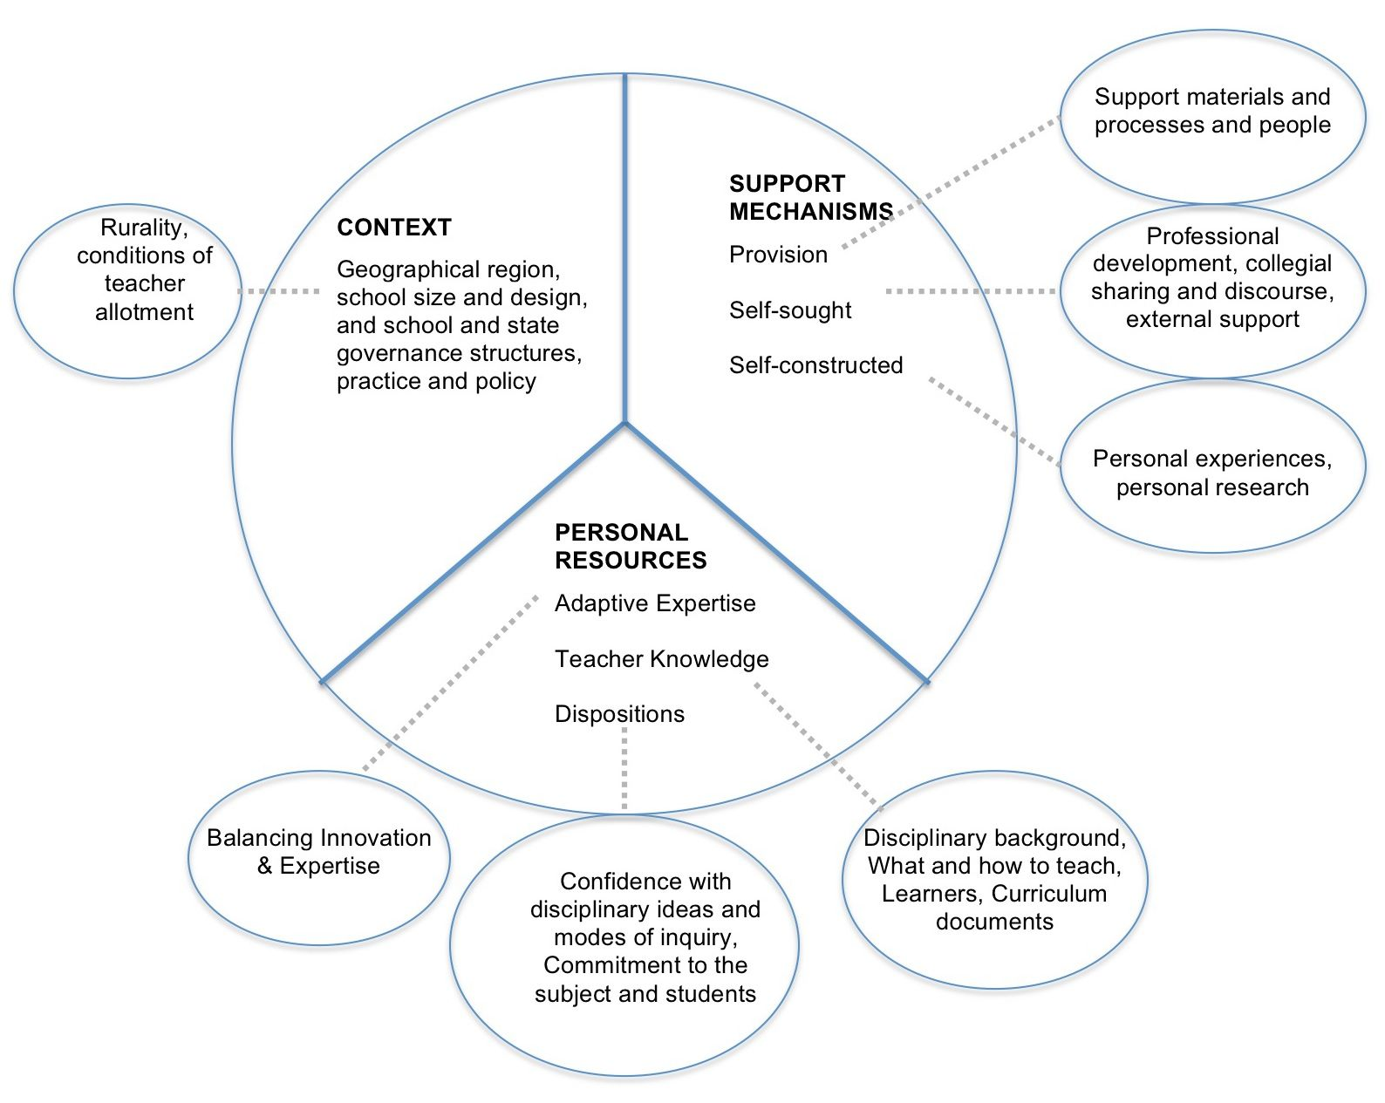

Figure 1. Factors influencing whether teachers identify themselves as “OOF”

Context
Contextual factors related to geographical region, school size and design, and school and state governance structures, practice and policy.
Rurality, focused on this study, created a range of limitations and possibilities for the OOF teachers, influencing availability of resources, collegial support, and professional learning opportunities. Some teachers recognized teaching OOF as part of their identity and role as rural teachers:

Kevin (34 years teaching): I think the challenges are probably created because over a period of time you become settled in the areas for which you are qualified and feel comfortable. Then suddenly, you find years later, perhaps you are moving into another area, it is a challenge. But I think that’s what teaching is all about, a challenge, and certainly if you’re working in a bush school like School B I think you’ve got to be fairly adaptable and where possible try and accommodate, the needs of the school, more so the needs of the students, and I feel happy with that.

While rural settings provide many benefits for school, rurality limits the support mechanisms available because there are limited subject specialists close by to ask for advice, and professional development is held at great distances from the school. Certainly, difficulties in attraction and retention of qualified teachers in rural areas provide a constant pressure on schools.

Governance practices determining the circumstances of teacher allotment had some bearing on whether teachers felt OOF. Circumstances related to the decisions that led to leadership placing teachers OOF. For the teacher, decisions by administration translated into the degree of choice, or autonomy that teachers had in determining their teaching load and career generally. For leadership, decisions were made out of a need to fill the gaps in the timetable. Leadership sometimes asked teachers if they were interested in or felt confident teaching a subject, so, in some circumstances, teachers had some input into their allocation. Science teachers were often targeted for maths. The views of three teachers are given below: Tahlia, who was responsible for the time table at one school, recognised the dilemma facing school leadership; and Nelly and Rick explain different circumstances under which they have taught OOF.
Tahlia (23 years teaching): There’s two types [of teachers]…You’ve got a group that may not be qualified, but have got an interest and understanding, even though it’s not on paper. And I think that’s probably better, if they’re interested and know their stuff; but also some teachers have to be just put in an area, like for example, like I had to put A2 into science, not that she wanted to. But she was our design tech person, and if we wanted to accept her husband here who is also design tech, there’s not enough design tech for two of them. So I said someone’s got to be prepared to teach outside their area and she said ‘Oh yes, I will, I will’. So she’s prepared to, but, although she didn’t have the knowledge to start with they need to be prepared to get to know their stuff. But also have good control, good teaching skills.
Nelly (9 years teaching): Sometimes it would mean that the person who would normally teach that subject is away, like on leave or something for an extended period of time. So you might be on your own and perhaps having to rely on friends or other people in other schools or people here who might have taught the subject before for any support that you might need.
Rick (20 years teaching): History is OOF [for me], but it was an interest area… When I first came here I had two maths classes, and then the science teacher left, so I took more science, and I’ve only – in the last three years – started to teach maths again. And I asked to do that; because if I wanted to get a transfer I thought that having a bit of maths behind you would help.
The data presented here shows that teachers found themselves teaching OOF for a number of reasons:
- ‘covering’ someone else’s load on a short or medium term;
- filling in on a longer term to cover a longer absence;
- load allocation, where there are no other teachers available; and
- by request to do something that was of interest or for other advantages.

Support
The level of support was an important factor. The degree to which a teacher felt supported by teachers within the school, from networks outside of the school, and by documentation, impacted on teachers who wanted to improve in their practice. Generally speaking, as teachers adapt to different educational environments, they construct their knowledge and beliefs “from the perspectives of self-in-relation-to-social context” (Simmons et al., 2008, p. 948). Expectations placed on teachers by the school context, such as having to teach OOF, require teachers to adapt to different educational environments. Simmons et al. explains that “how the environment in which one functions, especially with regard to the expectations of others, contributes to teachers modifying their actions and eventually their beliefs” (p. 932). If teachers are to adapt to the new field or domain, conditions must be conducive for them to make the necessary adjustments to their knowledge, but also their perceptions of themselves as teachers of the subject. Thus, support mechanisms are vital.

Table 2 lists the support mechanisms mentioned by teachers in the interviews. The support mechanisms are arranged into three categories that recognise their mode of access. The analysis has shown that teachers accessed support mechanisms: structures provided by the school to support teaching; resources that teachers sought and initiated; and resources and structures constructed by the teacher and that required some personal investment.

Table 2.
Support Mechanisms used by Out-of-field Teachers

SUPPORT PROVISION | SOUGHT SUPPORT | CONSTRUCTED RESOURCES
1. Support materials  a. Curriculum & syllabus documents  b. Provision of materials  c. Textbook  2. Processes and people  a. Strong direction, leadership  b. Reduced allocation  c. Meetings  d. Team teaching  e. Observing others  f. Formalised induction  g. Mentors  h. Access to Principal  i. PD In-service (school initiative) | 3. Professional Development  a. PD External (school or self motivated)  b. Further study  4. Collegial sharing and discourse  a. Sharing of resources  b. Discussion of concepts and teaching ideas (Expert others)  c. Mentors  e. Interschool links, networking  5. External support  a. Family and friends  b. Community resources | 6. Personal experiences  a. Collecting examples and stories relevant to the topic  b. Interests informing curriculum development  7. Personal research  a. Mastery of concepts  c. Collecting resources  d. Construction of resources

Distance played a factor in uptake of professional development generally, but especially in the OOF subject because IF professional development tended to be preferred. Alternative PD or teaching arrangements were often developed, and were sometimes successful, such as sharing of expertise from teachers at other rural schools, or participation in cross marking where teachers joined with teachers from schools in adjoining regions for assessment purposes. Regardless of context, the most effective professional development is “on-going, includes training, practice and feedback, and provides adequate time and follow-up support. Successful programmes involve teachers in learning activities that are similar to ones they will use with their students, and encourage the development of teachers’ learning communities” (OECD, 2005, p.95). Rather than disjointed, one-off professional development events, a range of support mechanisms over a period of time that is negotiated or initiated by the teacher and offered at the teacher’s point of need is more likely to lead to real professional learning and identity development.

Personal Resources
Personal Resources included teachers’ adaptive expertise, knowledge, and confidence and commitment as dispositions.
Adaptive expertise, which is the ability to apply knowledge effectively to novel problems or atypical cases in a domain (Holyoak, 1991), is a useful lens for examining teacher adaptability. Two dimensions of expertise are efficiency and innovation (Schwartz, Bransford, & Sears, 2005). Efficiency refers to the high level of knowledge and skills that can be applied to a problem. Teachers who hare highly efficient have much experience with using such knowledge, but they practice in a relatively stable environment. Innovation requires moving away from efficiency momentarily and unlearning previous routines. Teachers who engage in innovation experience some degree of ambiguity or uncertainty, and there is a letting go of held beliefs. As discussed above, teaching is a dynamic career, where broad scale and local changes mean that teachers are continually learning new things and need to adapt. Teachers find themselves in situations where they must ‘do research’, learn from colleagues, and be adaptable. How a teacher copes in these situations is not just critical to their practice but also to their professional identity. The level of autonomy or choice that teachers have can influence their capacity or willingness to adapt. Some of the teachers in this study welcomed the opportunity to teach a new subject and were willing to forego the efficiency of their in-field practice and embrace the required innovation to adapt to the OOF setting; others held strongly to the high degree of efficiency in the preferred field and were consequently resistant to change.
Teacher knowledge was a major factor influencing how teachers felt about their in-field and OOF teaching. Teachers referred to:
- Background in a discipline through university training or exposure: Strongly represented in the data. Some teachers maintained that tertiary qualifications in an area is a necessity to teach a subject effectively, no matter how much experience one has teaching the subject; others felt exposure and practice equipped them with the necessary knowledge.
- Knowledge of how to teach referred to knowing how to teach the subject, whether teachers relied on traditional teaching approaches or searched for innovative and more engaging strategies, and how to apply the content in practical ways that students would understand, such as knowing stories or examples that apply science ideas. Interestingly, some teachers felt OOF because they lacked knowledge of how to engage the students, while other teachers felt in-field because they were happy to perpetuate traditional approaches.
- Knowledge and accessibility of curriculum documents were mentioned by one teacher. Having a curriculum document or syllabus that guides what needs to be taught, teaching strategies and activities made Rebecca feel less OOF.
- Knowledge of learners was raised in relation to whether teachers had adequate knowledge and skills for particular years levels or types of learners, and was considered by some to be more significant for less experienced teachers, or was raised in relation to differences between primary and secondary students.

Confidence and commitment were two dispositions that were associated with the other factors. Having confidence with disciplinary ideas and modes of inquiry appeared to determine the degree to which teachers felt OOF and was mentioned by many teachers. Confidence often meant having the necessary knowledge of content, strategies and learners. Confidence was seen to be gained through the range of support mechanisms mentioned in Table 2, but especially through:
- tertiary exposure;
- researching subject matter;
- teaching the topic a number of times;
- in-service training or professional development; and
- other support mechanisms in or out of school.
Teacher commitment was manifested as:
- seeking better ways to engage students,
- devoting time to planning,
- identifying oneself as a teacher of the subject, and
- showing an interest in the subject.
Commitment can be thought of in terms of two imperatives driving teachers’ practice: a pedagogical imperative and a personal imperative (Darby, 2009). The effect of these two imperatives of teacher passion is represented in Figure 3.

Figure 3. Passion Model: Relationship between pedagogical and personal imperatives (Darby, 2009)

A pedagogical imperative was evident where a teacher took seriously the ethical responsibility of teaching and committed to doing the best thing for their students. A personal imperative was evident where a teacher was committed to the subject due to their personal interest it. Passions are often associated with these imperatives: a passion for students, a passion for the subject, and a passion for engaging students in the subject (Darby, 2009). In this study, there was an assumed interest in the in-field subject partly because teachers’ identities were bound up in a background of interaction with the subject; they were thus more likely to identify themselves in a particular way, for example, ‘I am a maths-trained teacher’. When teaching OOF, there is no taken-for-granted alignment with the subject, so justification for teaching a subject must come from somewhere else in the teacher’s background, some positive interaction, interest or pattern of success that enables the teacher to relate to it, or identify with it. Problems arise for teachers when this socio-historical interaction with the subject is missing, negative or ambivalent. Wanting to do the best thing for their students, the pedagogical imperative, becomes a driver for those teachers who have little passion for the actual subject. Teachers who are passionate about their students’ education spend time preparing and searching for materials, seek support, basically act professionally in their conduct. However, if teachers are not able to devote time or energy to acquainting themselves with the new knowledge, modes of enquiry or teaching strategies, or make links between engaging activities and the related concepts, professional learning can be limited resulting in reliance on traditional and ineffective, less engaging teaching practices. Various reasons, such as short term appointments, devotion to preferred subject areas, lack of autonomy, lack of time or support, or simply lack of interest or motivation, can make it difficult for the OOF teacher to embrace this pedagogical imperative and thus cater for student learning needs.

Influence of these factors on the identity of OOF teachers
A major point of consideration for the Productivity Commission is that teachers respond to their OOF allocation in a variety of ways, suggesting that any response to amending the problem of out-of-field teaching needs to be complex and respond to the individual needs of schools and teachers. A teacher’s response to teaching OOF demonstrates their adaptability, their commitment to the subject, beliefs about their role, and identity as teachers. Figure 2 presents what I have called an Adaptability Scale for teaching OOF (Hobbs, under review).
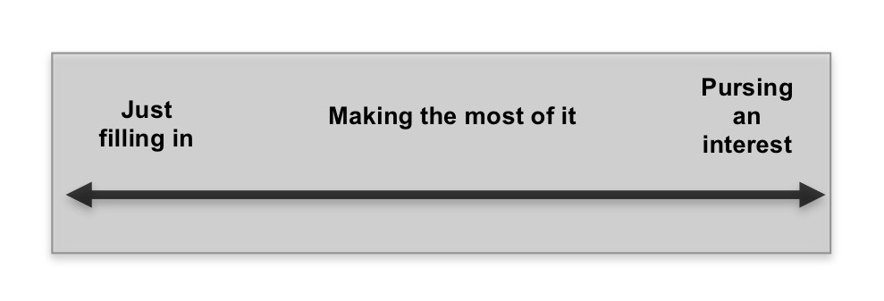
Figure 2. Adaptability scale for teaching OOF

Teachers can be situated on this scale to reflect their level of commitment and their identity in relation to the subject. Teachers who are ‘just filling in’ have limited or no identity in relation to the subject, possibly because of a history of failure or negative experiences, they can’t relate to it, they lack interest, or lack knowledge of how to teach it. Teachers who are ‘pursuing an interest’ have expanded their identity to being a teacher of that subject due to a personal interest and high level of self-efficacy arising from positive historical interactions with the subject. Teachers who are ‘making the most of it’ tend to be committed to endeavouring to engage students through interesting, contextualised learning experiences. Based on my research findings, I posit that how the teacher sees themselves in this OOF role will influence their interest and ability to engage with professional learning and professional development designed to upskill teachers. To illustrate the relationships between teachers’ use of support mechanisms and identity development, I refer to the experiences of three teachers: Daniel, Seral and Rebecca.

Daniel could be identified as ‘just filling in’ in mathematics. He had taught maths and science for the same amount of time (10 years), but is not maths-qualified. Daniel was philosophically opposed to having to teach mathematics because he believed that qualifications legitimated one’s role as a subject teacher. Daniel took advantage of a government initiative where he could upgrade his qualifications to teach ICT. In maths, he felt that searching for engaging problem-based activities was a waste of time since he did not fully understand the concepts behind them, a product of his lack of formal training in the subject. He was not motivated to participate in maths-related departmental activities or PDs.

Seral, a first year physchology teacher, could be seen as ‘pursuing an interest’ as she had a personal interest in mathematics and high level of self-efficacy arising from positive historical interactions with the subject. She requested to have mathematics in her teaching load. She spent considerable amounts of time talking to maths specialist teachers in the school and researching interesting activities. Seral used her history of success in high school, a mother who was a mathematics specialist teacher, and an interest in the subject as a justification for feeling in field when technically OOF.

Rebecca (2 years teaching) could be seen to be ‘making the most of it’ because, although she did not necessarily see herself as a maths teacher, she was committed to endeavouring to engage students through interesting, contextualised learning experiences. Rebecca had been part of a successful teaching team facilitated by a maths Teaching and Learning Coach who worked with the teachers to develop a differentiated mathematics program designed for a new open space classroom. Collegial support played a valuable role in building competence and confidence, leading to the development of a more positive identity in relation to the subject.

d) Summary of key learnings

Any response to this issue of teaching OOF should principally attend to the issues around teacher supply and demand. However, given that these problems are unlikely to be resolved immediately, in the interim, and in light of the findings presented above, I offer the following key learnings to the Productivity Commission:
- A more complex definition of teaching OOF is needed that recognises the influence of teacher’s personal resources, context and support needs on their levels of competence and confidence with respect to teaching OOF.
- The support needs of OOF teachers are not universal, but differs with the personal resources of the teacher and context. Schools and governments should ensure teachers have access to a range of structures to support subject boundary negotiation.
- The uptake of professional develop or re-training schemes will depend on how teachers see themselves in relation to the subject – whether they see themselves as “just filling in”, “making the most of it” for the benefit of their students, or “pursuing an interest”. Teachers who are personally interested in the subject are more likely to take up such opportunities. However, further research is needed to investigate teachers’ motivations for undertaking professional development.
- Rather than disjointed, one-off professional development events, a range of support mechanisms over a period of time that are negotiated or initiated by the teacher and offered at the teacher’s point of need, is more likely to lead to real professional learning and identity development.
- Context has a shaping influence on the range of support mechanisms available. There is a need for closer examination of the availability, variety and opportunity for teacher support in rural and regional areas, and comparison with other geographical regions.
- Promote leadership models that encourage teacher participation and professional dialogue around teacher allocation gives teachers’ more control over their career and professional development. Consider teachers’ interests, commitments, and confidence in relation to OOF subjects when allocating teacher loads
- There is a need for a focus in teacher education on the skills, knowledge and attitudes needed to increase teachers’ adaptability when faced with having to move outside their domain.
- Inexperienced teachers who have not yet developed expertise may be less suited to teaching a subject OOF. However it is also important to recognise that there are many factors that can impact a teacher’s appropriateness to teach a subject OOF that may or may not depend on level of experience.
- These findings may apply to many beginning teachers who are faced with a steep learning curve in their first few years of teaching. The range of support mechanisms types and modes of access may be useful for any beginning teacher, regardless of whether they are in field or OOF.
- Recognition by school leadership of what is involved for teachers when they teach OOF, and an awareness of the requisite conditions for teachers to approach instances of teaching OOF as opportunities for professional learning, where they are ‘pursuing an interest’ instead of ‘just filling in’.

References
Australian Education Union (2009). State of Our Schools Survey 2009 Retrieved January 5, 2010, from www.aeufederal.org.au/Publications/2009/SOSreport.pdf
Beauchamp, C., and Thomas, L. (2009). Understanding teacher identity: an overview of issues in the literature and implications for teacher education, Cambridge Journal of Education, 39(2), 175-189.
Darby, L. (2009). Translating a "relevance imperative" into junior secondary mathematics and science pedagogy. Eurasia Journal of Mathematics, Science and Technology Education, 5(3), 277-288.
Department of Education and Early Childhood Development (2008). 2008 Teacher Supply and Demand Report. Carlton: State of Victoria.
Department of Education and Early Childhood Development. (2009). Energising science and mathematics education in Victoria. Blueprint Implementation Paper. Melbourne: State of Victoria.
Dillon, J. (2011, July 05). School maths number crunch by unqualified teachers. The Daily Telegraph. Retrieved from http://www.dailytelegraph.com.au/news/sydney-nsw/school-maths-number-crunch-by-unqualified-teachers/story-e6freuzi-1226087545471
Education & Training Committee (2006). Inquiry into the promotion of mathematics and science education. Melbourne: Parliament of Victoria.
Harris, K.-L., & Jensz, F. (2006). The preparation of mathematics teachers in Australia. Meeting the demand for suitably qualified mathematics teachers in secondary schools. Melbourne: Centre of the Study of Higher Education, The University of Melbourne.
Harris, K.-L., Jensz, F., & Baldwin, G. (2005). Who's teaching science? Meeting the demand for qualified science teachers in Australian secondary schools. Melbourne: Centre for the Study of Higher Education, The University of Melbourne.
Hobbs, L. (accepted subject to major changes, August 11, 2011). Teaching 'out-of-field' as a boundary-crossing event: Factors shaping teacher identity. International Journal of Science and Mathematics Education.
Holyoak, K. J. (1991). Symbolic connectionism: Toward third-generation theories of expertise. In K. A. Ericsson & J. Smith (Eds.), Toward a general theory of expertise: Prospects and limits (pp. 301-335). Cambridge, UK: Cambridge University Press.
Ingersoll, R. M. (1998). The problem of out-of-field teaching. Phi Delta Kappan, 79(10), 773-776.
Ingersoll, R. M. (2002). Out-of-field teaching, educational inequity, and the organization of schools: An exploratory analysis. Washington: Centre of the Study of Teaching and Policy.
Ingvarson, L., Beavis, A., Bishop, A. J., Peck, R., & Elsworth, G. (2004). Investigation of effective mathematics teaching and learning in Australian secondary schools. Melbourne: Australian Council for Educational Research.
Luehmann, A. L. (2007). Identity development as a lens to science teacher preparation. Science Educa-
tion, 91(5), 822–839.
Lyons, T., Cooksey, R., Panizzon, D., Parnell, A., & Pegg, J. (2006). Science, ICT and Mathematics Education in Rural and Regional Australia. The SiMERR National Survey. Canberra: Department of Education, Science and Training.
McConney, A., & Price, A. (2009). An assessment of the phenomenon of "teaching out-of-field" in WA schools. Perth: Western Australian College of Teaching.
OECD
Panizzon, D., Westall, M., & Elliott, K. (2010). Exploring the profile of teachers of secondary science: What are the emerging issues for future workforce planning? Teaching Science, 56(4), 18-40.
Pillay, H., Goddard, R., & Wilss, L. (2005). Well-being, burnout and competence: Implications for teachers. Australian Journal of Teacher Education, 30(2), 22-33.
Ponte, J. P., & Chapman, O. (2008). Preservice mathematics teachers' knowledge and development. In L. English (Ed.), Handbook of international research in mathematics education (2nd ed., pp. 225-263). New York, NY: Routledge.
Rodd, D. (2007, January 30). Teachers' doubt casts cloud over classrooms. The Age, p. 3.
Schwartz, D. L., Bransford, J. D., & Sears, D. a. (2005). Efficiency and innovation in transfer. In J. Mestre (Ed.), Transfer of learning from a modern multidisciplinary perspective (pp. 1-52). Greenwich, CT: Information Age Publishing.
Simmons, P., Emory, A., Carter, T., Coker, T., Finnega, B., Crockett, D., et al. (2008). Beginning teachers: Beliefs and classroom actions. Journal of Research in Science Teaching, 36(8), 930-954.
Steyn, G. M., & du Plessis, E. (2007). The implications of the out-of-field phenomenon for effective teaching, quality education and school management. Africa Education Review, 4(2), 144-158.
Tasmanian Audit Office. (2010). Auditor-General Special Report No. 90. Science Education in public high schools. Hobart: Crown in Right of the State of Tasmania.
Topsfield, J. (2007, February 1). Labour pledges HECS cut for maths, science. The Age, p. 5.
Taylor, T. (2000). The future of the past: Final report of the National Inquiry into School History. Retrieved January 6, 2010, from http://www.dest.gov.au/sectors/school_education/publications_resources/profiles/school_history.htm
White, A. (2011, May 29). NSW Secondary mathematics teachers battered by a 'perfect storm'. Editor21C in Education Policy and Politics, Educational Leadership, Primary Education, Secondary Education. Retrieved from http://learning21c.wordpress.com/2011/05/29/nsw-secondary-mathematics-teachers-battered-by-a-perfect-storm/

