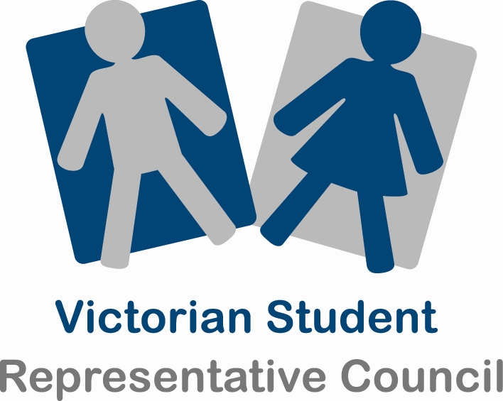
Submission by: The Victorian Student Representative Council

To: The Productivity Commission

Regarding: The Schooling Workforce

Introduction
The Victorian Student Representative Council (VicSRC) is a democratic network of Student Representative Councils (SRCs) working to represent the views of secondary students throughout Victoria. It aims to make students’ voices heard across the school system and beyond. The VicSRC holds a range of forums and events each year to hear student views, enable students to share ideas across schools and network together to take action on issues of concern to them. While an independent and student run body, the VicSRC is funded by the Victorian Department of Education and Early Childhood Development and auspiced by the Youth Affairs Council of Victoria.

The VicSRC would like to thank Commissioner Alison McClelland for meeting with the VicSRC Executive to discuss the issues raised in this inquiry directly. Since that time, the VicSRC has also held its annual Congress with over 100 students from 40 schools participating. Students themselves initiated discussion on several issues within the terms of reference and passed some resolutions relevant to the inquiry. This submission includes these resolutions as well as other ideas and input from across the three day Congress and from the discussions held with Commissioner McClelland. The submission addresses three areas: student expectations of teachers and the student teacher relationship; relationships between parents and teachers; and student relationships with school principals.

Student Experiences and Expectations of teachers
Students report a broad range of experiences of their teachers. These range from teachers who are inspiring and fun to learn with, to teachers who don’t inspire anything more than frustration and dissatisfaction. Different students experience the same teachers differently as factors relating to personality and styles of learning and teaching come into play. Students acknowledge that teachers have a difficult job to not only cater to the diverse needs of students but also to the broader needs of the education system and other stakeholders such as principals, parents and wider society. Overall students agree that there is a mixture of both good and bad teachers within the workforce. They believe that good teachers are under-valued while at the same time bad teachers remain working in school settings. The VicSRC is not in a position to assess the numeric balance of ‘good’ and ‘bad’ teachers.

Qualities of a good teacher
After consulting with students the VicSRC offers the following elements that contribute to a high quality teacher:
- They have a friendly and personal relationship with students based on mutual respect
- They have a passion for and good knowledge of their subject
- They are well organised and set out a plan for the term enabling students to be partners in the learning process by planning ahead or catching up on things they’ve missed
- They provide students with the freedom and responsibility to explore a range of learning options to cater to a range of learning styles.
- They have expectations of both students and themselves that spring from their passion to see students succeed in life, not just in school.
- They hear and respond to feedback from both students and other teachers.

When the VicSRC asked students what they want from their teachers, the strongest theme is in regards to how teachers and students relate to each other. This is an aspect of school life that the current generation of students is more passionate about than any preceding generation. Students desire and expect to be respected as individuals who have their own unique personal approach to learning and life and who can take responsibility for much of their own learning, if given the chance. Students want teachers who will treat them as partners in the learning process, based on relationships of mutual respect. Students are increasingly aware of their own learning styles and want teachers who understand and accommodate them as individual learners.

Students are increasingly approaching learning within the context of their whole life journey and they want teachers to understand, support and relate to them in a way that is not bounded by the school fence. They want teachers who relate to students as a person, not just as a ‘teacher’ and to draw on their own life experience within their teaching practice.

Students report that some teachers do relate to them in this way and are able to respond to the changing way in which students are seeking to relate to their teachers. Other teachers have not demonstrated an interest or ability to relate to students in this way. In developing policy regarding the schooling workforce, the VicSRC encourages the government to find ways to support teachers to adapt to these changing cultural expectations.

The VicSRC notes that some schools have begun to include student input within teacher selection and performance appraisal. It is particularly important to students that teachers are able to take on board student feedback, and that students get some response to this feedback in the form of changes or discussion about the students’ concerns. Some students are also keen to participate in teacher selection. They acknowledge that this is an important role and needs to be undertaken with a sense of responsibility. This responsibility makes some other students wary of taking on this role but many feel they would have something to contribute if they were offered the opportunity and supported appropriately. The VicSRC recommends that mechanisms for effectively implementing these forms of student participation be promoted among schools.

VicSRC Congress 2011 Relevant Resolutions:
“That the VicSRC create a resource to strengthen interaction and relationships between students and teachers.”
“That the VicSRC establish a ‘teach the teacher’ training course for individual SRCs to enact at their schools around the way students learn.”
“That the VicSRC encourage schools to include student opinion and voice on teacher selection panels.”

VicSRC Recommendations
1. That teachers are encouraged and resourced to relate to students in a way that respects the authentic individuality of both student and teacher.
2. That students are given the opportunity to contribute to teacher performance appraisal and that teachers are supported to receive and respond to student feedback.
3. That willing students are included in teacher selection processes and that schools are provided with a framework and the resources to support students participating in this process.
Relationships between teachers and parents
The relationship between teachers and parents is an area about which the VicSRC is receiving a growing amount of feedback. While some students are quite happy to maintain the status quo of minimal interaction between parents and school, much of the feedback the VicSRC receives is from students who would like their parents to be more engaged in their school life. This is consistent with students seeing their school life as being embedded within their wider life journey. These students would like more outreach towards parents from their schools and teachers. Many students want to be able to access support from both teachers and parents who understand what is going on for the student both at school and at home. In most cases this requires an improved relationship between teachers and parents with more regular communication. Students are critical of current reporting and communication arrangements that are either superficial or that exclude an active role for students. They are also critical of relationships that are solely concerned with responses to negative behaviour.
Some specific student comments and policy implications are as follows:

Student comments: | Policy implications
‘Why do teachers only contact our parents when we’ve done something wrong?’ | The teacher-parent relationship should be about more than just managing bad behaviour. It should focus on supporting student learning.
‘My parents don’t understand how the VCE system works’ | Students, particularly those from non-English speaking backgrounds, need more help from schools and teachers in explaining to parents the different options and pathways available to students, and the details of how the system works. This will help parents to feel informed and confident to help their children navigate the system.
‘Five minutes at parent-teacher interviews isn’t enough contact for my mum to know how I am really going.’ | Schools need to provide better systems, structures and time allowance for teachers to communicate more regularly with parents. Students should be included within and central to these communications and discussions. In some cases, students lead the reporting and discussion.

VicSRC Congress 2011 Relevant Resolutions:
“That the government provide some sort of resource for schools to help better educate parents about the Victorian schooling system. This resource could include funding, professional facilitators and/or kits.”

VicSRC Recommendations
4. That teachers are equipped and supported to maintain active relationships with parents and to include students in this process.
5. That schools provide opportunities and structures in which students, teachers and parents can come together for meaningful conversations.
6. That governments increase outreach and education for parents to equip and encourage them to take a greater interest in their children’s school experience.
Relationships with principals

Student feedback about school principals also varies greatly, and emphasises the importance of the principal’s style, personality and ways of interacting with students. The way that the principal exercises leadership within the school directly influences the behaviours and responses of students and teachers, and can establish a school climate that welcomes and values the participation of students as partners. Students report that some principals are great at interacting with students, take an active interest in student views, attend SRC meetings and discuss with students their ideas and concerns. Other principals are almost invisible to students, conducting their work beyond closed doors without including student representatives and appearing occasionally at school assemblies.

Students want to relate to their principals in the same way that they relate to their teachers: as individual people with different roles, opinions and experiences but able to converse as mutually respecting equals. They want principals who are easy to approach, open to student ideas and input and treat them as partners in school governance and decision making. SRC representatives want principals and leading teachers to attend SRC meetings when invited and to take their ideas seriously. They want principals to be proactive in inviting input from students about the core issues within the school: teaching and learning, relationships, resources and so on. Students who are given a voice in these realms of school life feel a sense of ownership and belonging that has benefits not just for students and their learning outcomes but for other stakeholders in the school as well.

VicSRC Recommendations
7. That principals are encouraged to fulfil their role as leader of the school community in way that openly engages with students as equal stakeholders and participants in school life.
8. That principals are encouraged to see SRCs as a useful partner in school governance, to attend SRC meetings when invited and to nurture student leaders within the school.

Summary of Recommendations
1. The teachers are encouraged and resourced to relate to students in a way that respects the authentic individuality of both student and teacher.
2. That students are given the opportunity to contribute to teacher performance appraisal and that teachers are supported to receive and respond to student feedback.
3. That willing students are included in teacher selection processes and that schools are provided with a framework and the resources to support students participating in this process.
4. That teachers are equipped and supported to maintain active relationships with parents and to include students in this process.
5. That schools provide opportunities and structures in which teachers and parents can come together for meaningful conversations.
6. That governments increase outreach and education for parents to equip and encourage them to take a greater interest in their children’s school experience.
7. That principals are encouraged to fulfil their role as leader of the school community in way that openly engages with students as equal stakeholders and participants in school life.
8. That principals are encouraged to see SRCs as a useful partner in school governance, to attend SRC meetings when invited and to nurture student leaders within the school.

