25 October 2012

Electricity Network Regulation
Productivity Commission
Canberra, ACT

RE: Electricity Network Regulatory Frameworks draft, 2012

Thank you for the opportunity to make a submission to the Draft Electricity Network Frameworks draft report. My submission briefly covers a number of issues around air conditioning. In general, I believe the discussion of air conditioning in the draft report provides an excellent overview of the topic. The three issues that may be worthy of more detailed analysis include:

- The relationship between household energy efficiency and peak demand.
- The technical potential of air conditioning demand management.
- The use of evaporative cooling as an effective tool in reducing peak demand.

1. The relationship between household energy efficiency and peak demand

It is often assumed that there is a direct relationship between energy efficiency and peak demand mitigation (for example Diesendorf 2007, D’Arcy 2009, Elliston et al. 2011). While there is no doubt some overlap between energy efficiency and peak demand mitigation, the relationship between the two is complex and often poorly understood (Langham et al. 2010, York 2007).
In the case of Victorian heating for example, it has been shown that the correlation between efficiency and aggregate gas peak demand becomes decoupled on very cold mornings (Palmer 2012). This occurs when the cumulative heating load of the building stock exceeds the heating capacity of the heating appliances. The saturation temperature defines the temperature at which the appliances cannot "work any harder", beyond which a large proportion of appliances will run continuously at near full load. Air conditioning load saturation is almost certainly more pronounced since residential air conditioners are regularly installed under-sized, and performance declines at a higher ambient temperature due to higher condenser temperatures. However air conditioning tends to be more discretionary than heating and there is a lack of good data to quantify the correlation between peak load and technical efficiency improvements.
The draft report (page 320) correctly notes that "many approaches do not have a targeted impact during peak events". As such, caution should be exercised in assuming a simple relationship between reduced energy consumption due to energy efficiency (such as air conditioning MEPS and the increasing thermal performance stringency of the building code) and the associated peak demand mitigation. In general, there is a need for greater understanding and accurate quantification of their relationship.

2. Air conditioning demand management

The draft report states that a 30 to 50% reduction in peak load of air conditioning may be achievable (page 329 box 9.6, item 4). However my reading of the reference (Futura 2011 page 212) is that the reduction applied to the whole household, including pool pump, cookers, dishwashers etc. Another trial conducted by Energex recorded a 17% reduction in peak demand due to residential air conditioning (McGowan 2009), which is more consistent with the type of response expected from remote air conditioner compressor cycling.
Trials such as these can provide valuable information but caution should be exercised in assuming that these results will be replicated more broadly in the long run. For example, self-selection, or people who are already interested in energy conservation, may be more likely to participate in trials (Somerville 2007, Hartman 1988). In the Energex trial, 2,300 households responded from 16,000 invitations, with 900 selected to take part. Also, participants may be initially enthusiastic and monitor their usage, but may revert to normal habits some time after the trial is complete.
It is well established that energy efficiency is subject to behavioural rebound (Maxwell et al. 2011, Gavankar & Geyer 2010), and it is reasonable to suggest that household demand management may also be subject to behavioural rebound. The challenge for energy efficiency and demand management policy is narrowing the gulf between theoretical potential and the durable, reliable returns under everyday conditions in the long-run.
3. Evaporative cooling

There is a strong argument in favour of including a more detailed discussion of evaporative cooling in the report, which is mentioned only once (page 316), based on three basic propositions:
- The penetration of evaporative coolers relative to the total stock of coolers is well below the share suggested by raw consumer preferences alone, and has been declining as a total share of the cooling market, driven by a number of factors.
- A range of demand management and pricing instruments will permit some mitigation of peak demand due to household cooling, but the overwhelmingly most significant factor in determining the peak load is the nameplate power rating of the cooling appliance.
- The electrical load of evaporative cooling is typically less than a fifth of the load of refrigerated air conditioning, permitting a substantial and guaranteed reduction in peak load, irrespective of future developments in smart grids or demand management. Note that the main load of an evaporative cooler is the fan, and that the fan power is approximately proportional to the cube of fan speed. Since experienced users run the fan at much less than full speed, most evaporative coolers will typically operate well below full nameplate power even on the hottest days. In contrast, refrigerated will always run at nameplate power under full load conditions.

Put together, these basic propositions suggest there exists significant scope for peak demand mitigation through re-balancing the relative share of evaporative versus refrigerated cooling (Denlay 2009). For example, if 100,000 households used evaporative instead of two split systems, the reduction in peak load would equate to an estimated 225 MW (assume 2 splits at 2.5 kWe, evaporative at 0.5 kWe, and allowing 50% capacity for some units turned off and operating at less than full load). Given that air conditioner sales total around 1 million units per annum with evaporative at 50-60,000 units (Saman et al. 2009), cumulative gigawatt scale relative reductions are achievable over a number of years. Based on the figures above, the substitution for a single evaporative cooler equates to successfully delivering remote cycling of compressors in five air conditioned homes. Therefore evaporative cooling, which provides a guaranteed load reduction, presents at least as significant an opportunity for demand reduction as remote compressor cycling of air conditioners, which itself represents the long-term end-point of a prospective "intelligent grid".
In relation to the suitable climate zones for evaporative, approximately 40% of residents live along the humid east coast regions, starting from Sydney in the south through the Gold Coast, Brisbane and the rest of the tropical Queensland coast, in addition to the tropical north of Australia. Therefore approximately 60% of the Australian population inhabit climate zones suitable for evaporative cooling. Note that the hottest days corresponding to the highest demand in the southern population centres are invariably days of low humidity, and the use of indirect evaporative coolers permits use in regions that would otherwise be considered marginal for evaporative cooling.

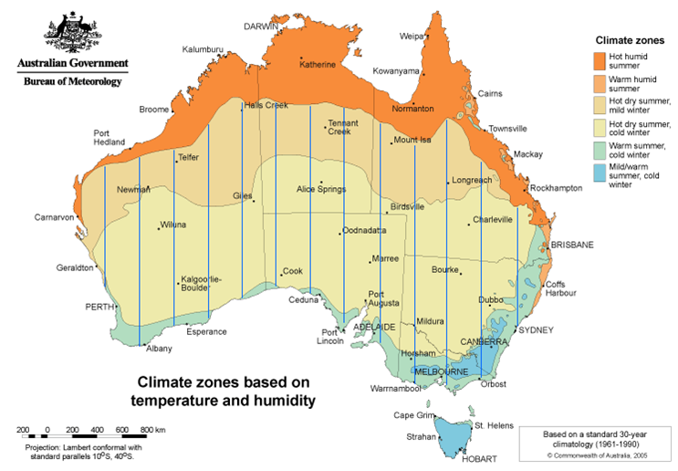

Figure 1. Blue lined areas (added by author) have potential for evaporative cooling. Region around NSW central coast and Sydney is marginal, but indirect evaporative coolers permit operation in some marginal regions.

Although anecdotal evidence suggests that a significant proportion of owners report a very high satisfaction with evaporative coolers, there are many reasons why evaporative cooling has declined as a share of the cooling market, including:
- Refrigerated wall split systems have become relative inexpensive because of a reduction in manufacturing costs, competition, and the strong Australian dollar.
- Virtually all of the large-budget marketing, sponsorship and endorsement is by the large international manufacturers who promote refrigerated air conditioning units.
- The concurrence of the extended drought in the 2000’s with the emergence of summer peak demand worked against the promotion of evaporative cooling due to concerns over water use. However, on average evaporative coolers consume 2-9% of the total annual water used in typical Australian households (Saman et al. 2009, Roberts 2005)
- The fact that evaporative coolers do not provide a universal cooling solution due to their ineffectiveness in humid climates has tended to blur their efficacy as an effective comfort solution. The lack of a thermostat doesn’t always match common consumer expectations of coolers, and people are used to air conditioned cars, offices, shopping centres etc.
- Electrical bulk stores dominate the air conditioning market. But the sale of ducted evaporative systems, requiring in-house specification and quotation, is not suited to the bulk store sales model, which have little incentive to provide a customised in-house "comfort solution" beyond selling a competitively priced box to a walk-in consumer. Like many products, air conditioning has become a commoditised product. The strength of market share of evaporative in new homes in Victoria provides evidence of consumer preference for evaporative when the option is offered and accessible
- Households with evaporative do not benefit from the reduced network load.

The apportionment of network costs due to air conditioning load to those households using air conditioning would assist a re-balancing of the market share of evaporative cooling and refrigerated. Although many consumers still prefer refrigerated, the actual market share of evaporative cooling does not necessarily reflect raw consumer preferences. Instead, it reflects the particular market conditions that have evolved in Australia, in particular the market dominance of electrical bulk stores (Harvey Norman, Retravision etc.) and the advertising and promotional dominance of the international air conditioning manufacturers. Indeed, given a shift in demand pricing signals, a mature market exists to exploit the relative demand benefits of evaporative cooling and re-balance their respective shares.

Yours sincerely

Graham Palmer

References

D’Arcy, D., 2009, Woolly claims on insulation. Building Products News, 2009. Available online: http://www.bpn.com.au/article/Insulation-rebates-major-response-to-major-challenge/437163.aspx (accessed on 1 May 2012)

Denlay, J., 2009, Evaporative Air Conditioners - Measuring and communicating their performance, E3 air conditioner industry stakeholder conference

Diesendorf, M., 2007, Greenhouse Solutions with Sustainable Energy; UNSW Press: Sydney, NSW, Australia, pp 346-347.

Elliston, B., Diesendorf, M., MacGill, I., 2011, Simulations of Scenarios with 100% Renewable Electricity in the Australian National Electricity Market, p 9

Enkvist, P.-A., Naucler, T., Rosander, J., 2007, A cost curve for greenhouse reduction. McKinsey Q., 1, 35–45

Futura, 2011, Power of Choice - giving consumers options in the way they use electricity. Final report commissioned by the Australian Energy Market Commission

Gavankar, S., Geyer, R., 2010, The Rebound Effect : State of the Debate and Implications for Energy Efficiency Research. Bren School of Environmental Science and Management

Hartman, R. S., 1988, Self-selection bias in the evaluation of voluntary energy conservation
programs, The Review of Economics and Statistics, 70(3), 448-58.

Langham, E.; Dunstan, C.; Walgenwitz, G.; Denvir, P., 2010, Reduced Infrastructure Costs from
Improving Building Energy Efficiency; Institute for Sustainable Futures, University of
Technology, Sydney

Maxwell, D., Owen, P., McAndrew, L., Muehmel, K., Neubauer, A., 2011, Addressing the Rebound Effect. European Commission DG Environment

McGowan, S., 2009, Hot in the city., Ecolibrium Feb 2009, 14-17.

Palmer, G., 2012, Does Energy Efficiency Reduce Emissions and Peak Demand? A Case Study of 50 Years of Space Heating in Melbourne, Sustainability, 4, no.7: 1525-1560

Roberts, P, 2005, Evaporative air conditioner study, Joint project between Yarra Valley Water and Water Services Association of Australia, Yarra Valley Water

Saman, W., Bruno, F., Liu, M, 2009, Technical background research on evaporative air conditioners and feasibility of rating their water consumption, Institute for Sustainable Systems and Technologies

York, D., Kushler, M., Witte, P., 2007, Examining the Peak Demand Impacts of Energy Efficiency:
A Review of Program Experience and Industry Practices; Report Number U072; American
Council for an Energy-Efficient Economy: Washington, DC, US

