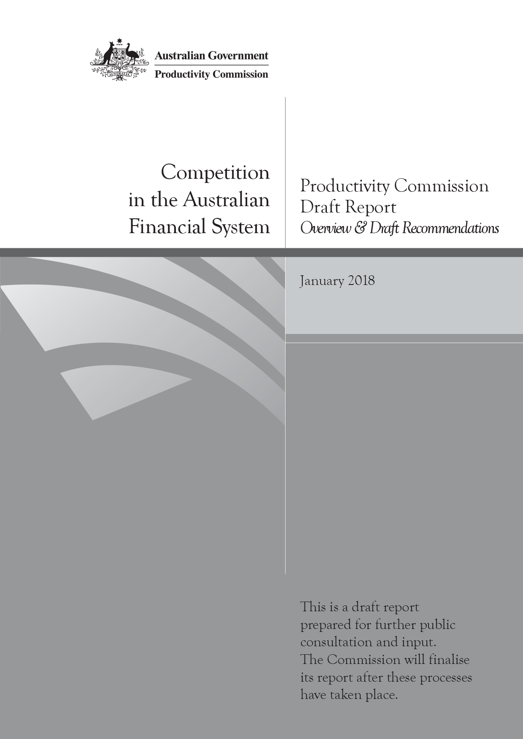
Competition in the Australian Financial System
Productivity Commission Draft Report, Overview & Draft Recommendatoins, January 2018

Commonwealth of Australia 2018

Except for the Commonwealth Coat of Arms and content supplied by third parties, this copyright work is licensed under a Creative Commons Attribution 3.0 Australia licence. To view a copy of this licence, visit http://creativecommons.org/licenses/by/3.0/au. In essence, you are free to copy, communicate and adapt the work, as long as you attribute the work to the Productivity Commission (but not in any way that suggests the Commission endorses you or your use) and abide by the other licence terms.
Use of the Commonwealth Coat of Arms
Terms of use for the Coat of Arms are available from the Department of the Prime Minister and Cabinet’s website: https://www.pmc.gov.au/government/commonwealth-coat-arms
Third party copyright
Wherever a third party holds copyright in this material, the copyright remains with that party. Their permission may be required to use the material, please contact them directly.
Attribution
This work should be attributed as follows, Source: Productivity Commission, Competition in the Australian Financial System, Draft Report
If you have adapted, modified or transformed this work in anyway, please use the following, Source: based on Productivity Commission data, Competition in the Australian Financial System, Draft Report
An appropriate reference for this publication is:
Productivity Commission 2018, Competition in the Australian Financial System, Draft Report, Canberra
Publications enquiries
Media, Publications and Web, phone: (03) 9653 2244 or email: mpw@pc.gov.au

The Productivity Commission
The Productivity Commission is the Australian Government’s independent research and advisory body on a range of economic, social and environmental issues affecting the welfare of Australians. Its role, expressed most simply, is to help governments make better policies, in the long term interest of the Australian community.
The Commission’s independence is underpinned by an Act of Parliament. Its processes and outputs are open to public scrutiny and are driven by concern for the wellbeing of the community as a whole.
Further information on the Productivity Commission can be obtained from the Commission’s website (www.pc.gov.au).

Opportunity for further comment
The inquiry team thanks the industry associations, businesses, individuals and government bodies who have contributed data, information and insights to the inquiry to date.
We invite examination of this draft inquiry report and comment on it by written submission to the Productivity Commission, preferably in electronic format, by 20 March 2018 and/or by attending a public hearing.
The final report will be prepared after further submissions have been received and public hearings have been held and will be forwarded to the Australian Government by 1 July 2018.

Public hearing dates and venues
Location | Date | Venue
Sydney | Wednesday 28 February 2018  Thursday 1 March 2018 | Wesley Conference Centre  220 Pitt Street
Melbourne | Monday 5 March 2018  Tuesday 6 March 2018 | Productivity Commission  Rattigan Rooms  Level 12, 530 Collins Street
Closer to the time of the hearings, further details will be provided on the inquiry website at: http://www.pc.gov.au/inquiries/current/financial-system.

Commissioners
For the purposes of this inquiry and draft report, in accordance with section 40 of the Productivity Commission Act 1998 the powers of the Productivity Commission have been exercised by:
Peter Harris | Presiding Commissioner
Julie Abramson | Commissioner
Stephen King | Commissioner

Disclosure of interests
The Productivity Commission Act 1998 specifies that where Commissioners have or acquire interests, pecuniary or otherwise, that could conflict with the proper performance of their functions during an inquiry they must disclose the interests.
All the Commissioners on this Inquiry, or their families, own shares, either directly or indirectly, in financial institutions.

Contents
Opportunity for further comment iii
Key points 2
Overview 3
Competition is constrained 3
Reforms that promote competitive behaviour by firms 17
Reforms that give individuals a greater role in competitive outcomes 28
Draft findings and recommendations 31
The full report is available from www.pc.gov.au

Overview

Key points
- Competition — and the innovation it fosters — has given us a financial system that offers ready access to funds at all hours of the day, safe and quick movement of money between accounts, payment via personal devices such as mobile phones, and speedy loan approvals.
- Yet the system is also generally highly profitable (which may be no bad thing) and lacking strong price rivalry. We examine why this is so.
- First, the benefits of competition to the individuals and businesses for whom the financial system exists are being reduced in the quest for stability. Regulators have focused almost exclusively on prudential stability since the Global Financial Crisis, promoting the concept of an unquestionably strong financial system.
- Second, although financial institutions generally have high customer satisfaction levels, customer loyalty is often unrewarded with existing customers kept on high margin products that boost institution profits. For this to persist, channels for provision of information and advice (such as mortgage brokers) must be failing.
- In retail banking, market concentration is very high in many product markets, but concentration by itself is not the calamity that it is often made out to be, so long as new and innovative business models can thrive.
- Scope for price rivalry in principal loan products is constrained by a number of external factors: price setting by the Reserve Bank facilitating price coordination by banks; expectations of ratings agencies that large banks are too big to fail; and some prudential regulation (particularly in risk weighting) that favours large institutions over smaller ones.
- Competition in quality of services — effective use of technology to better price risk, responsiveness to demand shifts, simpler and cheaper processes — is not so constrained. But much of what passes for competition is more accurately described as persistent marketing and brand activity designed to promote a blizzard of barely differentiated products and ‘white labels’.
- The growth in mortgage brokers and other advisers does not appear to have increased price competition. The revolution is now part of the establishment. Non-transparent fees and trailing commissions, and clear conflicts of interest created by ownership are inherent. Lender-owned aggregators and brokers working under them should have a clear best interest duty to their clients.
- In general insurance, market concentration is high and camouflaged, with a proliferation of brands but far fewer actual providers. Consumer confusion on product differences is attributable to the poor quality of information required to be provided to consumers and, to a lesser degree, the incentives faced by advisers.
- While new entrants to financial markets have brought increased competitive pressure in the past, evidence over the past decade suggests they cannot be counted on as a primary source of competitive pressure. Thus, reforms to the regulatory framework under which incumbents operate are also essential to realise further benefits of competition in the financial system.
- The institutional responsibility in the financial system for supporting competition is loosely shared across APRA, the RBA, ASIC and the ACCC. In a system where all are somewhat responsible, it is inevitable that (at important times) none are.
- More nuance in the design of APRA’s prudential measures — both in risk weightings and in directions to authorised deposit-taking institutions — should be sought. This would help address issues of market power and imbalance that have emerged in lending between businesses and housing.

Overview
Australia’s financial system has changed beyond recognition in the past several decades. Australians have ready access to funds at all hours of the day, can get home loan approvals in under 24 hours, quickly and safely move money between accounts with the swipe of a finger, pay for products with the tap of a card, smartphone or watch, and have investment portfolios managed by robo-advisers.
Competition — and the innovation it fosters — has underpinned these developments. When firms have been driven to offer improved or better value financial products in order to strengthen their competitive positions, benefits have also flowed to those for whom the financial system exists — the businesses investing in the Australian economy, and the individuals whose consumption drives the majority of economic activity.
The financial system must be strong and stable. But equally, it should ensure that Australia’s businesses and households are well-served and can have confidence that ‘unquestionably strong’ institutions are not exploiting the market power that might accompany this exalted status.
This inquiry focusses on competition in Australia’s financial system as a means to improve consumer outcomes, enhance the productivity and international competitiveness of the financial system and the broader economy, and support ongoing financial system innovation — without undermining financial stability objectives.

Competition is constrained

Market concentration
Australia’s financial system is dominated by large players — four major banks dominate retail banking, four major insurers dominate general insurance, and some of these same institutions feature prominently in funds and wealth management. A tail of smaller providers operate alongside these institutions, varying by market in length and strength.
The combined market shares of major players in banking and insurance are well over 70% in some product lines (figure 1). Internationally, Australia’s banking concentration is on par with that of Canada and the Netherlands, but well above that of the United Kingdom, United States and Japan.
These large market shares do not necessarily indicate that competition is weak or that community outcomes will be poor. Markets can be competitive and deliver beneficial outcomes even when they are dominated by large players, provided it is possible for:
- new providers to enter easily (including through takeover of incumbents) and offer innovative products that the community values
- existing smaller incumbents to expand and capture market share from their rivals
- consumers to conveniently switch to alternative products or providers.
Among some particular customer groups, smaller financial institutions have comparatively high market shares. For example, some regional and customer-owned authorised deposit-taking institutions (ADIs) and some of the foreign-owned banks structure their operations to target a particular part of the community (such as their home state, employees in a particular profession, or dual nationals from their base country) to overcome the disadvantages of potentially limited scale, higher funding costs, or in the case of foreign-owned banks, limited public-facing branches.

Figure 1 Concentration in banking and insurance markets
Major institution sharea, annual averagec
a Major banks are the CBA, Westpac, NAB and ANZ. The top 4 level 1 general insurers are IAG, AAI Limited (Suncorp), QBE Insurance, and Allianz Australia Insurance Limited. b Insurance concentration estimates are calculated at the level 1 insurer level. General insurance includes direct general insurance only (excludes reinsurance and lenders mortgage insurance). c For banking markets, values for 2007 and 2017 are shown. For general insurance markets, values for 2006 and 2016 are shown.

Market entry and consolidation
The number of ADIs has halved since 1999 to 148 institutions in 2017, with many small banks, credit unions and building societies merging or being absorbed by larger domestic banks.
There have been limited new entrants in general insurance and a steady decline overall in regulated insurers from 171 in 1999 to around 104 in 2017.
Australia’s Four Pillars policy, aimed at ensuring that whatever other consolidations occur in retail banking, the four major banks will remain separate, has been an underlying feature of the financial system policy landscape throughout this period of considerable consolidation.
It is an ad hoc policy that, at best, is now redundant, as it simply duplicates competition and governance protections in other laws. At worst, in this consolidation era it protects some institutions from takeover, the most direct form of market discipline for inefficiency and management failure. Raising the cap on ownership would offer a greater threat of market discipline, without green-lighting mergers.
When there have been periods of heightened competition in the Australian financial system, these have typically been driven not by established providers but by new entrants — such as Aussie Home Loans providing home loan competition in the 1990s and early 2000s, foreign banks such as ING offering online retail banking, and Rabobank providing services to medium/large agribusinesses. But this revolution is over. All new entrants to the banking system over the past decade have been foreign bank branches, usually targeting important but niche markets (and these entrants have evidenced only limited growth in market share).
Although a very small part of the financial system, fintechs represent a group that could fundamentally change the nature of competition in the banking system. While the overall trend towards collaboration between fintechs and incumbents may improve efficiency of operations and reduce transaction costs for both fintechs and incumbents, it also reduces the potential for these new entrants to be a source of competition. If barriers to entry and expansion continue to fall, and data reforms are pursued effectively by the Australian Government, fintechs will find it easier to compete against incumbents.
It remains to be seen how the big tech players (such as Apple, Google and Amazon) will ultimately choose to compete in the global and Australian financial systems. These companies have already established a large network of customers with multifaceted relationships and trust. This gives them a strong position to offer competitive financial services.
Despite consolidation in provision of financial services and indications that new entrants have brought competitive pressure in the past, most analysts and consumer advocates have suggested to us that more banks or more insurers should not be counted on as a primary driver of improved market outcomes.
Rather, we need: regulatory settings that do not thwart competition between existing institutions; more customer-oriented providers that consider their existing customers (not just potential new customers); less of a blizzard of new but barely-distinguishable products with labels that obfuscate; much better and far more open information on product prices and conditions; and scope for consumers to more easily become unstuck (should they wish to be) from their current banks and insurers.

Consumer choice and switching
Little switching occurs — one in two people still bank with their first-ever bank, only one in three have considered switching banks in the past two years, with switching least likely among those who have a home loan with a major bank. ‘Too much hassle’ and a desire to keep most accounts with the same institution are the main reasons given for the lack of switching, with home loans being a particularly difficult product for consumers to switch.
Barriers to switching can make loyal customers ripe for exploitation. The Reserve Bank of Australia (RBA) reports that the variable interest rates of existing home loan customers average around 0.3 to 0.4% points higher than rates on new home loans. These higher rates are paid by around 15% of existing customers and equate to an extra $66 to $87 per month on the average home loan balance (figure 2).
That 50-70% of Australians interact with more than one bank (this tendency increases with age and home ownership), should make switching product providers a more realisable proposition. It may appear that there is reasonable competition here, but it exists only in those markets (such as transaction accounts and some credit cards) where it costs you little to have multiple versions of very similar products.

Figure 2 New home loan customers pay lower interest rates
Compared with standard variable rate (SVR)
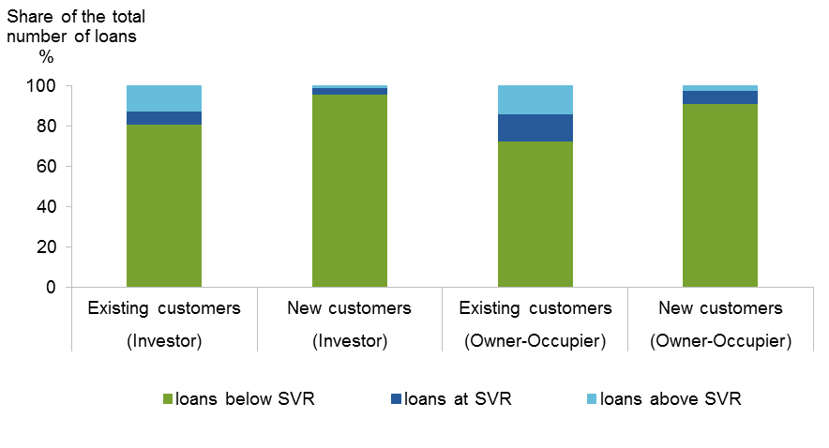

In practice, multiple accounts or flick and tick account changing are not panaceas for more competition in markets. Awareness and convenience must be added to make opportunities attractive.
In banking, there is often no evident trigger for consumers to consider making a change that saves them costs or earns them a higher return. But there is in insurance. The annual renewal point for insurance should act as a trigger point for reconsidering insurance providers, yet the complexity of product offerings and an overwhelming orientation to trusted brands induces inertia.
Satisfaction of consumers with their own financial institutions is very high. This is a positive characteristic, but when considered in conjunction with what we know about a lack of responsiveness to better offers, it indicates a substantial failure in information and advice. With the relative explosion in advisory services in the last decade or so, this is surprising and suggests an important avenue for potential reform.
The channelling of products offered to consumers through the vertical integration of brokers and other distribution channels can mean these consumers are not given the choice of products that are better for them. Unlike in wealth management (a similar advisory business, involving serious financial cost) mortgage brokers are not obliged by law to act in the best interests of the customer. And an important source of advice subsequent to the transaction is compromised, as trailing commissions encourage broker loyalty to the financial institution, not the customer.
From a relatively small industry in the 1990s, mortgage broking has grown such that just over 50% of all new home loans now originate through a broker. While enabling ready comparisons between a selection of home loan providers and reducing consumer search costs, mortgage brokers do not consistently get lower home loan interest rates for consumers than would be available to the consumer by going directly to the provider.
The current approach to the provision of many financial products still, ultimately, puts the onus on consumers to find better deals and negotiate with providers, which places many at a disadvantage.

Rivalry through price competition is rarely evident
As in many other sectors in the economy, financial service providers offer a choice of products varying to some extent on price, service, product features and add-ons to attract additional customers, enhance existing customer satisfaction and prevent loss of customers. Compared to banks overseas, Australia’s banks offer products that have comparatively low fees but give the banks moderately high interest margins.
While industry participants point to lower fees and falls in some loan interest rates as indicative of price competition, lower input costs (the RBA’s target cash rate has fallen from 7.25% to 1.5% over the past decade) are substantially responsible.
The fall in the cash rate does not appear to have been fully passed on in lower prices across the board. Instead, the spread between home loans and the cash rate, for example, has largely increased in recent years (figure 3). The RBA reports similar increases in interest rate spreads for business lending. In credit card markets, interest rates were estimated by CHOICE to be around 3% points higher than they would be had the reduction in the cash rate in recent years been reflected in credit card interest rates. In part, the lack of pass through of cash rate changes to other interest rates reflects the decreasing importance of the cash rate (relative to other factors such as prudential settings) on the cost of funds to institutions.
In general insurance, there have been substantial increases in claim costs in some markets which have flowed through to increased premiums. The overall decline in profitability in these markets though is indicative of some level of price competition.
Prices of many comparable banking products tend to converge (but not necessarily to the marginal cost of provision) between the different providers — with a congruence in underlying influences on bank pricing and with smaller players (including the so-called challenger banks) following the pricing decisions of the major providers.
For competition analysis it is significant that the state of the market persistently allows this.
The forces at work here are not all under the control of the ADIs. There are two broad drivers of the pricing of retail banking products: externally-imposed factors (features intrinsic to the regulated market) and internal factors (features within the control of the ADIs themselves).

Figure 3 Home loan interest rate spread
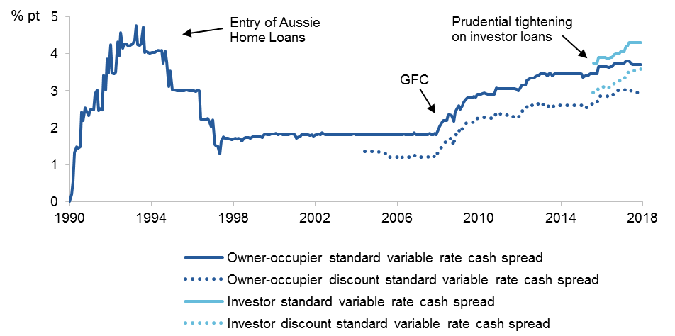

Price competition in banking is limited by external factors
Australia’s key financial regulators — the RBA, the Australian Prudential Regulation Authority (APRA) and the Australian Securities and Investments Commission (ASIC) — work together to create a stable financial system, coordinated to a degree through the Council of Financial Regulators (CFR). Through the setting of the cash rate in response to market conditions, capital holding requirements and other prudential requirements, the RBA and APRA indirectly determine the costs of funds for all ADIs. This, in turn, influences the interest rates the ADIs need to charge to borrowers to cover funding costs. For non-ADIs (that are not able to take retail deposit funds), regulatory settings affect the amount they have to pay for funds through warehouse funding (temporary lines of credit provided by larger banks to other lenders) and securitisation arrangements. Other operating costs of the ADI (for example, IT maintenance, branch and back-office costs) and a return on capital are added onto funding costs.
Evidence suggests that despite consolidation of smaller financial institutions and efforts by these institutions to develop shared solutions and use service providers to reduce operating expenses, a gap remains between the average costs of Australia’s major banks and its smaller institutions. Operating costs for major banks are around 45% of income, compared with 65% for other smaller domestic banks (figure 4). Australia’s major banks also have relatively low operating costs compared with foreign banks operating in Australia and overseas. But they also tend to have a comparatively large and increasing component of their business centred on lower-cost traditional retail lending activity (home loans) rather than on higher-cost areas such as business lending.
There is also variation between larger and smaller institutions in funding costs (with a large regulatory-determined component). Not all ADIs face the same regulatory arrangements and regulatory effects on their pricing capacity. A source of differential funding costs to banks is a series of regulatory measures and levies that apply (both positively and negatively) to the major Australian-owned banks but not to smaller Australian-owned ADIs or foreign banks operating in Australia. These include:
- Risk models — Westpac, CBA, ANZ, NAB and Macquarie have all invested in the necessary risk management capability to operate internal ratings-based (IRB) risk models. This allows them to decide on the amount of regulatory capital they hold based on their own models, subject to APRA’s scrutiny and some limits on minimum capital holdings. All other ADIs use APRA’s standard risk weighting. Specifically, in the case of home loans, an IRB bank holds 25-29% of the value of its home loan portfolio as regulatory capital — whereas for a standardised bank this ranges between 35% and 45%. In July 2017, APRA announced that in order to be ‘unquestionably strong’, IRB banks would be required to hold an additional 1.5% points in common equity tier 1 capital, and other ADIs would be required to hold an additional 0.5% points. The more capital required, the more costly it is for the institution to lend, and the less capacity it has to compete on price.
- Domestic systemically important banks (D-SIBs) — In 2013, APRA designated Westpac, CBA, ANZ, and NAB as D-SIBs, which have the size, interconnectedness, substitutability and complexity that necessitate they hold extra capital to address the potential risk to the stability of the financial system should they become stressed or fail. While not intended to reinforce a ‘too big to fail’ labelling of banks, APRA states that the designation is intended to ensure that banks perceived to be too big to fail have a greater capacity to absorb losses. The international ratings agencies reflect this designation of D-SIBs in a three-notch credit rating uplift, significantly reducing the interest they pay on wholesale funding.
- Major bank levy — In its May 2017 Federal Budget, the Government introduced a 0.015% levy paid quarterly on the balance of bank liabilities of Westpac, CBA, ANZ, NAB and Macquarie. The motivation for the levy was explained as: ensuring that the banking sector makes a fair contribution to the economy, improving competition and accountability, and complementing prudential reforms.
The net result of these regulatory measures is a funding advantage for the major banks over smaller Australian banks that rises in times of heightened instability. RBA estimated this advantage to have averaged around 20 to 40 basis points from 2000 to 2013 (worth around $1.9 billion annually to the major banks). More recently, the funding cost advantage of major banks has been estimated to have declined to about 10 basis points, due in part to prudential reforms. But it nevertheless persists, and ratings agencies are unlikely to rate institutions’ fund raising such that there is no effective differential between Australia’s major and smaller banks.
To the extent that smaller institutions use securitisation as a source of funding and rely on larger banks to act as intermediaries in accessing wholesale debt markets, their cost of funds and scope for initiating or persisting with price competition will be even more limited. New APRA measures that take a one-size-fits-all approach to risk weightings in this area will further increase the costs of warehouse funding. Again, this will reduce the capacity of smaller institutions to compete even at the margin, let alone in a market-shifting fashion.
History suggests that even where Australia’s smaller ADIs are given a regulatory advantage over the major banks, they do not noticeably take advantage of major bank price rises by maintaining their own loan prices in an attempt to gain market share. Rather, they seek to raise prices and improve margins earned from their existing customer base.
An exception may be the mutual ADIs, which do not face the same shareholder pressures as other ADIs. The Customer Owned Banking Association reports its members’ standard variable rate on home loans average 0.4 to 0.8% points lower than the major banks’ rates. However, their scope to lower lending rates further is probably even more limited than other ADIs simply due to narrower sources of funding.
The prudential requirements (including capital requirements) for insurers similarly contribute to the premiums insurers charge. We have not, however, observed similar issues in the regulatory arrangements for different size insurers.

Figure 4 Bank input costs
Operating efficiency (operating costs as % of operating income)
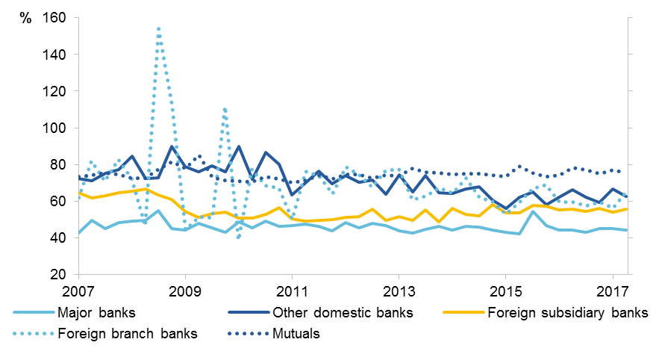
Funding costs
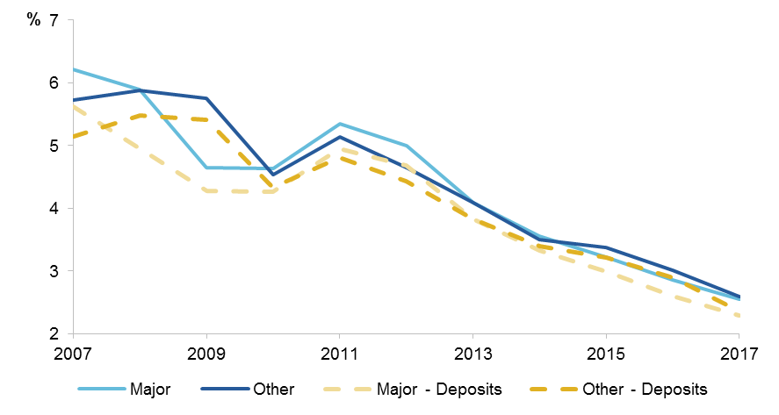

This persistent advantage suggests that the scope for smaller ADIs and non-ADIs to compete on price is more limited than for larger institutions, unless margins are sacrificed — and this has not occurred since the global financial crisis (GFC).
But the solution is not to increase major bank costs. It is one thing to lift IRB risk weights, as the Murray FSI proposed, if they were demonstrably too low. It is entirely another to add to one sub-group’s costs and expect this will improve outcomes for consumers.

Consumers have lost their market power to shareholders
Publicly listed institutions are required to act in the interests of their shareholders when devising their competitive strategies. This means that they are motivated to keep prices high in order to deliver profits that are in line with market expectations. But if the market were competitive, such practices would cause consumers to switch to a lower price provider, lowering profits and shareholder expectations. It is, at least in part, the stickiness of consumers with their current bank, insurer or adviser that allows these providers to maintain profits without loss of market share.
Australia’s major banks have delivered substantial profits to their shareholders (figure 5) — over and above many other sectors in the economy and in excess of banks in most other developed countries post GFC. In recent times, regulatory changes have put pressure on bank funding costs, but by passing on cost increases to borrowers, Australia’s large banks in particular have been able to maintain high returns on equity (ROEs).
The ROE on interest-only investor loans doubled, for example, to reach over 40% after APRA’s 2017 intervention to stem the flow of new interest-only lending to 30% of new residential mortgage lending (reported by Morgan Stanley). This ROE was possible largely due to an increase by banks in the interest rate applicable to all interest-only loans on their books, even though the regulator’s primary objective was apparently to slow the growth rate in new loans. Competing smaller banks were unable to pick up dissatisfied customers from this re-pricing of their loan book because of the application of the same lending benchmark to them.
To be clear, it is completely unsurprising that faced with the opportunity to re-price their loan book as a consequence of a regulatory changes, banks did just that. Shareholders expect that of their managers. But this additional cost impost — part of which (through the tax deductibility of interest on housing investment loans) is being paid now by all Australian taxpayers — was not an objective of the regulator and means that the intervention could have been better focused.
These type of macroprudential interventions by APRA seem likely to be widely used in future. As such, clear objectives should be set, banks’ responses should be forecast, and the Council of Financial Regulators (CFR) should consider a tabled analysis of these. Regulators should seek to keep costs to the least necessary to achieve their objectives in all material future macroprudential actions. This must include the impact on competition.

Figure 5 Profitability
Banks
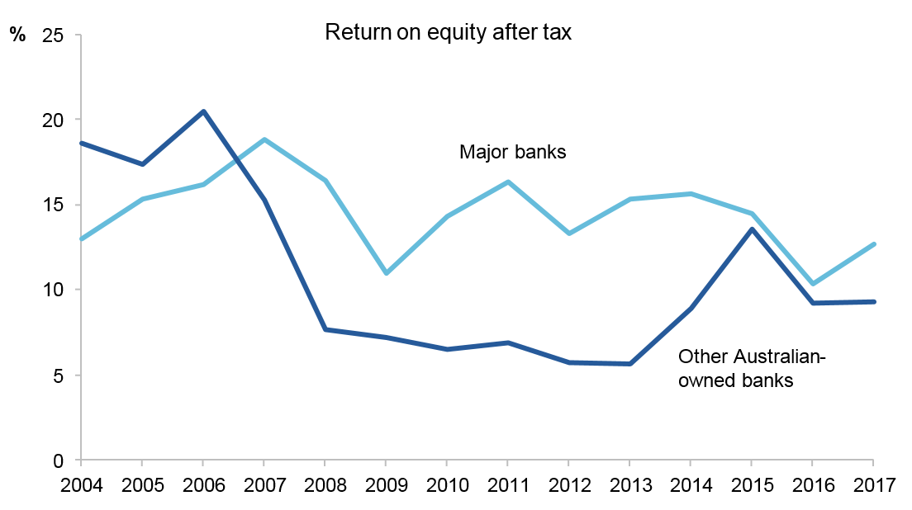
General insurance

Product proliferation: poorly aligned with consumer interests
Providers of financial products emphasise their service levels and product features (such as increased functionality in internet banking or online services provided by insurance companies) in attracting and retaining customers.
Scope for product features based on technology improvements is considerable, given Australia’s relatively high use of ‘self-serve’ digital channels for financial services compared with that reported in other countries. The level of technical innovation in service provision in some parts of Australia’s financial system is indicative of a strong and adaptive system that has the capacity and motivation to innovate. From ‘tap and go’ payments with near real time payment clearance, high uptake of online retail banking, and product comparison websites, Australians are, for the most part, at the forefront internationally of innovative banking services and payments systems.
In contrast, insurance and innovation have often been described as co-existing only in the dictionary. There exists some innovation in Australia’s general insurance markets, but it is typically more focused on using masses of consumer data (such as from shopper loyalty programs) in novel ways to increase returns, than in innovation that improves consumer outcomes. The UK insurance market offers, by way of comparison, much more innovation in insurance products.

Product proliferation is confusing consumers and enabling price discrimination
Across the financial system, there is a continual flow of new products and a re-packaging of existing products to appeal to specific groups of consumers. As a consequence, there is a very large number of products in financial markets, with sometimes only marginal differences between them: nearly 4000 different residential property loans and 250 different credit cards are on offer, for example. The same situation is apparent in insurance markets: the largest 4 general insurers hold more than 30 brands between them. In the pet insurance market this is particularly pronounced — 20 of the 22 products (with varying premiums) on offer are underwritten by the same insurer.
The need to decide between a large number of options makes product comparisons difficult and leads to ‘choice overload’. Product features can be useful, but white labelling as a practice does not offer different features, just proliferation. Moreover, consumers consistently report that price, rather than extras, is the most important factor to them when choosing products such as home loans.
In some parts of the financial system (such as insurance and funds management) the proliferation of products with slight variations in features has, over time, become a burden not just for consumers but also for providers. The Financial Planning Association of Australia noted that, with a lack of transparency around product features and performance objectives, it has become increasingly difficult for its planners to compare products for each client.
The costs for providers of product proliferation become magnified where dated products, often on legacy IT systems, are used by a comparatively small number of customers with contracts that cannot readily be varied. This burden does not yet appear to have deterred most institutions from creating yet more product variations, though some are now seeking to simplify their range.
The huge product variety also provides latitude for price discrimination between consumers (for example, insurers may offer policies with relatively high premiums to existing customers compared to new customers posing a similar level of risk), with associated profit opportunities for those institutions able to do so.

A web of products and providers
Scope for bundling of products to be used as a relationship feature is high, given strong consumer preferences to keep their financial products together. A CHOICE survey found that half of all Australians who have a transaction account, home loan and credit card have all three products with the same institution. One third of people who had not switched accounts gave keeping all their accounts at the same institution as the reason for their lack of change.
Australia’s largest financial institutions, in particular, have in the past leveraged their incumbency and scale to move into parallel markets and activities either side of them in the supply chain (such as financial planning) — offering more scope to bundle products and services (figure 6).
To the extent that integration is reducing product search costs for consumers and offering bundling benefits, it is a market feature that should be welcomed. But where integration is used as a means to create impediments to new entrants, to lock in consumers or up-sell them into additional products with poor quality information on the options available to them, this could distort market outcomes.
The effects on systemic risk of the greater complexity that comes with integration can be overstated. When prudentially regulated institutions expand into high risk unregulated areas, this might have the effect of raising the risk of their regulated activities. Offsetting this will be the effectiveness of the regulators. In Australia, some of APRA’s prudential measures, including requirements for the major banks to be ‘unquestionably strong’, diminish these potential risks for those regulated institutions that expand into other markets.

Figure 6 The major bank networksa,b
Select subsidiaries and other entities of major banks
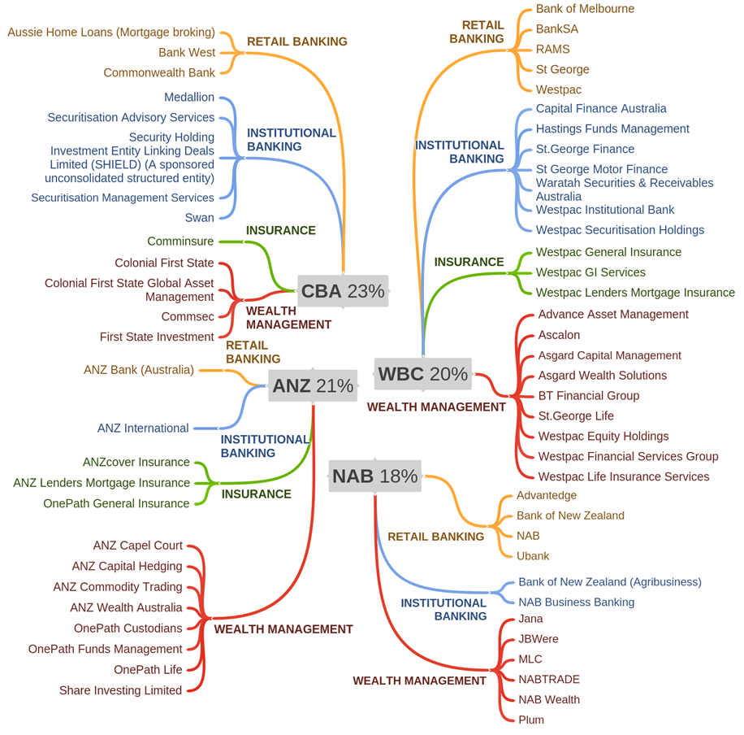

a Banks include Australia New Zealand Banking Group (ANZ), Commonwealth Bank Group (CBA), National Australia Bank Group (NAB), Westpac Banking Corporation (WBC). Total assets of group as % of total assets of all Australian financial institutions. b Entities listed may fall within more than one category and may not reflect investment or divestment activity since annual reports were released. The listed entities do not comprise an exhaustive list, do not show exclusive contracts, and are generally entities incorporated in Australia.

The state of competition
Overall, the extent of competition in Australia’s financial system is widely variable across different product areas. This inquiry focuses on markets where there is evidence of limited competitive effect.
Innovation and rivalry in price is limited in most of the markets we examined. There appears to be more evidence of competition in product features. The markets for home loans, consumer credit cards, household insurance, wealth management and financial advice demonstrate this. Yet the proliferation of products appears excessive. And its contribution to paralysing consumers with uncertainty about the benefits of switching call into question the scope for product proliferation to improve outcomes for consumers.
In some key markets — for example, small business credit and lenders mortgage insurance — competition appears constrained by factors that may be alleviated by regulatory reform.

Reforms that promote competitive behaviour by firms
When competition in the financial system is strong, rival providers strive to deliver better services and greater choice to consumers as efficiently as possible, and well informed mobile consumers place competitive pressure on providers. The Commission’s reforms that actively promote competition in Australia’s financial system are therefore directed at delivering:
- clarity around how prices or features vary with product differentiation, with minimal scope for a provider or group of providers (or, of less bearing in financial markets, for any single consumer or group of consumers) to exert significant influence over price;
- sufficient information for both providers and consumers to make informed decisions based on factors such as credit worthiness, risk or product choice (given product terms and conditions);
- low barriers for industry participants entering the market, for those expanding within it, and for existing providers that want to exit;
- a regulatory environment that does not impose undue distortions on the provision or access to particular financial products or particular providers, and is able to effectively assess and deal with the risks for competition that are posed by regulatory measures and market developments.

Adding competition via reforms to the regulatory framework

The financial system needs a competition champion
Competition in Australia’s financial system is without a champion among the existing regulators — no government agency is tasked with overseeing and promoting competition in financial markets, including forcing consideration of whether actions by regulators materially harm competition. Under the current regulatory architecture, promoting competition requires a serious rethink about how the RBA, APRA and ASIC consider competition and whether the Australian Competition and Consumer Commission (ACCC) is well-placed to do more than it currently can for competition in the financial system. As a forum for coordinating input from financial system regulators on regulatory interventions, the CFR should be a key avenue through which consideration of competition impacts is promoted, analysed and made more transparent.
The Murray Financial System Inquiry made a series of recommendations intended to strengthen regulators’ ability to consider competition, and to consider the effects of their actions on competition. The most direct recommendation — giving ASIC an explicit mandate to consider competition — is yet to be implemented.
In the absence of a competition advocate in the financial system, the role of balancing competition and financial stability falls mainly to APRA — which has financial system stability as its primary objective but is required to also consider the effects of its interventions on financial system efficiency, contestability, competition and competitive neutrality. In exercising its powers, APRA states that it aims to maintain sustainable competition, but there are times when it needs ‘to actively temper competitive spirits within the financial sector’. We do not propose to change the nature of APRA’s obligations in this draft report.
Yet in the current environment of emphasis on maintaining unquestionably strong institutions, and with macroprudential supervision likely to dominate regulator behaviour for some years to come, it is evident that finesse in the application of regulatory decisions that impact on competition can and should be improved.

Blunt application of some prudential measures is costing the community
Some of APRA’s interventions in the market — while undertaken in a way that is perceived by the regulators to reflect competitive neutrality — have been excessively blunt and have either ignored or harmed competition. Such consequences for competition were neither stated nor transparently assessed in advance.
In particular, APRA’s interpretation of Basel guidelines on risk weightings that non-IRB banks use for determining the amount of regulatory capital to hold, puts it among the most conservative countries internationally (table 1).
- For home loans, the main area in which Australia’s risk weights vary from international risk weightings is for (lower risk) home loans that have a loan to value ratio below 80%. Australian non-IRB lenders are required to use a risk weight of a flat 35%, compared with Basel-proposed guidelines of 25% to 35% for such loans.
- For small and medium enterprise (SME) loans, the main area of difference is lending that is not secured by a residence. A single risk weight (of 100%) applies to all SME lending not secured by a residence, with no delineation allowed for the size of borrowing, the form of borrowing (term loan, line of credit or overdraft) or the risk profile of the SME borrowing the funds. In contrast, Basel proposed risk weights for SME lending vary from 75% for SME retail lending up to €1 million, to 150% for lending for land acquisition, development and constructions.

Table 1 How Australia’s risk weights compare with Basel
Type of lending | Basel II Standard risk weightings | Basel III Standard  risk weightings | Australia’s standardised ADIs | Australia’s IRB banks
Home loans | 35% | 25 – 55% (depending on LVR) | 35 – 75% (depending on LVR and mortgage insurance) | Avg 26%  (with range from  5 – 137%)
SME lending | 75 – 100%a | 75 – 150%a | 100% | Avg 48 – 55%

a Risk weights vary with loan size, ownership structure of the business, loan to value ratio, and type of security.
These higher risk weights mean that Australia’s non-IRB lenders are generally required to hold more regulatory capital than are Australia’s IRB (major bank) lenders; foreign bank branches in Australia; and institutions with comparable loans in other countries.
This means that for SME loans that are not secured by a residence, Australia’s smaller banks need to hold twice as much capital as the major banks — in effect, paying twice as much to be able to offer loans to their customers. This difference is smaller for loans secured against a residence.
These differences in costs associated with regulatory capital holdings are passed on to borrowers. This approach to risk weights skews competitive opportunity away from consumer interests and provides strong incentives for both lenders and SME borrowers to secure a business loan with a residence as collateral. More generally, they create a strong preference for home loan lending over SME lending unsecured by residential property (figure 7).

Figure 7 Trend in ADI loans for business and housing
We consider that APRA should broaden its approach to the standardised risk weights for residential mortgages and small business lending. Such a review should be focused on more finely calibrating the risk weights to better reflect the risk in individual loans. In particular, consideration should be given to replacing the single risk weight that applies to standard eligible residential mortgages that have a loan-to-valuation ratio below 80% with risk weights defined in bands. Further (and more significantly for consumers), instead of applying a single risk weight to all SME lending not secured by a residence, APRA should provide a schedule of risk weights that takes into account alternative forms of loan security (such as commercial property) and differing loan to value ratios on this security.
APRA’s recent intervention to set a growth benchmark of 30% on new interest-only residential mortgages is a further example of a blunt intervention with detrimental effects on market competition. It followed a similarly blunt benchmark (in 2014) on investor home loans of 10% of new residential mortgage lending. Lenders interpreted the benchmark as a hard limit on lending.
APRA’s actions to slow new lending in what it determined are higher risk areas resulted in higher interest rates on both new and existing investment loans, boosted lenders’ profit on home loans, and saw a decline in competition from some smaller lenders in the home loan market. Up to half of the increase in lenders’ profit was in effect paid for by taxpayers, as interest on investment loans is tax deductible. We estimated that the cost borne by taxpayers as a result of changes in home loan investor rates following APRA’s intervention on interest-only loans in 2017, was up to $500 million per year (which may be partially offset by increased tax paid by the lending institutions on their profits).
Differences in the underlying risk of an ADI’s loan book should be the basis for such interventions. APRA should use targeted interventions to the risks it identifies (either at the institution level or groups of similar institutions), rather than imposing blanket rules across all institutions and geographic regions.
APRA’s new capital holding requirements for banks that offer warehouse funding similarly take a comparatively blunt approach — focused on the prudential outcome for the major banks with little apparent consideration of the impacts on those institutions (and lending) that rely on warehouse funds. At the margin (the only area where price competition seems a reasonable probability, in a highly regulated market), competition is consequently likely being suppressed.
APRA should monitor the impact of its changes on warehouse funding on not just those ADIs that offer warehouse funding but also on those that use it. For the non-ADIs (that are not prudentially regulated and are not likely to represent a systemic risk), how the new warehouse funding requirements would impact on this segment of the lending market should have been comprehensively assessed before such measures were introduced. In the absence of this assessment, implementation of the new capital holding requirements should, in the first instance, apply only to those warehouse funds provided to ADIs. Further consideration should be given to the funding sources and costs for non-ADIs before they are covered by the measure.

Some other regulatory measures are also likely to come with significant costs
Other regulatory measures, such as which institutions can use the descriptor ‘bank’, have created artificial barriers to entry and innovation. Such measures have also potentially hindered the growth of smaller institutions, with consumer perceptions that ‘banks’ are somehow more secure than non-bank financial institutions.
The Government should prioritise for completion by end-2018 any changes being considered to facilitate new entry and expansion of existing market participants, including phased licensing for authorised deposit-taking institutions, and changes to shareholding rules for entrants.

Stability and competition must co-exist
The interaction between competition and financial stability is a conceptual and practical challenge for financial regulators (box 1). It is only in those markets (such as retail banking) where liquidity is a material risk, that the impact of competition on stability is potentially an issue. However, to the extent that adverse outcomes from competition eventuate in some product areas and are able to threaten liquidity in others (for example through a major commitment to vertical or horizontal integration), a broader consideration of the interaction of product markets is also warranted.
Competition and stability in the financial system can coexist, but this is unlikely at the extremes of market structures. A market composed of a plethora of small banks may be competitive, but is unlikely to have the reserves to cope with sudden serious adverse circumstances, while a single or dominant entity may survive a shock, but only at an unacceptable ongoing cost to the economy in order to maintain its dominance. Australia, with an oligopolistic banking system, is not at either extreme and so can (and should) seek to give genuine attention to both.
The Commission’s assessment is that while unmonitored competition could result in risky ventures — and Australia does not have unmonitored competition — desirable growth in employment and national welfare is necessarily fuelled by risk-taking. We cannot therefore simply prefer stability, without acknowledging a significant cost to economic activity from having that as a default position. And there is no detectable evidence of risk to Australia’s financial system from integration, even in the GFC.

Box 1 Stability and competition
Australia has a well-established system of financial regulation, which has served the country well in ensuring stability across financial markets in recent years. While the regulatory framework is effective at promoting stability in all aspects of the financial system, it is the balancing of stability with competition in banking that attracts debate.
A stable financial system means that financial intermediaries, markets and market infrastructure offer reliable payment systems, security for deposits, facilitate the smooth flow of funds between savers and borrowers and handle distressed financial institutions in a way that ensures public confidence in the system as a whole is not undermined. The potentially devastating consequences of an unstable financial system on the welfare of households and businesses and the operation of an economy are well apparent in those overseas countries that were less well placed to cope with the global financial crisis.
Competition can support stability, for example, through preventing excessive concentration in the financial system that would otherwise lead to dependency on a very small number of providers — a ‘too big to fail’ scenario that characterises banking in Australia and many other countries (although at its extreme, a financial system that contains only one or two large dominant providers that are too big to fail could be very stable, at least in the short term). Competition can also stem distortions presented by large banks that might have become subject to internal inefficiencies and increased operational risk, deliver more consumer-oriented products and lower interest rates in the economy, reducing the risk of borrower default.
On the other hand, some regulators consider that strong competition could erode standards of conduct and cause banks to take more risks in lending activity and undermine system stability. This could occur because competition lowers margins and profits of banks, potentially making them more willing to take higher risk than they otherwise would and less able to withstand negative shocks (for given capital holdings). Competition could also lead banks to focus on increasing market share with less regard to the credit worthiness of borrowers. APRA considers that Australian banks’ lending on interest-only home loans was evidence of competitive pressures eroding stability.
Our view is that competition and stability in the financial system can coexist but not at the extremes: adding competitive pressures to a highly oligopolistic system could initially increase stability as borrower risk drops, but vigorous competition could become destabilising if banks attempt to maintain shareholder returns by taking higher levels of risk. Australia, with an oligopolistic banking system, is likely somewhere between the ‘no competition’ and ‘vigorous competition’ extremes: in some product markets there is considerable scope to increase competition, subject to regulatory oversight, without increasing the risks to financial stability.

Who should promote financial system competition?
Given the size and importance of Australia’s financial system, and the increase in stability since the global financial crisis, the lack of an advocate for competition, when financial system regulatory interventions are being determined, is a mistake that should now be corrected.
The Commission envisages that a designated competition champion would not be a new regulator, but rather, a designated entity that holds all parties in the financial system to account on competition. Such an entity should also undertake functions that include: transparent analysis of impacts of prudential and other regulatory measures on competition; recommend action where integration imposes barriers to competition; and ex-ante testing of the impacts on competition and community outcomes of additional provider integration.
This analysis has the virtue of also offering the basis for an ex-post evaluation. The absence of evaluations is a common failing of many Australian regulatory systems.
We considered two possible candidates for a government body that would champion competition when decisions on financial system interventions are made at the CFR: the ACCC and ASIC. APRA and the RBA have not been included as options since their primary focus is rightly, and should remain, financial stability.
Option 1 — ACCC
As Australia’s competition and consumer regulator, the ACCC may be well placed to take on the role of competition champion in the financial system. The ACCC has expertise in assessing competition issues across the economy and a newly established role in reviewing major bank responses to the bank levy.
There are, however, several challenges that the ACCC would need to overcome. Primary among these are issues that arise from the sheer size of the financial system and the pivotal role it plays in the Australian economy. Unless a substantial level of dedicated resources are made available, the need to pay greater attention to competition in the financial system would likely skew the ACCC’s focus towards financial services at the expense of other parts of the economy, or limit the regulator’s ability to monitor competition developments in the financial system as closely as required.
We envisage that the role of competition advocate would be proactive. For the ACCC, this would mean a switch in both legislated powers and culture from its current (largely and legitimately reactive) role with regard to competition. Furthermore, although its powers extend to some parts of the financial system, the ACCC is not currently an ongoing presence in either financial system regulation or policy setting and it does not have a regular seat on the Council of Financial Regulators (CFR).
To overcome these limitations, the ACCC would need additional authority to intervene at CFR and to be made a permanent member of the Council, particularly as CFR becomes (as we propose) the principal forum for discussing the competition effects of proposed regulatory changes.
Option 2 — ASIC
A second option is to task ASIC with this role. ASIC already has the legal authority for consumer protection in the financial system and has direct powers to intervene, as the regulator responsible for financial system licensing, conduct and disclosure, and consumer outcomes.
Unlike the ACCC, ASIC operates primarily within the financial system — although its responsibilities under the Corporations Act 2001 (Cth) do give it a national perspective. It already has the expertise and capability to analyse competitive behaviour across a broad range of markets for financial products, and it can do so within its existing scope of operations. There is considerable synergy between its existing responsibilities and the need to advance competition in the financial markets. The Government has already committed to adding competition explicitly to ASIC’s mandate, although the form of that mandate has not been settled.
As the only member of the CFR with a clear orientation towards advancing consumers’ interest in financial products, ASIC is in a position that would enable it to influence the actions of other financial regulators without the need to change existing institutional arrangements. That it has not already done so is of concern. Although to be fair, neither has the Government given ASIC advice that proactive effort focusing on its regulatory partners is required in this era of ‘unquestionably strong’ thinking.
Turning ASIC into a strong and pro-active financial system advocate for competition would require changes to its culture. Structural change might also become relevant and we seek information on this.
Principle among these changes would be the need for ASIC to move beyond just an enforcement regulator, to plan, prepare and advocate for greater competition in the financial system in a systemic way. The UK’s Financial Conduct Authority (FCA) takes this role. Its approach would provide important lessons for ASIC in refocusing its culture on proactive regulation, to achieve both effective competition and consumer protection. Created post GFC, the FCA has an objective to promote effective competition in consumers’ interests in regulated financial services, including to identify and address competition problems and adopt a more pro-competition approach to regulation.

Shedding light on regulator decision making
As part of the broader adjustment in regulatory focus required, greater transparency around decision making by the financial regulators, including the CFR, is essential to ensure accountability and an active consideration of effects on competition.
As a first step in this process, and as a matter of priority for the Government, the Statements of Expectations for ASIC and APRA need to be updated from their 2014 versions and reported against annually. Such statements would provide financial regulators with the Government’s perspective on their strategic direction and most crucially, allow assessment after the fact to see if performance matched expectations. This draft report should influence those documents.
The decisions made at the CFR are profound in their impact on the financial system and the economy but there is no public transparency around them. Regulation has tended to err on the side of financial stability. Due to a lack of transparency, it is difficult to establish whether this approach is justified in all cases.
The CFR’s consideration of competition analysis (and other market interventions) should be minuted and published, as the RBA Board meetings are. An assessment that analyses in depth the competition implications of a proposed regulatory intervention should be discussed at the CFR meeting prior to the intervention starting. Regulators should, in their Statement of Expectations, be required to consider amending policies to alleviate adverse impacts on competition.

Getting more competition in the payments system
The majority of retail payments in Australia are now made through non-cash methods — Australia has the fourth highest number of non-cash payments per person, the highest level of contactless card use in the world and digital payments are growing at an estimated 10% per year. The payment system is a part of the financial system that has attracted much fintech activity (in part because of the comparatively low start up requirements), including from major tech firms such as Apple and Google.

Giving merchants a choice
Card payment systems are dominated by the major banks (as the issuers of over 70% of Australia’s debit and credit cards), and the global card schemes, MasterCard and Visa (which enable over 80% of credit card payments).
The larger banks also offer acquiring payments services to merchants, usually bundled with card acceptance facilities. This market is slightly less concentrated than the market for card issuers, with strong growth in recent years by institutions such as Cuscal, Tyro, Indue and Square, and a number of new entrants.
The dominance of the major credit card schemes has been reinforced by developments such as ‘tap and go’ facility at point of sale, which defaults dual network card payments through the higher charge credit card route rather than the lower cost eftpos system.
Because of the limited technology offered to merchants by banks, consumers and merchants in Australia have little practical choice about payment pathway at the point of sale. In many overseas countries, either the merchant or the card holder is given the choice of payment pathway for dual network cards. In the United States, for example, merchants are given scope to select from at least two payment pathways and change between these; in Malaysia, merchants have first choice of the default pathway but the customer can override it. The technology is readily available to offer dual payment choice in Australia and we consider this must now be mandated.
The fees banks charge each other for card payments are passed on to merchants. These are, in turn, paid by consumers either as surcharges on particular purchases or more commonly in the case of smaller merchants, as higher prices overall. In practice, the fees also vary with the types of cards — a customer who pays with a premium credit card may cost the merchant a higher fee than a customer who pays with a basic ‘no frills’ card. To give merchants some control over their payments system costs, we consider that merchants should be given the capacity to select their own default route that is to be used for payments by dual network cards.
Regulation of bank interchange fees and surcharging has proved complex and there is little genuine commercial justification for interchange fees. The Payments System Board of the RBA should ban, by mid-2019, all card interchange fees as a way to lower overall costs to users.

Creating clear thresholds for when regulation begins
Digital wallets such as Apple Pay complement existing payment methods by providing another way to access card schemes and bank transfers — for example, use of apps on a mobile phone, rather than a physical card, to make payments. Some digital wallets, such as PayPal, have also developed their own purchased payment facilities (PPF), which act as a competitor to traditional payment methods. PPFs compete directly with debit cards, credit cards and traditional bank transfers. In Australia, PayPal now has over 6 million active customer accounts.
PPFs that are ‘widely available’ and redeemable upon demand for Australian currency, such as PayPal’s stored balance, are prudentially regulated by APRA. PPFs that are not widely available or not redeemable for Australian currency (such as electronic road toll devices) are either authorised or exempted by the RBA. Between the two regulators is a gap in which PPFs such as Alipay and WeChat (that have funds held in digital wallets that can be withdrawn to foreign bank accounts) operate.
PPFs may be a significant source of competition in the future. For this reason, a two tier regime for PPFs should be created to encourage innovation and offer an important alternative to incumbent payments systems. Under such a regime, PPFs without systemic risk would be not regulated if a consumer has only minimal funds ($500 or less) at risk and the PPF has less than $50 million in total stored value. The present system seems to have this thought in mind, but in practice there is an unnecessary grey area.
To ensure positive consumer outcomes are maintained as innovative products and services expand in the payment system, subscription to the ePayments Code (which sets out basic rules for who pays for unauthorised transactions and establishes a regime for recovering mistaken payments) should be made mandatory for any organisation that sends or receives electronic payments, with more clearly defined liability provisions.

The new payments platform requires an Access Regime
The new payments platform (NPP), to be operational in early 2018, enables transaction settlement in real time. The NPP was set up, and is mutually owned by 13 initial shareholder participants (including 9 banks, 3 key payment facilitators, and the RBA).
The NPP is expected to reduce technical barriers for new financial institutions to enter the payments system. The basic infrastructure of the NPP gives new entrants the ability to join the network using one single connection, rather than establishing bilateral links with all of the existing participants, a notable efficiency. Institutions can also choose to join the network by using an outsourcing arrangement to a shareholder participant who is already connected. It is, however, up to the board of the New Payments Platform Australia Limited (NPPA) (which includes 7 banks) to determine whether or not to accept an applicant.
The NPP is a significant piece of national infrastructure and more transparency and rigour around the process for access is needed to avoid conflicts of interest that would potentially restrict competition. The impending model requires new competitors to be accepted by the initial participants, which could reasonably be expected to involve conflicts of interest. A recent sample of Australian fintechs indicated that over 80% were unconvinced about the ease of access to the NPP and believed that there should be more transparent access points for fintechs to connect.
The NPPA considers that having the RBA on its board will be a sufficient safeguard to stop the eligibility criteria disadvantaging prospective entrants. The RBA, in turn, is taking a wait-and-see approach to NPP access regulation. But there are risks from a passive approach at the time a new market is created, as it can cement incumbency.
Accordingly, the RBA should establish a formal access regime for the NPP. As part of this regime, the RBA should review the fees set by participants of the NPP and transaction fees set by NPPA; and require all transacting participant entities that use an overlay service to share de-identified transaction-level data with the overlay service provider.

Strengthening the power of consumer choice
In the absence of a shift in orientation on the provider side to a more consumer-oriented approach to business, reforms to enable consumers to more readily switch providers of financial services provide perhaps the greatest scope to bring about more competition in those retail banking and insurance markets where it is costly (or not possible) for a consumer to hold multiple versions of the same product (such as home loans or insurance policies for a given item).
While not all financial institutions are the same, the vast majority are using tactics designed to lure new customers in and then exploit the system complexity to retain them.
Measures that should be prioritised to help consumers become a competitive force in the longer term include:
- consumer rights to have their financial data transferred directly from one service provider to another, either facilitated through Open Banking arrangements or as part of a more broadly-based consumer data right
- automatic reimbursement of the ‘unused’ portion of lenders mortgage insurance when a consumer terminates the loan
- payment system reforms that help detach consumers from their financial providers
- provision of information on median home loan interest rates provided in the market over the previous month
- inclusion on insurance premium notices, of the previous year’s premium and percentage change.
In contrast to many banking products, consumers are reminded annually of their option to renew general insurance policies. Despite this, renewal of existing insurance policies is the default taken by many consumers. Yet there is a wide disparity between insurers in quotes for essentially the same risks and customer passivity is exploited by providers. The scope is considerable for improvement in consumer outcomes from more information on insurance renewal, such as by inclusion of the previous year’s premium and percentage change on renewal notices.
Reforms to address the ongoing issue of provision of credit to SMEs on terms that are commercially viable have the potential to significantly improve the market for SME lending. Improved access of banks to information about businesses seeking credit, particularly new businesses — for example, through Comprehensive Credit Reporting, Open Banking and business accounting software) — should better inform lenders of the risk represented by SMEs seeking access to finance.

Reforms that give individuals a greater role in competitive outcomes
Consumers are in a weak position in financial services. Reforms aimed at improving the opportunity for individuals to defend their own interests can largely be achieved within the existing regulatory oversight framework.

Usable information, without the overload
Ensuring a critical mass of consumers have sufficient information to make informed decisions is necessary for a competitive outcome. Financial service providers in the product markets we examined have largely shifted liability to individuals via terms and conditions that are too dense, multi-layered, and poorly designed to understand. An exception is wealth management, under the Future of Financial Advice (FOFA) reforms.
Overwhelming evidence demonstrates that few consumers either read or understand terms and conditions for products purchased, and it would not be hard to conclude that a segment of the financial system is motivated to keep it that way. Financial literacy of the general population is also low. Even when ‘consent’ has been given, there can be a clear lack of understanding of terms and conditions of consent, and the ‘take it or leave it’ nature of many products discourages consumer engagement. This can be particularly problematic for disadvantaged consumers who may face both economic and social barriers in accessing financial products, but the problem is widespread.
A new design and distribution regime being considered by Government is intended to, at least partly, remedy the apparent shift in liability. The proposed regime would impose obligations directly on issuers and distributors of products to identify appropriate target and non-target markets for their products, and use distribution channels that take this into account.
Such a regime should be an approach to financial product disclosure that recognises incentives faced by providers and the realities faced by consumers, and takes advantage of digital data published in real time to show what the market opportunities are.

Knowing how your home loan rate stacks up with what others are actually paying
Shining a light on home loan interest rates would better allow mortgagees to see how their rate compares with other actual rates in the market for equivalent borrowers. Current comparators used by banks and brokers are not representative of rates actually paid. It is an unusual market indeed, when consumers are conditioned to expect a discount from a published comparison rate, but that rate is most often not the market price.
To improve the negotiating power of consumers, data should be collected on an ongoing basis from lending institutions by APRA on the interest rates for pre-determined and commonly used categories of new residential home loans. This data should be published regularly (monthly) on ASIC’s website in a form that would enable consumers to determine, for their particular circumstances, what home loan interest rate others in those same circumstances have received. Currently available digital data collection methods allow close to real time updating of such data.

Even in financial advice, all is not solved
To ensure consumers are able to clearly distinguish between general promotional effort related to products and actual personal advice, use of the term ‘advice’ should be limited to effort that is undertaken on a client’s behalf by a professional adviser. Currently, the terminology of advice requires consumers to intuitively understand that general advice is like marketing; and personal advice is actually tailored to their situation and carries with it some protection against misuse.
Rebadging of existing ‘general advice’ products to implement this will involve some cost to the industry, but we would expect that some documentation is electronic, most would be updated regularly and the marginal costs of this change would not be substantial. The important shift is to training in the use of this term (and the culture that accompanies it).

Dealing with conflicted brokers
With just over 50% of all new home loans now originating through mortgage brokers, the competitiveness of Australia’s home loan market centre is substantially dependent on incentives faced by home loan providers, brokers and aggregators (intermediaries between lenders and brokers) being aligned to customers’ best interests when advice is being given.
Particular concerns are that: commission payments made by lenders to aggregators and brokers are high (compared with other financial services and brokers overseas); and there is a lack of awareness by borrowers about how much their broker is being paid and how the payments are structured to keep borrowers in a loan, even if it is no longer a competitive product. Mortgage brokers receive, on average, an upfront payment from lenders of around 0.6% of the loan value and a trailing commission of just under 0.2% of the loan outstanding per year over the life of the loan. For an average loan value and duration, this amounts to a total fee of around $6000 per loan (compared with $200 to $700 for basic financial advice).
Further, the ownership of aggregators by lenders exacerbates potential conflicts of interest for brokers and carries the obvious risk that consumers have an illusion of choice rather than genuine choice in the market. In particular, the commission structure by which brokers are paid, combined with any incentives related to aggregator ownership, may mean that home loan options presented to consumers are limited. Mortgage aggregators and brokers that are owned by lenders should consequently be required to have a duty to act in consumers’ best interests.
Transparency to mortgagees of broker fees and commissions would also help improve outcomes for the community.

Addressing the power imbalance with add-on insurance
Add-on insurance is generally not a financial product that consumers actively seek, but is typically sold to them in addition to another purchase. The nature and context of the sale can mean that consumers are unable to exercise their normal competitive pressure on prices and quality. ASIC has exposed very poor practices in this market.
ASIC should proceed with its proposal to mandate a deferred sales model for all sales of add-on insurance by car dealerships. Even with this, however, the Government should look to extend the model to all add-on insurance products. There should be a clear break period between such sales and an extended cooling off period.

Draft findings and recommendations

Competition framework and assessment

DRAFT Finding 2.1 Key features of workable Competition in the financial system
The key features of workable competition in Australia’s financial system must include:
- an open digital information capacity for consumers to assess how prices or features vary between products and choose (including switching to) preferred products
- consumers actively supported by public advice or private advisers to conveniently make informed decisions regarding aspects such as risk (including credit worthiness)
- an Open Banking regime that gives consumers perpetual access to their data that is useful to other providers, with the capacity to see it safely moved from one provider to another
- minimal limits to entry by new providers, and expansion by existing providers, into regulated product markets (subject to other regulatory objectives such as prudential outcomes)
- regulators more open-minded towards innovation and aware of the effects of their actions on weakening competition and creating consumer detriment
- effective scrutiny of the adverse use of market power by any participant or set of participants.

DRAFT Finding 2.2 Competition and stability must co-exist
Competition and stability are both important to the Australian financial system. In order to preserve both, a genuine debate is essential before every material regulatory intervention.
The stability of Australia’s financial system has increased since the global financial crisis and prudentially regulated institutions are unquestionably strong. However, competition has suffered. It is important to ensure that the essential role of competition in economic growth is not eroded further by having stability as the default regulatory position.

draft Finding II.1 STATE OF COMPETITION IN THE FINANCIAL SYSTEM
Australia’s banking sector is a strong oligopoly with a long tail of smaller providers. The general insurance sector similarly has a small number of very large providers and a long tail of smaller providers.
Prudential regulation substantially limits the scope for traditional price competition in banking and, to a degree, in insurance. The Reserve Bank of Australia setting of cash rates offers an opportunity for coordinated pricing in banking that is unique to this industry.
Competition on product features and service is less constrained, and thus more evident. But the large number of marginally different products appears more reflective of a capacity for price discrimination than of competition.
- Although at less than desirable levels, there is evidence of more competition (albeit on product features rather than price) in the markets for home loans, consumer credit cards, home insurance, wealth management and financial advice.
- There is evidence of less competition in the markets for small business credit, lenders mortgage insurance, add-on insurance and pet insurance.

DRAFT Finding III.1 CONSUMERS’ capacity to put COMPETITIVE PRESSURE ON PROVIDERS is often limited
For many financial products, consumers are limited in their responses to variations in price and service and currently cannot be a source of significant competitive pressure on financial institutions. Consumers face information and switching barriers; and they perceive insufficient ongoing difference between providers and product offerings to make the process of switching worthwhile.

The landscape of retail banking

Draft Finding 3.1 The major banks’ oligopoly power
Australia’s four major banks hold substantial market power, as a result of their size, strong brands and broad geographical reach. This is further supported by regulatory settings, which contribute to the major banks’ structural advantages.
As a result, the major banks have the ability to pass on cost increases and set prices that maintain high levels of profitability — without losing market share.
The smaller banks and non-bank financial institutions follow the pricing trend set by the major banks, where they can. Size and scope, combined with regulatory advantages for the major banks, mean that competition from smaller institutions is not likely to prove sufficiently disruptive to offer consumers a market that is strongly competitive on prices.

DRAFT Finding 4.1 A CONSOLIDATION IN BANKING
In the past decade, there has been substantial consolidation in Australia’s banking system. The number of organisations with a banking licence reduced by more than 30%. This was largely a result of mergers between institutions, rather than exits.

DRAFT Recommendation 4.1 REDUCING Regulatory barriers to entry and Expansion
The Australian Prudential Regulation Authority (APRA) and the Australian Government should prioritise reforms that reduce regulatory barriers to entry and expansion in banking.
- APRA should finalise and implement its phased approach for licensing authorised deposit-taking institutions (ADIs) and revise its policies and guidelines for removing restrictions on the use of the term ‘bank’.
- The Australian Government should determine revised ownership rules (including a higher threshold on ownership) under the Financial Sector (Shareholdings) Act 1998 (Cth) to improve access to capital for both new entrants and existing banks. For existing ADIs, share ownership limits should be reviewed, without the presumption of the Four Pillars policy.
These reforms and determinations should be completed no later than end-2018.

Draft Finding 4.2 Foreign banks remain predominantly niche operators
Foreign banks have shown that they are willing to enter Australia’s banking system — between 2007 and 2017, all new entrants to the banking system were foreign bank branches.
The regulatory framework incentivises foreign banks to enter and compete in the wholesale banking sector, rather than compete for household deposits.
While most foreign banks thus remain relatively niche operators, offering financial services to subsets of the population, they cannot be relied on to be the primary source of new competition in the retail banking sector.

DRAFT Finding 4.3 Most fintechs are focusing on less-regulated services
Australia’s fintech sector has grown substantially in recent years and offers a range of financial services. However, few fintechs consider themselves to be challenger banks. The vast majority are focused on providing services in areas of the financial system with less onerous prudential regulation, such as wealth, small-scale lending and payments systems. It remains to be seen if and how global technology companies will compete in banking and the broader financial system.

DRAFT Finding 4.4 fintech Collaboration and competition
Many fintechs are attempting to work with and provide services to incumbent banks, rather than compete against them. Incumbent banks are also looking to collaborate with fintechs as a way to innovate and lower the threat of future competitors.
While this is a legitimate and sensible commercial strategy for many, it means that these fintechs are unlikely to provide the basis for vigorous competition against incumbent banks in the near future.
In the long term, lowering barriers to entry and expansion, including greater access to consumer data, may lead fintechs to favour competition against incumbents, over collaboration.

Information request 4.1 should asic’s regulatory sandbox be extended?
Should the fintech licensing exemption offered under the Australian Securities and Investments Commission’s (ASIC’s) regulatory sandbox be extended to prudentially regulated fintechs that want to take retail deposits and issue other eligible financial products? If extended, would:
- an extension encourage new fintechs to become banks or providers of financial products
- any additional consumer protections be necessary to prevent poor conduct and retain consumer confidence?

draft Finding 5.1 COST OF FUNDS FOR DIFFERENT SIZE banks
Larger authorised deposit-taking institutions (ADIs) benefit from lower costs of funding, compared with smaller institutions, as they can access funding markets overseas more easily and have higher credit ratings, which in part reflect an expectation of government support.
In addition, larger institutions gain a cost advantage from being allowed to use risk weights that are lower than the Australian Prudential Regulation Authority’s standard requirements.
These lower costs of funds are not fully passed on to borrowers in the form of lower interest rates.
Attempts to artificially raise the cost of funds for larger institutions to offset their cost advantages do not improve competition and harm consumers.

draft Finding 6.1 COST OF APRA INTERVENTIONS ON HOME LOANS
The Australian Prudential Regulation Authority’s (APRA’s) actions to slow interest-only lending on residential property in early 2017 resulted in higher interest rates on both new and existing residential investment loans, despite the regulatory objective being to slow new lending.
This led to a windfall gain for the banking sector.
Up to half of this gain is in effect being paid for by taxpayers, as interest on investment loans is tax deductible. The Commission estimates that the cost borne by taxpayers as a result of APRA’s intervention was up to $500 million a year.
Competition between lenders was restricted, and there was limited competitive variation in lenders’ responses to the regulatory intervention.

The residential home loan market

draft Finding 8.1 INTEREST RATES FROM BROKERS VS OTHER CHANNELS
Home loans originated by mortgage brokers have only slightly lower interest rates than those originated through direct channels. Further analysis is needed to inform the Commission’s view of the sources of such differences and whether they are significant.

draft Finding 8.2 COST OF HOME LOANS THROUGH BROKERS VS BRANCHES
Mortgage brokers enable smaller lenders to gain wider reach, increasing product variety in the home loan market. Whether brokers are an efficient, lower-cost distribution channel for lenders depends in large part on the way lender branch costs are apportioned between different activities.
That the providers of half of Australia’s home loans were unable to give evidence on how they assess the costs and benefits of using brokers rather than branches to source home loans is surprising.

draft Recommendation 8.1 duty of care obligations for lender-owned aggregators
The Australian Securities and Investments Commission should impose a clear legal duty on mortgage aggregators owned by lenders to act in the consumer’s best interests. Such a duty should be imposed even if these aggregators operate as independent subsidiaries of their parent lender institution, and should also apply to the mortgage brokers operating under them.

Information request 8.1 how should new duty of care obligations for Lender-OWned Aggregators be implemented?
How should obligations on lender-owned aggregators to act in clients’ best interests be imposed? Can such obligations be imposed under the current regulatory and licensing regime (the National Consumer Credit Protection Act 2009 (Cth)), or is there a need for a separate regime for mortgage aggregators and brokers?

Information request 8.2 SHOULD CONSUMERS PAY BROKER FEES FOR SERVICE?
Should consumers pay mortgage brokers directly through fees for service (rather than brokers receiving commissions from lenders)? What is the likely effect on consumers’ use of brokers and on home loan providers’ ability to source home loans through brokers? What is the likely effect on brokers’ incentives to recommend loans to consumers?

draft Recommendation 8.2 MORTGAGE BROKER DISCLOSURE REQUIREMENTS
The Australian Securities and Investments Commission should require that before mortgage brokers recommend loans to consumers, they must have a discussion with consumers about, and provide plain-English documents to consumers on:
- the types of products offered by different lenders (including white-label loans and which lender provides the funding for them) and associated loan features
- the role of mortgage brokers in matching borrowers with home loan providers, including how brokers are limited in their ability to help consumers apply for loans from all lenders because not all lenders are on the aggregator’s panel or the broker is not accredited with a particular lender
- how mortgage brokers are paid (including specific information about their payment arrangements)
- any ownership relationships between lenders and the aggregator, and the requirement for brokers to act in consumers’ interest where an ownership relationship exists (draft recommendation 8.1).
Specific details regarding the information provided and the way it is presented should be developed through consumer testing to ensure that consumers understand the information, and the effect of these measures should be reviewed after they have been implemented.

draft Recommendation 8.3 collection of home loan interest rate data
As part of the modernised Economic and Financial Statistics collection, the Australian Prudential Regulation Authority should, on behalf of the Australian Securities and Investments Commission, collect monthly data from mortgage lenders (ADIs and non-ADIs) on median interest rates for different categories of new residential home loans.
The categories of loans should be developed through consultation, but the data to be collected may include that relating to features of the loan or borrower, such as:
- the size and length of the loan
- the loan-to-value ratio
- loan fees
- the type of borrower (owner-occupier or investor)
- the type of repayments (principal-and-interest or interest-only)
- the type of interest rate (fixed or variable), and, for fixed rates, the length of the fixed period
- the credit rating(s) of the borrower(s)
- the nature of employment of the borrower(s) (for example, permanent full time, permanent part time, self-employed)
- the industry of employment of the borrower(s).

draft Recommendation 8.4 INTEREST RATE TRANSPARENCY for HOME LOANS
The Australian Securities and Investments Commission should, using data collected on its behalf by the Australian Prudential Regulation Authority (draft recommendation 8.3), develop an online tool that:
- allows consumers to select different combinations of loan and borrower characteristics
- reports median interest rates for loans issued in the previous month with those characteristics, by lender
- details the specific fees and charges that would affect the total cost of a loan.
The Australian Prudential Regulation Authority should also publish the underlying data in a way that is accessible to third parties such as web application developers, so that these parties are able to develop comparator websites if there is a commercial benefit in doing so. Making data accessible would, at a minimum, require it to be published in a machine-readable format.

Draft Recommendation 8.5 LENDERS MORTGAGE INSURANCE REFUND
The Australian Government should require all lenders to offer home loan customers refunds for the cost of lenders mortgage insurance when customers choose to refinance or pay out their loan. The refund schedule for the remaining life of the loan should be set and made available to the borrower at the time the policy is started.

DRAFT Finding 8.3 IF YOU HAVE A HIGH LOAN-TO-VALUE RATIO, YOU ARE PROBABLY PAYING FOR IT TWICE OVER
Home loan consumers with a loan-to-value ratio in excess of 80% are often required to compensate lenders twice for this risk: by bearing the cost of lenders mortgage insurance, and also by paying a higher interest rate on their home loan, even after other loan and borrower characteristics have been accounted for.

Information request 8.3 are changes needed to lenders mortgage insurance?
Are there any circumstances in which it is reasonable for a home loan consumer to be paying both lenders mortgage insurance and a higher interest rate? If not, what changes could feasibly be implemented?

Competition in credit provision to small and medium businesses

draft Recommendation 9.1 standardised risk weightings for sme lending
Instead of applying a single risk weight to all small and medium business lending not secured by a residence, the Australian Prudential Regulation Authority (APRA) should provide a broader schedule of risk weights in its Prudential Standard APS 112.
It should take into account the different risk profile and the type of lending (such as the value of the loans made to an individual business and alternative forms of loan security including commercial property and differing loan to value ratios on this security) to better reflect the Basel Committee’s standardised risk weightings. International best practice should be closely considered.
In light of apparent major improvements in the use of Artificial Intelligence algorithms and data collection via the new payments platform, APRA should consider proposals by ADIs for variations to the standardised risk assessment for business lending, based on their data and risk management systems.

Integrated services and the provision of warehouse funds

DRAFT Finding 7.2 NEW RULES COSTLY FOR NON-ADIS
Prudential regulations (Prudential Standard APS 120) affecting warehousing activities (temporary lines of credit provided by larger banks to other lenders) that came into effect on 1 January 2018 take a one size fits all approach to risk ratings between smaller authorised deposit-taking institutions (ADIs) and non-ADIs. This will increase the costs of warehousing and reduce the competitiveness of those institutions that rely on warehouse funding.

Information request 7.1 how will Prudential Standard APS 120
affect you?
We are seeking detailed estimates or hypothetical scenarios of how revised APS 120 will affect warehouse costs for standard ADIs and non-ADIs.
We are also seeking estimates of the costs of obtaining similar levels of finance to that obtained through warehousing, such as through commercial loans in retail markets.

DRAFT Recommendation 7.1 a proportionate approach to riskS non-adis pose
The implementation of the revised Prudential Standard APS 120 that came into effect on 1 January 2018 should be revised and limited in its effect, in the first instance, to warehouse funds provided to authorised deposit-taking institutions (ADIs). Prior to any later extension of the standard funds provided to non-ADIs, the costs to non-ADIs of changes to regulatory capital requirements for the provision of warehouse facilities should be subject to a public cost-benefit analysis that includes calculation of regulatory capital costs and any pass-through.

DRAFT Recommendation 7.2 building an evidence base on integration
Firms that are undertaking mergers or acquisitions within the financial system — including banks, insurers and other financial services firms — should notify the Australian Competition and Consumer Commission and the Australian Securities and Investments Commission (ASIC) on the nature and size of these acquisitions as they undertake them.
ASIC should maintain a publicly accessible database of the relationships between parent and subsidiary companies, and report annually on all notifications received.

Competition in the payments system

DRAFT Recommendation 10.1 Review Regulation of Purchased Payment Facilities
The Australian Prudential Regulation Authority should, either itself or outsourced elsewhere, design a tiered prudential regime for Purchased Payment Facilities to reduce barriers to growth.
- Purchased Payment Facilities with total stored value below $50 million and individual holdings of no more than $500 would not face prudential regulation.
- The lower prudential tier would maintain the current 100% liquidity ratio requirement but reduce other prudential requirements to lower compliance costs.
- The higher prudential tier would reduce liquidity requirements but strengthen other prudential requirements.
These reforms should be implemented no later than mid-2019.

Draft Recommendation 10.2 Making the Epayments Code Mandatory
The Australian Securities and Investments Commission should amend the ePayments Code to make subscription to the code mandatory for any entity that intends to send or receive electronic payments.

Information request 10.1 how should Liability for Unauthorised Transactions be shared?
What would be the costs and benefits of different ways that liability for unauthorised transactions under the ePayments Code may be shared between financial institutions and third parties, including participation in financial dispute resolution schemes? This includes the feasibility of having Code subscribers provide unique access details to third parties approved by customers.
We are also interested in stakeholder views about whether the new Open Banking policy (once implemented) could be relied upon as a better alternative for secure, shared access.

Draft Recommendation 10.3 ban card Interchange Fees
The Payments System Board should introduce a ban on card payment interchange fees by mid-2019.
Any remaining fees should be directly related to the costs of operating the system. Such fees should be made transparent and published.

Draft Recommendation 10.4 Merchant Choice of Default Network Routing
Merchants should be given the ability to choose the default network to route contactless transactions for dual-network cards. As the technology is readily available, this option should be offered from 1 January 2019 at the latest.
The Payments System Board should require that neither a scheme, nor any of its participants (including issuers and/or acquirers), can prevent merchants from setting (or asking their acquirers to set) the default route.

DRAFT Recommendation 10.5 Access Regime for the New payments platform
The New Payments Platform (NPP) is a significant piece of national infrastructure that can benefit competition in retail banking and payments. But more transparency is needed to facilitate third-party access. The NPP should be subject to an access regime imposed by the Payments System Board.
As part of an access regime, the Payments System Board should:
- review the fees set by participant entities of the NPP and transaction fees set by New Payments Platform Australia
- require all transacting participant entities that use an overlay service to share de-identified transaction-level data with the overlay service provider
- consult the Australian Competition and Consumer Commission on the final design of the data sharing obligations.

DRAFT Finding 10.1 The New payments platform COULD do more to ease customer switching
The New Payments Platform’s addressing service, PayID, has the potential to improve competition by making it easier for customers to switch financial institutions or products.
However, at launch, PayID will have very limited functionality.
New Payments Platform Australia Limited and its participating financial institutions have the capacity to improve the capability of PayID to give customers the ability to both send and receive recurring bank transfers, direct debits and card payments.
Changing bank accounts with many direct debits, or credit cards with recurring charges, would then require only a single update, removing one of the apparent reasons why there is limited switching of accounts.

Competition in general insurance

DRAFT Finding 11.1 market power IN general insurance provision
Because many general insurers provide insurance under multiple brands, this creates the illusion of more competition than actually exists in the general insurance market.
In every general insurance market considered — home insurance, domestic motor insurance, travel insurance, lenders mortgage insurance and reinsurance — the largest four firms (which are not always the same four) account for more than 70% of the relevant market.
The domestic motor insurance, travel insurance, lenders mortgage insurance and reinsurance markets are highly concentrated. While the domestic home insurance market is less concentrated, the two largest firms account for more than half the market.

DRAFT Finding 11.2 CONSOLIDATION OF general insurers
Australian general insurance markets have consolidated over the past 10 years. Despite some new entrants (including from overseas), mergers and restructures and exits have reduced the overall number of providers. Some of the new entrants have since been acquired by other insurers that are pursuing strategies of growth through acquisition. Of those remaining, many have links with banks and other large retailers, and some are niche providers that specialise in particular insurance lines.

DRAFT Recommendation 11.1 comparative pricing information on insurance renewal notices
Renewal notices for general insurance products should transparently include the previous year’s premium and the percentage change.

Draft Recommendation 11.2 TRANSPARENCY ON insurance UNDERWRITING
On the same part of an insurance brand’s website that contains the information about which insurer underwrites their product, a list of any other brands that are underwritten by the same insurer, for that particular form of insurance, should be included.
Insurers should provide an up-to-date list of the brands they underwrite to the Australian Securities and Investments Commission (ASIC). ASIC should publish this information as a transparent list on its website.

DRAFT Recommendation 11.3 phase out Distortionary insurance taxes
Consistent with the Commission’s 2014 Natural Disaster Funding Inquiry (recommendation 4.8), state and territory taxes and levies on general insurance should be phased out. This should commence from mid-2018.

Improving outcomes for consumers

Information request 12.1 Potential to increase the scope of financial advice to include some credit products
The Commission is considering recommending that ASIC-licensed financial advisers be able to provide advice on some credit products, in particular home loans, personal loans and credit cards. We seek views on:
- the merits of such a proposal
- which credit products should be included in this increased scope to provide advice
- the nature of any duty advisers would have to their clients
- different licensing approaches including the form of the licence
- the regulatory costs and impact on the industry.

DRAFT Recommendation 12.1 REname General advice to improve consumer understanding
General advice, as defined in the Corporations Act 2001 (Cth), is misleading and should be renamed. The Commission supports consumer testing of alternative terminology to ensure that misinterpretation and excessive reliance on this type of promotional information is minimised.
The term ‘advice’ should only be used in association with ‘personal advice’ that takes into consideration personal circumstances.

Information request 12.2 renaming general advice and merits OF further changes
In implementing draft recommendation 12.1, we request feedback on:
- how the scale of transition costs associated with renaming general advice could be minimised, including the effect of varying the transition timeframe
- barriers or unintended consequences of such a change, including licensing implications.
We also seek information on the merits of:
- redefining the activities that are currently regulated under general advice and providing a more customised regime for some activities
- removing licensing and regulatory obligations currently associated with some or all forms of general advice.

DRAFT Finding 7.1 CONSOLIDATION IN ASSET MANAGEMENT AND FINANCIAL ADVICE
The Future of Financial Advice reforms appear to have contributed to consolidation in the asset management and financial advice markets. Consumers may be better protected against poor advice, but be offered a narrower range of in-house products.

Information request 13.1 To what extent Does holding multiple accounts reduce or enable switching?
We are seeking information about consumers who hold multiples of the same financial product, such as payment cards and deposit accounts. This includes information about:
- how product holdings are distributed across the Australian population
- how many of these products are inactive or not being used
- the extent to which consumers ‘switch’ providers or products without closing old accounts.

DRAFT Finding 13.1 MORTgage broker commission structures weaken consumer switching
The payment of trail commissions creates perverse incentives for mortgage brokers by rewarding them for keeping customers in their existing loan. Broker loyalty appears skewed towards the institution, not the customer, and thus likely discourages refinancing.
The inclusion of commission clawbacks in the remuneration structure for mortgage brokers acts as a direct disincentive to consumer switching of home loans.

Information request 13.2 is there a RATIONALE FOR the structure of mortgage BROKER COMMISSIOns?
The Commission is considering making a recommendation to the Australian Government on the matter of trail commissions and commission clawbacks. We are seeking feedback on the rationale for how mortgage broker commissions are structured. This includes the contractual or other obligations imposed on brokers in connection with:
- trail commissions
- trail commissions that increase over time
- commission clawback.

DRAFT Finding 13.2 TICK AND FLICK HAS NOT BEEN EFFECTIVE
The ‘tick and flick’ account switching facility has not been effective at facilitating bank account switching for customers due to low awareness about the reform and delays in actioning a switch.
The low cost of retaining duplicate transaction accounts may also be a factor that reduces the importance of facilities such as tick and flick.

Information request 13.3 What red tape barriers to switching persist?
To what extent do ‘red tape’ barriers to consumer switching persist in Australian financial markets? Such barriers may include:
- contractual restrictions on switching
- unnecessary administrative or bureaucratic processes imposed by providers
- regulatory requirements that add unnecessary costs to switching.
What can be done to lower or remove these barriers?

Draft Recommendation 13.1 data access to enable switching
The Open Banking system proposed for Australia should be implemented in a manner that enables the full suite of rights for consumers to access and use digital data (as set out in the Productivity Commission’s inquiry report, Data Availability and Use).

DRAFT Recommendation 14.1 DeFERRED SALES MODEL FOR add-on insurance
The Australian Securities and Investments Commission should proceed as soon as possible with its proposal to mandate a deferred sales model for all sales of add-on insurance by car dealerships.
Following implementation, the Australian Government should establish a Treasury-led working group to extend the deferred sales model to all add-on insurance products in a practical timeframe.

The financial system regulators

DRAFT Finding 15.1 APRA not well placed to consider competition in the financial system
The Australian Prudential Regulation Authority (APRA) is not well placed to balance the cost to competitive behaviour in its regulatory actions. The preponderance in its remit favours system stability, even at a significant cost to competition.
The Commission does not propose to alter APRA’s ability to consider competition in making its risk assessments and actions, but it is evident that a debate on the question of whether the public interest is served by restricting competition could be better authorised. The Council of Financial Regulators is a valuable forum for a rigorous and informed competition debate.
In the absence of such a debate and of a party specifically authorised to take on responsibility for representing competition, consideration of competitive effects inevitably will continue to be subordinate to stability.

DRAFT Recommendation 15.1 STATEMENTS OF EXPECTATIONS FOR REGUlaTORS
Regulator Statements of Expectations and Statements of Intent, as agreed in the response by the Australian Government to the Murray Financial System Inquiry, should be urgently implemented. They should be written in clear language and updated at regular intervals thereafter.
Statements of Intent should be published by regulators within three months of receiving the Statements of Expectations.
In their annual reports, the financial regulators should provide information on the actions they have taken in line with their Statements of Intent.

DRAFT Recommendation 16.1 REVIEW STANDARDISED RISK WEIGHTS for residential mortgages
The Australian Prudential Regulation Authority should commence and complete a review of the standardised risk weights for residential mortgages set out in Prudential Standard APS 112 by June 2020.
The review should be focused on more finely calibrating the risk weights to better reflect the risk inherent in individual mortgages.
In particular, consideration should be given to replacing the single risk weight that applies to standard eligible residential mortgages with a loan-to-valuation ratio below 80% with risk weights defined in more narrow bands.

Information request 16.1 where can IRB accreditation processes be improved?
We are interested in any suggestions for improvements to the internal risk-based (IRB) accreditation process to make IRB modelling more accessible to non-major banks. Of particular interest is:
- Information on existing international programs or proposals for alleviating data requirement burdens (such as use of external/shared loan data)
- Availability of expertise to develop IRB models outside of major banks and potential to outsource IRB model development (or for external parties to develop ‘off the shelf’ solutions)
- Any other recommendations for APRA’s accreditation processes (such as process transparency)

draft Finding 16.1 Ratings agencies Exacerbate the perception of ‘too big to fail’
By incorporating perceived government support in their relative ratings of Australia’s banks, ratings agencies further embed the major banks’ ‘too big to fail’ status, with consequent advantages to these banks in the costs of funds.

DRAFT Finding 16.2 THE FOUR PILLARS POLICY IS REDUNDANT
The Four Pillars policy is a redundant convention.
There are sufficient provisions within the Competition and Consumer Act 2010 (Cth), the Banking Act 1959 (Cth) and the Financial Sector (Shareholdings) Act 1998 (Cth) that give the government or the designated regulator power to intervene to ensure competition, prudential outcomes and the broader public interest are protected.
It is also not clear that the Four Pillars policy has met its stated objective of preserving competition, or whether instead it has eroded competition by embedding a fixed market structure.

Draft Recommendation 17.1 New competition functions for a regulator
To address gaps in the regulatory architecture related to lack of effective consideration of competitive outcomes in financial markets, an existing regulator must be given a mandate to take the lead on matters related to competition in the financial system.
To minimise cost and disruption, this role should be implemented in substantial part through the Council of Financial Regulators (CFR).
There would be no change under this recommendation to the current legislated responsibilities of the regulators. Rather, the Australian Government should include in its Statement of Expectations for all members of the CFR the practice of reviewing, before they are implemented, regulator actions that may have material effects on competition.
The competition-related functions of the designated Council member would include:
- transparent analysis of competition impacts tabled in advance of measures proposed by regulators
- testing of the impacts of competition and community outcomes of additional provider integration.

Draft Recommendation 17.2 TRANSPARENCY OF regulatory DECISION MAKING
The Council of Financial Regulators (CFR) should implement a process of review before its members put in place regulatory interventions that may have a material impact on competition in a product market.
There must be a member of the CFR designated to take up the role of assessing planned interventions, to establish possible consequences for competition in financial markets.
The assessment of competition impacts should be discussed at the CFR meeting, and the regulator planning the intervention should consider amending its policies to reduce the effects on competition.
Competition analyses, as well as the minutes of the CFR meetings, should be made public in a timely manner.

Information request 17.1 which regulator should advance competition in the financial system?
The Commission has presented two possible options for a regulator to advance competition in Australian financial system and ensure robust consideration of competition in the regulatory decision making processes of the Council of Financial Regulators:
Option 1: that ACCC be afforded new proactive functions to supplement its current reactive role in the financial system
Option 2: that ASIC’s existing financial system focus be expanded beyond participant conduct and consumer outcomes to include the advancement of competition.
We welcome feedback on the merits of each option or alternative possibilities.

Draft Recommendation 17.3 ROBUST AND TRANSPARENT ANALYSIS OF MACROPRUDENTIAL POLICIES
The Australian Prudential Regulation Authority should conduct and publish annually quantitative post-implementation evaluations of its macroprudential policies, including costs and benefits to market participants and the effects on competition.

