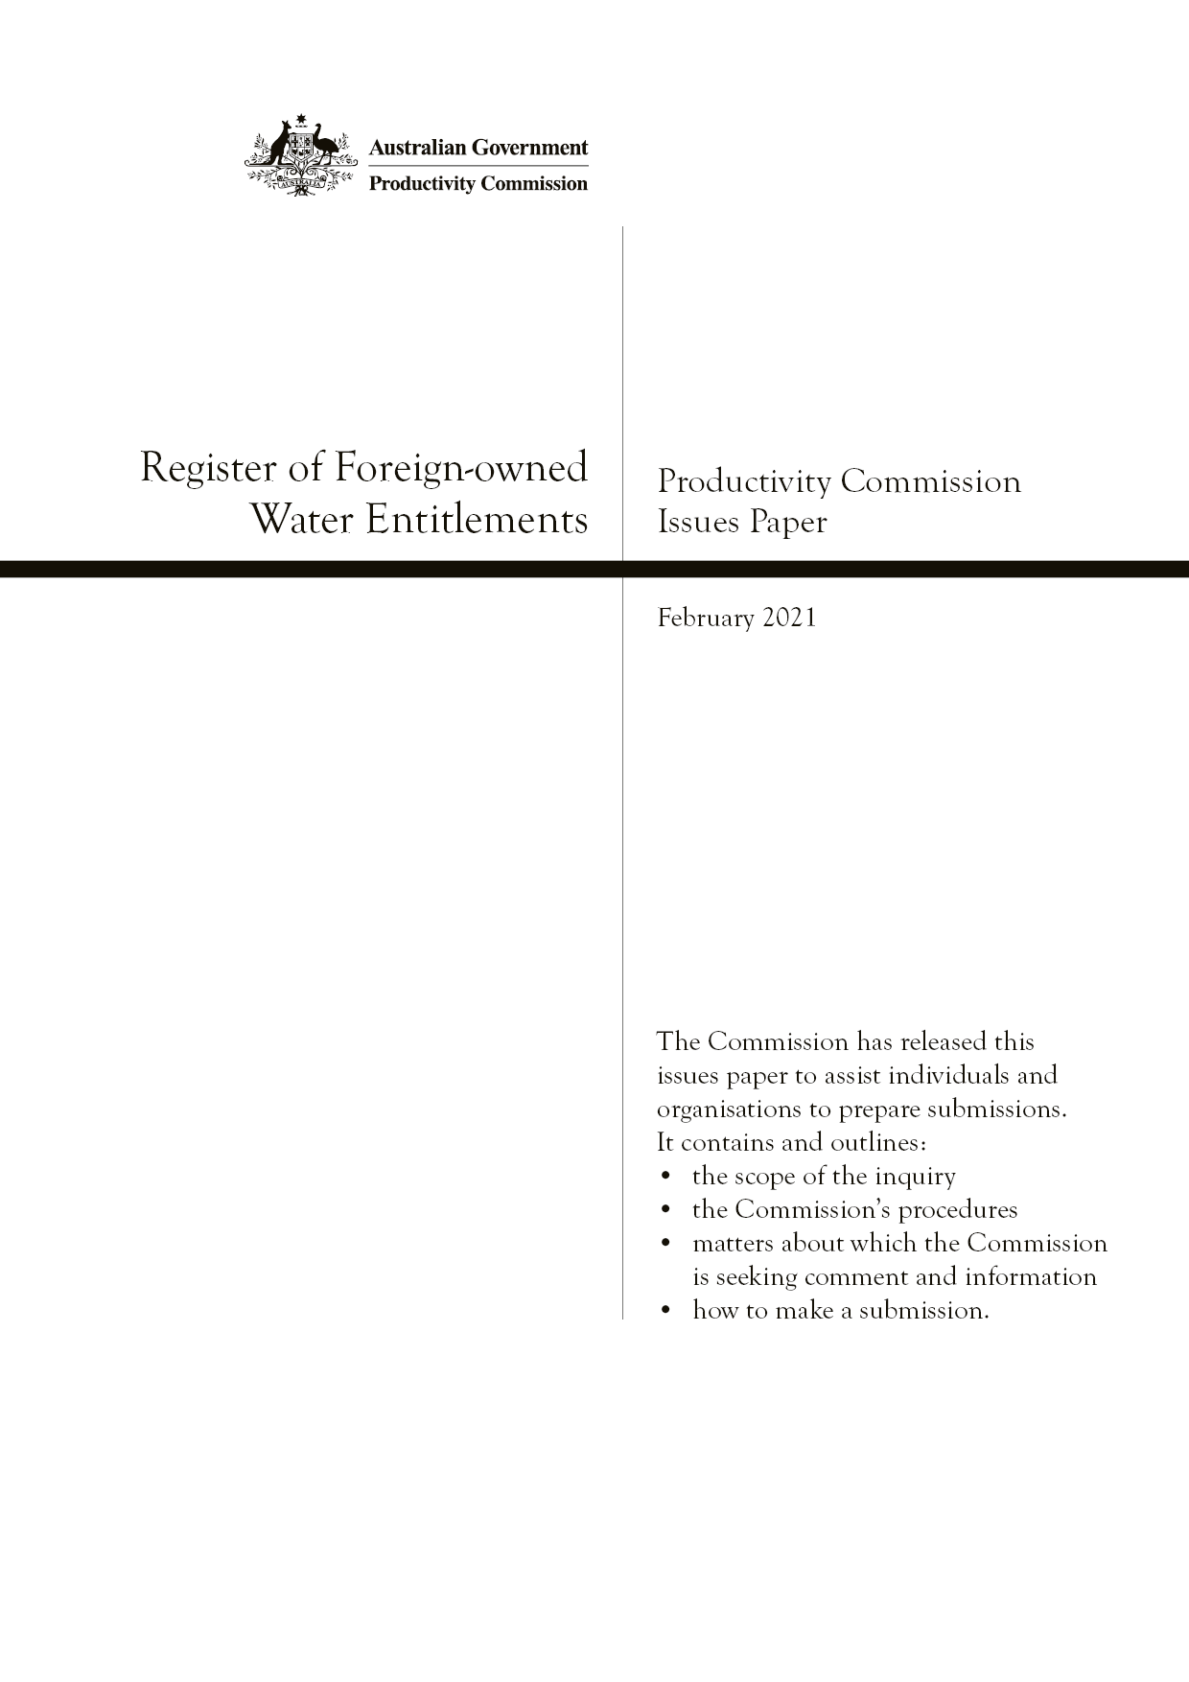
Register of Foreign-owned Water Entitlements
Productivity Commission Issues Paper, February 2021

The Issues Paper
The Commission has released this issues paper to assist individuals and organisations to participate in the inquiry. It contains and outlines:
- the scope of the inquiry
- matters about which we are seeking comment and information
- how to share your views on the terms of reference and the matters raised.
Participants should not feel that they are restricted to comment only on matters raised in the issues paper. We want to receive information and comment on any issues that participants consider relevant to the inquiry’s terms of reference.
Key inquiry dates
Announcement of terms of reference | 4 December 2020
Initial submissions due | 26 March 2021
Release of draft report  Post draft report consultations | July 2021  August to September 2021
Final report to Government | By 7 December 2021
Submissions and brief comments can be lodged
Online (preferred): | www.pc.gov.au/inquiries/current/foreign-water-entitlements/submissions
By post: | Foreign Water Entitlements Inquiry  Productivity Commission  GPO Box 1428, Canberra City, ACT 2601
Contacts
Inquiry matters: | Pragya Giri | Ph: 02 6240 3250
Freecall number: |  | Ph: 1800 020 083
Website: | www.pc.gov.au/inquiries/current/foreign-water-entitlements
Subscribe for inquiry updates
To receive emails updating you on the inquiry consultations and releases, subscribe to the inquiry at: www.pc.gov.au/inquiries/current/foreign-water-entitlements/subscribe

The Productivity Commission
The Productivity Commission is the Australian Government’s independent research and advisory body on a range of economic, social and environmental issues affecting the welfare of Australians. Its role, expressed most simply, is to help governments make better policies, in the long-term interest of the Australian community.
The Commission’s independence is underpinned by an Act of Parliament. Its processes and outputs are open to public scrutiny and are driven by concern for the wellbeing of the community as a whole.
Further information on the Productivity Commission can be obtained from the Commission’s website (www.pc.gov.au).

Contents
1 About the inquiry 1
2 How the Register works 5
3 The purposes of the Register 10
4 Benefits and costs of the Register 12
References 17
Attachment A: Terms of reference 19
Attachment B: How to make a submission 21

1 About the inquiry

Background
The Australian Government established the Register of Foreign Ownership of Water Entitlements (the Register) in 2017 under the Register of Foreign Ownership of Water or Agricultural Land Act 2015 (Cth) (the Act). The Act obliges foreign persons to notify the Australian Government of their interests in certain Australian water entitlements and keep it informed of any changes to these interests.
The primary aim of the Register is to increase transparency about foreign ownership of Australian water assets and, more broadly, maintain community confidence in Australia’s foreign investment policy. A statistical report on foreign ownership levels is published each year.
The need for the Register was contested during Parliamentary debate on the Bill proposing its introduction. This led to incorporation of a requirement in the Act that the Productivity Commission conduct an inquiry into the effectiveness of the Register within 5 years of relevant provisions coming into effect. This requires the Commission to complete the inquiry by 7 December 2021.
The inquiry does not cover the Register of Foreign Ownership of Agricultural Land, which is also established by the Act.

What the Commission has been asked to do
Section 34A of the Act requires the Productivity Commission to inquire into the effectiveness of the Register, including an assessment of its costs and benefits, and to make recommendations in relation to it. Accordingly, our terms of reference (attachment A) ask us to examine:
- whether the information provided in the Register delivers on the objective of increasing transparency on foreign ownership of water entitlements
- the direct and indirect costs and benefits of maintaining the Register and producing the annual Report
- the direct and indirect costs borne by foreign owners of water entitlements to ensure they are compliant with the legislation.
The Commission has been asked to consult with key interest groups and affected parties, including governments and stakeholders from the mining, irrigation infrastructure, urban water supply and agriculture sectors.

The Commission’s approach
Questions about the effectiveness, costs and benefits of the Register go, at heart, to whether it is a sound policy initiative — whether it is dealing with a material problem, and whether it has been designed and is being administered in a way that best meets the Government’s objectives while minimising compliance and other costs.
Matters we will consider in answering these questions include:
- the rationale for the Register — the problems or concerns giving rise to the need for government action and why a register is considered the best solution
- how well the Register is meeting the Government’s goals
- the nature and incidence of costs and benefits associated with maintaining the Register. These may be, for example, financial, economic and/or social costs and benefits accruing to government, scheme participants and/or other parties, including the broader community
- whether there are more effective or efficient ways of achieving the Register’s objectives.
Sections 3 and 4 of this paper raise specific questions about the above matters following a more detailed explanation of the Register in section 2.
The Commission notes that the Australian Government will introduce a new registration scheme for foreign interests in Australian assets by no later than 1 January 2025 and abolish the existing water (and agricultural land) Registers when the new scheme commences. Most aspects of the existing Register will continue under the new arrangements, including: rules on who must register, the types of water interests that must be registered, and publication of information. However, the primary purpose of the registration schemes and provisions relating to information access and use will shift more towards supporting policy decisions (box 1). Details on how the new register will be implemented are being determined.
Given the prospect of the new register, the Commission will, where possible, seek to provide advice that is useful in preparing for the new arrangements and/or guiding future policy in this area. This could be, for example, by focussing more on aspects of the existing scheme that will continue under the new arrangements, lessons learned, or, if appropriate, any low-cost modifications that will return material benefits while the Register continues to exist. We welcome input on the significance of the policy changes and how they should bear on the Commission’s approach to this inquiry.

Box 1 Similarities and differences between the existing and forthcoming foreign ownership registers
The Foreign Investment Reform (Protecting Australia’s National Security) Act 2020 (Cth) creates a register that amalgamates existing registers of foreign interests in Australian land, water entitlements and contractual water rights. It also expands registration requirements to foreign owners of commercial land and exploration tenements, and to business acquisitions that require foreign investment approval. In relation to water, the new register will have many similarities to the existing Register of Foreign Ownership of Water Entitlements, including:
- using the same definition of foreign persons and registrable water entitlements
- imposing the same reporting obligations on foreign persons
- requiring public, annual reporting of foreign ownership levels at an aggregate level using data from the Register.
However, there are some differences in the purpose, intended use and administration of the registers:
- Purpose — The existing Register’s primary purpose is to ensure greater transparency on the level of foreign ownership of water entitlements and promote more informed public debate. A second purpose is to increase the information available to the Government for policy purposes. Under the new system, more emphasis is placed on the Register as a resource to support the implementation of foreign investment policy. The Government will continue to publish reports annually to ‘provide a degree of public transparency on foreign investment in Australia’ (Australian Government 2020b, p. 171).
- Use of information — Access to information in the existing Register by government parties is more restricted than for the new register. For example, under the current system, Ministers and Secretaries of Departments responsible for areas such as agriculture, water and tax policy may access Register data for the purpose of discharging their responsibilities. The new system allows data to be disclosed for an expanded range of policy purposes and to a broader range of people, including Commonwealth officers, officers in other Australian jurisdictions and other countries.
- Administrative arrangements — The Commissioner of Taxation administers the 2017 Register in accordance with the Taxation Administration Act 1953 (Cth). The new register will be overseen by a Registrar under the Foreign Acquisitions and Takeovers Act 1975 (Cth). The Registrar’s powers include the ability to create statutory data standards relating to how information is collected, authenticated, stored, corrected and updated, and the internal processes and procedures to be followed by the Registrar and their delegates.
The new registration arrangements will be supported by a new ICT platform as part of broader reforms that are intended to enhance the efficiency and effectiveness of foreign investment application processing and compliance activities across government (Treasury, pers. comm., 31 January 2021).
Sources: Australian Government (2016, 2020a, p. 23, 2020b), Treasury (2020, p. 25).

IMPLICATIONS OF the NEW REGISTER FOR THIS INQUIRY
The Commission seeks input on:
- whether the new Register of Foreign Ownership of Australian Assets as it relates to water will be materially different to the existing Register of Foreign Ownership of Water Entitlements — and, if so, how
- how the forthcoming register should bear on the Commission’s approach to this inquiry
- what aspects of the existing Register are the most important to examine in light of the new register.

How you can participate in this inquiry
The Commission encourages interested parties to make a submission or brief comment in response to this paper, or on any matter parties consider relevant to the inquiry’s terms of reference. (Attachment B sets out how to do this.)
We will invite further submissions following the release of a draft report in July 2021.

2 How the Register works
The Register comprises two parts — the ‘basic part’, made up of information on foreign persons’ holdings of registrable water entitlements and contractual water rights (box 2), and the ‘statistical part’, which are summaries of data contained in the basic part. The Commissioner of Taxation is responsible for keeping the Register and for general administration of the Act.

Box 2 Water rights covered by the Register
Foreign persons must register their holdings of ‘registrable water entitlements’ and ‘contractual water rights’.
Registrable water entitlements comprise irrigation rights (rights to receive water from an irrigation infrastructure operator) and rights under State or Territory law to hold and/or take water from a water resource in Australia. The latter include water access entitlements providing exclusive, perpetual access to a share of the water resources of an area in a State or Territory. Water entitlements can be leased to others and traded.
Water entitlements differ to water allocations. Allocations refer to the actual amounts of water distributed to users or entitlement holders in a given year (or the ‘yield’ from entitlements, which may vary according to rainfall, inflows into storage systems and stores of existing water in relevant systems). Annual water allocations are not required to be registered, as it was envisaged when the Register was created that such a requirement would result in significant complexity and compliance costs for investors and the ATO.
Contractual water rights are rights to all or part of another person’s registrable water entitlement or water allocations. Such rights only need to be registered where the term of the contract is likely to exceed 5 years.
In addition to annual water allocations, rights not required to be registered include stock and domestic rights, riparian rights and any rights of a kind specified in the statutory rules. These other rights tend to involve a relatively small proportion of water entitlements (by volume).
Sources: Register of Foreign Ownership of Water or Agricultural Land Act 2015 (Cth), ATO (2020), Treasury (2016a).
Foreign persons are required to notify the Australian Taxation Office (ATO) if they acquire a relevant water asset or if there are changes to their holdings of assets (box 3).
The definition of a ‘foreign person’ includes:
- individuals not ordinarily resident in Australia
- entities in which individuals not ordinarily resident in Australia, foreign corporations or foreign governments have an interest of 20 per cent or more
- foreign governments.
The Register thus captures water holdings that may involve a proportion of Australian equity.
On water holdings, the ATO asks for information on:
- the type and terms of the water right held
- when and by whom the right was issued
- the State or Territory and water system the right relates to
- the resource (for example, volumes, reliability — the frequency with which water allocations under water access entitlements are able to be supplied in full — and the sector in which it is used).

Box 3 When foreign persons are required to register
A foreign person is required to register their interest in a registrable water entitlement or contractual right with the ATO when:
- they acquire a registrable water entitlement or contractual water right
- they become a foreign person while holding a registrable water entitlement or contractual water right.
A foreign person needs to update an existing registration when:
- they cease to hold the water entitlement or contractual water right
- they cease to be a foreign person
- the volume of water attached to their entitlement or contractual water right changes.
A foreign person may register at any time during the financial year, but no later than 30 days after the end of the financial year in which the transaction occurred.
Source: ATO (2019).
The basic part of the Register contains all the information registrants provide the Commissioner. This part is not available to the public, consistent with provisions for the protection of information on individuals and entities in the Taxation Administration Act 1953 (Cth). This is also consistent with the Government’s foreign investment regime, which does not reveal details on investors for privacy and commercial sensitivity reasons (Treasury 2016a, p. 15). The statistical part is published annually, subject to the requirement that it must not allow individual investors to be identified.
The statistical reports are published on the Foreign Investment Review Board website.
In addition to provisions about protecting personal information, the Register is subject to provisions in the Taxation Administration Act related to gathering and dealing with information, the exercise of powers and performance of functions, and enforcement of laws.

What the statistical part of the Register shows
Since the Register’s creation in 2017, the ATO has produced two reports, covering the financial years 2017-18 and 2018-19. The reported statistics cover:
- the proportion of water entitlements (denominated in volumes) held by foreign persons
- foreign-held water entitlements by State or Territory
- foreign-held water entitlements by State or Territory and water resource (i.e. groundwater or surface water)
- foreign-held water entitlements by State or Territory and type of water right
- the industries in which foreign-held water entitlements are used.

Select statistics from the 2018-19 report
In 2019, water entitlements with a level of foreign ownership accounted for 10.5 per cent of total water entitlements on issue in Australia, compared to 10.4 per cent in the previous year.
By country, the top three investors were China, with 1.9 per cent of total water entitlements, the USA, with 1.8 per cent and the United Kingdom, with 1 per cent.
As noted, the Register captures entities in which foreign persons have a 20 per cent or more share of equity. In 2019, the proportion of Australian equity in foreign-held water entitlements was about 14.4 per cent (594 GL), down slightly from the previous year (table 1).

Table 1 Australian equity in foreign-held water entitlements
2018 and 2019
 | 30 June 2018  Foreign-held water entitlements |  | 30 June 2019  Foreign-held water entitlements
 | GL | Share % | GL | Share %
Foreign-held portion | 3 371 | 83.5 | 3 519 | 85.6
Australian portion | 664 | 16.5 | 594 | 14.4
Total | 4 035 |  | 4 113

Source: ATO (2019).
Figure 1 shows foreign-held water entitlements as a proportion of total water entitlements on issue in each State and Territory in 2019. Western Australia had the highest proportion of foreign-owned entitlements (23.7 per cent), followed by Queensland (19.2 per cent).

Figure 1 Foreign-held water entitlements by State and Territory
Foreign-held water entitlements as a proportion of total water entitlements on issue in each State and Territory, 2019
Source: ATO (2019).
Queensland had the highest level of foreign-owned entitlements by volume (at 1301 GL), followed by New South Wales/ACT (at 1260 GL). All States and Territories except New South Wales/ACT and Western Australia saw an increase in the volume of foreign-held entitlements between 2018 and 2019.
The main sector in which foreign-held water in Australia is used is agriculture — except in Western Australia, where most foreign-held water is used in mining (figure 2). In Tasmania, 32 per cent of foreign-held water entitlements are used for ‘other’ purposes, which covers tourism, trade and research, dairy farm activities, pasture irrigation for stock feed and certain processing industries, such as wineries.

Figure 2 Use of foreign-held water entitlements by State and Territory
2019a
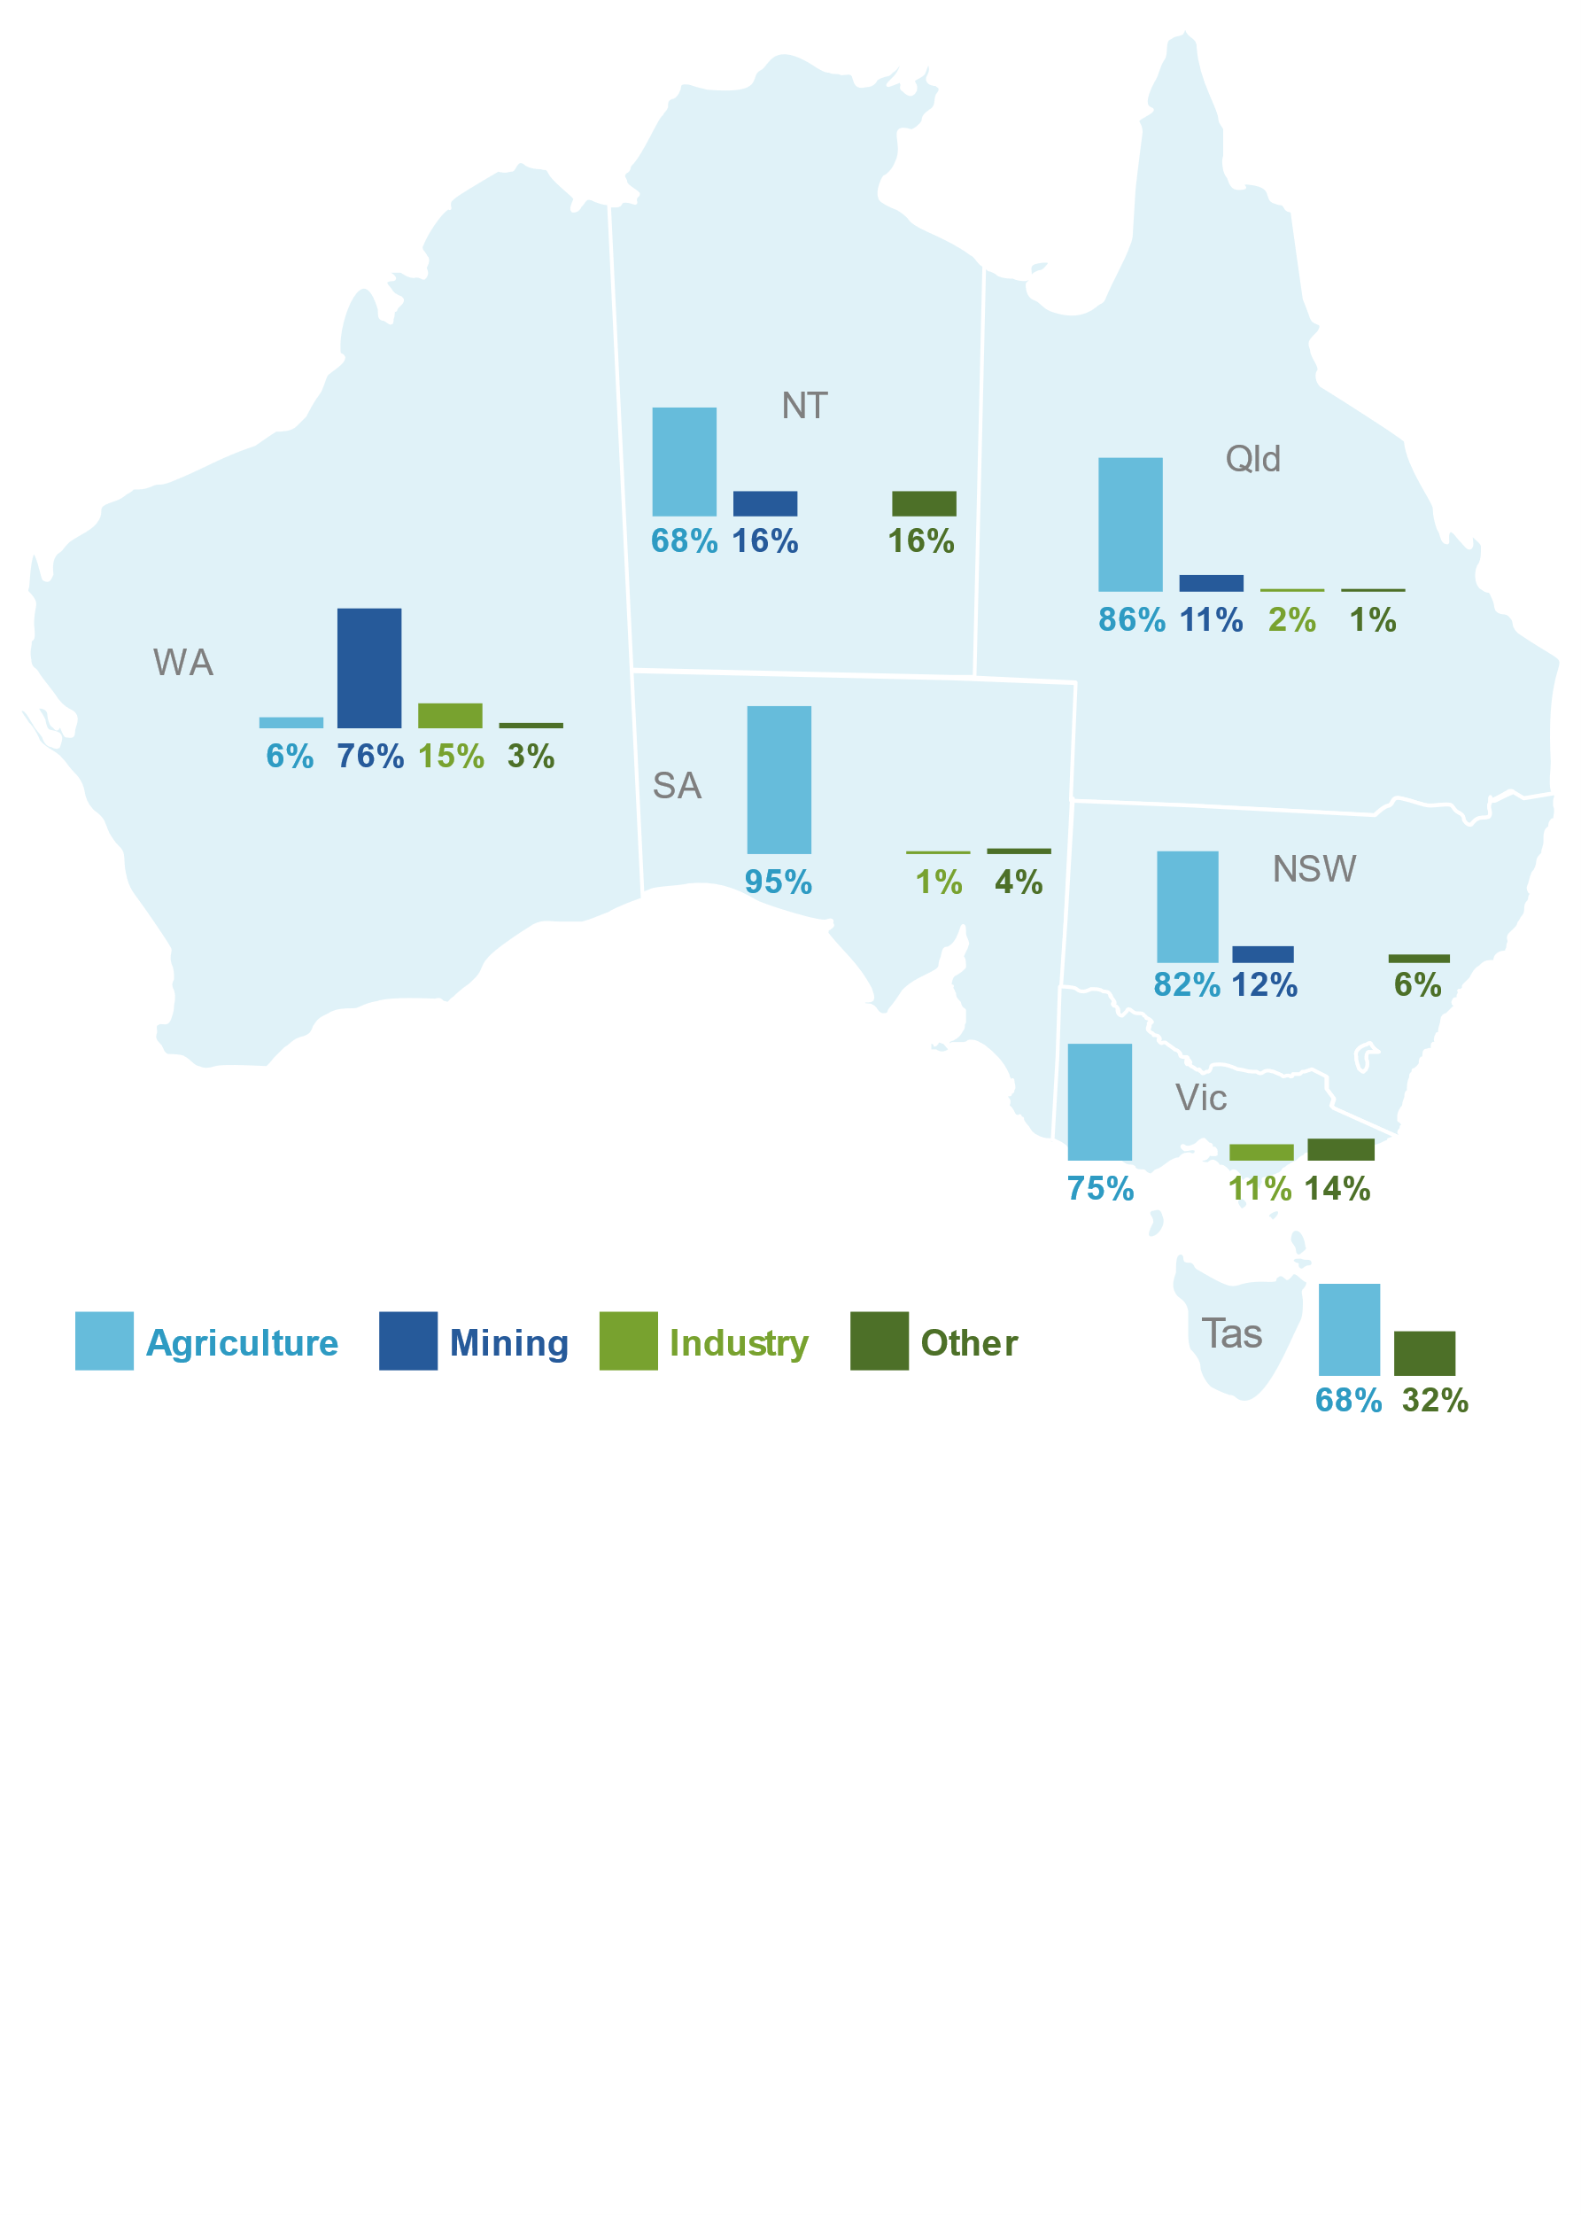

a ‘Industry’ includes construction, energy, industrial, manufacturing and transport. ‘Other’ includes, among other areas, tourism, trade and research.
Source: ATO (2019).
The statistical report does not include analysis of ownership at the catchment-specific level to avoid identification of individual owners. However, it does provide analysis for the Murray-Darling Basin, which accounts for just over half of the total volume of water entitlements on issue in Australia and most of trade in water entitlements by volume and value (BOM 2020, pp. 4–5). Foreign ownership accounted for 10.8 per cent of entitlements on issue in the Basin in 2019 (ATO 2020).

3 The purposes of the Register
The Australian Government introduced the Register to increase transparency on foreign ownership of Australia’s water entitlements interests, and thereby bolster public confidence in its foreign investment screening framework and policies aimed at attracting high levels of foreign capital (Australian Government 2016; Morrison 2016).
It sought to do this principally by providing facts on the level of foreign ownership of Australia’s water rights. A secondary purpose was to collate information on foreign ownership of water for use by policy makers.

Addressing community concerns about foreign ownership of water rights
During Parliamentary debate on the Bill proposing the Register, several concerns about foreign investment in Australia’s water sector were raised. These included:
- that foreign investors may be bidding up water prices, making it harder for locals to acquire water entitlements
- that foreign investors are potentially speculating in rights or hoarding water to control production and influence the price and availability of water or of agricultural commodities.
There may also be other or linked concerns, such as the effects of foreign ownership of water entitlements on downstream industries, food security etc. It is important to clarify the nature of the community’s concerns and the basis for them, as this will help form the basis of judgements on the Register’s merits and effectiveness.

NATURE OF COMMUNITY CONCERNS ABOUT FOREIGN ownersHip of water
- What specific concerns do community members hold about foreign ownership of Australian water rights?
- How widely held are these concerns, and which are seen as the most problematic?
- To what extent do the concerns derive from views on foreign ownership generally?
- How much do concerns relate to who owns water rights, or to how water is used and/or managed? For example:
- are there greater concerns about certain types of foreign investors more than others?
- are any concerns related to structural changes in sectors where water rights are used or to changes in how Australia’s water resources are managed?
- What has given rise to these concerns? For example, is there any evidence of foreign owners acting as ‘water barons’ and manipulating the supply or price of water?
Previous Commission work has noted the role of information on the nature and extent of foreign ownership of Australian assets in supporting public debate (PC 2016, pp. 560–562) — for example, information can put important facts on the table and may give the public a sense of the size of the matters about which they are concerned.
However, we also note that information on foreign ownership levels does not of itself address problems (actual or perceived) associated with decisions on who may invest in Australian water assets, how much they may acquire, or the conduct of parties who own water entitlements.
The Commission seeks input on the role of the Register, especially the role of published information on foreign ownership levels, in responding to community concerns about foreign investment in the water sector.

ROLE of the register in addressing community concerns
- What role does information on foreign ownership levels play in relation to community concerns about the foreign ownership of water resources?
- How effective has the Register been as a response to community concerns?
- Can you provide specific examples or indicators of where the Register has shaped public confidence?
- If the Register has not been effective, why is this so?
- How have communities used or responded to the information provided?
- Are there policies supporting promulgation or interpretation of the reports on foreign ownership of water assets? Or initiatives aimed at addressing underlying concerns about foreign investment in the water market?
- What other measures can governments take to respond to concerns?

Providing information for policy makers
As previously noted, the Register was also intended to increase the information available to government for policy purposes — a point emphasised for the new amalgamated Register of Foreign Ownership of Australian Assets (box 1).
It is notable that the Australian Government does not routinely screen proposed investments in water assets by foreign persons. Rather, proposed investments may be screened if they are a part of other types of acquisitions deemed of national interest, such as where water entitlements are attached to agricultural land or are the assets of an Australian business, or, since January 2021, if they pose national security concerns. The latter provision covers all proposed investments regardless of sector or value.
One view is that the new register may be used together with other sources of information by government agencies when providing advice relating to foreign investment decisions — for example, by providing additional information about a foreign entity’s interests in certain Australian assets.
There might also be scope for the new register to provide useful information to other agencies, both at a national and State or Territory level.

Information for policy makers
- How have authorities used the information collected in the basic part of the Register?
- Is the information, as currently collected, potentially useful for screening particular foreign investments, or for other policy purposes?
- Are there other potential uses for a register of foreign ownership of water entitlements?

4 Benefits and costs of the Register
The Commission seeks input on benefits and costs (that is, impacts) associated with the Register (to the extent not covered in responses to earlier questions). Given its impending replacement, the Commission also welcomes views on how the Register could be managed in the interim period (or how the new register could be implemented given lessons learned) so as to better meet its intended purposes, lower compliance and administrative costs or better fit with other government initiatives. Some questions on these matters are outlined below.

costs and benefits of the register – general
- Who are the main users of the Register?
- What are the main costs and benefits of the Register for users and other stakeholders? Please quantify or describe these costs and benefits.
- Has the Register had any unintended effects?
- How can the existing Register be managed or the new register of foreign ownership of assets be implemented so as to reduce costs or increase benefits in the future?

Information collected and disclosed by the Register
Prior to the introduction of the Register, there was no cross-sectoral national database on foreign ownership of water entitlements. And while there are different information sources covering aspects of water ownership and use in Australia, these sources (which include State and Territory water registers) generally do not identify the nationality of owners of water entitlements.
While the Register has increased the information available on foreign ownership of water resources, there have been criticisms that the Register does not collect information that could provide important insights into foreign ownership interests, such as the price or value of acquisitions of water entitlements (Swanson 2016).
On the other hand, there are trade-offs between maximising the benefits of the Register through information collection and minimising the regulatory burden for registrants. In this regard, a threshold question is whether the value of the information collected in the Register warrants the costs entailed. Another question might be whether, for the value of the information provided, an ongoing register of all foreign owners of water entitlements is necessary, rather than, for example, an occasional survey.
We also note that, within the constraints of the Act, the ATO has some discretion in determining the information that registrants must provide. In this regard, the ATO collects particulars on investors and their water holdings (as described in section 2) to enable meaningful use of the Register.
The Commission seeks feedback on whether the scope of and level of detail captured by the Register is well-targeted or whether more, less or different information is required, and why.

The annual statistical report
The ATO has considerable discretion on how statistical reports on foreign ownership are prepared, subject to ensuring that individual investors are not able to be identified. For the statistical reports to provide benefits (in terms of increased transparency), they need to contain accurate and relevant information, and be accessible to those wishing to read them.
One concern at the time the Register was introduced was that the public is not able to view the basic part of the Register, restricting the public from knowing who owns what. The constraint on identifying individual investors means, for example, that foreign ownership statistics and trends are provided mostly at the State/Territory and national levels although stakeholders may be also interested in ownership at their local, or catchment, level.

information collected and disclosed by the register
- Is the information collected for the Register well-targeted? If not, is more, less or different information required, and why?
- How useful are the published statistical reports? Can they be improved and, if so, how? For example, could they be published in a more timely way, or in a more useful format?
- Does confidentiality of investor information hinder the effectiveness of the Register?

Administration and compliance costs
The ATO incurs costs in operating the Register, and more generally in administering the Act. As noted, there are some features of the scheme that potentially reduce administrative costs and the burden on registrants. These include the flexibility accorded to the Commissioner of Taxation in deciding how information is gathered, verified and presented. Thus, for example, the ATO can maintain one system for gathering information on foreign interests in Australian water and land, allow registrants of interests in both agricultural land and water entitlements to provide information via a single form, and may modify the format of statistical reports over time.
However, the ATO will still face costs in ensuring that the information contained in the Register is accurate and allows for meaningful analysis. The ATO notes that ‘there are various approaches to water resource management across the states and territories and as such data collected by the Register is not consistent across those jurisdictions’ (ATO 2020, p. 4). Examples of these inconsistencies include the use of differing terminology across jurisdictions, different approaches to issuing water rights for specific industries (e.g. mining), and differences in approaches to issuing water entitlements, such as entitlements being expressed in volumetric terms in some jurisdictions and in nominal terms in others. The ATO has indicated that the effect of these inconsistencies is to marginally overstate some estimates of foreign ownership in its statistical reports.
The Commission will consult the ATO on the costs and benefits of administering the Register, including producing the annual statistical reports, and its considerations in relation to the creation and administration of the Register.

Compliance costs for registrants
The Register imposes regulatory compliance costs on entities and individuals who meet the definition of a foreign person and who acquire registrable water entitlements. These costs may include the time and expenses involved in collating the information and completing registration and update processes, and the cost of any legal advice to ensure compliance with regulatory requirements.
At the time the scheme was proposed, it was anticipated that foreign persons operating in agriculture, mining, irrigation infrastructure operation, energy and manufacturing would be affected. The costs of compliance were anticipated to be minimised by establishing the Register under an amended Register of Foreign Ownership of Agricultural Land Act 2015, which already set out a model for registration, reporting obligations and penalties (ultimately the model adopted). This was particularly so for foreign persons who are obliged to register both water and agricultural land holdings (Australian Government 2016).
The Commission seeks input on actual costs incurred, and on the impact of the registration scheme on participants.
The Act places the onus on foreign investors to register their interests in Australian water assets. However, the ATO has a role in raising awareness of foreign persons’ obligations and ensuring compliance. As for all areas imposing statutory obligations, a balance needs to be struck between encouraging and enforcing compliance. In this regard, there are some concerns that the ATO has undertaken limited enforcement activity to ensure that foreign water owners are registering their holdings (Farrell and McDonald 2020). The ATO has pointed out that there have been limited opportunities for compliance activities since the Register was established (ibid.).

Fit with other government requirements
The Commission is interested in whether the requirements or aims of the Register overlap with, duplicate, or are inconsistent with other government initiatives and, if so, views on how any negative impacts may be removed or reduced (or benefits enhanced). For example:
- States and Territories under the National Water Initiative are required to have publicly accessible registers of all water access entitlements and their trades, along with their location, price, and identity of entitlement holders (COAG 2004). Do the requirements for registers on water entitlements at both Commonwealth and State and Territory level create significant avoidable costs? Could governments create synergies between registers?
- Certain jurisdictions, like Victoria and New South Wales, have recently considered how water market transparency can be improved so as to strengthen public confidence in the market (Victorian Government 2020, NSW DPIE 2021), NSW Department of Industry 2021). Could initiatives to promote transparency be more effectively or efficiently organised?
The Commission also recognises that some requirements in isolation have a relatively minor effect but may, with other requirements, impose a material cumulative burden. This is relevant, as noted above, to the question of the value of the Register and whether this could be gained through less costly means.

compliance and administration costs
Design of legislation
- Does the Act provide the right balance between prescribing what the Register should do and providing flexibility to the Commissioner of Taxation on how it should operate? If not, how could it be improved?
Administration of the Register
- How has the ATO’s flexibility borne on compliance and administrative requirements?
- Are the ATO’s methods for encouraging compliance with and enforcing the obligations of the Act effective? For example, does the ATO:
- provide enough guidance to registrants?
- have effective processes in place to detect non-compliance?
- have an effective sanction regime?
- Is the system of self-reporting effective? Is there any evidence of widespread non-compliance?
- Could the ATO’s administration of the Register be improved? If so, how?
Compliance costs
- Please describe (and quantify to the extent possible) the direct and indirect costs and benefits involved in ensuring compliance with the Act.
- Are any registration requirements particularly costly or onerous to meet? Are costs relatively higher or lower depending on the type of water right involved or the attributes of the investor (for example, the industry, or part of the industry they operate in)?
- For foreign investors who are required to provide information for the agricultural land Register, to what extent does notifying the ATO on water entitlements present an additional burden?
- Do the requirements or aims of the Register overlap with, duplicate, or sit inconsistently with other government initiatives? If so, how, and what are the impacts? Could costs be reduced or synergies between initiatives be enhanced?
- How could the costs of complying with the Act be reduced without compromising its aims?

References
ATO (Australian Taxation Office) 2019, Register of Foreign Ownership of Water Entitlements, Report of registrations as at 30 June 2018, Canberra, https://firb.gov.au/sites/firb.gov.au/files/2019/02/2018-Register-of-foreign-ownership-Water-entitlements.pdf (accessed 9 January 2020).
—— 2020, Register of Foreign Ownership of Water Entitlements, Report of registrations as at 30 June 2019, Canberra, https://firb.gov.au/sites/firb.gov.au/files/2020-05/2019-rfo-water-entitlements.pdf (accessed 9 January 2020).
Australian Government 2016, Register of Foreign Ownership of Agricultural Land Amendment (Water) Bill 2016, Explanatory Memorandum.
—— 2020a, Budget 2020-21: Budget Paper No. 2, Canberra, https://budget.gov.au/2020-21/content/bp2/download/bp2_complete.pdf (accessed 29 January 2021).
—— 2020b, Foreign Investment Reform (Protecting Australia’s National Security) Bill 2020, Explanatory Memorandum.
BOM (Bureau of Meteorology) 2016, Murray-Darling Basin: Water Access and Use, http://www.bom.gov.au/water/nwa/2016/mdb/supportinginformation/wateraccessanduse.shtml (accessed 5 February 2021).
—— 2020, Australian Water Markets Report 2018-19, Victoria, p. 60.
COAG (Council of Australian Governments) 2004, Intergovernmental Agreement on a National Water Initiative.
Farrell, P. and McDonald, A. 2020, ‘Chinese state-owned company buys up water in the Murray-Darling’, ABC News, https://www.abc.net.au/news/2020-05-06/chinese-state-owned-companies-buy-up-water-in-murray-darling/12215548 (accessed 29 January 2021).
Morrison, S. 2016, Second Reading speech, Register of Foreign Ownership of Agricultural Land Amendment (Water) Bill 2016, House of Representatives, 12 October, https://parlinfo.aph.gov.au/parlInfo/search/display/display.w3p;query=Id%3A%22chamber%2Fhansardr%2F3bef5bfd-10a1-42ac-8cdf-41e8b9c0f758%2F0025%22 (accessed 24 September 2020).
NSW DPIE (NSW Department of Planning, Industry and Environment) 2021, What information about water ownership and water trading is made public in NSW - Water in New South Wales, https://www.industry.nsw.gov.au/water/licensing-trade/trade/have-your-say (accessed 4 February 2021).
PC (Productivity Commission) 2016, Regulation of Australian Agriculture, Report no. 79, Canberra.
—— 2020, Foreign Investment in Australia, Commission Research Paper, Canberra.
Swanson, M. 2016, Register of Foreign Ownership of Agricultural Land Amendment (Water) Bill 2016, Second Reading Debate, Hansard, No. 5, House of Representatives, Canberra, https://parlinfo.aph.gov.au/parlInfo/search/display/display.w3p;db=CHAMBER;id=chamber%2Fhansardr%2Fa2ba36f1-ee24-4aec-9f8e-b647c7fc92ce%2F0193;query=Id%3A%22
chamber%2Fhansardr%2Fa2ba36f1-ee24-4aec-9f8e-b647c7fc92ce%2F0016%22 (accessed 29 January 2021).
Treasury 2016a, National Register of Foreign Ownership of Water Access Entitlements, Consultation Paper, Canberra, https://treasury.gov.au/consultation/national-register-of-foreign-ownership-of-water-access-entitlements (accessed 11 January 2021).
—— 2016b, Register of Foreign Ownership of Water Entitlements, Regulation Impact Statement, November, Canberra, https://ris.pmc.gov.au/sites/default/files/posts/2017/
01/ris_0.pdf (accessed 4 February 2021).
—— 2020, Foreign Investment Reforms, Canberra, https://treasury.gov.au/sites/default/
files/2020-06/p2020-87595_0.pdf (accessed 29 January 2021).
Victorian Government 2020, New market insights to increase transparency - Water Register, https://waterregister.vic.gov.au/about/news/318-new-market-insights-to-increase-transparency (accessed 4 February 2021).

Attachment A: Terms of reference

Inquiry into the effectiveness of the Register of Foreign Ownership of Water Entitlements
I, Joshua Frydenberg, Treasurer, pursuant to Parts 2 and 3 of the Productivity Commission Act 1998, hereby request that the Productivity Commission undertake an inquiry into the effectiveness of the Register of Foreign Ownership of Water Entitlements.

Background
The Register of Foreign Ownership of Water or Agricultural Land Act 2015 (the Act) provides for the collection of information, and publication of statistics, about foreign interests in agricultural land and certain water entitlements and rights. The Act requires the Commissioner of Taxation to keep two registers: the Register of Foreign Ownership of Agricultural Land, and the Register of Foreign Ownership of Water Entitlements. These registers were established to provide greater transparency over the level of foreign ownership of Australia’s water and agricultural land entitlements. The Act also requires the Commissioner of Taxation to prepare an annual report outlining statistics from the registers.
Under section 34A of the Act, the Productivity Commission (the Commission) is required to undertake an assessment on the effectiveness of the scheme insofar as the scheme relates to the Register of Foreign Ownership of Water Entitlements and requirements to give information about foreign holdings of water entitlements, including the costs and benefits of that scheme. This inquiry is that assessment.

Scope of the inquiry
In accordance with section 34A of the Act, following a referral for the Commission to undertake this inquiry, the Commission is to report on the matter of the effectiveness of the scheme outlined in Parts 3A and 3B of the Act, which describe the Register of Foreign Ownership of Water Entitlements, and the requirements to give information about foreign holdings of water entitlements. This report is to include an assessment of the costs and benefits of the scheme.
In undertaking this inquiry, the Commission should:
- assess whether the information provided in the Report delivers on the policy objectives of the scheme of increasing transparency of foreign ownership of water entitlements;
- identify the direct and indirect costs and benefits associated with maintaining the Register and producing the Report; and
- identify the direct and indirect costs borne by foreign owners of water entitlements to ensure compliance with the Act.

Process
The Commission should consult with key interest groups and affected parties, invite public submissions and release a draft report to the public.
The Commission should consult with Commonwealth, state and territory governments and stakeholders from the mining, irrigation infrastructure, urban water supply and agriculture sectors.
The Commission should complete this inquiry by 7 December 2021 as required by section 34A of the Act.
THE HON JOSH FRYDENBERG MP
Treasurer
[Received 4 December 2020]

Attachment B: How to make a submission

Preparing a submission
Submissions may range from a short letter outlining your views on a particular topic to a much more substantial document covering a range of issues. Where possible, you should provide evidence, such as relevant data and documentation, to support your views.

Generally
- Each submission, except for any attachment supplied in confidence, will be published on the Commission’s website shortly after receipt, and will remain there indefinitely as a public document.
- The Commission reserves the right to not publish material on its website that is offensive, potentially defamatory, or clearly out of scope for the inquiry.

Copyright
- Copyright in submissions sent to the Commission resides with the author(s), not with the Commission.
- Do not send us material for which you are not the copyright owner — such as newspaper articles — you should just reference or link to this material in your submission.

In confidence material
- This is a public review and all submissions should be provided as public documents that can be placed on the Commission’s website for others to read and comment on. However, information of a confidential nature or which is submitted in confidence can be treated as such by the Commission, provided the cause for such treatment is shown.
- The Commission may also request a non-confidential summary of the confidential material it is given, or the reasons why a summary cannot be provided.
- Material supplied in confidence should be clearly marked ‘IN CONFIDENCE’ and be in a separate attachment to non-confidential material.
- You are encouraged to contact the Commission for further information and advice before submitting such material.

Privacy
- For privacy reasons, all personal details (e.g. home and email address, signatures, phone, mobile and fax numbers) will be removed before a submission is published on the website. Please do not provide a these details unless necessary.
- You may wish to remain anonymous or use a pseudonym. Please note that if you choose to remain anonymous or use a pseudonym the Commission may place less weight on your submission.

Technical tips
- The Commission prefers to receive submissions as a Microsoft Word (.docx) file. PDF files are acceptable if produced from a Word document or similar text based software. You may wish to research the Internet on how to make your documents more accessible or, for the more technical, follow advice from the Web Content Accessibility Guidelines (WCAG) 2.0<http://www.w3.org/TR/WCAG20/>.
- Do not send password protected files.
- Track changes, editing marks, hidden text and internal links should be removed from submissions.
- To minimise linking problems, type the full web address (for example, http://www.referred-website.com/folder/file-name.html).

Lodging a submission
Due to the coronavirus (COVID-19) situation, we strongly prefer to receive submissions electronically. Submissions should be lodged using the online form on the Commission’s website.
If you need to lodge by mail, please advise Pragya Giri on 02 6240 3250. Submissions lodged by post should be accompanied by a submission cover sheet. Please note there may be delays in processing submissions lodged by post.
Online* | www.pc.gov.au/inquiries/current/foreign-water-entitlements/make-submission
Post* | Foreign Water Entitlements Inquiry  Productivity Commission  GPO Box 1428  Canberra City ACT 2601, Australia
* If you do not receive notification of receipt of your submission to the Commission, please contact the Administrative Officer.

Due date for submissions
Initial submissions are sought by 26 March 2021.

The Register of Foreign Ownership of Agricultural Land was introduced in 2015.
Parts 3A and 3B of the Act set out requirements for a Register of Foreign Ownership of Water Entitlements and to give information on holdings of relevant water assets. These provisions constitute the ‘scheme’, which is the subject of this inquiry. For simplicity, the scheme may be referred to in this paper as ‘the Register’.
These changes are part of the Foreign Investment Reform (Protecting Australia’s National Security) Act 2020 (Cth). The new register will subsume the existing foreign ownership registers kept by the Commissioner of Taxation (water, agricultural land and residential land) and expand registration obligations to foreign owners of commercial land, exploration tenements, and businesses and entities.
The Register of Foreign Ownership of Water or Agricultural Land Rules 2017 provide that the following types of water rights are excluded from the definition of a ‘registrable water entitlement’: rights to capture, store or take rainfall for stock and domestic purposes; and rights held by an irrigation infrastructure operator to the extent that either another person holds an irrigation right in relation to that right, or they are for additional water that is required to deliver water to other users.
For example, in 2015-16, 307 996 ML of water in the Murray-Darling Basin was held under basic water rights, which include domestic and stock rights, harvestable rights for dams and native title rights. This comprised approximately 1.6 per cent of water held under all water rights and entitlements in the Murray-Darling Basin (BOM 2016).
Foreign acquisitions of Australian water assets are not subject to government screening processes unless the assets are attached to other acquisitions that meet screening criteria or they raise national security concerns. See section 4, “Providing information for policy makers” for a brief discussion on foreign investment screening requirements.
This threshold differs to the international standard of 10 per cent used by the ABS to compile foreign direct investment statistics.
As the ATO Commissioner has general administration of the Act, the Act is a taxation law for the purpose of the Taxation Administration Act.
The reports prepared by the ATO fulfil the Act’s requirements to keep and publish a statistical part of the Register and prepare a report annually on the operation of the Act that includes statistics derived from data in the Register (ATO, pers. comm 28 January 2021). The ATO also prepares statistical reports on foreign ownership of agricultural land under the Act, and separately monitors and publishes reports on foreign purchases and sales of residential real estate.
Register of Foreign Ownership of Agricultural Land Amendment (Water) Bill 2016.
The Commission has commenced publishing annual reports on foreign investment trends and effects to help inform policy and debate. The first such report, Foreign Investment in Australia, was released in 2020 (PC 2020).
Before the Register, the main source of information on foreign ownership of assets in the agricultural sector was the Australian Bureau of Statistics’ (ABS) Agricultural Land and Water Ownership Survey. The last survey was conducted in 2016 and included statistics on the level of foreign ownership of businesses with land and/or water entitlements in Australia, and the area of agricultural land and volume of water entitlements owned by these businesses as at 30 June 2016. See ABS (Agricultural Land and Water Ownership, Australia, 2015-16, Cat. no. 7127.0).
The Australian Government considered creating the Register from information contained in State and Territory registers. However, this option was considered excessively costly, as it would have required jurisdictions to harmonise the data that they each collect, which itself would have required agreement on terminology and alignment of certain laws (Treasury 2016b, p. 20).

