Human Services: Identifying sectors for reform
Issues paper, June 2016
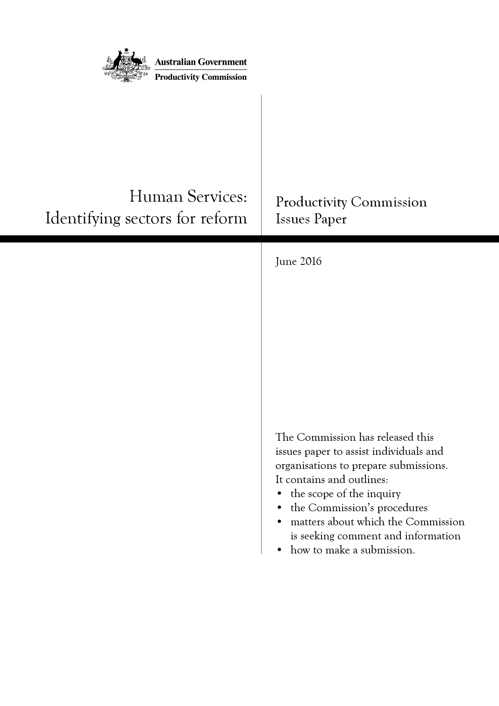

The Issues Paper
The Commission has released this issues paper to assist individuals and organisations to prepare submissions to the inquiry. It contains and outlines:
- the scope of the inquiry
- the Commission’s procedures
- matters about which the Commission is seeking comment and information
- how to make a submission.
Participants should not feel that they are restricted to comment only on matters raised in the issues paper. The Commission wishes to receive information and comment on issues which participants consider relevant to the inquiry’s terms of reference.
Key inquiry dates
Receipt of terms of reference | 29 April 2016
Due date for submissions | 25 July 2016
Release of preliminary findings report | September 2016
Final study report released | By 29 October 2016
Final inquiry report submitted to the Australian Government | October 2017
Submissions can be lodged
Online: | www.pc.gov.au/inquiries/current/human-services/identifying-reform
By post: | Human Services Inquiry  Productivity Commission  Locked Bag 2, Collins Street East  Melbourne Vic 8003
Contacts
Administrative matters: | Marianna Olding | Ph: 03 9653 2194
Other matters: | Stewart Turner | Ph: 03 9653 2218
Freecall number for regional areas: | 1800 020 083
Website: | www.pc.gov.au

The Productivity Commission
The Productivity Commission is the Australian Government’s independent research and advisory body on a range of economic, social and environmental issues affecting the welfare of Australians. Its role, expressed most simply, is to help governments make better policies, in the long term interest of the Australian community.
The Commission’s independence is underpinned by an Act of Parliament. Its processes and outputs are open to public scrutiny and are driven by concern for the wellbeing of the community as a whole.
Further information on the Productivity Commission can be obtained from the Commission’s website (www.pc.gov.au).

Terms of reference
PRODUCTIVITY COMMISSION INQUIRY INTO INTRODUCING COMPETITION AND INFORMED USER CHOICE INTO HUMAN SERVICES
I, Scott Morrison, Treasurer, pursuant to Parts 2, 3 and 4 of the Productivity Commission Act 1998, hereby request that the Productivity Commission undertake an inquiry into Australia’s human services, including health, education, and community services, with a focus on innovative ways to improve outcomes through introducing the principles of competition and informed user choice whilst maintaining or improving quality of service.

Background
The Australian Government is committed to working in partnership with State and Territory Governments and non-government service providers to ensure that all Australians can access timely, affordable and high quality human services, which are appropriate to their needs, and are delivered in a cost-effective manner.
The human services sector plays a vital role in the wellbeing of the Australian population. It covers a diverse range of services, including health, education and community services, for example job services, social housing, prisons, aged care and disability services. There are some features that are common across the range of services and models of service provision, while other features are unique in nature. Complexity arises from differences in the characteristics of the services, and of the individuals receiving the services, the objectives sought, and the jurisdiction and market in which the services are being supplied.
While governments have made progress in introducing competition, contestability and user choice to human services provision, the efficiency and effectiveness of the delivery of services within the sector varies significantly between jurisdictions. Service delivery frameworks in the human services sector that are inefficient or ineffective can result in significant costs to the economy and individuals, including poorer outcomes and reduced productivity.
Australia’s human services sector is facing significant challenges, including increasing demand for services due to the ageing population, the effect of technology and cost increases associated with new and more complex service provision demands. Finding innovative ways to improve the efficiency and cost effectiveness of the human services sector, and to target services to those most in need, will help ensure that high quality service provision is affordable for all Australians and leads to improved outcomes for the economy and individuals.

Scope of the inquiry
The Commission is requested to examine the application of competition and user choice to services within the human services sector and develop policy options to improve outcomes. These options should lead to improvement in the sector’s efficiency and effectiveness and help to ensure all Australians can access timely, affordable and high quality services, which are appropriate to their needs, and are delivered in a cost-effective manner.
The Commission is to undertake the inquiry in two stages.
- The first stage will deliver an initial study report identifying services within the human services sector that are best suited to the introduction of greater competition, contestability and user choice. The Commission will examine:
  - the current level, nature and future trends in demand for each major area of service delivery
  - the current supply arrangements and future trends, including the scope for diversity in provision and informed user choice, alternative pricing and funding models, and the potential for contestability in supply by government, not-for-profit and private sector providers
  - the effectiveness of previous reforms intended to introduce greater competition and user choice, and the pathway taken to achieve those reforms, through investigating:
    - case studies of existing practices and trials in Australian jurisdictions
    - international examples of best practice.
- In the second stage, the Commission will undertake a more extensive examination and provide an inquiry report making recommendations on how to introduce greater competition, contestability and user choice to the services that were identified above.
  - In providing its recommendations, the Commission’s report should identify the steps required to implement recommended reforms.
  - In developing policy options to introduce principles of competition and informed user choice in the provision of human services, the Commission will have particular regard, where relevant, to:
    - the roles and responsibilities of consumers within the human service sector, and the service or services being considered
    - the factors affecting consumer use of services and preferences for different models of service delivery, noting the particular challenges facing consumers with complex and chronic needs and/or reduced capacity to make informed choices
    - the role of the government generally, and as a commissioner, provider and regulator, in the delivery of human services
    - the role of government agencies in designing policy, commissioning and, in some cases, delivering human services in a client-centred way that encourages innovation, focusses on outcomes and builds efficiency and collaboration
    - the role of private sector and not-for-profit providers
    - the benefits and costs of applying competition principles in the provision of human services, including improving competitive neutrality between government, private and not-for-profit service providers
    - how best to promote innovation and improvements in the quality, range and funding of human services
    - the challenges facing the provision of human services in rural and remote areas, small regional cities and emerging markets
    - the need to improve Indigenous outcomes
    - the development of systems that allow the performance of any new arrangements to be evaluated rigorously and to encourage continuous learning.

Process
The Commission is to undertake appropriate public consultation processes including holding hearings, inviting public submissions, and releasing issues papers to the public.
The Commission will publish the initial study report within six months of receiving these Terms of Reference. The report will set out the findings from case studies and international experiences and identify which services within the human services sector are best suited to the application of competition, contestability and informed user choice principles.
The final inquiry report, including policy recommendations and a path and process to ensure sustainable, efficient and effective reform, will be provided within 18 months of receiving these Terms of Reference.
Scott Morrison
Treasurer
[Received 29 April 2016]

Contents
Terms of reference iii
1 What is the inquiry about? 1
2 Overview of human services 4
3 The Commission’s approach 9
4 Information on services best suited to reform 11
References 20
Attachment A: How to make a submission 21

1 What is the inquiry about?

Background to the inquiry
The Competition Policy Review recommended that governments should, wherever possible, put user choice at the heart of human services delivery as users are best placed to make choices about the services they need. The Review panel recognised that governments cannot distance themselves from the quality of human services and that they will continue to have an important role as market stewards, including through policy and funding decisions, but also in fostering service models that best meet the needs of individuals and the broader community (Competition Policy Review 2015).
In its response to the Review, the Australian Government committed to a Productivity Commission inquiry to examine policy options in the human services sector that incorporate the principles of competition, contestability and informed user choice (box 1) to lay the groundwork for future reforms and innovation in human services delivery.

What has the Commission been asked to do?
The terms of reference for this inquiry request that the Commission undertakes the project in two stages, outlined below. The full terms of reference are provided at the front of this issues paper.

The first stage — identifying the services best suited to reform
The task for the first stage of the inquiry is to produce a study report that identifies the human services that are best suited to increased application of competition, contestability and user choice. In undertaking the study report, the Commission will examine:
- the current level and nature of demand for services, as well as future trends
- the current supply arrangements and future trends, including the scope for user choice, diversity in provision, contestability, and alternative pricing and funding models
- the effectiveness of previous reforms intended to increase competition and user choice, both in Australia and internationally.

Box 1 Competition, contestability and informed user choice
Competition
Competition involves public and/or private providers of a service (or substitute services) striving against one another to attract business. If competition is effective, service providers will attempt to attract business by reducing the price they charge, improving the quality of their service, offering new and innovative services, or tailoring their services to better meet the needs of users.
Contestability
Contestable markets are those where there are no substantial barriers preventing a provider that is not currently supplying services in the market from doing so now or in the future. In a contestable market, the credible threat of competition can deliver some of, or even many of, the same benefits as effective competition. It is particularly relevant in situations where effective competition is not feasible, say where the market is too small to support multiple providers. Making a market more contestable could, for example, include opening up the provision of the service to tender, and ensuring that incumbent providers of human services face a credible threat of being replaced by an alternative provider.
Informed user choice
Someone, whether the user, the provider or a third-party such as a regulator, must decide which services a particular user can receive. Informed user choice models empower consumers of human services to be actively involved in decisions about the services they use. There are many types of user choice. Users can directly make decisions about the services that they receive (for example, a person with a disability deciding which services best support their needs) and which organisation will provide services to them (for example, deciding between different residential aged care facilities). The user’s choice may be assisted or facilitated through an agent or intermediary who is tasked with implementing the user’s preferences. In other cases, organisations or governments take the needs and preferences of the user into account when making decisions on the user’s behalf. To support informed user choice, governments may need to facilitate the flow of information about services to the user and provide support to users to help them understand and act on that information.
There are also circumstances when a user’s agency is explicitly removed, such as a court order to attend drug rehabilitation.
Sources: Baumol (1982); Competition Policy Review (2014, 2015); Davidson (2011); National Competition Policy Review (1993).

The second stage — reform to human services
Following the release of the study report, the Commission’s inquiry report will make recommendations as to how to increase competition, contestability and informed user choice in the provision of services identified as best suited, and outline a path and process to achieve sustainable, efficient and effective reform. In undertaking the inquiry, the Commission will have regard to:
- the roles and responsibilities of consumers, service providers (including the private sector, government agencies and the not-for-profit sector) and governments in the delivery of human services
- the factors affecting consumer use of services and preferences for models of service delivery, noting challenges facing consumers with complex and chronic needs or reduced capacity to make informed choices
- the benefits and costs of promoting competition in the provision of human services
- how best to promote innovation and improvements in the quality, range and funding of human services
- the challenges facing the provision of human services in rural and remote areas, small regional cities and emerging markets, and the need to improve Indigenous outcomes
- the evaluation of new arrangements and the need to encourage continuous learning.

The process for the inquiry and stakeholder participation
The Commission will consult widely over the course of the inquiry through a combination of stakeholder visits, roundtables, public forums and written submissions from inquiry participants.
This issues paper is to assist participants to prepare a submission to the first stage of the inquiry — the study report (information on how to prepare a submission can be found in attachment A). It provides background information and seeks feedback on the factors the Commission considers relevant to identifying the services best suited to increased application of competition, contestability and informed user choice (section 3 and section 4).
The Commission will release a preliminary findings report in September 2016, which will outline the Commission’s preliminary views on the services that would be best suited to reform, and will invite participants’ comments on this report. The study report will be released in late October 2016.
The second stage of the inquiry will commence following the completion of the study report. Shortly after the release of the study report the Commission will release a second issues paper, and provide an opportunity for written submissions. The Commission will release a draft inquiry report, provide a further opportunity for submissions, and will undertake further consultation through public forums and roundtables.
The final inquiry report will be submitted to the Australian Government in October 2017.

2 Overview of human services

Defining human services
‘Human services’ encompasses a range of activities that address many of an individual’s fundamental needs, including health, education, employment, shelter and safety. High-quality human services are essential for our communities to flourish and for people to develop the capabilities they need for economic, social and civic participation.
The terms of reference for the inquiry list examples of human services — health, education, community services, job services, social housing, prisons, aged care and disability services — that should guide participants as to the scope of the inquiry. This list is not exhaustive and participants are invited to bring to the attention of the Commission human services they consider suited to reform together with evidence to support their views. Further, each of these areas involves multiple human services that may be best considered either separately or together for reform (for example, palliative care and public dental care are both part of the healthcare sector, but might be better considered separately than together).
Human services are provided directly by governments and, increasingly, by non-government providers. Non-government organisations that provide human services differ in many ways, such as their organisational structure (for example, for-profit, not-for-profit, mutual), the degree that they rely on paid or volunteer labour, and the balance between profit motives and intrinsic or altruistic motivations. Providers can be small or large organisations with some having a large footprint, perhaps over several sectors or jurisdictions.
Some human services are funded entirely by governments and some through a mix of government and user payments. All levels of government provide funding for human services through a variety of funding instruments, including block grants, performance-based contracts and user-directed budgets. The way the services are funded influences the way providers deliver their services.
The provision of human services accounts for a significant proportion of the Australian economy. The Commission estimates that the four largest human services sectors (by government expenditure) — health, education, aged care and disability (figure 1) — accounted for about 12 per cent of gross domestic product in 2013-14 (ABS 2015; SCRGSP 2015, 2016).

Figure 1 Expenditure on human services
$ billion, 2013-14
a Private expenditure on education is based on ABS Government Financial Statistics and may include some government payments to private individuals that are spent on education services and are also included as government expenditure on education.
Sources: ABS (2015, 2016); ACFA (2015); Australian Government (2014); SCRGSP (2015, 2016).

The roles for government in human services
Human services help individuals develop their capabilities and maintain and improve their quality of life. High-quality human services also deliver social and economic benefits to the community as a whole. Governments fund, regulate and directly provide some human services to help achieve these benefits for the community.
Government involvement also helps to ensure that all members of the community have access to a minimum level of fundamental human services. In particular, people with low incomes, residents of rural and remote areas, Indigenous Australians and other culturally and linguistically diverse groups might miss out on high-quality human services if governments do not take an active role.
The benefits that human services deliver to individuals and the community as a whole depend on the level of resources allocated to the services and the way the services are provided. Human services are a large part of the economy and improvements in service provision can lead to significant benefits to service users and providers, as well as productivity and welfare improvements that accrue to the community as a whole.
The objective of this inquiry is to develop policy options to improve service provision, with a particular emphasis on using competition, contestability and user choice. Unpacking what constitutes improved service provision is the first step in identifying the services that could be improved by increasing competition, contestability and user choice. The Commission is proposing to assess human services using a set of attributes that Le Grand (2007) considered necessary for ‘good’ public services: quality, equity, efficiency, accountability and responsiveness (box 2). Other researchers have used a similar range of terms, as do the inquiry terms of reference. For example, Davidson (2015) defined ‘quality’ and ‘responsiveness’ as dimensions of the ‘effectiveness’ of human services, and also identified efficiency and equity as important.
Inquiry participants might have other suggestions or views on whether these are the most important attributes of human services and if there are other attributes that should be taken into account.
If it were agreed that the list above reflects the most important attributes of human services, the goal of policy reform would be to improve the quality, equity, efficiency, accountability and responsiveness of the provision of human services; and, to apply one of the clearest benefits of markets, that is, to place more emphasis on the individual user than may otherwise be the case.
It might not be possible to improve all of these attributes at the same rate, or in equal measure, for all service recipients. Reform options that do not, however, generally offer improvements across this range of attributes might well need to be rejected.
The outcomes realised from the provision of human services often depend on a range of factors outside the control of the provider and user of the service. This adds to the challenge of assessing the potential costs and benefits of any policy reform, including those designed to increase competition, contestability and user choice.

Request for information
The Commission is seeking participants’ views on what constitutes improved human services. Do the concepts of quality, equity, efficiency, responsiveness and accountability cover the most important attributes of human services? If these are the most important attributes, how should they be measured or assessed?

Box 2 The attributes of human services
Quality
The concept of ‘quality’ in human services is open to interpretation and there is no single agreed measure of quality in any human service. One measure might be the effect that the service has on the user’s quality of life, such as the reduction in pain from medical treatment, or the improvement in literacy from school education. These effects can be difficult to measure and proxies might be used instead, including service outputs (such as the number of students completing a particular year at school). For many human services the way the service has been delivered might also be an important aspect of service quality. Intangibles, such as courtesy and cultural sensitivity, might influence users’ views of service quality. Service providers, users and governments might regard measures of inputs (such as the number of staff or their qualifications) as indicators of service quality.
Equity
The meaning of ‘equity’ can vary. Davidson defined it as occurring when services are ‘accessible to all people who need them’ (Davidson 2015, p. 193). Equity might be achieved by providing the same service to all members of the community on the same terms. For example, all Australian citizens are entitled to access emergency hospital care when they need it. In many circumstances meeting an equity objective requires that the resources allocated to providing a service vary for different members of the community. For example, the cost per patient of providing emergency medical care in remote areas can be higher than the cost of providing the same level of care in a city.
Efficiency
Economic efficiency is a measure of how well inputs are combined to produce outputs. It has several dimensions. Increasing technical efficiency can be achieved by producing more outputs without increasing inputs, or by producing the same outputs with fewer inputs. Increasing allocative efficiency can be achieved by determining the level of social resources that should be devoted to human services and then producing the combination of human services that the community values most, given those resources. Improving dynamic efficiency is achieved by continually improving technical efficiency (including through innovation in service delivery) and allocative efficiency (by adjusting the combination of human services that are delivered as preferences change).
Accountability and responsiveness
Responsiveness refers to how well an individual or organisation reacts to things. Le Grand (2007) identified being responsive to the needs and wants of service users as an essential element of respecting people as deliberative and purposeful agents.
Although responsiveness is desirable, there are some qualifications to this attribute. Service users generally do not pay the full costs of human services so being solely responsive to their wishes could place an unreasonable burden on taxpayers and the broader community.
Accountability is responsiveness to the concerns of the people who fund human services (taxpayers and service users). Taxpayers are also users of human services, and their interests will often overlap. Beneficial human services require that these two attributes — responsiveness and accountability — are balanced.

The benefits and costs of competition, contestability and user choice
In some circumstances human services provision can be improved by applying the principles of competition, contestability and user choice. However, some services are not well suited to the application of competition principles and reform options must be analysed on a service-by-service basis.
Informed user choice can put power into the hands of individual users. When service recipients can choose from a range of providers, service providers must be responsive to their needs. If a provider charges an excessive price for its services, the quality of its service is poor or it does not take users’ preferences into account, it will not be chosen by service users and will contract while other providers that are more responsive will expand. The feedback they receive through user choices delivers signals to providers about where they need to improve their services. Informed choice also gives people agency over their decisions, encourages them to be engaged in decision making, and can directly improve their wellbeing by increasing their control over their lives.
Some providers of human services are intrinsically motivated to increase the quality of their services, to implement innovative approaches so they can reach more people more efficiently and to increase access to the services they provide. In some cases, these intrinsic motivations can be reinforced by a degree of competition. If a service provider’s ability to pursue its goals depends on convincing service users or governments that it is the best provider for a given service, it will have stronger incentives to deliver high-quality outputs.
The benefits of more competitive pressure can include an expansion of options available to users and a reduction in costs for the funders of services (governments and users), that frees up resources to be used elsewhere. Even where competition is limited, a contestable market (including one with a single provider) with the credible threat of entry or replacement by an alternative provider can keep current providers on their toes.
Increasing competitive pressures can also have costs. Increasing competition could lead to some service providers contracting or withdrawing from the market, or changing the way they deliver services, leading to a loss of connection for some service users. Redesigning the provision of human services can involve adjustment costs for service users, governments and providers, and the costs of complying with new requirements.

Only some human services are suited to competition, contestability and user choice
Competition, contestability and user choice are present in the provision of some human services, such as general practice, dental, optical and other allied health services, the majority of which are provided privately by practitioners who compete on price, quality, location and other characteristics. For many users of these services, competition and user choice mean that they can choose the practitioner they prefer given their financial resources, time and preferences. Examples outside the health sector include school and tertiary education services.
However, not all users of human services have the same ability to exercise informed choice. People with limited financial resources, those who live outside of major metropolitan areas and people who do not have strong English language skills or the ability to understand and evaluate the options available to them might have less capacity to exercise choice. Similarly, people with highly specific needs might have limited options when choosing a preferred service provider.
It will also be the case that some service recipients simply do not wish to choose or find making choices too difficult or costly — they may be more inclined to have choices made on their behalf by someone they trust like a family member or a health practitioner.
Nor are all human services providers subject to the same level of competition and contestability. In some locations the size of the market for a service might mean that potential new entrants are pessimistic about their prospects of gaining enough users to cover their costs of operation. Government regulations or the way that a service is funded can sometimes create unnecessary barriers to new providers entering the sector.
Services where the accurate, timely, cost-effective and reliable provision of user-oriented information is possible are prospective areas for reform. As the ability to ensure information flow diminishes, so too does the ability to generate benefits for individual users. This is an important test as to whether to increase competition, contestability and user choice in the provision of human services.

Realising the benefits of competition, contestability and user choice depends on policy design
Although increasing competition, contestability and user choice can lead to improved outcomes, the benefits can only be achieved if policies are well-designed and implemented. This includes consideration of the incentives that policy changes create for service providers and users, and whether regulatory frameworks, including consumer safeguards, are adequate.

3 The Commission’s approach
The objective of the first stage of this inquiry is to identify services that are best suited to reforms to increase competition, contestability and user choice. That is, services where reforms to the service delivery framework are likely to improve the quality, equity, efficiency, accountability and responsiveness of the provision of human services.
The Commission will take a range of factors into account to identify the services that are best suited to reform (figure 2). The framework proposed by the Commission is flexible enough to take into account the vastly different characteristics of each human service, including the characteristics of users and providers, and the complex needs of some users who may require access to a range of services. For each service, the Commission will examine:
- whether there is scope for changes in policy settings to improve the provision of human services
- whether the characteristics of the service user, the transaction and supply mean that improvements in service provision could be best achieved by increased application of competition, contestability and user choice
- the costs associated with increasing competition, contestability and user choice, including costs to users and providers, and the costs of government stewardship.

Figure 2 Identifying services best suited to reform
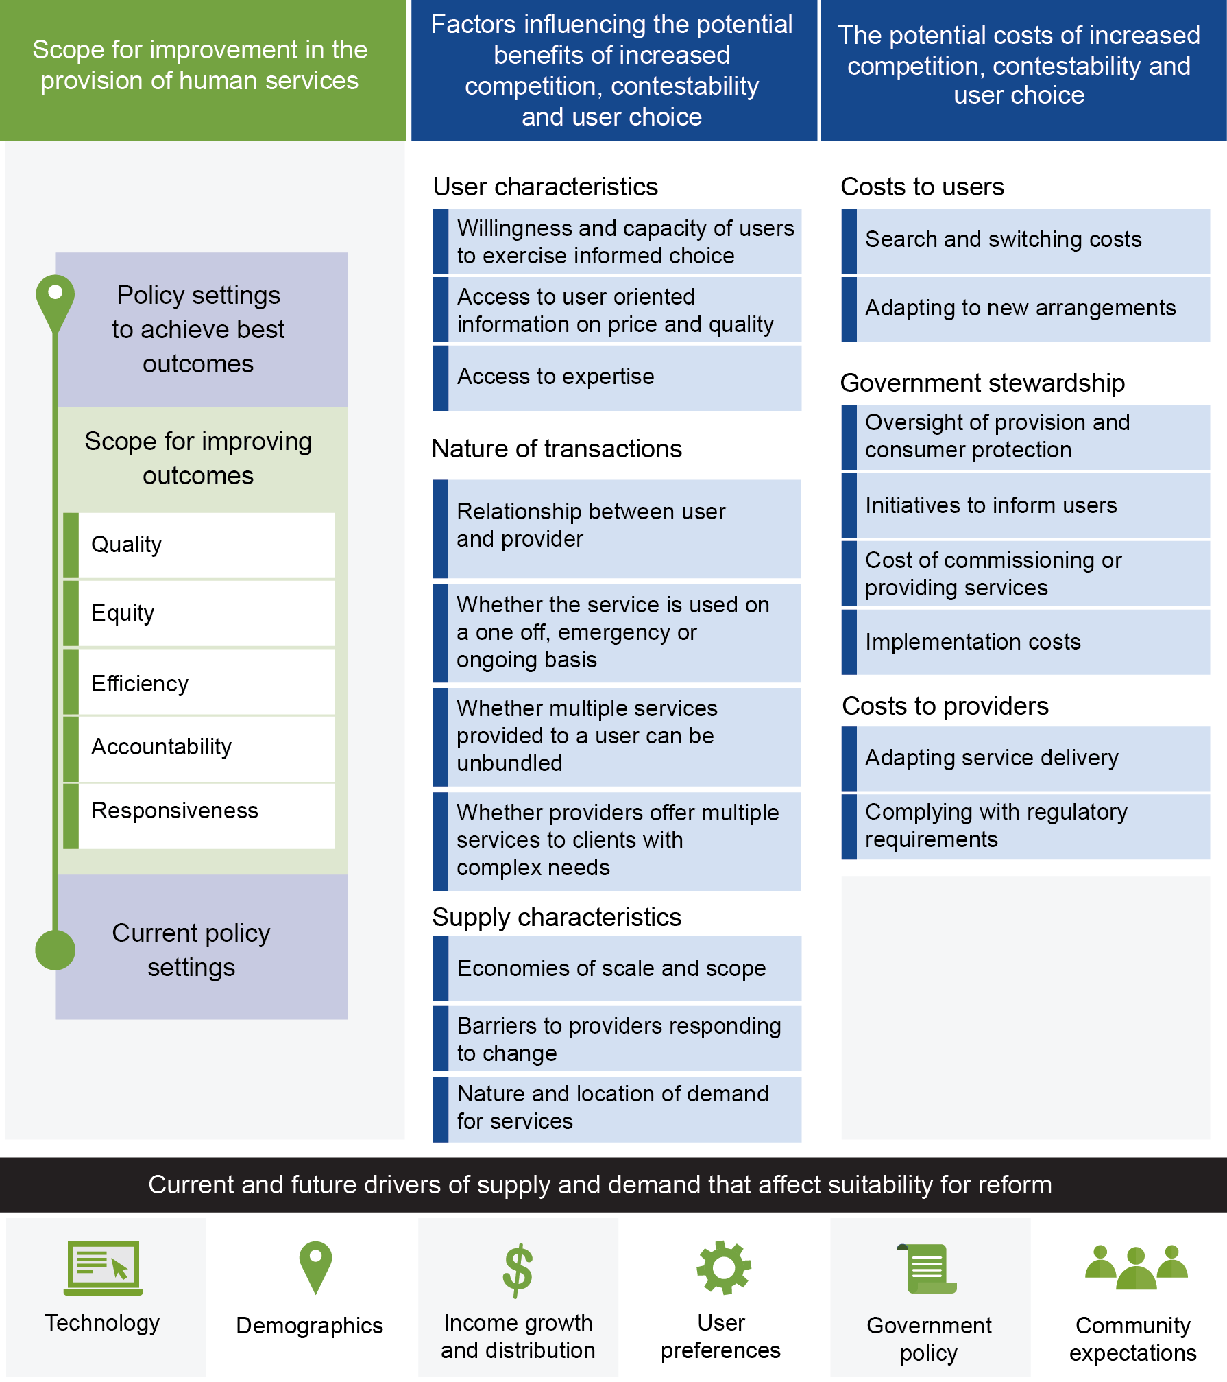

Services that appear well suited to reform based on current service characteristics may be less well suited if service characteristics change over time and vice versa. The Commission will consider how the suitability of a service for reform will be affected by current and expected future drivers of demand and supply across each area of service delivery, such as changes in technology, demographics, income and growth distribution, user preferences, government policy and community expectations.
The Commission’s assessment of which services are best suited to reform will largely be qualitative; taking into account evidence from a range of sources including contributions from participants, previous research and Commission analysis. Case studies from Australia and overseas where the principles of competition, contestability and user choice have been applied will be a valuable source of evidence, particularly where the policy reforms have been rigorously evaluated. The Commission will undertake quantitative analysis where relevant and where the underlying data are robust.

Request for information
The Commission is seeking feedback on whether the factors presented in figure 2 reflect those that should be considered when identifying human services best suited to the increased application of competition, contestability and informed user choice.

4 Information on services best suited to reform
This section outlines what information the Commission is seeking with respect to the factors presented in figure 2.

Scope for improving outcomes
Other things being equal, the potential benefits from increased competition, contestability and user choice are likely to be greater where:
- outcomes — assessed in terms of the attributes of service quality, equity, efficiency, accountability and responsiveness — are typically well below best practice
- current policy settings provide little competition, contestability and user choice, or do so in a way that is not as effective as it could be in driving best-practice outcomes.
Ideally, outcomes would be assessed using performance indicators that quantify quality, efficiency, equity, accountability and responsiveness. However, quantitative indicators often only provide a partial measure of performance against outcomes making it necessary to use them in combination with other quantitative or qualitative indicators. For example, while providing insight into outcomes, NAPLAN results on their own are unlikely to fully quantify quality, equity, efficiency, accountability and responsiveness in schools.
The Commission welcomes qualitative as well as quantitative evidence that participants may wish to provide to support their views on outcomes, given that quantitative indicators are rarely available for all aspects of performance.
In the case of healthcare, a range of performance data is collected. The Australian Commission on Safety and Quality in Health Care has used such data to document significant variation in the care received by individuals with the same condition, which it noted may be due to care not always being in accordance with evidence-based practice, differences in people’s access to services or disparities in how healthcare is organised (ACSQHC and AIHW 2016; ACSQHC and NHPA 2015). The National Health Performance Authority has documented large differences in the average cost of providing acute admitted-patient services in similar public hospitals, after controlling for differences in each hospital’s workload (NHPA 2015, 2016).
The Commission invites participants to consider both current and expected future outcomes. Current outcomes may be generally good whereas expected future outcomes may be much less so because of anticipated shifts in factors such as technology, demographics and government policies.

Request for information
The Commission is seeking participants’ views on which human services have the greatest scope for improved outcomes from the increased application of competition, contestability and user choice. Where possible, this should be supported by evidence from performance indicators and other information to show the extent to which:
- current and expected future outcomes — measured in terms of service quality, efficiency, equity, accountability and responsiveness — are below best practice
- competition, contestability and user choice do not exist under current policy settings, or are not as effective as they could be in meeting the goals of quality, equity, efficiency, accountability and responsiveness.
The Commission welcomes participants’ views on how best to improve performance data and information in the human services sector.
To judge the potential for increased competition, contestability and user choice to drive improvements in outcomes for a particular human service, the Commission invites participants to submit case studies of existing examples and past trials in Australia and overseas. The Competition Policy Review (2015) identified a number of Australian examples, such as home-based aged care and public dental services. The Commission welcomes information on these and other examples.

Request for information
Participants are invited to submit case studies of where policy settings have applied the principles of competition, contestability and user choice to the provision of a specific human service. Such case studies could describe an existing example or past policy trial in Australia or overseas. Participants should include information on the:
- pathway taken to achieve the reform
- effectiveness of the policy in achieving best-practice outcomes for quality, equity, efficiency, responsiveness and accountability
- applicability of the case study to the provision of human services in Australia if it is an overseas example.

Factors influencing potential benefits of increasing competition, contestability and user choice
The extent to which increased competition, contestability and user choice could improve quality, efficiency, equity, accountability and responsiveness of the provision of human services will vary according to user characteristics, the nature of transactions and the characteristics of service supply.

User characteristics
The benefits that service recipients gain from increased user choice will depend on whether they are willing and able to make informed decisions about alternative services and providers. Several factors can influence this, including the following.
- Whether users can make decisions on their own behalf — In some cases, users cannot be expected to exercise informed choice. For example, they may be very young, unconscious or have advanced dementia. In such cases, another party has to decide for the recipient. Increasing choice can still be beneficial in these circumstances, provided that the decision maker acts in the interests of the user.
- Information is available to users (or their decision maker) about alternatives — It may be difficult to make informed choices because providers release few details about their services, available information is not comparable across the alternatives, or service characteristics such as quality are not easily observed or measured. Importantly, the ability to exercise informed choice is not only related to the amount of information that is available to users or decision makers — that information needs to be user-oriented, timely and accurate so it can be drawn on to exercise choice. Without an adequate understanding of the alternatives, and the implications of those alternatives, service users can feel overwhelmed and less, rather than more, empowered.
- Level of expertise required to compare alternatives — Even if a user (or their decision maker) has access to information about alternative services, they may not have the technical expertise to make an informed choice. This can be the case where individuals are highly reliant on their doctor to make decisions for them about complex forms of healthcare. A lack of technical expertise may not be an insurmountable barrier if users can obtain a second opinion from another provider or engage an independent expert to advise on alternatives (noting that seeking advice from other sources will tend to raise the cost to the recipient of the service).
- Scope for service recipients to learn from past transactions — Concerns about access to information and technical expertise will be less pressing when users can learn from experience, due to the service being a repeat transaction. Similarly, they may be able to draw on the experiences of family and friends who have received comparable services. In contrast, there will be less scope to learn from experience when considering services that are rare, one-off transactions, or where it is difficult to switch between providers after making a decision (such as residential aged care).
There is a subset of human services where service recipients (or their representatives) are not given choice, irrespective of their ability to choose, because it is not considered to be in the interests of the wider community — for example, the choice of where to jail a prisoner.

Request for information
The Commission is seeking information on which human services have these characteristics:
- service recipients are willing and able to make decisions on their own behalf and, if not, another party could do so in the best interest of the recipient
- user-oriented, timely and accurate information to compare services and providers can be made available to users so they are able to exercise informed choice or, if not, this could be cost-effectively addressed
- service recipients (or their decision makers) have sufficient expertise to compare alternative services and providers or, if not, this barrier could be overcome
- outcomes experienced by a service recipient and their family and friends in past transactions can inform which service and provider they choose in the future.

The nature of service transactions
The nature of the relationship between the service recipient and the provider will have a bearing on whether services are suited to increased competition, contestability and user choice. For some services, building a relationship between the user and the provider is a very important part of the service model and, in these cases, it is trust in that relationship that drives outcomes. Building a relationship of trust with a psychologist, for example, will be a key driver of outcomes.
The nature of some community services is based on an outreach model (for example, services supporting rough sleepers) rather than a model where the user actively engages a service provider. While a consumer-driven model may work well in some areas (for example, disability services) others might be less well-suited to a model that relies on those needing support actively engaging in a market.
As noted above, services that involve repeat transactions may have greater scope for informed choice than unusual, one-off services. Other features of the transaction that affect the benefits of increased competition and user choice include whether it can occur remotely or requires the provider and recipient to be in the same location, and the extent to which services can be ‘unbundled’ so individuals can choose different providers to meet different needs. In other cases, it can be desirable for the transaction to involve a provider supplying multiple services to an individual. For example, a rough sleeper receiving short-term shelter and basic healthcare through the same provider at the same time, followed by assistance in finding other providers to meet longer-term housing and health needs.

Request for Information
For specific human services, the Commission is seeking information on the nature of service transactions based on these characteristics:
- the nature of the relationship between the service user and the provider
- whether the service is used on a one-off, emergency or ongoing basis
- whether the service can be provided remotely
- the extent to which services to an individual can be unbundled
- whether there is a strong case for the provider to supply multiple services to an individual with complex needs.

Supply characteristics
Competition between suppliers can be beneficial because it gives users more choice and increases pressure on suppliers to improve service delivery. A potential drawback is that competing suppliers may not be able to achieve the economies of scale or scope that could be gained by a monopolist or a smaller number of competitors. This could be reflected not only in costs but also quality if outcomes tend to improve the more frequently a provider supplies a given service, or when a provider supplies a bundle of different services.
For example, there can be large fixed capital costs associated with some forms of healthcare that cannot be provided remotely, such as diagnostic procedures like MRI scans, and types of treatment, such as intensive care. This can mean that facilities servicing a larger number of patients can achieve a lower cost per service. Higher service volumes can also improve the quality of healthcare where outcomes tend to improve with the frequency that healthcare professionals provide particular treatments.
Thus, increasing competition can sometimes be problematic in sparsely populated regions where remote provision of the service is not an option. For example, there is a risk that increasing competition between hospitals in rural and remote regions could lead to a marked increase in unit costs and a decline in service quality. Where competition between providers to attract users is not feasible, governments may still have the option of making service provision more contestable.
The scope for increased competition or contestability could be limited by unnecessary barriers to suppliers entering (or exiting) the market, including the way that governments fund or commission human services. While regulatory barriers, such as professional qualifications, are common for human services, particularly to maintain a minimum level of service quality, poor design or implementation of regulations can overly impede contestability.
Existing regulations, if inflexible or poorly designed, may limit innovation in service provision. Technological change has the potential to alter the factors affecting supply. Improvements in the ability to deliver services remotely, for example, are likely to transform the way that some services can be delivered. This could in turn make increased competition, contestability and user choice a more viable option. For example, telecare can include a device that the individual wears at all times so that they can contact a 24-hour response centre in case of an emergency, such as becoming immobilised after a fall in their home. This technology is making it possible for the elderly and physically less able to choose to continue living independently in their own homes.
The nature and location of demand for services, now and in the future, will also influence how services are supplied. Service needs can be very different between different groups in the community, such as the young, elderly, Indigenous people and recent immigrants. Maintaining or improving services for vulnerable groups is often critical to meeting equity objectives. Ensuring providers cater for people with limited cognitive abilities or English proficiency, and services are provided in a culturally sensitive manner is another important part of meeting equity objectives. Users in regional and remote parts of Australia may require different services, and different models of service provision, to those in densely populated metropolitan areas.
The nature and location of future demand for human services will be affected by a number of factors, including technology, demographics, income growth and distribution, user preferences, government policy, and community expectations. These factors will have varying effects across different types of human services. It should also be noted that the way a market responds to changes in factors affecting demand and supply is heavily influenced by government funding and decision-making arrangements.

Request for information
The Commission is seeking information on the supply characteristics of specific human services including:
- economies of scale and scope — in terms of costs and service quality — that may be lost by having a larger number of competing providers
- the potential for service provision to be made more contestable because there is capability beyond an existing provider that could pose a credible threat to underperformance
- whether there are barriers to providers responding to change, or new suppliers entering the market, that limit the scope for increased competition, contestability and user choice or, if they do, what could be done to address this
- technological change that is making competition and user choice more viable
- factors affecting the nature and location of demand, such as geographic dispersion of users, the distribution of demand among different types of users, particularly disadvantaged and vulnerable users, and anticipated future changes in demand.

The potential costs of increasing competition, contestability and user choice
The benefits from reform need to be weighed against the potential costs incurred by service users, governments and providers. An assessment of the potential costs of reform needs to identify both one-off adjustment costs and ongoing costs.

Costs to service users
To benefit from increased competition and choice, users need to become more active in selecting the services they receive. Government initiatives to provide information on alternatives can facilitate this, but users (or their decision makers) still need to invest effort and resources in making a choice. Where they are not satisfied with the service currently received, service recipients will incur costs in switching and adjusting to an alternative.
For services that are made more contestable without also providing consumer choice, users will still have to adapt to changes in how providers supply services, and any decision by governments to switch providers.

Government stewardship
Governments have an important stewardship role to ensure the quality of services, protect consumers, and make ongoing improvements to policies and programs. The introduction of increased competition, contestability or user choice typically requires changes to the stewardship function, which has associated costs for governments and possibly users and providers.
Governments use regulation and other measures to influence the structure of markets and the conduct of participants. This can be justified where markets would otherwise fail to provide the best possible outcomes from the perspective of the community as a whole. Reasons for this can include an information asymmetry between suppliers and service recipients, and the presence of disadvantaged groups who are not well placed to get the best possible outcomes. Safeguarding the interests of disadvantaged or vulnerable users can be particularly important in the case of human services.
An example of the changes that may be required to government stewardship is the introduction or expansion of initiatives to inform consumers about alternative services and providers. This could include developing uniform standards for measuring service characteristics, legislating mandatory reporting requirements for service providers, and providing comparison services for consumers (such as the myschools and myhospitals websites). These actions have associated costs for governments and often also service providers.
Another example is government oversight of service quality. Increased competition may mean that the performance of more providers has to be monitored. Monitoring of individual providers could also need to be more intensive if there is a risk that they will compete on price at the expense of service qualities that are difficult for users to observe in advance.
Moreover, general consumer protection laws may need to be changed where, for example, they do (or would) not adequately safeguard the interests of service users. For user choice to be effective at empowering service recipients and driving outcomes, it must be protected by vigilant enforcement of those laws.
The provision of human services through a government tender should include a transparent process resulting in a contract with the selected provider to codify service quality and other conditions to ensure outcomes are achieved, more timely monitoring so that substandard performance is quickly identified, and measures to promptly intervene when there is underperformance.
Changes such as those discussed above often require modifications to the functions of regulators and other government agencies, and possibly the establishment of new bodies.

Costs to service providers
Changes to the way human services are provided will involve adjustment costs and, importantly, different commissioning, contracting, government stewardship, pricing and delivery arrangements will affect different types of providers differently. Some providers may service a small number of users, drawing on in-kind support from the community, while others may be large corporate entities that can spread administrative and compliance cost over a sizable base of service users. Some will have more experience in user-directed care, while others may have managerial and operational structures based on attracting grants funding from governments. A shift to consumer-directed budgets, for example, may mean that service providers (including their workforces) face adjustment costs from having to adapt their model of service provision to be more responsive to the wishes of service users.
The costs that service providers incur to comply with regulatory and other government requirements will change due to shifts in government stewardship, such as those discussed above. Some of this change in compliance costs may be a one-off for providers, rather than an ongoing expense.

Request for information
For specific human services, the Commission is seeking information on:
- the costs that consumers would incur by becoming more active in selecting the services they receive, adapting to changes in how providers supply services, and switching services when a decision is made to do so
- the regulatory arrangements and other initiatives that governments would have to modify or establish as part of their stewardship role, including to inform users about alternative services and providers, maintain service quality, protect consumers (especially disadvantaged or vulnerable users) from being exploited, and to fine-tune policies in response to any problems that emerge
- how the compliance costs faced by service providers will be affected by changes in government stewardship, and the adjustment costs that providers will bear in order to shift to a more user-focused model of service provision
- the extent to which such costs are one-off or an ongoing impost.
The Commission welcomes information from participants on the costs faced by different types of providers, with different motivations and governance structures, when shifting to a more user-focused model of service provision.

References
ABS (Australian Bureau of Statistics) 2015, Australian System of National Accounts, 2014-15, 30 October, Cat. no. 5204.0, Canberra.
—— 2016, Government Finance Statistics, Education, Australia, 2014-15, Cat. no. 5518.0.55.001, Canberra, http://www.abs.gov.au/ausstats/abs@.nsf/mf/5518.0.55.001 (accessed 27 April 2016).
ACFA (Aged Care Financing Authority) 2015, Third Report on the Funding and Financing of the Aged Care Industry, Canberra, https://www.dss.gov.au/ageing-and-aged-care/aged-care-reform/aged-care-financing-authority/2015-report-on-the-funding-and-financing-of-the-aged-care-industry (accessed 27 April 2016).
ACSQHC (Australian Commission on Safety and Quality in Health Care) and AIHW (Australian Institute of Health and Welfare) 2016, Exploring Healthcare Variation in Australia: Analyses Resulting from an OECD Study, ACSQHC, Sydney.
—— and NHPA (National Health Performance Authority) 2015, Australian Atlas of Healthcare Variation, ACSQHC, Sydney.
Australian Government 2014, Portfolio Budget Statements 2014-15: Budget Related Paper No. 1.6 Employment Portfolio, Budget 2014-15, Canberra.
Baumol, W. 1982, ‘Contestable markets: An uprising in the theory of industry structure’, The American Economic Review, vol. 72, no. 1, pp. 1–15.
Competition Policy Review 2014, Competition Policy Review: Issues Paper, Canberra.
—— 2015, Competition Policy Review: Final Report, Canberra.
Davidson, B. 2011, ‘Contestability in human services markets’, The Journal of Australian Political Economy, no. 68, pp. 213–239.
—— 2015, ‘Community aged care providers in a competitive environment: past, present and future’, Markets, Rights and Power, pp. 191–229.
Le Grand, J. 2007, The Other Invisible Hand, Princeton University Press, Princeton, New Jersey.
National Competition Policy Review 1993, National Competition Policy Review Report, Canberra.
NHPA (National Health Performance Authority) 2015, Hospital Performance: Costs of Acute Admitted Patients in Public Hospitals in 2011–12, Sydney.
—— 2016, Hospital Performance: Costs of Acute Admitted Patients in Public Hospitals From 2011–12 to 2013–14, Sydney.
SCRGSP (Steering Committee for the Review of Government Service Provision) 2015, Report on Government Services 2015, Productivity Commission, Canberra.
—— 2016, Report on Government Services 2016, Productivity Commission, Canberra.

Attachment A: How to make a submission

How to prepare a submission
Submissions may range from a short letter outlining your views on a particular topic to a much more substantial document covering a range of issues. Where possible, you should provide evidence, such as relevant data and documentation, to support your views.

Generally
- Each submission, except for any attachment supplied in confidence , will be published on the Commission’s website shortly after receipt, and will remain there indefinitely as a public document.
- The Commission reserves the right to not publish material on its website that is offensive, potentially defamatory, or clearly out of scope for the inquiry or study in question.

Copyright
- Copyright in submissions sent to the Commission resides with the author(s), not with the Commission.
- Do not send us material for which you are not the copyright owner — such as newspaper articles — you should just reference or link to this material in your submission.

In confidence material
- This is a public review and all submissions should be provided as public documents that can be placed on the Commission’s website for others to read and comment on. However, information which is of a confidential nature or which is submitted in confidence can be treated as such by the Commission, provided the cause for such treatment is shown.
- The Commission may also request a non-confidential summary of the confidential material it is given, or the reasons why a summary cannot be provided.
- Material supplied in confidence should be clearly marked ‘IN CONFIDENCE’ and be in a separate attachment to non-confidential material.
- You are encouraged to contact the Commission for further information and advice before submitting such material.

Privacy
- For privacy reasons, all personal details (for example, home and email address, signatures, phone, mobile and fax numbers) will be removed before they are published on the website. Please do not provide these details unless necessary.
- You may wish to remain anonymous or use a pseudonym. Please note that, if you choose to remain anonymous or use a pseudonym, the Commission may place less weight on your submission.

Technical tips
- The Commission prefers to receive submissions as a Microsoft Word (.docx) files. PDF files are acceptable if produced from a Word document or similar text based software. You may wish to research the Internet on how to make your documents more accessible or for the more technical, follow advice from Web Content Accessibility Guidelines (WCAG) 2.0<http://www.w3.org/TR/WCAG20/>.
- Do not send password protected files.
- Track changes, editing marks, hidden text and internal links should be removed from submissions.
- To minimise linking problems, type the full web address (for example, http://www.referred-website.com/folder/file-name.html).

How to lodge a submission
Submissions should be lodged using the online form on the Commission’s website. Submissions lodged by post should be accompanied by a submission cover sheet.
Online* | http://www.pc.gov.au/inquiries/current/human-services/make-submission
Post* | Human Services Inquiry  Productivity Commission  Locked Bag 2, Collins Street East  Melbourne Vic 8003
* If you do not receive notification of receipt of your submission to the Commission, please contact Marianna Olding on (03) 9653 2194.

Due date for submissions
Please lodge submissions with the Commission by 25 July 2016.

