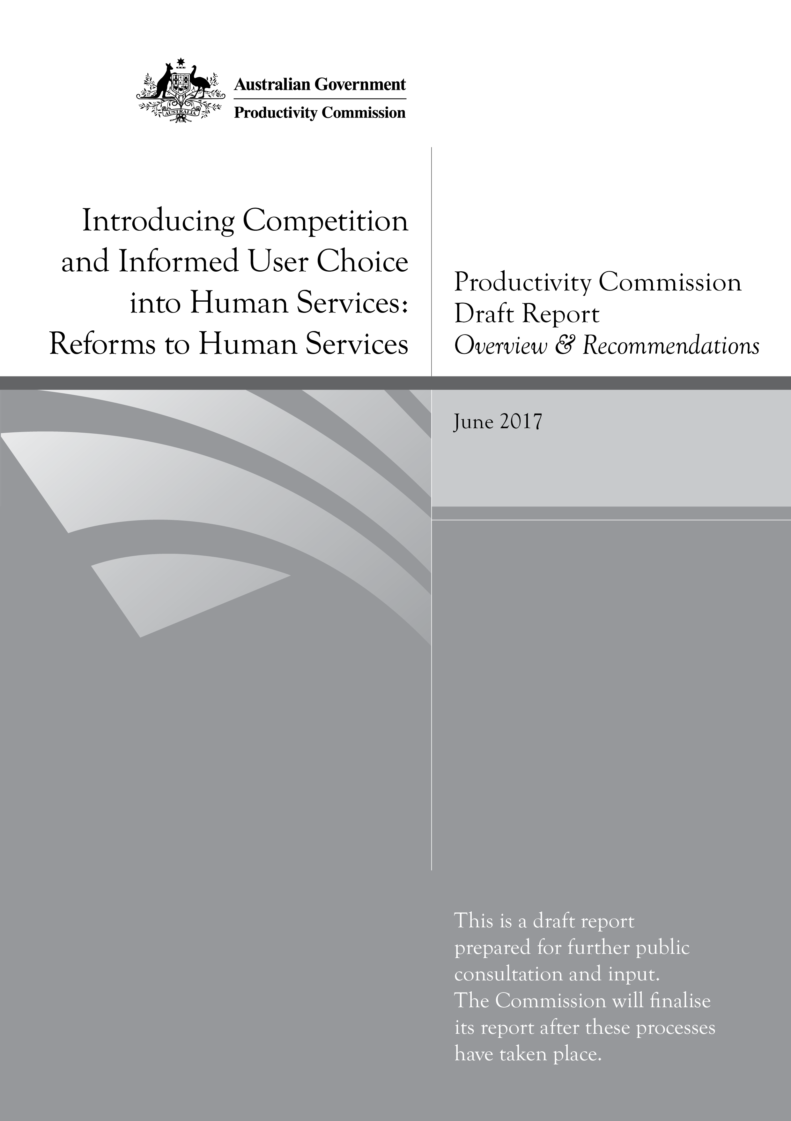
Introducing Competition and Informed User Choice into Human Services: Reforms to Human Services
Productivity Commission Draft Report, Overview and Recommendations
Commonwealth of Australia 2017

Except for the Commonwealth Coat of Arms and content supplied by third parties, this copyright work is licensed under a Creative Commons Attribution 3.0 Australia licence. To view a copy of this licence, visit http://creativecommons.org/licenses/by/3.0/au. In essence, you are free to copy, communicate and adapt the work, as long as you attribute the work to the Productivity Commission (but not in any way that suggests the Commission endorses you or your use) and abide by the other licence terms.
Use of the Commonwealth Coat of Arms
For terms of use of the Coat of Arms visit the ‘It’s an Honour’ website: http://www.itsanhonour.gov.au
Third party copyright
Wherever a third party holds copyright in this material, the copyright remains with that party. Their permission may be required to use the material, please contact them directly.
Attribution
This work should be attributed as follows, Source: Productivity Commission, Introducing Competition and Informed User Choice into Human Services: Reforms to Human Services, Draft Report.
If you have adapted, modified or transformed this work in anyway, please use the following, Source: based on Productivity Commission data, Introducing Competition and Informed User choice into Human Services: Reforms to Human Services, Draft Report.
An appropriate reference for this publication is:
Productivity Commission 2017, Introducing Competition and Informed User Choice into Human Services: Reforms to Human Services, Draft Report, Canberra.
Publications enquiries
Media and Publications, phone: (03) 9653 2244 or email: maps@pc.gov.au

The Productivity Commission
The Productivity Commission is the Australian Government’s independent research and advisory body on a range of economic, social and environmental issues affecting the welfare of Australians. Its role, expressed most simply, is to help governments make better policies, in the long term interest of the Australian community.
The Commission’s independence is underpinned by an Act of Parliament. Its processes and outputs are open to public scrutiny and are driven by concern for the wellbeing of the community as a whole.
Further information on the Productivity Commission can be obtained from the Commission’s website (www.pc.gov.au).

Opportunity for further comment
You are invited to examine this draft report and comment on it by written submission to the Productivity Commission, preferably in electronic format, by Friday 14 July 2017 and/or by attending a public hearing. Further information on how to provide a submission is included on the inquiry website www.pc.gov.au/inquiries/current/human-services/make-submission.
The final report will be prepared after further submissions have been received and roundtables and public hearings have been held, and will be submitted to the Australian Government in October 2017.

Public hearing dates and venues
Location | Date | Venue
Sydney | Monday 24 July | Adina Apartment Hotel, Surry Hills, 359 Crown St, Surry Hills
Canberra | Tuesday 25 July | Productivity Commission, Level 2, 4 National Cct, Barton
Melbourne | Thursday 27 July | Productivity Commission, Level 12, 530 Collins St, Melbourne
Perth | Monday 31 July | Mantra on Murray, 305 Murray St, Perth
Please note, public hearings may be held in other locations if needed, and you may also participate via teleconference. Please visit the inquiry website www.pc.gov.au/inquiries/current/human-services to register your interest in participating in a public hearing.

Commissioners
For the purposes of this inquiry and draft report, in accordance with section 40 of the Productivity Commission Act 1998 (Cwlth) the powers of the Productivity Commission have been exercised by:
Stephen King | Commissioner
Richard Spencer | Commissioner
The Commission has been assisted in this inquiry by Sean Innis, as Special Adviser.

Contents
Opportunity for further comment iii
Overview 1
Key points 2
1 What this inquiry is about 3
2 Government involvement in human services 4
3 Introducing greater user choice, competition and contestability 5
4 The Commission’s approach to assessing reforms 7
5 Caring for people at the end of life 9
6 Social housing 13
7 Family and community services 17
8 Services in remote Indigenous communities 21
9 Public hospital services 27
10 Public dental services 31
Draft recommendations and information request 35
The full report is available from www.pc.gov.au

Overview

Key points
- This inquiry is about finding ways to put the people who use human services, such as health care, social housing and family and community services, at the heart of service provision. This matters because everyone will use human services in their lifetime and change is needed to enable people to have a stronger voice in shaping the services they receive, and who provides them.
- Competition and contestability are means to an end and should only be pursued when they improve the effectiveness of service provision.
- This report sets out the Commission’s proposed reforms for: end-of-life care services; social housing; government-commissioned family and community services; services in remote Indigenous communities; public hospitals; and public dental services.
- The Commission’s proposed reforms vary according to the purposes of the services in question, the settings where they are accessed and, importantly, the users themselves.
- Each year, tens of thousands of people who are approaching the end of life are cared for and die in a place that does not reflect their choice or fully meet their end-of-life care needs. Most people who die do so in two of the least preferred places — hospitals and residential aged care.
- More community-based palliative care services are needed to enable more people who wish to die at home to do so.
- End-of-life care in residential aged care needs to be better resourced and delivered by skilled staff, so that its quality aligns with that available to other Australians.
- The social housing system is broken. The current two-tiered system of financial assistance for people who live in social housing or the private rental market is inequitable, and limits tenants’ choice over the home they live in. The system would be improved if a single model of financial assistance applied across social and private housing, based on an increase and extension to Commonwealth Rent Assistance.
- Social housing should continue to provide a home for people who are not well placed to rent in the private market.
- Family and community services are not meeting the needs of people experiencing hardship. The system is designed for the convenience of governments, not people. Practical changes to system planning, provider selection and contract management could shift the focus to improving outcomes for people who use these services.
- Human services are not making the contribution they should be to improving the wellbeing of Indigenous people living in remote communities. Increasing contract lengths for service providers, developing better planning, evaluation and feedback systems, and improving processes for selecting and managing service providers would contribute to improving outcomes for Indigenous people living in remote communities.
- Public hospital patients should be given greater control over the pathway leading to planned admissions. This requires removing barriers to patients choosing the outpatient clinic or specialist they initially attend when given a referral by their general practitioner. Improved public reporting on individual hospitals and specialists would support greater user choice and encourage performance improvements in hospitals.
- Public dental patients have little choice in who provides their care, when and where, and most services are focused on urgent needs. Patients’ choice and outcomes could be improved by a new payment and care model, with a focus on preventive treatments.

Overview

1 What this inquiry is about
This inquiry is about finding ways to put the people who use human services, such as health care, social housing and family and community services, at the heart of service provision. This matters because everyone will access human services in their lifetime and change is needed to enable and support people and their families to have a stronger voice in shaping the services they receive, and who provides them.
Human services are essential for the wellbeing of individuals and their families, and underpin economic and social participation. Ensuring that everyone, regardless of their means or circumstances, has access to a minimum level of high-quality human services promotes equity and social cohesion, which in turn contributes to the welfare of the community as a whole.
Public and private expenditure on human services is significant — over $300 billion in 2014-15 — with demand for services projected to grow as more people live longer, incomes grow and technological advances increase the types of services that can improve a person’s quality of life. The number of services provided each year in Australia is considerable — for example, there were more than 10 million admissions to public and private hospitals in 2015. Other services, such as homelessness services and social housing, are each used by hundreds of thousands of people every year.
The Commission has been asked by the Australian Government to recommend reforms to improve the effectiveness of human services using the policy ‘tools’ set out in the inquiry terms of reference — the introduction of greater user choice, competition and contestability. The Commission’s study report identified six services where these tools could put users at the centre of service provision. The six services that were identified are end-of-life care services; social housing; government-commissioned family and community services; services in remote Indigenous communities; public hospitals; and public dental services. This draft report seeks feedback from inquiry participants on reform proposals for these six services. Details about how to participate in this inquiry are in box 1.

Box 1 How can you participate in this inquiry?
This inquiry has been conducted in two stages. A study report completing the first stage of the inquiry was released by the Commission in December 2016. The study report sets out the Commission’s reasoning for identifying the six services that are best suited to reforms to introduce greater user choice, competition or contestability: end-of-life care services; social housing; government-commissioned family and community services; services in remote Indigenous communities; public hospitals; and public dental services.
This is the draft report for the second stage of the inquiry. This report presents the Commission’s draft recommendations for each of the six services, and seeks feedback from participants to inform its final report.
Participants are invited to provide written submissions to respond to this draft report. Submissions are due by 14 July 2017. The Commission will hold public hearings in Canberra, Melbourne, Sydney and Perth in July and August, and encourages parties to register their interest to participate. Details of how to prepare a submission and to register for public hearings are included at the front of this report and on the Commission’s website at www.pc.gov.au/inquiries/current/human-services. The Commission will hold roundtables and consultations in several locations, including outside major capital cities.
The final inquiry report will be provided to the Australian Government in late October 2017.
Details of the consultation process leading to this draft report can be found in appendix A. The Commission thanks all those who have participated in this inquiry.

2 Government involvement in human services
Governments have several roles in markets for human services. Governments are the primary funder of most human services and play a major role in determining who has access to a service and who does not. There are sound efficiency and equity reasons for this. Markets left to their own devices would not deliver the appropriate level, or distribution, of human services across the community. Governments’ approach to filling these gaps can take a number of forms including funding universal access to a service, as is the case for emergency health care, and fully or partly covering the cost of a service to targeted groups in the community, as is the case for public dental services. Governments also choose whether to provide services directly (as is the case for the management of public housing tenancies) or contract out to other providers.
Governments will (or should) always have the role of system stewards. This role incorporates a range of functions that help to ensure service provision is effective at meeting its objectives, including policy design, regulation, oversight of service delivery, monitoring of provider performance, and developing ways for the system to learn and continuously improve. Stewardship arrangements are difficult to get right — the design and performance of these functions should be tailored to each service, and to the settings in which it is delivered. Stewardship is a core part of the reform and delivery process and the Commission’s work on this inquiry has highlighted areas where governments need to improve.
- Greater coordination: Coordination problems can arise between governments, agencies and providers when, for example, services are funded by more than one level of government, or when services delivered by one provider duplicate or detract from another’s. In some cases, policy is developed in government silos which can lead to competing objectives, and stewards losing sight of the users’ overall wellbeing.
- More transparency: The provision of information to improve accountability and facilitate performance assessment can benefit all parties within the human services system. Without it, users are unable to assess providers, providers are unable to plan their services, and governments cannot effectively evaluate how providers or systems are performing.
- Smoother transitions: Policy reform in human services is a complex and delicate task. Reforms can be large, costly and disruptive to users and providers, take considerable time to fully implement, and affect the lives of many (sometimes vulnerable) users. Better planning and preparation for change should aim to preserve continuity of outcomes and minimise any negative effects on users from the transition. Transitioning between providers can also be disruptive as users find new providers and build a relationship of trust with them. Information and clarity about changes in advance can help.
Some inquiry participants have argued that for-profit providers should not be allowed to supply human services. The Commission disagrees. Human services are currently provided by a mix of government, not-for-profit and for-profit organisations. Experience suggests that no one type of provider has a monopoly over good service provision and each has had their share of successes and failures.
Governments need to focus on the capabilities and attributes of service providers when designing service arrangements and selecting providers — not simply the form of an organisation. Governments, as stewards, need to ensure that all providers meet minimum standards and have incentives that align with users’ and governments’ objectives.

3 Introducing greater user choice, competition and contestability

Informed user choice
There are different types of choice that users could make in markets for human services: which provider; which service; and where, when and how that service is delivered. Some of these choices will be dependent (only certain types of providers can offer a specific service), and some will not be feasible for an individual user (a person with late-stage dementia, for example, may not be well-placed to choose a medical specialist). The type of choice on offer is important because the net benefits of introducing greater choice differ according to which type of choice is being considered and for whom.
The Commission’s starting point is that users should have choice over the human services they access and who provides them, unless there are clear reasons why not. These reasons could include a lack of capacity to exercise informed choice and the inability of an agent to do so on a user’s behalf, or when there is a need for decisions to be taken quickly in a crisis (such as a medical emergency).
In a well-designed and managed market, informed choice can improve outcomes for users because it:
- has intrinsic value by empowering people to have greater control over their lives
- enables people to make decisions that best meet their needs and preferences
- can generate powerful incentives for providers to be more responsive to users’ needs and can drive innovation and efficiencies in service delivery.
A common theme in submissions is that people have a strong desire to have choice, and the empowerment that comes with it. In its submission to this inquiry, Alzheimer’s Australia stated:
Alzheimer’s Australia is strongly supportive of the principle of user choice in human services. For people living with dementia, their families and carers, having a say in their everyday lives is a basic desire and underpins a sense of purpose and wellbeing. Many people living with dementia have expressed a desire to feel that they are participating in decision making regarding their care but also recognise that their ability to do so can be impacted by their diagnosis: capacity to make informed decisions may change from day to day or may decline rapidly.
Not everyone shares this view. Some participants in this inquiry did not consider that user choice should be increased, pointing out that recipients of human services may not possess full knowledge of their preferences, have the capacity to act on their preferences, or have access to information that is necessary to make decisions.
The Commission recognises that there are circumstances where user choice is not appropriate, but the onus should be on those seeking to remove choice to justify why. If not the user, someone — the government or the provider — will be making a choice as to which services a person should receive and who should provide them. Even when user choice is not appropriate, a focus on users can be achieved through other approaches, such as increasing ‘user voice’ and co-design so a person’s (or community’s) preferences are taken into account when others make decisions on their behalf.

Putting the focus on users though greater competition and contestability
Competition and contestability are means to an end — improving the effectiveness of service provision — rather than ends in themselves. In the right circumstances, competition provides powerful incentives to deliver more effective services. When competition between multiple service providers is not possible or desirable, contestability, by mimicking competitive pressures, can deliver many of the same benefits as competition. Contestable arrangements for provider selection are used widely in the context of commissioning — an increasingly common approach that governments use when engaging organisations to deliver human services.
As with user choice, several participants in this inquiry questioned whether competition should have a place in the provision of human services. Some were sweeping in their rejection. Anglicare Australia, for example, in its submission did not accept that competition is a driver of efficiency; that efficiency is an inherently good thing in human services; that the innovation that comes with competition between providers is of benefit to service users; or that it is appropriate to equate individual consumer choice with agency and wellbeing. Others were more specific, describing the harmful effects of competition and contestability, including providers focusing on writing tender applications at the expense of their core business, and competition damaging the collaboration between providers needed to drive positive outcomes for users with multiple and complex needs.
Unlocking the potential benefits of competition or contestability in human services markets requires careful stewardship from governments and there are instances where neither competition nor contestability are appropriate. In considering the potential role of competition and contestability, the Commission has carefully examined the characteristics of each of the six services in this inquiry to assess whether: the likely benefits to the community of its proposed reforms would be expected to outweigh the costs; the incentives of providers and users would be aligned; and government objectives would be achieved.

4 The Commission’s approach to assessing reforms
A key aspect of the Commission’s approach is identifying the characteristics of service users, transactions and providers, how these characteristics affect the incentives of users and providers, and ultimately the potential costs and benefits of reform (figure 1). These characteristics affect not only how the proposed reforms would influence the effectiveness of service delivery, but also what stewardship arrangements would need to be put in place to support the reform. Each of the services the Commission has proposed for reform is different — there is diversity in the type and number of users, their capacity and willingness to make choices, the setting and circumstances under which services are provided, and the financial contribution made by users and governments. This makes the policy design task in each of these services unique.

Figure 1 Characteristics that influence the effectiveness of service provision
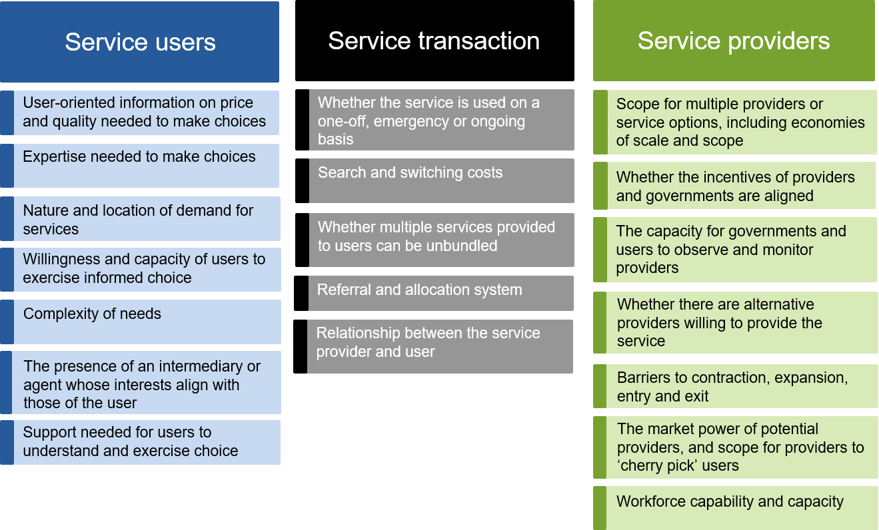

In its analysis, the Commission has assessed the attributes of effective service delivery:
- Quality: Whether the reform options would lead to incentives for providers to offer high-quality services to users
- Equity: Who would be affected by the reform options and how they would be affected
- Efficiency: Whether the reform options would lead to incentives for providers to reduce the costs of providing services while still maintaining quality, and for users to select the services that best meet their needs
- Accountability and responsiveness: Whether the reform options would result in service providers being more responsive to the needs of service users and more accountable to those who fund the services (taxpayers and users).
The proposed reforms to introduce greater user choice, competition or contestability would affect the attributes of effectiveness in different ways and, in some cases, negatively. Some reforms may lead to large increases in quality, with minimal effects on the other attributes. Some may lead to increases in the attributes across the board. The potential costs and benefits of reform will also fall unequally across the community. Recognising these trade-offs, the Commission’s overarching objective in assessing policy recommendations is to improve the welfare of the community as a whole.
Delivering more effective human services may involve additional costs for governments, especially in the early years of implementation. In some cases this may be somewhat offset by reduced spending over time. More effective end-of-life care and public dental services could, for example, reduce demand for some hospital services. These fiscal effects will not fall evenly across levels of government, with spending by one level potentially resulting in reductions in spending by others. On the basis of the available information, the Commission considers that the benefits of its draft recommendations, including improved service outcomes for users, would outweigh the fiscal (and other) costs. Governments should not allow the unequal distribution of these fiscal effects to become a barrier to reform.
The Australian, Territory and some State Governments have committed to working collaboratively to develop funding agreements for priority areas, such as the delivery of human services, through an intergovernmental agreement on competition and productivity-enhancing reforms. This agreement, which includes a commitment by the Commonwealth to provide incentive payments to participating State and Territory Governments, could help to provide much-needed impetus for reform.

5 Caring for people at the end of life
Too many people approaching the end of life miss out on quality end-of-life care. The availability of services is variable and few of those who would prefer to die at home are able to do so. Improving access to high-quality end-of-life care could play a major role in enhancing community welfare, by ensuring people have more choice about how they are cared for and where they die.
Between 80 000 and 140 000 of the 160 000 people who die each year in Australia would benefit from high-quality ‘end-of-life care’ — physical, spiritual and psychosocial services provided by health professionals and ancillary staff to people who are likely to die within the next 12 months.
A comprehensive approach to end-of-life care recognises that the patient and clinicians are both essential participants in discussions and decision-making about care needs at the end of life. This shifts the emphasis of care delivery from life extension toward care that attempts to fulfil each patient’s choices, values and preferences, given the realities of the patient’s clinical condition and treatment options.
There are significant gaps in information about the provision of end-of-life care in Australia. What is known is that:
- the quality, availability and affordability of end-of-life care in Australia are among the world’s best, but only a small proportion of those who die each year receive such care
- more than 80 000 people die in hospitals each year and about 60 000 die in residential aged care (figure 2) — two of the least preferred places to die
Figure 2 Age, location and cause of death in Australia, 2015
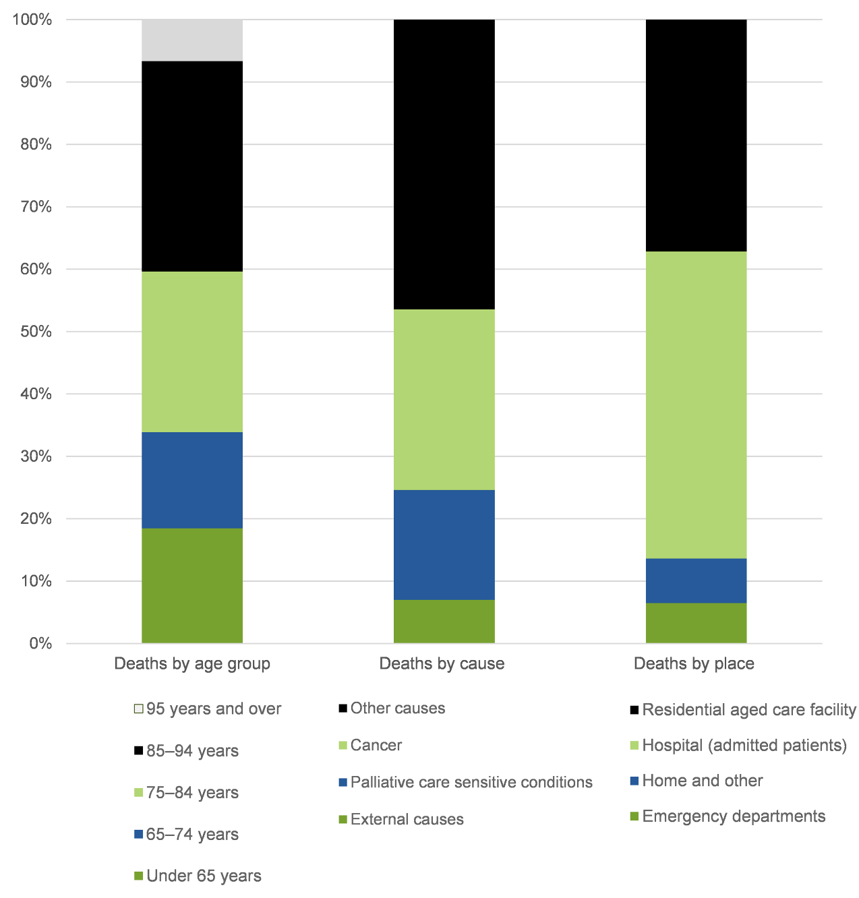

- people approaching the end of life in hospitals can find it hard to access care that is responsive to their preferences, and sometimes receive medical interventions that are not beneficial to them. This has an adverse effect on their quality of life
- about 70 per cent of Australians would prefer to die at home but few are able to do so. The number of people wishing to die at home with the support of a community-based palliative care service far exceeds the availability of that care, particularly for those with illnesses other than cancer. For many, access to community-based palliative care is determined by where they live, rather than where they would prefer to die
- four out of five residents of aged care facilities die in them but the lack of palliative care expertise and qualified staff to administer pain relief mean residents often make traumatic (and costly) trips to hospital to receive medical care that could have been provided in surroundings that are familiar to them. Some aged care residents die in unnecessary pain causing distress to themselves and the people who care for them.
Without significant policy reform, tens of thousands of people will die in a way, and in a place, that does not reflect their values or their choices. Their end-of-life journey will likely be punctuated with avoidable, or unwanted, admissions to hospital with the confusion, loss of dignity and loss of control that comes with it. This is not acceptable.
Reforms to better align care at the end of life with user preferences should be a high priority for governments. Reform is needed now to ensure that the growing number of people needing end-of-life care are able to receive services that better match their preferences.

Few people can access community-based palliative care
Tens of thousands of the people who die each year have a medical condition that would be amenable to palliative care, prefer to die at home, and have family and friends who are able to provide the considerable support needed to remain in their homes as they approach the end of life. But they cannot access the community-based palliative care that would enable them to be cared for and to die at home. Addressing this gap will require State and Territory Governments to substantially increase the availability of community-based palliative care. This expansion will require careful planning and stewardship. Systems will be needed to assess demand, commission services and ensure consumers receive consistent high-quality care with appropriate protections. While governments should consider options for offering choice of provider, the first priority should be on better meeting demand.
The Commission’s proposed approach would require governments to assess the needs of different regions and populations, and to determine priorities for service expansion. Once current gaps in service provision are better understood, State and Territory Governments should determine the appropriate approach to addressing those gaps. In most places, this would be to run competitive processes to select providers of additional community-based palliative care services. The providers selected to deliver community-based palliative care services should be able to achieve integrated and coordinated nursing, medical and personal care, and provide access to care and support 24 hours a day, seven days a week.
Approaching the market to provide additional community-based palliative care services would not require any changes to existing service arrangements — governments could choose to leave current services in place while adding to the service offering.
While data on the costs of care at the end of life are scarce, community-based care can cost less to provide than hospital-based care, and so care that better aligns with patients’ preferences may be delivered at lower overall cost to governments than the current model. Ultimately, though, potential longer-term savings should not be the primary driver of reforms to increase access to community-based palliative care services.

Residential aged care is ill equipped to meet end-of-life care needs
End-of-life care should be core business for residential aged care facilities but the quality of end-of-life care in residential aged care remains patchy. There is also a disconnect between the way in which the health system considers, or aims to consider, end-of-life care (the last 12 months of life) and definitions used in the aged care system (where intensive nursing and other end-of-life care services are only funded in the last week or days of life).
People living in an aged care facility should receive end-of-life care that aligns with the quality of care available to other Australians. To achieve this, two main reforms are needed.
First, addressing concerns about the quality of end-of-life care in residential aged care facilities will require providing greater access to services delivered by clinically qualified staff. As it stands, aged care facilities need more staff with the skills to lead and coordinate end-of-life care for residents. There are many possible staffing and contracting arrangements that could increase end-of-life care skills in aged care. For example, residential aged care facilities could purchase services from community-based palliative care providers or employ additional skilled staff themselves, such as nurses or end-of-life care nurse practitioners. Regardless of the model used, it is essential that people living in residential aged care facilities receive more care from trained staff, who can prepare advance care plans, administer pain medications, effectively coordinate care and train other (largely unqualified) aged care staff in relevant end-of-life care skills. Unavoidably, additional funding from the Australian Government would be required for these arrangements. The Australian Government will also need to ensure that consumers are appropriately protected, including through quality standards.
Second, consumers and their families need more information to help them select aged care facilities that deliver high quality end-of-life care. A good first step would be for the Australian Government to ensure that all of its aged care publications — both for consumers and for policy makers — explicitly acknowledge that one of the roles of residential aged care is to provide end-of-life care.

Other measures to deliver better end-of-life care
Ensuring that care is aligned to people’s preferences is critical to the effectiveness of end-of-life care. Not everyone will be capable of communicating their preferences at the time they receive care. To ensure a real choice people will often need to communicate their wishes ahead of time using an advance care plan (ACP). ACPs can include anything from a formal directive to a simple values statement, and have been shown to improve end-of-life experiences for patients, families and clinicians. Yet, despite efforts to promote advance care planning, less than 15 per cent of Australians have an ACP. People who could be more likely to need an ACP, such as those aged over 65 years, are not more likely to have one. Reforms are needed to increase the rate and quality of advance care planning. Primary care providers and residential aged care facilities are well placed to promote advance care planning and to facilitate the ongoing conversations that it requires. This will require training and supporting clinicians to hold advance care planning conversations and improving access to plans once they are made, including through electronic health records.
End-of-life care in acute hospitals will improve when hospitals implement a range of new practices to identify, and deliver higher quality care to, patients approaching the end of life. This includes an updated version of the National Safety and Quality Health Service (hospital accreditation) Standards, which will commence in 2019 and contain new end-of-life care standards. Provided clinical governance systems include end-of-life life care, and hospital clinicians are trained to engage patients (and their families and carers) in shared decision making, the new standards will help to ensure that patients are encouraged and supported to express their preferences about end-of-life care, and receive care that is responsive to those preferences.

6 Social housing
Australia’s social housing system is broken. It is inequitable, with people in similar circumstances receiving vastly different levels of support, and offers little choice of home for tenants. Over 150 000 households are waiting to enter social housing and, at any time, the number of households eligible for social housing substantially exceeds the availability of properties. Reform is needed to place users at the centre of the system.
Social housing provides a safety net for people experiencing homelessness, or who face high barriers, including financial barriers, to sustaining tenancy in the private rental market. It is part of the broader housing assistance system in Australia. The social housing system covers the allocation of tenants to properties, the ownership and management of properties, and the provision of financial assistance to tenants.
The circumstances and needs of people eligible for social housing vary significantly (box 2). Many households that satisfy the income eligibility criteria for social housing live in private housing. One estimate puts this number at 465 000 households, while another estimate puts the number at about 900 000 households. Some of these households are facing ‘rental stress’ in the private market and seek to enter social housing to reduce the cost of housing to a more affordable level. People can enter social housing because private market landlords are reluctant to rent to them, or because they value the stability offered by greater security of tenure. Increasingly, social housing has focused on people who have difficulty finding and maintaining a tenancy for reasons other than affordability. These people often draw on support services, such as treatment for mental health conditions, to help them maintain their tenancy.

Box 2 A two-tiered system of financial assistance
Currently, two models of financial assistance are potentially available to tenants with low incomes — assistance received by tenants in social housing who have their rent set at a proportion of their income, and the provision of Commonwealth Rent Assistance (CRA) to tenants currently renting in the private market. The type of assistance a household is eligible for depends on the tenure of the housing they live in.
Social housing
There are two main types of social housing in Australia, both of which are rationed using (what are often very long) waiting lists.
- Public housing — properties managed by State and Territory Government housing authorities, such as Housing SA or Housing NSW.
- Community housing — properties managed (and, in some cases, owned) by non-government providers.
Tenants in social housing properties pay rent that is set as a proportion of their income (typically 25 per cent), or at the estimated market rent, whichever is lower. Tenants living in community housing can also receive CRA but this assistance is generally passed straight through to the housing provider. Public housing tenants are not eligible for CRA.
Many people in the private rental market who receive CRA would also be eligible to apply for social housing.
Commonwealth Rent Assistance
A household renting in the private rental market or in community housing is eligible for CRA if they pay more than a minimum rent threshold, and are receiving a qualifying social security payment (such as Newstart Allowance, Youth Allowance and the Age Pension).
CRA is payable at the rate of 75 cents for every dollar of rent above the rent threshold, up to a maximum amount. The rent thresholds and maximum amount vary depending on household characteristics, such as the number of children they have, and are increased with the consumer price index.
The two models of assistance lead to a two-tiered system of financial assistance. This means that tenants in social and private housing can receive vastly different levels of financial assistance, even though their circumstances are similar, except for the tenure of their housing. The Commission estimates that households in public housing in Victoria, for example, on average receive about $50 per week more in financial assistance than if they received CRA.
The Commission identified social housing as a priority sector for reform because:
- the current system of financial assistance is inequitable. People on the same income and with the same characteristics, such as size of the household, can receive vastly different rates of assistance, both within social housing and between social housing and private rentals. There is a strong financial disincentive for many eligible tenants to move from social housing to the private rental market
- people have little choice over the home in which they live, which limits incentives for housing providers to respond to tenant preferences, and has flow on effects on the quality of housing and the efficiency of the system. Empowering a tenant to choose a home can lead to tenants being more likely to be satisfied with the property they receive, and having greater engagement with the broader community. Choice of home can have flow on effects to other aspects of the tenant’s life — they can locate closer to employment opportunities and to any support services they need.
The current system of social housing is failing those in housing need. There are people in the community who wait 10 years or more to access the financial support and security of tenure offered by social housing. About 400 000 families live in social housing but many have little incentive to exit and, in some cases, there is a considerable financial disincentive to do so. The two-tiered system of housing assistance drives decisions about where people choose to live, rather than the needs of the users themselves.
The Commission’s proposed reforms (figure 3) seek to put users at the centre of service provision by:
- moving to a single model of financial assistance for eligible households that is based on their circumstances, rather than whether they rent social or private housing
- improving the incentives, and the opportunity, for them to access the private rental market because their financial assistance would be calculated the same way for both social and private housing
- ensuring they have access to tenancy support services whether they choose to live in social housing or the private rental market
- focusing the social housing system on those who are not well placed to enter the private rental market.

Unlocking user choice through a single model of financial assistance
People eligible for social housing should have genuine choice over where they live, including the choice to rent in the private market, but whether they live in social or private housing should not determine the level of financial assistance they receive. A model where the level of assistance the government provides is based on a proportion of the rent the tenant pays, as is the case for Commonwealth Rent Assistance (CRA), is the Commission’s preferred mechanism. This model retains incentives for tenants to select a home that meets their requirements because they will pay some of the costs if they elect to rent a more expensive property. This is not the case when the rent a tenant pays is set as a proportion of their income, as is currently the case in social housing. The Commission is proposing that CRA should be extended to cover tenants in public housing (those in community housing already receive CRA), combined with a move to market rents for tenants in social housing.
A single model of financial assistance based on CRA would not, of itself, address the disincentives and inequities in the social housing system. More would need to be done.

Figure 3 Proposed reforms to improve outcomes for users of social housing
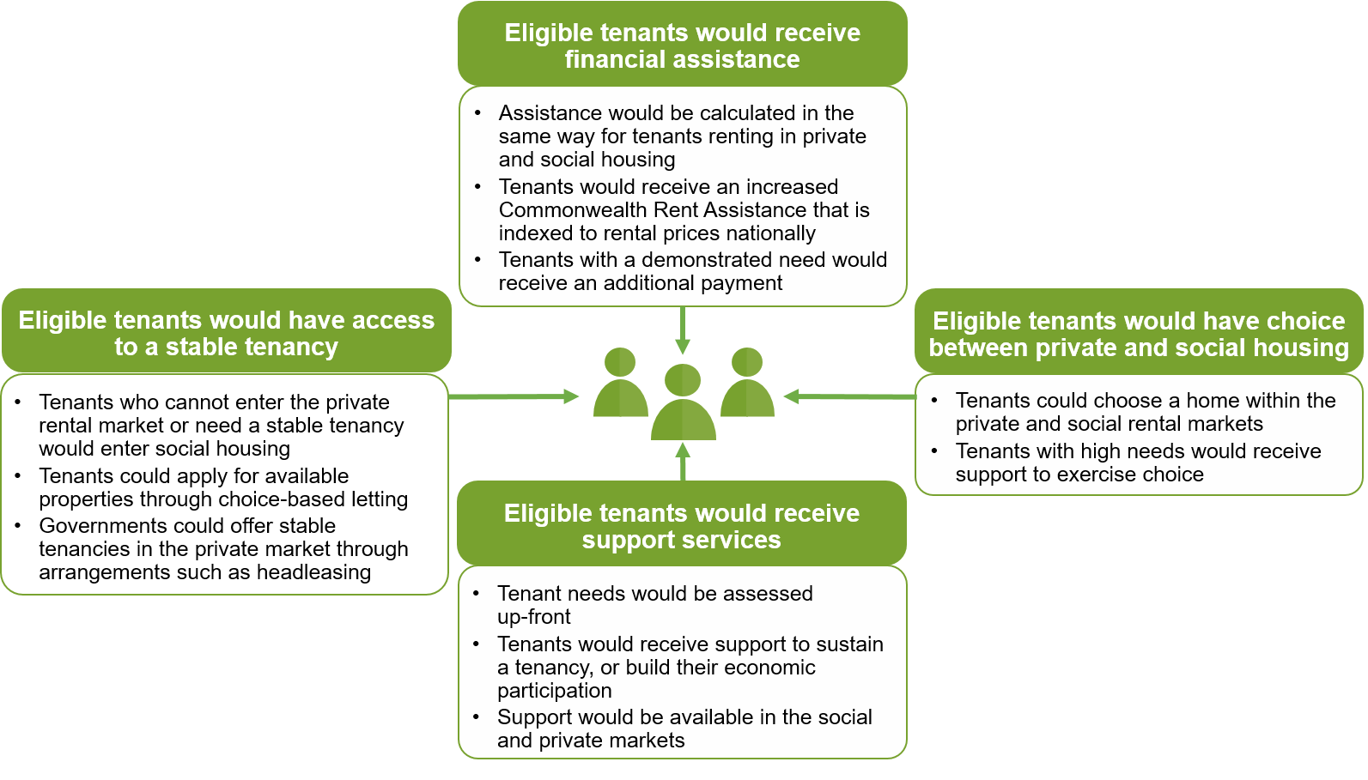

The need to address affordability concerns
Using Victoria as a case study, the Commission found the implicit subsidy received by social housing tenants is about, on average, $2500 per household each year higher than they would receive under CRA. A shift to rent payments that were based on market rates would address the inequity between private and social housing tenants, but would lead to affordability concerns for some social housing tenants. Three reform actions should be implemented together to help address these concerns.
- Conditions for current social housing tenants should be protected by allowing them to continue to pay rents set at a proportion of their income for an extended period of time.
- CRA should be increased. The relative value of CRA has fallen, because average rents have risen faster than CRA since 2007. To address this gap, the maximum CRA payment should be increased by about 15 per cent, and indexed to reflect changes in rental prices nationally.
- State and Territory Governments should provide an additional payment for tenants with a demonstrated need for additional assistance. Eligibility for, and the level of, this ‘high-cost housing payment’ would be a matter for State and Territory Governments but could include assistance for those who need to live in high-cost areas for work or other reasons. This payment could be delivered to the tenant as a top-up to CRA. Eligible tenants living in either private or social housing should be able to receive the payment.
These proposed reforms would result in a transfer of fiscal costs between the Australian, State and Territory Governments. The Australian Government would see an increase in its expenditure on CRA. State and Territory Governments would receive increased rental payments from public housing which may be offset by expenditure on the high-cost housing payment.
Reforms to improve the effectiveness of the social housing system need to be seen in the context of the housing market as a whole. If implemented, the Commission’s draft recommendations would increase the opportunity for people who are eligible for housing assistance to access the private rental market. Governments have policy initiatives underway to improve rental affordability in the private market and to reform rental tenancy rights. Longer tenure for private properties would be particularly valuable for those who are currently seeking social housing. The Australian Government announced in its 2017-18 Budget that it will work with State and Territory Governments to standardise the use of long-term leases, and also announced measures to facilitate access to lower-cost finance for the community housing sector. If well-designed and implemented, these initiatives would be expected to increase the net benefits of the Commission’s proposed reforms.

Improving the effectiveness of social housing
Reform of financial assistance would take some pressure off the social housing system. Those eligible for social housing would be able to choose whether to enter social housing (via a waiting list) or use their financial assistance in the private rental market. The Commission has outlined several draft recommendations to further improve the effectiveness of social housing, including:
- enabling and supporting social housing tenants to have more choice over their home
- improving available data on the efficiency of social housing and tenant outcomes
- improving information available to tenants, such as information on waiting times for social housing properties and on provider performance
- using contestable processes to select housing providers that are best-placed to improve outcomes for tenants.

7 Family and community services
Current approaches to commissioning family and community services are not delivering the benefits they should. Poorly designed contracting and contestability arrangements are hindering the ability of providers to deliver outcomes for users. The characteristics of family and community services do not lend themselves to the introduction of greater user choice at this time. Instead, governments need to focus on practical reforms to improve the way they select providers on behalf of users, and to plan and contract services in a way that puts users at the centre of service provision.
Family and community services cover a range of activities targeted at achieving improvements in the wellbeing of individuals and families. Some services provide support to people experiencing crisis situations, such as some homelessness services. Others offer longer term support, or episodic support, such as for recurrent mental health conditions. Some services aim to build people’s capability and resilience — family support services and settlement support services for example. A subset of services focus on communities.
This inquiry’s focus is on family and community services where governments select providers, user choice is limited and funding is often not linked to outcomes. Many of these services are delivered by not-for-profit organisations. Government funding to not-for-profit organisations whose main activities were in social services totalled $7.2 billion across over 5000 organisations in the 2015 reporting year. (This figure includes some activities, such as disability services, which are outside the scope of family and community services.)
Many governments have endorsed ‘commissioning’ as their preferred approach to designing, delivering and improving services, and as the process through which governments implement contestability in this sector. Commissioning is often conceptualised as a cycle that begins with planning the service system and moves through stages including designing services, selecting providers, managing contracts and undertaking ongoing monitoring, evaluation and improvement (figure 4).
Recent innovations, like the introduction of social impact bonds, have focused government attention on the importance and effort involved in establishing clear outcomes and a user-centric focus for services. Although social impact bonds have limited application, they highlight the need for further government investment in understanding users and defining outcomes in the broader delivery of family and community services.

Figure 4 The commissioning cycle

Better systems to support the commissioning cycle
Building better support systems for commissioning can improve the effectiveness of family and community services.
Family and community services have developed in an ad-hoc way over time. Decisions made by all levels of government about what services are commissioned, where and for whom, are siloed and uncoordinated. Many users, particularly those with complex needs, interact with a range of often poorly-coordinated services. Uncoordinated commissioning is wasteful and can result in inequitable access — some services, in some areas, are duplicated while there are service gaps in other regions and for some groups of people.
Governments could avoid these problems by undertaking systematic mapping and planning across services. A focus for governments should be on building a better understanding of users and their needs. Governments could commission services more systematically if they collected information on the characteristics and needs of service users, the performance of providers, and the costs of provision across the population. Recent work done by the Australian Government through the Priority Investment Approach to Welfare provides one example where a more detailed understanding of users can provide a sounder basis for the targeting of service investment. Collection of data on existing services (across funding streams) and publication of maps based on these data would also support better planning and could avoid inadvertent duplication of services by different levels of government.

Smarter contracting
Smarter tendering and contracting arrangements can improve the effectiveness of family and community services. Changes are needed to service system design, provider selection processes and the use of evaluations.
Tender processes that include opportunities for service providers to develop high-quality proposals, individually or as part of a group could increase contestability and lead to better coordination among service providers. Longer contact terms, with appropriate monitoring and safeguards, can provide more certainty for providers and users, improve investment incentives, and focus the attention of both providers and governments on delivering high-quality services, rather than worrying about the next funding cycle. Better handover periods would support service continuity for users and avoid periods of unproductive uncertainty for workers and providers. Selection processes that better identify the attributes, capabilities and areas of specialisation of providers help improve the delivery of outcomes for users.

Timing selection processes and contracts to support service improvement
Tendering and contracting arrangements should match the needs of users and assist providers to efficiently deliver services. Currently they appear designed to fit the cycles and needs of governments. This is the wrong way around.
The timing of tenders and the length of contract terms were often raised by inquiry participants as barriers to better services. Governments generally only hold tenders open for four to six weeks, which is not long enough for potential new providers to develop a high-quality proposal, or for providers to formalise consortium arrangements to take advantage of synergies. Holding tenders open for longer and coordinating tender rounds so that related services come up for tender at the same time could open up opportunities for new providers and consortium bids. Governments could provide more certainty by announcing forward schedules of tenders and committing to a clear timetable for decision making.
Currently, contracts for family and community services generally default to three years or less. This can deter providers from investing in service improvement, especially when combined with uncertainty about contract renewal until very close to contract end dates. As a result, service providers spend too much time seeking short-term funding, which is a costly distraction from delivering and improving services. Instability also creates difficulties in attracting and retaining staff and can also have adverse effects on service users, particularly where providers need to invest time to develop trust from users to achieve outcomes. For example, the Queensland Network of Alcohol and other Drug Agencies stated:
We are further concerned that the stop-start nature of short term funding arrangements impacts the development of a skilled workforce, as people seek more stable employment, which ultimately further disadvantages those who are most vulnerable.
A seven year default contract term would give providers a better opportunity to improve user outcomes while still retaining the benefits of periodic contestability. This would better recognise the time needed for setup (making the investments that are necessary to deliver effective services, including workforce capacity, and building relationships in the community) and the time needed for a smooth transition to a new provider at the end of the contract. In between, service providers should have a period of stability. Where circumstances demand, such as program trials, the default could be replaced with a shorter contract term. In all cases, contracts should incorporate safeguards to manage under-performance, including provisions to allow governments to remove providers in any cases of serious failure.
Longer contracts need to be combined with changes in the way governments relate to service providers. Many participants were concerned that governments did not provide the space and scope to innovate or find the best way of delivering an outcome. Micro-managing providers is not consistent with service effectiveness.
An alternative approach is to adopt more ‘relational’ approaches to contract management, where the parties to the contract seek to maximise the effect of their joint efforts on improving user outcomes over time. Governments should be prepared to state the intended outcomes of the program and then step back and allow service providers some latitude to choose the right approaches for each person or family that comes to their door, and to innovate to improve services over time. Although this will require governments to develop new expertise and change their attitudes to risk, collecting more evidence on service user outcomes will help — governments will be able to take a more ‘hands off’ approach to contract management and still keep service providers accountable for their actions.

Greater use of evidence in provider selection
The changes proposed by the Commission emphasise the importance of good provider selection processes by governments. Many participants argued that, when selecting service providers, governments tend to focus on the cost of service delivery and the ‘quality’ of tender applications rather than the ability of providers to deliver outcomes for users. This can favour the larger non-government organisations (which have resources to prepare professional quality bids) and providers that bid at a low price (even if the bid price is inconsistent with delivering quality services). This is not necessarily consistent with selecting the mix of providers that achieves the best outcomes for the service user population.
The Brotherhood strongly believes that a diversity of providers is necessary to deliver choice and accountability. However present trends in commissioning threaten diversity by placing undue pressure on smaller and mid-sized community sector organisations to merge in order to compete with larger providers. (Brotherhood of St Laurence)
Some negative impacts result from the natural advantages accruing to bigger players in the market with the greater brand recognition and resources to put forward their case. This means that the creativity and diversity generated within small ‘outlier’ services are lost. (Good Shepherd Australia New Zealand)
Governments need to place more emphasis on identifying the outcomes they are seeking and the skills and attributes needed from providers to deliver those outcomes. Doing this will require a stronger understanding of the users themselves. Governments could make more informed decisions about providers and services if they collected more evidence on the effects of services on users’ wellbeing. Developing outcome measures and collecting this data across programs is difficult and will have costs. However, it provides the foundation for more effective commissioning and the benefits, in terms of better life outcomes for people in hardship, could be substantial.

8 Services in remote Indigenous communities
Human services are not making the contribution they should be to improving the lives of Indigenous people living in remote communities. No one should pretend that more effective services alone will address the disadvantage and dysfunction existing in some remote Indigenous communities, but they can make a greater contribution than today. Changes are needed to improve the effectiveness of services, build local capacity, and enable remote Indigenous communities to better influence the services they receive.
About one in five Indigenous Australians live in a remote area. In 2011, there were over 1000 discrete Indigenous communities in remote areas of which more than three quarters had a population of less than 50 people (figure 5). Indigenous Australians living in these communities have significantly worse quality of life than other Australians. Since 2003, the Commission has published the Overcoming Indigenous Disadvantage report of indicators of Indigenous people’s wellbeing. Over that time, there has been evidence of improvement in some areas, but outcomes have stagnated or declined in others.

Figure 5 Discrete Indigenous communities by size and remoteness, 2011
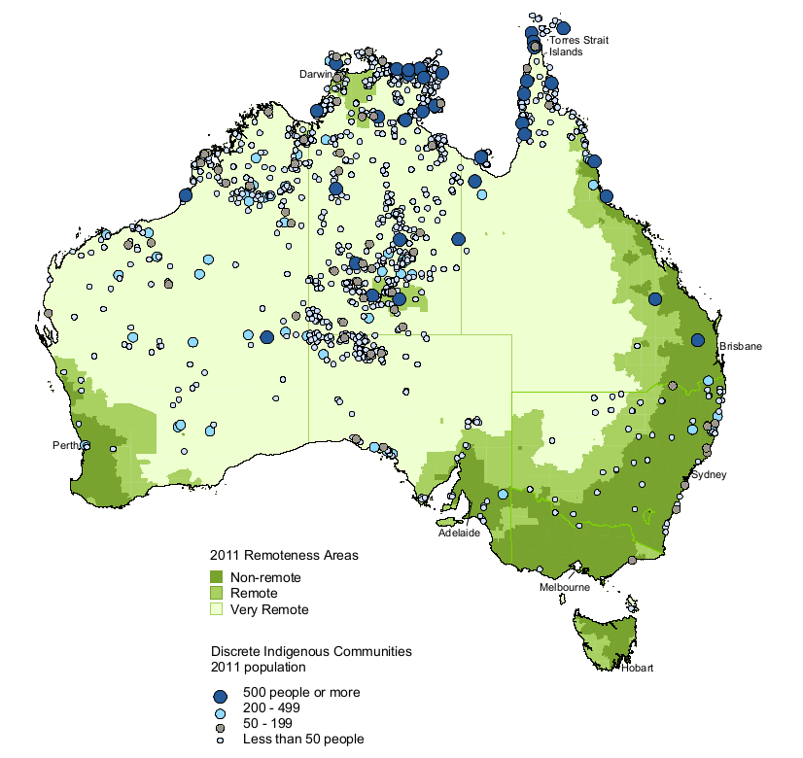

Service delivery in remote Indigenous communities faces challenges, many of which are related to scale and remoteness. Travel can be difficult, and at times, impossible. Communities with small populations may not be able to support full-time services, there may be few local people who have the skills necessary to deliver services, recruiting and retaining staff can be difficult and there may be a lack of fit for purpose infrastructure (such as buildings suitable for service delivery). High levels of unemployment and few economic opportunities both challenge — and are influenced by — service delivery. In some remote Indigenous communities, the delivery of government services can be the main economic activity.
Despite many announcements and a level of goodwill, decisions about service provision in remote Indigenous communities are characterised by a lack of coordination, duplication and inefficiency. For example, the remote community of Jigalong in Western Australia received 90 different social and community services in 2013-14 for a population of less than 400. The Aboriginal Medical Services Alliance Northern Territory gave another example of a remote community in Central Australia where about 400 people receive social and emotional wellbeing programs from 16 separate providers, mostly on a fly-in fly-out or drive-in drive-out basis. The Alliance described what happens on the ground.
There was little in the way of communication or coordination with the local ACCHS [Aboriginal Community Controlled Health Service], with providers often turning up unannounced and demanding information on and assistance with locating clients, use of buildings and vehicles etc. The resulting fragmentation and duplication of service delivery, lack of coordination, waste of resources and suboptimal outcomes for clients is totally counter to the improved outcomes sought by this inquiry and yet this was the result of government policy to introduce greater competition and contestability into service delivery.
The history of Indigenous policy has been characterised by instability, shifts between centralised and place-based approaches, between Indigenous-specific and mainstream programs, and by overlapping and shifting responsibilities within and across different levels of government.
[Likewise,] Indigenous leaders and communities trying to take responsibility for improving the future of their peoples are too often stuck in a morass of red tape and policy churn associated with the political cycle and the all-too-temporary whims of successive governments and their ministers. While we have the knowledge about our lives and communities, government holds nearly all the power. (Empowered Communities)

Principles for service delivery in remote Indigenous communities
Effective service provision in remote Indigenous communities requires long-term strategies that are developed to suit the circumstances and meet the needs of each community, and are developed in partnership with and owned by that community. Communities should be involved across the 360 degrees of the commissioning cycle — from needs assessment through to evaluation (figure 4). This requires a recognition that, while governments play a critical role in creating and maintaining the conditions for improving outcomes, the actions of Indigenous people themselves will also play a major role in determining outcomes. Governments need to adopt a mindset of working with — and investing in — remote Indigenous communities.
Increasing user choice is not a practical approach to putting Indigenous people at the centre of service provision in most remote communities. The majority of remote Indigenous communities are too small to support more than one provider of most human services, so user choice of service provider is not feasible. Nonetheless, governments that provide services in remote Indigenous communities are making choices about who will provide which services and how. Ensuring these investments better align with and support the priorities and preferences of a community, through greater community voice, has the potential to improve service effectiveness.
A focus on the priorities and preferences of communities can only be meaningful if services are planned at a local level. ‘Place-based’ approaches are service delivery models based on achieving outcomes for a place rather than aligning with jurisdictional, departmental or program boundaries. To be effective, place-based approaches require giving greater priority to community-led-and-owned needs assessment and planning, decision making and accountability, and should be tailored to the situation of each community. These approaches can overcome coordination issues by shifting the emphasis of planning to what is needed within a community, rather than what can be provided by each arm or level of government. In doing so, they can also build a community’s capacity to identify and develop responses to issues. These two principles — community voice and place-based approaches — are ways of improving service delivery in remote communities. They are consistent with the ‘success factors’ for programs for Indigenous Australians that the Steering Committee for the Review of Government Service Provision has identified in its series of reports on Overcoming Indigenous Disadvantage.

Learning lessons from history
This inquiry is the latest of many recognising the unacceptable outcomes experienced by Indigenous Australians living in remote communities, and suggesting community voice and place-based approaches as a basis for a solution. Many previous reforms (including the Council of Australian Governments trials, the National Partnership Agreement on Remote Service Delivery and the Indigenous Advancement Strategy) have been based on similar principles.
Despite goodwill and significant resources, initiatives aimed at improving outcomes for Indigenous Australians have often fallen short at the implementation stage. The Commission has drawn lessons from the experience of these initiatives, including that governments must:
- implement structures and processes that support a whole of government, place-based approach
- take into account community perspectives on how reforms should be developed and implemented
- allow enough time for implementation in order to establish relationships in the community and to build trust
- start small and grow slowly
- use flexible approaches that can be tailored to local circumstances and culture — a one-size-fits-all approach will not succeed (this includes flexibility over time within the community as needs may change)
- draw on existing arrangements and the strengths of communities
- build the capacity of governments (to implement reforms and work with communities) and communities (to work with governments, express voice and improve governance).
A vital lesson is that governments and communities must have realistic expectations about what changes can be implemented and how quickly change can occur. Successful implementation would depend on the capacity of both government and the community to fully engage in more localised approaches. This capacity does not exist everywhere, takes time and effort to build and would require changes to the highly centralised decision making currently used across Australia. Governments would need to make careful decisions about priorities and resources for implementation. Changing the way governments make decisions would be a gradual process that must evolve from governments’ current approaches to service delivery and be compatible with the fundamentals of the Australian system of government.
It is also inevitable that some changes will fail and some communities will show little or no sign of improvement, at least initially. Governments and communities must be patient and avoid overreacting to the first sign of falter.

Toward a better model of service provision
Delivery arrangements for human services in remote Indigenous communities, like those in family and community services, are largely designed around a model of commissioning where providers ‘compete’ periodically for funding to deliver services. This can be a sound model if implemented well. However, current approaches are often not delivering the benefits of contestability (better outcomes, more innovation and greater efficiency) and are exacerbating its potential weaknesses (poor collaboration and a lack of service continuity). Although many past reforms have been based on sound principles for service delivery in remote Indigenous communities, governments have not been effective in implementing these principles. As Phillips-Brown, Reddel and Gleeson noted:
Indigenous affairs is largely characterised by a litany of reports and strategies, but implementation failure.
Like family and community services, implementation requires effective stewardship with governments engaging in a continual cycle of designing, delivering and improving services, albeit with the extra challenges posed by the remote context. To be effective, implementation requires ongoing bottom-up consultation and engagement. Indigenous communities will only develop trust in governments if they see that there is genuine commitment to taking their views into account when decisions are made.
The provision of government-funded human services is a large part of the economy in remote Indigenous communities and is an opportunity for governments to invest in building local capacity. Where appropriate, the effectiveness of human services delivery in remote Indigenous communities can be improved by using local and/or Indigenous-specific providers. For example, Aboriginal Medical Services Alliance Northern Territory argued that, compared with mainstream primary care, Aboriginal Community Controlled Health Organisations provide greater health benefits, improve access for Indigenous people, deliver culturally appropriate services, are more likely to be committed to processes of clinical governance and evidence-based medicine and employ more Indigenous people (and develop their skills and career path). They also argued that Aboriginal Community Controlled Health Organisations are instrumental in developing and supporting innovative models of care (including through partnering with mainstream providers). Currently, government processes to select service providers do not adequately take these kinds of benefits into account.
Effective service delivery includes evaluation and continuous improvement. Explicitly requiring that programs are monitored and evaluated with input from communities can enhance community voice and improve service implementation and ongoing provision. Evaluations that are carried out after programs have concluded are not adequate — evaluation needs to be an ongoing process embedded in program design.
Many stakeholders have pointed to the potential of place-based approaches and the need for Indigenous people living in remote communities to have more voice in influencing the services they receive. Different models have been proposed. Some people favour providing Indigenous people with more control over the funding and design of local services at a community level. Others promote a regional governance approach. Others stop short of passing on control and promote greater engagement instead. No single model has universal support. To be effective any of these models would require a transfer of some control from centralised decision making in government.
The Commission has not developed specific recommendations in the area of greater community engagement and input, but may do so in its final report. It has been considering ways to empower communities, including using community plans to articulate community aspirations and incorporate community views in service planning and delivery. Plans would be developed by the community, with governments offering support. Minimum criteria would need to be developed, but communities would have flexibility in how the plans were developed and what they involved.
Once developed, governments would be obliged to: take each plan into account when funding services for the relevant community; and report publicly (to Parliament and to the community) on whether, and if so how, funding and other government actions have supported the community plan. The Commission is, however, conscious that many community planning approaches have been tried in the past and have not worked, and that many other approaches are possible. The Commission also recognises that a number of Indigenous communities already have plans or planning processes in place (for example, Empowered Communities and the Murdi Paaki Regional Assembly). Between this draft report and the final report the Commission will seek further feedback on community planning approaches, including through submissions, roundtables and participation in public hearings.

Proposed reform directions
The Commission has made draft recommendations in two areas.
Improved contestability arrangements: The Commission’s draft recommendations for improved family and community services are relevant for services in remote Indigenous communities. Some, however, need to be adjusted to better reflect the remote context. Specifically, the Commission proposes longer default contract terms (ten years rather than seven, with contracts to incorporate safeguards to manage under-performance), a greater focus on encouraging collaboration and coordination between providers, and better alignment between tender processes for related services to encourage greater coordination between government agencies. Commissioning processes would also have a much stronger focus on developing local capacity, including local employment, community engagement and governance.
Planning, evaluation and feedback systems: The Commission is also proposing that governments develop systems to support service planning, evaluation and the identification and sharing of best-practice approaches.

9 Public hospital services
Many Australians will be admitted to a public hospital at some stage of their life, often for elective (planned) care. Better information and greater patient choice can improve the outcomes for patients.
There are more than 2.3 million admissions to public hospitals each year for people receiving elective care. About 700 000 patients are admitted to public hospitals for elective surgery (and about 1.4 million are admitted to private hospitals). Elective patients are often given limited control over the pathway which determines the hospital and clinician that treats them. That pathway typically begins with a referral from the patient’s general practitioner (GP) to an initial specialist consultation at either a public outpatient clinic or private outpatient rooms (figure 6).

Figure 6 Pathways to elective hospital admission
Almost 10 per cent of GP consultations result in a specialist referral, amounting to about 14 million referrals annually, with some of these leading to an admission to a public hospital. The most frequent referrals include those to orthopaedic surgeons, dermatologists and cardiologists.
The Commission is proposing that, when given a referral for an initial specialist consultation, all patients should have the opportunity to choose either the:
- public outpatient clinic they attend (with the specialist chosen by the clinic)
- private specialist they see (usually in private rooms and possibly involving out-of-pocket charges).
Under current arrangements, patients wishing to attend a public outpatient clinic are often given no choice but to attend the clinic nearest to their home. This can be due to custom and practice among local GPs, public outpatient clinics having a policy of refusing appointments for people who do not reside in the clinic’s catchment area, or (in Perth) a requirement that referrals be processed through a central booking service that allocates patients to their nearest public clinic.
Patients wishing to choose a private specialist also face barriers to choice. GPs usually give their patients a ‘named referral’ to a specific specialist, based on the GP’s knowledge of local clinicians. This has led to a mistaken belief among many doctors and patients that a referral must name a specific specialist and, if it does, the patient cannot use it to book an appointment with an alternative clinician practising the same speciality. The Commission has heard that patients often contact their GP’s office to change the name of the specialist on a referral letter. In some cases, specialists will refuse to see a patient if a different clinician is named on the referral letter.
To give patients greater control over the referral pathway that they take to receive specialist health care, the Australian, State and Territory Governments should:
- direct public outpatient clinics to accept any patient with a valid referral, regardless of where the patient lives
- amend the regulation of referrals to make it clearer that patients can choose their clinic or specialist, irrespective of which service provider is named in a referral
- work with GPs to develop best-practice guidelines on how to support patient choice.
GPs would continue to play a vital role in supporting patients at the point of referral, with the level of support provided to exercise choice varying according to patients’ preferences. If they wish, patients would still be able to rely on their GP to make decisions on their behalf. There should also be scope for patients, after receiving a referral and associated advice from their GP, to independently choose a public outpatient clinic or private specialist after leaving the GP’s office. This would give patients the opportunity to do their own research, consider their options and perhaps consult family and friends before making a decision.
Greater choice at the point of referral has intrinsic value for patients because it empowers them to have greater control over their lives. This in itself is likely to improve the wellbeing of patients. Choice also allows patients to make trade-offs between options to better match their preferences — such as choosing a public clinic that has a shorter waiting time but is further from home. Overseas studies have shown that greater choice at referral, together with public information to support choice, can lead to better clinical outcomes — including fewer deaths — because it enables patients to seek out higher-performing hospitals and prompts service providers to move closer to best practice among their peers. The combined benefits from patients having greater control over their health care, making choices that better match their preferences and experiencing better clinical outcomes are likely to be significant at a communitywide level, given that there are around 14 million referrals annually.
There are risks to greater choice, but their likelihood is low. The Commission’s proposed reforms are unlikely to have a significant effect on the take up of private hospital insurance. They would not affect the advantages of being admitted to hospital as a private (rather than public) patient, such as being able to choose the treating specialist and avoid waiting times in the public system by choosing to be treated in a private hospital. Patients who initially attend a public outpatient clinic would still be treated by specialists chosen by managers of the public system.

Information to support patient choice and provider self-improvement
Patients can currently access some information to help them make choices on alternative hospitals and specialists, such as the advice of their GP, published waiting times for hospital admissions, and the views of the patient’s family and friends. However, more information could be publicly reported to facilitate comparisons between alternative providers, including on clinical outcomes and the wide variation in out-of-pocket charges for private specialist outpatient consultations. Other countries have shown that publishing more information would further empower consumers and help GPs to support them. In addition to benefits to patients, there is also evidence that publishing such information would prompt hospitals to engage in more self-improvement activity.
Governments in Australia already collect a large amount of information about individual hospitals and specialists but much of it is withheld from public view. The Commission’s recently completed inquiry on data availability and use identified this as a common problem across the economy and recommended a package of general reforms to make data more accessible. This included a new Data Sharing and Release Act, National Data Custodian, and sectoral Accredited Release Authorities to streamline access to datasets. These would complement the health care-specific information reforms proposed in this report.
Central to this report’s proposed information reforms is strengthening and expanding the commitment to public reporting that the Australian, State and Territory Governments made in the 2011 National Health Reform Agreement. In particular, it is proposed that the jurisdictions would, as part of their health funding arrangements, agree to:
- adopt a general policy of publishing all data they hold on individual hospitals and specialists unless it would clearly harm the interests of patients
- make the published data available in a format that other organisations can readily incorporate in advisory services they provide (for example, in the software used by GP clinics)
- transform the MyHospitals website into a national vehicle that better supports choice by patients, and encourages self-improvement by individual hospitals and clinicians, including by reporting more outcome indicators such as patient-reported outcome measures, user ratings and reviews, and clinical outcomes such as readmission rates
- phase-in public reporting on individual specialists, possibly beginning with their registration details, followed by process data (such as location, levels of activity and out-of-pocket charges), user ratings and reviews, and, in the longer term, whether clinical outcomes are within an acceptable range.

10 Public dental services
Public dental services do not focus on the prevention and early intervention needed to improve Australia’s oral health. Patients lack choice and too often require emergency and restorative treatments. Reforms to improve and support choice, better identify patient need and to focus public dental providers on timely intervention, can improve patient outcomes.
Publicly funded dental services provide safety net access to basic dental care for people who face financial and other barriers to accessing care, such as some people with a disability. Approximately 5.5 million adults and 3 million children are eligible for public dental services — about a third of Australia’s population. Public dental services operate alongside a substantial private sector.
Unlike some other parts of the health system, governments have paid scant attention to public dental services. Public dental providers face difficulties in tracking patients over time, and services exist in a silo, with little integration with the broader health system. Policy and funding uncertainty limits the long-term planning and evaluation needed to improve services. Short-term funding boosts in recent years have improved access to public dental care, but have done little to ‘break the cycle’ of treatment and repair.
People who receive public dental services have little choice in who provides their care, when and where. Services are largely provided in government operated clinics that have limited capacity. In people’s day-to-day lives this can mean the difference between an appointment near work or home, or one that requires a commute (or in rural areas, travelling to the next town), or being able to choose a time that does not conflict with school pick-up, rather than one that fits with the clinic. Ad hoc use of fee-for-service vouchers has not resulted in a systemic improvement in user choice, and has done little to improve the effectiveness of public dental services over time.
Improved choice would enable users to make decisions that suit them, and generate incentives for providers to be more responsive to patients’ needs (providing the right treatment at the right time). Consumer directed care, where the user’s choice determines which provider receives the funding allocated to them, if carefully designed and employed in the right settings, could make greater use of the private dental profession, enabling users to have choice over a greater range of providers.

A shift toward targeted preventive dental care
Most dental conditions are preventable. However, high levels of demand and government funding constraints mean that public dental services focus on treating emergency patients (seeing the most urgent cases first) and place other patients on a largely ‘first come, first served’ waiting list. While waiting times for non-urgent public dental care vary across jurisdictions and over time (with variations in levels of funding from governments), patients can wait up to two or three years to receive care.
This means that, for those at high risk of developing oral disease, their oral health deteriorates while waiting to receive care — resulting in larger costs to them, to governments and the community for largely preventable conditions (figure 7). Dental conditions were the second-highest cause of acute potentially preventable hospitalisations in 2015-16. The time to treatment is therefore an important metric for improving the effectiveness of public dental services. Public reporting of performance in treating patients within clinically-acceptable waiting times (by risk category) would improve accountability in the sector.
For public dental services to be able to move beyond the short-term focus on urgent care, they need to be able to measure the effectiveness of services in terms of the oral health outcomes of users. Developing an oral health outcomes framework would not only improve accountability, but also provide the basis for more comprehensive reforms to promote targeted preventive care. Outcome measures are not currently in use in Australia, but are being developed (in Victoria in the first instance). In England, outcomes have been measured by clinical indicators, such as rates of tooth decay, and patient reported indicators, such as being able to speak and eat comfortably.

Figure 7 A stylised pathway of dental health care and the costs
Performance benchmarks and outcome measures are important prerequisites for reform and should be developed and implemented as soon as practicable. These must be developed before the next stage of more fundamental and long-term reforms to introduce consumer directed care, and shift the system’s focus to targeted preventive care, can proceed.

Improving choice and outcomes for users
Introducing consumer directed care reforms for public dental services could give users choice over their provider, and by shifting the focus of care toward prevention, avoid the costs of deteriorating dental conditions, and improve outcomes and the effectiveness of services.
Implementing choice will require development of a new payment model for public dental services. At this stage, the Commission proposes development of a blended payment model that rewards preventive care and the overall quality of care, rather than the number of treatments provided. This approach balances introducing greater user choice with incentives for prevention and avoids some of the issues that are associated with fee-for-service vouchers. Similar to the model being progressively trialled and introduced for public dental contracts in England, the model should involve the user choosing their dental provider, and thereafter the provider would receive:
- a payment per enrolled patient, weighted to reflect their risk and treatment needs (a risk-weighted capitation payment)
- payments for achieving clinical and patient outcomes
- activity payments for complex and hard to define treatments (such as dentures).
Patients would be able to choose between public dental clinics and participating private clinics. By making better use of private and public dental clinics, the proposed reforms could also help to overcome any capacity constraints in the current system.
Triaging patients according to their escalating risk of oral disease would target the oral health of those most at risk in the eligible population and retain governments’ ability to constrain the costs of service delivery. A digital oral health record incorporated into the My Health Record system could improve linkages with the broader health system (including GPs and hospitals), assist in the identification and triaging of high-risk patients, and support user choice by ensuring a person’s records are portable between providers.
The payment model should not apply to all treatments and will require the development of a list of eligible services that provide patients with the clinically- and cost-effective treatments needed to have a disease-free mouth. State and Territory Governments could choose to provide eligible services free-of-charge or impose a co-payment (as some currently do). Patients could also choose to pay extra to access treatments beyond the eligible services. For example, these arrangements could allow individuals to choose to pay extra for a more expensive filling that better matches the colour of their teeth. Careful monitoring of patient outcomes and the payment of extra fees would be needed to ensure consumers are not exploited.
Patients would also be provided with consumer-oriented information (locations, waiting times, outcomes) to enable their choice of provider. In contrast to the current system, under a consumer directed care approach, an individual in need of non-urgent public dental services would be able to choose the location or clinic that suits their needs, see and understand provider ratings, and be treated on the basis of their risk rather than the date they joined the waiting list.

Improving contestability within public dental services
Some of the benefits from consumer directed care (to the user and the system) arise from the effects of choice. However, there are some circumstances where competition in the market would not be effective, such as in remote locations with small populations that may not be able to support multiple dental providers (or even a single provider all year round). Here, choice is not feasible. In these circumstances, governments would need to commission providers to deliver services. Improvements to governments’ commissioning processes are required, including a more systematic approach to selecting providers and monitoring their performance. Governments should use an outcomes framework to design contracts and select providers that focus on promoting the oral health of the people they treat. In the longer term, governments should focus on their role as system stewards (rather than primary service providers), driving service improvements and encouraging innovation by providing advice around best practices, benchmarking and monitoring outcomes.

Draft recommendations and information request

End-of-life care

DRAFT Recommendation 4.1
State and Territory Governments should ensure that people with a preference to die at home are able to access support from community-based palliative care services to enable them to do so. To achieve this, State and Territory Governments should:
- assess the need for additional community-based palliative care services
- design services to address identified gaps in service provision
- use competitive processes to select providers (or a single provider) to deliver additional community-based palliative care services
- monitor and evaluate the performance of community-based palliative care services to ensure that those services deliver integrated and coordinated nursing, medical and personal care, and provide access to care and support on a 24 hours a day, 7 days a week basis
- ensure that consumer safeguards are in place so that quality care is provided, and oversight is maintained, as the volume of services provided increases.

draft Recommendation 4.2
The Australian Government should:
- remove current restrictions on the duration and availability of palliative care funding in residential aged care so that palliative care is available to residents who have pre-existing high health care needs, and for periods of time that align with those provided in the health care system
- provide sufficient additional funding to residential aged care facilities to ensure that people living in residential aged care receive end-of-life care that aligns with the quality of that available to other Australians.

draft Recommendation 4.3
The Australian Government should promote advance care planning in primary care by:
- including the initiation of an advance care planning conversation as one of the actions that must be undertaken to claim the ‘75 plus’ health check Medicare item numbers. At a minimum, this would require the general practitioner to introduce the concept of advance care planning and provide written material on the purpose and content of an advance care plan
- introducing a new Medicare item number to enable practice nurses to facilitate advance care planning.

draft Recommendation 4.4
The Australian Government should amend the aged care Quality of Care Principles to require that residential aged care facilities ensure that clinically trained staff hold conversations with residents about their future care needs. This should include helping each resident (or their family or carers) to develop or update an advance care plan (or to document that the resident would prefer not to complete an advance care plan) within two months of admission to the facility.

DRAFT Recommendation 4.5
The Australian, State and Territory Governments should ensure that there are sufficient data to enable governments to fulfil their stewardship functions by monitoring how well end-of-life care services are meeting users’ needs across all settings of care.
Governments should work together to develop and implement an end-of-life care data strategy that leads to the provision of, at a minimum, linked information on:
- place of death
- primary and secondary diagnoses
- details of service provision at time of death (what, if any, health or aged care did they receive, at what level and for how long)
- whether they had an advance care plan.

Social housing

Draft Recommendation 5.1
The Australian Government should enhance Commonwealth Rent Assistance (CRA) by:
- extending CRA to cover tenants in public housing
- increasing the current maximum CRA payment by about 15 per cent to address the fall in the relative value of CRA caused by average rents rising faster than the consumer price index since 2007
- indexing the maximum CRA payment amount to reflect changes in rental prices nationally.

Draft Recommendation 5.2
State and Territory Governments should abolish the current assistance model for social housing where rents are set at a proportion of the tenant’s income and enhance user choice by:
- providing a high-cost housing payment funded by State and Territory Governments for eligible tenants, such as those with a demonstrated need to live in a high-rent area
- delivering the high-cost housing payment to the tenant in a way that would enable it to be used in either the social or private rental markets
- offering existing tenants in social housing an option between continuing to pay rent set at a proportion of their income for up to ten years, or electing to move to the new assistance model
- charging market rents for tenants in social housing.

draft Recommendation 5.3
State and Territory Governments should introduce choice-based letting for tenants entering into, and transferring between, social housing properties.

DRAFT Recommendation 5.4
State and Territory Governments should continue to make the management of social housing properties contestable, on a staged basis. The management of social housing properties should be subject to a tender process that is open to all providers, including the government provider.

draft Recommendation 6.1
When commissioning tenancy support services, State and Territory Governments should:
- clearly separate the funding and commissioning of tenancy support services from tenancy management services
- ensure that tenants renting in the private market have the same access to support services as tenants in social housing.

DRAFT Recommendation 6.2
State and Territory Governments should ensure that the entity responsible for managing social housing assets is separate from the entity responsible for social housing policy. The entity managing social housing assets should be subject to competitive neutrality policies.

Draft Recommendation 6.3
State and Territory Governments should ensure that applicants for social housing assistance:
- receive a comprehensive up-front assessment of their eligibility for: a social housing placement; the high-cost housing payment (draft recommendation 5.2); and tenancy or other service support, including support to enable the tenant to choose their home
- are made aware: that the high-cost housing payment would be payable if they chose to live in either the private or social housing markets; and of the extent to which support services available in social housing would also be available in the private market.

DRaft Recommendation 6.4
State and Territory Governments, in conjunction with the Australian Institute of Health and Welfare, should improve the data that are collected on:
- the efficiency of social housing
- tenant outcomes, including high-cost housing payment and service recipients who choose to rent in the private housing market.
State and Territory Governments should clearly define the outcomes they are seeking to achieve to support the commissioning of tenancy management and tenancy support services, and put in place frameworks to assess their success in meeting these outcomes over time. Outcomes data should, to the extent possible, be consistent and comparable to that developed for family and community services (draft recommendation 7.3).

draft Recommendation 6.5
State and Territory Governments should:
- publish information on expected waiting times to access social housing, by region, in a format that is accessible to prospective tenants
- make publicly available the regulatory reports on the performance of community providers that are undertaken as part of the National Regulatory System for Community Housing.
To facilitate choice-based letting, State and Territory Governments should publish information on available social housing properties, such as the rent charged for the property, number of bedrooms and the location of the property. This information should be disseminated across a range of mediums, such as online and printed leaflets.

Information request
The Commission supports the principle of consistent regulation across different types of social housing providers. The Commission is seeking information and evidence on whether changes to the National Regulatory System for Community Housing (NRSCH) are needed to accommodate different types of providers. This includes information and evidence on:
- whether the NRSCH is flexible enough to regulate different types of providers and, if not, the changes that are necessary
- the costs and benefits of extending the NRSCH to include different types of providers of tenancy management services
- the extent to which inconsistencies between jurisdictions add to administration costs and create barriers to entry (the Commission would welcome quantitative evidence on the costs incurred by providers)
- what changes to the regulatory system should be made to provide incentives for providers to improve outcomes for tenants, improve provider responsiveness to the needs of tenants and improve provider accountability to governments.

Family and community services

DRAFT Recommendation 7.1
The Australian, State and Territory Governments should work together to develop and publish:
- data-driven maps of existing family and community services
- analysis of the characteristics and needs of the service user population to assist with system and program design and targeting
- service plans to address the needs of people experiencing hardship.

draft Recommendation 7.2
The Australian, State and Territory Governments should adjust provider selection processes in family and community services to reflect the importance of achieving outcomes for service users. Governments should:
- design selection criteria that focus on the ability of service providers to improve outcomes for service users
- not discriminate on the basis of organisational type (for-profit, not-for-profit and mutual for example)
- allow sufficient time for providers to prepare considered responses (including the development of integrated bids across related services).

DRAFT Recommendation 7.3
The Australian, State and Territory Governments should prioritise the development of user-focused outcome measures for family and community services — indicators of the wellbeing of people who use those services — and apply them consistently across all family and community services.
Governments should also identify outputs from family and community services that can be used as proxies for outcomes or measures of progress toward achieving outcomes.
In developing outcome measures and outputs, governments should define the indicators broadly so they can be used in provider selection, performance management and provider, program and system-level evaluations across the full range of family and community services.

DRAFT Recommendation 7.4
The Australian, State and Territory Governments should improve systems for identifying the characteristics of service delivery models, service providers, programs and systems that are associated with achieving outcomes for the people who use family and community services. To achieve this, governments should:
- monitor the performance of providers of family and community services in achieving outcomes for service users
- evaluate service providers, programs and systems in ways that are commensurate with their size and complexity
- proactively support the sharing of data between governments and departments, consistent with the Commission’s inquiry report Data Availability and Use
- release de-identified data on family and community services to service providers and researchers
- develop processes to disseminate the lessons of evaluations to governments and service providers.

DRAFT Recommendation 7.5
The Australian, State and Territory Governments should set the length of family and community services contracts to allow adequate time for service providers to establish their operations, have a period of stability in service delivery and for handover before the conclusion of the contract (when a new provider is selected).
To achieve this the Australian, State and Territory Governments should:
- increase default contract lengths for family and community services to seven years
- allow exceptions to be made, such as for program trials which could have shorter contract lengths
- provide justification for any contracts that differ from the standard term
- ensure contracts contain adequate safeguards to allow governments to remove providers in any cases of serious failure.

DRAFT Recommendation 7.6
The Australian, State and Territory Governments should provide payments to providers for family and community services that reflect the efficient cost of service provision.

DRAFT Recommendation 7.7
The Australian, State and Territory Governments should:
- train staff to increase their capacity to implement outcomes-based approaches to commissioning and relational approaches to contract management
- trial relational approaches to contract management in family and community services.

Services in remote Indigenous communities

DRAFT Recommendation 8.1
The Australian, State and Northern Territory Governments should set the length of human services contracts in remote Indigenous communities to allow adequate time for service providers to establish their operations, have a period of stability in service delivery and for handover before the conclusion of the contract (when a new provider is selected). The contract period should take into account the additional challenges of service delivery in remote communities.
To achieve this the Australian, State and Northern Territory Governments should:
- increase default contract lengths for human services in remote Indigenous communities to ten years
- allow exceptions to be made, such as for program trials which could have shorter contract lengths
- provide justification for any contracts that differ from the standard term
- ensure contracts contain adequate safeguards to allow governments to remove providers in any cases of serious failure.

draft Recommendation 8.2
When conducting provider selection processes for services in remote Indigenous communities, the Australian, State and Northern Territory Governments should:
- better align tender processes for related services
- allow sufficient time for providers to prepare considered responses (including the development of integrated bids across related services)
- notify providers of the outcome of tender processes in a timely manner
- allow enough time for transition when new providers are selected.

DRAFT Recommendation 8.3
The Australian, State and Northern Territory Governments should ensure that commissioning processes for human services in remote Indigenous communities have a strong focus on transferring skills and capacity to people and organisations in those communities.

draft Recommendation 8.4
When selecting providers of human services in remote Indigenous communities, the Australian, State and Northern Territory Governments should take into account the attributes of providers that contribute to achieving the outcomes sought. This may include:
- culturally appropriate service provision (specific to the region where the service is being delivered)
- community engagement and governance (including through considering communities’ feedback on provider performance)
- collaboration and coordination with existing service providers, and community bodies
- employment and training of local and/or Indigenous staff.

draft Recommendation 8.5
The Australian, State and Northern Territory Governments should invest in better systems to underpin service delivery by working together to:
- develop objectives for human services in remote Indigenous communities
- conduct and publish ongoing assessments of the characteristics and needs of Indigenous Australians living in remote communities, including mapping the existing services delivered in communities
- establish systems to identify and share information on ‘what works’ in human services in remote Indigenous communities.
The Australian, State and Northern Territory Governments should involve communities at all stages of this process.

Public hospital services

draft Recommendation 9.1
The Australian Government should amend the Health Insurance Regulations 1975 to make it clearer that patients referred to a specialist can choose the public outpatient clinic or private specialist they attend for their initial consultation. This includes clearly specifying that:
- referrals do not need to name a particular clinic or specialist
- any specialist can accept a referral to a specialist of their type, irrespective of whether another person is named as the specialist in the referral
- when making a referral to a specialist, general practitioners (GPs) must explain to patients that they can attend a specialist or public outpatient clinic other than the one named in the referral, and patients can choose independently after receiving support and advice from their GP at the time of referral
- referral letters should clearly indicate that patients must be offered choice by their GP, can attend a specialist or clinic other than the one named in the referral, and can choose independently after receiving the referral.

draft Recommendation 9.2
The Australian Government should develop, with general practitioners (GPs), best-practice guidelines on how to support patient choice. These should form part of a broader strategy — designed with the relevant professional bodies — to help GPs, specialists and other health professionals implement the amendments to the Health Insurance Regulations 1975 in draft recommendation 9.1.

draft Recommendation 9.3
State and Territory Governments should direct their public outpatient clinics to accept any patient with a referral letter for a condition that the clinic covers, regardless of where the patient lives. Where a local hospital network or the WA Central Referral Service processes referrals, that service should be directed to:
- allow patients to lodge requests for an initial outpatient appointment when they have received a referral
- give patients the option of specifying the public outpatient clinic they will attend.

draft Recommendation 9.4
State and Territory Governments should change patient travel assistance schemes so that assistance is available to eligible patients regardless of which healthcare provider they attend. The level of assistance should continue to be based on the cost of getting to the nearest provider.

draft Recommendation 9.5
The Australian Government should undertake an evaluation of the referral choice reforms five years after they commence operation.

Information to support patient choice and performance improvement in hospitals

draft Recommendation 10.1
The Australian, State and Territory Governments should strengthen and expand their commitment to public reporting in the National Health Reform Agreement to better support patients and their general practitioners to exercise patient choice, and encourage performance improvement by hospitals and specialists. This should include a commitment by all jurisdictions to:
- provide data and other assistance to the Australian Institute of Health and Welfare (AIHW) to enable it to strengthen the MyHospitals website as a vehicle for supporting patient choice and provider self-improvement, as detailed in draft recommendation 10.2
- adopt a general policy of publicly releasing any data that a jurisdiction holds on individual hospitals and specialists unless it is clearly demonstrated that releasing the data would harm the interests of patients
- make the information that a jurisdiction publicly releases on hospitals or specialists available in a format that other organisations can readily incorporate in advisory services they provide.
To facilitate reporting on individual specialists, there should also be a commitment by:
- the Australian Government to amend the Health Insurance Act 1973 (Cwlth) so that medical specialists are required to participate in public information provision, as specified by the AIHW
- the State and Territory Governments to oblige all specialists serving public patients in their jurisdiction to participate in public information provision, as specified by the AIHW.

draft Recommendation 10.2
The Australian Government should, in consultation with State and Territory Governments, direct the Australian Institute of Health and Welfare to transform the MyHospitals website into a vehicle that better supports choice by patients and encourages self-improvement by hospitals and specialists. The changes should:
- draw on lessons from overseas examples of information provision, including the National Health Service website used to inform patients in England
- be based on market research on who would use an improved MyHospitals website, how their needs and health literacy vary, what indicators are useful to them, and how they could be informed by using best-practice approaches to presenting health information online
- put greater emphasis on reporting outcomes, such as by publishing patient-reported outcome measures, user ratings and reviews, and clinical outcomes such as readmission rates
- include the phasing-in of reporting on individual specialists as data become available, possibly beginning with registration details, followed by process data (such as location, levels of activity and out-of-pocket charges), user ratings and reviews, and, in the longer term, whether clinical outcomes are within an acceptable range.

Public dental services

Draft Recommendation 11.1
State and Territory Governments should report publicly against a consistent benchmark of clinically-acceptable waiting times, split by risk-based priority levels.
Once data systems are developed, provider-level reporting should be published monthly and aggregate measures included in public dental services’ annual reporting processes.

Draft Recommendation 11.2
State and Territory Governments should establish outcomes frameworks for public dental services that focus on patient outcomes and include both clinical outcomes and patient reported measures.
State and Territory Governments should assess Dental Health Services Victoria’s work to date on outcome measures, once implemented, with a view to identifying and commencing implementation of a nationally consistent outcomes framework.

Draft Recommendation 11.3
State and Territory Governments should develop comprehensive digital oral health records for public dental services. Once developed, these systems should be incorporated within the My Health Record system.

Draft Recommendation 12.1
State and Territory Governments should introduce a consumer directed care approach to public dental services. Under the new approach, participating providers should be paid based on a blended payment model that incorporates:
- risk-weighted capitation payments for preventive and restorative services for enrolled patients that incentivises the provision of clinically- and cost-effective treatments. Governments should weight capitation payments based on the treatment needs of different population groups (including adults and children)
- performance based outcome payments, incorporating payments for clinical and patient outcomes
- activity-based payments for complex and hard to define procedures (such as dentures). The dental treatments that would be eligible for activity-based payments should be determined by governments based on available evidence on the clinical- and cost-effectiveness of treatments.
State and Territory Governments should ensure that under the scheme:
- patients are offered choice of provider (public or private clinic) who will care for them for a defined enrolment period
- the enrolment period aligns with the time required to effectively measure outcomes
- users are able to change provider in certain circumstances (such as, when moving city).

Draft Recommendation 12.2
The Independent Hospital Pricing Authority, in consultation with State and Territory Governments and the dental profession, should be funded by the Australian Government to determine the efficient prices for consumer directed care payments.

Draft Recommendation 12.3
State and Territory Governments should transition to a consumer directed care approach by first establishing initial test sites to evaluate new blended payment models and allocation systems, before a staged roll out.

Draft Recommendation 12.4
State and Territory Governments should provide access to consumer directed care through a centrally managed allocation system. Under the allocation system, governments should triage patients for both general and urgent care through an initial assessment. The initial assessment should identify and prioritise access for eligible users most at risk of developing, or worsening, oral disease.
Governments should ensure that, when allocated funding, a patient has access to:
- clinically- and cost-effective treatments that are necessary for the patient to have a disease-free mouth
- payment arrangements where patients can choose to pay extra to the provider to access a range of clinically-effective treatments beyond the basic treatments
- consumer-oriented information on participating providers including, for example, clinic locations and published outcome measures, to enable their choice of provider.

Draft Recommendation 12.5
State and Territory Governments should establish outcomes-based commissioning systems for public dental services. Once systems are established, State and Territory Governments should examine opportunities for introducing greater contestability in public dental services.
At first, greater contestability should be introduced in those settings where it is clear that competition is not feasible, including remote provision and other outreach services.

End-of-life care does not include euthanasia or assisted suicide.

