B Information request to Australian Government agencies

B.1 About the information request
To inform our understanding of current evaluation policies and practices in Australian Government agencies, the Commission sent an information request to 182 agencies in November and December 2019. Agencies were identified using the List of Commonwealth entities and companies under the Public Governance, Performance and Accountability Act 2013 (PGPA Act).
The information request asked questions about evaluation generally and evaluation of policies and programs affecting Aboriginal and Torres Strait Islander people, including:
- mainstream policies and programs — policies and programs designed for all eligible Australians, such as most social security payments and the Medicare Benefits Schedule
- Indigenous-specific policies and programs — policies and programs designed specifically for Aboriginal and Torres Strait Islander people, such as the National Indigenous Australians Health Program and the Indigenous Advancement Strategy.
The information request asked agencies for:
- details on their evaluation and data policies, evaluation planning and governance arrangements and evaluation practices
- a list of evaluations undertaken in the years 2016-17 to 2019-20.
Changes to Australian Government departments came into effect in February 2020. We asked that responses reflected the situation at December 2019 prior to changes taking effect.
This appendix:
- documents response rates, methods used to analyse data, and limitations (section B.2)
- summarises agencies’ responses to the questions in the information request (section B.3)
- analyses data collected by the Commission from evaluation reports that agencies provided in their responses to the information request (section B.4)
- reproduces the questionnaire sent to agencies (section B.5).

B.2 Methodology and data quality

Responses received
46 agencies (or 25 per cent of agencies) responded to the information request (table B.1).

Table B.1 Australian Government agencies that responded to the information request
Departments
Department of Agriculture  Department of Communications and the Arts  Department of Defence  Department of Education  Department of Employment, Skills and Small and Family Business  Department of the Environment and Energy  Department of Finance | Department of Health  Department of Home Affairs  Department of Infrastructure, Transport, Cities and Regional Development  Department of Social Services  Department of the Prime Minister and Cabinet  Department of the Treasury
Other agencies
AgriFutures Australia  Army Relief Trust Fund  Australia Council for the Arts  Australian Curriculum, Assessment and Reporting Authority  Australian Electoral Commission  Australian Federal Police  Australian Naval Infrastructure Pty Ltd  Australian Pesticides & Veterinary Medicines Authority  Australian Renewable Energy Agency  Australian Research Council  Australian Sports Commission  Australian Taxation Office  Australian Trade and Investment Commission  Australian Transport Safety Bureau  Bureau of Meteorology  Coal Mining Industry (Long Service Leave Funding) Corporation | Comcare  Food Standards Australia New Zealand  Future Fund Management Agency  Great Barrier Reef Marine Park Authority  Infrastructure and Project Financing Agency  Inspector-General of Taxation and Taxation Ombudsman  IP Australia  Murray-Darling Basin Authority  National Archives of Australia  National Indigenous Australians Agency  National Transport Commission  NDIS Quality and Safeguards Commission  Office of the Australian Information Commissioner  Organ and Tissue Authority  Outback Stores  Safe Work Australia  Screen Australia

Source: Productivity Commission Indigenous Evaluation Strategy information request.
The Commission received responses from 65 per cent of departments, or 76 per cent when parliamentary departments were excluded. The non-parliamentary departments from which a response was not received were the Attorney-General’s Department, Department of Foreign Affairs and Trade, the former Department of Industry, Innovation and Science and the Department of Veterans Affairs. Of these, the Department of Foreign Affairs and Trade and the Department of Industry, Innovation and Science have well-established evaluation policies and practices (chapters 2, 6 and 7).
The response rate from other agencies was 20 per cent. In relative terms, agencies from the agriculture, education, environment, finance and infrastructure portfolios were more likely to respond to the information request, while those from the communication, defence, treasury and prime minister and cabinet portfolios were less likely to respond (figure B.1). Response rates were lower for smaller agencies than for medium or large agencies (figure B.2).

Figure B.1 Distribution of agencies (excluding departments) by portfolio, 2018-19
Data sources: Productivity Commission Indigenous Evaluation Strategy information request; Department of Finance, List of Commonwealth entities and companies under the PGPA Act, as at November 2019.

Figure B.2 Agencies’ response rate for the information request, by agency size (excluding departments)a
a Agencies are categorised into three groups by 2018-19 total departmental expenditure: small (less than $100 million); medium ($100-$300 million); large (more than $300 million). Excludes agencies for which data on expenditure were not available; response rate for these agencies was 14 per cent.
Data sources: Productivity Commission Indigenous Evaluation Strategy information request; Department of Finance, List of Commonwealth entities and companies under the PGPA Act, as at November 2019.
The sample of departments responding to the information request is large enough to be broadly representative. However, there is a possibility of response bias among other agencies. Those agencies that are well organised from an evaluation perspective, or felt they had a good story to tell, could have been more likely to respond to the Commission’s request. Larger, more well-resourced agencies were more likely to respond.
These limitations should be kept in mind when interpreting the results.

Analysis of questionnaire responses
Data from agencies’ responses to questions about evaluation policies and practices were compiled and presented in descriptive charts and tables (section B.3). Where possible, and where results differ across types of agencies, results are presented separately for departments and other agencies.
Some agencies failed to answer or answered ‘not applicable’ to some of the questions. This was typically when an agency that reported doing no evaluation was asked about evaluation practices. For example, there was a relatively large number of missing responses to questions about planning for evaluation when new policies and programs are developed. This is likely to be due to some responding agencies having no responsibility for developing new policies and programs. Likewise, agencies that reported doing no evaluation in recent years typically did not provide answers to questions about ethics and publication practices. In these cases, results are presented for the subset of agencies that answered the question. Notes to tables and figures provide more detail.
Some of the questions allowed open-ended responses. In order to compare across agencies, the Commission summarised these data into categories. However, the coding of responses into categories involved a degree of subjectivity. The questions involved concerned:
- decisions about what policies and programs get evaluated, including criteria for deciding on evaluation priorities and how often evaluation priorities are identified
- procedures for sharing evaluation results within agencies.
Data received from question five of the information request (relating to evaluation governance arrangements) were of poor quality and were not comparable across agencies. Many smaller agencies identified audit or risk committees when asked if they had an agency-wide committee to oversee evaluation. However, several larger agencies said that they had no committee to oversee evaluation, despite being likely to have similar audit and risk committees. The intent of this question was to identify governance mechanisms that were specifically designed to oversee evaluation within agencies, rather than general agency governance arrangements. Responses from these questions were not used in the analysis in section B.3.

Analysis of evaluation reports
The information request asked agencies to provide copies of, or links to, evaluations that they had conducted or commissioned from 2016-17 to 2019-20. Where evaluation reports were unpublished, agencies were asked to provide copies in confidence. Where this was not possible, agencies were asked to estimate the number of unpublished evaluation reports for each year.
Data from the information request were used to estimate the scale of evaluation activity in Australian Government agencies. Evaluation reports provided to the Commission were also analysed to gain an understanding of evaluation practices, including:
- the extent to which evaluations assessed impacts on Aboriginal and Torres Strait Islander people
- the use of external consultants
- methods and data used
- engagement with Aboriginal and Torres Strait Islander people during evaluation
- ethical review
- use of evaluation findings (section B.4).
Much of the analysis focuses on a subset of evaluation reports that mention or provide results for Aboriginal and Torres Strait Islander people. These are divided into two categories:
- mainstream evaluations with Indigenous results — these are evaluations of mainstream policies and programs that mention or provide results for Aboriginal and Torres Strait Islander people
- Indigenous-specific evaluations — these are evaluations of Indigenous-specific policies and programs.
Conclusions drawn from analysis of evaluation reports should be used with some caution. In addition to concerns raised above about the representativeness of the sample, issues include:
- not all evaluations were able to be identified — some agencies acknowledged that the evaluation reports they provided were a subset of evaluations they had undertaken because they were unable to identify all evaluations to include in their response (this included agencies where responsibility for evaluation was devolved to program areas, and/or where there was not a central register of evaluations)
- evaluations may not be comparable — the nature and size of evaluations, and the policies and programs being evaluated, varies. This means that counting the numbers of evaluations with different characteristics is only a rough approximation of patterns of evaluation practice
- evaluation conduct may not be reflected in evaluation reports — assessment of evaluation conduct is based on information available in evaluation reports, such as details of methodology, data, and engagement. Reports reflect the perspective of the agency commissioning the evaluation or the evaluator, rather than necessarily the perspectives of users, community members, service providers or experts on the usefulness or quality of the evaluation.

Analysis of other documents
Agencies responding to the information request were asked to provide copies of various policy documents. The Commission used these documents to analyse agencies’ evaluation policies, strategies and plans (chapter 2) and data strategies and plans (chapter 9).

B.3 Evaluation policies and practices
Most departments and more than half of other agencies reported having planned, conducted or commissioned evaluations between 2016-17 and 2019-20 (figure B.3). Further details on the number and characteristics of evaluations undertaken by agencies are in section B.4.

Figure B.3 Agencies that planned, conducted or commissioned evaluations in the years 2016-17 to 2019-20a
a Based on responses from 46 agencies: 13 departments and 33 other agencies.
Data source: Productivity Commission Indigenous Evaluation Strategy information request (question 2).

Evaluation and data policies
Just under half of all agencies reported that they had a formal evaluation policy, framework, strategy, plan or guide (figure B.4). Departments were more likely to have evaluation policies, strategies or guidance on evaluation activities than other agencies.

Figure B.4 Agencies with formal policies, frameworks, strategies, plans or guides for evaluation activitya
a Based on responses from 46 agencies: 13 departments and 33 other agencies.
Data source: Productivity Commission Indigenous Evaluation Strategy information request (question 1).
Departments were more likely than other agencies to report having a formal data policy or strategy (figure B.5). To ensure consistency across responses, agencies that reported having a privacy policy but no other formal data policy or strategy were excluded from the total for this item.

Figure B.5 Agencies with a formal policy, strategy or guidelines for collecting and managing dataa
a Based on responses from 46 agencies: 13 departments and 33 other agencies.
Data source: Productivity Commission Indigenous Evaluation Strategy information request (question 13).
The information request asked whether agencies had a formal data policy, strategy or guidelines for collecting and managing data about Aboriginal and Torres Strait Islander people, and to provide a copy of the relevant policy to the Commission. Responses to this question varied in quality: many agencies identified privacy policies or human resources policies relating to recruitment of Aboriginal and Torres Strait Islander staff. Rather than use the questionnaire responses, the Commission examined the provided policy documents to determine whether data policies were specifically for data about Aboriginal and Torres Strait Islander people, or whether general data policy documents mentioned Aboriginal and Torres Strait Islander data. Agencies that reported having neither a general data policy of any kind nor an Indigenous-specific data policy were classified as not having a data policy that considers Aboriginal and Torres Strait Islander data.
The results show that very few agencies of any size have a formal data policy or strategy that considers Aboriginal and Torres Strait Islander data (figure B.6).

Figure B.6 Agencies with a formal data policy or strategy that considers Aboriginal and Torres Strait Islander dataa
a Based on analysis of data policy documents provided by agencies responding to the information request.
Data source: Productivity Commission Indigenous Evaluation Strategy information request (question 14).

Central evaluation units
One-third of agencies reported having a unit dedicated to evaluation of policies and programs (figure B.7), with units more likely to be found in departments than other agencies. Among the 15 central evaluation units within responding agencies, most collated evaluation evidence and advised staff on evaluation conduct. Three-quarters reviewed evaluations conducted or commissioned by the agency (figure B.8). About 60 per cent of central evaluation units were involved in procuring evaluation services and/or undertaking evaluation themselves. Only 33 per cent conducted cross-cutting or meta-evaluations.

Figure B.7 Agencies with a central evaluation unita
a Based on responses from 46 agencies: 13 departments and 33 other agencies.
Data source: Productivity Commission Indigenous Evaluation Strategy information request (question 4).

Figure B.8 Roles of central evaluation unitsa
a Based on responses from 15 agencies that reported having a central evaluation unit. Agencies were asked to select roles from a list of possible roles. More than one response could be selected by each agency.
Data source: Productivity Commission Indigenous Evaluation Strategy information request (question 4).

Evaluation planning
About one-quarter of agencies reported having a set of formal criteria used for determining which policies and programs are evaluated (figure B.9). Agencies were only included in this total if their response listed a set of criteria or pointed to evaluation policy documents that listed a set of criteria used in a formal process of determining evaluation priorities.

Figure B.9 Agency has formal criteria for deciding which policies and programs are evaluateda
a Based on responses from 46 agencies: 13 departments and 33 other agencies. Open-ended responses have been coded into categories by the Commission.
Data source: Productivity Commission Indigenous Evaluation Strategy information request (question 6).
About 28 per cent of agencies have processes they use annually to identify policies and programs for evaluation (figure B.10). However, this is often part of a general business planning or audit exercise rather than being specifically to identify and prioritise policies and programs for evaluation. In most agencies, there is either no process of identifying evaluation priorities, or it is done on an ad hoc basis.

Figure B.10 Agencies that report that evaluation priorities are identified annuallya
a Based on responses from 46 agencies: 13 departments and 33 other agencies. Open-ended responses have been coded into categories by the Commission.
Data source: Productivity Commission Indigenous Evaluation Strategy information request (question 8).
Over half of the agencies reported that evaluation plans were always or very often required when developing new policies and programs (figure B.11). About one-quarter of agencies reported that evaluation plans were never or rarely developed when developing new policies and programs. Early planning for evaluation is more likely to occur in departments than other agencies (figure B.12).

Figure B.11 How often are evaluation plans required and developed for new policies and programs?a
a Based on responses from 30 agencies. Excludes agencies that answered ‘not applicable’ to questions about evaluation planning, typically those that do not have responsibility for developing new policies and programs.
Data source: Productivity Commission Indigenous Evaluation Strategy information request (question 9).

Figure B.12 Agencies that report always or very often developing evaluation plans when new policies and programs are developeda
a Based on responses from 30 agencies: 11 departments and 19 other agencies. Excludes agencies that answered ‘not applicable’ to questions about evaluation planning, typically those that do not have responsibility for developing new policies and programs.
Data source: Productivity Commission Indigenous Evaluation Strategy information request (question 9).

Ethical review
Few agencies reported regularly seeking formal ethical review during evaluations (figure B.13). Only 11 per cent of agencies that reported doing evaluation in the years 2016-17 to 2019-20 said that they always or often sought ethical review for evaluations. This is likely to be due in part to the nature of evaluations undertaken — agencies that reported seeking ethical review more frequently were typically social policy agencies where evaluations are more likely to involve vulnerable participants.
More than 40 per cent of agencies that reported doing evaluation since 2016-17 did not provide an answer for this question. This may be because they considered that the question was not relevant due to the nature of evaluations done. Regardless, it is clear that ethical review is not frequently considered by agencies.

Figure B.13 How often is formal ethical review sought for evaluation activities conducted or commissioned by your agency?a
a Based on responses from 28 agencies that reported conducting or commissioning evaluations in the years 2016-17 to 2019-20.
Data source: Productivity Commission Indigenous Evaluation Strategy information request (question 10).

Publication of evaluation reports
Agencies were asked whether evaluation reports are typically published on the agency’s external website. Publication practices varied across agencies (figure B.14). Only 10 per cent of agencies said that they always published evaluation reports, with one-third saying that evaluation reports were often published. Departments are slightly more likely than other agencies to regularly publish evaluation reports (figure B.15).

Figure B.14 How often are evaluation reports made available on agencies’ external websites?a
a Based on responses from 31 agencies. Sample excludes agencies that answered ‘not applicable’ to this question, which are typically agencies that report doing no recent evaluation.
Data source: Productivity Commission Indigenous Evaluation Strategy information request (question 12).

Figure B.15 Agencies reporting that evaluation reports are always or often published on the agency’s external websitea
a Based on responses from 31 agencies: 13 departments and 18 other agencies. Sample excludes agencies that answered ‘not applicable’ to this question, which are typically agencies that report doing no recent evaluation.
Data source: Productivity Commission Indigenous Evaluation Strategy information request (question 12).

B.4 Characteristics of evaluations

Most evaluations identified by agencies were unpublished
Just over 40 per cent of the 307 Australian Government evaluations identified through the Commission’s information request were published.
Agencies provided specific information on 207 evaluations conducted between 2016-17 and 2019-20. Two-thirds of these were published, one-third were unpublished. Agencies also identified (but did not provide details on) a further 100 unpublished evaluations (figure B.16).

Figure B.16 Known evaluations by Australian Government agenciesa
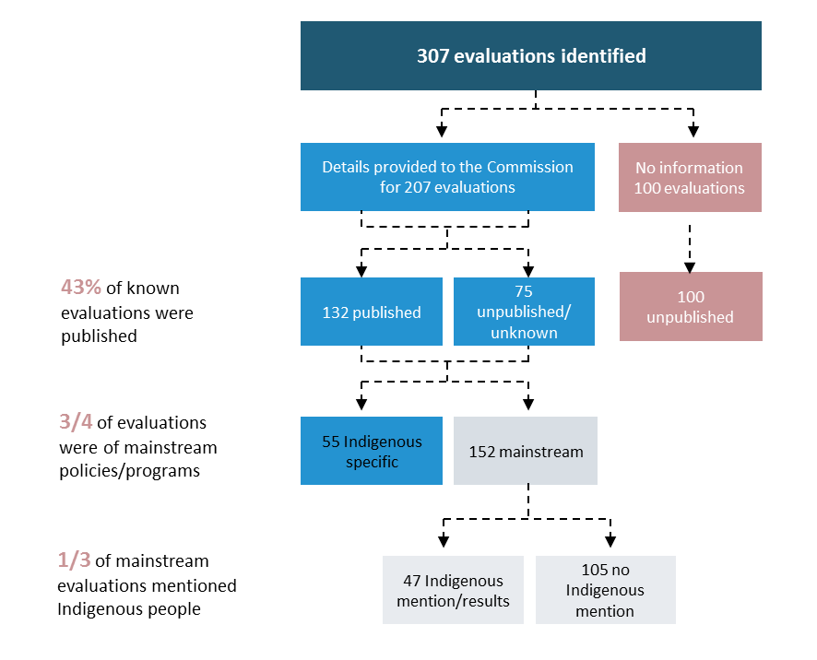
a Counts represent information provided by the 46 agencies that responded out of 182 agencies the request was sent to. Some agencies that did not respond were not able to provide information on all evaluations done by the agency. The nature and size of policies and programs and evaluations varied greatly, therefore, counts only provide an indicative picture of overall evaluation practice.
Data source: Productivity Commission Indigenous Evaluation Strategy information request.

Evaluation numbers vary across agencies and service areas
Numbers of evaluations undertaken varies across agencies. Based on our sample of responses, the number of evaluations undertaken does not seem to be correlated to agency size. Some small agencies conducted a number of evaluations, while others undertook very little or no evaluation. However, the low response rate of small agencies to the Commission’s information request means that it is not possible to generalise about evaluation practice in small and medium agencies. It is also not possible to generalise about evaluation practice in small Indigenous specific agencies.
Three quarters (152 out of 207) of the evaluations the Commission received information on were for mainstream policies and programs. However, only about one third (47) of these mentioned or provided results specific to Aboriginal and Torres Strait Islander people (figure B.16). There were 55 evaluations of Indigenous-specific policies or programs.
The numbers of evaluations of policies and programs mentioning or providing results on Aboriginal and Torres Strait Islander people varied substantially across service areas. A quarter of these were for public and community health services. Other areas where evaluation was more common were school education, labour and employment, and community and environment services (figure B.17). Areas where there were few or no recent evaluations were social security payments and healthcare subsidies and support (including Medicare and the Pharmaceutical Benefits Scheme) — coincidentally these are areas of significant government expenditure (chapter 3).

Figure B.17 Australian Government evaluations mentioning or providing results for Aboriginal and Torres Strait Islander people, by service areaa
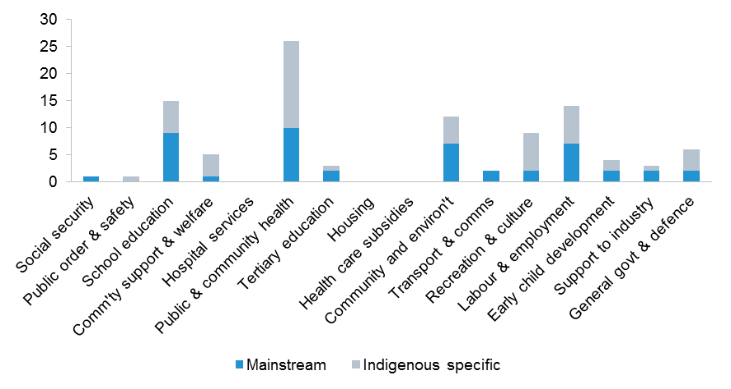
a Service areas match the definitions used in the Indigenous Expenditure Report (SCRGSP 2017). b Data should be interpreted with caution as not all agencies provided data, some were not able to report on all their evaluations and about one third of known evaluations were unpublished with no information on service area available.
Source: Commission analysis of information request to Australian Government agencies.
Two thirds of mainstream evaluations mentioning or providing results for Aboriginal and Torres Strait Islander people related to government programs, the rest related to policies. For Indigenous-specific evaluations, more than 80 per cent were for government programs (table B.2).
Very few evaluations mentioning or providing results for Aboriginal and Torres Strait Islander people examined issues across agencies or service areas — three Indigenous-specific policy evaluations and one mainstream program evaluation covered multiple agencies or service areas.
Evaluations of government policies were not always described as ‘evaluations’ but more commonly referred to as ‘reviews’. These are included in this assessment as evaluations as they share the same evaluative focus of assessing effectiveness, efficiency and appropriateness. Some policy evaluations were overseen by independent external committees, some sought public submissions as part of their research processes. Productivity Commission inquiries were not included as evaluations in the data presented here, but many of them share characteristics with policy evaluations.

Table B.2 Australian Government evaluations of policies and programs mentioning or providing results for Aboriginal and Torres Strait Islander people
 | Mainstream | Indigenous specific | Total
Program evaluationsa | 33 | 46 | 79
Policy evaluationsa | 14 | 5 | 19
Unknownb | – | 4 | 4
Total evaluations | 47 | 55 | 102

a Count of evaluations identified from responses by Australian Government agencies to an information request from the Productivity Commission. Program evaluations are evaluations of a program, service, or payment by an agency. Policy evaluations are evaluations of policies that do not involve delivering a policy, payment or service. Policies may relate to laws, regulations, taxes, charges or administrative requirements imposed on individuals, firms or government agencies. b There was insufficient information about some evaluations to classify them as either program or policy evaluations.
Source: Productivity Commission Indigenous Evaluation Strategy information request.

Mixed methods evaluation techniques dominate
About two thirds of evaluations mentioning or providing results for Aboriginal and Torres Strait Islander people used a mix of qualitative and quantitative methods. About a quarter were based primarily on qualitative methods, such as interviews and focus groups with service users and service providers (table B.3). About one in seven evaluations were based solely on quantitative methods. The most common evaluation methods used were:
- literature reviews and analysis of documents
- interviews, consultation meetings and focus groups with service providers, representative bodies, service users and subject matter experts
- analysis of administrative data
- surveys of service users or providers and other relevant groups.

Table B.3 Evaluation methods used in Australian Government evaluations of policies and programs mentioning or providing results for Aboriginal and Torres Strait Islander peoplea
 | Mainstream | Indigenous specific | Total
Mixed methodsb | 31 | 22 | 53
Quantitative methods evaluationsc | 6 | 6 | 12
Qualitative methodsd | 10 | 11 | 21
Unknowne | – | 16 | 16
Total evaluations | 47 | 55 | 102

a Count of evaluations identified from responses by Australian Government agencies to an information request from the Productivity Commission. b Evaluations using a mix of quantitative and qualitative methods. c Evaluations using a only quantitative methods. d Evaluations using only qualitative methods. e There was insufficient information about some evaluations to classify them as either program or policy evaluations.
Source(s): Productivity Commission Indigenous Evaluation Strategy information request.
Qualitative techniques are useful for evaluating why a policy or program is working or not and why it may be more or less effective for particular situations or types of service users (chapter 4).
Quantitative analysis in Australian Government evaluations mentioning or providing results for Aboriginal and Torres Strait Islander people primarily involved analysis of administrative data and surveys. Some evaluations had good data on outcomes, however, the majority of quantitative analysis focused on activities, outputs, and user perceptions and feedback. While these can all be useful in their own way, they can be of limited value for measuring outcomes.
Most evaluations attempt to measure impact, but most have limited data and/or do not have a control group. Very few include cost-benefit analysis. (Chapter 9 provides more information on the use of data in evaluations.)

Engagement with Aboriginal and Torres Strait Islander people is minimal
About one-fifth of evaluations of Indigenous-specific policies or programs included engagement with Aboriginal and Torres Strait Islander people in evaluation planning and decision making. Only one out of 47 mainstream evaluations included Aboriginal and Torres Strait Islander people in planning and decision making (figure B.18). The lack of engagement was not restricted to evaluations of policies or programs affecting Aboriginal and Torres Strait Islander people — for evaluations more generally, most or all decisions about evaluation design and governance were made without input from service users, service providers, community organisations or other external parties.

Figure B.18 Evaluations that included Aboriginal and Torres Strait Islander people in planning and decision-makinga
a Proportion of evaluations that mentioned or provided results for Aboriginal and Torres Strait Islander people that included Aboriginal and Torres Strait Islander people in evaluation planning or decision-making.
Data source: Productivity Commission Indigenous Evaluation Strategy information request.
For evaluations that mentioned or provided results for Aboriginal and Torres Strait Islander people, participation of service users and providers in evaluations was primarily limited to interviews, group discussions. or as survey respondents. About half of mainstream evaluations that mentioned or provided results for Aboriginal and Torres Strait Islander people had no engagement with Aboriginal and Torres Strait Islander people; about one third had some engagement, and for the remainder there is insufficient information on the level of engagement. Most of the mainstream evaluations without any direct engagement presented administrative or other data on Aboriginal and Torres Strait Islander people.
About half of Indigenous-specific evaluations engaged with Aboriginal and Torres Strait Islander people as part of the research process, mostly in the form of interviews, group discussions and as survey respondents. Seven out of 55 Indigenous specific evaluation reports mentioned having Aboriginal and Torres Strait Islander people as part of the research or evaluation team. For the remaining evaluations, most have insufficient information to know whether there was engagement with Aboriginal and Torres Strait Islander people. About one third of mainstream evaluations that mentioned or provided results for Aboriginal and Torres Strait Islander people engaged with Aboriginal and Torres Strait Islander people as part of their research.
No mainstream evaluations that mentioned or provided results for Aboriginal and Torres Strait Islander people mentioned any participation of Aboriginal and Torres Strait Islander people in evaluation analysis or writing of the report, nor did they specifically provide results back to Aboriginal and Torres Strait Islander people. For Indigenous specific evaluations about one-tenth involved Aboriginal and Torres Strait Islander people in analysis or reporting and about one-tenth provided results directly back to Aboriginal and Torres Strait Islander people.

A majority of evaluations were done by external consultants
About 60 per cent of evaluations of both mainstream and Indigenous-specific policies or programs that mentioned or provided results for Aboriginal and Torres Strait Islander people were undertaken by external consultants (figure B.19).
Information on the cost of evaluations was only available for two out of 207 evaluations.

Figure B.19 Evaluations undertaken by external consultantsa
a Proportion of evaluations that mentioned or provided results for Aboriginal and Torres Strait Islander people conducted by external consultants.
Data source: Productivity Commission Indigenous Evaluation Strategy information request.

Formal ethics assessment is uncommon
Ethics assessment was undertaken for a small proportion of evaluations — one in five mainstream program evaluations mentioning or providing results for Aboriginal and Torres Strait Islander people and one in four Indigenous specific program evaluations (figure B.20). More information on agency use of ethics assessment is in figure B.13.

Figure B.20 Evaluations that included a formal ethics assessment
a Proportion of evaluations that mentioned or provided results for Aboriginal and Torres Strait Islander people that included a formal ethics assessment by a human research ethics committee.
Data source: Productivity Commission Indigenous Evaluation Strategy information request.

There is little information on the use of evaluation results
Fewer than 10 per cent of Australian Government evaluation reports mentioning or providing results for Aboriginal and Torres Strait Islander people include information on how the Government or the commissioning agency has used the evaluation findings or recommendations. Other evaluations are probably being used but there is very little information on the usefulness of evaluation or the extent to which it assists government decision-making.

B.5 Information request questionnaire
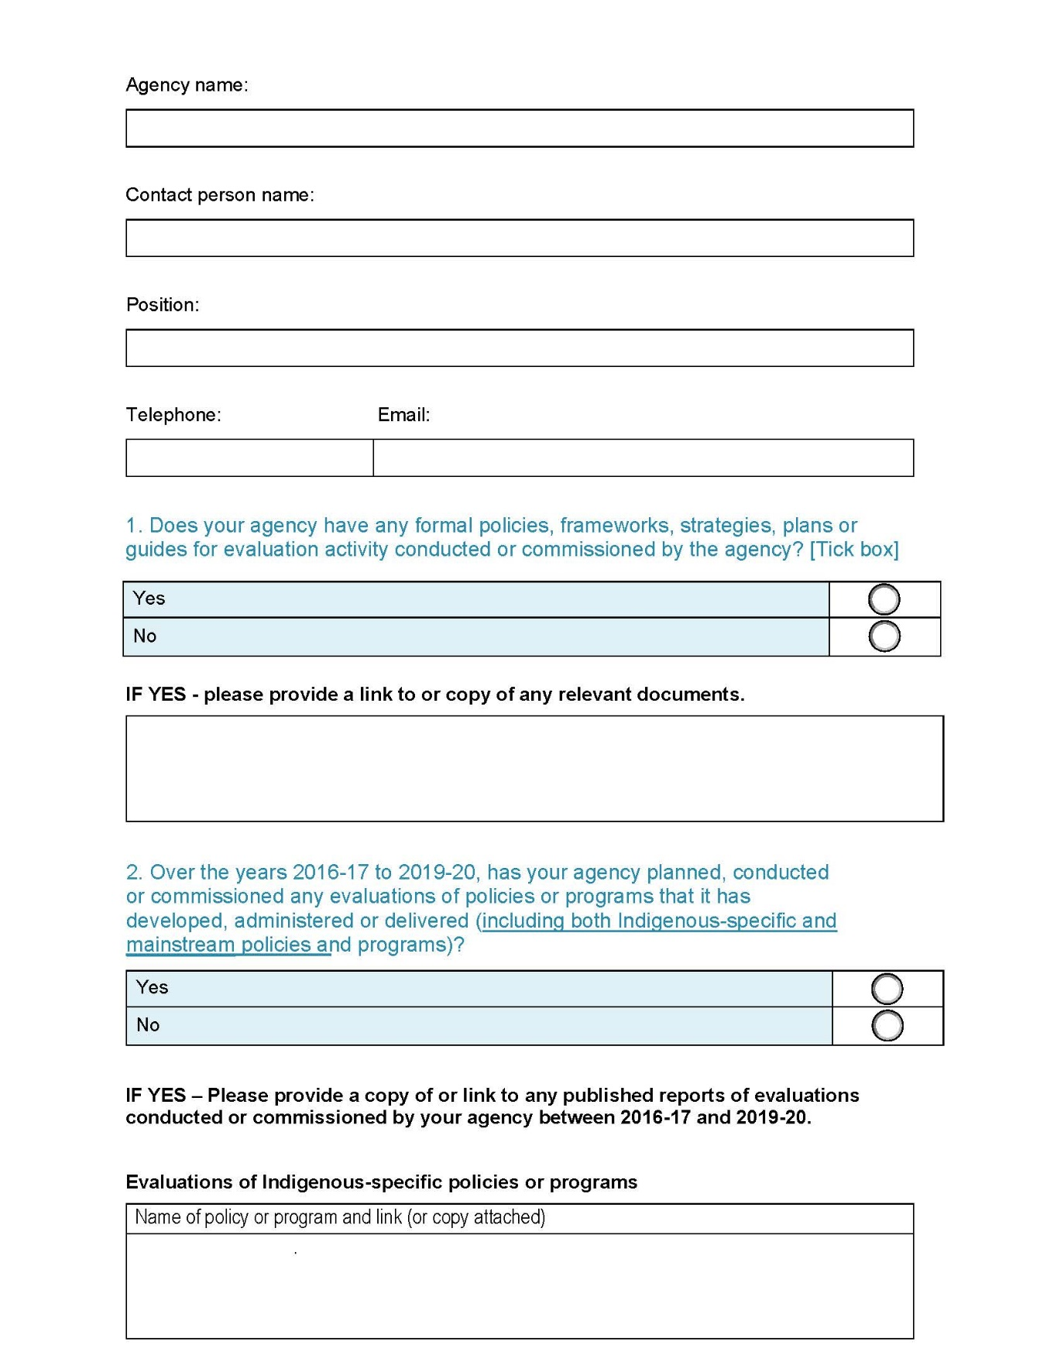
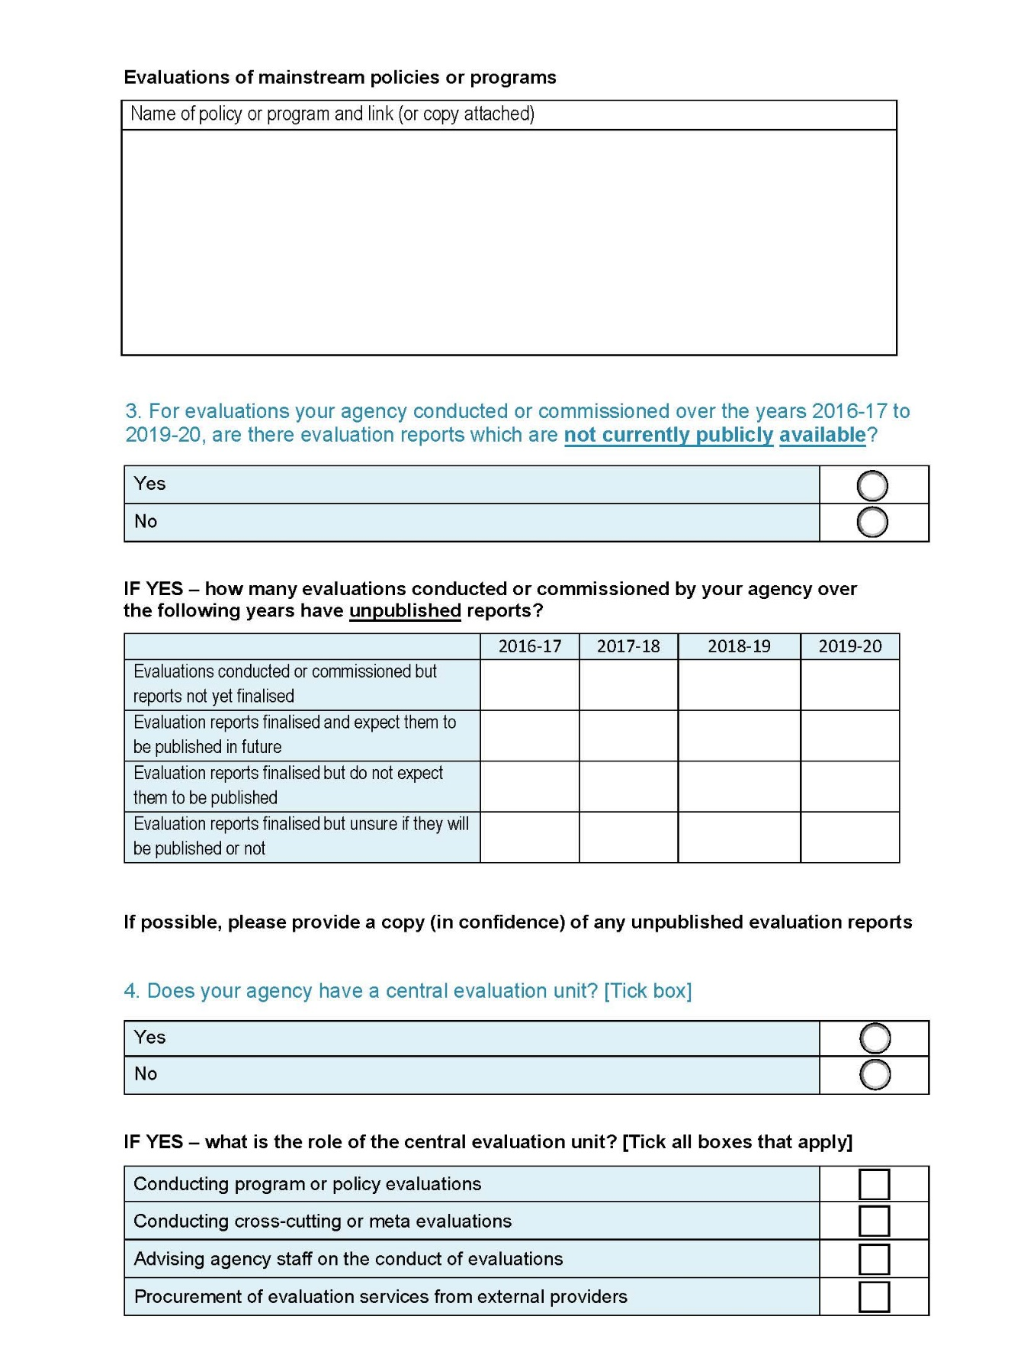

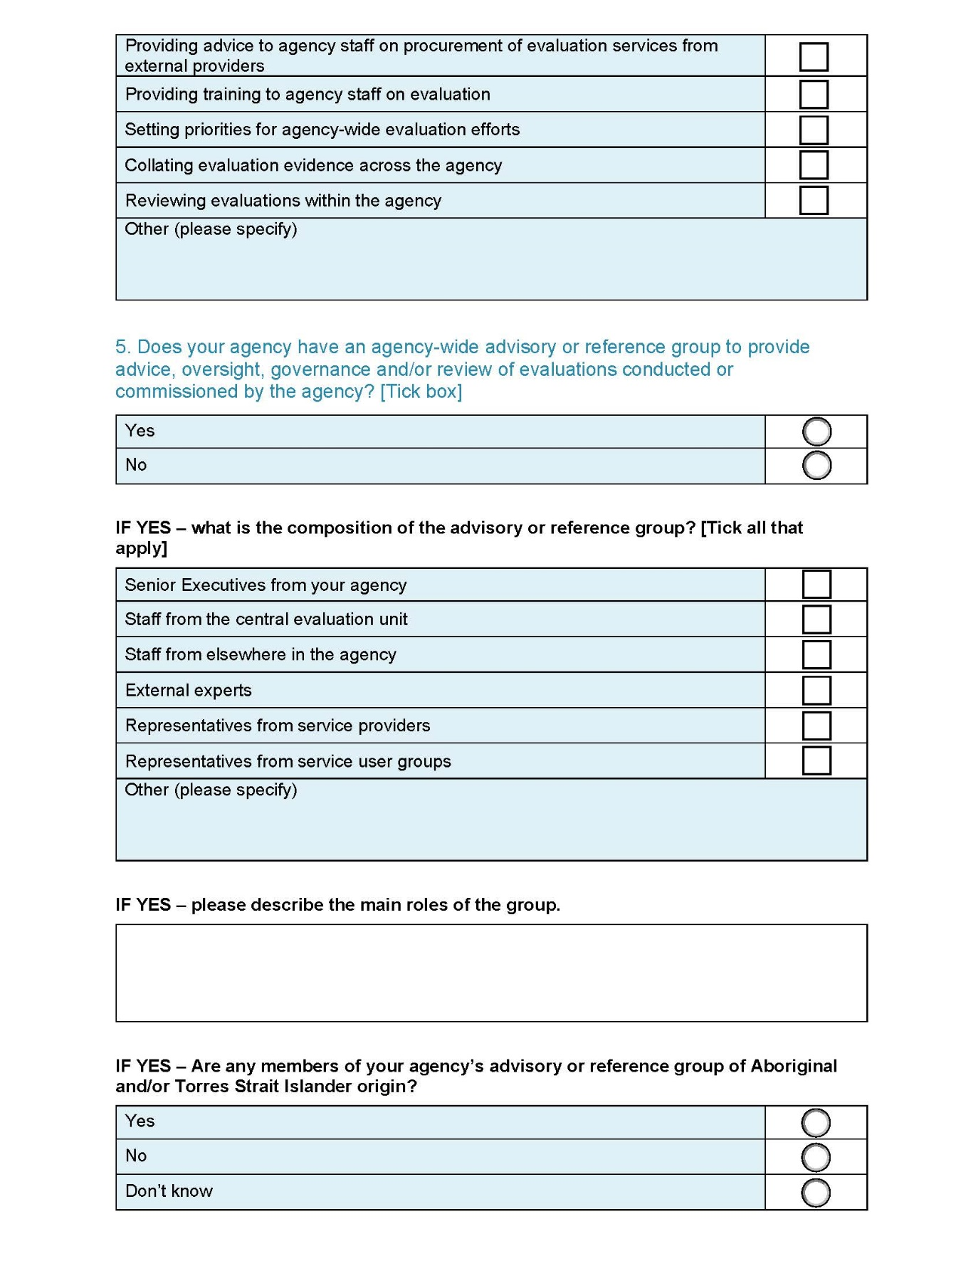

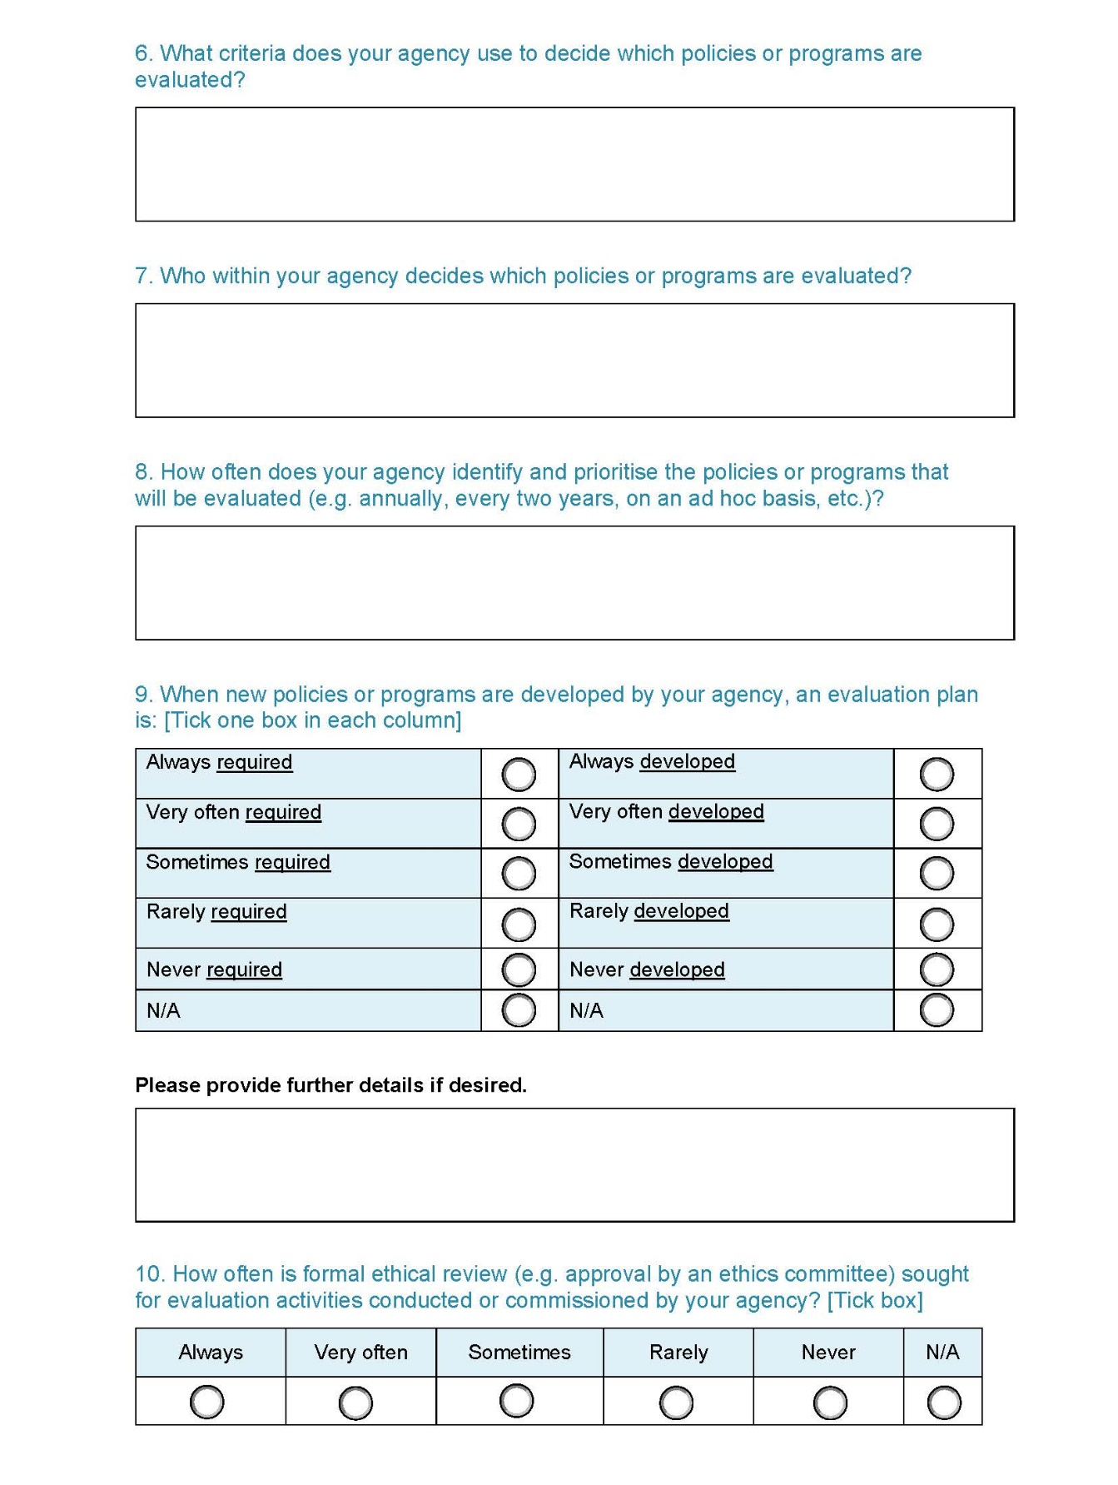

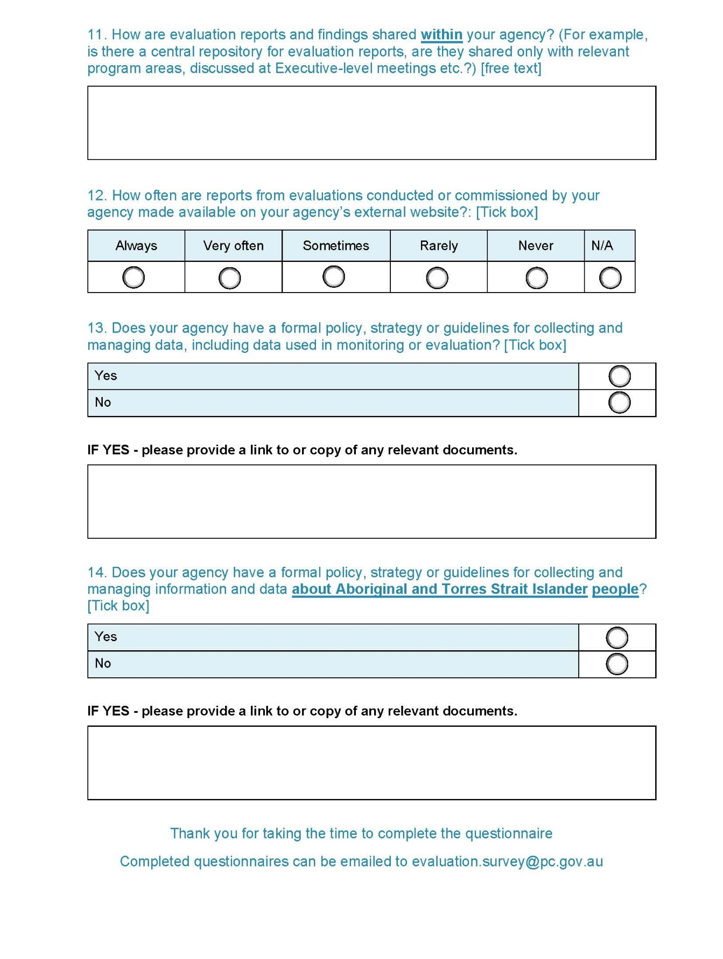

Further analysis of published and unpublished evaluation reports provided by agencies was undertaken to collect data on evaluation characteristics.
As at 15 May 2020.
The three parliamentary departments (Department of Parliamentary Services, Department of the House of Representatives and Department of the Senate) did not respond to the information request. It could be argued that they are outside the scope of the Indigenous Evaluation Strategy, being departments of the parliament rather than the government.
Several smaller agencies reported that their privacy policy was their data policy or strategy. Few departments reported privacy policies in this item, however all Australian Government agencies with turnover greater than $3 million are required to have a privacy management plan under the Privacy (Australian Government Agencies – Governance) APP Code 2017. As such, it is likely that most agencies responding to the information request have a privacy policy, even if it was not mentioned in their response.
General data policies were searched for the terms ‘Aboriginal’, ‘Torres Strait Islander’ and ‘Indigenous’.

