Intellectual Property Arrangements
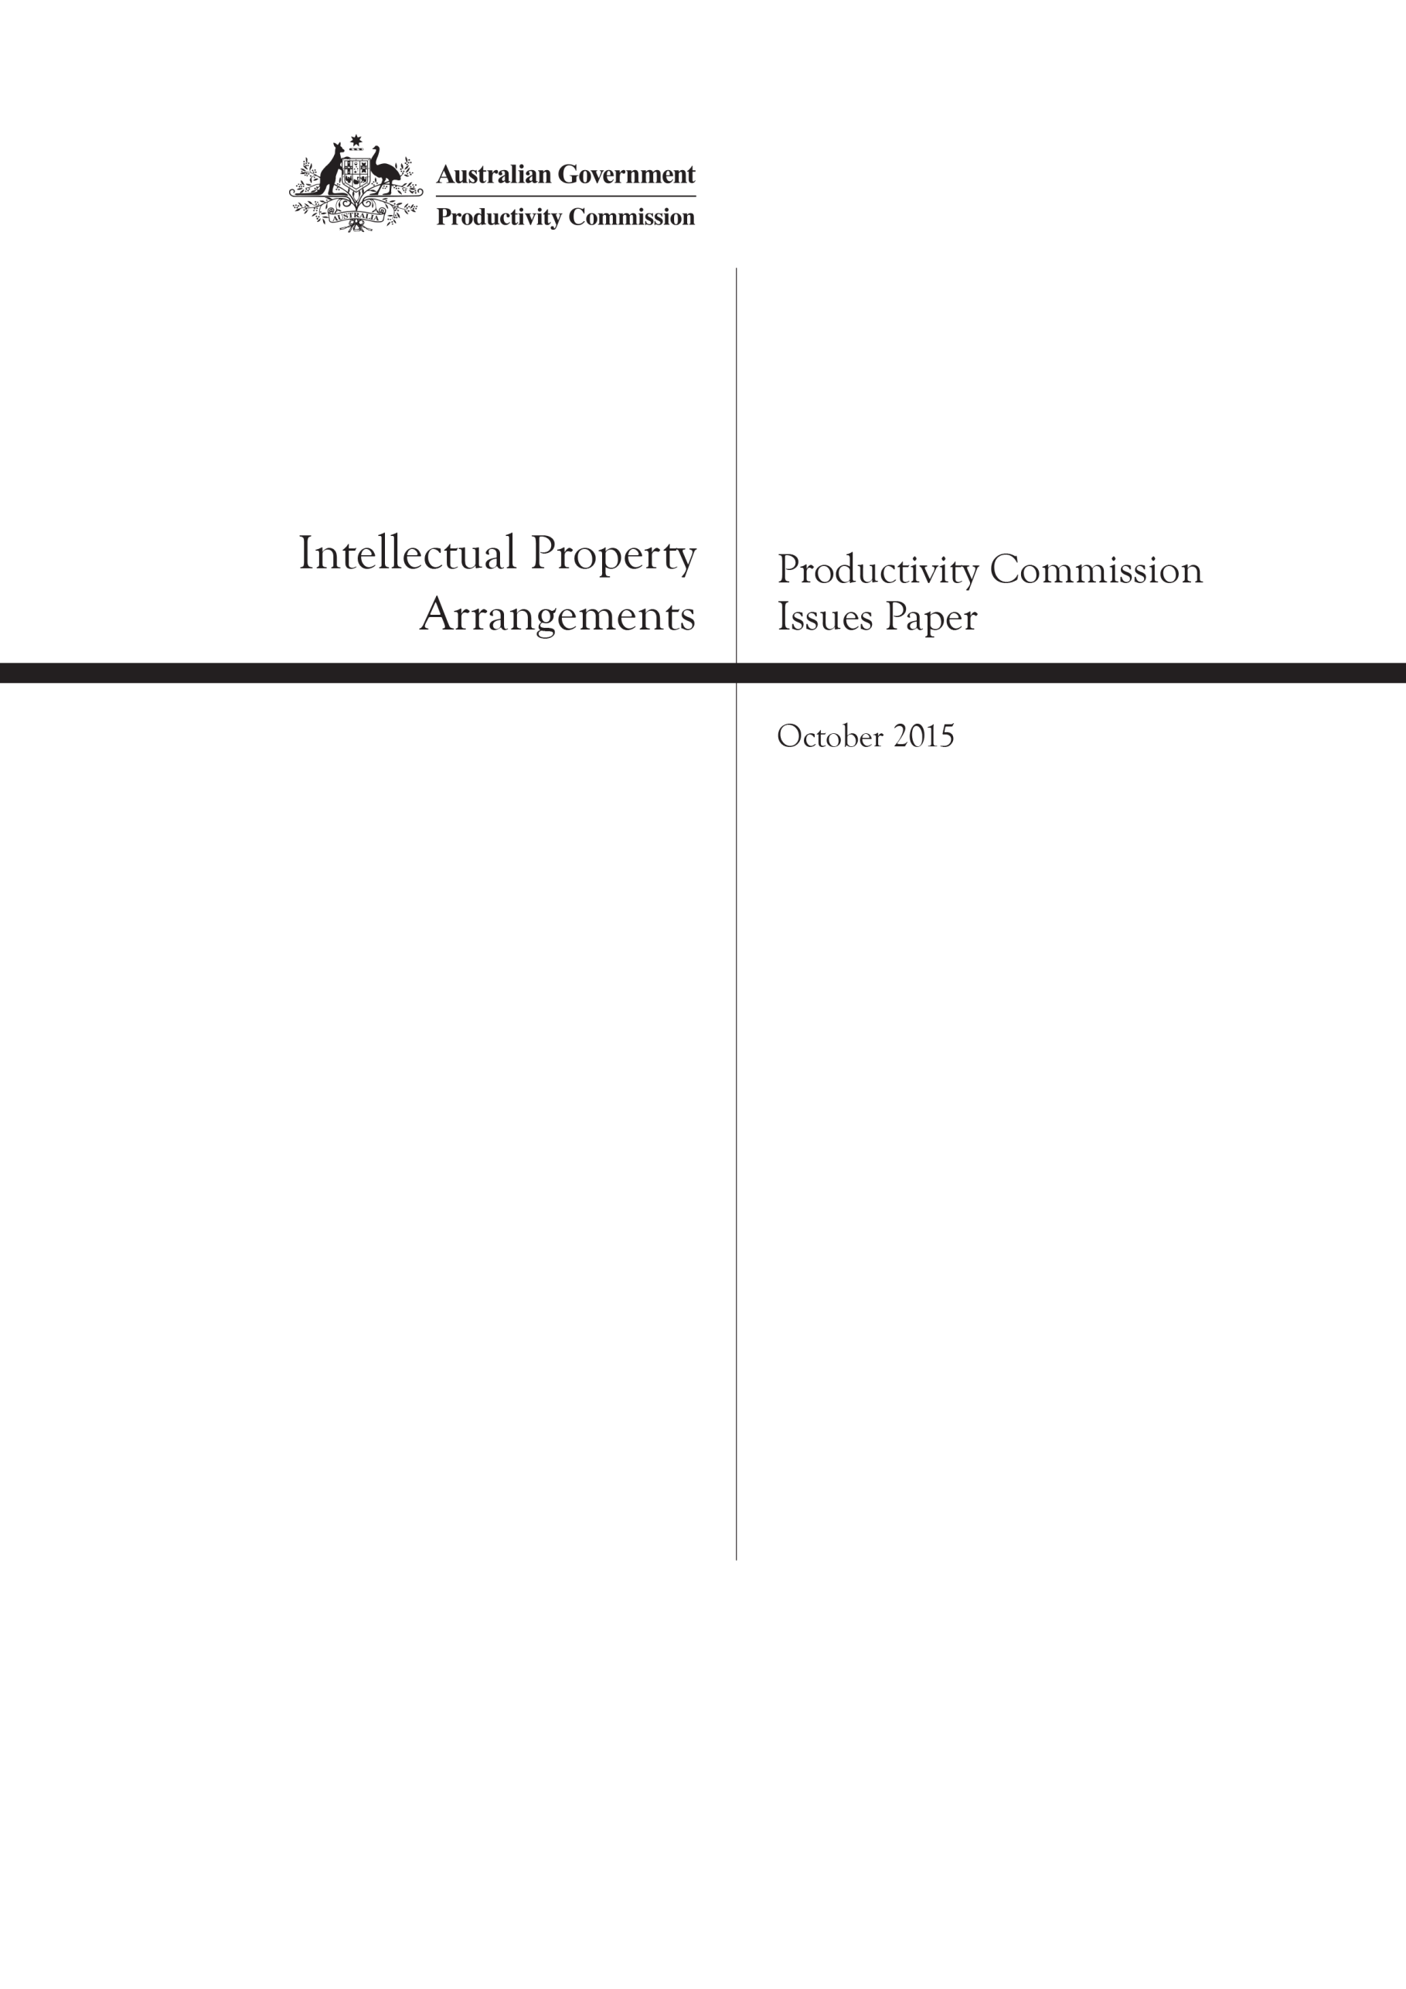
Productivity Commission Issues Paper, October 2015

The Issues Paper
This issues paper has been released by the Commission to assist individuals and organisations to prepare submissions to the inquiry. This paper outlines:
- the scope of the inquiry
- a proposed framework for considering intellectual property arrangements
- some broad questions about the objectives and operation of Australia’s intellectual property arrangements, as well as some more specific questions, which relate to particular forms of intellectual property rights
- how to make a submission.
Participants should not feel that they are restricted to comment only on matters raised in the issues paper. The Commission wishes to receive information and comment on issues that participants consider relevant to the inquiry’s terms of reference.
Key inquiry dates
Receipt of terms of reference | 18 August 2015
Due date for initial submissions | 30 November 2015
Release of draft report | March/April 2016
Draft report public hearings | April/May 2016
Final report to Government | 18 August 2016
Submissions can be made
By email: | intellectual.property@pc.gov.au
By post: | Intellectual Property Arrangements Inquiry  Productivity Commission  GPO Box 1428  CANBERRA CITY 2601
Contacts
Administrative matters: | Pragya Giri | Ph: 02 6240 3250
Other matters: | Leo Soames | Ph: 02 6240 3214
Freecall number for regional areas: | 1800 020 083
Website: | www.pc.gov.au

The Productivity Commission
The Productivity Commission is the Australian Government’s independent research and advisory body on a range of economic, social and environmental issues affecting the welfare of Australians. Its role, expressed most simply, is to help governments make better policies, in the long term interest of the Australian community.
The Commission’s independence is underpinned by an Act of Parliament. Its processes and outputs are open to public scrutiny and are driven by concern for the wellbeing of the community as a whole.
Further information on the Productivity Commission can be obtained from the Commission’s website (www.pc.gov.au).

Inquiry into Australia’s Intellectual Property Arrangements
Terms of Reference
I, Joseph Benedict Hockey, Treasurer, pursuant to Parts 2 and 3 of the Productivity Commission Act 1998, hereby request that the Productivity Commission undertake an inquiry into Australia’s intellectual property arrangements, including their effect on investment, competition, trade, innovation and consumer welfare.
Background
Australia provides statutory protection for intellectual property through patents, trade marks, geographical indications, registered designs, plant breeders’ rights, copyright, moral rights, performers’ rights and circuit layout rights. Current laws are consistent with treaties under the auspices of the World Trade Organization, the World Intellectual Property Organization and the World Health Organization to which Australia has acceded, as well as bilateral and regional trade agreements.
The global economy and technology are changing and there have been increases in the scope and duration of intellectual property protection. The Australian Government seeks to ensure that the appropriate balance exists between incentives for innovation and investment and the interests of both individuals and businesses, including small businesses, in accessing ideas and products.
Scope of the Inquiry
The Australian Government wishes to ensure that the intellectual property system provides appropriate incentives for innovation, investment and the production of creative works while ensuring it does not unreasonably impede further innovation, competition, investment and access to goods and services. In undertaking the inquiry the Commission should:
- examine the effect of the scope and duration of protection afforded by Australia’s intellectual property system on:
  - research and innovation, including freedom to build on existing innovation;
  - access to and cost of goods and services; and
  - competition, trade and investment.
- recommend changes to the current system that would improve the overall wellbeing of Australian society, which take account of Australia’s international trade obligations, including changes that would:
  - encourage creativity, investment and new innovation by individuals, businesses and through collaboration while not unduly restricting access to technologies and creative works;
  - allow access to an increased range of quality and value goods and services;
  - provide greater certainty to individuals and businesses as to whether they are likely to infringe the intellectual property rights of others; and
  - reduce the compliance and administrative costs associated with intellectual property rules.
- in undertaking the inquiry and proposing changes, the Commission is to have regard to:
  - Australia’s international arrangements, including obligations accepted under bilateral, multilateral and regional trade agreements to which Australia is a party;
  - the IP arrangements of Australia’s top intellectual property trading partners and the experiences of these and other advanced economies in reforming their IP systems to ensure those systems meet the needs of the modern economy;
  - the relative contribution of imported and domestically produced intellectual property to the Australian economy, for example to Australia’s terms of trade and other economic impacts of IP protection, including on inward investment;
  - the Government’s desire to retain appropriate incentives for innovation and investment, including innovation that builds on existing work, and production of creative works;
  - the economy-wide and distributional consequences of recommendations on changes to the existing intellectual property system, including on trade and competition;
  - ensuring the intellectual property system will be efficient, effective and robust through time, in light of economic and technological changes;
  - how proposed changes fit with, or may require changes to, other existing regulation or forms of assistance (such as research subsidies) currently providing incentives for the development of intellectual property;
  - the findings and recommendations of the Harper Competition Policy Review in the context of the Australian Government’s response, including recommendations related to parallel import restrictions in the Copyright Act 1968 and the parallel importation defence under the Trade Marks Act 1995; and
  - the findings and recommendations of the Advisory Council on Intellectual Property’s Review of the Innovation Patent System; the Senate Economics References Committee’s inquiry into Australia’s innovation system; and the Australian Law Reform Commission’s Copyright and the Digital Economy report.
Process
The Commission is to undertake an appropriate public consultation process, inviting public submissions and releasing a draft report to the public.
The Final report is to be provided to the Government within 12 months of receipt of this Terms of Reference.
J. B. HOCKEY
Treasurer
[Received 18 August 2015]

1 What has the Commission been asked to do?
The Australian Government has asked the Productivity Commission to undertake a broad-ranging inquiry into Australia’s intellectual property (IP) arrangements. In doing so, the Commission is to consider whether IP arrangements strike the right balance between incentives for innovation and investment, and the interests of both individuals and businesses in accessing ideas and products. The Commission has also been asked how best to ensure the system will be efficient, effective and robust through time, in light of economic and technological change.
The Commission is mindful that various aspects of Australia’s IP arrangements have been subject to review in recent years, including:
- the Innovation Patent System, which was reviewed by the Advisory Council on Intellectual Property and IP Australia (ACIP 2015b; Johnson et al. nd)
- pharmaceutical patents, which were reviewed by a government appointed panel (Harris, Nicol and Gruen 2013)
- the Designs System, which was reviewed by the Advisory Council on Intellectual Property (ACIP 2015a)
- Copyright and the Digital Economy, which was reviewed by the Australian Law Reform Commission (ALRC 2013).
While the Commission will have regard to the findings and recommendations of past reviews, this inquiry presents an opportunity for a high-level and holistic consideration of Australia’s IP arrangements, including as they relate to:
- the underlying objectives of Australia’s IP system and the principles that should inform and guide policy making
- the economy-wide and distributional impacts of affording IP rights and how they differ depending on the nature, scope and term of rights
- the role that granting exclusivity of rights should play as part of a broader landscape of policies to encourage innovation and the development of IP
- the role that other policies (such as competition and trade policy) can play in striking a balance between providing incentives for innovation and investment in knowledge-based assets and the ability of parties to access ideas and products
- the way that IP policy is designed, implemented and enforced
- the relevance of international organisations — such as the World Intellectual Property Organization (WIPO) — and other multilateral frameworks.

2 What is IP and why are IP arrangements important?
IP refers to creations of the mind, such as inventions; literary and artistic works; designs; and symbols, names and images used in business (WIPO nd). IP differs from other forms of property in that it embodies thoughts and knowledge created by people and so is intangible in nature (Aoki and Small 2004). Governments typically grant creators of IP with time-limited exclusive rights over their works or knowledge-based assets. Rights can take a variety of forms, including patents, copyrights, registered designs, trade marks, and geographical indications (box 1).

Box 1 Intellectual property rights
All IP rights grant their holder a number of time-limited exclusive rights, which generally enable the holder to control industrial production, communication, sale or derivative use of their work. Australia offers a range of IP rights:
Patents protect new inventive or innovative products or processes. In exchange for the exclusive rights provided, patent owners must make technical information about their invention publicly available.
Copyright protects the original expression of literary, musical, artistic and dramatic works, as well as their industrial form, such as books, sound recordings, films and broadcasts. Music, paintings, sculptures, computer programs, databases, advertisements, maps and technical drawings can all qualify for copyright protection. Copyright also provides ‘moral’ rights of attribution of performance or authorship.
Plant breeder’s rights provide protection to breeders of new plant varieties by giving them exclusive control over their commercial exploitation.
Circuit layout rights protect the layout design (three dimensional topography) of integrated circuits (commonly known as semi-conductor chips). These rights are based on copyright but are a separate, unique form of protection.
Trade marks distinguish the goods or services of one firm from those of other enterprises. A trade mark can be a letter, number, word, phrase, smell, shape, logo, picture, and/or aspect of packaging.
Geographical indications identify goods as originating in a specific territory, region or locality where a particular quality, reputation or other characteristic is essentially attributable to its geographical origin.
Registered designs protect the appearance of a product, such as its shape, configuration, pattern and ornamentation.

Australian law provides other protections for knowledge-based assets:
- Contract law can allow businesses to specify how their goods are used or adapted by others, as well as non-disclosure of information.
- Common law can be used to protect confidential information and trade secrets, business reputation and goodwill in trade names.
- Legislation such as the Therapeutic Goods Act 1989 (Cwlth) and the Agricultural and Veterinary Chemicals Code Act 1994 (Cwlth) provide protections for test data submitted for regulatory approval of human and veterinary medicines, and agricultural chemicals.
- Consumer law can protect businesses against misleading and deceptive conduct by competitors.
IP rights form a core component of a broader set of arrangements, which embody a system of assets; government-afforded rights; licensing and trading of those rights; and institutions to assess, recognise, afford and enforce those rights and their exchange. Importantly, the system is extraordinarily dynamic — the trade-offs involved are ever moving and subject to many exogenous forces such as technological change and globalisation. For these reasons, the governance and accountability of the institutions that are the guardians to these rights and their use matter.

IP rights are intended to promote innovation and creativity …
IP is an important contributor to economic growth and community welfare. However, some forms of IP, once known, can be copied at little cost, which may in turn lead to under-investment in innovation. The process of granting individuals and organisations with exclusive rights to their inventive and creative output seeks to overcome this and other attributes of IP by limiting the extent to which competitors can ‘free ride’ (box 2).
The nature of the legal entitlement differs across the types of IP rights granted. Most IP rights establish general ‘exclusivity’ for a specified period, which the holder may then use to derive a financial benefit (figure 1).
As with other legal property rights, most IP rights can be bought and sold, or made freely available. Rights holders also have the capacity to license their IP to another party to use their invention on agreed terms. Licensing allows rights holders to unlock the value of their IP by partnering with others who may have a better capacity to commercialise their works.

Box 2 The special characteristics of intellectual property
Consumers demand both inventive and creative output, and in a well-functioning market, creators would invest time and cost into developing new knowledge to satisfy this demand. However, the new knowledge created to satisfy consumer demand suffers from a number of attributes that mean creators and innovators may not produce as much as consumers would be willing to pay for. Knowledge can be:
- ‘non-rivalrous’ — when someone uses an idea, it does not stop others from using that idea
- ‘non-excludable’ — it can be difficult to prevent other people from using ideas. IP rights are often designed specifically with this in mind by creating a legal framework that prevents people from using others’ IP without consent and adequate compensation
- cumulative — new ideas often build upon old ideas
- subject to ‘network effects’ — it can be easier to generate IP in a cooperative, rather than competitive environment. This has implications for legal frameworks about collusion, and the overriding general desire for competition in markets for efficient outcomes.
The costs borne by creators in developing new IP is often considerably higher than the cost of reproducing that knowledge many times over — IP is sometimes characterised by high fixed costs and low marginal costs. Coupled with the non-excludable nature of IP, creators who bear the cost of developing new works may be unable to compel others who reproduce their work to contribute to the original development costs. Unable to earn a sufficient rate of return on their investment, creators might instead opt not to produce that new knowledge.
While IP rights are intended to provide a window in which rights holders can derive a financial benefit, they are no guarantee of commercial success. Moreover, much creative and inventive work is done with no expectation of remuneration or reward, but is done for the personal benefit or joy it provides creators. Coding software as part of the open software movement, writing a travel blog, and tinkering in the shed to make better farm tools are all forms of creative and inventive work that do not rely on IP rights to take place. And many involved in basic research are motivated more by expanding the stock of human knowledge than by financial reward.
Not all forms of IP rights are intended to promote innovation and creativity, some, such as trade marks and geographical indications, relate more to the provision of information and the protection of brand or reputation. These forms of IP (at least in part) are intended to avoid consumer deception and address information asymmetries between producers and consumers, which, if left unaddressed, could potentially impact on the operation of markets, such as on the level and quality of output.

Figure 1 Characteristics of different forms of IP rights
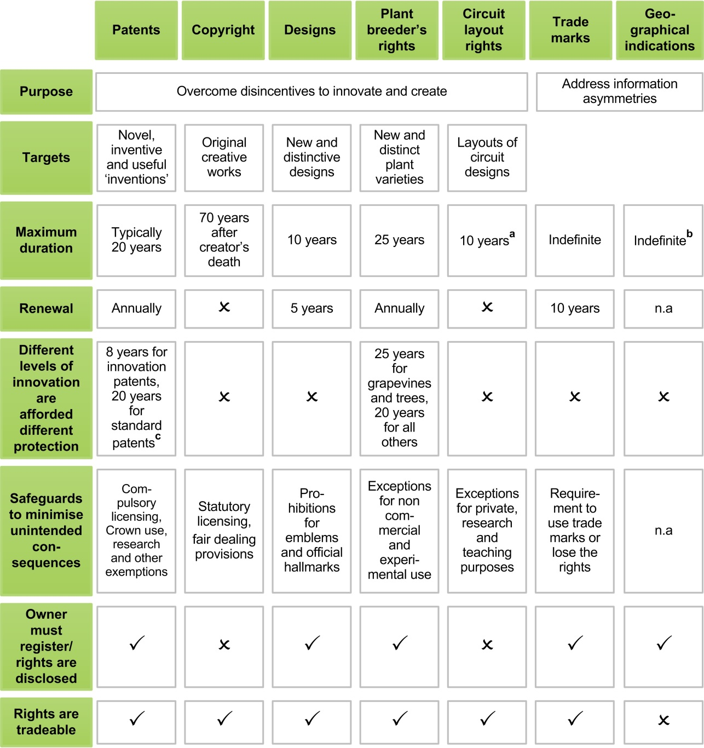

a From the first commercial exploitation, rights continue for 10 years. The first commercial exploitation must occur within 10 years of creation of the layout, or 10 years from when it was made. b Depending on the type of geographical indication registered. For those covered by certified trade marks, there is a period of 10 years, which can be renewed indefinitely. In the case of wine and spirits, there is no term. c Patents for pharmaceuticals can be extended by up to 5 years.

… but granting parties exclusive rights can limit competition
The exclusive nature of IP rights can also lead to undesirable outcomes. Because IP rights give holders the ability to prevent others from using that IP, there is a risk the rights allow parties to exercise market power or engage in other anticompetitive behaviour. This, in turn, can give rise to a number of problems, such as allowing rights holders to extract excessive licensing royalties, and promote and entrench other rent-seeking behaviour. When this occurs, consumers bear the burden — through higher prices, less choice and lower output (WIPO 2011). And there can be broader social consequences, such as when IP rights affect access to affordable medicines (box 3). For net importers of IP, such as Australia, welfare losses from higher prices and restricted availability are not always offset by increases in Australian producer profits.
The extent of market power emanating from IP rights varies. Market power may be limited in cases where companies face competition from similar products or technologies. However, for radical innovations market power can be substantial (WIPO 2011).

Box 3 Beyond the theory
While discussions about IP rights are often theoretical, policy decisions about the balance between creators and consumers matter in real ways. Striking the wrong balance can impact the price and availability of books, music, cars, phones or even clothes.
The balance is particularly contentious in pharmaceuticals. Cases exist where patents have allowed pharmaceutical companies to charge what some consider to be unconscionably high prices for life-saving medicines. New compounds and biologic drugs, and their safety and efficacy, are no doubt expensive to develop and test and consumers are often willing to pay almost anything to access them (or the community as a whole through pharmaceutical subsidy schemes). Practices such as patent ‘evergreening’, seeking extended test data exclusivity for biologics, or paying competing firms not to produce generic medicines makes the balance of IP rights all the more contentious.

… and restrict the diffusion of knowledge
IP rights can also impede how knowledge and discoveries are diffused through an economy, with implications for subsequent innovation and wellbeing more generally. The exclusivity of IP rights can make it difficult for firms to build on the ideas of others. As Stiglitz noted, IP rights can end up protecting today’s ideas at the expense of future ideas:
… a poorly designed intellectual property regime — one that creates excessively “strong” intellectual property rights — can actually impede innovation. … Knowledge is the most important input into the production of knowledge. Intellectual property restricts this input; indeed, it works by limiting access to knowledge. (Stiglitz 2008, p. 1694,1710)
The impacts of IP rights on the diffusion of knowledge have become increasingly important. Evidence suggests that the role of IP in the economy has evolved from one where it applied to a handful of industries to one where it affects a wide range of sectors (OECD 2015). IP is also increasingly important to global value chains, and by extension, international trade (OECD, WTO & World Bank Group 2014).
Features of the IP system recognise this drawback, and methods such as patent disclosure and copyright’s fair dealing exemption seek to mitigate the worst outcomes. The efficacy of these methods is all part of the broader balance of costs and benefits inherent in Australia’s IP system.

3 A framework for assessing IP arrangements
The goals of the IP system are articulated in the terms of reference provided to the inquiry:
… that the intellectual property system provides appropriate incentives for innovation, investment and the production of creative works while ensuring it does not unreasonably impede further innovation, competition, investment and access to goods and services. (Hockey 2015)
These desired outcomes are complex, interconnected and sometimes at odds with one another. When combined with a broader consideration of making sure that the IP system should serve the long-term interests of the Australian community, it can be very difficult to determine a set of ‘prescriptive’ rules that satisfy all those that are affected by the system — especially when their incentives do not align. Instead, the Commission proposes to use a set of principles to guide its assessment of the IP system, and as a basis to recommend welfare-enhancing reforms. These principles and the ‘economic framework’ within which they reside, are outlined in figure 2.
Do not delete this RETURN as it gives space between the info request and what precedes it.
The Commission welcomes feedback on the framework it proposes employing to guide its assessment of IP arrangements and for recommending welfare-enhancing reforms.
How these principles of effectiveness, efficiency, adaptability, and accountability relate to policy questions are discussed in more detail, below.

Effectiveness: do IP rights target additional innovation and creative output?
An IP system is effective if it promotes the creation of genuinely new and valuable IP that in the absence of such a system would not have occurred. This ‘additionality’ is important given that the objective of the IP system is to improve wellbeing by correcting an under provision of IP that may exist in the absence of IP rights.
Conversely, it is desirable to make sure that IP rights cannot be used to protect things that are not innovative, or would have been generated anyway (‘non additional’). An IP system that only promotes substitution between different types of IP or encourages the use of IP rights for anticompetitive purposes is not desirable as it does not foster additional innovation.
Do not delete this RETURN as it gives space between the info request and what precedes it.
Do IP rights encourage genuinely innovative and creative output that would not have otherwise occurred? If not, how could they be designed to do so? Do IP rights avoid rewarding innovation that would have occurred anyway? What evidence and criteria should be used to determine this? Are IP arrangements in other jurisdictions more effective in generating additional creative output?

Figure 2 The Commission’s proposed approach
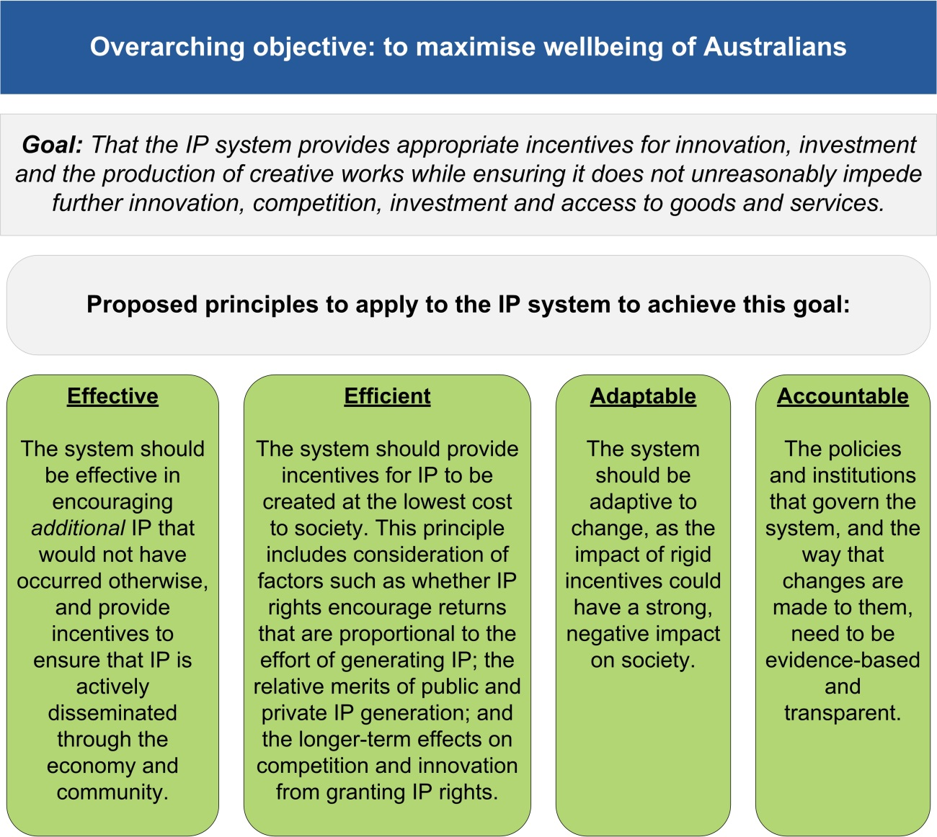

An effective IP system also promotes the dissemination of innovation and ideas. To some extent, there is a more direct tension here between the exclusivity that IP rights confer, and the cumulative nature of much IP. IP systems often include measures to ensure dissemination, such as the disclosure of how patented inventions work, to make them visible to all innovators.

Do not delete this RETURN as it gives space between the info request and what precedes it.
To what extent does the IP system actively disseminate innovation and creative output? Does it do so sufficiently and what evidence is there of this? How could the diffusion of knowledge-based assets be improved, without adversely impacting the incentive to create?
What, if any, evidence is there that parties are acting strategically to limit dissemination?

Efficiency: getting the balance right
There is a balancing act when it comes to making sure IP generators have an incentive to innovate with the cost of providing these incentives to the rest of the community. How to strike such a balance is one of the key questions the Commission has been asked to examine in this inquiry. From an economic efficiency viewpoint, finding the appropriate degree of IP protection involves balancing:
- the incentives for creators to produce new and additional works that IP rights and protections provide; against
- the costs to users that IP rights and protections cause, by extending market power and restricting innovation elsewhere in the supply chain.
As the Commission has previously noted:
… IP protections that are either too strong or too weak can have adverse economic effects. For individual countries, the optimum design and level of IP rights also depends on the extent to which they are net importers or exporters of different forms of IP material and other considerations, such as their level of economic development and the nature of their legal system. (PC 2010, pp. 257–258)
The principle of efficiency can thus be thought of as encompassing several dimensions — it makes sure that IP is generated at the lowest cost to society; that IP is traded and made use of by those that can generate the greatest value from it; and that the longer-run effects of granting IP rights on competition and innovation are balanced against their impacts on growth and wellbeing.

An efficient system ensures IP is generated at lowest cost to society
An efficient IP system should encourage those that can create IP at the lowest cost to do so, while also providing disincentives for those with higher costs from doing so. There are many factors that could be considered when assessing this principle against the current IP system.

For example:
- whether the returns from securing an IP right should be (or indeed could ever be) proportional to the effort of generating that IP — that is, the system should not allow for windfall gains that might encourage inefficient innovators from attempting to generate IP as well (and could provide for ‘windfall losses’ to the community at large as a result)
- how the costs and benefits of generating IP vary between the public, private and not-for-profit sectors, and how IP generation from these different sectors may serve as complements or substitutes to one another
- how the costs and benefits vary between formal IP rights and other methods to secure IP, such as private agreements between firms (box 4)
- how the costs and benefits to secure IP rights (such as the time and charge to register a right) and to defend IP rights (through various enforcement mechanisms) encourage or deter creation of IP (discussed in greater detail in section 5, below).

Box 4 Alternatives to IP rights
Government assignment of property rights and subsidies are not necessarily the only way to promote innovation. Indeed, firms use a variety of methods to protect their IP, as shown in the figure below.a The maintenance of trade secrets is a popular means by which inventors try to protect their IP from unauthorised use, and in doing so, retain sufficient incentives to innovate. Trade secrets can prevent others from copying inventions, and thus can allow firms to recoup the costs of innovating. However, trade secrets can be wasteful from the community perspective as they may lead to suppression of rapid advancement, and duplication of research effort, and so hinder cumulative innovation.
a Note that businesses can nominate more than one type of protection.
Source: ABS (Selected Characteristics of Australian Business, 2012-13, Cat. no. 8167.0).
Do not delete this RETURN as it gives space between the info request and what precedes it.
Do IP rights provide rewards that are proportional to the effort to generate IP? What evidence is there to show this? How should effort be measured? Is proportionality a desirable feature of an IP system? Are there particular elements of the current IP system that give rise to any disproportionality?
What are the relative costs and return to society for public, private and not-for-profit creators of IP? Does the public provision of IP act as a complement or substitute to other IP being generated? Are there any government programs or policies that prevent, raise or lower the costs of generating IP?
What are the merits and drawbacks of using other methods to secure a return on innovation (such as trade secrets/confidentiality agreements) relative to government afforded IP rights? What considerations do businesses/creators of IP make in order to select between options? How does Australia’s use of methods besides IP rights to protect IP compare to other jurisdictions? Why might such differences arise?

An efficient system ensures that IP rights are tradeable
An efficient IP system should also facilitate trade in IP rights, so that those that can make the best use of IP have an opportunity to do so. How IP rights allow for licensing, and fair use and/or fair dealing provisions are therefore relevant when it comes to making sure that the most efficient users of IP can gain access to it.
Where a system of rights discourages trade — for example, because the complexity of the arrangements raises disproportionate legal transactions costs or where IP rights holders seek to secure an anticompetitive advantage — then the benefits that stem from IP can be greatly diminished.
Do not delete this RETURN as it gives space between the info request and what precedes it.
Are there obstacles in the IP system which limit the efficient trade of IP between creators and users? Are there particular areas where trade, licensing and use of IP could be more readily facilitated?
Are there sufficient safeguards to ensure that IP rights do not lead to unduly restrictive market power? Are there ways (including examples employed overseas) to improve the dissemination of IP while preserving incentives to generate IP? Could such methods be adopted or adapted within the Australian IP system?

An efficient system considers the longer-term effects of IP rights
An efficient IP system also needs to ensure that any trade off between the gains to IP rights holders and the costs to IP rights users (including consumers) is balanced through time. Put another way, IP rights ‘generate monopoly positions that reduce current consumer welfare in return for providing adequate payoffs to innovation, which then raises future consumer welfare’ (Maskus 2000, p. 6).
IP systems thus need to consider their effects on IP generation and the consequences for competition and innovation over a period of time, rather than just at a point in time. For example, if IP rights enable a firm to achieve and maintain a monopoly in a market over a long period of time, then the benefits of that IP are likely to be mitigated by the costs to consumers and other firms. Understanding how and when such outcomes are likely to occur is necessary to craft an IP system that delivers long-term gains for both innovators and consumers.
Do not delete this RETURN as it gives space between the info request and what precedes it.
What are the longer term effects of the IP system on competition and innovation? What evidence is there to assess and measure these effects?

Adaptability: making sure IP rights are apt for the future
Given that IP rights can affect society considerably over a period of time, it is necessary for an IP system to be adaptable to changing conditions. IP arrangements and stakeholders have been, and continue to be, affected by a number of developments, including the rise of cloud computing, the growth of the Internet, digitisation, and globalisation (OECD 2015). The clear boundaries around physical goods that once made it easy to define IP protection are now becoming increasingly blurred.
While these developments have given rise to new challenges, such as the facilitation of piracy, they have also given rise to new opportunities for diffusion and commercialisation. New business models and research tools — such as those based on text and data mining, and open access — have the capacity to promote inventions and creativity and provide for greater access to information and creative works. It is important that Australia’s IP system has sufficient flexibility to accommodate these new technologies and developments.
Do not delete this RETURN as it gives space between the info request and what precedes it.
How well has Australia’s IP system adapted to changes in the economic, commercial and technological environment and how well placed is it to adapt to such changes in the future? What factors may make it harder for the IP system to adapt to change? What policy options are there to remedy any difficulties, and why might they be preferable?
Are there other ways of ensuring the IP system will be efficient, effective and robust through time, in light of structural economic changes and the importance/pervasiveness of IP? Is a principles-based approach preferable to a prescriptive approach in this regard? Are there particular parts of the IP system that should be principles-based or prescriptive?
Do not delete this RETURN as it gives space between the info request and what precedes it.
What additional challenges does technological change and new methods of diffusion, including digitisation, present for the adaptability of the IP system? How should such challenges be approached?

Accountability: a transparent, evidence-based system
Building the evidence base to determine the balance between benefits to IP rights holders and benefits to broader society is challenging, and it appears that, in some cases, measures to strengthen rights have proceeded absent a detailed understanding of their economy-wide and distributional effects. There also appears to have been little effort to assess the impacts of such policies once in place.
Do not delete this RETURN as it gives space between the info request and what precedes it.
Ideally, what sort of information is needed to evaluate the IP system? In their absence, what alternative data or proxies are available?
What factors have constrained transparent evaluation of IP rights extensions?
Given that IP affects much of the economy and society, the effects of any policy change are likely to be systemic. The need for broad, public consultation and transparency in decision-making is important. Understanding the nature and scope of public consultation in the past may help to provide a better understanding of what needs to be redressed to have an evidence-based IP system in the future.
Do not delete this RETURN as it gives space between the info request and what precedes it.
The Commission seeks submissions about how the parameters of the IP system came to be set, and on the basis of what evidence and analysis.
How were decisions to extend IP rights in the past (e.g. copyright) assessed? Is an evidence-based approach systematically used to assess changes to the IP system? How transparent have decisions to change the IP system been, including when it comes to legislation and international agreements? Is a stronger evidence base and greater transparency in the public interest, and if so, how should this be accomplished?
The Commission recognises that full information to make policy is not always available, and that the effects of making changes to the IP system may be asymmetric — the size of the costs from strengthening arrangements could be different from those associated with a weakening of IP rights. Hence, it is necessary to assess the relative risks (and net benefits) of over- and under-protecting IP. Further, the rules embodied in the IP system can have a long legacy, particularly where IP arrangements are driven by international obligations. In the event that the evidence suggests that the costs of overprotection are higher to society and that it is difficult to reverse policies once implemented, then policy makers might reasonably err on the side of caution and start with less stringent protection as their general position. Or put more simply, when the evidence is unclear, a ‘precautionary principle’ applied to IP might be to have less stringent IP rights rather than more.
Do not delete this RETURN as it gives space between the info request and what precedes it.
How should a context of limited information, long legacy tails and IP policy irreversibility bear on the stringency of IP rights? In particular, if a precautionary principle is applied, should it err on the side of the consumers or on the side of the IP rights holder? In a global context, which approach best suits Australia?

Bringing it all together
The Commission’s proposed approach will rely on applying the principles of effectiveness, efficiency, adaptability and accountability in assessing and recommending changes to the IP system. Such an approach is designed to make sure that the ultimate goal of improving the wellbeing of Australians — by having a well-functioning IP system — is achieved (figure 3).

Figure 3 How the proposed principles fulfil the objective
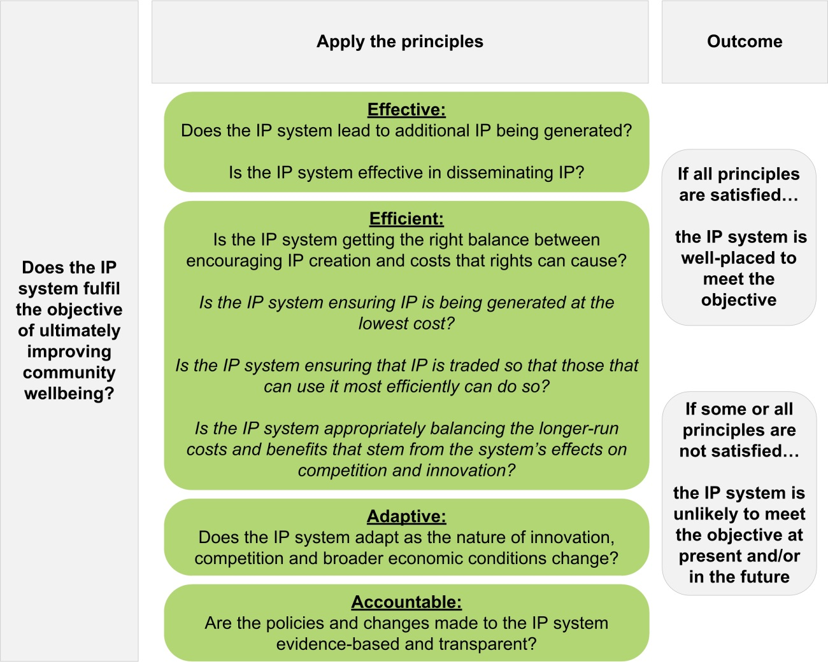

Do not delete this RETURN as it gives space between the info request and what precedes it.
Are there other principles that should be considered when assessing the IP rights system? Are there other factors relating to efficiency, effectiveness, adaptability and accountability that the Commission should consider as part of its inquiry?
The application of the framework is likely to vary between different parts of the IP system. For example, the law governing one sort of IP right may not be as ‘efficient’ as the law pertaining to another right. This means that the principles embodied in the Commission’s proposed framework have to be applied holistically — and flexibly — to each part of the system. The next section explains how this approach would work for different types of IP rights.

4 Improving arrangements for specific forms of IP
The nature of the balance between IP creators and users varies across the different forms of IP, and is affected by a range of policy levers such as the nature, scope and duration of protection, the presence of exceptions and limitations, and options for enforcement (figure 4).
IP rights also vary in their ability to adapt to change. The apparent inability of some aspects of the system to effectively deal with new circumstances has prompted the emergence of new, specific rights. In other cases, individuals and businesses can be uncertain as to whether they are likely to infringe the IP rights of others.
The rest of this issues paper covers issues and questions in relation to Australia’s specific forms of IP.

Figure 4 Applying the framework to IP arrangements
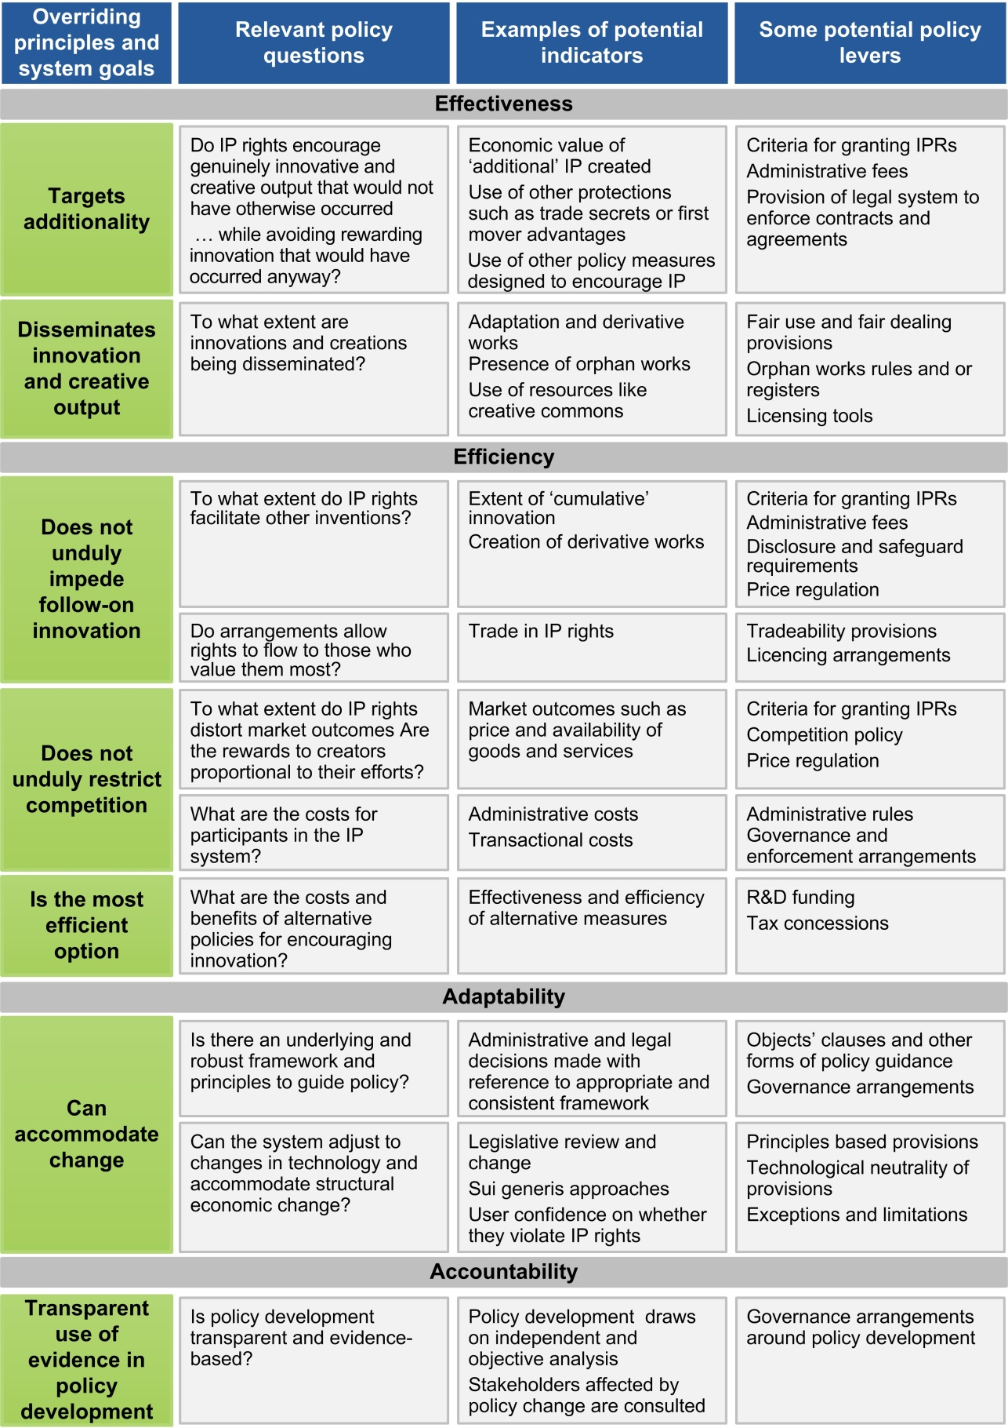

Patents
Australia’s patent system aims to promote innovation by providing firms with exclusive rights to commercially exploit their inventions. Patents are used in a wide range of industries — from medical technology and pharmaceuticals through to electrical machinery and apparatus. ‘Standard patents’ are granted for inventions deemed novel, inventive and useful compared with current knowledge. Most standard patents can last up to 20 years (pharmaceutical patents can last 25 years). ‘Innovation patents’ have a lower inventive threshold than standard patents, with the tradeoff being a lower maximum term of 8 years.
Multiple features of the patent system influence outcomes for the community, including the scope and length of patent protection, administrative rules and processes for granting patents, and legal remedies for protecting patent rights. Policy makers may also design patent systems to address equity and ethical objectives.
Partial evidence on the effects of patent protection on innovation and community welfare makes designing an effective and efficient patent system challenging. Debate exists about whether the benefits of patent protection outweigh the costs; for example, whether patents impede ‘follow-on’ innovations that build on patented inventions. While the empirical evidence sheds some light on the various tradeoffs at play, the evidence varies across sectors of the economy.
A survey of recent research concluded that if there is an increase in innovation due to patents, it is likely to be concentrated in a subset of industries, including pharmaceuticals, biotechnology and medical instruments (Hall and Harhoff 2012). The research suggests that outside of these fields, there are other, more important, means to appropriate returns to innovation.
Digital technologies and the way firms innovate add to the challenges of designing an effective and efficient patent system. Australia’s patent system has expanded to cover new sectors and innovations — such as software and business methods — and the growing importance of cumulative research in areas such as information technology and medical instruments has increased the risk of the patent system impeding follow-on innovation. At the same time the patent system has had to accommodate technological and other changes, global frameworks and bilateral and regional trade agreements are a constraint on IP policy flexibility.
Reflecting some of these difficulties, IP policy in Australia has been the subject of recent reviews and reforms. The Intellectual Property Laws Amendment (Raising the Bar) Act 2012 (Cwlth) raised the inventive step and standard of proof required for an invention to be granted patent protection. A review into pharmaceutical patents recommended reducing the maximum effective life of pharmaceutical patents that receive an extension of term by between 3 and 5 years (Harris, Nicol and Gruen 2013). Following recent reviews into the innovation patent system, IP Australia is currently consulting with stakeholders on whether the system should be abolished.
This inquiry provides an opportunity for the Commission to assess recent reforms to the patent system and whether further reform would provide net benefits to the community.
Do not delete this RETURN as it gives space between the info request and what precedes it.
What evidence is there that patents have facilitated innovations that would not have otherwise occurred, or have imposed costs on the community, including by impeding follow-on innovation?
Are there aspects of Australia’s patent system that act as a barrier to innovation and growth? If so, how could these barriers be addressed?
Do patents provide rewards that are proportional to the effort to generate IP? What evidence is there to show this? How should effort be measured? How does the balance of costs and benefits from patent protection compare across sectors and innovations?
What scope is there to better leverage the economic benefits of patents, by taking steps to improve the diffusion of patent information?
Is the patent system sufficiently flexible to accommodate changes in technology and business practices?
Do the criteria for patentability in the Patents Act 1990 (Cwlth) help the patent system to meet its objectives? Would introducing economic criteria for patentability and/or gradually reducing the duration of patent protection substantially improve the efficiency and effectiveness of the patent system?
Is the existing coverage of patents optimal? Are there areas of innovation that should be included/excluded? Should the duration of patent protection take into account how the development of IP was funded?
Are there any issues with the administrative arrangements of IP Australia for assessing and granting patents?

Data protection
Data protection operates separately but often in parallel to the patent system. It prevents unauthorised use of test data used to apply for regulatory approval of products such as therapeutic goods and agricultural products. The protection of data has become a source of debate, particularly in relation to biologics, with some arguing that the scope and length of data protection (currently five years) should be extended to match the length offered in other jurisdictions such as the United States, European Union and Japan. Others argue that extending data protection provides only limited benefits for the manufacturers of original pharmaceutical products and has little impact on the level of pharmaceutical investment (Harris, Nicol and Gruen 2013).
Do not delete this RETURN as it gives space between the info request and what precedes it.
How does Australia’s current protection of regulatory test data affect innovation and the diffusion of new products?
Do data protection arrangements limit the ability of parties to understand breakthroughs and build on innovation?
Could Australia’s arrangements for the protection of test data be improved?

Copyright
Copyright protects the original expression, in a material form, of ideas or information. Literary, musical, artistic and dramatic works can all qualify for copyright protection. Copyright also separately protects sound recordings, films, television and radio broadcasts, and books.
Similar to other IP laws, copyright seeks to encourage creative output by granting ‘exclusive rights’ to creators to enable them to deal commercially with their works. Creators commonly licence their work to intermediaries, such as publishers, record companies, film studios, broadcasters, and copyright collecting agencies to bring their creations to market. A range of exceptions allow people to use copyright material without penalty.
Unlike patents, copyright applies at a very low threshold to works that are merely ‘original’ rather than innovative or useful. And unlike patents, which offer variable degrees of protection to inventors through the provision of innovation and standard patents, copyright applies uniformly to all new works, offering a standard scope and period of protection.
Copyright law also grants creators ‘moral rights’, protecting a creator’s claim of authorship and preventing their work from derogatory treatment. Moral rights are a recent addition to the Australian copyright system, having been introduced in 2000 and extended in 2004. Debate exists about the purpose and effect of moral rights, and whether they are primarily personal rights or have economic effects similar to the underlying copyright in a work.
The scope and duration of copyright fundamentally impacts the tradeoff between creators and users. Both have been subject to recent change, predominantly as a result of the Australia-United States Free Trade Agreement. The term of copyright protection has been extended, new rights have been created (such as the right to communicate a work to the public), measures introduced to prevent circumventing technological protections, and exceptions made to allow consumers to time- and format-shift content for greater convenience.
Debate on changes to copyright focuses on the benefits and costs imposed on Australians, both as consumers and producers of creative works. Empirical assessment of the costs and benefits is difficult, both in assessing the impact of those agreements Australia has already joined, and for assessing the prospective impacts of any new agreement.

Modern pressures on an old system
Copyright protection for creative works has existed for centuries, and Australia passed its first national copyright law in 1905. But copyright — perhaps more than other IP rights — is facing significant challenges in the modern, digital era. The rapid growth of internet use in Australia offers both enormous benefits and costs for creators, and ‘digital natives’ — those who have grown up since mass adoption of the internet — are challenging many of the long-held precepts of copyright law.
- The internet allows creators to market and sell their works to consumers directly, both in Australia and overseas, reducing the need for (and returns to) intermediaries. Discovery and derivative use of copyright works easier, but has also made copyright infringement easier and cheaper.
- Rights holders have increasingly demanded internet service providers (ISPs) take responsibility for copyright infringement on their networks, and in some instances have demanded customer details be handed over, at a time when consumers are increasingly concerned about privacy.
- Technology rapidly changes. Smart phones are still relatively new. Applications capable of live-streaming television broadcasts and online subscriptions to music catalogues did not exist even five years ago. Archiving and accessing data has become increasingly important. Yet copyright protections and exceptions are very prescriptive and, many argue, are insufficiently flexible to cope with rapid change.
Do not delete this RETURN as it gives space between the info request and what precedes it.
To what extent does copyright encourage additional creative works, and does the current law remain ‘fit for purpose’? Does the ‘one size fits all’ approach to copyright risk poorly targeting the creation of additional works the system is designed to incentivise?
Are the protections afforded under copyright proportional to the efforts of creators? Are there options for a ‘graduated’ approach to copyright that better targets the creation of additional works?
Is licensing copyright-protected works too difficult and/or costly? What role can/do copyright collecting agencies play in reducing transaction costs? How effective are new approaches, such as the United Kingdom’s Copyright Hub in enabling value realisation to copyright holders?

Are moral rights necessary, or do they duplicate protections already provided elsewhere (such as in prohibitions on misleading and deceptive conduct)? What is the economic impact of providing moral rights?
What have been the impacts of the recent changes to Australia’s copyright regime? Is there evidence to suggest Australia’s copyright system is now efficient and effective?
What should be considered when assessing prospective changes to copyright, and what data can be drawn on to make such an assessment?
How should the balance be struck between creators and consumers in the digital era? What role can fair dealing and/or fair use provisions play in striking a better balance?
Are copyright exemptions sufficiently clear to give users certainty about whether they are likely to infringe the rights of creators? Does the degree of certainty vary for businesses relative to individual users?
Do existing restriction on parallel imports still fulfil their intended goals in the digital era?
To be efficient and effective in the modern era, what (if any) changes should be made to Australia’s copyright regime?

Designs
The appearance of products, such as their shape, configuration, pattern and ornamentation can be protected under the Designs Act 2003 (Cwlth). Examples of designs include garments, tools, electronics and packaging. Design rights represent a small share of IP rights activity in Australia.
Registering a design protects a product’s appearance, but not its function or operation, which is the purview of patents. Some designs may also be protected by copyright law, typically one-off works such as pictures or artistic objects, as opposed to designs that are ‘industrially applied’ (that is, reproduced and sold).
Protection of designs under the Designs Act occurs over two stages — registration and certification. Registration is automatic, provided that filing formalities are met. Around 5000 to 7000 designs are registered in Australia annually. A registered owner has an exclusive right to use, and authorise others to use, their design. This protection lasts for a maximum of 10 years, with renewal required after five years. Less than 20 per cent of designs are renewed after five years (ACIP 2015a).
However, the rights on a registered design are only enforceable once it has been examined and certified to confirm it is ‘new and distinctive’. This incurs an extra cost to the registered owner. Only around one in eight registered designs are examined and certified (Bowman and Lloyd 2011). This low certification rate reflects the fact that design rights only need to be enforced in a small number of cases. Indeed, registration on its own may prevent others copying a design in the first place.
The Designs Act was updated in 2003 in response to concerns that creators found it difficult to enforce their rights (ALRC 1995). While the new Act reduced the burden for creators to prove an infringement, this was balanced by raising the eligibility threshold and reducing the period of protection from 16 to 10 years.
The effectiveness and efficiency of the new Act in stimulating innovation and its impacts on economic growth were examined by the Advisory Council on Intellectual Property (ACIP) in the Review of the Designs System, which was completed in March 2015. In making its recommendations, ACIP noted that the current system ‘is expensive for what it offers, and is, as a result, neglected by designers who find it does not offer the rights they need’ (ACIP 2015a, p. 41). This was consistent with the survey findings of Lim et al. (2014) that applying for IP rights on designs was not seen as a valuable use of time compared with efforts to get to market first. Moreover, they found IP rights were not actively considered during the design process.
Do not delete this RETURN as it gives space between the info request and what precedes it.
What role do design rights play in fostering innovation? To what extent do design rights encourage additional innovation?
Are there continuing issues with the overlap between design rights and copyright or other forms of protection?
Are the protections afforded under design rights proportional to the efforts of innovators? Is the design rights system cost effective for users?

Trade marks
Trade marks allow firms to differentiate themselves in the market, providing an incentive to improve the quality of their goods and maintain a positive reputation. At face value, trade marks assist consumers by reducing the search and transaction costs they might otherwise incur in distinguishing between products.
Trade marks can be granted over a wide range of elements including letters, numbers, words, phrases, sounds, smells, shapes, logos, pictures and/or aspects of packaging (IP Australia 2015b). Registering a trade mark grants a 10 year period of exclusive use, and can be repeatedly renewed. Trade marks are a popular form of IP protection. More than 64 000 trade mark applications were filed with IP Australia in 2014 (compared with 25 974 patent applications and 6596 applications for registered designs in the same year) (IP Australia 2015a, p. 8,12,15).
In some ways, trade mark law plays a similar role to the tort of ‘passing off’ — where it is unlawful to misappropriate another’s reputation — as both provide incentives for investment in product quality and reputation (Intellectual Property and Competition Review Committee 2000, p. 187). There are also protections in the Competition and Consumer Act 2010 (Cwlth) and fair trading laws at the state and territory level, which make it unlawful to mislead or deceive consumers.
Firms need not register brands as trade marks, but there are benefits in doing so. If a registered trade mark is infringed, a firm need only prove that an infringement has occurred, whereas firms with unregistered trade marks must also prove that the disputed mark is associated with its products. Parties who counterfeit or infringe registered trade marks are subject to penalties under the Trade Marks Act 1995 (Cwlth). While trade marks can be used to help protect a brand, there have been some attempts by firms to ‘push the boundaries’ by being deliberately broad in terms of what they try to register. Examples include attempts by some firms to trade mark particular colours. This can make it difficult for new and existing businesses to secure their branding and reputation — and potentially lead to a reduction in competition.
Another way in which trade marks potentially impact on competition relates to parallel imports. A firm that has licensed a trade mark for use in Australia may be able to prevent others from importing and selling goods with the same trade mark. While the Trade Marks Act 1995 (Cwlth) does contain provisions about when parallel imports may be allowed, there is uncertainty about the costs and benefits of allowing such parallel imports to occur and whether recent findings have ‘muddied the waters’ to the point where firms are unsure whether they are able to import or not.
Do not delete this RETURN as it gives space between the info request and what precedes it.
Are trade marks operating as an effective and efficient method for firms to protect their brand and reputation? Is the cost of preparing an objection or defending a trade mark infringement reasonable? How could the system for registering and using trade marks be improved?
Where should the line be drawn between defending a firm’s branding through trade marks to the benefit of both consumers and producers and attempts to use trade marks to inhibit competition? What sort of tests could be used to identify when trade marks are being used in anticompetitive ways?
Are trade marks working effectively and fairly when it comes to competing claims to similar or identical branding? Are there changes that could improve how trade marks operate in this regard?
The Commission welcomes submissions in relation to the costs and benefits of changing the way that trade marks are administered to allow for parallel importation.

Plant breeder’s rights
Plant breeder’s rights (PBR) are a form of IP granted to breeders of new plant varieties and were introduced with a view to stimulating plant breeding efforts in Australia and to encourage the development of new varieties of plants for domestic industries and for export. It was expected that the introduction of PBRs would also improve access by Australian farmers and horticulturists to new varieties from overseas.
PBRs allow for the exclusive right to commercially exploit the registered plant variety. In general, PBR protection applies for 25 years for grapevines and trees, and 20 years for all other plant species.
PBRs are a relatively recent phenomenon. Even so, concerns are emerging that technological changes (such as molecular plant breeding techniques) are altering the focus of plant breeding activity and potentially making PBRs (which are based on differences such as morphological characteristics) an uncertain and unsuitable form of protection.
Do not delete this RETURN as it gives space between the info request and what precedes it.
The Commission seeks evidence from plant breeders and other stakeholders (particularly farmers and farmer representatives) on whether the introduction of PBRs has led to a more productive and profitable agriculture sector in Australia than would have been the case under general IP protections.
Is there quantitative evidence to show that the introduction of PBRs led to an increase in the quality and quantity of new plant varieties, and an increase in the role of the private sector in plant breeding?
Are the protections afforded under PBRs proportional to the efforts of breeders?
Is there evidence the introduction of PBRs has contributed to the development of Australia’s seed export industry? Is this a suitable role for IP policy?
How adaptable is the system of PBRs to technological change? Should PBR legislation be amended in light of technological developments, or can new high-value plant varieties (however they are developed) be adequately supported by patent laws?

Circuit layout rights
Circuit layout rights cover the topography and layout of integrated circuits, and provide creators with certain exclusive but time-limited rights. These include the right to copy the layout and to commercially exploit the layout for a period of 10 years. As with copyright law, Australian developers of integrated circuits do not need to register their layouts.
Circuit layout rights were introduced in Australia in 1989 in anticipation of the Washington Treaty on Intellectual Property in respect of Integrated Circuits. The introduction of circuit layout rights came about in response to growing industry concerns in the United States regarding piracy.
Do not delete this RETURN as it gives space between the info request and what precedes it.
What is the economic justification for a specific system of rights covering circuit layouts? In particular, the Commission seeks evidence from integrated circuit developers and other stakeholders in Australia regarding:
- the extent to which circuit layout rights are utilised in Australia
- the efficiency and effectiveness of circuit layout rights (as opposed to other related protections, such as patents or trade secrets or being first to market) in reducing piracy and encouraging innovation.
What costs would be incurred if such rights were abolished?

Geographical Indications
A Geographical Indication identifies goods as originating in a specific territory, region or locality where a particular quality, reputation or other characteristic is essentially attributable to its geographical origin (IP Australia 2013). As such, it plays a similar role to trade marks: providing better information to consumers of goods while providing an incentive for producers to invest and build their reputation. For most goods, a Geographical Indication can be secured through a form of trade mark, or by the same protections in civil law that prevent ‘passing-off’. There are also specific provisions for Geographical Indications when it comes to wine and spirits that result from some of Australia’s international trade and treaty obligations.
Do not delete this RETURN as it gives space between the info request and what precedes it.
The Commission welcomes submissions on how effective and efficient Geographical Indications are in terms of protecting IP, including on a firm’s branding and reputation. Submissions on how Geographical Indications may help or hinder competition and consumer outcomes are also welcomed.

5 The broader intellectual property landscape

Institutions play an important role in the IP system
A range of institutions are responsible for allocating, administering and enforcing IP rights in Australia. Development of IP policy is also a shared responsibility (figure 5). Key public institutions include IP Australia, which administers laws relating to patents, trade marks, designs, some geographical indications and plant breeder’s rights, and the Department of Communications and the Arts, which administers copyright law.
Private institutions that lower the costs of coordinating the shared use of innovations have emerged, including creative commons communities and patent pools.

Figure 5 The institutional landscape
The growing international exploitation of knowledge-based assets and the ‘territorial’ nature of rights has led to pressures on the international institutional system. Both the World Trade Organisation (WTO) and WIPO seek to achieve a multilateral approach to setting and enforcing IP. The Department of Foreign Affairs and Trade has lead responsibility for negotiating Australia’s international commitments on IP both through these two bodies and on a regional and bilateral basis.
The institutions involved in defining, allocating, and enforcing IP rights have important impacts on outcomes for the Australian community. Policy makers shape public institutions by setting governance arrangements and establishing organisational and legislative objectives. The quality of the information and evidence base upon which they rely, and the transparency of their policy formulation processes are critical for achieving welfare enhancing outcomes.

Do not delete this RETURN as it gives space between the info request and what precedes it.
Are there reforms to public institutions involved in defining, allocating and enforcing IP rights in Australia that would provide net benefits to the community?
How can processes for formulating IP policy — be it ultimately embodied in domestic law or an international agreement — better harness available evidence? How can the tradeoffs implicit in IP policy be more comprehensively accounted for in policy making processes?
How does Australia formulate its position on IP policy in the context of international agreements? What evidence and analysis informs decision-making and negotiating positions along the way and is this adequate and sufficiently transparent?
To what extent does the work of WIPO and the WTO impact on Australian policy settings?
Are international institutions being sidelined or marginalised in an increasingly plurilateral or bilateral negotiating process?

Enforcing IP rights
The value of IP rights to creators — and the value of exceptions to users — depends on the ability of both sides to enforce their rights. Enforcement mechanisms weighted too far in favour of rights holders may increase the value of IP rights over and above what is necessary to incentivise creative or innovative works. Conversely, enforcement mechanisms that are too costly or lengthy, or have rules of evidence or procedure that are too stringent, can unduly lower the value of IP.
‘Enforcement’ likely means different things to rights holders and users, but can include the ability of a patent holder to stop an alleged infringer from producing copies of their goods, a public interest organisation challenging the validity of a patent claim, a firm challenging the use of a trade mark or geographical indication, or an artist seeking to prevent infringing copies of their work being shared online.
There is mixed evidence about whether enforcement of IP in Australia is too easy or too hard. Anecdotally, some creators argue it is almost impossible to stop copyright or patent infringements, while some organisations and individuals claim that defending a case of alleged infringement is too costly. In the case of online copyright infringement in particular, creators have argued the process for seeking customer details from ISPs is too expensive and takes too long. Other groups argue safe harbour regimes make ISPs into ‘copyright police’, and the practice of ‘speculative invoicing’ threatens alleged infringers into paying rights holders, without infringement being proven in court.
It is unlikely rights holders or consumers are completely satisfied with the current regime.
Specialised courts may create benefits through accumulated experience and potentially reduce costs for stakeholders involved in legal proceedings. The Commission intends to examine international approaches to enforcement, such as the model adopted by the UK Intellectual Property Enterprise Court.
Do not delete this RETURN as it gives space between the info request and what precedes it.
Are IP rights too easy or hard to enforce in Australia, and if so, why?
To what extent can Australian firms enforce their IP rights internationally? Does this differ across regions and/or countries?
Which features of the current enforcement system work well, and which could be improved?
Is the role expected of ISPs a practical option?
Are there particular issues relating to IP enforcement that are different from the general community’s ability to access Australia’s justice system, and if so, what are they?
Is Australia’s enforcement system well balanced, or weighted in favour of one group?
What improvements could Australia adopt from overseas approaches?

International obligations constrain domestic flexibility
Australia’s domestic IP legislation is strongly influenced by its commitment to international conventions and agreements. Accession to agreements has been one of the major drivers for strengthening IP protections. Two examples stand out as increasing the scope and term of IP rights:
- the WTO Agreement on Trade-Related Aspects of Intellectual Property Rights (TRIPS)
- bilateral and regional trade agreements, and in particular the Australia-United States Free Trade Agreement.

The TRIPS Agreement
The WTO Agreement on TRIPS is the most comprehensive multilateral agreement on IP covering the protections of patents (including the protection of new varieties of plants), copyright and related rights, trade marks, geographical indications, industrial designs, integrated circuit layouts and undisclosed information (trade secrets and test data).
TRIPS establishes a basic structure for IP rights in member countries by setting minimum standards of protection and requiring procedures and remedies for enforcement and dispute settlement (DFAT 2015). Parties have the right to implement higher levels of protection as long as they apply the general principles of national treatment and most-favoured-nation treatment.

Bilateral and regional trade agreements
Although IP protections have traditionally fallen within the domain of domestic legislation and multilateral agreements, in recent years they have also been included in Australia’s bilateral and regional trade agreements (BRTAs).
Some of Australia’s existing BRTAs encourage partner countries to join or reaffirm commitments to multilateral IP treaties including the TRIPS Agreement. However, Australia’s agreement to the Australia–United States Free Trade Agreement required an increase in protections for IP rights beyond the levels required by TRIPS.
The Trans Pacific Partnership (TPP) Agreement — negotiated between 12 countries in the Asia Pacific region — raised concerns among some interested parties about the nature of IP provisions in trade agreements. Most significantly, these concerns related to reported proposals to extend the protection provided by pharmaceutical patents, data exclusivity periods and copyright terms, and may extend to potential use of investor state dispute settlement provisions. With the recent conclusion of negotiations, the Australian Government (2015) has stated that the TPP will not require any changes to Australia’s patent system or copyright regime, and no change will be made to the five year data protection term for biologic medicines.
Australia’s participation in BRTAs has seen an ongoing debate about whether the approach to IP in trade agreements is in the best interests of either Australia or its trading partners. The debate centres on whether:
- the outcomes in BRTAs have struck the right balance. For example, analysis indicates extending the duration of copyright protection from 50 years to 70 years after the death of the author, as required by the Australia–United States Free Trade Agreement, imposed net costs through increased royalty payments (PC 2010).
- BRTAs reduce domestic flexibility through the inclusion of IP and/or Investor State Dispute Settlement provisions.
The Commission has previously expressed the view that Australia’s participation in international negotiations in relation to IP laws should focus on plurilateral and multilateral settings, including through multilateral treaties and international organisations such as WIPO and the WTO.

Do not delete this RETURN as it gives space between the info request and what precedes it.
The Commission seeks input on the impact of Australia’s international IP obligations on domestic innovation, production, trade and consumption. Has a move towards stronger IP rights served Australia’s economic interests? Is there a case for Australia to pursue stronger IP rights in excess of minimum standards for particular types of rights or specific technologies?
What are the main constraints on IP policy imposed by the TRIPS Agreement and other international agreements? What scope is there to adjust Australia’s domestic IP legislation without violating the provisions of TRIPS and other international agreements?
What mechanisms other than adjusting the scope and duration of IP rights could be used to more effectively influence domestic IP settings?
To what extent do investor state dispute settlement provisions impede or prevent changes to domestic IP legislation?
What principles should guide decision making for future international negotiations on IP rights?

References
ACIP (Advisory Council on Intellectual Property) 2015a, Review of the Designs System, Final Report, March.
—— (Advisory Council on Intellectual Property) 2015b, Review of the Innovation Patent System: Final Report, May.
ALRC (Australian Law Reform Commission) 1995, Designs, ALRC Report 74, June, Sydney.
—— (Australian Law Reform Commission) 2013, Copyright and the Digital Economy, ALRC Report 122, November, Sydney.
Aoki, R. and Small, J. 2004, ‘Compulsory licensing of technology and the essential facilities doctrine’, Information Economics and Policy, vol. 16, pp. 13–29.
Australian Government 2015, Trans-Pacific Partnership (TPP) pact to drive jobs, growth and innovation for Australia, Media release, 6 October 2015, Minister for Trade and Investment, the Hon Andrew Robb MP.
Bowman, B. and Lloyd, M. 2011, Protected by Design: The changing face of registered design protection in Australia, Griffith Hack, Melbourne.
DFAT (Department of Foreign Affairs and Trade) 2015, Intellectual Property.
Hall, B. and Harhoff, D. 2012, Recent Research on the Economics of Patents, Working Paper, 17773, NBER Working Paper Series.
Harris, T., Nicol, D. and Gruen, N. 2013, Pharmaceutical Patents Review Report.
Hockey, J. 2015, Productivity Commission inquiry into Australia’s intellectual property arrangements, http://jbh.ministers.treasury.gov.au/media-release/073-2015/ (accessed 25 September 2015).
Intellectual Property and Competition Review Committee 2000, Review of intellectual property legislation under the Competition Principles Agreement.
IP Australia 2013, Geographical Indications, http://www.ipaustralia.gov.au/get-the-right-ip/trade-marks/types-of-trade-marks/certification-trade-mark/geographica-indications/ (accessed 14 September 2015).
—— 2015a, Australian Intellectual Property Report 2015, Canberra.
—— 2015b, Trade Marks, http://www.ipaustralia.gov.au/get-the-right-ip/trade-marks/ (accessed 10 September 2015).
Johnson, M., Mitra-Kahn, B., Bialowas, A., Man, B., Nicholson, P. and Bakhtiari, S. nd, The economic impact of innovation patents, Economic Research Paper 05, IP Australia, Canberra.
Lim, K., O’Sullivan, D. and Falk, M. 2014, The market for design: insights from interviews with Australian firms, IP Australia Economic Research Paper 03, IP Australia, Canberra.
Maskus, K. 2000, International Property Rights in the Global Economy.
OECD (Organization for Economic Co-operation and Development) 2015, Enquiries into Intellectual Property’s Economic Impact, OECD Publishing, Paris.
OECD, WTO & World Bank Group (Organisation for Economic Co-operation and Development, World Trade Organisation and World Bank Group) 2014, Global Value Chains: Challenges, Opportunities, and Implications for Policy, Report prepared for the G20 Trade Ministers Meeting, Sydney.
PC (Productivity Commission) 2010, Bilateral and Regional Trade Agreements, Research report, Canberra.
Stiglitz, J. 2008, ‘Economic foundations of intellectual property rights’, Duke Law Journal, vol. 57, pp. 1693–1724.
WIPO (World Intellectual Property Organization) 2011, World Intellectual Property Report: The Changing Face of Innovation, Geneva.
—— (World Intellectual Property Organization) nd, What is Intellectual Property?, http://www.wipo.int/about-ip/en/ (accessed 2 October 2015).

Attachment A — How to make a submission
The Commission invites interested people and organisations to make a written submission.
Each submission, except for any information supplied in confidence (see below), will be published on the Commission’s website shortly after receipt, and will remain there indefinitely as a public document. The Commission reserves the right to not publish material on its website that is offensive, potentially defamatory, or clearly out of scope for the inquiry or study in question.
When providing a submission to the Commission, you may wish to remain anonymous or use a pseudonym. Please note that, if you choose to remain anonymous or use a pseudonym, the Commission may place less weight on your submission.
Copyright in submissions sent to the Commission resides with the author(s), not with the Commission. Submitters should ensure that they hold copyright in any submitted documents, or that the copyright holder has authorised the publication of any relevant documents on the Commission’s website.

How to prepare a submission
Submissions may range from a short letter outlining your views on a particular topic to a much more substantial document covering a range of issues. Where possible, you should provide evidence, such as relevant data and documentation, to support your views.
This is a public review and all submissions should be provided as public documents that can be placed on the Commission’s website for others to read and comment on. However, information which is of a confidential nature or which is submitted in confidence can be treated as such by the Commission, provided the cause for such treatment is shown. The Commission may also request a non-confidential summary of the confidential material it is given, or the reasons why a summary cannot be provided. You are encouraged to contact the Commission for further information and advice before submitting such material. Material supplied in confidence should be provided under separate cover and clearly marked ‘IN CONFIDENCE’.

How to lodge a submission
Each submission should be accompanied by a submission cover sheet. The submission cover sheet is available on the study web page. For submissions received from individuals, all personal details (for example, home and email address, signatures, phone, mobile and fax numbers) will be removed before they are published on the website for privacy reasons.

The Commission prefers to receive submissions as Microsoft Word (.docx) files. PDF files are acceptable if produced from a Word document or similar text based software. You may wish to research the Internet on how to make your documents more accessible or for the more technical, follow advice from Web Content Accessibility Guidelines (WCAG) 2.0 <http://www.w3.org/TR/WCAG20/>.
Do not send password protected files. Do not send us material for which you are not the copyright owner — such as newspaper articles — you should just reference or link to this material in your submission.
Track changes, editing marks, hidden text and internal links should be removed from submissions before sending to the Commission. To ensure hyperlinks work in your submission, the Commission recommends that you type the full web address (for example, http://www.referred-website.com/folder/file-name.html).
Submissions sent by email must not exceed 20 megabytes (Mb) in size as our email system cannot accept anything larger. If your submission is greater than 20 Mb in size, please contact the Administrative Coordinator (Pragya Giri, (02) 6240 3250)) to organise another method of sending your submission to the Commission.
Submissions can be accepted by email or post:
Email* | intellectual.property@pc.gov.au
Post | Intellectual Property Arrangements  Productivity Commission  GPO Box 1428  Canberra City ACT 2601
* If you do not receive notification of receipt of an email message you have sent to the Commission within two working days of sending, please contact the Administrative Officer.

Due date for submissions
Please send submissions to the Commission by Monday 30 November 2015.

In this issues paper, the Commission uses the term ‘creators’ to refer to those who engage in the development of knowledge-based assets.
Official versions of the proposed TPP Agreement text have not been released. Concerns are based on media reports regarding the purported text.

