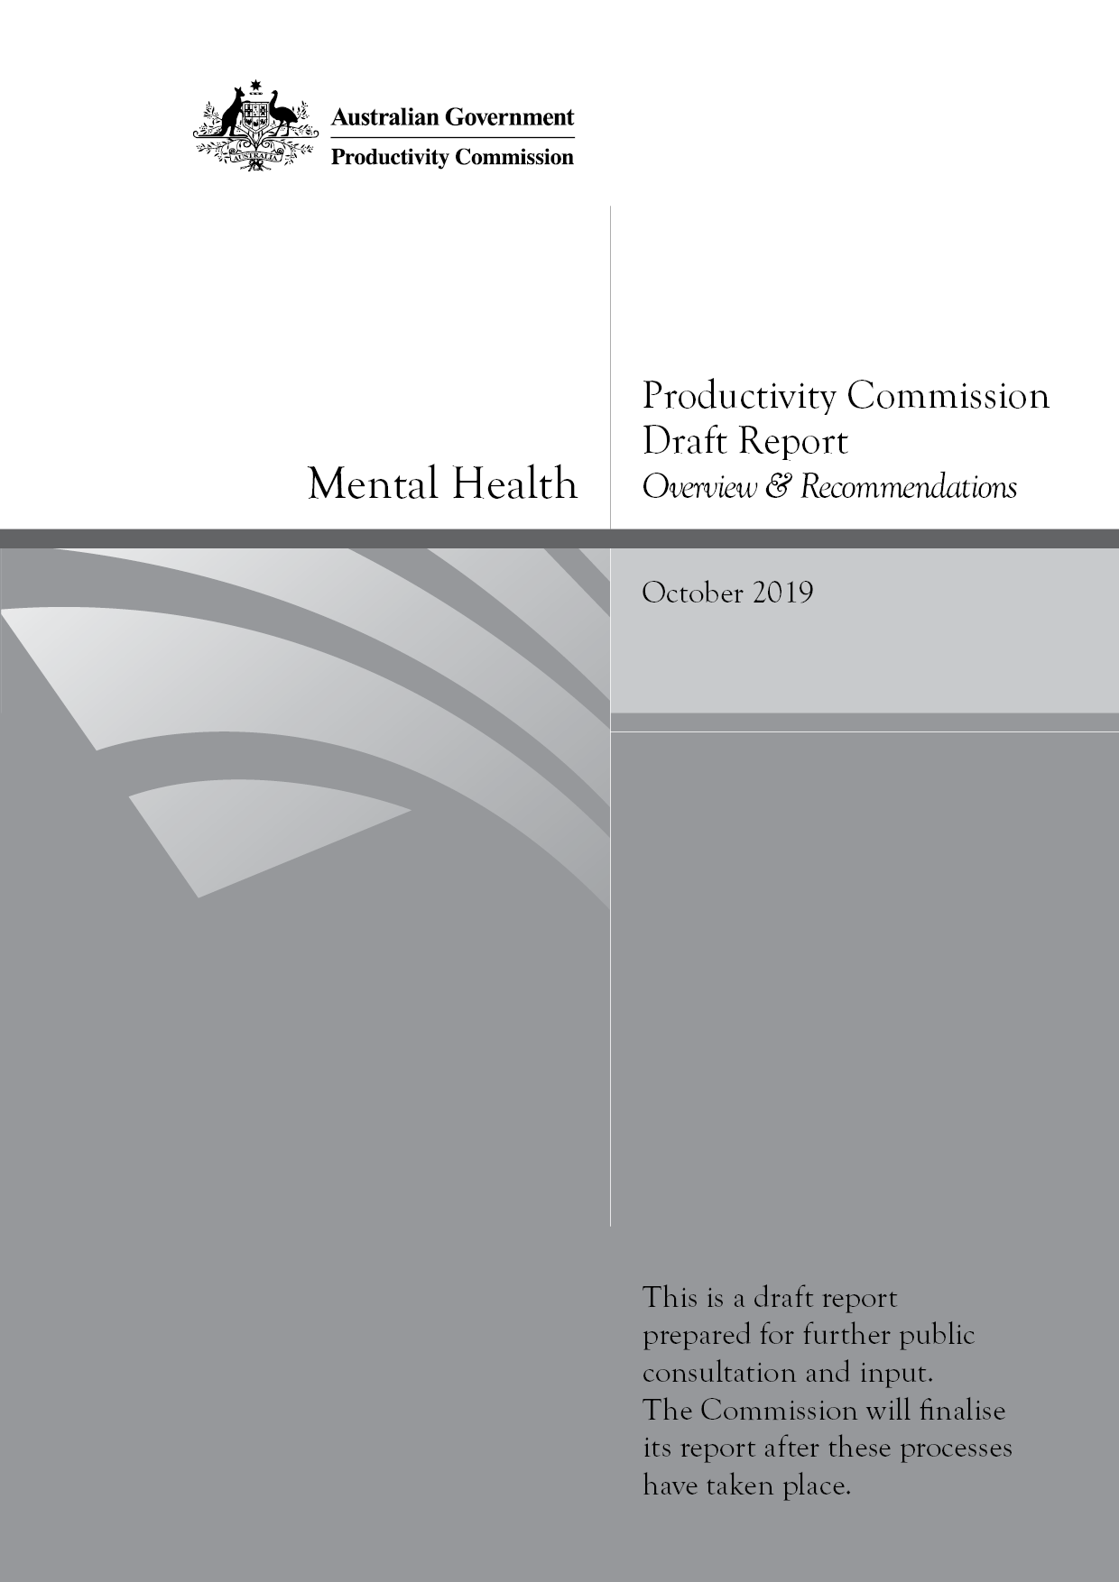
Mental Health
Productivity Commission Draft Report, Overview & Recommendations, Canberra

Commonwealth of Australia 2019

Except for the Commonwealth Coat of Arms and content supplied by third parties, this copyright work is licensed under a Creative Commons Attribution 3.0 Australia licence. To view a copy of this licence, visit http://creativecommons.org/licenses/by/3.0/au. In essence, you are free to copy, communicate and adapt the work, as long as you attribute the work to the Productivity Commission (but not in any way that suggests the Commission endorses you or your use) and abide by the other licence terms.
Use of the Commonwealth Coat of Arms
Terms of use for the Coat of Arms are available from the Department of the Prime Minister and Cabinet’s website: www.pmc.gov.au/government/commonwealth-coat-arms
Third party copyright
Wherever a third party holds copyright in this material, the copyright remains with that party. Their permission may be required to use the material, please contat them directly.
Attribution
This work should be attributed as follows, Source: Productivity Commission, Mental Health, Draft Report.
If you have adapted, modified or transformed this work in anyway, please use the following, Source: based on Productivity Commission data, Mental Health, Draft Report.
An appropriate reference for this publication is:
Productivity Commission 2019, Mental Health, Draft Report, Canberra
Publications enquiries
Media, Publications and Web, phone: (03) 9653 2244 or email: mpw@pc.gov.au

The Productivity Commission
The Productivity Commission is the Australian Government’s independent research and advisory body on a range of economic, social and environmental issues affecting the welfare of Australians. Its role, expressed most simply, is to help governments make better policies, in the long term interest of the Australian community.
The Commission’s independence is underpinned by an Act of Parliament. Its processes and outputs are open to public scrutiny and are driven by concern for the wellbeing of the community as a whole.
Further information on the Productivity Commission can be obtained from the Commission’s website (www.pc.gov.au).

Opportunity for further comment
We invite examination of this draft inquiry report and comment on it by written submission or comment to the Productivity Commission, preferably in electronic format, by 23 January 2020 and/or by attending a public hearing.
The final report will be prepared after further submissions and comments have been received and public hearings have been held and will be forward to the Australian Government by end May 2020.

Public hearing dates and venues
Location | Date | Venue
Canberra | Friday 15 November 2019 | Dialogue  4 National Circuit, Barton
Melbourne | Monday 18 November 2019  Tuesday 19 November 2019 | Rattigan Rooms 1-2  L12, 530 Collins Street, Melbourne
Geraldton | Wednesday 20 November 2019 | The Geraldton Club  160 Marine Terrace
Perth | Thursday 21 November 2019 | Pan Pacific Perth  207 Adelaide Street
Sydney | Monday 25 November 2019  Tuesday 26 November 2019 | Wesley Conference Centre  220 Pitt Street
Broken Hill | Thursday 28 November | Broken Hill Civic Centre  31 Chloride Street
Rockhampton | Monday 2 December 2019 | Quality Hotel Regent Rockhampton  192 Bolsover Street
Brisbane | Tuesday 3 December 2019 | Flex by ISPT (Dialogue)  Central Plaza Annex Bldg  345 Queen Street
Launceston | Monday 9 December 2019 | Launceston Conference Centre  50 Glen Dhu Street
South Australian and Northern Territory Public Hearings will be held at dates and locations to be advised in early 2020

Commissioners
For the purposes of this inquiry and draft report, in accordance with section 40 of the Productivity Commission Act 1998 the powers of the Productivity Commission have been exercised by:
Prof. Stephen King | Presiding Commissioner
Ms Julie Abramson | Commissioner
Prof. Harvey Whiteford | Associate Commissioner

Disclosure of interests
The Productivity Commission Act 1998 specifies that where Commissioners have or acquire interests, pecuniary or otherwise, that could conflict with the proper performance of their functions during an inquiry they must disclose the interests.
Professor King has advised the Commission that he is Adjunct Professor at Monash University. He is married to a Psychologist who is in private practice.
Ms Abramson has advised the Commission that she is a Council Member and Chair of the Regulatory Risk Committee of the Photography Studies College, a dual sector higher education provider.
Professor Whiteford has advised the Commission that he is a Fellow of the Royal Australian and New Zealand College of Psychiatrists and has served previously as the Director of Mental Health for the Queensland Government, the Director of Mental Health for the Australian Department of Health and as a National Mental Health Commissioner.
With his appointment at the University of Queensland, Professor Whiteford’s research funding has included grants and contracts from the National Health and Medical Research Council and the Australian Department of Health. He has regularly provided clinical and technical advice on mental health service reform to the Australian Department of Health and to State Governments. His research team at the University of Queensland is currently contracted to undertake revisions of the National Mental Health Service Planning Framework on behalf of the Australian, State and Territory Governments.

Contents
The Commission’s report is in two volumes. Volume 1 contains the overview, recommendations and findings and chapters 1 to 16. Volume 2 contains chapters 17 to 26, appendices A to E and references. Below is the table of contents for the overview and recommendations.
Overview
Opportunity for further comment iii
Acknowledgments vi
Key points 2
Overview 4
Why this inquiry? 4
1. Early help for people 11
2 Improving peoples’ experiences with mental healthcare 16
3. Improving peoples’ experience with services beyond the health system 30
4. Increasing the participation of people with mental illness in education and work 34
5. Reforming the funding and commissioning of services and supports 42
Draft recommendations and findings 49
PART I The case for major reform 51
PART II Reorienting health services to consumers 52
PART III Reorienting surrounding services to people 66
PART IV Early intervention and prevention 82
PART V Pulling together the reforms 99

Acknowledgments
The Productivity Commission thanks the members of the community, and numerous organisations and government agencies who have provided data and other information for use in the inquiry. A number of service providers shared their time with us, and explained and walked us through the operations of their services, which considerably enhanced our understanding. The insights of individuals from their use of mental health services and supports, and the stories of their carers and families, continue to be a much appreciated input to the inquiry.
The Commissioners express their appreciation to the inquiry Assistant Commissioner Rosalyn Bell, and the inquiry team who have undertaken extensive consultations across Australia, drafted this report and prepared the underlying analysis.

Overview

Key points
Australia’s mental health: a generational shift is needed
- In any year, approximately one in five Australians experiences mental ill-health. While most people manage their health themselves, many who do seek treatment are not receiving the level of care necessary. As a result, too many people suffer additional preventable physical and mental distress, relationship breakdown, stigma, and loss of life satisfaction and opportunities.
- The treatment of mental illness has been tacked on to a health system that has been largely designed around the characteristics of physical illness. But in contrast to many physical health conditions
- mental illness tends to first emerge in younger people (75% of those who develop mental illness, first experience mental ill-health before the age of 25 years) raising the importance of identifying risk factors and treating illness early where possible.
- there is less awareness of what constitutes mental ill-health, the types of help available or who can assist. This creates need for not only clear gateways into mental healthcare, but effective ways to find out about and navigate the range of services available to people.
- the importance of non-health services and organisations in both preventing mental illness from developing and in facilitating a person’s recovery are magnified, with key roles evident for — and a need for coordination between — psychosocial supports, housing services, the justice system, workplaces and social security.
- adjustments made to facilitate people’s active participation in the community, education and workplaces have, for the most part, lagged adjustments made for physical illnesses, with a need for more definitive guidance on what adjustments are necessary and what interventions are effective.
- The cost to the Australian economy of mental ill-health and suicide is, conservatively, in the order of $43 to $51 billion per year. Additional to this is an approximately $130 billion cost associated with diminished health and reduced life expectancy for those living with mental ill-health.
A path for maintainable long term reform
- Changes recommended are substantial but they would set Australia on a path for maintainable long term reform of its mental health system. Priority reforms are identified and a staged reform agenda is proposed.
Reform area 1: prevention and early intervention for mental illness and suicide attempts
- Consistent screening of social and emotional development should be included in existing early childhood physical development checks to enable early intervention.
- Much is already expected of schools in supporting children’s social and emotional wellbeing, and they should be adequately equipped for this task through: inclusion of training on child social and emotional development in professional requirements for all teachers; proactive outreach services for students disengaged with school because of mental illness; and provision in all schools of an additional senior teacher dedicated to the mental health and wellbeing of students and maintaining links to mental health support services in the local community.
- There is no single measure that would prevent suicides but reducing known risks (for example, through follow-up of people after a suicide attempt) and becoming more systematic in prevention activity are ways forward.
Reform area 2: close critical gaps in healthcare services
- The availability and delivery of healthcare should be reformed to allow timely access by people with mental ill-health to the right treatment for their condition. Governments should work together to ensure ongoing funded provision of:
(continued next page)

Key points (continued)
- services for people experiencing a mental health crisis that operate for extended hours and which, subject to the individual’s needs and circumstances, provide an alternative to hospital emergency departments
- acute inpatient beds and specialised community mental health bed-based care sufficient to meet assessed regional needs
- access to moderate intensity care, face-to-face and through videoconference, for a duration commensurate with effective treatment for the mental illness
- expanded low intensity clinician-supported on-line treatment and self-help resources, ensuring this is consistently available when people need it, regardless of the time of day, their locality, or the locality choices of providers.
Reform area 3: investment in services beyond health
- Investment is needed across Australia in long-term housing solutions for those people with severe mental illness who lack stable housing. Stable housing for this group would not only improve their mental health and inclusion within the community, but reduce their future need for higher cost mental health inpatient services.
Reform area 4: assistance for people with mental illness to get into work and enable early treatment of work-related mental illness
- Individual placement and support programs that reconnect people with mental illness into workplaces should be progressively rolled out, subject to periodic evaluation and ongoing monitoring, to improve workforce participation and reduce future reliance on income support.
- Mental health should be explicitly included in workplace health and safety, with codes of practice for employers developed and implemented.
- No-liability clinical treatment should be provided for mental health related workers compensation claims until the injured worker returns to work or up to six months.
Reform area 5: fundamental reform to care coordination, governance and funding arrangements
- Care pathways for people using the mental health system need to be clear and seamless with: single care plans for people receiving care from multiple providers; care coordination services for people with the most complex needs; and online navigation platforms for mental health referral pathways that extend beyond the health sector.
- Reforms to the governance arrangements that underpin Australia’s mental health system are essential to inject genuine accountability, clarify responsibilities and ensure consumers and carers participate fully in the design of policies and programs that affect their lives.
- Australian Government and State/Territory Government funding for mental health should be identified and pooled to both improve care continuity and create incentives for more efficient and effective use of taxpayer money. The preferred option is a fundamental rebuild of mental health funding arrangements with new States and Territory Regional Commissioning Authorities given responsibility for the pooled resources.
- The National Mental Health Commission (NMHC) should be afforded statutory authority status to support it in evaluating significant mental health and suicide prevention programs. The NMHC should be tasked with annual monitoring and reporting on whole-of-government implementation of a new National Mental Health Strategy.
- These changes should be underpinned by a new intergovernmental National Mental Health and Suicide Prevention Agreement.

Overview

Why this inquiry?
This inquiry is about the mental health and wellbeing of Australia’s population, the prevention and early detection of mental illness, and treatment for those who have a diagnosed condition.
Through the lens of participation and contribution, this inquiry examines how people with or at risk of mental ill-health can be enabled to reach their potential in life, have purpose and meaning, and contribute to the lives of others. This benefits individuals. But it also enhances the wellbeing of the wider community through more rewarding relationships with family and friends; provides more opportunities for carers; scope for a greater contribution through volunteering and community groups; a more productive workforce; and an associated expansion in national income and living standards.
Almost half of all Australian adults will meet the diagnostic criteria for a mental illness at some point in their lives, and one-in-five Australians will meet the criteria in a given year (figure 1). Mental illness affects people of all ages, but it tends to first emerge in younger Australians — 75% of those who develop mental illness, first experience mental ill-health before the age of 25 years. Improving mental health of Australians requires focussing on what can be done to prevent mental illness from developing, and identifying and intervening early — early in life and early in the development of a condition. But this focus must be coupled with addressing the needs of those who already have mental illness and who require additional care and support to have fulfilling lives.
This inquiry is about a generational change. Community awareness about mental illness has come a long way, but the mental health system has not kept pace with needs and expectations of how the wellbeing and productive capacity of people should be supported. The treatment of, and support for, people with mental illness has been tacked on to a system that has been largely designed around the characteristics of physical illness. And while service levels have increased in some areas, progress has been patchy. The right services are often not available when needed, leading to wasted health resources and missed opportunities to improve lives.

Figure 1 Who is mentally distressed and unwell
Prevalence with age (common conditions) | Prevalence with age (less common conditions)
Household characteristics  of people with mental illness | Suicide rates
 | 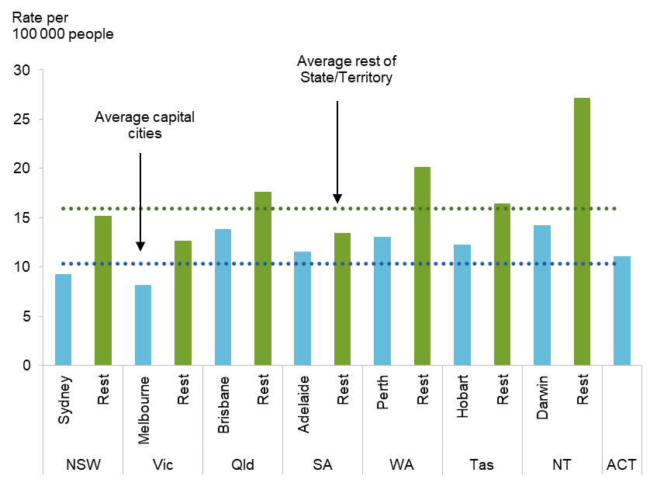
Psychological distress by engagement type | Psychological distress in  Aboriginal and Torres Strait Islander people
Key factors driving poor outcomes in Australia’s mental health system include:
- under-investment in prevention and early intervention, meaning that too many people live with mental ill-health for too long
- a focus on clinical services which often overlooks other determinants of, and contributors to, mental health, including the important role played by carers, family and kinship groups, and providers of social support services
- difficulties in finding and accessing suitable support, sometimes because the relevant services do not exist in the regions where the people who need them live
- the support people do receive is often well below best practice, is not sustained as their condition evolves and circumstances change, and is often unconnected with the clinical services received
- stigma and discrimination is directed at both those people with mental illness and those who support them
- a lack of clarity across the tiers of government about roles, responsibilities and funding, leads to both persistent wasteful overlaps and yawning gaps in service provision, with limited accountability for mental health outcomes.
These are long-standing problems that are documented in numerous reports written over the past decades. Substantial reform of Australia’s mental health system is needed and there is no quick fix.

Reform direction
This draft report presents a long term reform agenda. The changes needed are substantial but the recommended reforms would set Australia on a path for maintainable long term reform of its mental health system.
Many reforms will need to be implemented in stages. The feasibility of later reforms may depend on the success of earlier reforms. Some reforms require trialling and inevitable fine-tuning before they can be implemented on a national scale. And major changes, such as many of those presented in this draft report, require continuous feedback and learning, to make sure that the reforms are working to improve the lives of Australians.
While existing resources can be deployed more efficiently and effectively, additional taxpayer funding would likely be needed to engender long-term reform of the mental health system. This will require Governments to make choices as to priorities, not just within the mental health system but across all areas of public expenditure — a dollar spent in mental health represents a dollar not spent on another, potentially equally important, area of need.
The Commission has suggested priorities based on:
- reforms that could be implemented quickly, often deploying existing resources to bring about immediate benefits for those already experiencing mental illness. These are typically interventions that have a sound evidence base indicating that they can cost-effectively deliver significant benefits either to a small group in the population or community-wide. They involve comparatively little disruption to other parts of the community, a redirection of existing funding or relatively small additional expenditure. For example, mandatory follow up when a person is discharged from hospital after a suicide attempt has been proven to reduce the risk of the person making another attempt on their life and is a reform that could be quickly implemented.
- reforms that should be started in the short term, but with the understanding that benefits, while potentially substantial and widespread, may not be evident for many years into the future. In some cases, these reforms may require agreement between multiple governments, multiple parts of a government, or additions to the workforce needed to deliver the relevant services. Such reforms are often staged over time and it is important to ensure that intermediate actions are consistent with and focussed on the goal of the reform. For example, the introduction of wellbeing leaders in schools will involve identifying, training and deploying a relevant workforce and developing resources for these leaders.
- reforms that are likely to be beneficial, but where further evidence and evaluation is needed. For example, some existing mental health services require evaluation, and potential changes to these services need to be trialled.
Unsurprisingly, many of the reforms recommended in this inquiry draft report have been proposed before. Some were not accepted due to inadequate evidence at the time. Others faced barriers to implementation.
This inquiry addresses both of these issues. We consider evidence that has emerged, and we tackle the implementation barriers. The Commission’s draft recommendations create institutions and mechanisms that would promote and support mental health in the community, are flexible enough to allow support to adjust as individual circumstances and needs change, and can systematically evaluate whether progress is being made to improve peoples’ lives.
The reforms outlined in this draft report provide incentives for key players to work together without relying simply on the goodwill of committed staff. And they present a way for governments to coordinate within, and improve, a mental health system that fails far too many people. We recommend reforms to the roles of the Australian and State and Territory Governments in funding mental health services. As the delivery of many of Australia’s mental health services is, appropriately, at a regional level, alternative options are presented for the funding and regional commissioning of services and supports.
The Commission’s recommended reforms fall into five broad areas:
- helping people to maintain their mental health and reduce their need for future clinical intervention, including by tackling early mental health problems and suicide risks
- improving the consumer and carer experience of the mental healthcare system to ensure the care received is timely, is consistent with treatment needs and does not impose undue burden on either the consumer or their carer
- improving the experience of people with mental illness and their carers beyond the healthcare system, recognising that there are numerous gateways in the community through which people enter the mental health system and a range of services beyond healthcare — in particular, psychosocial services, housing, and justice — that are important for an individual’s recovery
- improving incentives for people to remain engaged in education and stable employment; reforms designed to support and enable those Australians with mental health problems to reach their potential in life, have purpose and meaning, and contribute to the lives of others
- reforming the behind-the-scenes arrangements and incentives to ensure services for people in need are as seamless and timely as possible.
For each reform area, reform actions are identified to start either in the short term or later, with the priority actions shown in bolded type. These priorities may be adjusted in the presentation of the inquiry final report, after feedback from inquiry participants and further work on estimating the costs and benefits of reform options.
The effectiveness of the proposed changes would be amplified, were we also able to reduce stigma, and generate a change in community culture around how mental ill-health is understood and the way we respond to those who experience these difficulties.

How much could reform benefit Australia?
The costs of mental ill-health and suicide are large and pervasive, and are borne not just by those people with lived experience of poor mental health and of caring, but also by their families and friends, governments (through current and future taxpayers), employers, insurers, and the broader community.
These costs include:
- the resources used for healthcare and other services and supports, as well as the time and effort spent by family members and friends in caring for and supporting people living with mental ill-health
- the lost opportunities and lower living standards that arise when young people disengage from education and when those with mental ill-health and their carers have reduced hours of work, cannot work, or are less productive when at work
- the social and emotional costs of pain, suffering, exclusion and in some cases, premature death
- the loss to the community as a whole from not having the unique and valued contribution of a group of its people.
It is not necessary to quantify the cost of mental ill-health and suicide to know that it imposes damaging and costly impacts on the lives of individuals and the community as a whole. But quantifying these costs helps to identify where reform efforts should be focussed.
Data and measurement limitations mean that our estimates for the cost of mental ill-health cannot be complete. Nevertheless, the Commission has estimated that, conservatively, the cost to the Australian economy of mental ill-health and suicide is in the order of $43 to $51 billion per year (table 1). There is also an approximately $130 billion per year additional cost associated with diminished health and reduced life expectancy for those living with mental ill-health.

Table 1 Estimated cost of mental ill-health and suicide
2018-19
Cost category | $ billion per year
Australian Government expenditure
healthcare (includes prevention) | 3.6
other portfolios (eg. employment, psychosocial support) | 1.3
State and Territory Government expenditure
healthcare (includes prevention) | 6.9
other portfolios (eg. education, housing, justice) | 4.4
Individual out-of-pocket expenses | 0.7
Insurer payments for healthcare | 1.0
Informal care provided by family and friends | 15.0
Loss of productivity and reduced participation | 9.9-18.1
Cost to economy (excluding the cost of diminished health and wellbeing) | 43-51
Cost of diminished wellbeing (for those living with mental ill-health or self-inflicted injuries, and/or dying prematurely, including those who die by suicide) | 130
Other costs that overlap with (and cannot be added to) the above
Costs to the economy of suicide and suicide attempts (excludes the costs of pain and suffering of the individual and their family and friends) | 16-34
Income support payments for those with mental ill-health and carers | 9.7

These costs have been rising over time. Despite the rising expenditure on healthcare, there has been no clear indication that the mental health of the population has improved. A reformed system that leads to better mental health requires reprioritising and coordinating expenditure over time, as much as an increase in expenditure.
At the draft report stage, the benefits of some key recommended reforms have been modelled, in terms of people’s additional capacity to work and earn higher wages and in terms of their improved health-related quality of life. We cannot readily quantify the broader community benefits associated with improved mental health, and in this sense, the benefit estimates should be viewed as lower bounds.
Benefits could not be modelled for all draft recommendations. In some cases, this was because the reforms aim to improve processes or system architecture, where benefits are diffuse. In other cases, draft recommendations propose the use of trials because the evidence-base about the effectiveness of a policy intervention is still emerging. Similarly, it was not possible at this stage to determine the cost of all recommended reforms. It is intended that the cost-effectiveness of all key recommended reforms will be included in the inquiry final report.
Those reforms that were able to be quantified at this stage were estimated, conservatively, to be likely to provide a boost to Australia’s economy of around $100 million for some small-scale reforms up to $5.6 billion for larger reforms, in each year in the long term, through the increased economic participation of people with mental ill-health. Of course, some of the reforms with larger benefits, such as improving the social and emotional wellbeing of young Australians, which could provide substantial benefits in quality of life and income opportunities, would not be fully realised for some time.
Across those reforms for which benefits have been estimated, total benefits were estimated to be up to $11 billion per year as a result of the increased economic participation of people with mental ill-health — noting that this does not take into account the costs incurred to achieve these reforms. The annual benefits of improved health and life expectancy for those living with mental ill-health were estimated to be the equivalent of between 4.6 and 6 years of healthy life per 1000 working-age people. Ultimately though, the benefits of reform extend to all Australians: those who are currently receiving or require treatment and support for their mental health, their carers and families, and those who are well now but may one day seek help for themselves or someone they know.
The costs necessary in order to achieve the estimated benefits are an important consideration in determining priority areas for reform. These will be determined once we refine the recommended interventions in response to feedback from inquiry participants.

Early help for people
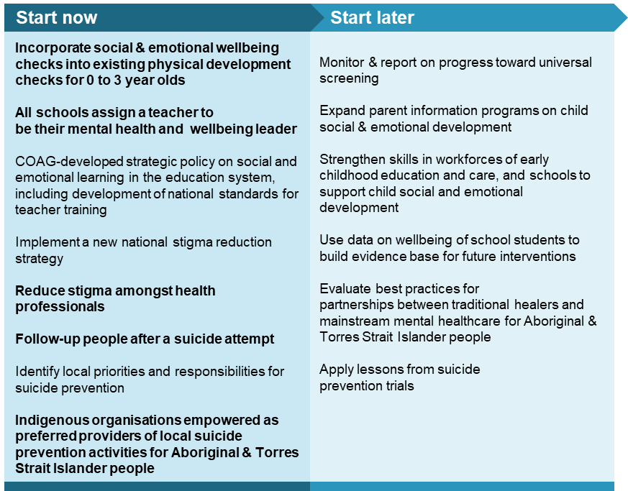
Early intervention — either early in life or early after the detection of risk factors that may lead to mental illness — is important to prevent the onset of illness or curtail a deterioration in mental health. However, some 40% of those with mental ill-health have never accessed mental health services nor seen their GP about their condition, with young people particularly unlikely to seek help. This may not be a significant problem for some people with mild mental illness, which can dissipate as the individual’s risk factors subside. But for others, untreated mental ill-health may percolate throughout their life, reducing the wellbeing and standard of living of the affected individuals and often those around them.

Early identification of risks in families and children
Early identification of risks in children offers the greatest potential for improving health, social and economic outcomes. Young Australians with mental ill-health miss opportunities to develop the skills they need for long-term academic outcomes (figure 2) and post-school opportunities.
The existing physical development checks of Australia’s 1.25 million 0 to 3 year olds in community health services can be expanded to incorporate social and emotional wellbeing aspects of development, so that any necessary assistance can be provided to both the child and parents/carers.
Attendance at preschool and school can present the first opportunity for some parents and carers to become aware of social and emotional development issues emerging in their children. Schools are already expected to play a major part in supporting children’s social and emotional wellbeing, and while most teachers are well able to identify behaviour that is atypical, we were advised that many teachers find that their training has generally not equipped them to either identify mental health risks or respond effectively. To address this, initial training of early childhood educators and of teachers should include explicit instruction in child and adolescent social and emotional development with practical tools to support students. Training on social and emotional development should also form part of teacher professional development requirements.
Identification of children at risk is simply a starting point. Schools need to be effective gateways for students and their families to access help.
The introduction of senior school leader positions for student wellbeing could go a long way toward: improving the early identification and treatment of mental ill-health in young people; helping to maintain a continued engagement of those with mental ill-health in their own education; helping create workable linkages between schools and healthcare pathways; and raising awareness of mental wellbeing in the community.
All schools (primary and secondary, over a certain size, or in groups, when small or geographical spread) should be required to provide a suitably trained full-time senior teacher with responsibility for the mental health and wellbeing of students, including maintaining links to mental health support services in the local community. This approach has been trialled and is being rolled out across UK schools with early signs of success. It has already been adopted in some schools in at least three Australian States. The cost of these senior leader positions is estimated to be up to $660 million per year in public schools, or up to $975 million in public and private schools. Training senior teachers for the new role would take time, but should be started in the short term.
Schools are already funded to provide social and emotional wellbeing programs. However, they face a confusing and disjointed proliferation of poorly evaluated programs and services on child wellbeing. Data that has already been collected on the wellbeing of school students should be used to build an evidence base for future interventions.

Figure 2 Students with mental ill-health fall behind in school
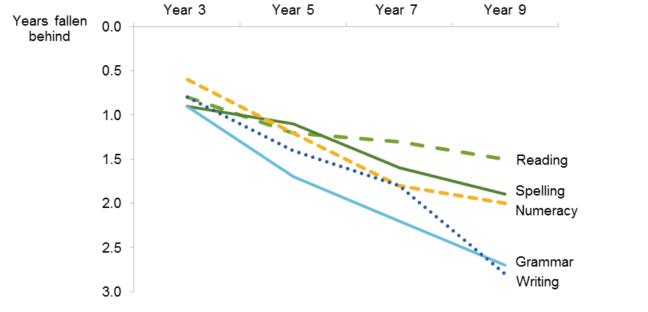

Cultural barriers to improving mental health and wellbeing
Culture and societal influences, such as stigma toward mental illness, exacerbate the cost of mental ill-health. They contribute to a reluctance for people to seek help (particularly in some cultural groups and in smaller communities where it is difficult to receive care without others becoming aware of this), alter the types of help they seek and the symptoms they experience, delay diagnosis, compromise adherence to treatment, and reduce the availability of social supports to both the consumer and their carer. For example, stigma can limit the scope for those with mental ill-health to re-engage with their community or workplace, slowing recovery and increasing the burden of ill-health.
Most people with mental illness report experiencing stigma, although the degree, nature and experience of stigma and consequent discrimination varies with the type of mental illness, and with the person’s age, gender and culture. Stigma associated with depression and anxiety has declined to some extent, although severe mental illnesses — such as psychosis and borderline personality disorders — remain poorly understood by society and are highly stigmatised, particularly in publicised issues of public safety.
Effective stigma reduction requires an ongoing commitment over a long time period in order to ensure that any reductions in stigma persist. The National Mental Health Commission should develop and drive the implementation of a renewed national long-term stigma reduction strategy that: targets stigma reduction messages for different audiences; focusses on the experiences of people with those mental illnesses that are poorly understood by the community; addresses different aspects of stigma including the desire for social distance, and perceptions of danger and unpredictability; and identifies and draws on a small number of national ambassadors for mental health.
Stigma within the health system can compromise diagnosis and treatment. Stigma reduction programs, including interactions between health professionals and mental health consumers on an equal footing outside of a clinical setting, should be rolled out in a staged manner, into the initial training and continuing professional development requirements of mental health professionals.
Given the cultural diversity within Australia, the training of all clinicians should include measures that instil an understanding of how peoples’ cultural background affects the way they describe their mental health and their compliance with treatment options. The Australian Government should also evaluate best practices for how partnerships between traditional healers — who protect and heal the physical, emotional and social wellbeing of individuals and communities — and mainstream mental health services can best support Aboriginal and Torres Strait Islander people with mental illness and facilitate their recovery in their community.

Suicide prevention
The facts on suicide in Australia are stark. Just over 3000 people are lost to suicide each year in Australia, an average of more than 8 people per day. It is the leading cause of premature death in Australia’s young adults, accounting for around one-third of deaths among people aged 15-24. Suicide rates of Aboriginal and Torres Strait Islander people are more than double that of other Australians, with young males and those in regional communities particularly at risk. For every death by suicide, as many as thirty people attempt suicide and are hospitalised due to intentional self-harm. And there has been no significant and sustained reduction in the death rate from suicide over the past decade, despite ongoing efforts to make suicide prevention more effective.
Only a very small proportion of those with mental illness self-harm or have suicidal thoughts, and not all people who suicide had a mental illness. However, up to 25% of people who attempt suicide will re-attempt, with the risk being significantly higher during the first three months following discharge from hospital after an attempt. Half of those discharged from hospital after a suicide attempt do not attend follow-up treatment and responsibility and accountability for follow-up is unclear and inconsistent.
A recent study concluded that adequate aftercare could reduce the prevalence of suicide attempts that reach hospital emergency departments by about 20% and all suicide deaths by 1%. This is equivalent to preventing 34 people per year from dying by suicide, and a further 6000 people per year from attempting suicide that results in some level of incapacity for them. It is estimated that effective aftercare can provide a long-term return of investment of between 6:1 and 36:1 for every dollar spent, depending on the extent of aftercare provided and the income earned by people whose suicide or suicide attempt was prevented.
A program to provide access to timely, effective aftercare for every person who presents to a hospital, GP or other service following a suicide attempt or in suicide distress should be provided as soon as possible. Aftercare should include support prior to discharge or leaving the service, as well as immediate and sustained follow-up support.
A range of suicide prevention trials are underway in different parts of Australia, and due to be evaluated over the next few years. A key aspect of these trials is that they reflect the needs of local communities instead of a fragmented and uncoordinated approach to preventing suicide. The features of these programs that are evaluated as effective should be determined and published to enable other localities across Australia to similarly adopt effective suicide prevention measures.
Suicide prevention programs for Aboriginal and Torres Strait Islander people should have Indigenous-controlled organisations as the preferred providers, to increase the likelihood that program provision is sensitive to the experiences, culture and specific social issues faced within particular communities. Stronger connection of individuals with their culture and control over services have reduced suicide risk and improved social and emotional wellbeing in some communities.
Beyond the short term, the linkage of data on agreed risk factors for suicidal behaviour could be useful in preventing some suicides. This may require, however, Australia to place a higher priority on preserving someone’s life, than on preserving their privacy.

Improving peoples’ experiences with mental healthcare
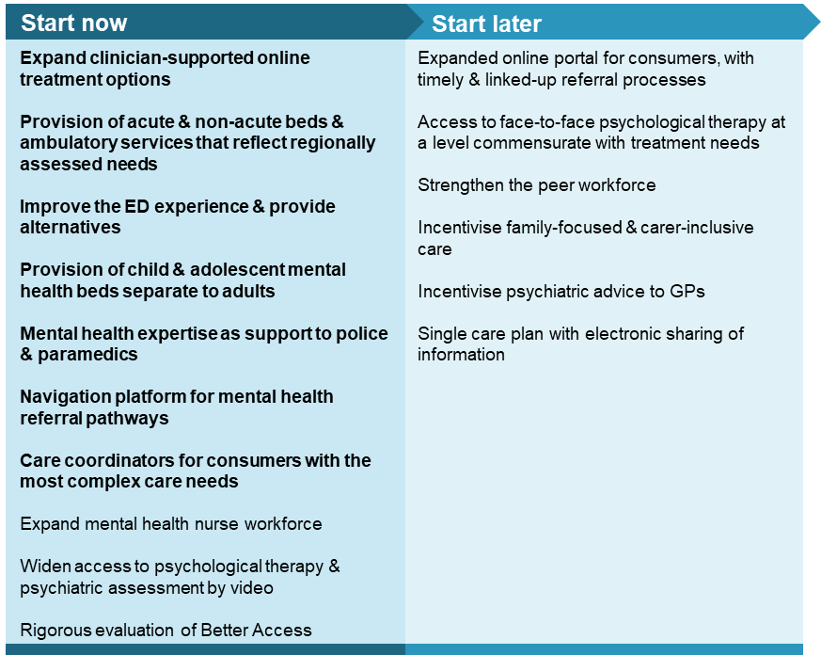
Those with mental illness and their carers face a complex system of healthcare and broader social supports. A well-functioning mental health system would:
- deliver prevention and early intervention activities that reduce the incidence of mental ill-health and improve the wellbeing of individuals
- provide healthcare that varies in line with the nature and severity of the individual’s mental ill-health, is flexible to the changing clinical needs of the individual, and recognises the importance of addressing the individual’s non-clinical needs
- provide and facilitate access (that is affordable, culturally appropriate, timely and available regardless of whether you live in an urban or regional part of Australia) to necessary psychosocial supports, stable housing, assistance at school or work, income support, carer supports, and other relevant services that support recovery for those with mental ill-health and their carers
- deliver care that is seamless and joined-up regardless of how the individual first enters the mental health system, without significant gaps either at a point in time or, as needs change, across time and locality.
The current Australian mental health system falls well short of this benchmark.
Services are often unconnected. All those who interact with Australia’s mental health system — consumers, carers, service providers and funders — should have clarity around who can and is providing what services to which groups of people and under what conditions. Not every consumer will have their needs met at their first point of contact with the mental health system. There should be clear pathways to facilitate access to healthcare and other services, consistent with the level of expertise, intensity and duration required for that person’s level of need.
There are significant service gaps. From the point of view of people needing care, an improved system would mean access to services that are consistent with their treatment needs when they need them; continuity of care, based on effective information flows between clinicians and other services; and person-centred care that accommodates individual needs. Implementing person-centred care consistently across the mental health system will be a significant cultural shift. This shift will require structural changes to aspects of the mental health system (including online navigation platforms), workforce training, a more holistic approach to families and carers and an increased focus on monitoring and improving outcomes for consumers.
This inquiry has recommended reforms to improve the mental health system using a stepped care model (figure 3). Under stepped care, the intensity of services provided for individuals should vary with their level of need. While there are multiple levels within a stepped care approach, they are neither uni-directional, nor siloed steps — rather, they are a spectrum of service interventions. Stepped care has been adopted nationally in Australia, and while its use is widely accepted, its implementation has proved challenging.

Figure 3 Stepped model of care
Estimated number of people requiring each level of care
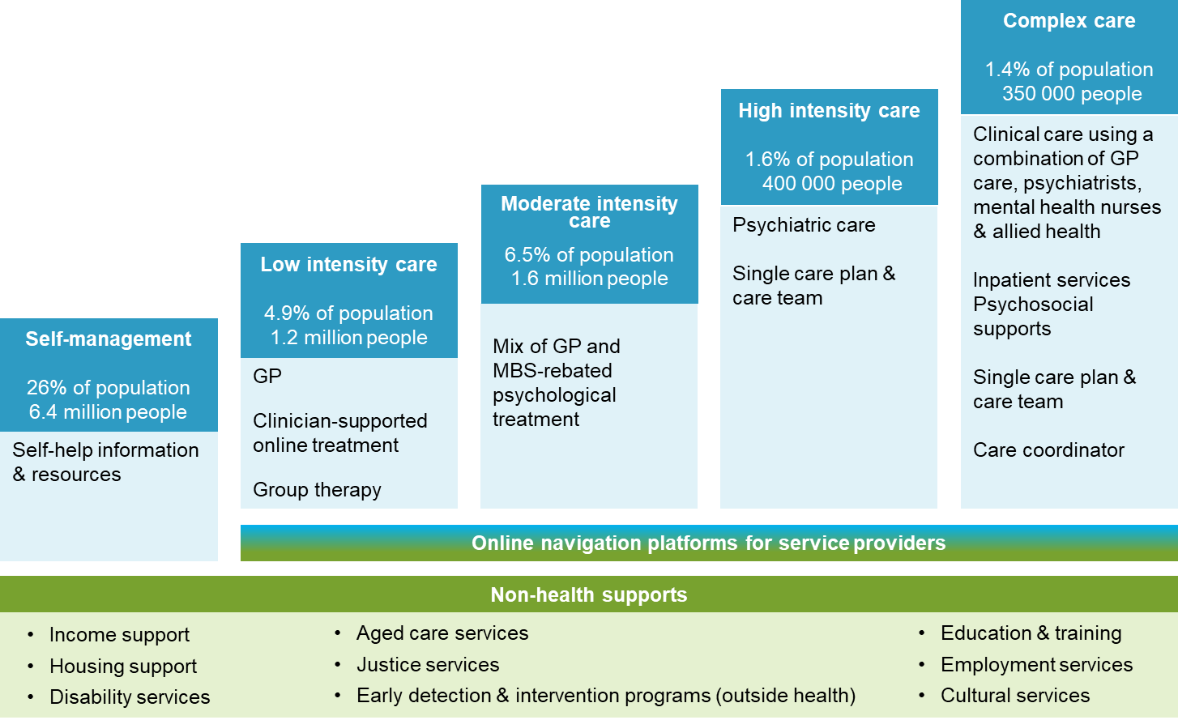

Re-orienting health services to people
Mental healthcare services are characterised by two ‘poles’, reflecting the level of government providing the service funding. One pole represents services for people with mild and moderate symptoms and impairment who can be treated online or in primary care by GPs or psychologists (mainly Australian Government funding under the MBS), and the other represents those requiring specialist treatment and often hospitalisation (mainly State and Territory Government funding).
There is a large service gap between these two poles, sometimes referred to as the ‘missing middle’. Up to one million people typically have symptoms that are, too complex to be adequately treated by a GP and the limited MBS-rebated individual sessions with allied mental health providers (predominantly psychologists). But their condition also does not reach the threshold for access to State or Territory funded specialised mental health services, private psychiatrists or private hospitals due, for example, to long waiting lists or very high out-of-pocket costs. Too often, the necessary services exist but are being absorbed by people whose needs would be met just as well by lower intensity services.

For people self-managing or needing low intensity treatment
Resources for self-help
Many Australians with mild mental illness are able to manage their mental health themselves without formal clinical intervention and without significant impact on their relationships or engagement in study or employment, so long as they can access relevant information. People needing resources for self-help should have ready access to evidence-based information and assistance through publicly available sources, including pamphlets, telephone services, and online information. There is much already available, but its effectiveness and accessibility would be improved through a well-advertised national phone-line to assist in locating relevant services and supports, and an expansion in online portals to include more information on e-health, telehealth and group therapy services and mental health pathways in local communities.
Clinician-supported online treatment as a flexible option for people
Beyond self-help, there should be an expansion in low intensity treatment options that would allow those with mild symptoms to get quick access to help, at a time and location of their choice, and minimise their need for medical intervention.
People needing low intensity care, those at risk of mental illness, some with a mild mental illness, or people with symptoms that have not yet reached a diagnostic threshold, should be able to access appropriate care directly through evidence-based clinician-supported online treatment. Where relevant, this on-line treatment can complement treatment received through a GP.
Clinician-supported online mental health treatment has the potential to substantially increase treatment coverage of those living with mental ill-health. Internet-based treatment allows consumers to undertake treatment at a place and time that is suitable and convenient to them. One online service reported that almost half of the people using its site accessed it outside of normal business hours, and that access occurred all days of the week, with 14% of course registrations undertaken on a weekend.
It is well-established that clinician supported online treatment is as effective as face-to-face treatment for some conditions. In particular, supported online treatment is an effective intervention for people living with high prevalence mental illness (such as anxiety and depression) when they are experiencing mild to moderate symptoms. There is also some evidence that supported online therapy may be effective in complementing specialist mental health treatment for severe and less prevalent conditions, such as schizophrenia and bipolar disorder. Online treatment carries the added benefit of fidelity of the treatment (avoids individual providers administering their own personal version of the intervention), could be made culturally appropriate, and be cost effective to provide to a large number of people.
Around 20 000 people accessed supported online mental health services in 2018, with about 4000 of these receiving clinician-supported online treatment. This treatment can be integrated into the stepped care model with an expanded capacity to accommodate use by up to 150 000 people. Currently approximately two thirds of this group are likely to be accessing MBS-rebated psychological therapy (including through headspace centres), while one third are not currently receiving any care for their condition.
Summary online treatment information provided back to referring clinicians
To further integrate online treatment into the stepped care model, for those people referred to the service by a clinician, treatment information should be provided back to the referring clinician. More generally, online services should annually publish summary output for clinicians on the use of their services, treatment provided, and any measurable outcomes.

For people needing moderate intensity treatment
Re-target face-to-face psychological therapy
Clinical evidence shows that people experiencing moderate mental illness typically benefit from face-to-face therapy with a mental health specialist. Approximately 1.3 million people currently receive MBS-rebated sessions of face-to-face psychological therapy (individual or group) each year. Such therapy is a key element in a stepped care model of mental health care. A strength of the Better Access program is its ability to fund services at comparatively low cost. It provides psychological therapy services at a much more economical per-session rate than a block funded service without financial incentives to drive efficiency. However, there are problems with the current system.
First, while there is strong clinical evidence that individual psychological therapy can be effective, there is little evidence on the overall effectiveness of the current MBS-rebated psychological therapy program (the Better Access program). The Better Access program should be rigorously evaluated as soon as practical to ensure that it is delivering cost-effective benefits for those who need it.
Second, Better Access is poorly targeted. The Commission estimates that more than a third of people currently accessing MBS-rebated individual psychological therapy (including through headspace centres) could have their treatment needs equally well met through services that are of lower intensity, but which offer the consumer a lower treatment burden (in terms of time and cost).Targeting could be improved to make sure that the right people are receiving the right treatment. The Better Access program should be aimed primarily toward those people with moderate to high intensity needs who stand to gain the most from face-to-face psychological therapy.
Retargeting Better Access will only succeed if supported by GP referrals. Primary Health Networks (PHNs) should be tasked with promoting and monitoring GP assessment and referral practices in line with a stepped care model of mental health.
Third, the Better Access program is inflexible. Currently, a person can only access up to 10 individual MBS-rebated psychological therapy sessions in a calendar year. The average number of sessions used per person across all consumer groups is currently only 4.6 sessions. However, the Commission estimates that, as part of a stepped care model, approximately 10% of the people who are best treated through the Better Access program would benefit from an increase in the session cap. A trial on the number of MBS-rebated psychological therapy sessions should be undertaken to assess the merits of increasing the current 10 individual plus 10 group sessions per calendar year to up to 20 flexible sessions (either individual or group) over a 12 month period, with re-referral required after 10 sessions.
Fourth, mental health treatment plans are currently used in place of standard referrals. Approximately 1.32 million consumers have a mental health treatment plan written for them by their GP, and 1.26 million follow through to use MBS-rebated psychological therapy. However, psychologists report these plans are largely not useful to them, only 440 000 plans get reviewed and there is no evidence that mental health treatment plans have improved mental health outcomes. We are seeking more information on: what value mental health treatment plans have for consumers (particularly as not all consumers are provided with a copy of their plan); why GPs need an additional MBS-rebate (over and above a longer consult rebate) for completion of a plan; and what audit arrangements could practically be put in place to ensure referral practices are in line with the stepped care model.
For people without access to face-to-face psychological therapy
Ironically, access can be an issue with Better Access. Use of the program is disproportionately by people in Australia’s large urban centres (figure 4). This reflects the location of most psychologists and psychiatrists. Group sessions and sessions via tele-health are significantly underutilised. ).
Many people with moderate (or higher) intensity needs either live in regional parts of Australia without ready access to a psychologist or simply have difficulty (such as for reasons related to their mental illness, transport access, or family scheduling) getting to a face-to-face psychological therapy session. Access to video-psychological therapy should be widened (with associated changes to MBS rules) to allow people — regardless of whether they currently reside in areas designated as ‘telehealth areas’ — to access MBS rebates for psychological therapy via videoconference. To ensure efficacy of the treatment provided, at least 3 out of each 10 sessions for those in metropolitan areas and large regional centres should be face-to-face, including at least one of the first four, with no restriction on how far apart the individual and their clinician reside.

Figure 4 Regional access to low and moderate intensity care services

Use of MBS-rebated mental health services is lower in regional areas
Users of supported online treatment are geographically widespread
Improving access to other specialist moderate intensity services
Other people with moderate intensity needs will also require access to specialist assistance (such as from psychiatrists, mental health nurses, social workers, dieticians or occupational therapists) through the MBS or community ambulatory services from time to time. Access to psychiatric care is particularly constrained, with high costs and long wait times in some areas. In the long term, more psychiatrists in some specialty areas and localities are needed. Supplementing this, the Australian Government should create an MBS item that allows psychiatrists to provide general advice over the phone to a GP on diagnosis and management issues for an individual who is being managed by the GP.

For people needing high intensity treatment
People with more severe forms of mental illness require high intensity, often multi-disciplinary care, from specialist services delivered through MBS-rebated or government salaried psychiatrists and expanded community-based clinical services, with service continuity between primary care and acute/specialist care.
Improving the ED experience and providing alternatives
People experiencing a severe episode of mental illness often (re)enter mental healthcare via a hospital emergency department (ED). The rate of mental health presentations at EDs has risen by about 70% over the past 15 years, in part due to the lack of community-based alternatives to ED, particularly after hours and in sparsely populated areas.
While only 4% of ED presentations were for mental health, this group comprised 19% of patients waiting in EDs for inpatient beds and 28% of those delayed from leaving the ED due to an inpatient bed not being available. Compared to people with other health conditions presenting at an ED, people with mental illness are: nearly twice as likely to arrive by ambulance; ten times as likely to arrive by police or correctional services vehicles; and twice as likely to be in ED for more than 8 hours.
While reforms are underway at some hospitals, the typical ED experience exacerbates the distress of those with a mental illness, frustrates and diverts emergency clinicians, paramedics and police, and is very expensive. In some cases, people transported by police to EDs or mental health facilities are not admitted because mental illness is considered not to be the primary impairment (drugs or alcohol are involved), the person is behaving violently or mental health inpatient beds are not available.
Timely availability of crisis support services can prevent or reduce emergency department presentations and be an alternative diversion point for police and other crisis first responders. For example, in Queensland mental health clinicians are co-located in the police communications centre, supported by an on-call forensic psychiatrist; mental health staff accompany police and provide on-site clinical interventions; and police, health and ambulance services partner to identify issues, discuss complex cases and develop preventative interventions, alternative referral pathways and review procedures.
While some other States have similar services, all State and Territory Governments should fund and implement mechanisms for police, health and ambulance services to respond to mental health crisis situations in a coordinated manner, including by embedding mental health expertise in police and emergency service communication centres to provide real-time support for the individual whom police and emergency services are responding to, advise on how the individuals with mental illness can be managed and appropriate referral pathways, and coordinate deployment of co-responder resources to prioritised cases.
Complementing this, State and Territory Governments should aim to provide more and better alternatives to EDs for people with mental health problems, including peer- and clinician-led after-hours services and mobile crisis services. This may include providing separate spaces in or near EDs for mental health patients, or otherwise creating a more de-escalating environment. The ‘Safe Haven’ spaces created in Melbourne and more recently in Queensland provide an effective model for this. When Emergency Departments are built or renovated, the design should take account of the needs of people with mental health problems.
Inpatient beds for all who need hospitalisation
The demand for acute inpatient mental health beds would be reduced by: measures that prevent people’s conditions deteriorating to the point where they need acute hospital care; and by accommodating more people with persistent, severe and complex mental illnesses in community treatment and residential care, so that these people can live in the community, instead of having to remain in an acute hospital bed for extended periods. However, as not all hospitalisations are avoidable; acute inpatient beds will still be needed.
Areas of high population growth may need to increase their number of acute inpatient beds in order to match supply with demand, even after filling gaps in non-acute services which lead to avoidable hospital admissions. Lack of mental health inpatient beds for children and adolescents seems to be a particular short fall in some States and Territories. All States and Territories should provide child and adolescent mental health beds that are separate to adults. Where it is not possible to provide these beds in public hospitals, States or Territories should contract with private facilities, or if suitable given the individual’s condition, provide care as hospital-in-the-home.
Specialised mental healthcare in-community
For many people, a first step either to receive more intensive care as an alternative to being admitted to a hospital psychiatric ward, or after discharge from a psychiatric ward before returning home, would be sub-acute residential care within the community. There are approximately 3400 non-acute mental health beds in the public sector — an estimated half of that likely to be required. Increasing the number of these beds would improve the path of care for individuals in need. Individuals who are best treated in community would face fewer delays in discharge from hospitals, and as acute in-patient beds in hospitals become available, this will reduce waiting times in ED. Each State and Territory Government should provide sufficient residential care within their communities to accommodate demand from those with mental illness as an alternative to admitting people into, and/or retaining them with, hospital acute care.

For people with complex health and social needs
Between 190 000 and 250 000 Australians with episodic or persistent severe mental illness have significant complex needs arising from their illness. Their needs are complex because of:
- the presence of both mental and physical health conditions, sometimes including substance abuse, requiring coordination between primary care and specialist mental healthcare and coordination with other clinical service providers (treating the physical illness)
- impaired psychosocial functioning due to the severity of the mental illness, where coordination is required between the disability support provider (including the NDIS) and the clinical treatment system
- social adversity, such as poverty, unemployment, social isolation, housing instability or complex family situations where coordination is required with the relevant social service providers.
Even with the best clinical treatment, episodic or persisting mental illness can result in the need for psychosocial and other supports, such as stable accommodation, income and vocational support, to assist the person to live as independently as possible in the community.
But when the gaps in healthcare services are greater, dealing with the complexity of needs becomes more critical to health and socioeconomic outcomes for people. For example, Aboriginal and Torres Strait Islander people in urban areas can face additional service gaps that arise because of a lack of culturally capable services and discrimination; those in remote communities can face further service gaps associated with lack of availability or continuity in the trained workforce, while coping with additional complexity in needs.
Improving outcomes for people with complex needs is about ensuring they have access to the services needed (both clinical and broader), when they are needed, with effective information flows and coordination between clinicians and other services.

Structural reforms to deliver the changes needed

Navigation platforms
To assist clinicians and other providers in the health system, and those who facilitate entry of consumers to the mental health system via non-health pathways — such as schools, aged care facilities, Indigenous service providers and correctional facilities — to locate services and supports suitable to people with mental health problems, online navigation platforms should be established. These navigation platforms should be created at a regional level and act as centralised online and phone platforms for clinicians and care coordinators into mental health and physical clinical and non-clinical care. The HealthPathways portal model, which is already used by most PHNs, could be used as the basis for the navigation platforms.
Linkages through the online navigation platforms should be able to identify services available and directly book consumers into a service. For services outside the scope of the navigation platforms (such as Centrelink), there would need to be direct contacts with the services to facilitate support. The navigation platforms would need to be supplemented by more accessible and situation-specific online information and resources for consumers and carers.

Care plans
Consumers requiring intensive clinical treatment, especially those with more complex care needs, typically require a team of service providers involved in their care — the size of the team and its composition depend on the individual’s needs. The greater and more complex the needs, the larger and more diverse the team of providers. A single care plan is needed to help coordinate treatment. The coverage of the plan would vary from person to person according to their needs at particular points in time, but could include a plan to address aspects such as mental healthcare, physical healthcare, cultural and spiritual needs, psychosocial support needs, housing needs, community inclusion needs, the role of their carer or kinship group, and reintegration into education or the workforce. The effective development and operation of the care plan would necessitate: a sharing of patient information between professions that is not currently evident (even within the health sector); someone to have responsibility for plan development, follow-through and update; and financial arrangements that incentivise this to occur.
A single care plan developed by the individual’s primary treating clinician and covering physical and mental health can help address the issues raised by comorbidity. Physical ailments are more common when a person has a mental illness and can contribute to early death. For example, compared to people without mental illness, those with mental illness are 18-36% more likely to have musculoskeletal problems and 10-23% more likely to have asthma. One Australian study estimated that physical illnesses cause almost 80% of the gap in average life expectancy between people with a mental illness and the whole population, compared to 14% of the gap being due to suicides.
Substance use comorbidity is common for individuals with some types of mental illness, and where relevant care plans will need to cover drug and alcohol issues. Further, a large proportion of people who present for substance use treatment display symptoms of mental disorders (while not meeting the full criteria for a diagnosis of a disorder). For effective treatment there should be an alignment between mental health and alcohol and drug policies.

Care coordinators
Consumers with the most complex mental health needs (up to approximately 460 000 people) should have both a single care plan developed with and for them and a care coordinator provided to oversee the implementation of the plan. This will avoid gaps in support services that can lead to a deterioration in mental health and, potentially, unnecessary hospitalisation.
Care coordinators would work directly with the consumers, their carers, clinicians (or clinical coordinator) and providers from other sectors, to establish the types of services needed and provide access to those services. The level of support would be adjusted according to need — for the most complex cases, the care coordinator would need to bring together a care team, comprising the various services the individual requires, and put in place a detailed plan for their support. For those admitted to hospital, care coordinators would be linked in with the hospital discharge planning, to provide continuity of care.
There are already a significant number of government funded programs offering care coordination services to people with a mental illness — including through the NDIS, and care coordination programs commissioned by PHNs or provided by State or Territory Governments. However, the coordination of care is often ad hoc, relies on personal contacts of individuals rather than established networks, suffers from variable skilled care coordinators, and is provided under short-term funding arrangements that encourage premature closure of cases and relapse in mental illness. And while not all consumers who would benefit from a care coordinator have access to one, some people have multiple care coordinators with overlapping responsibilities. Efficient and effective care coordination would replace many of these services and would partly be based on existing funding.
As an interim goal, all those with a severe and persistent mental illness and complex needs requiring support from multiple agencies should have efficient and effective care coordinating services (that is, approximately 64 000 people). Ultimately, all people with mental illness and high intensity needs, using a mix of clinical and non-clinical services, should have access to a care coordinator (up to 460 000 people nationally, depending on needs and use of existing care coordinator services). The expenditure associated with this is likely to lead to some cost savings elsewhere in the health system, as demonstrated by past programs, where care coordination led to reductions in hospital admissions.

A health workforce that can deliver the changes needed
There are many health professionals who can help people to improve their mental health and address any physical comorbidities they may have. Only some of these professionals —psychiatrists, psychologists, mental health nurses and mental health peer workers — specialise in mental health. Those that have more general roles include: GPs, general nurses, and a mix of allied health professionals such as dieticians, occupational therapists, physiotherapists, Aboriginal health workers, social workers and counsellors.
There is considerable disparity in health workforce numbers between urban and regional areas, and potentially between the public and private sectors, and an inefficient use of skilled professionals (such as mental health nurses) in administrative roles that could likely be undertaken by non-clinical staff. There are also notable gaps in the availability of some specialists — such as psychiatrists specialising in child and adolescent mental health and people with expertise in treating eating disorders — in a number of jurisdictions.

Clinicians at initial entry points to the health system
GPs are the front-line service for mental healthcare in most urban and regional parts of Australia, representing a key referral gateway into services and an important point for the ongoing monitoring of individuals’ physical, and potentially mental, health. Australians have almost 20 million GP consultations per year for mental health problems, with mental health being one of the main reasons people go to their GP.
Yet there can be significant delays in getting a GP appointment in some (urban and regional) areas, appointments can be very time consuming (sitting in waiting rooms) and expensive, and not everyone views their GP as a useful or easy person with whom to discuss their mental health. Furthermore, some GPs lack knowledge and skills in mental health and require considerably more training in identifying risks, diagnosing conditions, assessing and recognising the physical health consequences of prescribed treatments, and connecting patients with other services (such as online mental health services and allied health services).
Proposed changes as a result of the current MBS review (if adopted) would increase the number of ways for GPs to be reimbursed for treating people with mental illness. We have also recommended changes to motivate an increase in care coordination between clinicians and to provide scope for GPs to consult with designated carers and family of a person with a mental illness. The recommended navigation platform and improved access to advice for GPs from psychiatrists should also improve GP links to other health and non-clinical supports for those with a mental illness. To provide more incentive for GPs to improve their mental health training, the merits of introducing a specialist registration system for GPs with advanced specialist training in mental health should be independently assessed.
Aboriginal health practitioners and health workers comprise a relatively small proportion of the health workforce but play an important role in providing culturally capable care to Aboriginal and Torres Strait Islander people. There is a well-developed system of training for these workers, including in mental health. We are seeking more information on ways to expand their career opportunities, including scope for transition-to-practice arrangements for those wishing to move into more general mental health clinical or non-clinical roles.

Mental health specialists
Among those providers who work specifically in mental health in Australia, we see scope for a greater role for mental health nurses and mental health peer workers, although there are notable gaps in some other specialities that should be addressed to improve consumer outcomes. We found no evidence of a need for more psychologists (indeed, Australia has one of the largest workforces, per population, of psychologists in the world).
Mental health nurses are a critical part of the current mental health workforce, being the largest clinical occupational group dedicated to mental health, and one of the most geographically dispersed and cost-effective sources of expertise for combined management of mental and physical health and care coordination. The number of mental health nurses practicing in Australia — in GP clinics, community health services, and aged care facilities — should be significantly increased. Measures to promote this include the development of a three year direct entry (undergraduate) degree in mental health nursing, similar to options available in midwifery in Australia and for nurse training in the UK. The merits of introducing a specialist registration system for nurses with advanced qualifications in mental health also should be assessed.
Additional funding is likely to be needed to address the need for more mental health nurses in all parts of Australia, and in Indigenous communities in particular.
Overall, the number of psychiatrists for Australia’s population is at the low end of rates in other developed countries. This is less of a concern in adult mental health treatment in urban areas, but the profound difficulty of those in need of psychiatrists for children and adolescents, in aged care and in regional and remote areas, should be addressed. Governments should collectively ensure that the National Mental Health Workforce Strategy, currently being developed, includes actions: to raise the number of funded training placements and supervisors, with State and Territory Governments to do so in public sector health facilities, and the Australian Government to contribute to funding more positions in regional and remote areas; and increase the availability of supervision for trainees, including through remote models of supervision for trainees outside major cities.
Peer workers — people employed on the basis of their lived experience of mental illness — are well placed to support people with mental illness during their recovery. The nature of the experience and training required to allow peer workers to be most effective and the circumstances in which they can best be utilised, is the subject of ongoing work in the sector. A barrier to more widespread use of peer workers is the acceptance of their role by clinicians. A program to build support among clinicians for role and value of peer workers should be developed and implemented in collaboration with the relevant professional bodies.

3. Improving peoples’ experience with services beyond the health system
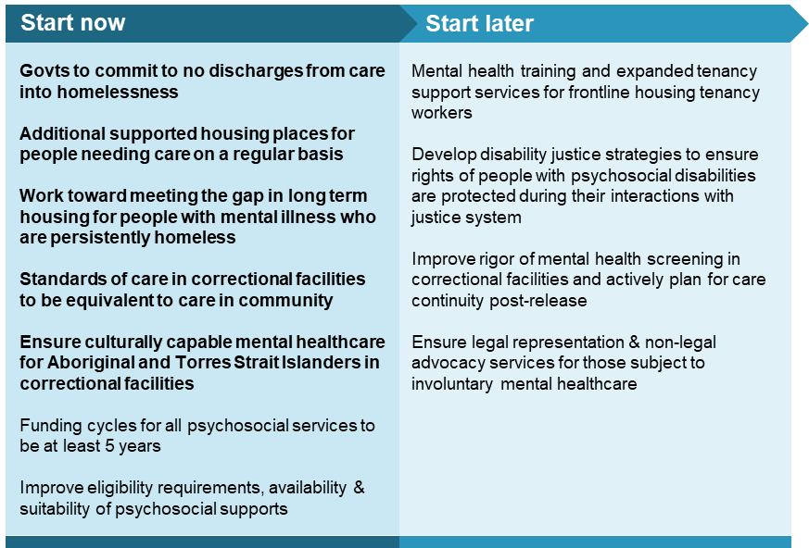
There are a range of services beyond the health sector that support people (usually those with severe mental illness) to live satisfactory lives within the community, including psychosocial supports and housing services (services related to education and employment are discussed separately further below). The justice system also plays an important role in the lives of some people with mental illness — for those who interact with police as first responders in a crisis, those who commit offences or are victims of crime, and those who confront legal issues associated with their mental health treatment. These services often are not delivered in ways that account for the nature of mental illnesses, impeding recovery or contributing to a relapse in mental ill-health.
Of course, many people without mental illness also interact with housing, justice and other non-health services. In making our recommendations we have been cognisant of the issues that might arise were we to recommend reforms in some of these services that extend beyond people with mental illness.

For people needing psychosocial supports
Even with optimal treatment some mental illnesses do not fully remit and result in persisting or episodic impairment with the individual, and often carers, requiring psychosocial support (such as respite services, assistance with transport or with household management and finances) to live as independently as possible in the community. For all people with mental illness, social inclusion — the capacity to live contributing lives and participate as fully as possible in the community — is a necessary, but too often neglected, part of a recovery plan.
Approximately 690 000 people have a severe mental illness, and while for some their illness is of short duration, many require psychosocial support. Approximately 21 700 of these people currently receive psychosocial supports under the NDIS, and a further 42 300 are considered likely to be eligible for psychosocial supports under the NDIS but are not yet receiving them. While some other people currently receive psychosocial supports funded through either the Australian or a State/Territory Government, there remains a massive gap between assessed needs and services provided or taken up.
For those people who are eligible for the NDIS, the psychosocial disability stream should be fully rolled out across all NDIS sites by the end of 2020, incorporating lessons learned from the Independent Assessment Pilot into the NDIS access and planning processes.
Participants of other Australian Government-funded psychosocial supports should continue to receive support, should they require it, regardless of whether or not they have tested their eligibility for the NDIS. For people not receiving NDIS funding, Governments should provide certainty on the long-term funding of psychosocial supports beyond the period to June 2022 that these supports will be funded by the Australian Government. To further enhance continuity of care for people, Governments should extend the funding cycle length for all psychosocial support programs from what is typically a one-year contract term to a minimum five-year term.

For people needing housing services
Suitable housing (housing that is secure, affordable, of reasonable quality and of enduring tenure) is a particularly important factor in preventing mental ill-health and a first step in promoting long-term recovery for people experiencing mental illness. Some 16% of people with mental illness live in unsuitable accommodation (homelessness, overcrowding, at risk of eviction, substandard quality).
Accommodating people in the community rather than in hospitals
The costs of not adequately addressing the accommodation needs of people with mental illness is evident through increased expenditure on these people in the health sector and in some cases, in the justice system. The proportion of health sector expenditure related to mental health patients rotating through hospital ED departments, and accommodating people with mental illnesses in the most expensive forms of care (hospital acute inpatient facilities) for time periods beyond that required for their effective treatment is difficult to determine. But surveys suggest that around 30% of admitted patients (about 2000 people) in psychiatric wards could be discharged if appropriate housing and community services were available. For each individual retained in an acute hospital bed, who could be treated (at least as well) in a non-acute bed-based service, the health system is overspending (figure 5).
Programs that support people’s discharge out of acute mental healthcare or prisons can prevent people becoming stuck in institutional care or being discharged into homelessness.

Figure 5 Average daily ongoing cost of accommodation per person
For those people with a mental illness that is severe but necessitating low to moderate intensity care on a regular basis, supported housing places (integrated housing and mental health supports to people with mental illness) in the community provide long-term housing stability, scope to actively interact with the community and provide life satisfaction. There are currently 5 200 supported housing places across Australia. But an estimated 8 000 to 12 000 additional places are required to accommodate individuals with severe mental illness who are at significant risk of housing instability.
The cost of providing additional supported housing for this group of people — through a mix of social housing, private rentals or head-leasing of private rental properties — is estimated to be in the order of $200 to $700 million per year. The final cost may be lower than this, to the extent that some proportion of people may have capacity to fund part of their housing costs and for some, stable housing would reduce their use of healthcare, justice or community services. Each State and Territory Government, with support from the Australian Government, should actively work towards meeting the gap in supported housing places in their jurisdiction.
Reducing homelessness for those with severe mental illness
To reduce homelessness among people with mental illness, each State and Territory Government, with support from the Australian Government, should work towards meeting the unmet demand for homelessness services. The cost of providing accommodation for about 13 000 to 17 000 people with mental illness in need of longer-term housing is estimated to be $234 to $352 million per year. Where such measures have been undertaken on a smaller scale previously (in Australia and overseas), there have been significant associated reductions in use of health, justice and community services.
Some of these additional homelessness services for people with severe mental illness who are persistently homeless, should follow a Housing First approach — rapid access to long-term housing and mental health supports that is not conditional on participants becoming housing ready or engaging with support services. Several trials of Housing First programs in Australia and around the world have been effective at housing thousands of people with severe mental illness, with participants reporting improved quality of life, and reduced health service usage. In some cases, trials show a small net cost or a potential net benefit. Some Housing First programs should be tailored to particularly vulnerable population sub-groups with mental illness, including young people and Aboriginal and Torres Strait Islander people.

For people interacting with the justice system
A need for mental healthcare at all stages of the justice system
People with mental illness are overrepresented in every part of the justice system. Among police detainees, around 43% of males and 55% of females were reported to have a previously diagnosed mental disorder; while around 40% of prison entrants have been told they have a mental health disorder at some stage in their life (including substance use disorder) — double the rate of the non-prison population. Mental illness is particularly common among female prisoners, and at a much higher level among those Aboriginal and Torres Strait Islander people who are in prison. While the majority of prisoners with mental illness spend relatively short periods of time in custody before returning to the community, inadequate healthcare in prisons and poor transition support services are likely to raise the burden on the community healthcare system and increase recidivism.
For the benefit of those people with mental illness who progress further into the justice system (as either offenders or victims), State and Territory Governments should continue to develop and implement Disability Justice Strategies to ensure the rights of people with mental illness are protected in their interactions with the justice system.
Comprehensive mental health screening and assessment of all individuals (sentenced or awaiting sentencing) should be undertaken on admission to correctional facilities, and on an ongoing basis where mental illness is identified. Those who have an ongoing mental illness should, prior to release, be connected with a relevant community-based service (and care information shared with this service) to enable individuals with mental illness to receive continuity of care post-release. In the case of Aboriginal and Torres Strait Islander people, services within correctional facilities and post-release care should be culturally capable. More generally, the Australian Commission on Safety and Quality in Health Care should review standards of mental healthcare in correctional facilities to ensure they are equivalent to the standards upheld in the community.
Advocacy for people facing mental health tribunals
Legal representation is an important protection for those people who face involuntary detention and treatment due to mental illness. For example, people who are represented when appearing at a mental health tribunal have a substantially lower likelihood of being subject to an application for involuntary treatment. However, State and Territory legal assistance providers have reported that they have inadequate resources to represent all but a small proportion of clients appearing before mental health tribunals.
While there are many legitimate claims on legal aid budgets, we consider that representation when facing involuntary detention and treatment due to mental illness is a priority. To meet this need, governments should provide a grant to legal assistance providers specifically for assisting with mental illness-related legal issues. This could be modelled on the approach taken under the NDIS, whereby legal aid commissions apply to the relevant government department for grants to provide legal assistance in cases outside of the ordinary legal aid guidelines, with consideration of the applicant’s capacity to self-represent or obtain other legal assistance.

4. Increasing the participation of people with mental illness in education and work
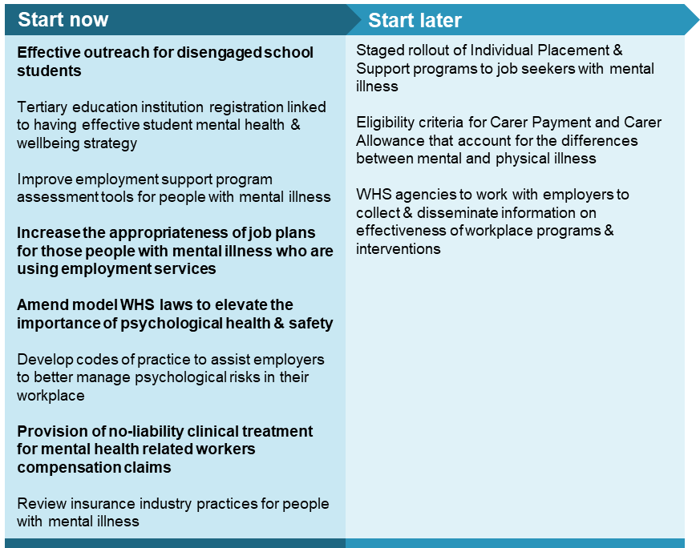

Improving outcomes for school-age children with mental ill-health
In any given year, about 188 000 school-aged children with a social and emotional disability require some adjustment to their education (representing 26% of all children requiring adjustment due to disability, and nearly 5% of all children attending school). These adjustments include, for example, changes to teaching methods within the classroom and support provided by specialist staff.
It is a legal requirement for schools to provide these adjustments. And in general schools quickly and appropriately provide adjustments for physical disability. However, we have heard that the same is not the case for adjustments relating to social and emotional disability. There can be substantial differences in how well schools implement these adjustments, depending on the resources available and staff skills.
Education adjustments are a relatively low cost way to help improve engagement with education. And this engagement can significantly improve outcomes over a child’s life. Governments should ensure that students with mental illness (and indeed, all student with a disability) have timely access to the support they require. State and Territory Departments of Education should evaluate the quality of adjustments implemented in schools. Application processes for disability funding should be reviewed and simplified, with the default position being that a student receives the support necessary to remain engaged in their education.
For students who are at risk of disengagement or who have become disengaged from education due to either their own mental illness or that of a family member, services to support their continuity in, or return to, school should be funded. Departments of Education should put in place clear policies for outreach services to proactively engage with students and families referred to them, once a student’s attendance declines below a determined level, and monitor their implementation.
The recommended senior teacher with responsibility for the mental health and wellbeing of students, that is discussed above, would have an important role in ensuring children with mental illness get the supports they need within their school and are linked into mental health support services in the local community. Coordination of team-based care for children diagnosed with severe mental illness should be funded for case conferencing that includes the child’s school.

Economic participation of the young adult population
The years of 16 to 24 are an important transition point in a person’s life regardless of their mental health. However, of all age groups, young adults have the highest rates of mental ill-health — 26% of 16-24 year olds have an anxiety, mood or substance use disorder — and report relatively high rates of psychological distress.

For tertiary students with mental ill-health
Mental ill-health in tertiary students — more so than physical health problems —are associated with poorer engagement in education, lower average grades, and higher drop-out rates. While young people with mental ill-health are less likely to enter tertiary education and tertiary students are more likely to experience mental health problems than the general population, participation in some years of post-school education increases employment prospects and consequent socioeconomic status, and has been found to be associated with reduced odds of being depressed. Psychological distress has been found to be particularly high among international undergraduate students, and under-reporting (associated with differing cultural views of mental ill-health) is a significant problem.
The level and types of mental health support offered to students varies substantially between tertiary education providers. At a minimum, tertiary institutions should have a student mental health and wellbeing strategy and actively create a learning environment that does not undermine the mental health of its participants. This strategy should be included as a requirement for the institution’s registration.
The Commission is seeking views from inquiry participants on whether tertiary institutions could play a more active role in promoting the use of online services for student mental health. We are also seeking information on difficulties international students may face accessing mental health services in Australia, and views on whether tertiary institutions should be required to take responsibility for ensuring their international students have sufficient private healthcare cover.

For young adults who are disengaged
Around 12% of Australia’s 15 to 24 years olds seeking help for mental health problems were not engaged in employment, education or training. Those not engaged are more likely to be male, in their mid-20s, have a history of criminal charges, risky cannabis use, higher levels of depression, poorer social functioning, greater disability and economic hardship, and a more advanced stage of mental illness than those who are engaged.
For those young adults disengaged from both education and work, the Individual Placement and Support (IPS) program (involving a rapid job search, followed by on-the-job training and ongoing support from case workers) may be effective in re-engaging young people with either education or work. The program has been found very effective overseas for adults with severe and complex mental illness, and is currently being trialled for youth with less severe mental illness at a number of sites across Australia. The placement rate of young people into education or work has been about 72%, with about 20% of those in the program placed into education. Depending on the final outcomes of the youth trial, the IPS youth focused services should be established and co-located within community mental health services.

Workplaces that work for all
There are particularly strong links between employment and mental health. Being employed can improve mental health and mentally healthy work places are important to maintain the good mental health of those that work there. There are a number of avenues through which employment can improve mental health:
- working can give people a sense of identity, and provide regular interaction and shared experiences with people outside of an individual’s immediate family
- the collective effort and purpose of work can provide a sense of personal achievement
- structured routines associated with work help give direction to the day and promote the need for prioritisation and planning
- increased employment of people with mental illness can reduce the stigma of mental illness throughout the workforce.
The lost opportunities and missed chances experienced by those living with a mental illness to work productively and fruitfully creates economic costs for the individual (lost income) and the community more broadly (in terms of lost output or reduced productivity). These costs are particularly high because the effects of mental illness fall mainly on people during their working lives, as opposed to the burden of most other diseases which commonly affect older individuals.
At least 3 million working Australians either have mental ill-health or are carers of someone with mental ill-health. Among those with mental ill-health, the rate of absenteeism of these people from work is, on average, around 5 percentage points higher and the rate of presenteeism 5 to 8 times higher than for other Australians without reported mental health problems. Approximately 36% of workers with mild-to-moderate mental health problems and 56% of those with severe problems report having trouble doing their job properly due to their health problems. Estimates for the cost of workplace absenteeism and presenteeism due to mental ill-health range from $13 billion/year up to $17 billion/year, with 70-80% of this cost attributed to absenteeism. As with physical ill-health, the costs of mental ill-health go beyond just the immediate loss in activity of the person concerned, but also extend to impacts on the productivity of their work colleagues.
There is a growing focus on the role businesses can play in maintaining the mental health and wellbeing of their workforce — particularly the potential high returns to employers in terms of lower absenteeism, increased productivity and reduced compensation claims from investing in strategies and programs to create mentally healthy workplaces. While businesses already have some obligations to ensure the (physical and mental) wellbeing of their staff, we are proposing ways to strengthen these and provide additional clarity on what is expected.

Explicit inclusion of mental health in workplace health and safety
Less attention has been provided to psychological hazards in the workplace than traditional physical hazards as they are often harder to define and investigate. However, such hazards, including workplace bullying, are increasingly identified as significant contributors to psychological injuries. Workplace mental health and productivity would be improved by making psychological health and safety as important as physical health and safety in practice. The same risk management approach that applies to physical health and safety (an approach familiar to employers and employees) should be applied to psychological health and safety.
Workplace health and safety agencies should develop and implement codes of practices to assist employers, particularly small employers, to better manage psychological risks in the workplace. They should also monitor (potentially through industry associations) and build a better evidence base on employer initiated interventions and advise employers of interventions that would likely be effective in protecting and improving the mental health of their employees. This will bring clarity for employers, in what is currently a highly complex web of legal requirements and expectations, and help them to capture benefits of reduced absenteeism and presenteeism in their workplace.

Reforms to workers compensation schemes
While only around 6% of all workers compensation claims in Australia are for work related mental health conditions, the cost of these claims are typically around three times the cost of other workers compensations claims and involve significantly more time off work (the median time off work for mental health related workers compensation claims is 16 weeks, compared with 6 weeks for other claims). In some schemes, there can be delays in providing treatment while liability is being determined, which in turn delays recovery and return to work.
Return to work outcomes are improved through early identification and treatment of mental ill-health. ‘No liability’ medical treatment should be provided for mental health related workers compensation claims until the injured worker returns to work or up to a period of six months following lodgement of the claim.
The Commission is seeking further information from inquiry participants as to how the provision of medical treatment should be funded for workers with mental health related workers compensation claims. Options include increasing workers compensation insurance premiums, a levy based on employment, or direct government funding. Between 11 000 and 13 000 people return to work earlier than otherwise as a result of accessing no liability medical treatment. This includes around 7 200 who have their mental health-related claims for workers compensations upheld. The estimated cost of this reform measure is $17 to $48 million per year, generating potential income benefits of approximately $121 million per year.

For those people with mental illness who are searching for work
Although most people with mental illness indicate that they want to work, some find it nearly impossible to either secure a job or retain it while experiencing mental illness.
The current employment support programs in Australia — jobactive and Disability Employment Services (DES) — tend to stream participants with mental ill-health (including those with complex needs) into programs that offer limited assistance with job searching and penalise participants when they fail to complete mutual obligation requirements, where they are required. The assessment tools for these programs should be reviewed with consideration given to: adding a mental health diagnostic instrument to the job seeker classification instrument and supplementing the employment services assessment with a personal and social performance measure.
As an alternative to jobactive and DES for those with mental illness, Individual Placement and Support (IPS) programs should be rolled-out on a staged basis, allowing for the incorporation of lessons learned at each stage, across Australia. This model involves rapid job search with a ‘place-train’ focus, ongoing support from case workers after employment is found and consistent communication between employment specialists. IPS programs were developed in the US for people with severe and complex mental illness and implemented on a small scale in Australia. The Commission estimated that approximately 50 000 job-seekers with mental illness could benefit from participation in IPS.

For those people in need of income support
Australia’s income support system would ideally enable people with episodic mental illness to flexibly transition on and off income support as their functional capacity to earn income changes with their health (or that of an individual they are the carer for). The episodic nature of many mental illnesses can mean that study or work that is on a part-time rather than full-time basis not only remains possible but is essential to the recovery and continued social inclusion of the individual.
Approximately 380 000 people with a mental illness receive income support through the Disability Support Pension, the Newstart Allowance or Youth Allowance. A further 75 000 Australians receive Carers Payment to support someone who has a psychological or psychiatric condition as their primary illness, while a number of other carers of people with mental illness receive DSP, Age Pension, Newstart Allowance or Youth Allowance. Approximately one third of DSP recipients have a psychosocial disability as their primary disability, but some estimates suggest that more than half of all DSP recipients have a mental illness.
Approximately 170 000 people with either a self-reported or diagnosed mental illness participate in an employment support service — the majority of these people either receive the Newstart Allowance or no income support (figure 6). While DSP recipients with psychological or psychiatric disabilities may work while continuing to receive a benefit, very few do so.
This largely reflects that, given the eligibility criteria, DSP recipients have a limited capacity to work. While there may be some disincentives to work presented by the design of the DSP (such as the income taper rate and work hour limits), the Commission has not at this stage recommended changes be made to these, in part due to lack of evidence. Further, any changes would impact on the broader DSP cohort beyond just those with mental illness. There may also be cases where people find it hard to demonstrate they have been fully diagnosed and treated in order to be eligible for DSP. The recommendations of this report for improved access and quality of mental health services should partly address this concern.
Job plans, where required as part of the mutual obligation requirements for Newstart Allowance and Youth Allowance recipients, can be problematic for people with mental illness. Inquiry participants advised that, contrary to intentions, plans are often not adequately tailored to participants and in some cases have devolved to be a purely administrative function, with participants allowed just two business days to consider their plan, and some encouraged to sign their plans without reading them. People with a mental illness can apply for a ‘temporary incapacity’ exemption if they are unable to work (or complete another work-like activity) for more than eight hours per week due to a medical condition. Approximately 17% of Newstart Allowance recipients with a recorded psychological or psychiatric condition receive an exemption on this basis.

Figure 6 Use of employment services by people with mental illness
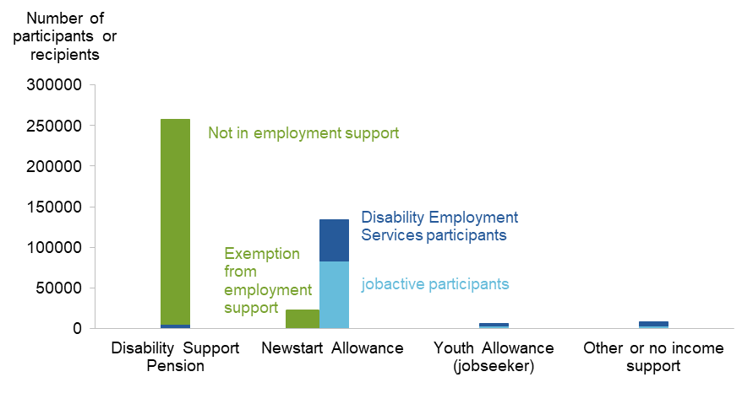

The Australian Government should ensure that employment services providers are meeting their obligations to provide personalised job plans that go beyond compliance, targeted at job seekers with complex needs. This should include extending the period of time that participants have to consider and propose changes to their job plan and greater flexibility in the application of the targeted compliance framework for those participants experiencing mental illness.
To better meet the needs of carers whose care recipient has a mental illness, the Australian Government should amend eligibility criteria for the Carer Payment and Carer Allowance to reflect that: the nature of care provided for someone with mental illness is not necessarily as ‘constant’ as that for a physical illness, can vary substantially from day to day, and is less likely to relate to the care recipient’s ‘bodily functions’. To provide more flexibility for the carer in undertaking their own economic and social activity, the restriction on hours that the carer can work or volunteer should be evaluated over a month rather than each week, and the restriction on study should be removed.

Use of insurance to enable ongoing economic and social participation
Given the large number of people who experience mental illness, the negative impact that mental illness has on capacity to earn an income, and the extent to which insurance is used to offset personal financial risk, it is not surprising that the insurance sector is particularly relied on by some people with mental illness. Access to insurance — including life insurance, income protection insurance, temporary or permanent disability insurance, private health insurance and travel insurance — that covers mental ill-health has been raised as a concern during the inquiry. One survey found that of those who identified as a mental health consumer and had applied recently for income protection insurance, 45% had their application declined due to mental health, 34% received the product with exclusions for mental illness, 16% received the product with increased premium for mental illness, and 8% received the product without exclusions or additional premiums.
Insurer practices on mental health — such as blanket exclusions, the extent to which differences between different types of mental illness are taken into account in assessing risk, information provided to applicants and claimants, and insurer access to clinical records — should be reviewed. We are seeking views on any barriers to employers with high risk workplaces purchasing (community-rated) income protection insurance on behalf of their employees that would cover loss of income because of mental illness.

5. Reforming the funding and commissioning of services and supports
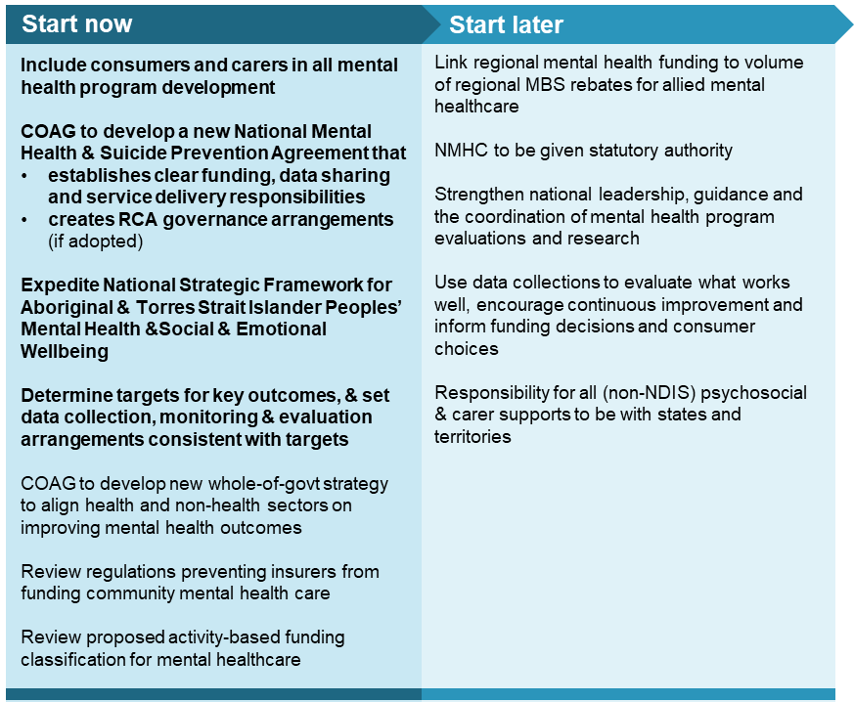
A range of the reforms canvassed in this draft report, including care coordination and navigation, and the integration of seamless care through the stepped-care model, will involve institutional change covering different tiers of Government. Both tiers will remain responsible for the outcomes of the mental health system. However, the success of reform will, in part, depend on improved clarity as to which level of Government is responsible for funding which services and how that funding translates into incentives for services to be provided (or not provided) to particular people in a particular manner. Success will also depend on the creation of a strong, evidence-based feedback loop so that program effectiveness can be evaluated with the results being used to help determine which activities are funded in the future.

Improving government coordination
To deliver seamless care and support for an individual as their mental health circumstances change requires improved coordination over funding and service delivery by all levels of Government. This includes greater clarity over who is taking responsibility for what. While inevitably there will be ‘grey areas’, to minimise both service duplication and service gaps, pragmatic governance arrangements to enable the various parts of the mental health system to come together as envisaged under the Fifth National Mental Health and Suicide Prevention Plan are needed.
Broadly speaking, the Australian Government has generally taken responsibility for primary mental healthcare and State and Territory Governments have taken responsibility for acute mental healthcare (public hospital mental healthcare). Fundamentally, this will not change under our proposed reforms. However, the ‘missing middle’ reflects the failure of clarity and coordination where primary and acute mental health care meet.
A clearer division of responsibilities between tiers of government is required to avoid these interface problems. In broad terms:
- activities that need local knowledge, expertise and flexibility in order to plan and deliver intended outcomes should be the responsibility of a sub-national level government — follow-up care for people who have been discharged from hospital after a suicide attempt is one such activity;
- activities that need national coordination or consistency in order to effectively, efficiently or equitably achieve intended outcomes should be the responsibility of the Australian Government — provision of infrastructure to enable dissemination of funding, information, online diagnosis or treatment is one example of this.
However, in practice, even these broad areas of responsibility will be blurred. The necessary interlinkages between the mental health system and the broader systems of health, community and Indigenous services, social security, public housing, justice and employment relations necessitate some flexibility around boundaries for reform in mental health.
Nothwithstanding, reform will aid both transparency and the allocation of responsibility and accountability. Agreed roles and responsibilities of Governments should form the basis of a new intergovernmental agreement on funding.

Table 2 Proposed government responsibilities in mental health
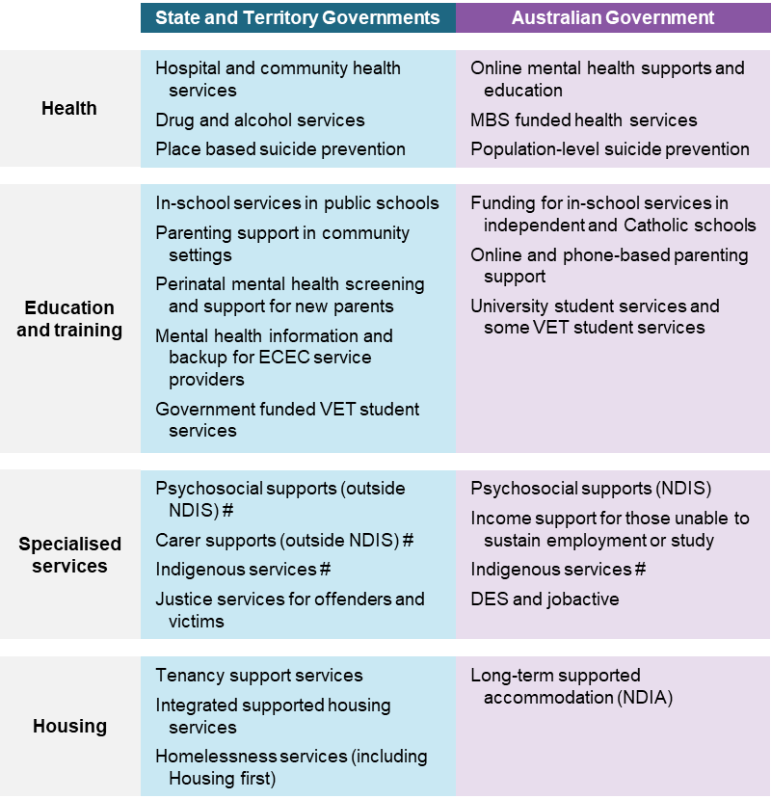
# current shared responsibility

Funding and institutional reform
Current funding arrangements in the mental health system contribute to poor consumer outcomes and a mix of services that is inefficient. For example, they provide few incentives at a local hospital level to minimise hospitalisations and avoid repeated presentations to emergency departments. Beyond the healthcare system, funding for other supports such as psychosocial services is extremely fragmented and based on short contract cycles, which make it harder to deliver quality services on a continuous basis to people. Similarly, mental health interventions delivered in schools and other types of community services are funded through a very wide range of programs, which is leading to duplication, inefficiency and unnecessary red tape.
Reforming funding arrangements in the health system and for psychosocial and carer supports to create the incentives to deliver services that are more consumer-oriented, should be a priority for governments. In part this will require recognition that improvements to the mental health system can result in both costs and benefits beyond the healthcare system, and that these benefits may occur over time. In particular expenditure in some parts of the mental health system today (such as in-community supported residential mental healthcare) would not only generate benefits in the wellbeing of those with severe mental illness but generate long term economy-wide benefits. Funding that is efficient and creates effective incentives will require both intra-government and inter-government coordination and cooperation.
Improved clarity over funding and responsibilities requires institutional reform in the mental health system. The Commission is presenting two options in this inquiry draft report:
Option 1 Renovate model
The renovate model is largely a continuation of the current approach, with some changes that would give more flexibility to PHNs by relaxing centrally imposed restrictions on their funding pools and enabling them to contract with Medicare-funded clinicians to better meet the needs of consumers in their region. To prevent cost shifting, the size of a PHN’s mental health funding pool would be linked to the volume of Medicare rebates for allied mental healthcare in their region.
Public hospital and community mental health services would remain the responsibility of State and Territory Governments. Community mental health services (currently block funded) would be activity-funded, which should improve their productivity and negate incentives for Local Hospital Networks to preference hospital-based over community-based care. In addition, psychosocial supports (outside of the NDIS) and individual placement and support (IPS) employment services would become solely a State and Territory Government responsibility, with the Australian Government providing additional funding to support this.
Option 2 Rebuild model
The rebuild model would have most mental health funding held in regional funding pools controlled by each State and Territory Government and administered by Regional Commissioning Authorities (RCAs). The purpose of RCAs is to create a seamless mental healthcare system that offers continuity of service for people with mental ill-health and fills gaps in service provision. RCAs would overcome unnecessary and inefficient care discontinuities, duplication and gaps that would otherwise persist at the interface between Australian Government and State and Territory Government responsibilities. These new bodies will be responsible for allocating all mental healthcare, psychosocial and carer supports (with the exception of those for people receiving NDIS funding).
To enable this change, the following Australian Government funding should be pooled and transferred directly to the RCAs:
- payments by State and Territory Governments for mental healthcare under the National Health Reform Agreement
- funding for PHN-commissioned mental healthcare (PHNs would no longer commission mental healthcare under the rebuild model)
- the additional payments proposed for psychosocial and carer supports.
The size of each RCA’s funding pool would be linked to the volume of MBS rebates for allied mental healthcare in their region and each RCA would be permitted to contract with MBS-subsidised allied mental professionals, so as to create a single budget from which all such mental healthcare in a region would be funded.
The Rebuild model is the Commission’s preferred option.
Rather than creating institutional arrangements that enable two tiers of government to operate as one, the Rebuild model would allocate responsibility for mental healthcare to a single level of government. This avoids practical difficulties that have emerged when governments have tried collaborative funding. In the Commission’s view, State and Territory Governments are better suited to establish RCAs and be responsible for their operation, as they have a more firmly embedded role in the health system, and they are also responsible for other major services such as housing, education and justice, which all need to collaborate to support improved mental health and wellbeing. Where regional expertise has become established in PHNs, it would be important to draw on this to assist in the operation of the RCAs.
The rebuild model should help to build a people-oriented mental health system, as it creates strong incentives to invest in prevention and early intervention and avoid costly hospitalisations. Of course, while roles and responsibilities are clarified under the rebuild model, all levels of government will remain involved. For example, even if State and Territory Governments establish RCAs, the Australian Government would retain its responsibility for welfare payments and MBS rebates for mental healthcare.
A key component of the rebuild model (and any other model) is developing a National Mental Health and Suicide Prevention Agreement, separate from the existing National Health Reform Agreement. This agreement would codify Australian, State and Territory Government responsibilities, and facilitate transfers of funds from the Australian Government to the State and Territory Governments that outlast the government of the day. In return, it obliges State and Territory Governments to comply with a new monitoring, reporting and evaluation framework.
The Commission recognises that this reform involves major changes in the way the mental health system is funded and governed. We are seeking feedback from inquiry participants and will be conducting further analysis on these issues; a complete governance and funding model will be presented in the inquiry final report.

Getting bang from the taxpayer buck
Many of the reforms recommended in this inquiry draft report would involve governments spending more taxpayer funds on mental health. But even under current spending levels, governments are obligated to ensure taxpayer funds are used as efficiently and effectively as possible. Throughout this report, we report numerous instances in the mental healthcare system where this is not occurring.
Improvements can be made across the system. For example, improving the efficiency of public community mental health services is desirable and necessary, given the expanded role that our recommendations would have for them. It is not just taxpayers who are losing out. The Commission estimated that, across Australia, only 29% of staff time at community mental health services was spent on consumer-related activities (with or without the consumer present). This falls well short of an agreed national benchmark (that 67% of staff time in community mental health services be related to consumers). Extending activity-based funding to community mental health services should both improve their efficiency and reduce incentives to prioritise hospital-based care.
The Commission supports using activity-based funding to fund both hospital-based mental healthcare and community mental health services to improve incentives across the healthcare system. However, implementing this approach requires care to ensure that funding reflects underlying costs and that reform does not itself create perverse incentives.

Monitoring, evaluation and reporting for improved outcomes
Improved monitoring, reporting and evaluation are needed to support the reforms to the mental health system outlined in this draft report. Accountability for outcomes and the creation of a ‘learning system’ can only be achieved through a comprehensive and nationally-consistent monitoring and reporting framework.
A key change supporting this would be a focus on better using and publishing data that is already collected. Vast amounts of data are collected throughout the mental health system, but the system as a whole is data rich but information poor: there is limited use of data to either improve consumer choices, experiences and outcomes, or inform improvements in service delivery and effectiveness. For example, data on specialised mental health services collected by State and Territory Governments, data on services commissioned by PHNs, and data in the National Outcomes and Casemix Collection are underutilised.
The mental health system as a whole needs to move toward collecting data on the impacts of mental illness on the functional capacity of people and the outcomes of programs (rather than just activity data) where at all possible. Long time frames and the interaction of multiple services to improve outcomes complicate this, but there is agreement on some basic indicators and additional outcome measures are proposed. The intention is that this data will feed back in to policy and program development, through an enhanced understanding of which programs are effective in delivering improved consumer outcomes and represent a reasonable investment of taxpayer funds.
Some key data collections should be expanded and updated and priorities should be established for ensuring data that data collected is translated into useful, and publicly available, information.
The role of the National Mental Health Commission (NMHC), which already reports on some mental health indicators, should be expanded, so that it can report on whole-of-government shared outcome indicators. Shared outcome indicators should be used to support joint responsibility and funding programs across different portfolios, including health, housing, human and social services, education and training, employment and justice. The NMHC should also monitor and report on system performance and government expenditure on mental health. Performance of mental health services at a regional level should be publicly reported on nationally by the AIHW.
Rigorous evaluations of programs and policies in the mental health system are very important — and very rare. Evaluation should be embedded into program design, not only to ensure that public funds are spent efficiently but also that programs achieve their intended goals, and contribute positively to mental health and wellbeing. The role of the NMHC should include preparing and publishing a rolling three-year schedule for evaluation of mental health and suicide prevention programs that are funded by the Australian, State and Territory Governments, and other programs that have strong links with mental health outcomes, including those in non-health sectors. The evaluation processes should explicitly provide a means by which lessons garnered during program delivery can be incorporated into ongoing program improvements.
To support the NMHC in these new roles and to allow it to report independently on whole-of-government implementation and performance of mental health programs, the NMHC should be afforded statutory authority status as an interjurisdictional body.

DRAFT RECOMMENDATIONS
AND FINDINGS

PART I The case for major reform

DRAFT Finding 2.1 — The state of mental health in australia
Mental illness is the second largest contributor to years lived in ill-health, and almost half of all Australians will experience mental illness at some point in their life. Compared to other developed countries, the prevalence rate of mental illness in Australia is above the OECD average.

Draft Finding 3.1 — The cost of mental ill-health and suicide to australia
The costs of mental ill-health and suicide are pervasive, reflecting costs incurred in healthcare, education, housing, justice, work, family and friends, and the quality of life of consumers and their carers.
The direct economic costs of mental ill-health and suicide in Australia are estimated to be in the order of $43 to $51 billion in 2018-19. These estimates are apportioned as follows:
- direct expenditure on healthcare and other supports and services ($18 billion)
- lower economic participation and lost productivity ($10 to $18 billion)
- informal care provided by family and friends ($15 billion)
The cost to individuals of the diminished health and wellbeing of living with mental ill-health was a further $130 billion.
These estimates do not include some broader social effects such as the cost of stigma or lower social participation.

Information request 3.1 — Education activities that support mental health and wellbeing
We are seeking information or methodologies that would help us to estimate the cost of activities undertaken by educational institutions in supporting mental health and wellbeing of students.

Information request 3.2 — Out-of-pocket costs for mental healthcare
We are seeking more information on the out-of-pocket costs of mental healthcare that consumers or their carers incur. We are interested in surveys that have been undertaken, particularly if they capture costs outside of the government funded healthcare system, such as estimates of the cost of travel to services, medications not covered by the Pharmaceutical Benefits Scheme and consultations outside the Medicare Benefits Schedule.

Draft Finding 26.1 — Modelled benefits of some key proposed reforms
Improvements to people’s mental health increases their likelihood of employment and their expected income, while also improving their health-related quality of life. In the long-run, the economic benefits from some key proposed reforms are likely to be between $8.8 to $11.5 billion dollars per year.

PART II Reorienting health services to consumers
Healthcare access | REFORM OBJECTIVE:  A range and quantity of treatment options that allows people timely access to culturally appropriate mental healthcare at the right level for their condition

draft Recommendation 5.9 — ensure access to the right level of care
The Australian, State and Territory Governments should reconfigure the mental health system to give all Australians access to mental healthcare, at a level of care that most suits their treatment needs (in line with the stepped care model), and that is timely and culturally appropriate.

draft Recommendation 5.2 — assessment and referral practices in line with consumer treatment needs
In the short term (in the next 2 years)
Commissioning agencies (PHNs or RCAs) should promote best-practice in initial assessment and referral for mental healthcare, to help GPs and other referrers match consumers with the level of care that most suits their treatment needs (as described in the stepped care model).
In the medium term (over 2 – 5 years)
Commissioning agencies (PHNs or RCAs) should establish mechanisms for monitoring the use of services that they fund to ensure that consumers are receiving the right level of care. If service use is not consistent with estimated service demand, commissioning agencies may need to make changes to initial assessment and referral systems (or work with providers to do so).

draft Recommendation 5.3 — ensuring headspace centres are matching consumers with the right level of care
headspace centre funding should be conditional on centres following the stepped care model.
In the medium term (over 2 – 5 years)
headspace grant funding for individual centres should be made conditional on centres meeting targets for the proportion of young people referred to low-intensity services. The targets set by commissioning agencies (PHNs or RCAs) for each centre should depend on the full range of relevant characteristics of the young people they see. The targets should start low and increase over time.

draft finding 5.1 — the link-me trial may improve assessment and referral practices
The decision support tool, developed as part of the ongoing Link-me Trial, can improve GP assessment and referral practices by identifying the mental health needs of people going to the GP and providing the GP with tailored treatment recommendations.
The extent to which this tool leads to clinical benefits and cost savings relative to usual care, should be used to inform actions taken by governments and commissioning authorities (PHNs or RCAs) to ensure that consumers are matched with the level of care that most suits their treatment need, in line with the stepped care model.

draft Recommendation 5.6 — practitioner online referral treatment service
Commissioning agencies could learn from the success of Practitioner Online Referral Treatment Service (PORTS) in Western Australia in improving accessibility and effectiveness of online mental healthcare treatment options.
In the medium term (over 2 – 5 years)
Commissioning agencies (PHNs or RCAs) in other States and Territories should consider implementing the PORTS model, or incorporating aspects of the PORTS model into their services.

draft Recommendation 5.8 — INCREASE consumer CHOICE WITH REFERRALS
In the short term (in the next 2 years)
The Australian Government should amend the MBS regulations for referrals to require:
- that general practitioners and other referrers advise people that they can use an alternative to any provider mentioned in a referral to a specialist or allied health professional
- that all referrals to specialists and allied health professionals include a prominent and easy to understand statement advising people that they can use an alternative to any provider mentioned in the referral.

Information request 5.2 — Mental health treatment plans
How should the requirements of the Mental Health Treatment Plan (MHTP) and MHTP Review be changed to ensure that GPs assess, refer and manage consumers in line with best practice (as laid out in the Australian Department of Health’s guidance)?
- What should be added to the MHTP or MHTP Review to encourage best-practice care?
- Are there current unnecessary aspects of the MHTP or MHTP Review that should be removed?
- Are there additional or alternative clinical thresholds (to a mental disorder diagnosis) that a consumer should meet to access Psychological Therapy Services or Focused Psychological Strategies?
- Should consumers continue to require a MHTP for therapy access if being referred by a GP?
- What new clinical thresholds, if any, should be introduced to access additional sessions beyond the first course of therapy? Should these be part of or separate to the MHTP Review? Should a MHTP Review be required to access additional sessions, instead of just a new referral?
- How could audits be used to ensure that clinicians are assessing, referring and managing patients in line with best-practice and the stepped care model?
- What information should clinicians be required to give the consumer when completing a MHTP or MHTP Review? Should they be required to give the consumer the completed and reviewed Plan?
- Should GPs continue to receive a higher rebate for MHTPs and MHTP Reviews than for standard consultations?

DRAFT Recommendation 6.1 — supported online treatment options should be integrated and expanded
The Australian Government should facilitate greater integration and use of supported online treatment, into the stepped care model as a low intensity service, for people living with mental ill-health with mild to moderate symptoms.
In the short term (in the next 2 years)
- Funding should be expanded for services to accommodate up to 150 000 clients per year in supported online treatment.
- Supported online treatment programs offered should each have a strong evidence base for their efficacy and be offered to children, youth and adults.
- To aid integration of healthcare services, supported online treatment should have the option for outcomes data to be forwarded to a nominated GP or other treating health professional. Online service providers should annually publish summary output on use of their services, treatment provided, and other measurable outcomes.
In the long term (over 5 – 10 years)
- A review of supported online treatment services as a low intensity option should be undertaken. This review should assess whether there are any barriers to take up, the effectiveness of the services contracted and future funding options.

Information request 6.1 — Supported online Treatment for culturally and linguistically diverse people
The Productivity Commission is considering recommending the expansion of supported online treatment to cater for people from culturally and linguistically diverse backgrounds. We seek views on:
- the merits of such a proposal
- in what circumstances would the delivery of supported online treatment be cost-effective
- what constraints would need to be considered
- which language or cultural group should be the focus of any trial expansion.

draft Recommendation 6.2 — INFORMATION CAMPAIGN To promote supported ONLINE TREATMENT
In the short term (in the next 2 years)
The Australian Government should instigate an information campaign to increase awareness of the effectiveness, quality and safety of government-funded clinician-supported online therapy for treatment of mental ill-health for consumers and health professionals.

DRAFT Recommendation 5.5 — encourage more group psychological therapy
Changes should be made to MBS rules to encourage more group therapy.
In the short term (in the next 2 years)
- The Australian Government should change MBS rules so that group therapy is allowed with a minimum of 4 people (instead of 6 people), and with less than 4 people, as long as the course of group therapy began with at least 4 in the group.
- The Australian Government should create new Medicare items for group sessions that run for ‘at least 90 minutes’ and ‘at least 120 minutes’.
- The Australian Government should clarify — and communicate with referrers and providers — that unless explicitly stated otherwise, referrals for MBS-rebated Psychological Therapy Services and Focused Psychological Strategies can be used for either group therapy or individual therapy — at the discretion of the psychological therapist receiving the referral after discussion with the consumer.

draft finding 5.2 — the effectiveness of MBS-rebated psychological therapy
Despite evidence for the clinical effectiveness of psychological therapy, there is no well-resourced and rigorous evaluation of the effectiveness of MBS-rebated psychological therapy (Psychological Therapy Services and Focused Psychological Strategies).
The clinical evidence suggests that of those people with mental illness who are best treated through individual face-to-face psychological therapy, most need more than 10 sessions (the current MBS limit) for their condition to significantly improve.
More flexibility around the number of rebated sessions available per year would mean more people with mental illness could get the treatment they need, but this would need to be trialled.

DRAFT Recommendation 5.4 — MBS-rebated psychological therapy
MBS-rebated psychological therapy should be evaluated, and additional sessions trialled.
In the short term (in the next 2 years)
The Australian Government should commission an evaluation of the effectiveness of MBS-rebated psychological therapy. As part of this evaluation, the Australian Government should undertake trials allowing up to 20 sessions of individual or group therapy in total over a year for consumers whose clinical condition requires more than the current 10 sessions. The trials should allow a GP to re-refer a consumer after the first 10 sessions rather than the present 6 sessions.
The Australian Government should change the MBS so that the maximum number of sessions of MBS-rebated psychological therapy (Psychological Therapy Services and Focused Psychological Strategies) is per 12-month period, as opposed to per calendar year.
In the medium term (over 2 – 5 years)
Based on the results of these trials and evaluation, the Australian Government should determine whether to:
- roll out the trialled changes above
- continue funding psychological therapy through the MBS, or whether some other mechanism is more appropriate
- make any other changes to increase the effectiveness of MBS-rebated psychological therapy.

Information request 5.1 — Low-intensity therapy coaches as an alternative to psychological therapists
We are seeking information on the gains from having a greater share of treatment provided by low-intensity therapy coaches. This includes:
- improvements in mental health outcomes and/or the cost-effectiveness of therapy for consumers and the wider community
- the groups of consumers that would most benefit.

draft Recommendation 5.7 — psychology consultations by videoconference
Widening access to psychology consultations by videoconference.
In the short term (in the next 2 years)
- The Australian Government should change MBS rules so that videoconference can be used for MBS-rebated Psychological Therapy Services and Focused Psychological Strategies by consumers residing in metropolitan areas, regional centres and large rural towns (Monash Modified Model areas 1–3) in addition to those residing in small and medium rural towns, remote and very remote communities (Monash Modified Model areas 4–7).
- For consumers in areas 1–3, at least 3 out of each 10 sessions must be face-to-face (including at least one out of the first four), and there should be no restriction that the consumer and clinician must be at least 15 kilometres away from each other.

draft Recommendation 7.2 — psychiatry consultations by videoconference
In the short term (in the next 2 years)
- The Australian Government should introduce a new suite of time-tiered items for videoconference consultations to regional and remote areas (RA2–5), as recommended by the MBS Review Psychiatry Clinical Committee, removing item 288 from the MBS.
- In addition, the Australian Government should add new items for videoconference consultations mirroring existing items for psychiatric assessments (item 291) and reviews (item 293), that are available in major cities (RA1) as well as in regional and remote areas (RA2–5), and that are paid at the same rate as items 291 and 293.

Healthcare — improvements  for people receiving care in hospitals | REFORM OBJECTIVE:  In-patient services that reflect the treatment needs of consumers

draft Recommendation 7.1 — Planning regional HOSPITAL AND COMMUNITY MENTAL HEALTH SERVICES
In the short term (in the next 2 years)
State and Territory Governments should determine, through regional service planning, the numbers of public acute mental health beds in hospitals, specialist mental health community treatment services and subacute/non-acute mental health bed-based services that would meet the specific needs of each region and undertake to provide these on an ongoing basis.

draft Recommendation 8.1 — Improve emergency mental health service experiences
In the short term (in the next 2 years)
- State and Territory Governments should provide more and improved alternatives to hospital emergency departments for people with acute mental illness, including peer- and clinician-led after-hours services and mobile crisis services.
- State and Territory Governments should consider best practice approaches to providing paramedics with access to mental health resources when undertaking medical assessments in the field.
- Public and private hospitals should take steps to improve the emergency department experience they provide for people with a mental illness. This could include providing separate spaces for people with mental illness, or otherwise creating an environment more suitable to their needs.
In the long term (over 5 – 10 years)
- State and Territory Governments should, when building or renovating emergency departments, design them to take account of the needs of people with mental illness.

DRAFT Recommendation 8.2 — child and adolescent mental health beds
In the short term (in the next 2 years)
State and Territory Governments should provide child and adolescent mental health beds that are separate to adult mental health wards. If it is not possible to provide these beds in public hospitals, State and Territory Governments should contract with private facilities, or provide care as hospital-in-the-home.

Healthcare workforce | REFORM OBJECTIVE:  A health workforce with capacity to deliver mental health treatment and care

draft Recommendation 11.1 — the National mental health Workforce Strategy
The forthcoming update of the National Mental Health Workforce Strategy should align health workforce skills, availability and location with the need for mental health services.
In the short term (in the next 2 years)
The Australian Government should ensure that its development of a new National Mental Health Workforce Strategy includes the following actions.
- Set the objective of achieving a health workforce which aligns the skills, cultural capability, availability and location of mental health service providers with demand. This goal should be given effect by integrating the workforce strategy with service and infrastructure planning.
- Quantify the future supply of specific skills and health professions under a business-as-usual scenario, and the extent to which this will fall short of what is needed.
- Specify what will be done to address any forecast shortages in skills or professions, and quantify the expected timing and reduction in those shortages.
- Include a commitment to implement the recommendations that this inquiry has made on specific skills and professions, including a more efficient allocation of tasks.
- Set targets to attract and retain workers, and establish a system to monitor and report progress in achieving the targets.
This work should also inform the workforce development program which is being undertaken for the National Mental Health and Suicide Prevention Plan.

draft Recommendation 11.2 — increase the number of psychiatrists
In the medium term (over 2 – 5 years)
The Australian, State and Territory Governments should collectively develop a national plan to increase the number of psychiatrists in clinical practice, particularly outside major cities and in sub-specialities with significant shortages, such as child and adolescent psychiatry.
This should be done in collaboration with the Royal Australian and New Zealand College of Psychiatrists, and form part of the broader National Medical Workforce Strategy which is currently being developed.
The plan should include actions to:
- raise the number of funded training placements and supervisors, with State and Territory Governments doing so in public sector health facilities, and the Australian Government contributing funding for more positions in the private sector and rural and remote areas
- increase the availability of supervision for trainees, including by considering interventions recommended in the 2016 report by the National Medical Training Advisory Network (titled Australia’s Future Health Workforce – Psychiatry) such as remote models of supervision for trainees outside major cities.
The size of the targeted increase in psychiatrists should be based on assessments of future workforce needs to be undertaken as part of broader workforce planning by governments, including for the National Mental Health Workforce Strategy (draft recommendation 11.1).

draft Recommendation 5.1 — psychiatric advice to GPs
In the medium term (over 2 – 5 years)
The Australian Government should introduce an MBS item for psychiatrists to provide advice to a GP over the phone on diagnosis and management issues for a patient who is being managed by the GP. The effectiveness of the new item should be evaluated after several years.

Information request 7.1 — freeing up psychiatrists for people who need them most
What additional steps, if any, should be taken to support private psychiatrists to increase the number of consultations involving new patients?

draft Recommendation 11.3 – More specialist mental health nurses
In the short term (in the next 2 years)
- Accreditation standards should be developed for a three-year direct-entry (undergraduate) degree in mental health nursing, similar to the option already available to midwives. The new standards should be developed by the Australian Nursing and Midwifery Accreditation Council in consultation with stakeholders, including the Australian College of Mental Health Nurses and the Nursing and Midwifery Board of Australia. Nurses who complete the three-year direct-entry degree would be registered as having an undergraduate qualification in mental health and (if the above recommendation results in a specialist registration system for nurses with advanced training in mental health) be distinguished from registered nurses with a post graduate degree in mental health.
In the medium term (over 2 – 5 years)
- The merits of introducing a specialist registration system for nurses with advanced qualifications in mental health should be assessed. The assessment should be independent and be commissioned by the Australian, State and Territory Governments through the COAG Health Council. If specialist registration is found to have merit, the COAG Health Council should direct the Nursing and Midwifery Board of Australia to provide it with a formal proposal to amend the registration arrangements for nursing to recognise nurses who have specialist qualifications in mental health.

draft Recommendation 11.4 — strengthen the peer workforce
Governments should strengthen the peer workforce.
In the short term (in the next 2 years)
- The National Mental Health Commission should, when submitting its finalised national guidelines on peer workers to governments for approval in mid-2020, recommend how the guidelines should be supported by work standards for particular areas of practice.
- The National Mental Health Commission should, by the end of 2019, submit a recommendation to the Australian Government on how to establish of a professional organisation to represent peer workers. This should include advice on how governments should, if at all, make a financial contribution, such as by providing seed funding to establish the professional organisation.
In the medium term (over 2 – 5 years)
- The Australian, State and Territory Governments should, in consultation with stakeholders, develop a program to educate health professionals about the role and value of peer workers in improving outcomes. The program will need leadership to improve workplace cultures.
- The Australian Government should, in consultation with State and Territory Governments and other stakeholders, commission a national review to develop a comprehensive system of qualifications and professional development for peer workers. This should consider of how peer worker qualifications would be recognised as prior learning for health professional qualifications.

draft Recommendation 11.5 — improved mental health training for doctors
Improve medical practitioners’ training on medication side effects and consider specialist registration for GPs who have advanced specialist training in mental health.
In the short term (in the next 2 years)
- Continuing professional development requirements for GPs and psychiatrists should incorporate best-practice approaches to managing the side effects of medication prescribed to treat mental illness. To ensure this is the case, the Australian Government should request the Australian Medical Council to review current CPD requirements and make any changes necessary. This should be done in consultation with stakeholders, including the Medical Board of Australia and relevant colleges for GPs and psychiatrists.
- The merits of introducing a specialist registration system for GPs with advanced specialist training in mental health should be assessed. The assessment should be independent and be commissioned by the Australian, State and Territory Governments through the COAG Health Council. If specialist registration is found to have merit, the COAG Health Council should direct the Medical Board of Australia to provide it with a formal proposal to amend the registration arrangements for GPs to recognise those who have specialist qualifications in mental health.

Draft Recommendation 11.6 — mental health specialisation as a career option
Governments and specialist medical colleges should take further steps to reduce the negative perception of, and to promote, mental health as a career option.
In the short term (in the next 2 years)
The Australian, State and Territory Governments should, in collaboration with specialist medical colleges, act to reduce the negative perception of, and to promote, mental health as a career option by:
- exposing health students and practising health professionals to people with a mental illness (and their carers) outside a clinical environment to help break down negative perceptions
- rebalancing where trainees undertake clinical placements and internships to a more representative mix of settings, including in the private sector and settings other than inpatient units.

draft Recommendation 11.7 — attracting a rural health workforce
In the short term (in the next 2 years)
The Australian, State and Territory Governments should make working in rural and remote areas a more attractive option for health professionals by reducing professional isolation, increasing opportunities for professional development, and improving the scope to take leave. This should include:
- greater use of videoconferencing, subject to the availability of communications infrastructure, for health workers to remotely participate in professional development activities and meetings and conferences with peers
- expanding initiatives such as the Rural Locum Assistance Program to fund visiting health professionals to temporarily stand in for rural and remote health workers, including psychiatrists, while they attend professional development activities, meetings and conferences with peers, and take leave.

Information request 11.1 — aboriginal and torres strait islander health workers
The Productivity Commission is seeking information from participants on any barriers impeding career progression for Aboriginal and Torres Strait Islander health workers, including barriers to the ability to move to broader health professions, such as mental health nursing.

PART III Reorienting surrounding services to people

Care integration  and coordination | REFORM OBJECTIVE:  Care pathways for people using the mental health system that are obvious and joined up

draft recommendation 10.1 — consumer assistance phone lines
Assistance phone lines offering support for people with mental ill-health and their carers should facilitate better exchanges of information between service providers.
In the medium term (over 2 – 5 years)
- In its funding contract with existing assistance phone lines, the Australian Government should require providers to implement timely referral processes that minimise the need for consumers to repeat information.
- The phone line that will be part of the Australian Government’s mental health portal, Head to Health, should use a similar approach to referrals. The range of services listed on Head to Health should be expanded. The Australian Government can also consider funding an advertising campaign, to raise community awareness of the phone line and the online portal.

Draft Finding 10.1 — digital records would facilitate information sharing
Expanding the use of digital records in the mental healthcare system would facilitate greater information sharing and improve consumer experience. Existing digital health record systems, such as My Health Record, can provide an adequate platform for information sharing between providers of mental healthcare services.

draft Finding 10.2 — supporting collaboration between service providers
A range of approaches to collaboration, including co-location, alliances and networks, can improve service delivery and benefit consumers.
Depending on the scale and type of services involved, providers could consider formalising links using memorandums of understanding to create clear accountability structures and overcome barriers to collaboration.

draft Recommendation 10.2 — online navigation platforms to support referral
Pathways
Commissioning agencies should ensure service providers have access to online navigation platforms offering information on pathways in the mental health system.
In the short term (in the next 2 years)
- All commissioning agencies (PHNs or RCAs) should, either individually or collaboratively, develop and maintain an online navigation platform, including detailed mental health referral pathways. The HealthPathways portal model, which is already used by most PHNs, can be used to contain this information.
- Access to these platforms should be expanded beyond health, in particular to schools and psychosocial service providers. Each commissioning agency should also, either individually or collaboratively, fund a small dedicated team supporting the users of the online platform.
In the medium term (over 2 – 5 years)
- All online navigation platforms should incorporate the ability to book consultations with service providers directly from the platform.

draft Recommendation 10.3 — single care plans for some consumers
Governments should support the development of single care plans for consumers with moderate to severe mental illness who are receiving services across multiple clinical providers.
In the medium term (over 2 – 5 years)
The Department of Health should:
- develop and promote protocols for sharing consumer information between service providers, and allocating responsibility for plan development, follow-through and updating the consumer’s primary treating clinician (unless otherwise agreed by their treating team)
- amend the MBS to include a specific item to compensate a clinician overseeing a single care plan for their time.

draft Recommendation 10.4 — care coordination services
All people with severe and persistent mental illness who require care coordination services due to their complex health and social needs should be receiving them. Governments should set a national benchmark for all commissioning authorities, to ensure such services are available and any gaps are addressed.
In the short term (in the next 2 years)
All commissioning authorities should:
- assess the number of people who require care coordination services in their region of responsibility, and the extent to which they are already accessing effective care coordination through existing programs, including the National Disability Insurance Scheme (NDIS)
- streamline care coordination arrangements and ensure that people with a severe and persistent mental illness and complex needs requiring support from multiple agencies have access to effective care coordination.
In the medium term (over 2 – 5 years)
All commissioning agencies should ensure that care coordination programs are available to match local needs, including for those people with severe and persistent mental illness and complex needs who do not qualify for the NDIS, and people with severe mental illness who require care coordination only for brief periods of time.

DRAFT Recommendation 12.1 — Extend the contract length for psychosocial supports
In the short term (in the next 2 years)
The Australian, State and Territory Governments should extend the funding cycle length for psychosocial supports from a one-year term to a minimum of five years.

Draft Recommendation 12.2 — guarantee continuity of psychosocial supports
Requirements for continued access to psychosocial support should be changed so that anyone who requires it is able to access it, including former participants of Australian Government-funded psychosocial supports.
In the short term (in the next 2 years)
- Should someone choose to apply for the National Disability Insurance Scheme (NDIS), they should continue to be supported during the application process
- Should someone choose not to apply for the NDIS, they should be allowed to continue to access support through the National Psychosocial Support Measure, should they require it, until it has been phased out
In the medium term (over 2 – 5 years)
- For those who did not apply for the NDIS, the psychosocial support commissioning agencies should conduct an evaluation of barriers and remove them as necessary
- When the National Psychosocial Support Measure is phased out, participants should either be shifted onto the NDIS, if appropriate, or access the replacement psychosocial support.

Draft Recommendation 12.3 — NDIS support for people with psychosocial disability
The National Disability Insurance Agency (NDIA) should continue to improve its approach to people with psychosocial disability.
In the short term (in the next 2 years)
- The NDIA should complete the evaluations of the psychosocial disability stream trial sites in Tasmania and South Australia, and incorporate improvements into the stream, as soon as possible
- The psychosocial disability stream should be fully rolled out across all National Disability Insurance Scheme sites by end-2020
- Incorporate the lessons learnt from the Independent Assessment Pilot into the National Disability Insurance Scheme access and planning processes by end-2020.

Carers and families | REFORM OBJECTIVE:  Increased support for the wellbeing and role of carers and families of people with mental illness

DRAFT Finding 13.1 — POTENTIAL IMPROVEMENTS to income support FOR ALL CARERS
The existence of a Carer Payment, Carer Allowance and Carer Supplement that all achieve similar objectives, but have arbitrary differences in eligibility, contributes to an income support system that is complex and not well understood by carers.

draft Recommendation 13.1 — REDUCE BARRIERS TO ACCESSING INCOME SUPPORT FOR MENTAL HEALTH CARERS
In the short term (in the next 2 years)
The Australian Government Department of Social Services (DSS) should complete its review of the Adult Disability Assessment Tool used to assess eligibility for Carer Payment and Carer Allowance. DSS should:
- publish its analysis and findings from the review and field testing process
- consult with carers and health professionals before setting revised weightings for the new questions and the minimum score required to be eligible for each payment
- expand the list of persons who can complete the health professional questionnaire to include psychologists and social workers.
In the medium term (over 2 – 5 years)
DSS should amend eligibility criteria for Carer Payment (adult) and Carer Allowance (adult). Amendments should include:
- replacing the requirements for ‘constant care’ and ‘care and attention on a daily basis’ with a requirement to provide ‘regular care’
- replacing the 25 hour per week restriction on work, study and volunteering with a 100 hour per month restriction on work and volunteering only
- replacing the requirement that care must be provided in the home of the care recipient with a requirement that care must usually be provided in the home of the care recipient
- removing the eligibility restriction for Carer Allowance that states that for carers who do not reside with their care recipient to be eligible, they must provide care that relates to the care recipient’s bodily functions or to sustaining their life and for more than 20 hours per week.

draft Recommendation 13.2 — employment Support for mental health carers
In the short term (in the next 2 years)
- The Australian Government Department of Social Services should evaluate its Carers and Work program to identify how to effectively support mental health carers to enter or maintain employment.
- A working group consisting of both Department of Social Services and Department of Employment, Skills, Small and Family Business representatives should use the evaluation to inform the development of guidelines that jobactive providers can use to tailor their services to the needs of current and former mental health carers.
In the medium term (over 2 – 5 years)
The Australian Government should require designated staff who are delivering the mainstream jobactive program and the Career Transition Assistance, Mid-Career Checkpoint and Transition to Work programs to undertake training to apply these guidelines.

draft Recommendation 13.3 — Family-focused and carer-inclusive practice
Family-focused and carer-inclusive care requires mental health services to consider family members’ and carers’ needs and their role in contributing to the mental health of consumers.
In the short term (in the next 2 years)
- Where this is not already occurring, State and Territory Government mental health services should routinely collect responses to the Carer Experience Survey. The data collected should be sufficient for each Local Hospital Network to compare and assess the level of carer-inclusive practice across its services.
- The Australian Institute of Health and Welfare should use the data to report publicly on survey take-up rates and survey results at the state and territory level.
In the medium term (over 2 – 5 years)
- To improve outcomes for children of parents with mental illness, the National Mental Health Commission should commission a trial and evaluation of the efficacy of employing dedicated staff to facilitate family-focused practice in State and Territory Government mental health services.
- The Australian Government should amend the MBS so that psychologists and other allied health professionals are subsidised:
- to provide family and couple therapy, where one or more members of the family/couple is experiencing mental illness. These sessions should count towards session limits for psychological therapy
- for consultations with carers and family members without the care recipient present. Consistent with existing items that are available to psychiatrists, there should be a limit of four subsidised consultations with carers and family members per 12 month period.

Income support | REFORM OBJECTIVE:  Income support for people with mental illness and their carers that is accessible and does not discourage work, study or volunteering activity

DRAFT Recommendation 14.1 — employment support assessment measures
Assessment tools for jobactive and Disability Employment Services participants should be more relevant to job seekers with mental illness.
In the short term (in the next 2 years)
The Departments of Social Services; Human Services; and Employment, Skills, Small and Family Business should review the jobactive and Disability Employment Services assessment tools to increase their relevance for job seekers with mental illness. The review should consider:
- providing more specific guidance to job seekers answering the Job Seeker Classification Instrument about the types of medical illnesses or disabilities relevant to employability
- adding a short-form mental health diagnostic instrument to the Job Seeker Classification Instrument
- a new instrument for predicting employment likelihood based on a blend of administrative and self-reported data, and using more sophisticated analytical tools
- supplementing the Employment Services Assessment with the Personal and Social Performance Scale or similar instrument.

DRAFT Recommendation 14.2 — tailor ONLINE employment services
Ongoing development of the New Employment Services should consider the needs of participants with mental illness.
In the short term (in the next 2 years)
As part of the national rollout of New Employment Services, and drawing on evidence of the trial underway from 2019 to 2022, the Department of Employment, Skills, Small and Family Business should:
- assess the potential for online peer group support for participants with mental illness as part of the Digital First software
- consider adaptation of the use of the Job Seeker Classification Instrument so that anyone reporting a mental illness is referred for personal assessment before being allocated to Digital First
- ensure participants with inadequate digital literacy and/or mental illness maintain access to face-to-face services
- ensure scope for participants to inform service providers of relapse in mental illness in a timely manner.

DRAFT Recommendation 14.3 — staged rollout of individual Placement and Support MODEL
The Individual Placement and Support (IPS) model of employment support should be extended beyond its current limited application through a staged rollout to (potentially) all State and Territory Government community mental health services, involving co-location of IPS employment support services.
The Commission is seeking further feedback on whether this should occur through partnerships between dedicated IPS providers and community mental health services, or direct employment of IPS specialists by community mental health services.
In the short term (in the next 2 years)
- Governments should thoroughly trial and evaluate the IPS program to better establish the factors that influence its cost-effectiveness (for example, the impacts of local labour market conditions and participant characteristics).
- The program should initially be open to all non-employed consumers of community mental health services who express a desire to participate and meet the other requirements of the IPS model. Participation in the program should fulfil mutual obligation requirements for income support recipients.
In the medium term (over 2 – 5 years)
Subject to these trials, the IPS program should be rolled out gradually with data shared across jurisdictions and a mechanism for diffusion of best practice. If the net benefits of the program apparent in the small scale trials are not replicated as the program is scaled up, its design (and if necessary, its desirability) should be re-appraised.

Information request 14.1 — iNDIVIDUAL PLACEMENT AND SUPPORT EXPANSION OPTIONS
The Productivity Commission is seeking further information about the pros and cons of the two distinct options for expanding the Individual Placement and Support (IPS) model of employment support. The options are:
- direct employment of IPS employment specialists by State and Territory Government community mental health services. This could be supported by additional Australian Government funding
- a new Australian Government-administered contract for IPS providers, based on fee-for-service compensation and subject to strict adherence to the IPS model (including that a partnership is in place with a State and Territory Government community mental health service).
What are the pros and cons of each option? Which is your preferred option and why? If the direct employment option is pursued, how should State and Territory Local Hospital Networks be funded to deliver the service?

Information request 14.2 — incentives for DSP recipients to work
In relation to the Disability Support Pension (DSP), the Productivity Commission seeks feedback on the costs, benefits and risks of:
- increasing the income threshold at which recipients begin to lose their payments and the value of the taper rate after that threshold
- increasing the weekly hour limit above which no DSP is payable from 30 hours to 38 hours (ordinary full time hours of work), but retaining the requirement that a person will lose eligibility for the DSP if they work for more than 30 hours per week for more than two years.

DRAFT Recommendation 14.4 — INCOME SUPPORT RECIPIENTS’ MUTUAL OBLIGATION REQUIREMENTS
In the short term (in the next 2 years)
The Departments of Human Services; Social Services; and Employment, Skills, Small and Family Business should:
- provide greater flexibility in the application of the Targeted Compliance Framework for jobseekers experiencing mental illness
- assess more systematically whether employment service providers are meeting their obligations to provide personalised Job Plans that go beyond compliance, targeted at job seekers with complex needs
- consider extending the period of time that job seekers with more complex needs have to consider and propose changes to their Job Plan beyond two business days.

Preventing housing issues from arising | REFORM OBJECTIVE:  Housing services that actively prevent people with mental ill-health from experiencing housing issues or losing their home

draft Recommendation 15.1 — Housing security for people with mental illness
Housing services should increase their capacity to prevent people with mental illness from experiencing housing issues or losing their home.
In the medium term (over 2 – 5 years)
- Each State and Territory Government should offer and encourage the use of mental health training and resources for social housing workers. Training should incorporate awareness about how to identify early warning signs of mental illness and the benefits of early intervention. It should also provide advice on appropriate interventions to stabilise existing tenancies for people with poor mental health, such as connecting tenants to mental health services or care coordinators.
- State and Territory social housing authorities should review their policies relating to anti-social behaviour, temporary absences and information sharing to provide consideration for people with mental illness, so as to reduce the risk of eviction.
- Each State and Territory Government, with support from the Australian Government, should ensure that tenants with mental illness who live in the private housing market have the same ready access to tenancy support services as those in social housing by meeting the unmet demand for these services.
In the long term (over 5 – 10 years)
- State and Territory Governments should monitor the impacts of forthcoming reforms to residential tenancy legislation, including no-grounds evictions, and assess the potential impacts for people with mental illness who rent in the private market.

Housing supply | REFORM OBJECTIVE:  Long-term stable housing solutions for those people with severe mental illness

draft Recommendation 15.2 — support people to find and maintain housing
Housing and homelessness services should have the capacity to support people with severe mental illness to find and maintain housing in the community.
In the short term (in the next 2 years)
- Each State and Territory Government, with support from the Australian Government, should commit to a nationally consistent formal policy of no exits into homelessness for people with mental illness who are discharged from institutional care, including hospitals and prisons.
- Governments should ensure that people with mental illness who exit institutional care (particularly hospitals or prisons) receive a comprehensive mental health discharge plan, and services have the capacity to meet their needs. These programs should integrate care coordination and access to accommodation.
- The National Disability Insurance Agency should review its Specialist Disability Accommodation strategy and policies with a view to encouraging development of long-term supported accommodation for National Disability Insurance Scheme recipients with severe and persistent mental illness.
- Each State and Territory Government, with support from the Australian Government, should work towards meeting the gap in the number of ‘supported housing’ places for those individuals with severe mental illness who are in need of integrated housing and mental health supports.
- Governments should provide (either themselves or outsourced to non-government organisations) a combination of long-term housing options for this cohort to support the diverse needs for mental health support and tenancy security.
- Each State and Territory Government, with support from the Australian Government, should work towards meeting the gap for homelessness services among people with mental illness in their jurisdiction. This could include increasing existing homelessness services as well as scaling up longer-term housing options such as Housing First programs.
- Housing First programs should target people who experience severe and complex mental illness, are persistently homeless, and are unlikely to respond to existing homelessness services.
- This would require governments to invest in homelessness services that make long-term housing available specifically for these programs.

Justice system | REFORM OBJECTIVE:  Increased importance at each stage of the justice system on identifying people at higher risk of mental illness, enabling early care intervention and ensuring effective links back into the community for continuity of care on release

draft Finding 16.1 — prevention and early intervention to reduce contact
with the criminal justice system
There is some evidence that investment in prevention and early intervention is a strategy that can reduce offending. Governments locally and internationally have acknowledged this with expenditure on such approaches. However, further research and evaluation is required to improve and refine these initiatives.

DRAFT Finding 16.2 — police responses rely on community mental health services
The effectiveness of police responses to mental health related incidents relies heavily on mental health services being available in the community. Police responses are limited by a ‘bounce back’ problem — where individuals referred to mental health services by police are unable to access appropriate treatment and care, and are discharged without support. Police can respond multiple times to the same individuals experiencing mental health crises.

draft Recommendation 16.1 — support for POLICE
A systematic approach should be implemented to support police respond to mental health crisis situations.
In the short term (in the next 2 years)
All State and Territory Governments should implement initiatives that enable police, health and ambulance services to collectively respond to mental health crisis situations. The approach undertaken in Queensland should be considered.
The initiatives should ensure that:
- mental health professionals are embedded in police communication centres to provide real-time information on the individual to whom police are responding, to advise on responses and referral pathways, and to prioritise deployment of co-responder resources
- police, mental health professionals and/or ambulance services (draft recommendation 8.1) are able to co-respond to mental health crisis situations if necessary
- roles and responsibilities of all service providers are clearly defined
- approaches are tailored to meet the needs of particular groups, such as Aboriginal and Torres Strait Islander people.

DRAFT Finding 16.3 — COURT DIVERSION PROGRAMS
All State and Territory Governments have implemented court diversion programs that aim to support people with mental illness access appropriate mental health treatment and social support. Court diversion programs differ across States and Territories and include court liaison services, mental health courts, integrated support services and Victoria’s Neighbourhood Justice Centre. All programs have demonstrably reduced recidivism rates and some have improved mental health.
However, the success of court diversion programs can depend on coordination of mental health court diversion programs with relevant agencies, particularly health and housing. Additional research and evaluation in this area would assist to improve existing and future programs.

draft Recommendation 16.2 — MENTAL HEALTHCARE STANDARDS IN CORRECTIONAL FACILITIES
National mental health service standards should apply to mental healthcare service provision in correctional facilities to the same level as that upheld in the community.
In the short term (in the next 2 years)
The Australian Commission on Safety and Quality in Health Care should review the National Safety and Quality Health Service Standards to ensure that it applies to mental health service provision in correctional facilities.

draft Recommendation 16.3 — mental healthcare in correctional facilities and on release
Mental health screening and assessment of individuals in correctional facilities should be undertaken to inform resourcing, care and planning for release.
In the medium term (over 2 – 5 years)
- All State and Territory Governments should undertake mental health screening and assessment of all individuals (sentenced or unsentenced) on admission to correctional facilities, and on an ongoing basis where mental ill-health is identified.
- The mental health information obtained from the screening and assessment needs to be comprehensive enough to inform resourcing of mental health services in correctional facilities. Where appropriate, authorities should share this information with community-based mental health services to enable individuals with mental illness to receive continuity of care on release.

Information request 16.1 — TRANSITION SUPPORT FOR THOSE WITH MENTAL ILLNESS RELEASED FROM CORRECTIONAL FACILITIES
We are seeking further information on transition support for individuals with mental illness released from correctional facilities (on parole or not) that link them to relevant community services. This includes information on the benefits of transition support and the extent of transition support that should be provided.

Information request 16.2 — Appropriate treatment for forensic patients
The Productivity Commission is seeking further information about those held in correctional facilities who are eligible for forensic mental healthcare, but are unable to access it due to capacity constraints. In particular, we are seeking information about the likely indirect costs and benefits to the wider community from increasing access to forensic mental healthcare.

draft Recommendation 16.4 — incarcerated aboriginal and torres strait islander people
In the short term (in the next 2 years)
- State and Territory Governments should ensure Aboriginal and Torres Strait Islander people in correctional facilities have access to mental health supports and services that are culturally appropriate. These services should be:
- designed, developed and delivered by Aboriginal and Torres Strait Islander organisations where possible
- trauma-informed, particularly when services are delivered to Aboriginal and Torres Strait Islander women
- focused on practical application particularly for those on remand or short sentences who need the skills on release to reintegrate.
- State and Territory Governments should work with Aboriginal and Torres Strait Islander organisations to ensure Aboriginal and Torres Strait Islander people with mental illness are connected to culturally appropriate mental healthcare in the community upon release from correctional facilities.

Advocacy | REFORM OBJECTIVE:  Ensure advocacy for people scheduled under mental health Acts

DRAFT Finding 16.4 — health justice partnerships
Approaches to integrate health and legal services, such as health justice partnerships, show promise in helping people access legal support early and thereby reduce risks to mental health. Existing analysis suggests health justice partnerships can help people access legal support early and improve mental health, but empirical evidence is lacking.

draft Recommendation 16.5 — disability justice strategies
In the medium term (over 2 – 5 years)
All State and Territory Governments should continue to develop disability justice strategies to ensure the rights of people with mental illness are protected and promoted in their interactions with the justice system. Disability justice strategies should consider how people with mental illness can be better supported to:
- initiate legal proceedings
- participate in the justice system
- access other appropriate support in the community, where required.
In the long term (over 5 – 10 years)
All State and Territory Governments should implement their disability justice strategies.

draft Recommendation 16.6 — LEGAL REPRESENTATION at MENTAL HEALTH TRIBUNALs
In the medium term (over 2 – 5 years)
State and Territory Governments should adequately resource legal aid services to assist people appearing before mental health tribunals and other tribunals that hear matters arising from mental health legislation. This could be addressed through broader legal aid funding or providing a specific legal aid grant.

draft Recommendation 16.7 — NON-LEGAL INDIVIDUAL ADVOCACY SERVICES
In the medium term (over 2 – 5 years)
State and Territory Governments should ensure that non-legal individual advocacy services are available for all individuals subject to involuntary treatment under mental health legislation. In particular, services should:
- focus on facilitating supported decision-making by individuals subject to orders
- be resourced to provide assistance to all individuals who require it
- integrate with rather than replace legal advocacy services.

PART IV Early intervention and prevention
Early childhood | REFORM OBJECTIVE:  Better use of childhood services to identify and enable early intervention for social and emotional development risks

Draft Recommendation 17.1 — perinatal mental health
Governments should take coordinated action to achieve universal screening for perinatal mental illness.
In the short term (in the next 2 years)
- The Australian Institute of Health and Welfare should expand the Perinatal National Minimum Data Set, to include indicators of mental health screening, outcomes and referrals. This data should be reported by State and Territory Governments.
- State and Territory Governments should use the data to evaluate the effectiveness of health checks for infants and new parents, and adjust practice guidelines in accordance with outcomes.
In the long term (over 5 – 10 years)
- The National Mental Health Commission should monitor and report on progress towards universal screening.
- State and Territory Governments should put in place strategies to reach universal levels of screening for perinatal mental illness for new parents. Such strategies should be implemented primarily through existing maternal and child health services, and make use of a range of screening channels, including online screening and outreach services.

draft Recommendation 17.2 — social and emotional development in preschool children
Services for preschool children and their families should have the capacity to support and enhance social and emotional development.
In the short term (in the next 2 years)
- State and Territory governments should use existing guidelines to expand early childhood health checks, such that they assess children’s social and emotional development before they enter preschool.
- State and Territory departments of education should ensure that all early childhood education and care services have ready access to support and advice from qualified mental health professionals.
- The Australian Children’s Education and Care Quality Authority should review the pre service training programs for early childhood educators and teachers to ensure qualifications include specific learning on children’s social and emotional development.
In the medium term (over 2 – 5 years)
- State and Territory departments of education, as the regulators responsible for early childhood education and care, should review the quality improvement plans of all services to ensure they include professional learning for staff on child social and emotional development.
- Where this is not already occurring, funding for backfilling should be made available to enable early childhood education and care staff to attend accredited professional development, to support their knowledge of child social and emotional development and mental health.
- State and Territory Governments should expand the provision of parent education programs through child and family health centres.

Draft Recommendation 17.3 — social and emotional learning programs in the education system
Governments should develop a comprehensive set of policy responses to strengthen the ability of schools to assist students and deliver an effective social and emotional learning curriculum.
In the short term (in the next 2 years)
- The COAG Education Council should develop a national strategic policy on social and emotional learning in the Australian education system. This policy should include:
- a clear statement on the role of the education system in supporting mental health and wellbeing, and the role of schools in interacting with the mental health system
- a commitment to cooperate with the COAG Health Council in the implementation of mental illness prevention policy, and a clear delineation of responsibility, to prevent overlap and confusion in policy development
- guidelines for the accreditation of initial teacher education and professional development courses for teachers, which will include social and emotional learning. These guidelines should be developed by the Australian Institute of Teaching and School Leadership
- guidelines for the accreditation of external social and emotional learning programs offered to schools. These guidelines could be developed by an expert advisory panel.
In the medium term (over 2 – 5 years)
- State and Territory departments of education should use the national guidelines to accredit social and emotional learning programs delivered in schools.
- State and Territory teacher regulatory authorities should use the national guidelines to accredit initial teacher education programs and professional development programs for teachers. Ongoing learning on child social and emotional development and wellbeing should form part of professional development requirements for all teachers. This should include the social and emotional wellbeing of Aboriginal and Torres Strait Islander children.

draft Recommendation 17.4 — educational support for children with mental illness
The education system should review the support offered to children with mental illness and make necessary improvements.
In the short term (in the next 2 years)
- The Disability Standards for Education are due to be reviewed in 2020. The upcoming review should:
- include specific consideration of the way the standards affect students with mental illness and their educational outcomes.
- examine application processes for adjustments and consider any necessary improvements.
- MBS-rebated health professionals treating children should be required to include recommendations for parents/carers and teachers in their report to the referring medical practitioner.
In the medium term (over 2 – 5 years)
- The Australian Government should use data collected by schools as part of the National Consistent Collection of Data on School Students with Disability to evaluate the effectiveness of its disability funding structures for children with social-emotional disability.
- State and Territory departments of education should review the funding for outreach services supporting students who have disengaged from education due to mental illness to return to school. Services should be expanded such that they are able to support all students who are at risk of disengagement or have disengaged from their schooling. Departments should put in place clear policies for outreach services to proactively engage with students and families referred to them, once the student’s attendance declines below a determined level, and monitor their implementation.

draft Recommendation 17.5 — wellbeing leaders in schools
All schools should employ a dedicated school wellbeing leader, who will oversee school wellbeing policies, coordinate with other service providers and assist teachers and students to access support.
In the short term (in the next 2 years)
- State and Territory Governments should review existing programs that support school wellbeing initiatives, and establish which funding could be redirected towards the employment of school wellbeing leaders in government schools.
In the medium term (over 2 – 5 years)
- All schools should have a dedicated wellbeing leader. In larger schools, this should be a full-time position.
- Where government schools can demonstrate that they already employ a staff member in an equivalent position, and are delivering effective mental health and wellbeing programs, they should be able to access the equivalent funding to be used for additional investment in social and emotional wellbeing.

Information request 17.1 — funding the employment of wellbeing leaders in schools
The Productivity Commission is seeking input on funding mechanisms for the employment of wellbeing leaders in schools.
- What existing funding could State and Territory Governments redirect towards employing wellbeing leaders in government schools?
- To what extent should the Australian Government contribute to funding their employment in non-government schools?
- What would be the number of students enrolled in a school above which a full-time school wellbeing leader would be required?

draft Recommendation 17.6 — data on child social and emotional wellbeing
Governments should expand the collection of data on child social and emotional wellbeing, and ensure data is used (and used consistently) in policy development and evaluation.
In the short term (in the next 2 years)
- the Australian Government should fund the AIHW’s work to finalise the development and implementation of an indicator of child social and emotional wellbeing. Where jurisdictions do not collect the required data, the AIHW should work with Departments of Health to implement data collection. Data should be collected and reported annually.
- State and Territory departments of education should use existing school surveys to monitor the outcomes of wellbeing programs implemented in schools. These should be used to identify schools that require additional support to implement effective wellbeing programs.
In the long term (over 5 – 10 years)
- The Australian Government should fund the creation of an education evidence base, including an evidence base on mental health and wellbeing. This should include funding networks of schools to trial and evaluate innovative approaches.
- The Australian Government should fund the Australian Institute of Family Studies to establish new cohorts of the Longitudinal Study of Australian Children at regular intervals.

Young adults | REFORM OBJECTIVE:  Environments in which young adults can remain engaged and mentally well

Information request 18.1 — greater use of online services
Should tertiary institutions play a more active role in promoting the use of online services for student mental health? To what extent could (and should) an increase in the use of online services in tertiary institutions be used to improve information on, and practical support for, the mental health of student populations?

draft Recommendation 18.1 — Training for Educators in tertiary education institutions
In the short term (in the next 2 years)
The Australian Government should amend the Higher Education Standards Framework (Threshold Standards) 2015 and the Standards for Registered Training Organisations (RTOs) 2015 to require:
- all teaching staff to undertake training on student mental health and wellbeing
- all tertiary education providers to make available guidance for teaching staff on what they should do if a student approaches them with a mental health concern and how they can support student mental health.

Information request 18.2 — what type and level of training should be provided
to educators
What type and level of training should be provided to teaching staff to better support students’ mental health and well-being?

draft Recommendation 18.2 — student mental health and wellbeing strategy in tertiary education institutions
In the short term (in the next 2 years)
The Australian Government should amend the Higher Education Standards Framework (Threshold Standards) 2015 and the Standards for Registered Training Organisations (RTOs) 2015 to require all tertiary education institutions to have a student mental health and wellbeing strategy. This strategy would be a requirement for registration and would be assessed by the Tertiary Education Quality and Standards Agency or Australian Skills Quality Authority as part of the registration process.
This strategy should cover:
- how they will meet their requirements under the Disability Discrimination Act 1992 (Cth) and Disability Standards for Education 2005 (Cth)
- how they will meet their requirements under the Higher Education Standards Framework (Threshold Standards) 2015, Standards for Registered Training Organisations (RTOs) 2015 and National Code of Practice for Providers of Education and Training to Overseas Students, including information on their internal and external support and the partnerships with providers of external supports
- ensuring on-site counselling services, where available, provide appropriate links into the broader health system and are adequately resourced to meet the needs of students who require these services
- the prevention and early intervention support institutions provide
- training and guidance for staff.
In the medium term (over 2 – 5 years)
The Tertiary Education Quality and Standards Agency and the Australian Skills Quality Authority should monitor and collect evidence from interventions initiated by tertiary education providers to improve mental wellbeing and mental health of students and staff. They should then disseminate this information to tertiary education providers.

draft Recommendation 18.3 — Guidance for tertiary education providers
In the short term (in the next 2 years)
To supplement guidance being developed for universities to address student mental health, the Australian Government should develop or commission guidance for non-university higher education providers and Vocational Education and Training providers on how they can best meet students’ mental health needs. This should include best-practice interventions that institutions could adopt to build students’ resilience and support their mental health.

Information request 18.3 — International students access to mental health services
The Productivity Commission is seeking more information on:
- the difficulties international students face accessing mental health services, including any problems with the Overseas Student Health Cover and the merits of requiring tertiary institutions to take responsibility for ensuring their international students have sufficient healthcare cover
- what reforms are required to improve the treatment of and support provided to international students.

Workplaces | REFORM OBJECTIVE:  Develop and support mentally healthy workplaces

draft Recommendation 19.1 — psychological health and safety in workplace health and safety laws
Psychological health and safety should be given the same importance as physical health and safety in workplace health and safety (WHS) laws.
In the short term (in the next 2 years)
The model WHS laws (and the WHS laws in those jurisdictions not currently using the model laws) should be amended to ensure psychological health and safety in the workplace is given similar consideration to physical health and safety.
- All WHS legislation should clearly specify the protection of psychological health and safety as a key objective.
- Necessary amendments should be made to ensure that the relevant legislation and regulation addresses psychological health and safety similarly to physical health and safety.

draft Recommendation 19.2 — codes of practice on employer duty of care
In the short term (in the next 2 years)
Codes of practice should be developed by Workplace Health and Safety authorities in conjunction with Safe Work Australia to assist employers meet their duty of care in identifying, eliminating and managing risks to psychological health in the workplace. Codes of practices should be developed to reflect the different risk profiles of different industries and occupations.

draft Finding 19.1 — return to work is more difficult in smaller businesses
Return to work for those with a psychological injury or mental illness is difficult if the injury or illness was related to personal conflict or wider cultural issues in that workplace that have not been addressed prior to return to work. These difficulties are more acute for smaller businesses operating from a single location, as unlike larger organisations that have multiple sites, the business is unable to provide return to work at a different location.

draft Recommendation 19.3 — lower premiums and workplace initiatives
In the medium term (over 2 – 5 years)
Workers compensation schemes should provide lower premiums for employers who implement workplace initiatives and programs that have been considered by the relevant Workplace Health and Safety authority to be highly likely to reduce the risks of workplace related psychological injury and mental illness for that specific workplace.

draft Finding 19.2 — the role of workers compensation in addressing mental health
Workers compensation arrangements can most effectively deal with mental health claims and improve outcomes for employers and employees by providing for:
- early intervention
- early treatment
- successful return to work.

draft Recommendation 19.4 — no-liability treatment for mental health related workers compensation claims
In the short term (in the next 2 years)
Workers compensation schemes should be amended to provide clinical treatment for all mental health related workers compensation claims, regardless of liability, until the injured worker returns to work or up to a period of six months following lodgement of the claim. Similar provisions should be required of self-insurers.

Information request 19.1 — How should the treatment be funded?
How should the clinical treatment for workers with mental health related workers compensation claims (irrespective of liability) be funded until return to work or up to a period of six months?

draft Recommendation 19.5 — disseminating information on workplace interventions
In the medium term (over 2 – 5 years)
WHS agencies should monitor and collect evidence from employer initiated interventions to create mentally healthy workplaces and improve and protect the mental health of their employees. They should then advise employers of effective interventions that would be appropriate for their workplace.

draft Finding 19.3 — Employer assistance programs (EAPs)
Employer Assistance Programs (EAPs) are reported to be highly valued by at least some employers and employees. The type and level of EAP services an individual business requires to meet its needs and those of its employees is best determined by the business itself.
The services provided by EAPs, as well as concerns around the reliability of services and the reputation of providers, would be enhanced through further evaluation of their outcomes. To facilitate this, the EAP industry could:
- develop mechanisms to enable individual businesses and EAP service providers to evaluate outcomes for that business
- invest in research to improve external evaluation and benchmarking of best practice in the wider provision of EAP services.

Information request 19.2 — personal care days for mental health
Would designating a number of days of existing personal leave as ‘personal care’ to enable employees to take time off without medical evidence to attend to their personal care and wellbeing improve workplace mental health and information on absenteeism due to mental ill-health? If so, what would be needed to make this provision effective?

Information request 19.3 — barriers to purchasing income protection insurance
Are there any barriers to employers — in sectors where there is a higher risk of workers developing a work related psychological injury or mental illness — purchasing income protection insurance (including for loss of income relating to mental ill-health) for their employees on a group basis to enable their employees to access this insurance at a lower cost?

Social inclusion | REFORM OBJECTIVE:  Action and strong leadership on stigma reduction in the community and in the health workforce, and active responses to the cultural context of people

DRAFT FINDING 20.1 — SOCIAL EXCLUSION IS ASSOCIATED WITH POOR MENTAL HEALTH
Social exclusion is strongly associated with poor mental health. People with mental illness are more likely to be socially excluded, and people facing social exclusion for other reasons are likely to subsequently experience poor mental health.
People likely to experience both social exclusion and poor mental health include those on lower incomes and with poor access to material resources, single parents, Aboriginal and Torres Strait Islander people, people who live in public rental accommodation, and people who do not complete secondary school.

draft Recommendation 20.1 — national stigma reduction strategy
A national stigma reduction strategy can direct efforts to reduce stigma towards people with mental illness that is poorly understood in the community.
In the short term (in the next 2 years)
The National Mental Health Commission should develop and drive the implementation of a national stigma reduction strategy that focuses on the experiences of people with mental illness that is poorly understood in the community. The strategy should:
- rely on the leadership and direction of people with lived experience, including as national ambassadors for mental health
- promote meaningful interactions between people with and without mental illness
- focus on the experiences of people with mental illness that are poorly understood by the community, including those with schizophrenia and borderline personality disorder
- target stigma reduction messages for different audiences, and address different aspects of stigma, including the desire for social distance, and perceptions of danger and unpredictability
- develop an evidence base of effective anti-stigma activities, including through the trial and assessment of different interventions in different areas
- recognise that effective stigma reduction requires a sustained commitment to ensure that reductions in stigma persist.
The strategy should actively target stigma and discrimination directed towards people with mental illness by health professionals, including by developing contact interventions that involve interactions between health professionals and mental health consumers, on an equal footing outside of a clinical setting. Stigma reduction programs should initially be included in training programs for mental health nurses, with the aim of developing evidence as to their effectiveness.
Australian Governments should recognise their commitments to reducing stigma and discrimination made under the Fifth National Mental Health and Suicide Prevention Plan, and should support the National Mental Health Commission in developing and implementing this strategy.
In the medium term (over 2 – 5 years)
Stigma reduction programs should be incorporated in the initial training and continuing professional development requirements of all mental health professionals, subject to periodic evaluation as to their appropriateness and effectiveness.

draft Recommendation 20.2 — awareness of mental illness in the insurance sector
In the short term (in the next 2 years)
- The Financial Services Council should update the mental health training requirements for insurers in Life Insurance Industry Standard 21, in consultation with a national consumer and carer organisation to reflect contemporary thinking about mental illness. The Financial Services Council should also:
- expand the coverage of Life Industry Standard 21 to include all employees of covered insurers so as to ensure the industry as a whole has a better understanding of mental illness
- publish data they receive on industry compliance with the Standard
- rollout the Standard to superannuation funds and financial advisory group members.
- The Australian Securities and Investments Commission should evaluate the operation and effectiveness of the insurance industry Codes of Practice and industry standards that relate to the provision of services to people with mental illness. The evaluation should consider whether the insurance industry:
- has removed blanket exclusions relating to mental illness
- differentiates between types of mental illness, takes into account the history, severity and prognosis of individual applicants or claimants and uses up-to-date prevalence, prognosis and pricing information to assess risk and make decisions about claims
- has implemented standardised definitions of diagnosed mental illnesses that are used to assess risk
- meets maximum timeframes for the resolution of insurance claims consistently, and whether these timeframes are adequate
- has implemented industry guidelines that require claimants and applicants be provided with written advice when insurance coverage is declined or a claim refused on the basis of mental illness.
Where these changes have not been achieved, regulatory changes to ensure that these changes are put in place should be recommended. This review should occur within two years.
- The Office of the Australian Information Commissioner should review whether the protocols for insurer access to clinical records have resulted in more targeted requests for clinical information and whether they give sufficient protections to people with histories that include seeking psychological treatment or counselling. This review should be conducted in 2022 after the protocols have been operating for two years.

draft Recommendation 20.3 — TRADitional healers
Traditional healers have the potential to help improve the social and emotional wellbeing of Aboriginal and Torres Strait Islander people.
In the medium term (over 2 – 5 years)
- The Australian Government should evaluate best practices for partnerships between traditional healers and mainstream mental health services for Aboriginal and Torres Strait Islander people.
- This evaluation should incorporate the knowledge and views of Aboriginal and Torres Strait Islander people and seek to improve the evidence about how a partnership between traditional healers and mainstream mental healthcare can most effectively support Aboriginal and Torres Strait Islander people with mental illness and facilitate their recovery in their community.

draft Finding 20.2 — social and emotional wellbeing of aboriginal and torres strait islander people
The social and emotional wellbeing of Aboriginal and Torres Strait Islander people is profoundly influenced by their connection to land, culture, spirituality, family and community, in addition to the broader social determinants of health and wellbeing. The accumulated effects of traumatic experiences over many generations, and racism and discrimination that are endemic in many communities, can impede efforts to improve wellbeing.
Improvements in mental health of Aboriginal and Torres Strait Islander people require improvements in the conditions of daily life as well as actions to promote healing of past traumas and address discrimination.
Government actions that support inclusion and empowerment of Aboriginal and Torres Strait Islander people to positively shape and control their futures are likely to improve social and emotional wellbeing both for Aboriginal and Torres Strait Islander people and the broader community.

Suicide prevention | REFORM OBJECTIVE:  Reduce suicide deaths and intentional self-harm

draft finding 21.1 — The Cost of Suicide and Non-Fatal Suicide Attempts is high
Suicide and suicide attempts create enormous social and emotional impacts on individuals, families and the broader Australian community. The quantifiable cost of suicide and non-fatal suicide attempts in Australia is estimated to be $16 billion to $34 billion each year. The vast majority of these costs are due to lost productivity resulting from suicide deaths and permanent incapacity from non-fatal suicide attempts.

draft finding 21.2 — School-based awareness programs can be cost-effective
School-based suicide prevention awareness programs can be effective at reducing suicide attempts and are likely to be cost-effective. Governments can encourage the use of these programs by accrediting evidence-based programs through the process outlined in draft recommendation 17.3.

draft Recommendation 21.1 — UNIVERSAL ACCESS TO AFTERCARE
In the short term (in the next 2 years)
Australian, State and Territory Governments should offer effective aftercare to anyone who presents to a hospital, GP or other government service following a suicide attempt. Aftercare should be directly provided or referred, and include support prior to discharge or leaving the service, as well as proactive follow-up support within the first day, week and three months of discharge, when the individual is most vulnerable.

draft Recommendation 21.2 — EMPOWER INDIGENOUS COMMUNITIES TO PREVENT SUICIDE
In the short term (in the next 2 years)
- The Council of Australian Governments Health Council should develop a renewed National Aboriginal and Torres Strait Islander Suicide Prevention Strategy and associated Implementation Plan to guide suicide prevention activities in Indigenous communities.
- Indigenous organisations should be the preferred providers of local suicide prevention activities for Aboriginal and Torres Strait Islander people. For all organisations providing programs or activities into Indigenous communities, the requirements of performance monitoring, reporting and evaluation should be adapted to ensure they are appropriate and reflective of the cultural context.

draft Recommendation 21.3 — approach to suicide prevention
Australia’s approach to suicide prevention holds promise, but there are opportunities to improve going forward.
In the short term (in the next 2 years)
- The proposed National Mental Health and Suicide Prevention Agreement (draft recommendation 22.1) should identify responsibilities for suicide prevention activities across different levels of government and across portfolios to create a truly whole-of-government approach to suicide prevention. Responsibilities should be informed by, and consistent with, the National Suicide Prevention Implementation Strategy under development.
- The National Suicide Prevention Implementation Strategy should be extended to include strategic direction for non-health government portfolios that have influence over suicide prevention activities.
In the medium term (over 2 – 5 years)
- The National Mental Health Commission should assess evaluations of current trials that follow a systems approach to suicide prevention. It should consider whether the evidence shows if these approaches are likely to be successful at reducing suicide rates and behaviours in Australia. If so, this approach should be implemented across all Australian regions.

PART V Pulling together the reforms
Governance, responsibilities and consumer participation | REFORM OBJECTIVE:  To inject genuine accountability for system outcomes, to clarify responsibilities for program funding and delivery, and to ensure consumers and carers participate fully in the design of policies and programs that affect their lives

draft Recommendation 22.1 — A National Mental Health and suicide prevention Agreement
All stakeholder groups, including government, should know which tier of government is responsible for funding particular services and is accountable for mental health outcomes that are attributable to the provision of those services.
In the short term (in the next 2 years)
COAG should develop a National Mental Health and Suicide Prevention Agreement between the Australian, States and Territory Governments that:
- sets out the shared intention of the Australian, State and Territory Governments to work in partnership to improve mental health and suicide prevention outcomes for all Australians
- recognises the importance of separating funding and governance arrangements of mental health from those of physical health to strengthen the accountability of individual jurisdictions for mental health outcomes
- specifies the responsibility of each tier of government to fund and deliver particular mental health services and supports, and suicide prevention activities to ensure maximum separation in responsibilities and maximum coverage of consumer and carer needs
- introduces new funding and governance arrangements between both tiers of government for mental health services and supports, including the mechanism for establishing funding allocations
- includes consumers and carers as key partners in developing the agreement
- recognises the role of non-health supports in meeting consumer and carer needs, particularly psychosocial supports
- sets out clear and transparent performance reporting requirements
- sets out the governance arrangements for the proposed Regional Commissioning Authorities, if recommended and accepted by all governments.
The COAG Health Council should be responsible for developing and implementing the proposed National Mental Health and Suicide Prevention Agreement.

draft Recommendation 22.2 — A new whole-of-government mental health strategy
A national strategy that integrates services and supports delivered in health and non-health sectors should guide the efficient allocation of government funds and other resources to improve mental health outcomes over the long term.
In the short term (in the next 2 years)
The Council of Australian Governments (COAG) should amend the terms of reference of the COAG Health Council to enable it to include other COAG Councils in policy discussions and decisions, or ministers responsible for portfolios that do not have a relevant COAG council, where this is necessary to cement cross-portfolio commitment to reforms directed at the social determinants of mental health and suicide prevention.
The Australian Government should expedite the development of an implementation plan for the National Strategic Framework for Aboriginal and Torres Strait Islander Peoples’ Mental Health and Social and Emotional Wellbeing 2017–2023.
The COAG Health Council should develop a new whole-of-government National Mental Health Strategy to improve population mental health over a generational time frame. In developing the new strategy, the COAG Health Council should:
- collaborate with relevant health and non-health portfolios of Australian, State and Territory Governments, consumers and carers, and the private sector
- redraft its mental health vision statement to better balance the outcomes desired by consumers and carers with the level of ambition it has for mental health reforms
- ensure that it is a single document that has the demonstrable support of consumers and carers, for whom it exists.
The National Mental Health Commission should be responsible for monitoring and reporting on the strategy’s implementation annually.
The COAG Health Council should ensure that progress in implementing the strategy is independently reviewed and improvements recommended every five years.
The COAG councils should ensure that all national, and State and Territory agreements and strategies that affect mental health outcomes explicitly articulate how they contribute to meeting the aims of the National Mental Health Strategy and how they will demonstrate progress in meeting these aims. Similarly, the new National Mental Health Strategy should include corresponding links to other strategies that support it.

draft Recommendation 22.3 — enhancing consumer and carer participation
Consumers and carers should have the opportunity to participate in the design of government policies and programs that affect their lives.
In the short term (in the next 2 years)
- The Australian, State and Territory Governments should ensure that they collaborate with consumers and carers in all aspects of mental healthcare system planning, design, monitoring and evaluation.
- COAG should instruct the National Mental Health Commission to monitor and report on total expenditure by individual jurisdictions on systemic advocacy in mental health that is provided by peak representative bodies.
In the medium term (over 2–5 years)
The Australian, State and Territory Governments should strengthen systemic advocacy by:
- extending the funding cycle length for peak bodies to a minimum five years to improve business planning and capability development
- concluding contract renewals at least one year before expiry
- reporting their total funding to peak bodies that represent mental health consumers and carers through the annual Report on Government Services.

draft Recommendation 22.4 — establishing targets for outcomes
Accountability for mental health outcomes should include measurement against predetermined performance targets.
In the medium term (over 2 – 5 years)
The COAG Health Council should agree on a set of targets that specify key mental health and suicide prevention outcomes that Australia should achieve over a defined period of time.
To ensure these targets reflect an appropriate balance of ambition and reality, it should develop a process for setting them that, among other things, involves collaboration with consumers and carers. Following this collaborative process, the COAG Health Council should publish the targets and an explanation of how they were set.

draft Recommendation 22.5 — building a stronger evaluation culture
A robust culture of program evaluation should inform the allocation of public funds across the mental health system to ensure that they are deployed most efficiently and effectively.
In the medium term (over 2 – 5 years)
The National Mental Health Commission (NMHC) should have statutory authority to lead the evaluation of mental health and suicide prevention programs funded by the Australian, State and Territory Governments, and other programs that have strong links with mental health outcomes, including those in non-health sectors.
- The NMHC should be an interjurisdictional body. The COAG Health Council should communicate its support to the NMHC in taking on the proposed broad-ranging evaluation role.
- The NMHC should be governed by a skills-based Board of multiple persons. It should be granted full powers to act in the interests of the NMHC in fulfilling its statutory functions, including powers to appoint and remove a Chief Executive Officer.
- The NMHC should continue to work closely with the Australian Bureau of Statistics, the Australian Institute of Health and Welfare, and the Australian Commission on Safety and Quality in Health Care to minimise duplication in monitoring and reporting.
- The NMHC should not advocate, defend or publicly canvass the merits of governments’ or oppositions’ policies.
As part of its annual planning cycle, the NMHC should prepare and publish a rolling 3-year schedule of program evaluations. To this end, the NMHC should:
- develop a consultation process and consult with, at a minimum, State and Territory Government health/mental health departments, the Australian Government’s Department of Health, the Department of Social Services, the National Indigenous Australians Agency, and consumer and carer peak bodies
- in consultation with key stakeholders, develop and publish a process for prioritising policy and program evaluations, including decision-making criteria.

Information request 22.1 — governance arrangements for NMHC
The Productivity Commission is seeking views on the form the National Mental Health Commission should take as an interjurisdictional statutory authority and the nature of its governance arrangements to enable it to effectively lead evaluations of mental health and suicide prevention programs funded by the Australian Government, State and Territory Governments, and other programs that have strong links with mental health outcomes, including those in non-health sectors.

Funding | REFORM OBJECTIVE:  To incentivise investment in those services that best meet the needs of people with mental illness and their carers and promote more efficient use of taxpayer funds

draft Recommendation 23.1 — Review proposed activity-based funding Classification for mental healthcare
In the short term (in the next 2 years)
The Independent Hospital Pricing Authority should review the Australian Mental Health Care Classification to determine:
- whether the structure of the Australian Mental Health Care Classification and the variables within it should be refined or changed (especially the ‘phase of care’ variable)
- if the ‘phase of care’ variable is retained, how the variable can be refined to improve inter-rater reliability
- if a new costing study is required
- a revised timeframe for implementing the classification.
As an interim measure, the Independent Hospital Pricing Authority should consider developing a classification system for community ambulatory mental healthcare services based on hours of care provided.

DRAFT Recommendation 23.2 — responsibility for psychosocial and Carer support services
In the medium term (over 2 – 5 years)
State and Territory Governments should take on sole responsibility for commissioning psychosocial and mental health carer support services outside of the National Disability Insurance Scheme. The Australian Government should provide funding to support the new and expanded roles that State and Territory Governments are taking on, and continue to administer the Carer Gateway’s service navigation and information services for all carers.

draft Recommendation 23.3 — structural reform is necessary
The Australian Government and State and Territory Governments should work together to reform the architecture of Australia’s mental health system to clarify federal roles and responsibilities and incentivise governments to invest in those services that best meet the needs of people with mental illness and their carers. There should be greater regional control and responsibility for mental health funding.

Information request 23.1 — architecture of the future mental health system
The Productivity Commission has proposed two distinct models for the architecture of the future mental health system:
- The Renovate model, which embraces current efforts at cooperation between Primary Health Networks (PHNs) and Local Hospital Networks (LHNs).
- The Rebuild model, under which State and Territory Governments would establish ‘Regional Commissioning Authorities’ that pool funds from all tiers of government and commission nearly all mental healthcare (Regional Commissioning Authorities would take over PHNs’ mental health commissioning responsibilities and also commission more acute mental healthcare) and psychosocial and carer supports (outside the NDIS) for people living within their catchment areas.
At this stage, the Rebuild model is the Commission’s preferred approach.
How could the Rebuild model be improved on? Are the proposed governance arrangements appropriate? Should RCAs also hold funding for, and commission, alcohol and other drug services?
If you consider the Renovate model or another alternate approach is preferable, please describe why, and outline any variations you consider would be an improvement.

DRaft Recommendation 24.1 — flexible and pooled funding arrangements
MBS-rebated and regionally commissioned allied mental healthcare should be funded from a single pool, and commissioning agencies should be able to co-fund MBS-rebated allied mental health professionals. State and Territory Government agencies should be permitted to co-fund MBS-rebated out-of-hours GP services where this will reduce mental health-related emergency department presentations
In the short term (in the next 2 years)
The Australian Government Minister for Health should issue a direction in relation to section 19.2 of the Health Insurance Act 1973 (Cth) that allows State and Territory Government agencies to provide additional funding to MBS-rebated out-of-hours GP services, with the agreement of PHNs. The Australian Government should direct PHNs to approve these requests if there is a reasonable prospect that additional out-of-hours GP services would yield reductions in mental health-related emergency department presentations.
In the medium term (over 2 – 5 years)
MBS rebates for allied mental healthcare should be explicitly linked to commissioning agencies’ (PHNs or RCAs) mental health funding pools, so as to create a single budget from which all primary allied mental healthcare would be funded.
Once this linkage has been established, the Minister for Health should issue a direction in relation to section 19.2 of the Health Insurance Act 1973 (Cth) that:
- allows commissioning agencies (PHNs or RCAs) to provide additional funding to allied mental health professionals whose services receive MBS rebates
- allows other Australian, State and Territory Government agencies to provide additional funding to MBS-rebated allied mental health professionals with the agreement of commissioning agencies (PHNs or RCAs).

Information request 24.1 — regional funding pools
The Productivity Commission is seeking further feedback on its proposals for implementing draft recommendation 24.1.
If the Commission were to adopt the Renovate model:
- What would be the pros and cons of our proposal to implement this recommendation by linking PHN mental health funding with projected MBS-rebates for allied mental healthcare?
- What would be the pros and cons of our proposal to implement this recommendation by linking PHN mental health funding with past MBS-rebates for allied mental healthcare?
- Do you have another proposal for how draft recommendation 24.1 might be implemented?
If the Commission were to adopt the Rebuild model, our preference would be to link RCA mental health funding with projected MBS-rebates for allied mental healthcare. Is there any reason that funding linkage should be undertaken on a different basis?

draft Recommendation 24.2 — regional autonomy over service provider funding
In the short term (in the next 2 years)
The Department of Health should cease directing PHNs to fund headspace centres, including the headspace Youth Early Psychosis Program, and other specific service providers. PHNs should be able to continue funding headspace services or redirect this funding to better meet the needs of their local areas as they see fit.
In the medium term (over 2–5 years)
There should be no requirements that commissioning agencies (RCAs or PHNs) have to fund particular service providers.

draft Recommendation 24.3 — the National Housing and Homelessness Agreement
In the medium term (over 2 - 5 years)
As part of the next negotiation of the National Housing and Homelessness Agreement, the Council of Australian Governments should increase the quantum of Australian Government funding for State and Territory Government-provided housing and homelessness services. State and Territory Governments should use this additional funding to expand their provision of housing and homelessness services for people with mental illness.

DRAFT Recommendation 24.4 — Toward More Innovative payment models
In the long term (over 5 – 10 years)
The Australian Government should establish a Mental Health Innovation Fund to trial innovative system organisation and payment models. Commissioning agencies (PHNs or RCAs) could apply for additional funding to trial new models under the proviso that they have them independently evaluated and share the findings.
As part of these trials, and with appropriate governance arrangements in place, commissioning agencies (PHNs or RCAs) should be permitted to cash-out Medicare Benefits Schedule rebates for allied mental health professionals in their regions and administer this funding through a means of their choosing.

draft Recommendation 24.5 — private health insurance and funding of community-based healthcare
In the short term (in the next 2 years)
The Australian Government should review the regulations that prevent private health insurers from funding community-based mental healthcare with a view to increasing the scope for private health insurers to fund programs that would prevent avoidable mental health-related hospital admissions.

draft Recommendation 24.6 — life insurers and funding of mental healthcare
In the short term (in the next 2 years)
The Australian Government should permit life insurers to fund mental health treatments for their income protections insureds on a discretionary basis. The Australian Securities and Investments Commission should work with the life insurance industry on the preconditions necessary for this to occur.

Monitoring, reporting  and evaluation | REFORM OBJECTIVE:  To promote accountability and to continuously drive system improvements

Information request 25.1 — under-utilised datasets
The Productivity Commission is seeking further information about what specific datasets are being under-utilised, the reasons why specific datasets are being under-utilised including examples of existing barriers, and what potential solutions can be practicably implemented to improve use of specific datasets.

draft Recommendation 25.1 — a data linkage strategy for mental health data
In the medium term (over 2 – 5 years)
The Australian, State and Territory Governments should task the Mental Health Information Strategy Steering Committee with developing a strategy to improve data linkage in mental health including:
- identifying high-priority data linkage projects
- assessing the barriers to implementing such projects
- advising on solutions to address them.

draft Recommendation 25.2 — routine national surveys of mental health
In the long term (over 5 – 10 years)
The Australian Government should support the ABS to conduct a National Survey of Mental Health and Wellbeing no less frequently than every 10 years.
The survey design should enable consistent comparisons across time, and aim to routinely collect information on:
- prevalence of mental illness
- service use by people with mental illness, and
- outcomes of people with mental illness and their carers.
The survey design should ensure that it adequately represents vulnerable population sub-groups who may have diverse needs. Opportunities for linking the survey data with other datasets should be considered.

draft Recommendation 25.3 — strategies to fill data gaps
High-quality and fit-for-purpose data should be collected to drive improved outcomes for consumers and carers.
In the medium term (over 2 – 5 years)
- The Australian, State and Territory Governments should complete Action 24 in the Fifth National Mental Health and Suicide Prevention Plan to update the statement on National Mental Health Information Priorities. The priorities should consider data gaps identified in this inquiry, in particular for mental health services provided by general practitioners, private providers and non-government organisations, and vulnerable population sub-groups.
In the long term (over 5 – 10 years)
- The Australian, State and Territory Governments should develop and adequately fund strategies to address identified data gaps and information priorities. This should include consultation on how best to:
- collect the data in a way that imposes the least regulatory burden to ensure data is high-quality and fit-for-purpose
- publish the data in ways that are useful to policy makers, service providers and consumers.

Information request 25.2 — proposed indicators to monitor progress against contributing life outcomes
The Productivity Commission is seeking information on what additional indicators should be considered to monitor progress against Contributing Life Outcomes and whether routine data is available for the Commission’s proposed indicators.

Information request 25.3 — data sharing mechanisms to support monitoring
The Productivity Commission is seeking information on whether formal mechanisms would be required to support the National Mental Health Commission to undertake its proposed monitoring and reporting role in mental health and suicide prevention. If formal mechanisms would be required, what mechanisms would be preferred?

draft Recommendation 25.4 — STREngthened monitoring and reporting
Monitoring and reporting should be more focused on outcomes for consumers and carers and broadened beyond health portfolios.
In the short term (in the next 2 years)
- The National Mental Health Commission (NMHC) should conduct monitoring and reporting on mental health and suicide prevention outcomes, activity and reforms across portfolios. This should include monitoring and reporting on:
- outcome areas derived from the Contributing Life Framework for people living with mental illness, their carers and suicidal behaviour annually
- mental health and suicide prevention expenditure (including in non-health sectors), with the frequency of reporting to be determined by the NMHC
- the progress of mental health reforms (including strategies and plans) annually.
- The NMHC should consult with stakeholders, including consumers and carers, Aboriginal and Torres Strait Islander representatives and sector experts in finalising the set of indicators to monitor progress against outcomes.
- The NMHC should consult with stakeholders and sector experts to identify what expenditure across which sectors should be reported on.
- The NMHC should continue to monitor and report on progress against mental health reforms under the National Mental Health Strategy.

draft Recommendation 25.5 — reporting service performance data by region
In the short term (in the next 2 years)
- The Australian, State and Territory Governments should authorise the Australian Institute of Health and Welfare (AIHW) to report all data relating to the performance of mental health and suicide prevention services at a regional level, as defined by commissioning agencies (PHNs or RCAs), as well as at a State and Territory, and national level.
- The AIHW should ensure that this data is readily accessible to the public, including as historical time series, to maximise their use for planning and research.
- The Australian Government should continue to provide AIHW with additional resources to establish service performance reporting at the regional level and to make this data more accessible.

draft Finding 25.1 — monitoring and reporting at the service provider level
Monitoring and reporting at the provider level can improve transparency and accountability, and potentially service quality, through:
- publishing data that informs consumer choice and drives self-improvement
- benchmarking analyses, where services are able to regularly compare their performance relative to similar services, that prompt discussions and information sharing.
However, there are several challenges including data limitations and risks of unintended consequences, such as gaming.
Governments would need to address these before the potential benefits of a national approach to monitoring and reporting of service providers were to be realised.

draft Recommendation 25.6 — standardised regional reporting requirements
In the short term (in the next 2 years)
The Australian, State and Territory Governments should provide commissioning agencies (PHNs or RCAs) with guidance and support to enable them to implement standardised monitoring and reporting requirements for commissioned services, with minimal undue regulatory burden.

draft Recommendation 25.7 — Principles for conducting program evaluations
In the short term (in the next 2 years)
The COAG Health Council should agree to a set of principles by which the National Mental Health Commission would undertake its evaluation function, as set out in draft recommendation 22.5. These principles should be set in consultation with relevant stakeholders.

draft Recommendation 25.8 — requiring cost-effectiveness consideration
In the medium term (over 2 – 5 years)
The Australian Government should consider the expected cost-effectiveness of all mental health programs or interventions before funding is provided. Allocation of funding should only be considered for programs or interventions that are expected, on the basis of evidence provided in the funding request, to be cost-effective.

draft Recommendation 25.9 — a clinical trials network should be established
In the short term (in the next 2 years)
The Australian Government should fund the establishment of a national clinical trial network in mental health and suicide prevention. In developing this network, the Australian Government should consult with bodies that work in this area including the National Medical and Health Research Centre and the Australian Clinical Trials Alliance.

