

Submission to the Productivity Commission Issues Paper
Compulsory Licensing of Patents

28 September 2012

Professor Julie Campbell AO, FAA
President
Association of Australian Medical Research Institutes
c/- The Wesley Research Institute
PO Box 499, Toowong QLD 4066
e:aamri@wesleyresearch.com.au

1. Introduction

The Association of Australian Medical Research Institutes (AAMRI) welcomes the opportunity to comment on the Productivity Commission’s Issues Paper on Compulsory Licensing of Patents.

AAMRI is the peak body representing Australia’s pre-eminent independent medical research institutes (MRIs). Our 41 members – stand-alone not-for-profit research organisations independent of hospitals and universities – are international leaders in health and medical research. Collectively they account for over 8,000 research staff and students and an annual research expenditure of over $700 million.

The core aim of Australia’s MRIs is to conduct world-class health and medical research in order to contribute to advances in healthcare. In achieving this aim, they proactively capture, protect and market intellectual property resulting from their research.

The purpose of this submission is to provide general context regarding the extent and nature of patent licensing in Australia’s MRIs, and their experiences regarding compulsory licensing provisions. The submission is based on feedback from the commercialisation arms of several of our members, including five of our seven largest members – Walter & Eliza Hall Institute of Medical Research (WEHI), Murdoch Childrens Research Institute, Baker IDI Heart & Diabetes Institute, Peter MacCallum Cancer Centre, and the Garvan Institute of Medical Research. These members account for a substantial portion of commercialisation activities of Australia’s MRIs.

2. Extent and nature of MRI patent licensing agreements

The research commercialisation activities of MRIs take several forms, including collaborations with industry, licensing of intellectual property (IP), and the creation of spin off companies. However, the primary means by which IP generated in MRIs is marketed is through licensing of patents, either directly, or as part of background IP in a collaborative R&D arrangement. This is because of the core research (rather than commercial) focus of MRIs, and the lack of skills or capital to translate research discoveries into marketable products without private sector involvement.

MRI patent licensing agreements include exclusive licences and non-exclusive licences. These usually involve up-front payments, milestone payments and/or royalties on sales. The licences might be preceded by an options agreement, a collaborative agreement, a research support agreement, or even a material transfer agreement.

Several MRIs have a very substantial patenting and licensing activities, particularly the WEHI, which has lodged more than 130 patent family applications in the last decade and entered into more than 485 commercial agreements, the majority of which involved IP and licensing provisions. Another of our largest members, the Garvan Institute, has 20 patents in its portfolio and enters into approximately two new licences each year.

3. Reasons to refuse a licence to an invention

While none of our members has refused a licence to an invention, reasons that might warrant refusal include:
- the financial and other terms offered by the proposed licensee are not competitive;
- a proposed licensee is not committed to developing or working the invention, often evidenced by a reluctance to agree to meaningful diligence obligations in the licence agreement;
- a proposed licensee, upon due diligence, does not have the financial or managerial capacity to properly develop or commercialise the technology;
- a proposed licensee has a poor ethical track record;
- a proposed licensee engages in business activities that aren’t aligned with the MRI’s mission;
- depending on the technology (platform versus single product), a preference by the licensee for an exclusive licence rather than a non-exclusive licence; or
- the patent holder intends to work and commercialise the invention him/herself.
4. Adequacy of the current patent system and compulsory licensing provisions

It is AAMRI’s view that the current patenting system functions well, and that the compulsory licensing and related provisions of the Patents Act are adequate for the purposes of MRIs.

To the best of AAMRI’s knowledge, none of our members has ever had a licence to an invention refused, and none has ever considered pursuing a compulsory licence. The research exemptions in the recent ‘Raising the Bar’ reforms appear to be adequate for accessing patents for research purposes, and there has been no need to invoke a compulsory licence. Further, to the best of our knowledge, none of our members has ever refused to license an invention.

Thus, in our opinion, the lack of compulsory licensing applications is reflective of a well-functioning patent system, at least in the case of MRIs.

AAMRI is of the view that the current compulsory licensing provisions in the Patents Act are an important safety net. Perhaps even more importantly, the provisions are likely to act as a deterrent, encouraging business resolution should licensing issues arise.

There are several cases amongst our membership where collaborations or relationships with industry partners involving IP have broken down, or where a company appears to have engaged in anti-competitive conduct in connection with a patent to the detriment of a researcher. In no case was invoking a compulsory licence the appropriate course of action. However, one could imagine a case for a licence not given in good faith in certain circumstances, hence the importance of the compulsory licensing provisions.

5. Changes to compulsory licensing provisions and mechanisms

AAMRI recommends caution with regard to changes to the compulsory licensing provisions. Any potential detrimental effects of changes must be comprehensively assessed along with any benefits. We suggest a cost/benefit analysis be conducted before considering any change.

A strong patent system incentivises industry investment in R&D, technology transfer and innovation. Any amendment to the compulsory licensing provisions resulting in an increase in litigation has the potential to compromise the security of intellectual property to the detriment of business investment in R&D, innovation and productivity. In a country with a particularly poor performance in IP prosecution – ranking 20th in the OECD in triadic patents per capita despite being among the top five countries in terms of scientific articles per capita – this would be a disastrous outcome.

The Issues Paper suggests mechanisms to reduce the cost and increase the efficiency of the compulsory licensing provisions. While the high costs associated with invoking a compulsory licence are not the reason that MRIs have never considered invoking a compulsory licence, it is obvious that the costs would be prohibitive for most MRIs unless a large industry partner was involved. However, there is no clear solution to this monetary barrier, as any legal process requiring representation, due diligence and evidentiary material will remain costly.

In light of the above, and assuming MRIs reflect other sections of the Australian research and business communities, AAMRI recommends that the current compulsory licensing provisions be maintained. In the interest of Australia’s innovation, productivity and competitiveness, one might argue that any investment in changing provisions for compulsory licensing would be far better spent on addressing Australia’s poor performance in IP prosecution and licensing. There is a range of factors that hinder the translation of research discoveries to market, but of particular relevance to MRIs is the paucity of funds to support the patenting activities of universities and not-for-profit research organisations so that the thousands of potential inventions sitting in Australia’s laboratories can be protected and developed to the point where industry is interested in investing in their commercial translation.

AAMRI members

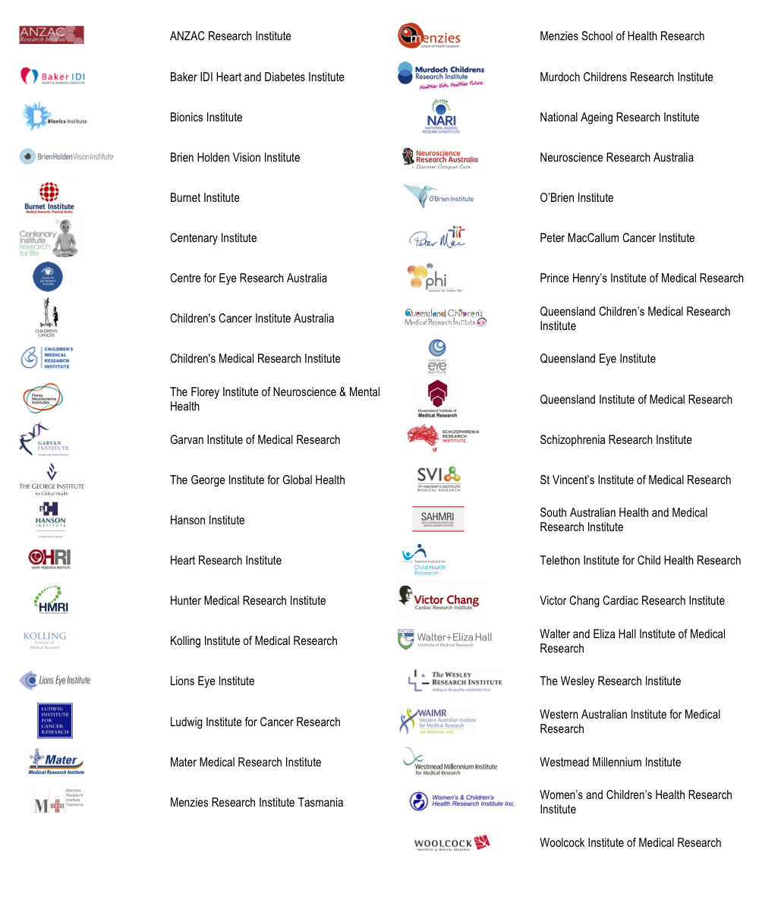

OECD (2010) OECD Science, Technology and Industry Outlook 2010, OECD Publishing, Paris.
AAMRI (2012) Enhancing the commercialisation outcomes of health and medical research, Supplementary submission to the Strategic Review of Health and Medical Research, AAMRI, Brisbane.

