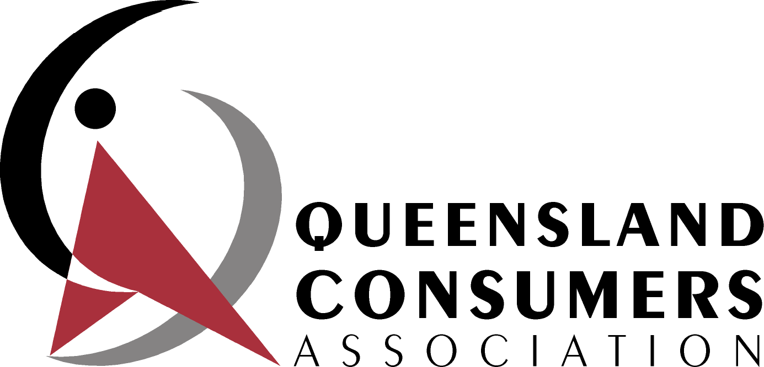 | A non-profit, volunteer organisation, advocating to advance the interests of consumers in Queensland  Secretary:  Max Howard  PO Box 261  Corinda Q 4075
4 October 2012
SUBMISSION ON PRODUCTIVITY COMMISSION’S DRAFT REPORT ON REGULATORY IMPACT ANALYSIS: BENCHMARKING
BACKGROUND
The Queensland Consumers’ Association (the Association) is a non-profit organisation which exists to advance the interests of Queensland consumers. The Association’s members work in a voluntary capacity and specialise in particular topics.

The Association is a member of the Consumers’ Federation of Australia, the peak body for Australian consumer groups, and a member of the Association is a member of the Federation’s executive committee.

This inquiry could have very significant impacts on consumers in Queensland via the activities of the Queensland and Federal governments and their agencies.

However, many consumers and community groups in Queensland or other parts of Australia will be unable to participate in the inquiry. This is mainly due to their lack of resources.

Therefore although the Association has very few resources, it has made a special effort to participate by making a brief submission on the Issues Paper and this brief submission on the Draft Report.

GENERAL COMMENTS
Obstacles to consumer participation in RIA processes
We consider that the usefulness of RIA processes is greatly reduced by obstacles to the participation of consumer and community groups.

The magnitude of these obstacles is demonstrated clearly by the very low involvement of consumer and community groups in this inquiry so far.

There are many obstacles including, agencies undertaking RIAs not making sufficient efforts to identify and contact relevant consumer and community groups, and not making it very easy for them to participate.

However, we consider the main obstacle is usually that many groups lack the resources to participate, especially to prepare written submissions for such processes.

The need to reduce this obstacle was recognised in the Productivity Commission’s, Review of Australia’s Consumer Policy Framework Inquiry Report, 8 May 2008. Recommendation 11.3 of that Report said “Within the broader consumer policy implementation framework agreed to by CoAG, the Australian Government, in consultation with the MCCA, should take the lead role in developing arrangements to provide additional funding to:
- Help support the basic operating costs of a representative national peak consumer body;
- Assist the networking and policy functions of general consumer advocacy groups; and
- Enable an expansion in policy-related consumer research.
The new funding arrangements should be subject to appropriate guidelines and governance requirements to help ensure that taxpayer support contributes to high quality advocacy and policy research in priority areas, and that the national interest is appropriately represented.”

However, this recommendation has yet to result in additional government funding for a national peak consumer body, etc. despite being considered and supported by consumer affairs ministers. For example the Ministerial Council for Consumer Affairs Communiqué of 3 December 2010, said “MCCA believes that enhancing capacity in consumer representation in Australia is a worthwhile goal. Ministers directed consumer affairs officials, led by Victoria, to continue work on a range of practical and innovative ways that governments can support and facilitate consumer policy advocacy.”
We request that this inquiry recognise the need for such funding and recommend that more rapid progress be made to provide it.
Need for balanced RIAs
If RIAs are to be effective and consumer and community groups are to have confidence in them, it is essential that they be undertaken in a balanced way. This means that there must be adequate consideration of impacts (positive and negative) of policy options and instruments on consumers. It is also important that there is no bias against regulation as a potentially relevant policy instrument or towards minimising industry costs (as opposed to optimising them relative to likely benefits).

Non RIA policy development and assessment processes
We emphasise that these are now, and likely to remain, the dominant processes used, so it is important that they also be undertaken efficiently and effectively and that consumer and community groups are able to participate in them.

SPECIFIC COMMENTS
Processes for determining when a RIA will be undertaken
We agree that currently there is great inconsistency, and often a lack of public information, about when a RIA will be undertaken.

Greater consistency and better information about this would increase the awareness, confidence and participation of consumer and community groups in RIA processes.

Given the substantial resources needed to undertake RIAs and for consumer and community groups to participate in the process, RIAs should be undertaken only for existing or proposed policy proposals that do or would have significant impacts.

Decisions on whether a RIA is required, and if so when, must take account of other relevant processes and timetables. For example, we were recently involved with a RIA of an existing regulation which we understand will be reviewed again in 2014.

Consultation on and publication of RIAs
We agree that a draft RIS for early consultation and publishing of all RISs would be very beneficial for stakeholders, including consumer and community groups. We also believe that in many cases it could be beneficial to have consultation before the preparation of a draft RIS and that there should definitely be consultation if the proposals are changed significantly after consultation on the draft RIs. We strongly support publication of final RISs.

However, this is only likely to result in the increased involvement of such groups in relevant RIA processes if other measures are adopted. For example, agencies undertaking RIAs need to proactively contact relevant consumer and community groups to ensure they are aware of relevant RIA processes underway and assist them to participate. Often, this will be most effective if the agency is prepared to meet with such groups and not rely only on written submissions the preparation of which may be very difficult and often impossible for such groups.

It is also essential that the consultation period is long enough to allow consumer and other groups to participate effectively, the objectives are clearly stated, a draft report is released, and non confidential submissions are made publicly available. This was not the case with a recent RIA we were involved with.

Data etc for RIAs
As indicated in our submission on the Issues Paper, but not mentioned in the Draft Report, we are concerned that because RIA processes are heavily dependent on objective evidence about likely costs and benefits, consumer organisations often do not have enough resources to be able to provide such evidence whereas industries, trade associations etc. generally do.

Accordingly, we consider that government agencies must be prepared to either provide funding for consumer organisations to obtain such evidence or to themselves obtain such information.

As also indicated in our previous submission and not mentioned in the Draft Report, we consider that complaints data should be used very cautiously as indicators of the extent or importance of consumer problems or possible detriment caused by many such problems.

We consider that surveys of consumers are often the only way to satisfactorily measure these problems and assess possible solutions. The benefits of obtaining information in this way are shown clearly by the results of the Australian Consumer Survey 2011 commissioned by the federal government. For the first time ever, the Survey provided detailed national information about many important consumer issues, including the extent of consumer problems with goods and services purchased the extent to which consumers took action to resolve problems, and the cost of resolving problems.

We also endorse the arguments in the Consumer Action Law Centre’s submission on the Issues Paper about the need for RIAs to make use of qualitative information and case studies to assess the consumer impacts of policy options.

We also emphasise the need for RIAs to not simply follow neo-classical economic theory but to take account of important information about how in practice, rather than in theory, consumers think and act, now being provided by behavioural economics.

Consultation on this Inquiry
We note that the Draft Report indicates that that only 1 consumer/community group was involved in consultations so far and only 2 made written submissions whereas there was much consultation with, and many submissions, from business and industry.

While we recognise that this low level of involvement by consumer and community groups may reflect many influences, including resource constraints, we hope that the inquiry will be able, and proactively attempt, to consult with more consumer and community groups prior to the preparation of its final report.

