Remote Area Tax Concessions and Payments
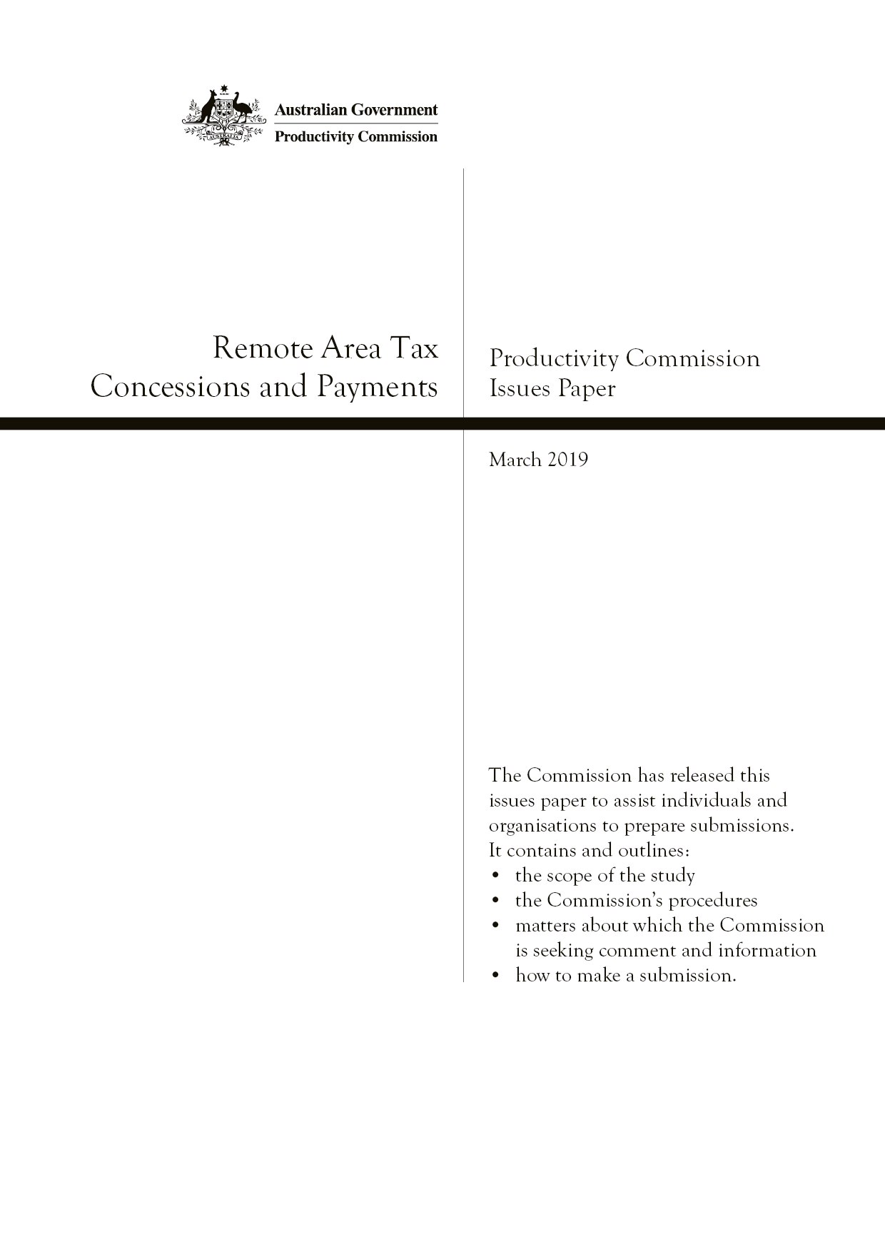
Productivity Commission Issues Paper, March 2019

The Issues Paper
The Commission has released this issues paper to assist individuals and organisations to prepare submissions to the study. It contains and outlines:
- the scope of the study
- the Commission’s procedures
- matters about which the Commission is seeking comment and information
- how to make a submission.
Participants should not feel that they are restricted to comment only on matters raised in the issues paper. The Commission wishes to receive information and comment on issues which participants consider relevant to the study’s terms of reference.
Key study dates
Receipt of terms of reference | 28 November 2018
Study commenced | February 2019
Due date for submissions | 29 April 2019
Release of draft report | Late August 2019
Final report released | February 2020
Submissions can be lodged
Online: | www.pc.gov.au/remote-tax
By post: | Remote Area Tax Concessions and Payments  Productivity Commission  GPO Box 1428, Canberra City ACT 2601, Australia
Contacts
Administrative matters: | Pragya Giri | Ph: 02 6240 3250
Other matters: | Jane Melanie | Ph: 02 6240 3380
Freecall number for regional areas: | 1800 020 083
Website: | www.pc.gov.au

The Productivity Commission
The Productivity Commission is the Australian Government’s independent research and advisory body on a range of economic, social and environmental issues affecting the welfare of Australians. Its role, expressed most simply, is to help governments make better policies, in the long term interest of the Australian community.
The Commission’s independence is underpinned by an Act of Parliament. Its processes and outputs are open to public scrutiny and are driven by concern for the wellbeing of the community as a whole.
Further information on the Productivity Commission can be obtained from the Commission’s website (www.pc.gov.au).

Terms of reference

Remote Area Tax Concessions and Payments
I, Josh Frydenberg, Treasurer, pursuant to Parts 2 and 4 of the Productivity Commission Act 1998, hereby request that the Productivity Commission undertake a study into the zone tax offset and related remote area tax concessions and payments.

Background
The Australian Government provides assistance to Australians who reside in specified geographic areas through the zone tax offset, the fringe benefits tax (FBT) remote area concessions and the Remote Area Allowance.
The eligible zones for the zone tax offset were originally established in 1945 and were based on exposure to uncongenial climatic conditions, isolation or a relatively high cost of living. The zones still largely reflect the original design in 1945, notwithstanding the demographic and infrastructure changes that have occurred in regional Australia in recent decades. The areas eligible for FBT remote area concessions are partly determined by reference to the zone tax offset boundaries, and the Remote Area Allowance is available to recipients of Australian Government income support payments who live in specified zone tax offset areas.
There have been concerns that the design of these mechanisms has not evolved to adequately reflect varying degrees of demographic, infrastructure and cost-of-living change occurring in Australia.

Scope of the report
The Productivity Commission is asked to determine the appropriate ongoing form and function of the zone tax offset, FBT remote area concessions, and Remote Area Allowance.
In conducting this review, the Productivity Commission is to:
- examine the operation of the zone tax offset and FBT remote area concessions, including the levels of assistance provided, indexation and the boundaries of eligible areas and prescribed zones
- examine the economic and employment impacts of the zone tax offset, FBT remote area concessions, and Remote Area Allowance, including the effect of applying indexation, in regional Australia
- examine the operation of the Remote Area Allowance, which extends the benefits of the zone tax offset to income support recipients in remote zones
- consider whether the zone tax offset, FBT remote area concessions, and the Remote Area Allowance are delivering on their policy objectives and whether those objectives remain appropriate in a contemporary Australia
- consider if businesses in remote areas should be provided with similar support
- consider if there are alternative mechanisms to better provide this support to Australians residing in specified geographic areas.

Process
The Productivity Commission is to undertake an appropriate public consultation process. This will include inviting public submissions in response to an issues paper and draft report. It will also involve consultation and meetings in regional communities.
The Productivity Commission is to commence this work in February 2019. A final report with recommendations should be provided to the Government within 12 months of commencement.
The Hon Josh Frydenberg MP
Treasurer
[Received 28 November 2018]

Contents
Terms of reference iii
1 What is this study about? 1
2 Overview and evolution of current arrangements 2
3 The Commission’s analytical approach 7
4 Issues for investigation 10
5 Options for revising current arrangements 13
6 References 17
Attachment A: How to make a submission 19

1 What is this study about?
This study focuses on three longstanding measures that provide support to individuals and businesses in remote areas, namely the:
- zone tax offset (ZTO)
- fringe benefits tax (FBT) remote area concessions
- Remote Area Allowance (RAA).
There have been concerns within the community that these measures have failed to keep pace with demographic, cost of living and infrastructure changes in Australia. In response to these concerns, the Australian Government has asked the Productivity Commission to evaluate these measures’ objectives, design, operation and effects, and to consider alternatives to them. Box 1 outlines how you can contribute to our study.
The Commission will meet with interested parties, including in regional and remote Australia, during the course of the study. There will be further opportunity to make submissions to the study following the release of the draft report in late August (figure 1).

Box 1 How you can contribute
The Commission is seeking input from affected individuals, communities and businesses. We want to hear your views on the rationale for these schemes, what is working well (or not so well), and what could be improved.
We have released this issues paper to assist you in preparing a submission to this study. It sets out some of the issues and questions the Commission has identified as relevant at this early stage of the study. You do not need to comment on every issue raised in this paper and you are free to raise any other issues or ideas that are relevant to the terms of reference.
Where you identify problems with the system, you should provide some indication of the nature, size and scope of the problems, why change is needed and ways the system might be improved. Where possible, you should support your views with data and other evidence.
Submissions are due by 29 April 2019.
You can also make a brief comment through the Commission’s website. We will not treat comments as formal submissions, but may use them to inform our report. Attachment A provides further details on how you can make a submission or brief comment.

Figure 1 Study process

2 Overview and evolution of current arrangements

Post-war origins of remote area support
In 1945, the Australian Government introduced income tax deductions for inhabitants of remote areas. The main justification was to compensate people for the relatively high living costs, isolation and uncongenial climate in remote Australia (Chifley 1945). The Government considered it in Australia’s economic and strategic interests to encourage people to settle in remote areas. There were two large zones — the more northern Zone A, which attracted the highest tax deduction, and, below it, Zone B (figure 2). Together they covered around three-quarters of Australia’s landmass.
At the time, people in these areas faced some particular challenges: for example, most highways and truck routes were unsealed, planes were expensive and relatively dangerous, people relied on the post rather than email, and there was no or limited access to government services or modern comforts such as television and air conditioning. This heightened the costs and deprivations of geographical isolation and of living on parched earth or in the tropics.
The remote tax deductions received widespread support and indeed were increased significantly in their early years. The Zone A deduction reached 120 pounds ($240) annually (for individuals) in 1947, compared to average annual wages of about 350 pounds ($700) that year (ABS 1992; Cox et al. 1981). This reduced the taxable income of recipients by about a fifth of average annual earnings in 1950, thereby reducing tax paid by about 3.4 per cent of after-tax income for someone on an average salary (ABS 1992; ATO 2018b).

Subsequent additions and amendments
Governments added to the arrangements over the following decades. Notable changes were:
- in 1958, inclusion of a loading for taxpayers with dependent children
- in 1975, conversion of the (pre-tax) deductions into (post-tax) rebates — the ZTO
- in 1982, creation of ‘special areas’ with higher rebates for especially remote areas (in essence, places more than 250 kilometres from a town of more than 2500 people, as measured in the 1981 census)
- in 1984, introduction of the Remote Area Allowance (RAA), which was an equivalent payment for welfare recipients to extend the benefits of the ZTO to non-taxpayers residing in remote Australia
- in 1986, introduction of remote area concessions to lessen the impact of the then new FBT on business operations in remote locations (hereafter, FBT remote area concessions)
- in 2000, expansion of the FBT remote area housing exemption to cover all employers in remote areas (instead of just primary producers).

Figure 2 Tax offset zonesa,b
Note: a Zone A also includes Macquarie Island, Norfolk Island, the Territory of Heard Island and McDonald Islands, the Australian Antarctic Territory, the Territory of Cocos (Keeling) Islands, The Territory of Christmas Island and Lord Howe Island. Special areas are approximate only. b Data in this figure are from unpublished 2016-17 ATO data and include claimants of the overseas forces offset.
Thus, by 2000, the three sets of arrangements under reference were in place, largely as they are today. Table 1 provides more details on them. Notably, the FBT remote area concession has a different geographic coverage to the ZTO — including areas outside of zones A and B away from larger towns, and excluding areas around large ZTO-recipient centres such as Darwin and Townsville.

Table 1 Key features of remote area tax concessions and paymentsa,b
 | Zone Tax Offset  (ZTO) | FBT remote area concessions | Remote Area  Allowance (RAA)
Recipients | Income taxpayers (employees) | Employers | Income support recipients
Original objectives | Compensating employees in remote areas for the disadvantages of uncongenial climate, isolation and high cost of living. | Lessening the impact of the (then new) FBT on business operations in remote locations | Equity with recipients of the zone tax offset
Area | Zone A, Zone B and special areas | Covers the ZTO areas (with exclusions in major towns) and regional areas outside the zones sufficiently distant from large urban centres | Zone A and special areas
Rates | Special areas:  $1173 + 50% of dependent rebate (max. $188 per child) a year  Zone A:  $338 + 50% of dependent rebate (max. $188 per child) a year  Zone B:  $57 + 20% of dependent rebate (max. $75.20 per child) a year | Various exemptions or concessions may apply  Some benefits, such as employer-provided housing and fly-in fly-out travel, are exempt from FBT  For other benefits, such as housing subsidies, residential fuel and holiday travel, the taxable value may be cut by 50% | For a single person:  $18.20 per fortnight  ($473 as an annual rate)  For each member of a couple:  $15.60 per fortnight  ($406 as an annual rate)  Add $7.30 per fortnight  ($190 as an annual rate)  per dependent child
No. of recipients/claimants | Approx. 487 000 claimants  (2016-17) | Not available | Approx. 105 000 recipients  (2017-18)
Cost | $156m  (2016-17) | Est. $120m–$1.2b  (2016-17) | Not available

a Data for the ZTO are for the number of claimants and total value of claims, but some claimants may not utilise any or all of the claim amount due to insufficient gross tax liabilities. These data also include overseas forces tax offset claims. b The cost estimates for the FBT concessions are the sum of the upper and lower bounds of the order of magnitude estimates for the various FBT remote area concessions in Treasury’s Tax Benchmarks and Variation Statement.
Sources: ATO (2018a, unpublished ATO data); DHS (2018); DSS (pers. comm. 7 March 2019); Treasury (2019).

Current operation of remote area support

Some consider that the ZTO has become outdated and ineffectual
Apart from a 2015 amendment to the ZTO to exclude fly-in fly-out workers who reside outside the zones, there has been no substantive change to the arrangements for more than thirty years. Moreover, the ZTO’s nominal value was last increased in 1993. The base payment for a single person has thus remained at $338 a year in Zone A, $57 in Zone B and $1173 in the special areas for twenty-five years.
Over time, inflation has eroded the real value of the ZTO (and RAA). Whereas the (pre-tax) Zone A tax deduction reduced tax paid by about 3.4 per cent of after-tax income for someone on an average salary in 1950, the (post-tax) Zone A rebate is worth less than 1 per cent of average after-tax income today (ABS 1992, 2019; table 1; ATO 2018b).
The low level of payments and the limited number of claimants, particularly in the ‘special’ zones and Zone A, mean that the arrangements are not so significant a budget item as they once were.
- Fewer than 500 000 people currently claim the ZTO, which is about 3 per cent of income taxpayers. In 2016-17, the total value of ZTO claims was about $156 million (table 1).
- Queensland, Western Australia and the Northern Territory account for the vast majority of ZTO claimants and costs (figure 3).
- About two-thirds of ZTO claimants (in 2016-17) lived in one of the four largest cities in northern Australia: Darwin, Townsville, Cairns and Mackay (figure 2).
Stakeholders take different positions on the ZTO. While some have questioned the rationale for having remote area tax concessions at all (see e.g. Cox et al. 1981, pp. 15–6; 29), others have advocated substantially increasing the offset to restore its value and to pursue the current Government’s Northern Australia development agenda. Several suggest redesigning the program to better target assistance to those regions most in need. Senator the Hon. Matthew Canavan (2014, p. 19), for example, has observed that:
People in Cairns and Townsville still get $57 a year for living in an area of “uncongenial conditions”. The zones are out of date, no one will move to Cairns for a carton of beer a year.
Senator the Hon. Ian McDonald has previously noted:
The proper revision and indexation of the Zone Tax Rebate, or some other form of incentive in Northern and Remote Australia, would encourage many Australians to move to the remote parts of our country to where we know the wealth is in agriculture and mining is waiting to be extracted, where what we need most is the people there to do it. (Macdonald 2018)

The costs of the RAA and FBT remote area concessions are unclear, but the latter could be substantial
In 2017-18, about 105 000 people received the RAA. There is no up-to-date information on the cost of the RAA (table 1). When introduced in 1984, the RAA was expected to benefit 30 000 people with an annual budgetary cost of around $16 million (Commonwealth of Australia 1983).
Although the size and significance of the FBT remote area concessions are unclear, the upper end of Treasury’s broad-ranging estimates ($1200 million) (table 1), while equivalent to less than 1 per cent of total budget outlays, would account for one quarter of all FBT revenue collected.

Figure 3 ZTO, claimants and total claims, by state, 2016-17a
a Data are based on individuals’ location at the time of lodging their tax returns, so individuals who move outside the zone before lodging (including to Victoria or the ACT) are included in those jurisdictions. About 2 per cent of total claimants could not be identified by location and are not included. Data also include overseas forces tax offset claims. Data are for the total value of claims, but some claimants may not utilise any or all of the claim amount due to insufficient gross tax liabilities.
Data source: Unpublished ATO data.

Past reviews and context for this study
Only one dedicated review of the ZTO has been undertaken during its life — the Cox review (1981) — although other inquiries into the tax system have commented on the arrangements. For example, the ZTO along with other offsets was covered by the Henry Tax Review (2009). It recommended that the ZTO be reviewed, with a suggestion that this could lead to its removal or replacement. However, that recommendation for a review has not been acted upon until now.
To our knowledge, this study is the first dedicated review of the FBT remote area concessions and the RAA, although they have been examined in broader reviews, such as the Industry Commission’s inquiry into Impediments to Regional Industry Adjustment (IC 1993). The Department of Social Security prepared a discussion paper on the RAA in 1989 (DSS 1989).
This study is one of a number of recent projects examining economic issues facing rural and regional Australia. For example, the Australian Government released a white paper in 2015, Our North, Our Future, outlining a policy framework for developing Northern Australia (Australian Government 2015). More recently, in 2018, the Australian Senate referred an inquiry into the indicators and impact of regional inequality in Australia to the Senate Economics References Committee for inquiry and report in June 2019.
Due to this study’s focus on remote areas, we will evaluate the effects of remote area tax concessions and payments on remote Indigenous communities, as well as any interaction with other government policies designed to assist those communities.

3 The Commission’s analytical approach
In essence, the terms of reference ask us to look at:
- the economic and employment impacts of the ZTO, FBT remote area concessions, and RAA
- whether the ZTO, FBT remote area concessions, and RAA are delivering on their policy objectives
- whether those objectives remain appropriate — in other words, whether special assistance for living or operating in remote areas is warranted
- if it is, the appropriate form of that assistance, including whether other instruments may better achieve those objectives for remote areas.
In making such assessments, the Commission will take a community-wide perspective as required by the Productivity Commission Act 1998. Thus, although the terms of reference require that we have regard to the economic and employment impacts of remote area tax concessions and payments in regional Australia, the Commission will also consider broader impacts on other parts of the community, such as forgone tax revenue or increased government outlays.
Accurately quantifying the effects of the ZTO, FBT concessions and RAA is not straightforward. For one thing, these arrangements are often highly localised, and in many places the value of the benefits is now quite small, making it difficult to disentangle their effects from other factors. Data at the level of detail required to examine these policies are also hard to come by. In undertaking some initial consultations prior to the release of this issues paper, the Commission has been struck by how little is known about the operation of these arrangements and their impacts.
A recent study by Kettlewell and Yerokhin (2017) — which to our knowledge is the first and only evaluation of the effects of the ZTO — found that the ZTO had a positive but temporary effect on population growth in the targeted areas. However, that study focused on a subset of localities on the border of Zone B during the post-World War Two period, when the real value of the offset in that zone was much higher than it is today.
Given these challenges, the Commission intends to investigate multiple analytical approaches to the evidence, including modelling, statistical analyses and case studies. For example, the Commission’s Geographic Labour Mobility study includes quantitative analysis that provides some insight into the ‘locational responsiveness’ of workers to a small increment in their wages, and/or of employers to a small reduction in their labour costs (PC 2014).
In assessing specific forms of assistance and reform options, the Commission will also draw on findings from past Australian and international studies on regional development, such as the Commission’s reports on Transitioning Regional Economies (2017) and Geographic Labour Mobility (2014). We will also draw on a well-established literature on good policy and tax system design, which emphasises principles such as efficiency, equity and simplicity (box 2).

Information request
The Commission invites feedback and input on our analytical approach including:
- our proposed approach to analysis
- Australian or international studies that may be relevant for our analysis.

Box 2 Tax and transfer design principles and good policy design
In this study, the Commission will need to engage with fundamental questions about remote area tax concessions and payments (such as the circumstances under which special assistance for living or operating in remote areas is warranted) as well as detailed questions about tax design (such as how to tailor eligibility rules and rates so that assistance is well targeted). Addressing these types of questions will require a flexible approach which is fit for purpose.
Design principles for the tax and transfer system
In assessing detailed tax design options, the Commission will be able to draw on a well-established literature on good-practice tax design. For example, three key design principles for the tax and transfer system, as outlined in the Henry Tax Review (2009) and the Asprey Review (1975), are:
- Equity: the tax and transfer system should treat individuals with similar economic capacity in the same way, while those with greater capacity should bear a greater burden.
- For example, a tax concession intended to compensate for a particular economic disadvantage should be designed so that only taxpayers affected by the disadvantage can benefit from it.
- Efficiency: the tax and transfer system should generally raise and redistribute revenue at the least cost to economic efficiency and with minimal administration and compliance costs.
- Taxes and transfers affect the choices individuals and businesses make by altering their incentives. The tax and transfer system should not unduly get in the way of individuals and businesses acting in their own interests.
- Simplicity: the tax and transfer system should be easy to understand and simple to comply with.
- If individuals and businesses understand the system, they are more likely to act in their best interests and respond to intended policy signals. A simpler system may also involve lower administrative and compliance costs.
Good policy design
For more fundamental questions about the ongoing case for, and form of, remote area assistance, the Commission may need to draw on broader principles of good policy design (Banks 2003; COAG 2007; PC 2001; PM&C 2014), to the effect that policy interventions should:
- have a sound rationale
- bring a net benefit to society
- be better than any alternative
- be proportional to the objective that they are designed to achieve
- be evaluated over time to ensure that they remain relevant and cost-effective
- be transparent, clear and concise
- be consistent with other laws, agreements and international obligations.

4 Issues for investigation
This section outlines some of the issues the Commission will examine as part of this study, along with related questions. Participants are welcome to propose further areas consistent with the terms of reference.

Economic and employment effects
The terms of reference require the Commission to examine the economic and employment impacts of the ZTO, FBT remote area concessions, and RAA, including the effect of applying indexation, in regional Australia.
Typically, the intended effect of place-based policies, such as the ZTO and the FBT remote area concessions, is to boost employment, population, and output in the target regions (or reduce the rate of decline) by making employment in those regions more financially attractive. The extent to which they actually achieve this goal will depend on such factors as the size of the incentives relative to incomes and living costs, public knowledge of the incentives, and the degree to which employers are able to capture the benefits of the tax concessions by reducing wages below what they would otherwise be. As a supplement to income support payments, the RAA will mainly affect income levels and is unlikely to have a significant effect on employment. That said, the RAA will tend to increase spending in remote areas.
Remote area assistance policies may also have broader implications for the Australian economy. To the extent that they affect the allocation of resources (such as labour) across different regions, they will influence productivity in multiple regions and industries. What’s more, the cost of assistance policies leaves less tax revenue to spend on public goods, such as public hospitals and roads.

Information request
The Commission is seeking data or other evidence that could be used to assess employment and economic effects of remote area tax concessions and payments on affected communities, businesses and individuals. In particular:
- the impact of the concessions and payments on wage and employment decisions
- the impact of the concessions and payments on labour mobility and retention, and changes to these impacts as the real value has eroded
- the extent to which fringe benefits tax (FBT) remote area concessions influence employers’ decisions between offering fly-in fly-out and regular employment
- the materiality of the remote area FBT exemptions and concessions to businesses and industry (for example, levels of uptake and total amount claimed)
- the likely impost on business and industry if the concessions or exemptions were removed
- the materiality of the Remote Area Allowance for individuals and families in remote areas, including Indigenous communities (for example, levels of uptake and share of income)
- evidence that employers pay more to attract and recruit labour to remote areas where there is demand for workers.

Objectives of remote area assistance programs
The terms of reference ask whether the arrangements are delivering on their policy objectives and whether those objectives remain appropriate in a contemporary Australia.
A range of justifications have been advanced for special assistance for people living and/or working in remote areas (box 3), although many of these are contentious. For those justifications drawing on the isolation and arduousness of life in the outback, the changes in transport, communications and living conditions over the past seventy years mean that their strength has diminished (at least in many parts of the country). Such arguments have also been challenged on the basis that ‘individuals have a free choice whether or not to live or work in remote areas and to compensate them, if they so choose, would lead to resource misallocation and reduced growth for the country as a whole’ (see Cox et al. 1981, p. 15).

Box 3 Policy rationales given for the zone tax offset and related arrangements
Different policy rationales have been proposed (at times, simultaneously) to justify Australian Government support to the specified regions.
- Equity: to compensate residents of remote areas for the various disadvantages of living in those areas. These were originally conceived of as uncongenial climatic conditions, isolation or higher costs of living; an alternative basis for comparison may be the level of access to public services.
- Regional development: to actively encourage individuals to move to and work in remote regions. This includes historical justifications (an imperative to develop northern Australia’s resources, and to populate the north to shore up national security) and contemporary arguments (decentralisation).
- Industry-specific assistance: to support industries located in remote areas by mitigating the higher costs of doing business (for example, freight).
After considering various arguments for and against zone allowances, the 1981 Cox inquiry report found that the most compelling rationale for their continuation was on social grounds, but the panel caveated this finding (Cox et al. 1981, p. 31).
The Inquiry does, however, believe that at the present time there is justification for the continuation of zone allowances on social grounds. There is a need for some measure of relief from the disadvantages suffered as a result of isolation, climate and high costs …
The cessation of what has become an accepted and expected concession would create a feeling of loss among the people concerned. However, as conditions in what are at present isolated areas improve, either by natural economic growth or as a result of government policy, the need for a special taxation concession will diminish.
The Commission will need to evaluate the merits of all the arguments put forward in support of the remote area arrangements. In doing so, we will have regard to Australia’s system of horizontal fiscal equalisation, which transfers goods and services tax revenue from the Commonwealth to the States and Territories with the aim of equalising their fiscal capacity to deliver public services, taking into account differences in the cost of providing services due to factors such as remoteness. We will also have regard to relevant expenditures, activities and legislation of the Commonwealth and State and Territory governments focused on regional development and assistance, such as the Commonwealth’s Assistance for Isolated Children Scheme and the Western Australian Government’s Royalties for Regions program.
As the Cox inquiry predates the introduction of the RAA and FBT remote area concessions, and there is limited public information on either of these policies, we are particularly interested in views on the extent to which the policy rationales used to support the ZTO (and its previous incarnations) apply to the RAA and FBT remote area concessions.

Information request
The Commission is seeking information on:
- which, if any, of the policy rationales given for special assistance for people in remote areas remain valid in a contemporary Australia and why
- the costs of living in regional and remote areas within the zones compared to other parts of Australia (for example, the costs of food, communications, transport, education, healthcare and housing)
- changes in the cost of living in remote areas over recent decades
- changes in technology, transport, and infrastructure over recent decades that have affected the hardships of living in areas that are geographically isolated or have uncongenial conditions
- any other forms of government assistance available to people living in remote areas (including Indigenous communities) to assist them in overcoming disadvantages such as a high cost of living or limited access to government and non-government services
- whether the policy rationales given to support the zone tax offset (and its previous incarnations) apply to the fringe benefits tax, remote area FBT concessions, or Remote Area Allowance.
- whether there is merit in moving away from remote area assistance based on concepts such as the relative costs of living, and instead basing assistance on more direct measures of disadvantage or need.

5 Options for revising current arrangements
Another issue the Commission will need to evaluate is whether the current system of remote area tax concessions and payments is the most efficient, cost-effective, equitable, and simple way to provide that assistance. As noted in section 2, some stakeholders have suggested that the current ZTO assistance is inadequate and/or poorly targeted, resulting in anomalous outcomes (Australian Government 2015, p. 104; Manning 2013). Others have questioned the constitutionality of the ZTO in its current form (box 4).

Box 4 Constitutionality of the zone tax offset
Since the establishment of remote area deductions in 1945, there has been ongoing debate about whether providing assistance through the tax system based on geographic delineations of remoteness complies with the Constitution of Australia. Section 51(ii) of the Constitution confers on the Commonwealth the power to make laws with respect to ‘Taxation; but so as not to discriminate between States or parts of States’. Section 99 further states ‘The Commonwealth shall not, by any law or regulation of … revenue, give preference to one State or any part thereof over another State or any part thereof’.
After seeking the advice of the Attorney-General’s Department on the constitutional validity of zone tax offset, as described in section 79A of the Income Tax Assessment Act 1936 (Cwlth), the Cox review (1981, p. 5) noted that:
there was doubt about the issue and that [the reviewers] could have no assurance that the provision was constitutionally sound, notwithstanding that the arrangements had been in existence since 1945.
The arrangements have never been tested in the High Court.
While it is not the Commission’s role to pass judgment on the constitutionality of the zone tax offset and fringe benefits tax remote area concessions, it will consider potential constitutional risks when analysing different reform options.
The Commission is seeking participant views on the following Information Request.

Information request
The Commission is seeking information on:
- what you consider to be the policy objectives of the ZTO, FBT remote area tax concessions and Remote Area Allowance, respectively
- whether these remote area tax concessions and payments are delivering on their policy objectives (including any quantitative evidence)
- whether the ZTO, FBT remote area tax concessions or RAA should be kept
- ways to redesign the ZTO, FBT remote area tax concessions and Remote Area Allowance (collectively or individually) so they are more efficient, equitable and simple
- the anticipated benefits, costs and implementation issues associated with proposed reform options.
There are also a number of specific questions based on the terms of reference and initial research and consultation for this study on which participants may wish to provide views, including:
- Should the ZTO special area boundaries be redrawn to reflect contemporary settlement patterns? The current special areas are based on town sizes as measured in the 1981 census. Would updating these boundaries based on more recent census data increase the effectiveness of special assistance through better targeting? If so, should the boundaries continue to be updated with each new Census?
- Are there criteria that would help better target assistance in line with whatever objectives are deemed appropriate for remote area support? The Cox inquiry (1981, p. 30) noted that ‘dissatisfaction with the taxation system is increased when the necessarily arbitrary nature of the zone areas is realised and individuals recognise the wide variations in conditions within the zones’. Would measures of remoteness (such as the Australian Bureau of Statistics Remoteness Areas) or functional economic regions be a more effective and transparent basis for allocating assistance?
- Should larger regional centres continue to be included in the arrangements? The largest four cities in the zones (Darwin, Townsville, Cairns and Mackay) account for around two-thirds of ZTO claimants. Is there a valid justification for the inhabitants to receive special assistance relative to the inhabitants of other Australian cities or regional areas that are not currently eligible?
- Should the payment levels be changed, indexed, and/or means tested? Is there a case for changes to the level of payments (or eligibility for payments) to ensure that assistance is both adequate and well-targeted?
- Given that the RAA was introduced as a companion payment to the ZTO, should eligibility and payment rates be amended to address eligibility anomalies between ZTO and RAA? (figure 4)
- Is there scope to rationalise the three arrangements into one payment for people in remote areas? The Henry Tax Review (2009, p. 32) recommended that ‘To remove complexity and ensure government assistance is properly targeted, concessional offsets should be removed, rationalised, or replaced by outlays’.
- Should businesses in remote areas be provided with ZTO-like support? If so, what would be an appropriate mechanism for doing so? What need would this address that is not already addressed by the FBT remote area tax concessions and other policies targeting businesses in remote areas?
- Are there alternative mechanisms to more directly support Australians residing in specified geographic areas?
- Would the forgone revenue and expenditure from the tax concessions and payments be better allocated to State and Territory governments to provide additional funding for their regional development programs?
- Should the Government seek to attract graduates possessing in-demand skills to regional areas by forgiving their HELP debts?
Figure 4 Example of differences in ZTO and RAA ratesa
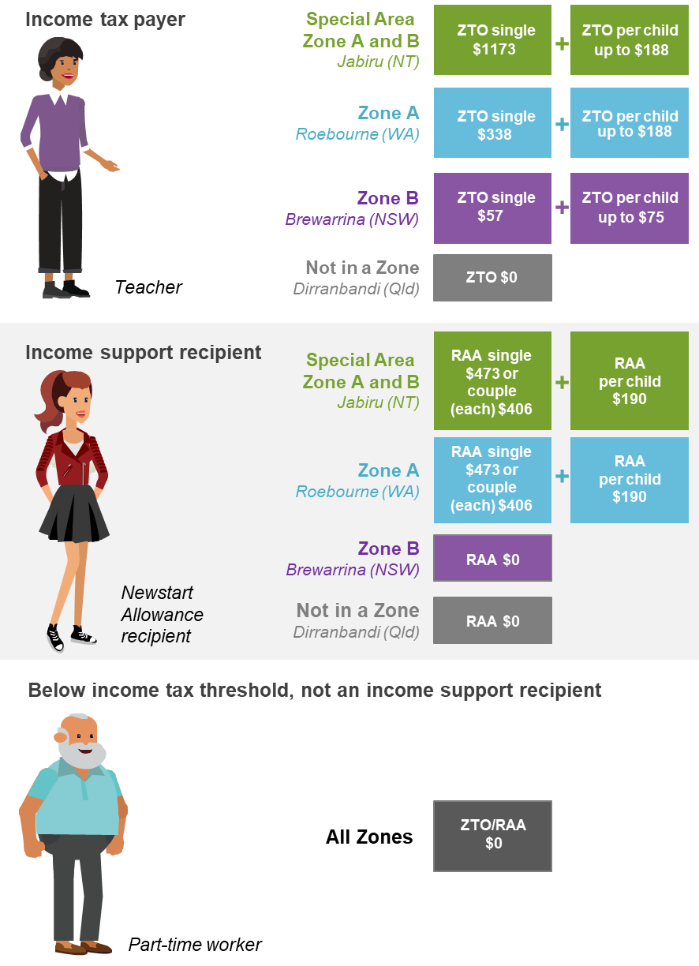

a The Remote Area Allowance (RAA) is paid fortnightly. RAA estimates have been annualised for comparative purposes. The zone tax offset (ZTO) refers to the maximum rate; less will be paid if tax liability is less than the maximum ZTO. Income support recipients who also pay income tax may be eligible for both RAA and ZTO, but the ZTO is reduced dollar-for-dollar by any RAA received during the assessment year.

6 References
ABS (Australian Bureau of Statistics) 1992, Average Weekly Earnings Australia: 1941 - 1990, Catalogue no. 6350.0, Canberra.
—— 2019, Average Weekly Earnings, Australia, Nov 2018, Cat. no. 6302.0, ABS, Canberra.
Asprey, K.W., LLoyd, J.P.D., Parsons, R.W. and Wood, K. 1975, Report of the Taxation Review Committee.
ATO (Australian Taxation Office) 2018a, Calculation of zone or overseas forces tax offsets, https://www.ato.gov.au/Forms/Withholding-declaration---calculating-your-tax-offset/?page=4 (accessed 3 January 2019).
—— 2018b, Taxation statistics 2015-16: Individuals, https://www.ato.gov.au/About-ATO/Research-and-statistics/In-detail/Taxation-statistics/Taxation-statistics-2015-16/?anchor=info1#info1 (accessed 26 February 2019).
Australian Government 2015, Our North, Our Future: White Paper on Developing Northern Australia, Canberra.
Banks, G. 2003, The Good, the Bad and the Ugly: Economic Perspectives On Regulation in Australia, Productivity Commission Chairman’s Speech, Canberra.
Canavan, M. 2014, Developing Northern Australia: A Taxing Problem, Senator Matt Canavan, http://www.mattcanavan.com.au/developing_northern_australia_a_taxing_problem (accessed 27 February 2019).
Chifley, B. 1945, Income Tax Assessment Bill 1945: second reading speech, 19 April, 16, Debates, House of Representatives, Canberra, pp. 923–926.
COAG (Council of Australian Governments) 2007, Best practice regulation: a guide for ministerial councils and national standard setting bodies, October.
Commonwealth of Australia 1983, House of Representatives Official Hansard, vol 133, Canberra.
Cox, P., Burston, S., Kerr, A. and Slater, G. 1981, Report of the Public Inquiry into Income Tax Zone Allowances.
DHS (Department of Human Services) 2018, Remote Area Allowance: How much you get, Australian Government Department of Human Services, www.humanservices.gov.au/
individuals/services/centrelink/remote-area-allowance/eligibility-payment-rates/how-much-you-get (accessed 7 March 2019).
DSS (Department of Social Security) 1989, Discussion Paper on Remote Area Allowance, Prepared by Bill Pennington, North Australia Development Unit.
Henry, K. 2009, Australia’s future tax system - Part two: detailed analysis, Canberra.
IC (Industry Commission) 1993, Impediments to Regional Industry Adjustment, Report no. 35, Canberra.
Kettlewell, N. and Yerokhin, O. 2017, ‘Area‐specific subsidies and population dynamics: Evidence from the Australian zone tax offset’, Pap Reg Sci., pp. 1–26.
Macdonald, I. 2018, Speech - Central Western Local Government Association, Speech - Central Western Local Government Association | Senator Ian Macdonald | LNP Senator for Queensland, http://www.senatormacdonald.org/speech-central-western-local-government-association/ (accessed 27 February 2019).
Manning, I. 2013, ‘Income tax zone rebates’, National Economic Review, 68, pp. 23–39.
PC (Productivity Commission) 2001, Structural Adjustment: Key Policy Issues, Commission Research Paper, Canberra.
—— 2014, Geographic Labour Mobility, Research Report, Canberra.
—— 2017, Transitioning Regional Economies, Study Report, Canberra.
PM&C (Department of the Prime Minister and Cabinet) 2014, Australian Government Guide to Regulation.
Treasury (Australian Government Treasury) 2019, Tax Benchmarks and Variations Statement 2018, January, Canberra.

Attachment A: How to make a submission

How to prepare a submission
Submissions may range from a short letter outlining your views on a particular topic to a much more substantial document covering a range of issues. Where possible, you should provide evidence, such as relevant data and documentation, to support your views.

Generally
- Each submission, except for any attachment supplied in confidence, will be published on the Commission’s website shortly after receipt, and will remain there indefinitely as a public document.
- The Commission reserves the right to not publish material on its website that is offensive, potentially defamatory, or clearly out of scope for the inquiry or study in question.

Copyright
- Copyright in submissions sent to the Commission resides with the author(s), not with the Commission.
- Do not send us material for which you are not the copyright owner — such as newspaper articles — you should just reference or link to this material in your submission.

In confidence material
- This is a public review and all submissions should be provided as public documents that can be placed on the Commission’s website for others to read and comment on. However, information which is of a confidential nature or which is submitted in confidence can be treated as such by the Commission, provided the cause for such treatment is shown.
- The Commission may also request a non-confidential summary of the confidential material it is given, or the reasons why a summary cannot be provided.
- Material supplied in confidence should be clearly marked ‘IN CONFIDENCE’ and be in a separate attachment to non-confidential material.
- You are encouraged to contact the Commission for further information and advice before submitting such material.

Privacy
- For privacy reasons, all personal details (e.g. home and email address, signatures, phone, mobile and fax numbers) will be removed before they are published on the website. Please do not provide these details unless necessary.
- You may wish to remain anonymous or use a pseudonym. Please note that, if you choose to remain anonymous or use a pseudonym, the Commission may place less weight on your submission.

Technical tips
- The Commission prefers to receive submissions as Microsoft Word (.docx) files. PDF files are acceptable if produced from a Word document or similar text based software. You may wish to research the Internet on how to make your documents more accessible or, for the more technical, follow advice from Web Content Accessibility Guidelines (WCAG) 2.0<http://www.w3.org/TR/WCAG20/>.
- Do not send password protected files.
- Track changes, editing marks, hidden text and internal links should be removed from submissions.
- To minimise linking problems, type the full web address (for example, http://www.referred-website.com/folder/file-name.html).

How to lodge a submission
Submissions should be lodged using the online form on the Commission’s website. Submissions lodged by post should be accompanied by a submission cover sheet.
Online* | www.pc.gov.au/remote-tax
Post* | Remote Area Tax Concessions and Payments  Productivity Commission  GPO Box 1428, Canberra City ACT 2601, Australia
* If you do not receive notification of receipt of your submission to the Commission, please contact the Administrative Officer.

Due date for submissions
Please send submissions to the Commission by Monday 29 April 2019.

Income taxation rates prior to 1950 are not readily available.

