Ref: 475110195 / 2011
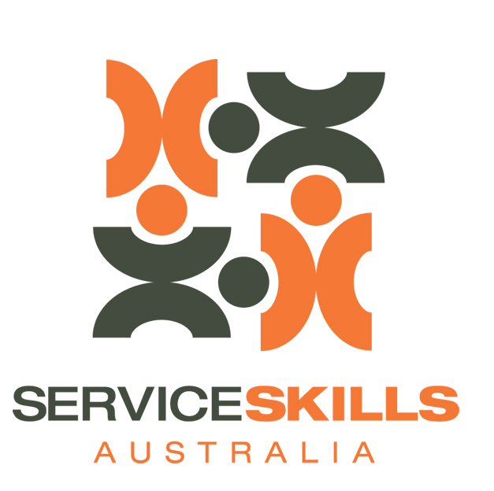
The Industry Skills Council for the Service Industrs
Service Industries Skills Council
ABN 37 107 591 864
Level 10, 171 Clarence St
Sydney NSW 2000
GPO Box 4194
Sydney NSW 2001
Tel: +61 2 8243 1200
Fax: +61 2 8243 1299
www.serviceskills.com.au
info@serviceskills.com.au

18 May 2011
ATTN: Maggie Eibisch
Productivity Commission
GPO Box 1428
CANBERRA CITY, ACT 2601
Dear members of the Productivity Commission,

RE: Inquiry into Australian Retail Industry
Service Skills Australia (SSA) welcomes the opportunity to discuss the Australian retail industry with the Productivity Commission in its inquiry into Australian Retail.
Our response to the discussion paper relates to those terms of reference that fall within our remit of skills and workforce development for the Australian Retail industry.

About Service Skills Australia
Industry Skills Councils are independent, not-for-profit companies funded by the Australian Government’s Department of Education Employment and Workplace Relations (DEEWR) to support skills development across all industries.

Service Skills Australia is the Industry Skills Council (ISC) for the service industries.

Roles and functions
We consult and engage with industry, training organisations, government and other stakeholders to develop and support the implementation of nationally-recognised training products that respond to industry skill needs. This includes:

- Providing industry intelligence and advice to Skills Australia, government and enterprises on workforce development and skills needs.
- Actively supporting the development, implementation and continuous improvement of high quality training and workforce development products and services, including training packages.
- Providing independent skills and training advice to enterprises, including matching identified training needs with appropriate training solutions.
- Work with enterprises, employment service providers, training providers and government to allocate training places.

Our Response
Our response will highlight the importance of considering targeted workforce planning and development to improve productivity in the retail industry. With regard to the terms of reference this strategy to improve efficiency of Australian retail is linked to:

- The current structure, performance and efficiency of the retail sector and impediments to its contribution to the Australian economy
- The drivers of structural change in the retail industry, including globalisation, increasing household and business access to the digital economy, cost structures of the domestic retail industry, employment structure, the exchange rate and structural change driven by the resources boom
- Any other regulatory or policy issues which impact on structural change in the sector.
We provide for you a copy of SSA’s 2011 Environmental Scan for the wholesale, retail and floristry industries. In this document you will find key information that:

- Describes the significant contribution of Australian Retail to the national economy
- Details ongoing issues of attracting and retaining quality skills including “improving succession planning to develop the next generation of leaders for a sustainable industry”.
- Highlights that the Australian retail industry provides the first job for many Australian’s be it part-time during studies or as a first full time job
- Tables the specific skills required by the industry to support its growth
- Outlines the effect of changing population and economy on the skills of the retail workforce
Critically, the Scan also identifies key strategies that can be undertaken to address the workforce development issues facing the industry. What we know is that the link between improvements in productivity of industries is inextricably linked to capacity and capability building. This is a keystone policy of current governments domestically and internationally.

Our recommendation in response to the terms of reference is that;

The Commission should consider workforce development and planning as a critical component to any strategies that are recommended to improve the efficiency of the retail industry. In making this recommendation Service Skills Australia would be pleased to assist the Commission and industry on approaches that can be employed to build efficient and sustainable industry outcomes.

If there is any way that Service Skills Australia may be able to further assist with your inquiry, please do not hesitate to contact me

Sincerely

[signed]

Kit McMahon
General Manager.
Attach: Service Skills Australia 2011 Environmental Scan for Wholesale, Retail and Floristry Services

Service Skills Australia, Wholesale Retail and Floristry Services Environmental Scan 2011 p2
Service Skills Australia, Wholesale Retail and Floristry Services Environmental Scan 2011 p3 quoting ABS Job Search Experience Survey July 2007

