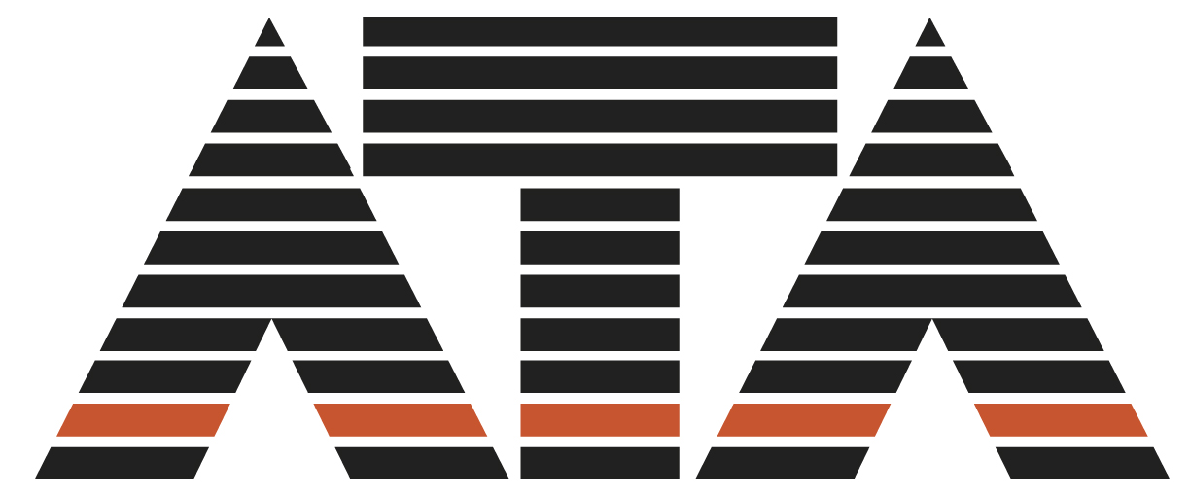

16 May 2011

Retail Inquiry
Productivity Commission
GPO Box 1428
Canberra City ACT 2601
retail@pc.gov.au

Economic Structure and Peformance of the Australian Industry
Attached is the submisson of the Australian Toy Association to the above inquiry.
Executive Summary

The Australian Toy Association (ATA) makes the following recommendations to the Productivity Commission Retail Industry Inquiry.

Current Indirect Tax Arrangements

Restore fairness and equity to the indirect taxation regime for all Australian retailers by

EITHER

Removing the Low Value Importation Threshold to ensure Australian retailers can compete on even ground with offshore online sellers.

OR

Removing GST and import duties from all domestic retail where the transactional value is less than $1000 to achieve competititve neutrality.

Australian Consumer Law

Address the significant problems Australian retailers are experiencing with online trading in relation to warranties, spare parts and repairs by recommending that the Australian Competition and Consumer Commission (ACCC) publish a simple, clear statement of retailers' rights and obligations covering goods they have not sold.

Paul Hodgson
General Manager

Introduction

“What is sauce for the goose is sauce for the gander”

The Australian Toy Association (ATA) welcomes this inquiry particularly the investigation into the 'Appropriateness of current indirect tax arrangements' as this has been an increasingly vexing issue for ATA members for about ten years. It was of such concern by 2005 that the Association commissioned a report focussing on the radio-controlled model toy market.

ATA is an independent and not-for-profit organisation established in 1983. Its 240 members include those involved in the manufacture, wholesale and retail of toys, hobbies, confectionery, games, books and collectibles as well as suppliers of services. According to IBISWorld Industry: Toy and Games Industry in Australia: December 2010, ATA members account for the majority of the industry's sales.

Low Value Importation Threshold

Although some members of ATA are retailers, the majority are involved in other aspects of toy, hobby and nursery product manufacture and distribution. Hence ATA is not competent to, nor would it be appropriate for the Association to comment on those aspects of the inquiry relating exclusively to retail.

However, ATA is a member of the Fair Imports Alliance (FIA) and fully endorses its submission.

The issue for ATA is not 'bricks and mortar versus the internet'. Membership encompasses e-traders and companies which utilise online channels as well as those which for reasons of superior customer service or the nature of their merchandise choose to retain the traditional retail model.

ATA is not seeking reform of the indirect tax arrangements as a form of industry protection. As IBISWorld observed in its most recent Toy and Games Industry Report, cited above, operators are getting more creative in order to meet changing demand.

In part this creativity has involved embracing online channels for the obvious reason that young people and children who are the main target audience of the toy industry communicate extensively via social networks and websites.

“Innovation is a major issue affecting the industry, and industry operators have placed more focus on the development of new products. This is in response to children playing with more advanced toys and games at an earlier age, and is in an effort to remain competitive. Products are becoming more technically advanced, with higher demand for electronic and interactive toys and games”. (IBISWorld, December 2010).

In fact, the Issues Paper for this inquiry accurately reflects the view of ATA members when it states “..that the low value threshold places them at a significant competitive disadvantage compared to international retailers selling directly to Australian consumers over the internet”. (PC Issues Paper, page 21).

Similarly ATA concurs with the following statement in the Issues Paper, “...it would be preferable to apply the same rate of taxes to all imports so that competing businesses were treated equally”. (PC Issues Paper, page 22).

Equal treatment is precisely what ATA is seeking or, to put it another way, 'What is sauce for the goose is sauce for the gander'.

Australian Consumer Law

In a survey conducted to inform this submission ATA asked members of the toy industry to respond to the consumer protection questions in the PC's issues paper. The most important issue after the low value threshold was being expected to meet warranties, provide spare parts and undertake repairs for imported online product.

Members of the toy industry were asked to provide specific examples of "problems with regard to the safety, quality or performance of goods purchased by Australians from overseas online traders". (Issues Paper page 19) A sample of the responses are quoted below.

"We see goods with unlicensed and non-approved wall chargers being brought into the country. Added to this are non-approved transmitters which operate on different frequencies to those approved in Australia."

"The obvious lack of after sales support and warranty is also common."

"We continually have customers asking us to service their items that they purchase from overseas online because they have broken down and they expect us to stock parts for these items. We consider that these items that they purchase to not meet with the safety requirements."

"Transmitter/receiver sets imported ... do not comply with Aussie standards and operate off-band causing safety issues".

The main issues are the same as those identified in the Issues Paper, safety (electrical parts, chargers and batteries), quality and performance. Australian retailers in the toy industry have particular difficulty with being expected to meet warranty provisions and provide spare parts for products they have neither sold nor for which they have any responsibility.

In this respect the reference in the Issues Paper to the new Australian Consumer Law which came into effect on 1 January 2011 is encouraging. The suggestion that the new law now gives the ACCC powers in relation “to the purchase of goods and services from overseas-based traders carrying on business in Australia" and enhanced ability to enforce laws in cross border transactions could provide relief for Australian retailers.

Hence ATA recommends that the Productivity Commission to explore with the ACCC and make appropriate recommendations on:

. enforcement of compliance with Australian safety standards by goods being imported online, and

. provision of a clear statement from the ACCC which retailers can display in their shops outlining responsibilities under the Australian Consumer Law in relation to warranties, spare parts, repair and maintenance.

ATA submits that the ACCC should already be giving active consideration to these recommendations because its own statistics list 'Online auctions and shopping' as Number Two in the Top 10 scam types complained about to the ACCC in 2010 with 5,577 cases of online scams reported. (ACCC Update. Autumn 2011. page 17)

Background
In its most recent report into Toy and Game Retailing in Australia: September 2010 IBISWorld found that industry operators operated in a highly competitive environment over the previous five years. In order to compete, smaller indendent retailers have had to ensure that their business plans were constantly evolving.

“Other long established competitors have included chemists, newsagents, service stations, post offices and supermarkets; however many toy retailers don't believe such competitors have substantially affected their business due to their limited product range and lack of specialisation. However, online shopping sites have emerged as a new threat to toy retailing over the past five years. Offering consumers a new and innovative way of shopping, online demand toy and game merchandise has gained in popularity.”

The time scale of the emergence of this issue reported by IBISWorld accords with ATA's experience. ATA has been aware of use and in some cases abuse of the low value importation threshold since 2005.

Representations by ATA and other affected organisations resulted in the Board of Taxation reviewing this aspect of GST administration. While the Board's report of 2010 was welcome in that it recognised for the first time in a government document that there is a competition issue, it was disappointing that the Board accepted without question or further inquiry the oft-repeated assertion that the cost to the taxpayer of reducing or eliminating the current threshold in terms of administration would be greater than the revenue derived.

Following the unsatisfactory outcome of the Board of Taxation review, ATA determined there was a need to combine with kindred organisations whose members were similarly affected. ATA took the lead role in convening the group now called the Fair Imports Alliance (FIA).

A key objective was to test independently the assumption underlying the retention of the current threshold at such an uncompetitive and internationally out-of-step level. Hence the Australian retail industry reference to the Productivity Commission is welcomed by ATA and FIA.

Survey

In order to assess the importance of the low value importation threshold value to the toy industry ATA conducted an online survey. The questions mirrored those asked in the Commission's Issues Paper on Indirect Tax Arrangements and Consumer Protection.

A total of 130 responses were received which is the highest number since the organisation began using online surveys about three years ago. The respondents were a mix of distributors, importers and retailers.

The following aggregated outcomes may assist the Commission.

The low value importation issue is one which affects small business most heavily. Of the 130 responses, 80 were from businesses with annual turnovers not exceeding $5million and employing no more than four staff.

In line with the first question on page 24 of the Issues Paper:

. 27 respondents were 'Very significantly' impacted by the low valyue importation threshold
. 28 respondents were 'Significantly' impacted, and
. 14 were 'Marginally' impacted.
. A further four were either not affected or benefitted.

The difference in totals (ie total number of respondents compared to number of respondents replying to low value importation threshold question) is due to some respondents either only replying to some questions or only providing comments.

