.

Submission in response to:

Productivity Commission (2011)

Economic Structure and Performance
of the Australian Retail Industry,

Draft Report, Canberra.

Note that all opinions in this submission are mine alone and
do not necessarily accord with the opinions of any of my employers.

Nigel Flannigan
MSc., BTRP, B.Com., Dip.Arch., LFPIA
Senior Fellow, Faculty of Architecture Building & Planning, The University of Melbourne, Victoria 3010. and
Associate Director SGS Economics & Planning, Melbourne

About the author: Nigel Flannigan

I am a retired academic in urban planning (after 38 years at the University of Melbourne) with a particular interest in planning for shopping and retailing. I am still working part-time on a number of projects for a number of employers.

Throughout my working life I have taught how to plan cities for shopping and retailing. I have a particular research interest in how traditional shopping districts (strips) can be better planned to make them more productive and competitive with their corporate shopping centre counterparts.

This submission is very specific to that interest. Consequently the submission is limited in scope to that which is largely covered in Ch.7: planning and zoning regulation.

INTRODUCTION

Since the 1960s, corporate shopping centres have set the standard for retailing against which traditional shopping districts & town centres are inevitably assessed.

Throughout the paper distinction is made between:

Traditional shopping district: ‘shops and service premises in multiple ownership, developed along traditional streets using a process of land subdivision and development regulation rather than overall urban design and development.

Corporate shopping centre: ‘shops and service premises that are planned, designed, owned and managed as a single corporate entity’.

The term ‘corporate’ to distinguish shopping centres is not common. It is used to emphasise their corporate characteristics that allows them to do what they do so well. Hereafter only the terms ‘shopping district’ and ‘shopping centre’ are used.

The Productivity Commission Draft Report (PC 2008c, p.203) recognises that corporate shopping centres are in the ascendency:
While most retailing still occurs outside of shopping centres, centres represent a growing share of the total market. The contribution of shopping centres to total retail space increased from 28 per cent in the early 1990s to 38 per cent in 2005-06.

These corporate shopping centres get their main competitive edge over shopping districts by the comprehensiveness of their business planning, development and ownership.

The fundamental reason for the ascendency of shopping centres over shopping districts is that they are more efficient: with higher productivity across a number of criteria. This enables them to offer a better value for money option.

If shopping districts are to maintain their market share (or even survive) they must take steps to make themselves more competitive against their shopping centre counterparts; and the planning systems must facilitate them to doing so. Ironically, the current Australian planning systems hinder shopping districts from applying the state-of-art logic and techniques that are applied in shopping centres, all with the aim of maintaining a competitive market. In this, most planning systems in Australia are biased against shopping districts to the point of them being unfairly anti-competitive.

THE FUNDAMENTAL SHOPPING CENTRE MODEL

What is it that shopping centre developers and managers do that makes them so competitive against shopping districts?

Corporately Owned, Planned and Designed Cluster of Shops

Shopping centre planners research and analyse the demand of consumers within their trade area to ascertain what that trade area needs, wants and can support. This is similar to what occurs with shopping districts. Thereafter shopping centre management identifies and selects the most appropriate functional composition of retail and service businesses to meet that demand.

At this point there is a noticeable difference between the selection mechanisms of the two types of shopping facility. The functional composition (business mix) in shopping districts is determined in a process of self-selection based on the ability of individual traders to pay rent for specific premise in particular positions. Premises go to the highest bidder (or more likely the first to meet the asking rent) in competitive process between individual retailers. The positive contribution that a particular business can make to the whole district does not come into the reckoning; or indeed any negative externality effects on other businesses therein.

On the otherhand, in shopping centres the functional composition occurs by purposeful selection of businesses by centre management to ensure that the shopping centre is competitive as an entity against other shopping centres and districts in the region. In this the wider interest of the productivity and competitiveness of the shopping centre as an entity takes precedence over the personal or self interest of individual businesses.

Shopping centre planners and managers distinguish between destination shops and dependent shops:

- Destination shop: attracts custom in own rights and creates 'positive externalities' for other businesses in the centre. Colloquially, they are called 'magnets' or 'anchors';

- Dependent shop: depends on destination shops to attract custom and benefits from positive externalities of them. Colloquially, they are called ‘on-line’ shops.

The rent that individual businesses are required to pay is determined not only by their ability to pay but more significantly by the contribution that each makes to the whole centre. Since it is the number and status of the 'destination shops' that determines the range or drawing power of a shopping centre as an entity, so they tend to be required to pay less rent than the less spectacular dependent shops. This effectively means that the dependent shops subsidise the rent of the destination shops. Later, the leasing and rent paying practice of tenants is discussed at greater length.

In short, a shopping centre is a carefully managed cluster of shops that was selected to provide a predetermined retail offering so as to be competitive as an entity with other centres and districts in the region. There is likely to be some competition between shops in-centre (enough to prevent outlandish profit taking) but more significantly there is a complementarity between businesses to equip the centre to compete successfully as an entity with other centres and districts in the region.

On the otherhand, a shopping district is a cluster of shops that self selected to cluster together to sell the products of their own choice. In trying to compete as an entity against other shopping centres and districts they are likely to obstruct each other because of poor co-location of businesses, incomplete offerings of products and the likes.

Spatial Structure and Shop Placements within Shopping Centres and Districts

The normal spatial structure and shop placements within shopping centres is to locate the main destination shops or attractors at the extremities and for the smaller dependent shops to be located along the concourse that leads between them. Figure 1.

Figure 1: layout of typical shopping centre

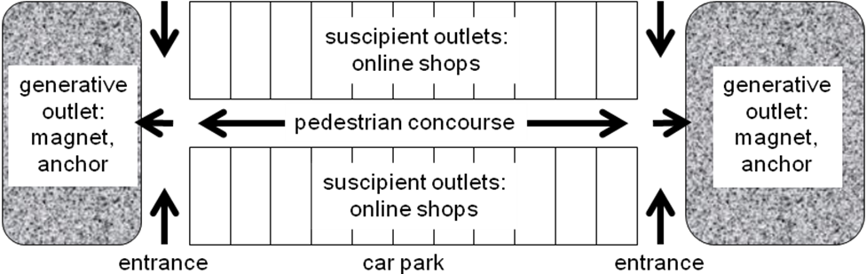

Shoppers passing between the destination shops have to pass the dependent shops and this provides them with the best opportunity to make sales. In large shopping centres where concourses are very long there may be a destination or mini-magnet to draw shoppers along the way. Figure 2.

Figure 2: layout of typical shopping centre with mini-magnet midway

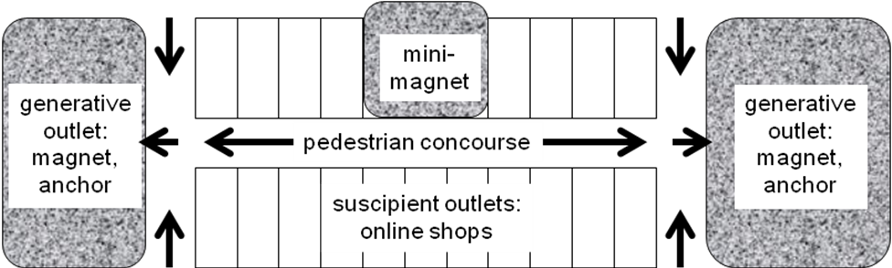
Whilst it is clearly advantageous to have a major new injection of a destination or magnet business to anchor either a shopping centre or district, it is difficult to realise in a shopping district for reasons discussed previously.

Even without a major destination shop it is possible to generate considerable drawing power by creating a critical mass of small complementary shops to exploit the potential synergy between them. Synergy is a phenomenon in retailing where the retail sales of a cluster of complementary shops are greater than the sum of the individual businesses located apart. Critical mass is the amount of floorspace needed for synergy to take effect; it is a qualitative concept rather than a quantitative one.

Synergy is enhanced by clustering uses into niches directed at a particular customer needs; for example, women's clothes, shoes and cosmetics agglomerated to create a fashion theme; or a butchery, bakery, delicatessen agglomerated as a cluster of food-for-home outlets.
Exploiting available synergy leads to an increase of productivity of the group of businesses and through that the productivity of the individual businesses. The corollary is the exclusion of business uses that negate the development of synergy. Outlets that can destroy the synergy are certainly not permitted in the mix and even those that cannot be illustrated to positively contribute to the whole cluster may well be banished from it.

It is now a common practice within shopping centres to have informal micro zones within which are clustered complementary shopping and service outlets. For example, immediately outside the major supermarket(s) is normally located an area for small tenancies of food-for-home and food related products (the sorts of products sold inside the supermarket). In this the supermarket(s) acts as the magnet and the smaller shops feed off the passing pedestrian traffic.

This contrasts with the self-selection process of shopping districts where it is common to find shops selling food-for-home scattered across a wide area and within a mix of shops without any synergetic relationship. For example, in amongst any potential food-for-home cluster is likely to be located a fashion shop, opportunity shop or even a fast food outlet. Note that there is nothing wrong with such businesses and most shopping district would benefit from their presence but it is counterproductive to have them located amongst a food-for-home cluster or niche.

This clustering of complementary businesses can be done very precisely in shopping centres but the self-selection of locations by individual business that occurs in shopping districts makes it difficult to achieve therein. For example, in Victoria it is nigh impossible to deny any location in a designated shopping district to anything that is definable as a ‘shop’.

Leasing of Retail Floor Space

In this the process by which shopping centre owners receive their rental income resembles that of a ‘contrived’ rather than a ‘free’ market (if not a ‘collusion’).

Normally shopping centres are in single ownership and management leases sites therein to individual businesses. Under lease conditions tenant businesses are allocated specific roles and locations within the centre.

Shopping centre tenants are expected to play a predetermined role within a centre. For example, the lease restricts tenants in what they sell and they cannot change their retail offerings without breaking their lease. This contrasts with shopping districts within which businesses are answerable only to their customers and themselves as to the products they choose to sell.

The allocation of a specific position is intended to maximise the potential retail synergy from clustering of complementary retail use. This contrasts with shopping districts within which businesses self-select specific locations subject to their ability to pay the rent.

These lease conditions effectively mandate shopping centre tenants to collective trading practices with the resolution of conflicting interests of businesses being made in the wider collective interest not merely the self interest of individual businesses. On the otherhand, in shopping districts individual businesses are answerable only to themselves and are under no obligation to act in the wider collective interest.

The most common leasing system used in Australia is the percentage lease in which tenants pay base rent (covering basic maintenance and operating costs) plus a predetermined percentage of the $ value of sales turnover. The minimum rent guarantees management a base income if tenant sales do not produce sufficient rental income.

The percentage of turnover component creates a win-win situation for both tenants and management. It provides tenants with a measure of rent relief in the early years of their businesses: when sales turnover is likely to be small. It puts the onus on centre management to provide facilities, a tenant mix and management quality that maximises aggregate tenant prosperity ($ turnover). In this way it brings both the tenant and management interests together in an effective tenant: landlord partnership.

The size of the percentage of turnover tends to vary according to the type of retailer. For example in a centre where the base rent is 80% of the prevailing market rent a supermarket (with high turnover but low profit margins) may only pay 1% of turnover whereas a fashion shop (with high profit margins but low turnover) may pay as much as 15%.

Clearly, because of the rent plus percentage turnover rental system management earns the most income by maximising the retail turnover of the shopping centre as an entity, not that of individual businesses within it.

Hence management has a self-interest in having enough competition to keep prices competitive with elsewhere but not so much that it leads to price cutting, lowering of profit margins, business closures, and the likes. Management decides the number of each type of retail offering that the trade area can support and provides no more floorspace than what is required to service it. Consequently, shopping centres have a measure of competition but in no way are they a mechanism of open competition: they have a self-interest in restricting competition to ensure the survival and success of tenants.

Furthermore, in order to maximise turnover management is willing and able to cross-subsidise the rent of businesses that have a particularly strong drawing power in order to entice them into their centre. For example, it is clear that for a shopping centre not to have a Myer or David Jones Department store (or indeed both) relegates that centre to second tier status at best. Consequently, recognised destination shops or magnets in shopping centres pay less rent than the smaller on-line shops such as a chemist/ pharmacy shop. Figure 3.

Figure 3: layout and typical rent gradient of shopping centre (NB. indicative only)
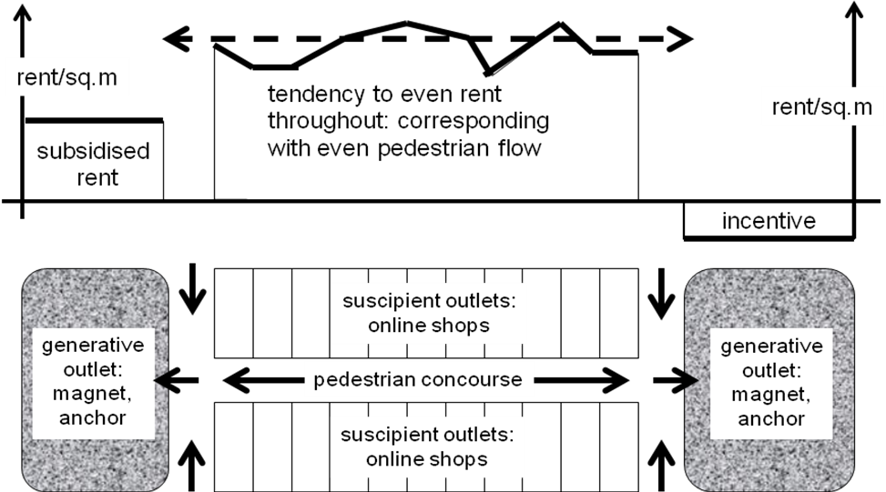

Management gives rent relief to the magnets in the understanding and expectation that their drawing power and resulting additional footfall in the centre will translate into additional turnover and rent accruing in the on-line shops. In some shopping centre formats in the USA magnets are so significant to the overall economic success that they are actually paid to locate within centres.

This cross subsiding of rents varies with the contribution that a business can make to the drawing power of the overall centre. It even extends to small businesses that provide a valued product or service but that are not so lucrative that they can afford the prevailing rent. For example, a good quality bakery is a valuable asset in any shopping centre but in a competitive market situation they usually cannot afford prime locations. However, in recognition of their wide customer appeal they are sometimes required to pay less rent than their more lucrative neighbours.

Also the now common food court was originally provided in shopping centres as a customer service. The idea was that by providing a range of cheap ready-to-eat food they would encourage shoppers to stay for lunch and that in turn would ensure that they would stay longer and shop after lunch. To achieve the required cheapness management was prepared to subsidise the rent of ready-to-eat food tenancies in the expectation that there would be additional sales and rental income accruing through cash registers of the dependent shops. As it turned out many food courts in shopping centres have become major draw cards in their own right and are so productive that they are able to afford and pay very good rent returns.

I emphasise that there is a sound economic logic for such cross subsidisation: from those that receive economic benefit to those that create it, but it is anti-competitive for governments to allow such behaviour in one situation (shopping centres) and not allow it in another (shopping districts).

It is economic mechanisms such as these that makes it very difficult for shopping districts to improve their productivity to the extent that they can be competitive with shopping centres. For example, it is nigh impossible for shopping districts to attract a major magnet therein (or even a mini-major) because they would be called upon to pay the prevailing market rent in competition with other businesses against their subsidised rent available in a shopping centre. To date, in shopping districts there is no effective way to subsidise their contribution to the profitability of the whole business cluster.

This is but one reason why shopping districts are unlikely to ever again be competitive with shopping centres. As indicated in the PC report shopping centres are increasing their ascendency: 38 per cent in 2005-06; and rising!

APPLYING INNOVATIVE TECHNIQUES TO SHOPPING DISTRICTS

There are several planning techniques that have been developed across the western world to make it easier to plan and regulate shopping districts in more sensitive way. This and other limited ways in which the best practice principles have been applied in shopping districts is the topic of Small Area Planning for Traditional Shopping Districts by Nigel Flannigan, published in Urban Planning and Research, Vol 20, No.2, pp.205-217, 2002. Carfax Publishing. This submission draws on that work.

The Concept of ‘Place’ Zoning

Conventionally the development of cities is regulated by designating developable land as specific zones identified (and named) according to predetermined permitted use(s): ‘use’ zoning. For example, land within the residential zone is developable for housing and allied uses to service them such as local playgrounds, primary schools, parks

Such zoning ignore the subtleties of the differences between locations and landscapes, the socio-economic characteristics of present and future residents, and their lifestyles and aspirations, and the likes. There is a more ‘place’ orientated approach to regulation that not only makes allowances for such differences but celebrates the uniqueness of different places and peoples.
.
Rather than a series of use zones being designated across an urban area there would be designated a number of distinct places. Each of these designated places would then be subject to detailed planning with the outcome being determined by a unique planning thought process and not by predetermined land use zones. The designation of places for special planning consideration occurs in planning systems under a number of different guises.

Special Districts & Business Improvement Areas

In the USA there is provision for designation of a ‘special district’ which is a government unit for delivery of services (Babcock & Larsen 1990). Common types of special district are:
- taxing district, where a special property tax applies.
- service delivery district, such as a school district.
- public land or real estate district, such as for public open space.
- economic improvement district, such as a local business district.
Many designated special districts are hybrids; for example, a district to improve business performance empowered to own real estate funded by a special property tax.

Victoria's Local Government Act 1989 provides for special taxing districts, although not versed in those terms. The Act provides for Councils to declare a ‘special rate’ or ‘special charge’ (s.163(1)) and to specify the ‘wards, groups, uses or areas for which the special rate or special charge is declared’ (s.163(3)). This place-specific provision is frequently used for shopping districts to collect revenue for maintenance and management programs. Used in this way special rates correspond with fees levied by shopping centres for the maintenance of common areas, collective advertising and the like.

Special districts are not a creation of planning but many USA planning systems have adopted the concept in 'planning and zoning districts'. These districts are particularly popular in New York and San Francisco.

San Francisco is a heralded example of the use of special district zoning specifically for shopping/ business districts, with its designated Neighbourhood Commercial Special Districts (San Francisco City Council 1971). In San Francisco's neighbourhoods during the 1970s, local-orientated businesses serving adjacent residential areas with daily needs were being displaced by region-orientated uses. For example, Union Street attracted fashion boutiques and restaurants, bars and other entertainment uses that created problems of traffic congestion, parking and late night noise and frequently imposed a new architectural character in the process. Initial attempts at preventing such incursions using historic preservation legislation failed because the area was not of historic significance. In 1979 the ‘Union Street Special Use District’ was designated stipulating the maximum streetfrontage that could be used for bars and restaurants. This became the model for the city's network of neighbourhood commercial areas.

Canada’s Business Improvement Areas (BIA) were initiated in the late 1960s by the business community of the West Bloor Street area in Toronto requesting the City of Toronto to designate its area for special management, to levy a special property tax and transfer the revenue to the business association for local improvements (Ministry of Municipal Affairs and Housing 2001).

In 1970 the Province of Ontario passed enabling legislation (Municipal Act section 220) and the West Bloor Village BIA was established (NB. this was over 40 years ago). BIAs are formally designated by their corresponding municipality. They are managed by a Board of Management comprised of property owners and business operators elected by the BIA membership and at least one member of Council. They are responsible for an annual budget to be approved by the membership and the local council. Funding comes from a special levy on all commercial property in the designated area and must be spent in accordance with the budget. BIAs have cited purposes to improve beautify and maintain public lands and buildings and to promote the area as a business and shopping destination. However, in practice the tasks undertaken are much more complex. For example, some BIAs recruit businesses to occupy private real estate.

There are now more than 230 BIAs in Ontario and the concept has been adopted by most provinces of Canada. Furthermore, the model has been applied in more than 1500 communities across the USA commonly under the term Business Improvement District (BID) (Houstoun 1998).

In the UK in the 1990s an interest was developing in having traditional town centres actively managed to make them more competitive. During this time the Association of Town Centre Management was established and it promoted the concept of a ‘Town Improvement Zone’ inspired by the success of BIDs in the USA (Shutt et al c2000). The Blair Government recently announced its adoption of the concept but reverting to the term ‘Business Improvement District’:
‘we have decided to introduce legislation to create Business Improvement Districts. These will be similar to the successful US examples where local businesses help pay for projects that improve their local area. This will enable local authorities and local businesses to enter into contracts to provide additional services or improvements, funded by an agreed additional business rate.’
(Department of the Environment Transport and the Regions 2001)

Much of this early enthusiasm for BIDs in the UK appears to have dissipated but that does not diminish the value of the concept.

Street Frontage Regulations for Shopping Districts

A tiered system of place zone designation in strategic plans and small area planning for the designated zones allows smaller scale location decisions to be made and finer detailed conditions to be imposed at the local level. Such 'fine-grained' zoning occurs in the street frontage policies and regulations applied in the UK, Canada, USA and Australia.

The importance of fine-grained distinction in uses for street vitality is sourced to Jane Jacobs (1961, pp.243-9) who discusses uses that foster vitality and those that negate it. Another noteworthy author is William Whyte (1988), a colleague of Jacobs, who continued the scholarship. Numerous cities in the 1970s (40 years ago) introduced street frontage policies to protect and enhance the vitality of traditional shopping districts; for example, San Francisco, Toronto, Portland, New York, Aberdeen, Edinburgh.

Toronto's Street-Related Retail and Service Use Policy (Toronto City Council 1991) designates a series of 'priority retail streets', defined to encourage only 'street-related retail and service uses' defined as:
• retail and service shops, except data processing, industrial computers and security services;
• recreation and places of amusement and assembly except for gardens, golf courses, landscape areas, playing fields, play lots, and public playgrounds;
• community services and facilities.

This acknowledges that retailing and service uses along a footpath attract pedestrians and make the street interesting and safe. The policy is accompanied with a penalty for any new development that does not conform to the amount of 'street-related retail and service uses' prescribed for ground floors.

In the 1980s rapid growth in the service sector of the UK economy led to increased demand for commercial premises and inflated rents. Planning authorities were pressured to allow establishment of non-retail service uses in retail shop premises along shopping streets. Allowing such changes detracted from the vitality and viability of town centres as shopping destinations and the Department for the Environment commissioned a study (URBED 1994) into how town centres could be enhanced as a precursor to a policy revision.

Such street frontage designation is fine-grained zoning. It is ironic that even the UK, where zoning is not a formal planning instrument, resorts to fine-grained designations of its shopping streets.

Quantitative Zoning

Under conventional zoning principles and practice it is difficult to stop extreme agglomerations of single uses that exclude other more socially desirable uses. An example is agglomerations of restaurants or antique stores serving regional markets squeezing out food shops needed to service the daily needs of local communities.

Conventional logic and precedence in zoning is that the more of a use that already exists the greater the expectation that additional amounts of that use will be permitted. Rejection of a use because sufficient similar uses already exist runs contrary to this convention. Permitting a wide range of uses but limiting the exclusiveness of any one use in shopping districts is the subject of ‘quantitative zoning’ (Babcock & Smith 1985) or ‘use quotas’. The logic is that a use is disallowed if there are already sufficient shopping opportunities.

Babcock and Smith (1985) discuss the USA’s ‘equal protection doctrine’ and cite a 1979 case in Illinois where a court held it to be illegal to exclude one use and not another similar use.

In Australia, it is a long standing principle that planning is not to be used to restrict competition. The maintenance of competition is based on expectation that competition fosters efficiency that inevitably flows through to increased community welfare. Limiting the amount of any specific use could be interpreted as anti-competitive. However, Australia’s National Competition Policy (Commonwealth of Australia 1995, cl 5(1)) states that legislation (including ordinances or regulations) should not restrict competition unless it can be demonstrated that the benefits of the restriction to the community as a whole outweigh the costs and that the objective of the legislation can only be achieved by restricting competition.

This allows planning schemes to restrict the number of competing businesses provided it is in the public interest to do so. However, the onus of proof lies with the proponent of such market intervention to illustrate any ‘adverse social consequences’ of allowing more than the quota of uses.

In any case, corporately-owned shopping centres set strict quotas on the amounts of various uses and merchandise, avoiding the legal difficulties because all the use and development rights are encapsulated in one ownership. This increases their efficiency and competitiveness as entities and to not allow shopping districts to do likewise puts them at a major disadvantage and could be interpreted as being anti-competitive.

Quantitative zoning is much more difficult to apply conceptually and legally than exclusive zoning. Yet the application of use quotas in planning is increasing. The UK's PPG6 sanctions the designation of street frontages within shopping districts, with accompanying regulations to specify the amount of permitted non-retail uses.

York City Council (1992) makes a 3-way distinction in street frontages:
- ‘protected’ streets: changes of use of existing retail uses to non-retail are opposed.
- ‘primary’ streets: 65% minimum of street frontage can be retail; 35% maximum can be non-retail.
- ‘secondary’ streets: 50% maximum of street frontage can be non-retail.

The Edinburgh District Council (1993) makes a 4-way distinction:
- 'core' frontage of the City Centre: no further loss of retail frontage to non-retail use is permitted;
- 'primary' frontage of the City Centre and District Centres: 20% maximum of frontage of each city block can be non-retail use;
- 'secondary' frontage of the City Centre and District Centres: 40% maximum of block frontage can be non-retail use;
- 'other centres' (groups of at least 5 shop units): 20% maximum of business units (not frontage) can be non-retail.

Toronto's designated 'priority retail streets’ within the ‘Central Retail Core’ are required to have 60% minimum of ground floor street frontage devoted to street-related retail and service uses (Toronto City Council 1991). Any building project that does not meet this requirement incurs a reduction in the amount of permitted development (other than residential use that is not penalised).

CONCLUSION

Shopping centres get their greatest competitive edge over shopping districts by their ability to recruit and locate retail and service businesses to exploit potential synergy between businesses. This ‘best practice’ discussed above enables them to exploit both the destination shop and dependent shop relationship and the synergetic relationships within niches.

However, Melbourne's shopping districts are regulated by planning schemes based on broadly defined use zones that do not make such fine-grained distinction between businesses and their uses. For example, they make no distinction between different types of shop: a food shop and a fashion shop are both treated as ‘a shop’ without concern about the type of retail offering or need. The inability to control the placement of retail businesses (in considerable detail) leaves shopping districts at a competitive disadvantage against their shopping centre counterparts.

In shopping centre development this ‘best practice’ is deemed to be a fair and legitimate market process (by inference, a ‘free market’) but if undertaken in a shopping district it would be scorned as an interference in the market or worse a collusion to fix the market; and that is illegal. Unless Australia’s planning systems enables the same ‘best practice’ to be applied in shopping districts they do not have a hope of competing in the long run against their shopping centre rivals.

No shopping district in Australia is subject to management in the mode of shopping centres and few have comprehensive business plans in operation. However, in recent years it has become increasingly common for managers to be appointed to look after shopping districts, following a trend in the UK and USA. To date most have adopted urban design solutions in which attempts are made to mirror the design response of shopping centres with emphases on pedestrianisation, paving, seating, and such. Some support this urban design approach with promotions in which the shopping districts are ‘talked up’, based on the advertising of shopping centres.

Both of these approaches are commendable but neither nor both are sufficient. The intention in the revitalisation of shopping districts should be to have them perform better as places to do business: improving retail business efficiency and productivity.

Some planning systems do make provision for such micro-zoning in shopping districts (especially in UK and USA) in the manner in which shopping centres do. It is worth while exploring the prospects of it being introduced into Australian practice to make shopping districts more competitive. However, it is unlikely that provision can be made to compare with the situation-by-situation flexibility that is practiced in shopping centres.

REFERENCES

Babcock, Richard F & Larsen, Wendy U (1990) Special Districts: the Ultimate in Neighbourhood Zoning. Lincoln Institute of Land Policy, Cambridge.

Babcock, R. F. & Smith, R. M. (1985) ‘Zoning by the Numbers.’ Planning, 51(6), June, pp.12-16. American Planning Association, Chicago.

Department of the Environment, Transport and the Regions (2001) News Release 234: 24 April.

Edinburgh District Council (1993) Policy on Non-Retail Uses in Principal Shopping Centres. Approved 25 March. Department of Planning, Edinburgh.

Flannigan, Nigel (2002) ‘Small Area Planning for Traditional Shopping Districts’. Urban Planning and Research, Vol 20, No.2, pp.205-217, 2002. Carfax Publishing.

Houstoun, Lawrence O (1988) ‘Smart Money: New Directions for Business Improvement Districts’. Planning, 64 (1), January, pp. 12-15. American Planning Association, Chicago Ministry of Municipal Affairs and Housing, Ontario (2001). An Introduction to Business Improvement Areas. Toronto

San Francisco City Council (1971) Urban Design: The Comprehensive Plan. San Francisco.

Schutt,John; De Silva, Pauline & Muller, Thomas (c.2000) The Case for Town Improvement Zone Programme. Leeds Metropolitan University for the Association of Town Centre Management, Leeds.

Toronto City Council (1991) Citizens' Guide to the Official Plan Proposals Report. Cityplan 91, June. Toronto, Canada.

URBED (Urban and Economic Development Group) with Comedia, Hillier Parker, Bartlett School of Planning University College London and Environmental and Transport Planning (1994) Vital and Viable Town Centres: Meeting the Challenge. (London, HMSO for the Department for the Environment, UK)

Whyte, William (1988) City: Rediscovering the Center. Doubleday, New York.

York City Council (1992) Policy for Safeguarding Retail Frontages in York City Centre. Directorate of Development Services, York.

DISPUTING THE CLAIM THAT NEW FORMAT RETAILING CREATES JOBS

As a separate issue I would like to suggest that you explain how it is that new innovative forms of retail can claim to create employment as cited by the ‘overseas evidence’ and reported in PC Draft Report (p.208, 7.3 and 7.4). The inference in the report is that the Commission accepts the credibility of the argument that new format retailing creates jobs. I dispute that claim using the logic that follows.

New format retailing generally comes about in order to deliver better price for quality products to the market. More specifically new format retailing is the result of the mix of inputs that achieves a more competitive quality for price outcome than hitherto. That is what it is for retailing to be innovative and why the community should support new format retailing; but that is not without its problems.

The factors of production/ distribution facing retailers can be identified as: occupancy (premises and fit-out), inventory (stock cost), labour (staff costs), and enterprise & technology (to substitute for other factors). There are potential substitutions between the factors of production that reduce overall costs. For example, labour can be substituted by technology the application of more sophisticated sales equipment to increase its productivity as measured by sales per employee. Superstores, for example, commonly get their competitive edge from reducing the amount and cost of the labour component of their operation (amongst the other factors). The relationship of wages to value of retail sales of a superstore is much less than that of a conventional smaller retail operation.

It is common at appeals tribunals for consultants to claim that the retail project of their clients will not only not result in a loss of jobs but will actually increase jobs. But innovation in retailing often reduces the labour input (as indeed is the intention): to increase labour productivity it must result in lower $ input to retail the products.

How then can it be claimed that new format retailing makes a positive contribution to a local economy by creating new jobs. It is acknowledged that the construction of a new retail store employs construction workers and when the outlet opens it requires and hires sales and maintenance staff. However, this has to be assessed against any associated job losses elsewhere in the region or district and there may actually be a net loss of jobs in the economy. If all retailing in a local economy was shifted to more efficient new format retailing there would be fewer jobs, or lower value/ wages jobs

I emphasise that I do not suggest that new format retailing be discouraged because it results in less jobs. It is precisely to improve labour efficiency (amongst the other factors) that it should be encouraged but it is fallacious for it to claim the shift will increase jobs. There may also be more consumption of goods and services as a result of the lower cost/ prices but the need for more jobs to service the uplift will be unlikely to equate with the loss of jobs. The job loss free people to move into other sectors of the economy but the job opportunities therein will need to be created.

It is also important not to makes comparisions with overseas countries out of their context. For example, in the USA the retail industry pays wages that are at best subsistence level with the USA new format retailing being particularly stringent on wage payment. The wage practices at the Wal-Mart corporation, for example, are now well publicised. Personally I hope that such wage standards and practices never come to Australia despite the cheaper prices that it would bring.

