NARGA
National Association of Retail Grocers of Australia Pty Ltd ABN 72 000 446 355

Tel: 61 2) 9585 0721 Suite 9, Level 2, 33 MacMahon Street
Fax: 61 2) 9579 2746 Hurstville NSW 2220
Email: info@narga.com.au www.narga.com.au

2 September 2011

Retail Inquiry
Productivity Commission
GPO Box 1428
Canberra City ACT 2601

By email to: retail@pc.gov.au

Dear Sir/Madam

Submission: Economic Structure and Performance of the Australian Retail Industry – A joint submission by the National Association of Retail Grocers of Australia and Master Grocers Australia.

In this second submission we wish to confirm our position on a number of matters, including the question of market concentration and market share in the retail grocery sector, the necessary contribution that planning law needs to make to the prevention of unhealthy market concentration at the local level, the problems we see in the use of contestability theory in matters of competition law and the general lack of transparency associated with markets that are increasingly becoming vertically integrated.

Market concentration

The draft report contains two estimates of the Woolworths and Coles share of the retail grocery market. Table 3.5 suggests a combined share of 64% of ‘food and liquor, whilst table 3.6, in an international comparison suggests a combined share of 54%.

Whilst the notes under the second table point to comparison difficulties with the data due to definitional differences, no indication is given as to how wide these differences are.

We are particularly concerned that the Productivity Commission has chosen to include in its table the Woolworths estimate of the combined market share of the two major retailers. It may not be aware of the campaign by Woolworths in recent years to downplay its dominance of the retail grocery market to make itself a smaller target in the general public criticism of the market power of the two major chains. Woolworths has achieved this by using increasingly wider definitions of the market in which it believes it operates, thereby downplaying its share of it.

The market share of supermarket chains has over many years been measured by survey companies such as AC Nielsen. Measurement methods have, over the years become increasingly sophisticated and are now based on scan data from checkouts. The Nielsen data has traditionally been used both here and internationally to assign market shares. Woolworths itself used the data over many years in its PR efforts to show how well it was doing in the market and to boost its stock price. As it grew in dominance a change of heart saw Woolworths retreat from its market share bravado. At some point ACNielsen ceased reporting the major chains’ individual market share figures.

We believe that the ACCC too had an incentive to downplay the market share growth of the two major chains, as it too decided to define the grocery market more broadly to include butchers, greengrocers, delicatessens and others in their definition of the market whilst it was clear that the political pressure for an inquiry was not based on the behaviour of the smaller participants, but on the behaviour of the major chains.

The Accenture Australia report submitted as an attachment to our first submission provides a detailed analysis of the food supply chain and of market shares within the sector. It drew on a wide range of data sources including the ABS, ACNielsen, IBIS, Euromonitor International, Planet Retail as well as the annual reports of individual companies.

Two tables from this report demonstrate how it is possible to come to quite different conclusions in relation to market share. The first table below is an analysis of share based on turnover data.

It shows that, when comparisons are made within the supermarket sector the combined market share of the two majors is 80.1% when liquor sales are included and 78.8% without liquor. This share picture changes when non-supermarket sales are added to the picture. For example, if non-supermarket liquor sales are included (i.e. sales in pubs, clubs, restaurants and other liquor outlets) the share picture will look more like that shown in Table 3.5 of the Commission’s draft report, but will not as clearly demonstrate the major chains’ dominance of the supermarket sector.

The second table from the Accenture report (see below) tracks the complete food and grocery supply chain.

We can use it to show how, by expanding the definition of who is in the ‘supermarket’ market to include a wider range of other food outlets such as fast food chains and restaurants, the market share of the majors chains can be shown to be much smaller.

The chart shows that the total ‘paddock to plate’ chain (including for sake of completeness non-food items such as tobacco and manufactured goods) to be worth $90 billion, of which supermarket sales are $60 billion, convenience and forecourt sales (where the majors now have a significant presence) are $10 billion, and other outlets (restaurants, fast food, greengrocers, butchers etc.) $20 billion.

If the ratios implicit in that breakup are applied to a concept of market share defined on the basis of ‘share of stomach’ or share of total food sales, the combined market share of the two major chains comes out at around 53%, but in no way reflects their total dominance of the supermarket sector.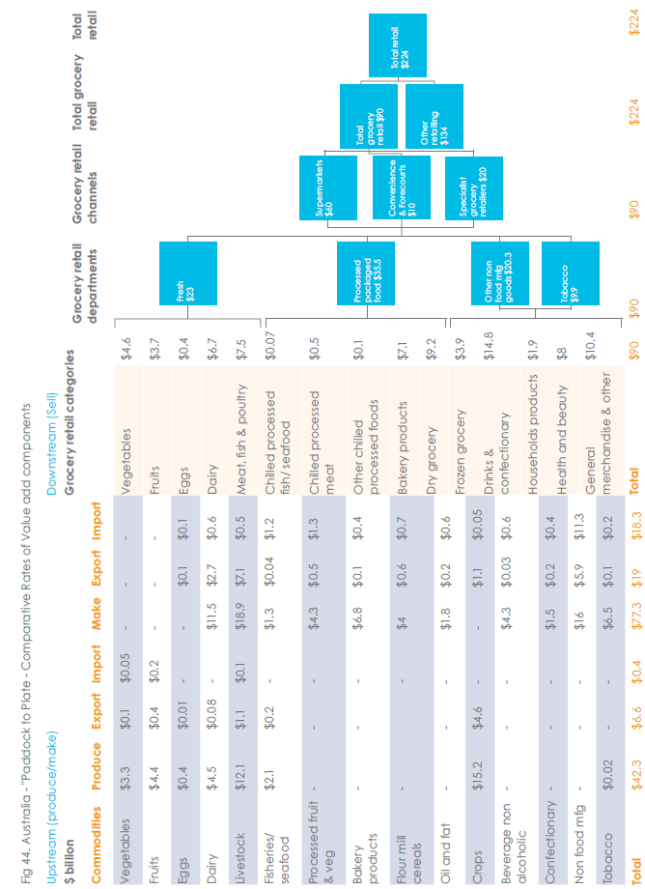
Major food and grocery suppliers to the sector will confirm where, in the case of packaged groceries, 80% of their sales go. It is this dominance that allows the major chains to be price setters (and hence margin setters) in the sector, and dictate supply terms.

It is also why the referenced Accenture Australia report highlighted the impact of retail grocery concentration on the food supply chain where in the fresh food sector vertical integration with owned and/or contracted producers has affected the ability of the farm sector to supply the variety and quality of inputs to the market, resulted in a decline of local food processing, an increase in food imports and a distortion of the fruit and vegetable market system.

Contestability Theory

The Commission’s draft report suggests, as does the ACCC, that market concentration does not necessarily indicate the level of competitiveness in a market, as indicated on p.36 of the draft report:

We would suggest that, apart from the planning issues raised in the draft report, there are substantial barriers to entry to a new entrant into the grocery market as a whole, the major barrier being the dominance of the two major players which makes it difficult for a new entrant to build the necessary critical mass needed to make distribution viable and match the incumbents’ buying power.

The interpretation of contestability theory relied upon by proponents suggests that it is possible to have competition without competitors, as long as the market is open to entry by another competitor at some future date: an invisible hand, apparently, keeps a dominant player honest.

The theory also assumes costless entry and exit by such a new competitor, reducing his risk. The recent case taken by the ACCC against the Metcash acquisition of Franklins suggests that in this sector neither entry nor exit is costless, and that a substantial turnover needs to be generated in order for a new venture to be viable. Needless to say, the Federal Court rejected the ACCC’s theory based approach in favour of a real world analysis.

We suggest that those basing competition decision on contestability theory actually misinterpret the theory itself. Competition theory literature suggests that if a market were to be truly contestable that the contestability theory based model would, in the limit, be equivalent to the traditional model used to define a competitive market. i.e. both models would merge – requiring a multitude of competitors in order to meet the assumptions in each.

Although challenged by us on many occasions, the ACCC has never been able to point to an example or otherwise demonstrate that competition is enhanced by having fewer competitors.

It is our view that the approach to competition policy and practice in Australia, particularly in relation to the question of market concentration, has resulted in markets that are less than optimally competitive to the detriment of the final consumer.

Planning issues

The Productivity Commission’s draft report recommends a more open and deregulated approach to planning, the rationale being that, with more sites available, competition will flourish.

Unfortunately that approach does not reflect the status quo where, in the case of the retail grocery sector the two major chains dominate the available high traffic space in many shopping precincts, until recently in many cases protected by anti-competitive covenants. Note that such covenants gave the incumbent the opportunity to become established within the centre without having to deal with a competing store and that even after such covenants are removed it is extremely difficult for a new entrant to become a viable competitor.

A situation has developed over the years where, even in those precincts that had a number of sites available for a supermarket that could compete with a Woolworths or Coles store, such sites were gradually taken over by other business formats run by the major chains – e.g. liquor outlets such as Dan Murphy’s, electronics stores, etc. (a form of ‘land banking’) ensuring that competitive entries were frozen out.

The market dominance of the two major chains also makes it less likely that a smaller competitor will chance his money by investing in a significantly sized store in or close to centres dominated by a major chain supermarket or that he will be accepted as a tenant in a major centre – even in the absence of any restrictive covenant or agreement.

Even though the two major chains between them have a substantial share of the grocery market, they are still in expansion mode, adding substantially to their store numbers each year. Such additions have come from takeovers of smaller players, but increasingly they are through the development of greenfield sites – more often than not as part of a new shopping complex on the edge of a small regional town, modelling the approach taken by Tesco in the UK where these are called Tesco towns – a new village complex on the outskirts of the original village which diverts shopping away from the main street, killing off the businesses there, resulting in a village with a ‘dead heart’ and a net reduction in retail employment.

Many Australian towns have already been affected in this way. They end up with a small shopping centre out of town and a substantial proportion of empty shops in the main street. In many cases the new supermarket on the town edge is too large for the catchment, but serves as a means of dissuading a competitive entry as well as destroying existing competition.

We would be happy to provide case studies.

In each case the appropriate planning processes would have been followed. The question is whether these properly assessed the net impact on the town or on competition in the affected sectors. Local government would have been sold on the ‘extra jobs’ provided by the new development, not realising that in many cases these came at the expense of existing employment and the loss of existing businesses, the diversity they offered and the support they gave to local communities. Launceston City Council recently rejected a development at Young Town for these very reasons.

Large companies also have the resources to game the regulatory system. We see examples of this when examining planning decisions and other government decisions that give access to markets.

In the case of the two major supermarket chains there are many examples of gaming behaviour. These include:

- Using threats of action under liquor licensing laws to reduce competition from smaller outlets
by requiring them to agree not to compete in return for not lodging an objection. Both chains have received multi-million dollar fines from the Federal Courtfor this behaviour.

- Gaming the council planning/zoning system to gain access to supermarket sites. In some
cases this has meant giving the local government access to part of a site, building a library as part of the project or offering some other benefit. A common approach is the purchase of a car park from a cash strapped council.

- Putting forward Das for modest developments, then, once approval is given, seeking
variations to expand the size of the development or the size of key stores within it.

- Lobbying government for ‘fast track’ approval for projects as was the case for many of the
12 Victorian sites earmarked for the development of a new hardware chain for Woolworths.

The latest growth opportunity for the major chains is in-fill development facilitated by proposed changes in planning law in some states which would allow the development of smaller shopping centres in residential areas.

What then is the role of planning?

Examination of each state’s planning laws clearly identifies the purpose of the planning regime as a coordinating function, one which ensures that the community’s infrastructure needs are met. But each Act also suggests that the role of planning is the optimisation of community benefit.

Governments are also fond of reminding us that they want to take a ‘whole of government’ approach to issues – so that decision making is not compartmentalised. This was the view taken by the UK Competition Commission (UKCC) during its review of the grocery sector there – where the grocery market is not nearly as concentrated as it is here – on the basis of similar market concentration measurement methods.

The UKCC in its report expressed concern about the level of concentration in the sector and in particular about concentration in individual local markets (defined in terms if isochrones). It therefore proposed a role for planners in ensuring that there was completion at the local level.

The mechanism adopted is a floor space ratio test where any new development or any expansion on an existing site needs to ensure that the entity involved does not have more than 60% of the grocery retail floor space. Where that percentage is currently exceeded the entity will not be allowed to open on a new site or expand on its current site. This ensures that there is room for other competitors in each local market and that such competitors are viable.

Given that the retail grocery market is essentially the sum of many local markets, the market can only be made more competitive by ensuring that there is an opportunity for competition at the local level.

Note here that amendments to Section 50 of the Competition and Consumer Act currently going through the parliament will mean that the ACCC will need to consider the local market (as well as national, state and regional markets) in its consideration of mergers and acquisitions.

We suggest that there is a need for planning law and competition law to act in concert to ensure that competition in the sector is optimised. There is little point in competition law demanding that the takeover of a rival in a local market should face the scrutiny of the regulator if, in that same market planning law does not reflect the need for competition.

We need to avoid more situations where there is ‘competition’ without competitors.

Trading Hours

The Commission’s draft report advocates the deregulation of trading hours in states that have not, to date, done so. It correctly says that, in states where trading hours have been deregulated, shops eventually match opening hours with consumer demand.

In the grocery sector we have seen that, although the major chains were at the forefront of efforts to deregulate trading hours and initially tended to open for extended trading – even to the extent of opening for 24 hours seven days a week, that over time trading hours have been cut back to more closely match peak purchasing periods, suggesting that shift workers etc. who were the supposed justification for longer hours will again miss out.

As many of our member companies are at the small business end of the spectrum, our concern is that larger stores use opening hours as a means of putting additional pressure on smaller local competitors, knowing that they are free to reduce their opening hours once the competition has been driven out of the market.

Workplace regulation

We endorse the Commission’s recommendations 10.1 and 10.2 in relation to workplace relations, but suggest that the sector would benefit from a more flexible approach than that offered under the current system.

Market transparency

A farmer sells his oranges for $150 a tonne – 15 cents a kilo – only to find that they appear on retail display at $4.99 a kilo or $4990.00 a tonne.

In a vertically integrated market it is difficult to determine where the money has gone. Who is getting the margin?

The complexity of the sector is demonstrated by the ongoing Senate Inquiry into milk pricing which is trying to determine the longer term impact on the farming and processing sectors of the current milk ‘price war’ between the major chains, where again the smaller retailers are collateral damage.

One of the key questions to be answered here is to what extent the lower prices being offered to the consumer is sustainable in the longer term, and what the longer term implications are for the dairy sector.

That question plagues the whole of the sector where we see margin pressure pushing suppliers off shore or out of business, with resulting implications for both the range and quality of product available to future consumers.

Whilst the Productivity Commission has reported on the overall profitability of the retail sector, including the retail grocery sector, and has suggested that it is within the bounds of the international experience, it needs to be recognised that the reported profit margin is the net outcome after all expenditure has been accounted for.

Due to the lack of transparency within the sector we do not know how much of the available margin within the supply chain accrues to the retail sector, nor how much of that margin is absorbed by internal inefficiencies associated with any large organisation, the absorption of the costs of running unprofitable or marginally profitable stores – stores that would not survive unless they were part of a larger conglomerate – or how much of that margin has been diverted to growing an ever expanding network of outlets.

In the packaged grocery sector increasing pressure is being applied to suppliers to decrease prices or support ‘specials’ – routinely paid for by suppliers. Even though the ‘special’ price is applied to purchases beyond the special period, the resulting price drop across that period does not translate to lower consumer prices throughout the period.

Although recent advertising by the major chains suggests that they are competing, the lower prices (supported by funding from suppliers) are, according to internal industry surveys, eclipsed by price increases within the same chains. This reality is confirmed by the fact that both chains have increased sales (in like for like turnover terms) and profits. Rather than competing, the two major chains appear to be market sharing – a natural consequence of the belief that a duopoly, under contestability theory, delivers a truly competitive outcome.

We have also argued for a considerable time past that the hyper-concentration of the retail grocery market – and the market power that flows from it – is exacerbated by the absence of a specific prohibition on anti-competitive price discrimination. Australia and New Zealand are currently the only OECD member nations without such a prohibition.

Anti-competitive price discrimination occurs where a supplier sells equivalent quantities of a product to different customers at different prices.

The former S49 of the Trade Practices Act 1974 was repealed in 1005 on the recommendation of the Hilmer report on National Competition Policy. Hilmer argued that S49 was unnecessary because S45 (restrictive trade practices) and S46 (abuse of market power) would do the job. The ACCC has never taken a single case under any of these sections and anti-competitive price discrimination is now rife in Australia.

The difficulty the retail grocery sector faces on the competition front is that there has been too much theorising and too little notice being taken of the practical, real world competitive realities.

Please contact me should you require any further information.

Yours faithfully,

Ken Henrick
Chief Executive Officer

The challenge to feed a growing nation, Accenture Australia, November 2010
Ibid p.26
Ibid p.35
Senate Economics References Committee: Inquiry into the impacts of supermarket price decisions on the dairy Industry

