December 2022


Review of the National School Reform Agreement
  - Study report
Overview

The Productivity Commission acknowledges the Traditional Owners of
Country throughout Australia and their continuing connection to land,
waters and community. We pay our respects to their Cultures, Country and Elders past and present.

The Productivity Commission
The Productivity Commission is the Australian Government’s independent research and advisory body on a range of economic, social and environmental issues affecting the welfare of Australians. Its role, expressed most simply, is to help governments make better policies, in the long-term interest of the Australian community.
The Commission’s independence is underpinned by an Act of Parliament. Its processes and outputs are open to public scrutiny and are driven by concern for the wellbeing of the community as a whole.
Further information on the Productivity Commission can be obtained from the Commission’s website (www.pc.gov.au).

© Commonwealth of Australia 2022

With the exception of the Commonwealth Coat of Arms and content supplied by third parties, this copyright work is licensed under a Creative Commons Attribution 4.0 International licence. In essence, you are free to copy, communicate and adapt the work, as long as you attribute the work to the Productivity Commission (but not in any way that suggests the Commission endorses you or your use) and abide by the other licence terms. The licence can be viewed at: https://creativecommons.org/licenses/by/4.0.
The terms under which the Coat of Arms can be used are detailed at: www.pmc.gov.au/government/commonwealth-coat-arms.
Wherever a third party holds copyright in this material the copyright remains with that party. Their permission may be required to use the material, please contact them directly.
ISBN 978-1-74037-756-0 (online)
ISBN 978-1-74037-755-3 (print)
An appropriate reference for this publication is:
Productivity Commission 2022, Review of the National School Reform Agreement, Study Report, Canberra.

Publication enquiries:
Media, Publications and Web | phone 03 9653 2244 | email publications@pc.gov.au

Foreword
The Australian, State and Territory Governments share responsibility for school education and have a long history of working together to build the national institutions, systems and tools that support better student outcomes.
This review considered the most recent focus for collaborative reform efforts, the National School Reform Agreement. The Commission was asked to assess the effectiveness and appropriateness of the National Policy Initiatives included in the agreement, and the appropriateness of the national Measurement Framework for Schooling in Australia in measuring progress towards outcomes. Importantly, the Commission was also asked to make recommendations to inform the design of the next school reform agreement.
This report presents the Commission’s analysis of progress on national reform efforts, and assessment of performance reporting and accountability arrangements. It also identifies potential reform options for a successor agreement. In doing so, the Commission focussed on factors that influence student outcomes that are amenable to intergovernmental collaboration.
In undertaking this review, the Commission has benefited from engagement with students, teachers, school leaders, unions, representatives from the Catholic and Independent school sectors, academics and officials from the Australian, State and Territory Governments. In addition, the Commission consulted with key education entities such as the Australian Curriculum, Assessment and Reporting Authority, the Australian Institute for Teaching and School Leadership, the Australian Education Research Organisation and Education Services Australia. The Commission would particularly like to thank those young people who took time out of their busy learning schedules to share their experiences of school, including over the past few challenging years.
The Commissioners would like to express their appreciation to the staff who worked on the review.
Michael Brennan  Presiding Commissioner | Malcolm Roberts  Commissioner | Natalie Siegel-Brown  Commissioner

December 2022

Disclosure of interests
The Productivity Commission Act 1998 specifies that where Commissioners have or acquire interests, pecuniary or otherwise, that could conflict with the proper performance of their functions they must disclose those interests. Commissioner Siegel-Brown advised that she is a board director of Aged and Disability Advocacy Australia and a member of Queensland’s Path to Treaty Independent Interim Body.

Contents
Foreword iii
Overview 1
Recommendations and findings 31

The full report is available at www.pc.gov.au

Overview

Key points
 | All Australian governments have endorsed the national goal of a high quality, high equity education system and have a long history of collaborating on reforms to pursue this goal.  The most recent vehicle for national collaboration — the National School Reform Agreement (NSRA) — outlines eight National Policy Initiatives (NPIs) to lift outcomes in student achievement, attainment and engagement.
The NSRA’s initiatives have done little, so far, to improve student outcomes.
Some NPIs are complete but will take time to produce results, while others have not yet led to actual reforms.
Two important NPIs — the Unique Student Identifier and Online Formative Assessment Initiative — have been delayed. In December 2022, Education Ministers announced progress in addressing sticking points.
Even so, the NSRA is a sound platform for intergovernmental collaboration.
The objective, outcomes and many of the NSRA’s sub-outcomes are still relevant and should continue to set the direction of reforms in the next school reform agreement. A new outcome on student wellbeing should be added, as wellbeing is both a desired outcome of schooling, and a means of improving learning outcomes.
The next school reform agreement should include firm targets for improving academic achievement for all students, including students from priority equity cohorts, in each jurisdiction.
New state-level targets would provide jurisdictions with greater discretion about how they improve achievement (compared to NPIs), while strengthening accountability for results (compared to national performance indicators that are directional and open ended).
The basis of each new target should be common to all jurisdictions; however, there should be scope for the Commonwealth and each jurisdiction to negotiate the level of the target.
All jurisdictions face common reform challenges — addressing these should be the focus of the next school reform agreement. Governments should advance reforms to:
support quality teaching and effective school leadership: priorities could include reducing low-value tasks and out-of-field teaching, disseminating best practice, and producing evidence-backed resources that teachers and leaders trust and use — the last of these could be the basis of new NPIs.
support all students to achieve basic levels of literacy and numeracy: tens of thousands of students do not achieve basic levels of literacy and numeracy each year. The next school reform agreement should include specific targets and measures to support these students.
reduce differences in achievement across students: many students identified as priority equity cohorts in the NSRA, along with other students (such as those in out-of-home care), face significant challenges. Governments should consider augmenting the priority equity cohorts, and adopt new approaches, developed and implemented in consultation with the relevant parties, to lift outcomes for all students.
promote wellbeing: many children and young people struggle with poor wellbeing because of experiences in and outside their schools. Teachers need more support to help students to manage these issues and achieve their potential.
Greater flexibility in progressing reforms should be accompanied by increased accountability for and transparency of results.
Along with better use of targets, bilateral agreements will need to be more of a focal point for jurisdictions to advance reforms, and annual performance reporting will need to be improved.
What is this review about?
Four years ago, on the back of a $319 billion funding deal, and amid concerns that Australia’s performance in international testing had fallen, the Commonwealth, States and Territories struck an agreement on national reforms to lift education outcomes — the National School Reform Agreement (NSRA).
The objective of the NSRA is for Australian schools to provide a high quality and equitable education for all students. This continues a longstanding commitment by Education Ministers to equity and excellence in schooling. While equity and quality are not defined in the NSRA, these concepts are embodied in the NSRA’s outcomes, targets and national performance measures (sub-outcomes).
To lift outcomes in student achievement, attainment and engagement, the NSRA outlines three reform directions, supported by eight National Policy Initiatives (NPIs) and bilateral agreements between the Commonwealth and each State and Territory government (figure 1). Implementing the reform initiatives is a condition of Commonwealth funding.
The Australian Government has asked the Commission to:
- assess the effectiveness and appropriateness of the NPIs under the NSRA, recognising that reforms take time to implement and mature
- assess the appropriateness of the Measurement Framework for Schooling in measuring progress towards achieving the outcomes of the NSRA
- make recommendations to inform the design of the next school reform agreement and to improve the National Measurement Framework.
Funding is outside the scope of the Commission’s Review.
In making recommendations to inform the next school reform agreement, the Commission recognises:
- the COVID-19 pandemic and recent natural disasters have disrupted education systems but also revealed their resilience and opportunities for innovation
- there are factors ‘outside the school gates’, that can significantly affect students’ performance and wellbeing. Schools usually cannot change these factors, but they can make a positive difference to the impact of these factors on student learning, and offer students the best chances of success
- all governments have committed to the National Agreement on Closing the Gap and Australia’s Disability Strategy 2021–2031, which embed obligations for education departments and school systems
- a new agreement will form part of a broader policy landscape. All states and territories have their own reform agendas and there are other intergovernmental initiatives in education underway, such as the National Teacher Workforce Action Plan.

Figure 1 – Snapshot of the National School Reform Agreement (2019–2023)ª
a. On 11 December 2020, Education Ministers agreed to amend the Council of Australian Governments (COAG) targets on attainment to reflect the adoption of the updated national target for school education endorsed by State and Territory First Ministers through the National Agreement on Closing the Gap. On 29 May 2020, National Cabinet agreed to the formation of the National Federation Reform Council and the abolition of COAG. The targets are still in effect.
How have national reforms fared?

Progress on initiatives has been slow and many focus on enablers rather than achieving outcomes
Parties intended for the NPIs to provide teachers, school leaders, and policy makers with resources to make informed decisions and improve practice. But progress on some of the initiatives that would make the most difference has been slower than expected.
Two NPIs — the Online Formative Assessment Initiative (OFAI) and the Unique Student Identifier (USI) — have the potential to provide much needed tools to better understand student progress.
- The USI could unlock insights on students’ progress, the factors that influence the paths they take, and the outcomes they achieve. As the New South Wales Department of Education (sub. 12, p. 13) observed: ‘… the USI has the potential to provide a new, unique and rich data source to inform policy in a way which was never possible before.’ Already more than 13 years in the making, differences about data use have hindered progress.
- The OFAI could enable teachers to better assess a student’s knowledge, skills and understanding, identify next steps in learning, and track progress over time. Given the significant variation in student achievement in any given year level — spanning, on average, as much as 4 years of learning in numeracy within individual schools and about 6 years across all schools — the OFAI would help teachers tailor their teaching to a student’s level of knowledge and understanding. But as progress has flagged, some jurisdictions have pressed ahead with local (albeit typically less comprehensive) solutions.
Two NPIs — the establishment of the Australian Education Research Organisation (AERO) and a requirement for Initial Teacher Education (ITE) providers to include teacher performance assessments (TPAs) — are complete but will take time to yield results.
- AERO was created to help build the national education evidence base, and it was identified by many participants as one of the NSRA’s key achievements. AERO’s success will depend on its capacity to undertake or commission relevant research and see its advice shape policy and practice. But it will take time for AERO to raise awareness of, and engender confidence in its work.
- As of September 2021, all accredited ITE programs require their students to undergo a final year TPA. Given that ITE providers have only just implemented TPAs, and TPAs focus on new entrants to the profession, it will be some time before this initiative influences teacher workforce quality.
Two NPIs, while complete, have not yet led to actual reforms. Governments are yet to indicate what, if any, reforms will follow the reviews of senior secondary pathways and teacher workforce needs. The latter was intended to provide the resources required by school systems and ITE providers to identify and plan for future workforce needs but did not fulfil this purpose.
The final NPI on national data quality comprised eight projects to improve the measurement of student outcomes, along with a project to develop NAPLAN proficiency standards — these are either complete or well underway.
Figure 2 – Progress implementing National Policy Initiatives
Expected outputs and implementation status as reported by Education Council, and issues identified by the Commission
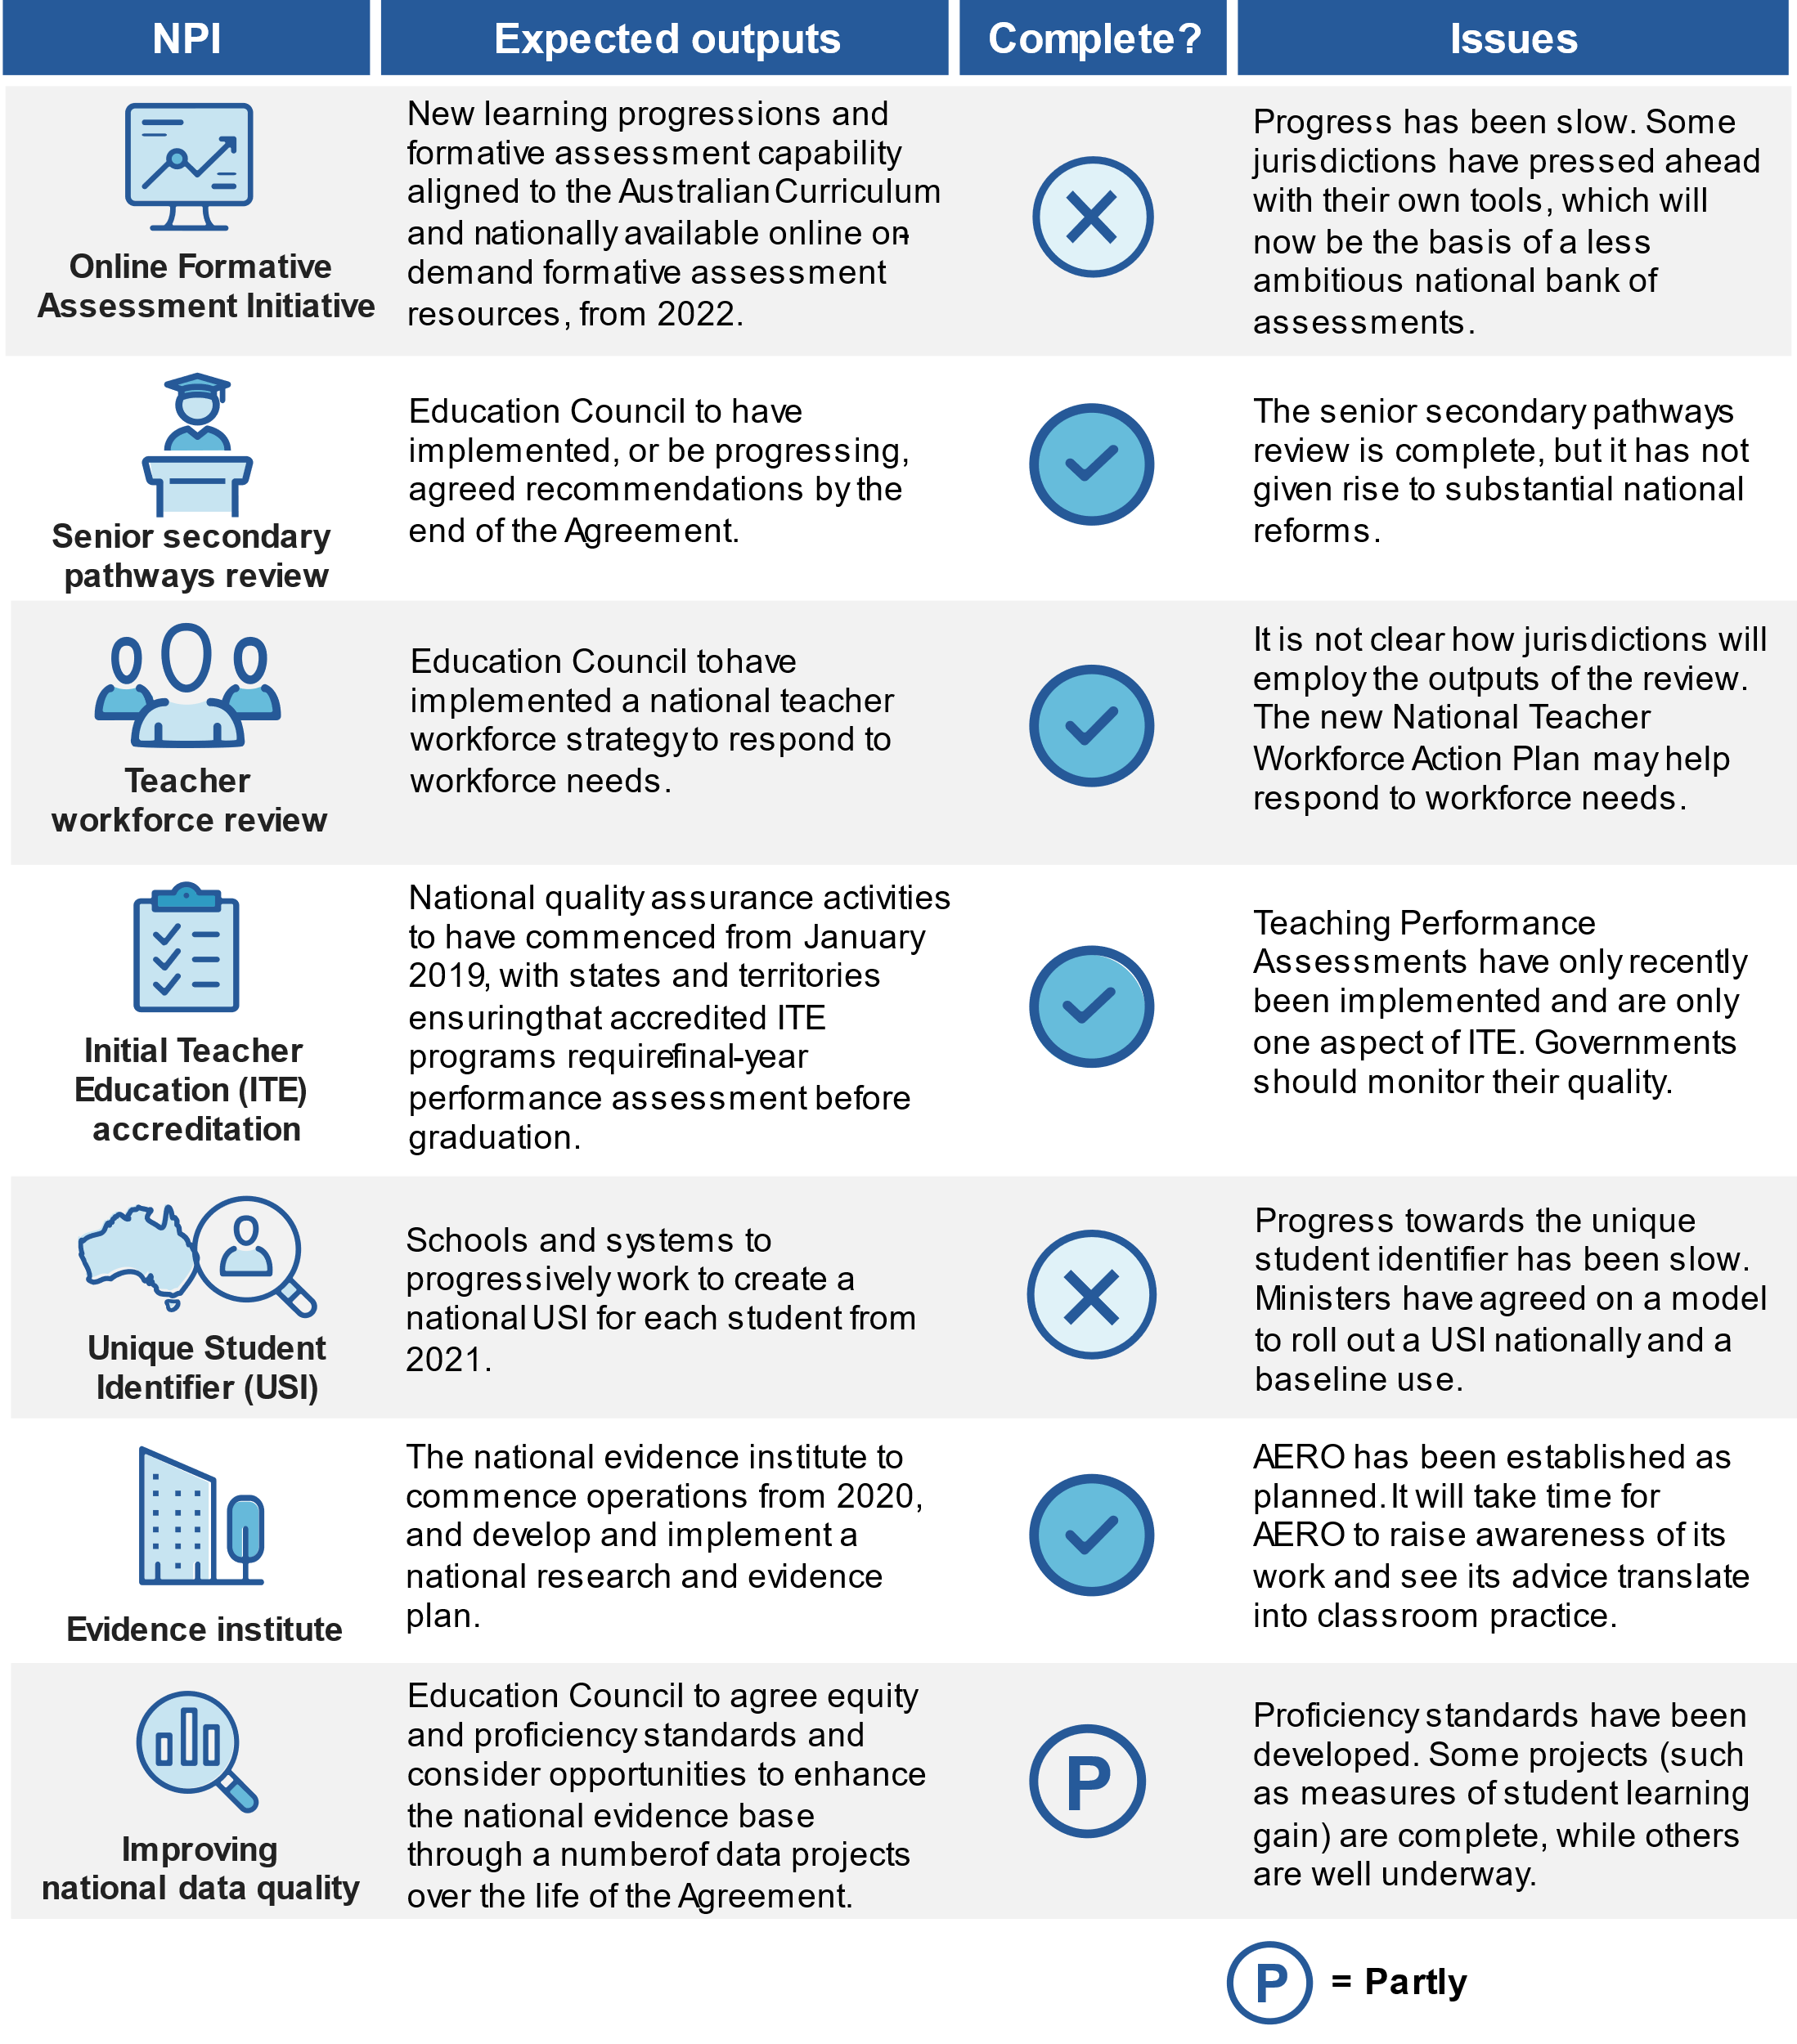

Where to with the NPIs?
On 15 December 2022, Education Ministers announced that they had made progress on the two substantive NPIs that remain incomplete — the USI and OFAI. They agreed on a model to roll out the USI nationally to all school students. Ministers also endorsed a pathway forward on the OFAI, which will leverage and align existing resources from New South Wales, Victoria, and Queensland to establish a national bank of assessments that jurisdictions can use on an opt-in basis.
These announcements are an important step forward. But further action would help realise the potential benefits of these two tools. The agreed models for progressing the USI and OFAI do not appear to reflect the original ambitions for, and anticipated benefits of, these NPIs. For example, many of the potential benefits ascribed to the USI (such as facilitating research to inform policy development) rely on the USI being integrated with other data sets. It is not clear the baseline use proposed for the USI (focused on information exchange across jurisdictions) will provide these benefits. Similarly, it was envisaged that the OFAI would provide time-poor teachers with a tool ‘to efficiently and effectively identify where students are in their learning, make informed decisions about what to do next, and monitor student learning to continually drive progress over time’ — a pooled assessment bank appears to fall short of this ambition.
Governments should set firm deadlines to complete these important projects. Once established, governments should consider opportunities to realise the full potential of the USI for informing education policy by linking the USI with other data sets and permitting additional uses. A national bank of high quality curriculum resources (discussed below) would provide some of the other functions originally envisaged as part of the OFAI.
Education Ministers also agreed the National Teacher Workforce Action Plan, which aims to address teacher workforce shortages. The Action Plan effectively supersedes the review of national teacher workforce needs NPI, with one of its five key priority areas being ‘[b]etter understanding future teacher workforce needs [to] improve the information available for teacher workforce planning’.

Initiatives are unlikely to have affected student outcomes so far
The measure of success of any reform is its effect on outcomes. Reflecting their early stages of development, the NPIs are unlikely to have yet had an impact on agreed NSRA outcomes. Educational attainment rates (both for Australian students overall and for Aboriginal and Torres Strait Islander students) are below the 2031 agreed targets, average outcomes in national literacy and numeracy testing have improved little, and differences in outcomes across students remain (figure 3).
Figure 3 – Performance against targets and sub-outcomes in the National School Reform Agreement, 2018-2022^{a,b}
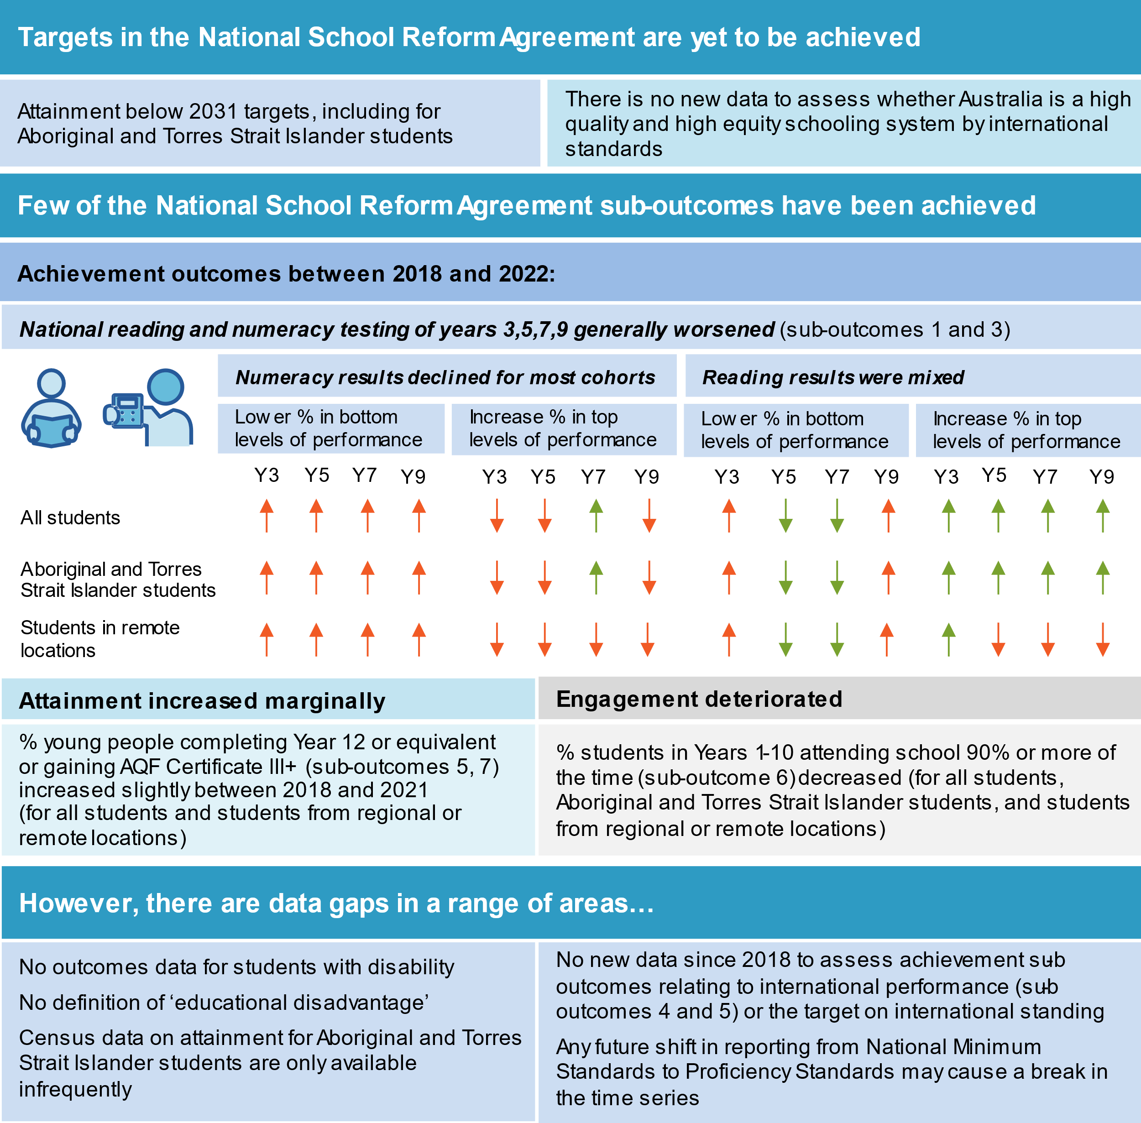
a. National Assessment Program – Literacy and Numeracy ( NAPLAN) tests for literacy skills other than reading. b. The former National Education Reform Agreement used Australia’s achievement in Programme for International Student Assessment relative to the OECD average as an indicator for the target ‘Australia considered to be a high quality and high equity schooling system by international standards by 2025’.

What are the lessons from the NSRA for the next school reform agreement?
The Australian Government asked the Commission to make recommendations to inform the design of the next school reform agreement. The Commission has identified three broad areas that could be improved in a future agreement to help lift student outcomes.

The Agreement’s outcomes and targets were incomplete
The existing outcomes in the NSRA (achievement, engagement and attainment) do not capture student wellbeing. Since the NSRA was signed, all governments have acknowledged, through the Mparntwe Education Declaration, the importance of student wellbeing, which is a desired outcome in itself, as well as a means of supporting student learning.
The NSRA’s targets are incomplete and too vague to drive reforms. The NSRA has only one target relating to academic achievement, namely that ‘Australia [is] considered to be a high quality and high equity schooling system by international standards by 2025’. This target is carried over from a previous agreement, which assessed schooling quality and equity based on Australia’s performance relative to the OECD average in the Programme for International Student Assessment (PISA) of 15-year-olds. As such, it omits performance in the critical early years of schooling, does not capture absolute improvements over time, and is not assessable for the period the NSRA has operated (the most recent PISA data relates to 2018).

Reform activity has at times lacked focus and flexibility
The nexus between the NSRA’s targets, outcomes and sub-outcomes and the NPIs is often tenuous, and national and bilateral reform initiatives do not work together to systematically address key priorities.
The NSRA was heavily focused on NPIs, usually pursued through a single, centralised approach. While this can be an effective, and in some cases necessary, way to advance reform, it requires a sustained commitment by all parties and does not allow them to adapt initiatives to their needs. When agreeing a single national approach takes time, some (particularly larger) jurisdictions with more capacity can forge ahead with their own reforms. Arguably some of the NPIs that adopted this approach could have left matters to state reforms in bilateral agreements (such as student pathways) or could have been better executed by embedding greater flexibility in the design and implementation process (for example, the OFAI).
The bilateral agreement initiatives, which set out jurisdiction-specific reforms, are patchy, lack additionality (they often catalogue existing measures), and give little sense of what they are trying to achieve. Some persistent, common issues faced by all jurisdictions, such as a lack of equity in outcomes across students, were largely left unaddressed.

Reporting and transparency arrangements have not had bite
Public reporting and transparency arrangements (national performance reporting on outcomes and progress updates on national and state reforms) are intended to give ‘the community confidence that outcomes are being achieved and reforms to improve the quality and equity of Australia’s schooling systems are being implemented by all Parties’. However, the NSRA’s arrangements have failed to impose strong discipline to progress agreed reforms, and have not operated effectively as a cohesive whole.
Although performance reporting against the NSRA sub-outcomes provides a health check of the school system, progress in sub-outcomes for priority equity cohorts is mostly reported for Australia, rather than at the jurisdictional level. As such, it is not clear whether individual jurisdictions’ reform efforts have been effective in some areas. Along with gaps in reporting (figure 3), this limits transparency and accountability. Further, results are published in different reports, and there is no stand-alone source where the public can gain a ‘clear read’ of progress against the NSRA outcomes.
What issues should be the focus of the next school reform agreement?

Parties should focus the next school reform agreement on directly lifting student outcomes …
There are no hard-and-fast rules for determining which priorities should be elevated to the national arena. Inevitably, the priorities on which jurisdictions seek to coordinate action will be influenced to some extent by alignment of views and community expectations.
The Commission considers the next school reform agreement should concentrate on directly lifting student outcomes: ensuring effective teaching and school leadership, reducing differences in outcomes across students, and supporting student wellbeing. These three issues lend themselves to being areas of focus in the next school reform agreement for two reasons.
- There is broad consensus that these are significant issues that can and must be addressed: These are common and persistent issues that governments will need to address to ensure that Australian schooling provides high quality and equitable schooling to all students. Problems related to teacher shortages, inequalities in schooling outcomes, and poor student wellbeing predate the NSRA. However, reforms under the agreement have done little to alter the trajectory of outcomes or assuage concerns expressed by students and their families, the teaching profession, and education experts. Community interest in these problems has intensified in recent years amid concerns about teacher burnout and student wellbeing during the COVID-19 pandemic.
- All governments have agreed that addressing these issues is a priority and recognised the merits of national collaboration: Since signing the NSRA, all Australian governments have reaffirmed this through national policies to support teachers and improve wellbeing in schooling, and through statements such as the Mparntwe Education Declaration. In addition, all governments have now formalised commitments to reducing inequities and to inclusive education through the National Agreement on Closing the Gap, and Australia’s Disability Strategy 2021–2031.
To give effect to these priorities, parties will need to significantly revise or augment aspects of the NSRA’s design. This includes strengthening the accountability mechanisms surrounding state-specific reforms.

… and adapt accountability mechanisms to reflect a greater role for state-specific actions
Addressing the future reform priorities outlined above will require greater flexibility than the ‘one in, all in’ approach to NPIs under the NSRA. In many cases, jurisdictional differences will demand more tailored responses, and bilateral agreement initiatives will need to do more of the heavy lifting than they have in the past. However, parties will need to address existing weaknesses with the accountability mechanisms in the NSRA, including those governing bilateral actions.

Parties should clarify ambitions through firm targets for academic achievement …
A successor agreement should include new targets for academic achievement for all students, and students from priority equity cohorts, with clear benchmarks and timelines. The new targets would help drive reform by drawing attention to key performance measures for which governments are willing to be held to account, and by making success or failure against those measures more transparent and verifiable (compared to existing national performance reporting). Experience, in Australia and overseas, highlights the value of well-designed targets in a range of policy contexts.
The new targets would be in line with community expectations around transparency and improved performance. The community should expect to see an improvement in student outcomes over the course of the next five years — funding will remain at all-time highs, current initiatives will have had time to mature, and a new generation of reforms will be underway.
To maximise their impact, targets should be few in number. The NSRA’s sub-outcomes (which reflect agreed goals) provide a starting point — an independent body (such as the Australian Curriculum, Assessment and Reporting Authority (ACARA)) could provide advice on how to convert these into a tight set of meaningful targets.
The basis for measuring the targets should be common to all jurisdictions (and set out in the main agreement). However, jurisdictions should ‘own’ their target and each state and territory should negotiate a realistic but ambitious target with the Commonwealth, reflecting their circumstances.

… and specify basic content, process, and reporting requirements for bilateral agreements
Rather than being a stocktake of existing measures, bilateral agreements will need to be more of a focal point for jurisdictions to advance reform initiatives.
In addition to (and to support) the new targets, parties should ensure jurisdictions develop, document and report on bilateral reform actions in a more systematic and meaningful way than under the NSRA. Greater flexibility in implementation will need to be balanced by enhanced accountability and public transparency mechanisms, such as basic content, process and reporting requirements for reforms in bilateral agreements.
What might this mean in practice?

Jurisdictions should support quality teaching and effective school leadership
Supporting teaching, along with school leadership and school improvement, is identified as one of the three national reform directions under the NSRA. The next school reform agreement should continue this focus.
Effective teaching is the single most influential ‘in-school’ factor for student outcomes. Effectiveness is determined by both teacher quality (the attributes of an individual teacher) and quality teaching (effective teaching practices).
Fostering a high-quality teaching workforce requires a portfolio of actions that allow teachers to refocus their efforts — freeing up teachers from low-value tasks, using teaching assistants more effectively, and making best practice pedagogy and materials more easily accessible. Some of these issues are being concurrently advanced by Education Ministers as part of the National Teacher Workforce Action Plan.

Freeing up teachers to focus on teaching
Teachers’ workload is high and increasing. Surveys suggest that fulltime teachers work between 44 to 57 hours a week during term time. Reported working hours are similar for primary, secondary and early career teachers, and even higher for Aboriginal and Torres Strait Islander teachers. International measures suggest that the working hours of Australian secondary teachers have increased from about 43 hours in 2013 to 45 hours in 2018 (figure 4).
Despite working more hours than their international counterparts, Australian teachers spend less time teaching, both in terms of absolute hours and as a proportion of their working week. Teachers spend more time on general administration, such as communication, paperwork and other clerical duties. At just over 5 hours a week, this is the fifth highest number of hours in the OECD.
Principals spend an even greater share of their time (more than one-third of their working hours) on administration, along with leadership tasks and meetings, while on average spending just 5 per cent on professional learning for school staff.
Figure 4 – Teachers typically spend most of their time teaching, lesson planning, marking and on general administrationª
Average share of weekly hours spent on teaching tasks by full-time teachers in 2018
a. Based on a survey of teachers from New South Wales, Northern Territory and South Australia in 2018.
Source: Commission analysis based on AITSL (2021a, pp. 67–70).
Reducing low-value tasks would not only improve teacher effectiveness — by increasing the time teachers have available to prepare for lessons and undertake professional development — it could help retain more teachers. High workload is the main factor behind teachers’ intention to leave the profession (figure 5). More manageable workloads might also encourage some former teachers to return to the profession — survey estimates suggest that just over one-in-ten registered teachers are not working in education. Teacher registration data in some jurisdictions point to a much larger number.
Figure 5 – Reasons for considering leaving the teaching professionª
a. 3216 survey respondents from New South Wales, South Australia and the Northern Territory.
Source: AITSL (2021c, p. 108).
Some jurisdictions and sectors in Australia have processes underway to reduce the administrative burden on teachers, and Education Ministers recently agreed to ‘continue to implement existing actions designed to address teacher workload issues’ under the National Teacher Workforce Action Plan (2022, p. 19). The Commonwealth has also offered interested states and territories access to a $25 million Workload Reduction Fund to pilot initiatives to maximise the value of teachers’ time.
But governments must make more consistent and concerted efforts. The Action Plan does not provide a systematic way to identify and reduce burdens on teacher workload across all jurisdictions and sectors. Nor does the Action Plan address principal workload — about two-thirds of Australian principals cite heavy workload (along with ‘level of responsibility’ in their job) as a factor limiting their effectiveness, with recent surveys suggesting that they work just over 61 hours per week. Freeing up teachers and school leaders so that they can focus on the things that matter should be a priority for the next school reform agreement. Jurisdictions should set out in their bilateral agreements measures they will put in place to free up teachers’ and leaders’ time and set clear benchmarks to gauge their success.

Supporting teaching assistants to support teachers
At the same time that teacher (and principal) workload has increased, the number of teaching assistants and other support staff has grown to just over 129 000 in 2021. Their remit is broad — working under the direction of teachers to support students (especially students with special needs) and helping with day-to-day running of the classroom, including administrative tasks.
When used effectively and supported well, international evidence has found that teaching assistants can help reduce teacher workload, allow teachers more time to teach, and improve the outcomes of some students. However, it is not clear how school leaders use teaching assistants and other support staff in Australian schools. Some review participants observed that the use of teaching assistants varies significantly within and across schools and jurisdictions, and they do not always receive the support or training they need to undertake the myriad of tasks they perform.
Participants highlighted the importance of gaining a better understanding of how teaching assistants are, and could best be, used.
As part of the National Teacher Workforce Action Plan, Education Ministers have agreed to review the role of teaching assistants and school support staff, along with initial teacher education students, to determine how they can be deployed to reduce teacher workload. In undertaking this work, parties should seek to preserve the benefits that come with being able to employ teaching assistants flexibly across schools, sectors and jurisdictions and identify ways to better prepare and support teaching assistants to take on their varied roles.

Making best practice approaches and materials more accessible
There is a growing evidence base on what works best to help students learn. But that evidence base will only matter if it leads to pedagogies and resources that teachers trust and use. Some Australian teachers are not using high quality, evidence-based pedagogical techniques and classroom materials. For example, AERO surveyed teaches across Australia about how often they used specific teaching strategies, and concluded that ‘[s]ome of these strategies are evidence-based, while others are not — in fact some have been found to be ineffective for student learning’ (2021a).
Governments and school systems can promote the diffusion of best practice by peer-to-peer professional learning through school-based networks. A recent survey has found that teachers are more likely to trust research shared by colleagues than research from any other sources.
Besides providing career pathways for highly effective teachers, the purpose of initiatives such as Highly Accomplished and Lead Teachers (HALT) is to help fulfil this role. But efforts to build a cohort of highly accomplished teachers has been slow — since the introduction of HALT certifications in 2012, only 0.3 per cent of the workforce (about 1 000 teachers) have become certified. And many certified teachers say they have too little time or opportunity to lead the development of colleagues in their school.
Processes to build, recognise and deploy best practice teaching expertise can take many forms. Like HALT, Master Teachers and Instructional Leaders are also intended to recognise expert teachers and support the dissemination of best practice. Employed by high-performing school systems overseas, Master Teachers are intended to be the pedagogical leaders in their subjects, working across schools in their region to identify teacher needs, coordinate training, and connect schools with research. Unlike Master Teachers, who have no classroom load, Instructional Leaders split their time between classroom teaching and instructional leadership, working in their own schools to support and guide other teachers in specific subjects.
Peer-to peer collaboration, where teachers work together in small groups to analyse and improve their practice, has also been found to improve teaching quality and student academic achievement. These models provide an accessible avenue for time-poor teachers to improve their practice.
These models are not mutually exclusive. Governments recently announced plans to expand Quality Teaching Rounds (a model that employs peer-based observation and analysis), and set a target to increase the number of HALTs and streamline their accreditation. The next school reform agreement is an opportunity for governments to leverage this work and support HALTs to disseminate evidence-based practice.
Governments could also increase the uptake of best practice by curating high-quality, evidence-based curriculum resources and making them easily accessible for teachers and school leaders. Many teachers develop lesson plans from scratch, or use materials from private platforms that are difficult to quality-assure. In a recent survey of Australian teachers, about half of respondents indicated they were the main person responsible for producing lesson plans for their classes, while a further 28 per cent reported that they shared responsibility for producing plans with others.
International studies have found that improving teaching through better curriculum materials can have a positive effect on student achievement, especially when partnered with professional development programs for teachers. Providing teachers with classroom resources would also free up teacher time. One study found teachers who had access to a comprehensive bank of lesson plans typically spent three hours less per week on sourcing and creating classroom materials than those who did not.
Governments tasked ACARA to examine ways ‘to develop and make available to teachers, optional supports to assist the implementation of the national curriculum,’ as part of the National Teacher Workforce Action Plan (EMM 2022, p. 22). However, a more concrete response — encompassing whole-school curriculum plans, whole-subject sequences, lesson plans and classroom tools — is needed to effectively support teachers. This could form the basis of a new NPI under the next school reform agreement.

Reducing out-of-field teaching
Notwithstanding recent attention, teacher shortages in key subject areas and locations are longstanding, and have resulted in high rates of out-of-field teaching (box 1).
Out-of-field teaching poses significant challenges. Teachers without subject expertise tend to be less effective, particularly in upper secondary school. Out-of-field teaching can also add stress to teachers and principals which, in turn, affects their wellbeing and ability to teach. Given that out-of-field teachers are often less experienced, the additional pressures placed on them can contribute to workforce attrition.
Governments have several options to attract teachers into in-demand subjects and to support out-of-field teachers. Options include better deployment and retention of in-field teachers; online delivery of classes from in-field teachers; reskilling teachers in areas of demand; attracting new and former teachers into in demand subjects; and providing access to learning resources and better sharing expertise for teachers teaching out-of-field.
Mid-career professionals have been identified as an important source of teachers in subject areas and locations where rates of out-of-field teaching are high. Recent surveys reveal up to four in 10 mid-career professionals would consider a career in teaching, with one in 10 planning a career change to become a teacher, and three in 10 open to the idea.
Many factors motivate mid-career professionals considering the switch to teaching, including the desire to make a social contribution. But they face significant switching costs, especially the time taken to undertake an ITE course (recently raised from a one-year graduate diploma to a two-year Master’s degree) and loss of income while studying and building a new career. Governments have committed to develop a framework to better recognise prior learning and experience, including for mid-career professionals. Reintroducing 12-month qualifications, for individuals who have demonstrated suitability for secondary teaching in areas of high workforce demand, would further encourage mid-career professionals to switch to teaching.
Jurisdictions should set out in their bilateral agreements measures they have in place to reduce out-of-field teaching and support educators teaching out-of-field, and report annually on progress.

Box 1 – Evidence of teacher and school leader shortages
Over the past decade, the teacher workforce has grown more quickly than the student population, particularly in primary schools, where student-teacher ratios are lower than a decade ago. In secondary schools, student-teacher ratios are relatively unchanged.
Rates of out-of-field teaching point to significant shortages in secondary subjects such as maths, science, technology and English. In 2018, almost one-quarter of surveyed teachers teaching mathematics had limited or no training in the subject; a trend echoed in science (18 per cent) English (18 per cent), design and technology (30 per cent) and languages other than English (29 per cent).
There continue to be longstanding shortages in regional, rural and remote areas. School principals in these areas report greater difficulty recruiting staff and higher rates of out-of-field teaching.
Some stakeholders suggested that many of the factors that have contributed to localised shortages are likely to persist. These factors include rising school enrolments, a drop in the number of people enrolling in teaching degrees, and an ageing workforce.
But gauging the extent of future shortages is difficult. Estimates of future shortages are contingent on assumptions, including about how school systems deploy teachers across tasks and schools, rates of teacher attrition, and in particular, the ratio of students to teachers.

Improving the representation of Aboriginal and Torres Strait Islander teachers
While subject specific or geographic shortages often draw attention, teacher shortages can also result in a lack of workforce diversity. As an example, Aboriginal and Torres Strait Islander teachers are underrepresented in schools, making up only about 2 per cent of the Australian teaching workforce, while the share of Aboriginal and Torres Strait Islander students was closer to 6 per cent in 2018.
One option identified by participants for growing the Aboriginal and Torres Strait Islander workforce was to provide better career pathways for community educators. These educators work alongside classroom teachers, combining pedagogical knowledge and practice with community-specific understanding.
Retaining existing Aboriginal and Torres Strait Islander teachers is equally important. In many instances, Aboriginal and Torres Strait Islander teachers play an important role within their schools and the broader community, building cultural awareness and supporting cultural safety for students and fellow educators. Some participants commented that this role was not always adequately recognised, resulting in difficulties managing workload and competing priorities for already stretched teachers. Aboriginal and Torres Strait Islander teachers can also face discriminatory attitudes. These attitudes, along with workloads, can be a major contributor to poor wellbeing and workforce attrition, which can have flow-on effects for students.
The Australian Government recently committed to co-design a new national strategy to attract and retain First Nations teachers, which they will develop in close partnership with Aboriginal and Torres Strait Islander education organisations. All jurisdictions should contribute to the development of this strategy to address these important issues.

Supporting school leaders to reduce differences in outcomes across schools
There was broad recognition among participants of the importance of effective school leadership for improving the efficiency and equity of schooling. School leaders are second only to teachers in terms of creating an effective learning environment, though the difference is small. Parties to the NSRA and the (then) Education Council have both recognised that ‘[s]chool leaders are an important part of the national teacher workforce landscape’ and that ‘[t]his is an area where there may be scope for more national collaboration in the future’ (2020b, p. 2).
While it is not possible to disentangle principal, teacher, peer and other school-based effects using NAPLAN data, Commission analysis confirms differences in average student outcomes across schools. As an example, students from priority equity cohorts demonstrated, on average, less learning growth (expressed in equivalised years of learning) if they attended a school with higher concentrations of students experiencing disadvantage. Similarly, students performing below NAPLAN minimum standards who attended a school with higher concentrations of students experiencing educational disadvantage were less likely to transition to performing at or above the minimum standard two years later.
In part this could reflect peer effects — research shows that students benefit from being in a class with high achieving students. Evidence also suggests that schools with higher concentrations of students experiencing disadvantage tend to have less experienced teachers on average and are more likely to struggle with staff shortages and classroom management.
However, there are also differences in average student outcomes across schools with students with similar characteristics. For example, among primary schools within the lowest quintile of socio-educational advantage, there was a difference of 21 NAPLAN points in numeracy learning gain and 23 NAPLAN points in reading learning gain from year 3 to year 5 between higher and lower performing schools.
These differences suggest that some between-school disparities in student performance may reflect the extent to which schools adopt effective practices. There is some consensus around what effective school practices might entail — such as fostering high expectations or providing opportunities for teachers to collaborate in evaluating and improving their day-to-day teaching — but more needs to be done to better understand their relative importance, and to develop and disseminate evidence-based programs that support school leaders to readily adopt effective practices.
There is a strong case for jurisdictions to come together to progress this critical work. There are substantial opportunities for sharing learnings and best practice — it would avoid duplication of effort and enable jurisdictions to better utilise national education institutions, such as AERO and the Australian Institute for Teaching and School Leadership. This could form the basis of a NPI under the next school reform agreement (figure 6).
Figure 6 – Enabling quality teaching and leadership

Jurisdictions should make clear commitments, expressed in targets, to reduce inequalities in achievement among students
The NSRA’s outcomes, which collectively articulate parties’ ambitions for school education, embody two distinct concepts of equity (figure 7). The first is to ensure schooling equips each student with the basic skills required for success in life (equity in minimum or basic skills). The second is to reduce or eliminate differences in outcomes across students with different backgrounds, experiences and needs (equity across students), particularly for the ‘priority equity cohorts’ in the NSRA — Aboriginal and Torres Strait Islander students, students living in regional, rural and remote locations, students with disability and students from educationally disadvantaged backgrounds.
Figure 7 – Equity and excellence in school achievement

Each year, tens of thousands of students do not meet minimum literacy and numeracy standards
One measure of equity in minimum or basic skills is the share of Australian students who do not meet year-level expectations. In 2021, between 5 and 9 per cent of Australian students did not meet NAPLAN minimum standards in reading or numeracy. About one-third of the students who do not meet minimum reading standards in year 3 also do not meet minimum standards in year 5. Similar patterns are evident in numeracy and across years 7 and 9 (figure 8).
However, a recent review of NAPLAN queried whether these standards are set too low, including by international standards, and so underestimate the share of students who do not meet basic levels of literacy and numeracy.

Figure 8 – Share of students not meeting minimum standards in NAPLANª
a. The bottom of the figure shows Commission estimates of the shares of students who were below the national minimum standard (NMS) in year 3 and subsequently remained below NMS, achieved the NMS, or achieved above the NMS in year 5, respectively. The Commission conducted the same analysis for students from years 7 to 9.

Such experiences can have lasting effects on students
When students do not achieve basic levels of numeracy and reading year after year, the experiences can negatively affect their feelings about themselves and towards learning and puts them at risk of not progressing satisfactorily at school and not fulfilling their aspirations in later life. The Australian Council for Educational Research observed:
[These students] tend to start each school year behind most of their age group and they are poorly equipped for the material they are about to be taught. Most struggle, and this is reflected in their poor performance on the year-level curriculum. Many students receive low grades year after year, reinforcing the message that they are not succeeding at school – or worse, that they are inherently poor learners. (Masters 2016, p. 1)
When students do not progress through school it can also have flow on effects for their families, communities and broader society.

Most students not meeting minimum standards do not belong to priority equity cohorts
Whether a student belongs to a priority equity cohort is not a strong predictor of whether they meet minimum standards (figure 9). While students from priority equity cohorts are three times more likely to be among those who have fallen below minimum standards, they still represent less than half of all students who fall behind. The precise number is uncertain because there are limited data for students with disability. As such, focussing solely on the barriers affecting students from priority equity cohorts would not improve outcomes for the majority of students not meeting minimum standards.
Figure 9 – The overlap between students below the national minimum standard and students from the NSRA priority equity cohorts, years 3, 5, 7 and 9, 2021ª
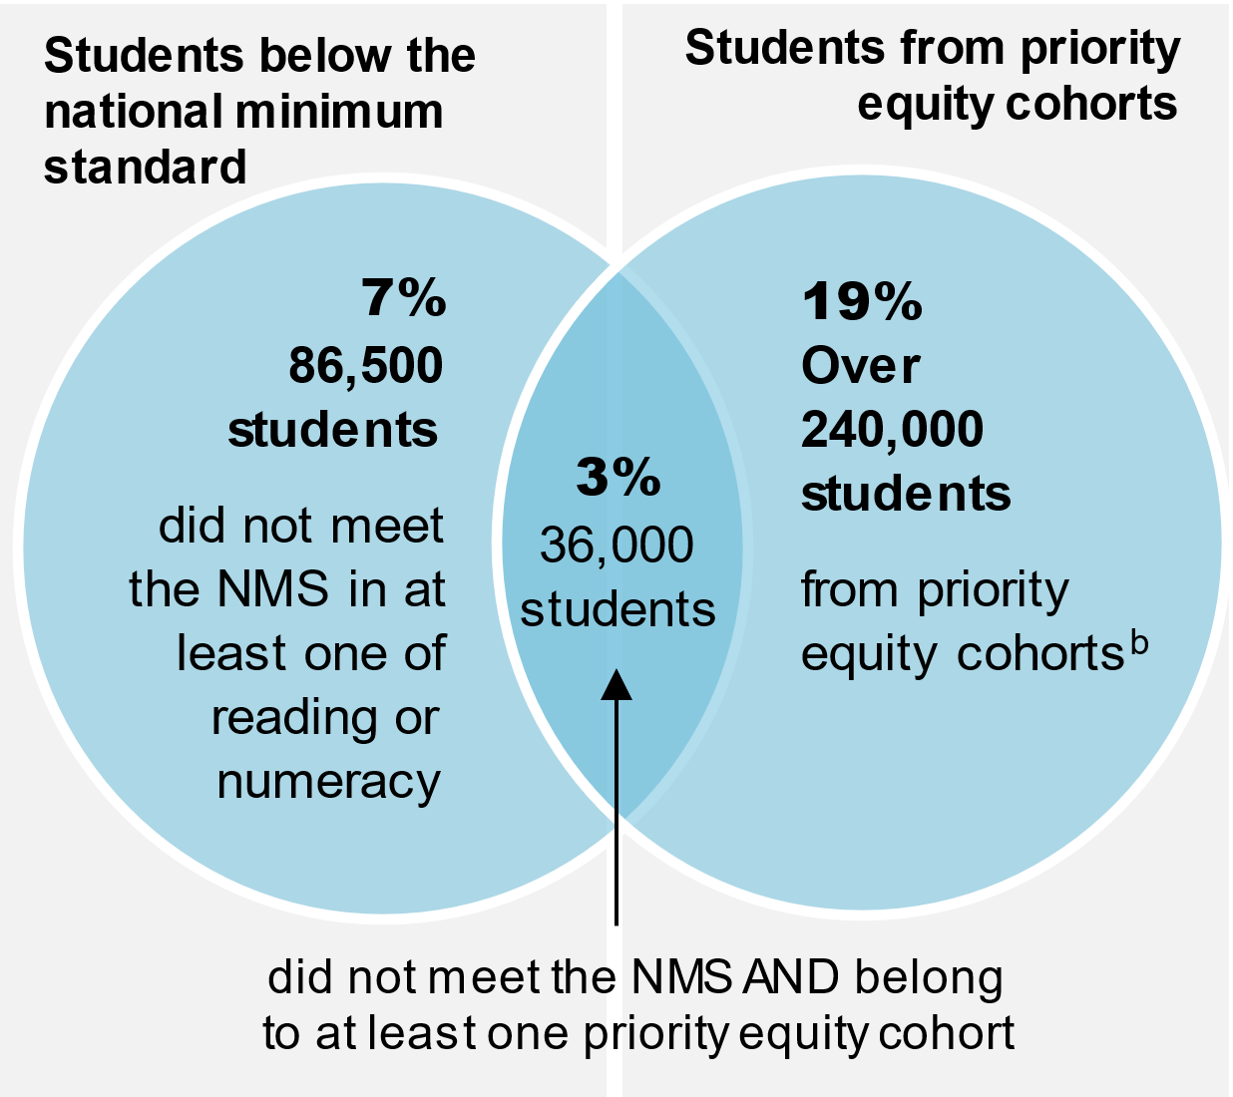 | 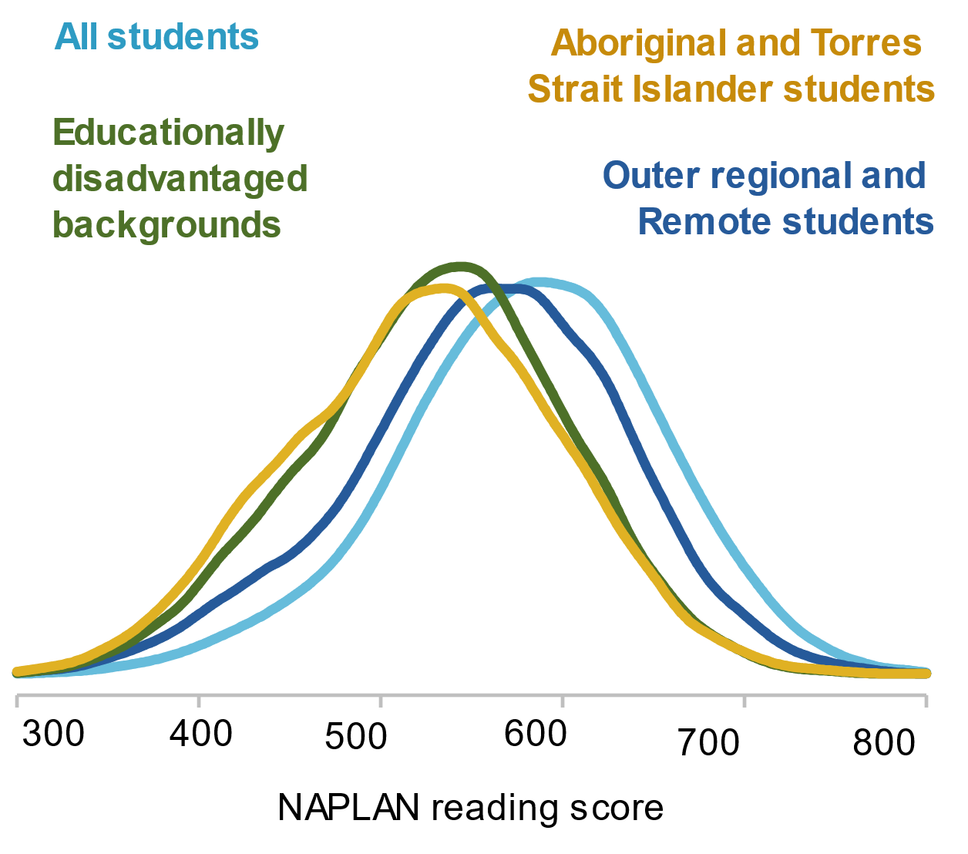
a. Students with disability are a priority equity cohort in the NSRA but ACARA does not publish NAPLAN performance data for students with disability. Commission analysis found similar distribution results for NAPLAN numeracy scores in year 9. b. This comprises: 80 000 Aboriginal and Torres Strait Islander students, 126 500 students in outer regional areas and 95 000 students of parents with low educational attainment
Source: Commission estimates based on NAPLAN de-identified student level data (2022).

Parties should adopt a suite of policies to help all students achieve basic levels of literacy and numeracy
Ensuring all students achieve basic literacy and numeracy skills is a fundamental purpose of schooling. Indeed, one of the goals of the Mparntwe Declaration is that ‘All young Australians become … successful lifelong learners … [who] have the essential skills in literacy and numeracy as the foundation for learning.’
Parties to the next school reform agreement should pursue a suite of policies to reduce the proportion of students who do not meet basic levels of literacy and numeracy. These include general policies to increase student achievement at all levels (such as policies to support teacher and school leader effectiveness), policies to reduce barriers to learning that affect students from priority equity cohorts (such as policies supporting culturally inclusive practices), and policies that have the express purpose of assisting students who do not have basic skills to catch up, regardless of their background, experience or needs. While it is up to parties to determine the right policy mix in their jurisdictions, given their commitments to ensure all students receive a quality education, they should give consideration to intensive targeted support measures, particularly where other approaches appear to be failing (box 2).

Box 2 – Efficacy of small group tuition
Small group tuition involves a teacher, trained teaching assistant or tutor working with a small group of students together in a group. This allows the teaching to be better tailored to the specific needs of the students and gives them additional focussed attention, with more opportunities for interaction and feedback.
Meta analysis of studies pertaining to small-group tuition identifies ‘moderate’ evidence that small-group tuition improves learning outcomes in reading by up to 4 months, and mathematics outcomes by up to 3 months.
Tutoring has proven to be successful in many contexts. Two high-performing nations — Finland and Singapore — have adopted this approach. In Finland for example, a specialist teacher, who has undergone additional training, is assigned to each school to work closely with teachers to identify students who need extra help.
The Smith Family has run a successful program targeted at students from low socioeconomic backgrounds, which took place at home with involvement from parents. By the end of Smith Family’s catchup learning pilot, seven in 10 students achieved higher than expected progress in literacy, and just under half of all students achieved higher than expected progress in numeracy.
Further, all parties should adopt targets, based on a common measure, for reducing the proportion of students who do not meet basic levels of literacy and numeracy. This measure could be adapted from one of the existing NSRA sub-outcomes or ACARA’s proposed proficiency standards (figure 10).
Adopting a public target would elevate the issue, signal a strong commitment to delivering equitable education for all students, and promote greater accountability.
Parties to the agreement should clearly identify in their bilateral agreements the reforms that they will undertake to achieve their targets over the life of the next school reform agreement.
Figure 10 – Ensuring all students have basic literacy and numeracy skillsª
a. The Commission is proposing that the next school reform agreement’s NAPLAN sub-outcome align with the related measure in the Measurement Framework for Schooling in Australia, which uses proficiency standards rather than top and bottom levels (chapter 9).

Differences in outcomes across students persist
While parties to the NSRA recognised the importance of supporting and facilitating the achievement of students from ‘priority equity cohorts’, it should not be taken as given that students belonging to these groups have low levels of educational achievement. Each year, many students from priority equity cohorts excel academically at school. And most students who identify as belonging to a priority equity cohort achieve at or above national minimum standards.
Indeed, participants to this review stressed that equating belonging to a priority equity cohort with disadvantage (in terms of ability or low achievement outcomes) contributes to a deficit discourse around students and hinders their ability to succeed at school.
[The] labelling of Aboriginal and Torres Strait Islander students and families as disadvantaged continues to play into a culture of deficit discourse and low expectations that stymie Aboriginal and Torres Strait Islander students’ ability to thrive in their education … While Aboriginal and Torres Strait Islander students and communities face a range of complex and compounding circumstances that impact their educational engagement and outcomes, they are not inherently disadvantaged by being Indigenous. (Indigenous Education Consultative Meeting, sub. 52, p. 3)
The term priority equity cohort denotes that, generally, students from these groups experience lower academic outcomes than the population across the full spectrum of results (figure 9) and this often stems from systemic barriers in education systems (and society generally).
Similarly, belonging to a priority equity cohort does not imply that students are homogenous in their learning needs. Students from priority equity cohorts have diverse education needs, experiences and ambitions.

Parties are yet to reduce differences in achievement across student cohorts
Along with improving outcomes for all students, parties to the NSRA also set themselves the goal of improving outcomes for students from priority equity cohorts and agreed to track progress against national performance measures.
So far, parties have failed to demonstrate that they are achieving the agreed outcomes for students from the priority equity cohorts. Performance against most of the national outcome measures in the NSRA (for which data are available) has declined for these students.
Rather than narrowing, the gap in learning (expressed as the time it would take for students from priority equity cohorts to catch-up) widens as students progress through their schooling (figure 11).
Figure 11 – Gaps widen as students progress through schooling
Difference in numeracy NAPLAN scores between students from equity cohorts and other students, expressed as equivalised years of learning
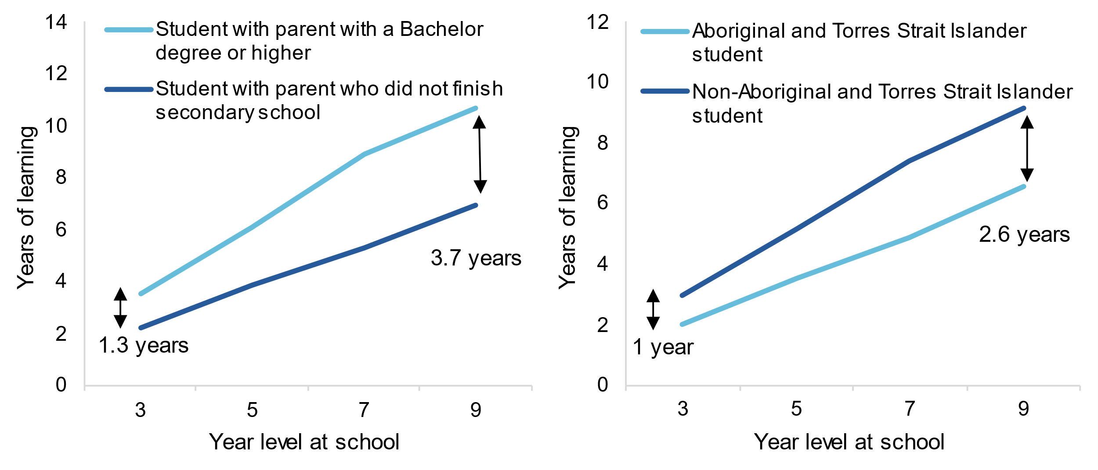
Source: Commission estimates based on 2022 NAPLAN de-identified student level data.

A new, inclusive approach is needed for students from priority equity cohorts
Parties to the next school reform agreement need to overhaul their approach to promoting equity in outcomes across different student cohorts.

Parties should ensure the next school reform agreement reflects new commitments and ways of working
Since agreeing the NSRA, governments have made further national commitments to support young people who are at higher risk of experiencing educational disadvantage, including through the 2019 Alice Springs (Mparntwe) Education Declaration, the National Agreement on Closing the Gap, and Australia’s Disability Strategy 2021–2031. These agreements represent a fundamental change to the way schools respond to the needs of their students.
Some of these commitments (such as those relating to shared decision-making and transforming the way governments respond to the needs of Aboriginal and Torres Strait Islander people under the National Agreement on Closing the Gap, and the vision for inclusive education under Australia’s Disability Strategy) will significantly shape how governments develop and implement reforms under the next school reform agreement. These commitments will need to be reflected across the schools reform agenda — from teacher and leadership training through to performance reporting.

Parties should consider whether to identify other cohorts as priority equity cohorts
The ‘priority’ equity cohorts do not capture all students that experience educational disadvantage. Children and young people living in out-of-home- care, for example, are considerably less likely than their peers to attend school, engage with education, or achieve the national benchmarks for reading and numeracy. And, in the Mparntwe Declaration, governments identified learners in out-of-home care as being at higher risk of educational disadvantage and noted these learners could benefit from targeted policy interventions. As such, there are reasonable grounds for asking why governments would not include them as priority equity cohorts in the next school reform agreement. Governments should develop an agreed approach for evaluating and prioritising new cohorts for inclusion in the next school reform agreement and apply these to cohorts commonly cited as at risk of educational disadvantage, particularly those mentioned in the Mparntwe Declaration.

Parties should address the barriers faced by students from priority equity cohorts
To achieve its ambitious objective of a high quality, high equity education system, parties will need to systematically identify and address the barriers facing students from priority equity cohorts.
Many participants (often drawing on lived experiences) highlighted the barriers faced by students from priority equity cohorts, which prevent them from reaching their potential at school. These barries permeate several aspects of the learning environment, including the culture within the classroom. While these barriers manifest in different ways for different individuals or groups of students, they provide a starting point for improvements under the next school reform agreement.

Overcoming barriers faced by Aboriginal and Torres Strait Islander students
Aboriginal and Torres Strait Islander organisations, children and young people reflected that schools are not always culturally safe spaces. They suggested that this prevents students from being engaged with their learning, and parents from sharing information about issues at home that may be impacting on their child’s wellbeing or capacity to learn.
Several participants observed that curriculum and assessment is a ‘western space’ that does not reflect aspects of learning valued by Aboriginal and Torres Strait Islander people, which include connections to Country, family, spirit, or ancestors. In seeking to address this, Aboriginal and Torres Strait Islander histories and cultures have been elevated to a cross-curriculum priority. However, participants highlighted the need for more widespread use of culturally responsive curriculum and pedagogies and in particular, practices such as two-way learning, which value and embrace Aboriginal and Torres Strait Islander knowledges and languages.
School leaders and teachers play a large role in establishing a schools’ culture and creating a safe and inclusive environment. However, participants observed that many teachers and school leaders have a poor understanding of Indigenous knowledges, Aboriginal and Torres Strait Islander cultures, and how to include and empower their students. Several participants attributed this to a lack of training on the part of some school leaders, teachers and other school staff. Some participants highlighted that a lack of understanding can perpetuate discriminatory attitudes, such as having lower expectations of students, or attributing behaviour (due to undiagnosed disability for example) to a student being ‘bad’, leading to higher rates of suspensions and exclusions among Aboriginal and Torres Strait Islander students.
As with students in remote areas more generally, access to local schooling options was also raised as a barrier by participants. A lack of local options mean children are not able to live and be educated on their own Country. Where students have to leave home in order to attend school, this can contribute to feelings of isolation and poor wellbeing and reduce opportunities to acquire cultural and familial knowledges.
While better training and resources can and should play a role in tackling these barriers, several participants suggested these barriers reflect broader issues relating to Aboriginal and Torres Strait Islanders’ lack of a voice and representation in education policy and broader social narratives around Aboriginal and Torres Strait Islander people.

Overcoming barriers faced by students with disability
Participants representing students with disability and their families also provided perspectives on the barriers they experience. They reported that not all schools fully embrace inclusion and that this leads to students feeling unsupported and left out.
Some participants suggested that there is a poor understanding of the social model of disability (which frames adjustments as changes systems need to make to include people with disability, rather than changes people with disability need to make to fit into mainstream environments).
Although there has been a significant increase in the number of students recognised as requiring additional supports, students with disability and their families pointed to a lack of adequate and consistent resourcing. Several participants noted that despite teachers’ best efforts, they were often not provided with the resources, time and training to create an environment that welcomes and supports students with disability and their families. Participants raised the specific example of school leaders and teachers not being well equipped and supported to recognise a student in need of support, and noted examples of students with disability progressing through school without their support needs being identified.
Even where the need for additional supports was recognised, some participants felt school systems were not up to date with contemporary practices of inclusive education. They reflected that the curriculum schools deliver to students with disability fails to foster high expectations or reflect students’ aspirations, and that in some cases, students were sanctioned instead of being given the behavioural supports they needed, contributing to their disengagement from education.

Overcoming barriers faced by students in regional and remote Australia
Participants highlighted the barriers students from regional and remote areas encounter — the Independent Review into Regional, Rural and Remote Education that informed the NSRA explored these issues at length. One significant theme was that families in regional, rural and remote areas can have limited choice about where and how they educate their children.
Where local schooling options are available, subject offerings can be limited. Many participants emphasised the challenges associated with attracting and retaining high quality teachers and leaders (box 1). Others reported that schools have historically relied on new teachers to fill vacancies in rural and remote areas, but that they are not well prepared and supported to undertake these often complex roles.

Parties should embed actions to address barriers in the next school reform agreement
There is a strong case for State and Territory governments to continue to take the lead on implementing reforms to reduce barriers faced by students from priority equity cohorts — they are best placed to design initiatives that reflect local conditions and are tailored to meet their students’ needs.
However, there are general features of the school learning environment that, along with high-quality teaching and leadership practices, are widely accepted as being critical for meeting the learning needs of students from priority equity cohorts. These include:
- governments making inclusion a centrepiece of education policy and integrating policies in education with those in other policy domains affecting young people
- governments ensuring that people that are affected by policies, programs and practices provide input into their design, to ensure they are relevant and effective
- teachers and leaders adapting their understanding of schooling success for each student, and being better trained to identify and respond to diverse needs
- schools supporting parents and carers to actively engage with their child’s education
- schools adopting culturally responsive curriculum and pedagogies to enable all students to see their identities, cultures, and knowledges reflected in what and how they are learning.
- governments implementing innovative (including technology-based) solutions to provide access to education for families, including in regional and remote communities.
Governments can encourage more widespread adoption of these practices through various levers, ranging from enshrining these practices in policies and guidelines distributed to schools, designing and delivering effective and targeted training to improve teachers’ skills and understanding, and establishing partnerships with community groups and representative bodies of students.
While it is up to each jurisdiction (and sector) to determine how best to embed these practices within their school systems, governments should incorporate specific features in the design of the next school reform agreement. This would place greater discipline on parties to help lift outcomes for students from priority equity cohorts and to hold parties to account (figure 12).
Figure 12 – Reducing inequities across studentsª
a. The Commission is proposing that the next school reform agreement’s NAPLAN sub-outcome align with the related measure in the Measurement Framework for Schooling in Australia, which uses proficiency standards rather than top and bottom levels (chapter 9).
One key aspect of this will be introducing new national targets (which could, for example, mirror any new general targets, such as reducing the proportion of students who do not meet basic levels of literacy and numeracy) to drive reform and provide insights into equity in outcomes across student cohorts.
Targets should be supported by jurisdiction-specific commitments in bilateral agreements, developed in consultation with those with lived experience, which identify the reforms parties will pursue to achieve agreed outcomes and targets. Parties should also set out in their bilateral agreements how they will advance relevant commitments under the National Agreement on Closing the Gap, and Australia’s Disability Strategy.

National reforms should include a greater focus on supporting student wellbeing

Many students experience poor wellbeing
Improved student wellbeing is both a desired outcome of schooling and a means to improve learning outcomes.
Schools can promote wellbeing by providing inclusive environments and supporting the social and emotional development of students so that they are equipped to cope with the various stresses of life.
Improving student wellbeing can also support students’ ability to engage and learn at school. Students struggling with challenges to their wellbeing often have difficulty engaging at school. A recent study found that students who experienced feelings of depression in Year 8 scored 7 per cent worse than similar students in Year 9 NAPLAN literacy and numeracy scores. Another study found that students with persistent emotional or behavioural problems between Years 3 and 7 fell a year behind in numeracy compared with their peers.
Although many children and young people experience positive wellbeing or can cope well with the issues they face, a sizeable proportion of children and young people experience challenges to their wellbeing. In 2014 (the most recent year for which data are available), one in five young people aged 11 to 17 years reported having high levels of psychological distress, and 14 per cent of children aged 4 to 17 years had a mental, behavioural or neurodevelopmental disorder during the previous year. Poor wellbeing can be particularly pronounced among children and young people in out-of-home care, students with disability, and Aboriginal and Torres Strait Islander students.
The COVID-19 pandemic and natural disasters such as bushfires and floods, have brought concerns about student wellbeing into sharper focus.

Parties should include student wellbeing in the next school reform agreement
While a range of factors influence a young person’s wellbeing, including their home environment, their experiences at school can play an important role — both positive and negative. In the case of students who have experienced trauma, for example, a failure by schools to recognise this and instead respond to disruptive behaviour with disciplinary actions (such as suspension or expulsion), can further entrench poor wellbeing.
Elevating student wellbeing as an area of national priority and co-operation in a successor agreement, along with greater transparency about wellbeing outcomes, would encourage more effective support for students.
In addition to adding wellbeing as an outcome in the next school reform agreement, governments should include specific reform actions. These reform actions need to shape day-to-day practices within schools, such as by supporting teachers to identify and respond to students’ wellbeing needs, rather than simply adding to the existing stock of wellbeing programs.
There are some core wellbeing strategies that governments should support all schools to have in place. All schools need strategies that help teachers to identify where behaviour may be communication of poor wellbeing and how to respond appropriately, as well as to clearly set out the roles and responsibilities of wellbeing staff and student pathways for support, both within and beyond the school. A clearer articulation of pathways and responsibilities will help ensure teachers do not feel they need to shoulder responsibility for student wellbeing alone.
But tailoring responses to local needs and conditions is also important. For Aboriginal and Torres Strait Islander students, connection to culture, spirituality, community and ancestry can all be key protective factors in helping to manage wellbeing. To allow jurisdictions to tailor responses to local needs and conditions, most actions to support wellbeing are likely to be best pursued through bilateral initiatives (figure 13).
There are clear benefits in developing a national indicator of student wellbeing to better understand how student wellbeing is tracking and to provide insights into the efficacy of policy interventions — governments should develop a sub-outcome on student wellbeing and report against it as a matter of priority.
Figure 13 – Supporting student wellbeing

Improved national performance reporting has a key role to play in supporting success
Along with better use of targets, improved performance reporting will be instrumental in improving transparency and accountability arrangements under a new agreement.
As part of the next school reform agreement, governments should fill reporting gaps on outcomes for Aboriginal and Torres Strait Islander students and students from regional and remote areas, making good on commitments to report outcomes for students in priority equity cohorts (including specific commitments related to reporting outcomes for Aboriginal and Torres Strait Islander students under the National Agreement on Closing the Gap). While reporting gaps for students with disability will be more difficult to progress due to a lack of available data, governments should make this a priority.
The absence of a standalone report on Australia’s performance against sub-outcomes of the NSRA (which means the National Report on Schooling is the primary reporting mechanism) has diminished transparency.
Australian, State and Territory governments should commit to standalone reporting on progress against the next school reform agreement’s sub-outcomes and targets. This could be achieved either through publication of a new standalone report or through augmenting the existing National Report on Schooling in Australia with a sub-section that clearly identifies the measures used for tracking performance against the Agreement. The Australian Government should table the report annually in Parliament.
Performance reporting arrangements (both as part of a future Agreement and an updated Measurement Framework for Schooling in Australia) should be updated to reflect contemporary views on the nature of student outcomes sought. This should include reporting on the new wellbeing outcome, more complete reporting on student achievement and post-school outcomes and, as new data becomes available, student engagement.
Parties should retain the provision in the next school reform agreement for an independent review. The scope of the review should consider all aspects of the agreement, including the effectiveness of state-specific reforms.
The Commission's recommendations on improved performance reporting, and the design of the next school reform agreement more broadly, are summarised in figure 14.
Figure 14 – Summary of recommendations on the design of the next school reform agreement
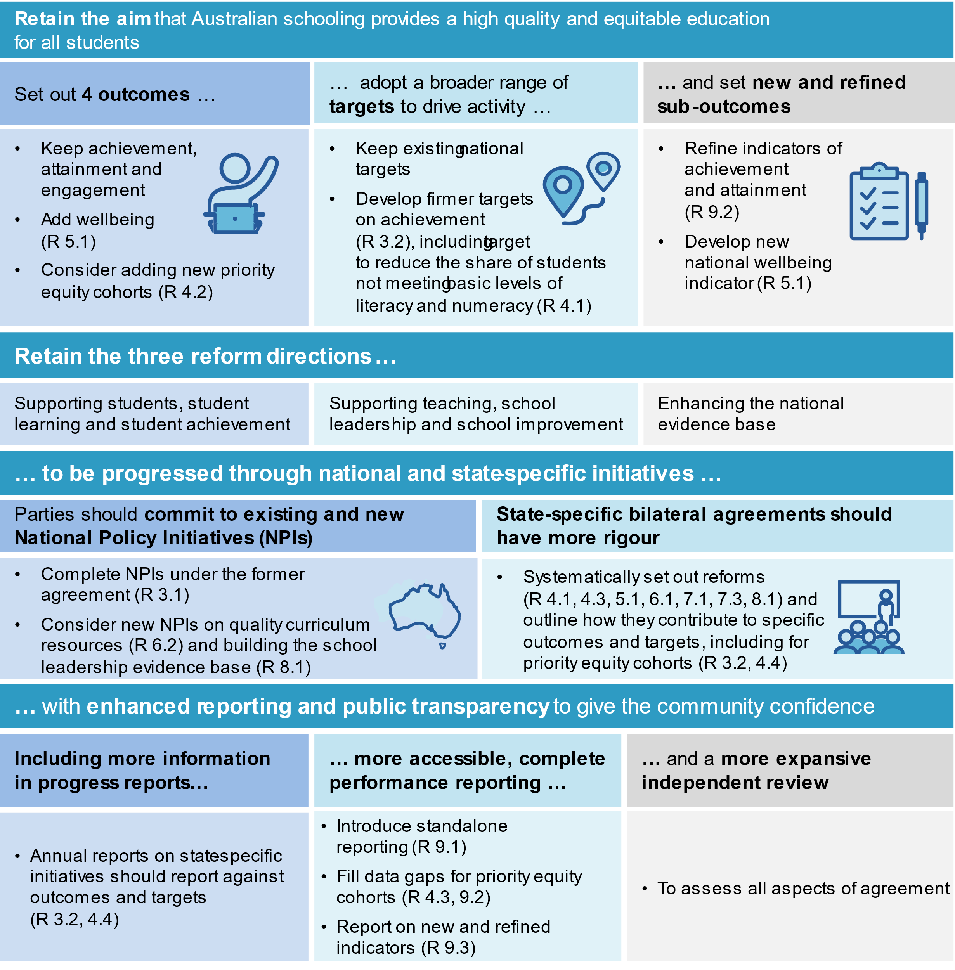

Recommendations and findings
Chapter 2: What has been happening to student outcomes?
 | Finding 2.1  Declines in Australia’s results in international testing of reading and mathematics among 15 year-old students likely overstate the deterioration of these skills among that age group.
Australia’s Programme of International Student Assessment results declined over the decade to 2018 (the most recent year for which data are available).
However, changes in the school starting age in two states meant that about 12 per cent of 15-year-old students who sat the test in 2018 had a year’s less schooling to develop their reading and mathematics skills, relative to 15-year-old students who sat the test in 2012.

Finding 2.2
Since 2013, NAPLAN results for reading and numeracy have been flat across all year levels, with exceptions in reading results for year 3 and year 5.
Since 2013, there have been marginal improvements in reading test results in year 3 and year 5, but no improvements in year 7 and year 9. Test results for numeracy have stagnated across all year levels since 2013.
Commission analysis tracking the same cohort from year 3 to year 9 shows that the improvements in year 3 and year 5 reading do not persist to year 7 and year 9.

Finding 2.3
Persistent differences in reading and numeracy outcomes across cohorts suggest some students face systemic barriers.
There are long-standing differences in national test results for reading and numeracy across students from different backgrounds, or who have different experiences or needs.
- Results for reading and numeracy for Aboriginal and Torres Strait Islander students, students in outer regional and remote areas, and students with parents with low educational attainment are consistently below the outcomes of the general student population.
- By year 9, these differences can be as great as the equivalent of 5 years of learning.

Finding 2.4
There has been a small increase in the level of educational attainment since 2015.
The proportion of 20 to 24 year-olds who completed year 12 or equivalent, or a Certificate III or above, increased by 2.5 percentage points to 90 per cent between 2015 and 2021.

Finding 2.5
School attendance has declined since 2015, particularly among students in middle years.
The proportion of students attending school regularly has declined, with much of this decline predating COVID-19.
Declines in attendance levels are more pronounced among students in middle years — attendance of primary students has fallen by 4 percentage points since 2015, while attendance of students in years 7-10 has fallen by 10 percentage points.

Finding 2.6
Many students experience poor social and emotional wellbeing.
There is no nationally consistent measure showing how student wellbeing has changed over time. While some jurisdictions collect data on aspects of student wellbeing, few publish the results.
Available data suggest a sizeable proportion of children and young people experience poor social and emotional wellbeing.
Chapter 3: High-level assessment of the National Policy Initiatives
Finding 3.1
To date, the National Policy Initiatives are unlikely to have affected the education outcomes of Australian students.
Some National Policy Initiatives (NPIs) have been completed but will take time to produce results. Others have been completed but have not yet led to actual reforms. The fate of two key NPIs was only resolved late in the life of the agreement.
- While the design of the unique student identifier and the online formative assessment tool has now been resolved, the agreed approaches do not appear to reflect the original ambitions for, and anticipated benefits of, these NPIs.
- The Senior Secondary Pathways Review and the National Teacher Workforce Strategy have not led to substantial national reforms.
- National data projects have progressed, but the majority are not yet complete.
- The Australian Education Research Organisation has been established but will require time to realise its potential.

 | Recommendation 3.1  Parties to the National School Reform Agreement should fulfil their commitments to deliver the National Policy Initiatives.
Parties to the next school reform agreement should:
- set firm deadlines to complete the unique student identifier (USI) and the online formative assessment tool
- once the USI is established, consider opportunities to realise its full potential for informing education policy by linking the USI with other data sets and permitting additional uses beyond the agreed initial baseline.

Finding 3.2
The National School Reform Agreement has gaps that undermine its effectiveness in facilitating collective, national efforts to lift student outcomes.
Shortfalls with the Agreement include:
- no outcome that captures wellbeing
- a single weak target for academic achievement
- a dearth of targeted reforms to lift outcomes for students from priority equity cohorts and for students who do not meet basic levels of literacy and numeracy
- a lack of transparent, independent and meaningful reporting on national and state reform activity which means there is limited effective accountability.

Finding 3.3
The next intergovernmental school reform agreement should be focused on achieving outcomes, sub-outcomes and targets broadly consistent with those already agreed by governments in the National School Reform Agreement (NSRA).
Many of the targets, outcomes and sub-outcomes in the NSRA remain relevant. Some modifications to improve the quality of reporting should be pursued, however this broad set of aims should continue to shape the direction of reforms in the next school reform agreement.
The next school reform agreement should be aligned with, and contain practical actions that implement commitments made under subsequent policy statements, such as the Alice Springs (Mparntwe) Education Declaration, and national commitments under the National Agreement on Closing the Gap and Australia’s Disability Strategy 2021-2031.

Recommendation 3.2
Firmer targets will strengthen the focus on achieving outcomes and improve accountability to the community.
The National School Reform Agreement does not include sufficient clear, measurable targets to drive reform and hold jurisdictions to account for their performance. The Commission recommends the following actions.
- To maximise their impact, targets should be realistic yet ambitious.
- There should be targets for academic achievement for all students and for students from priority equity cohorts (taking account of existing commitments to the National Agreement on Closing the Gap targets).
- A target should be developed to reduce the proportion of students who do not meet basic levels of literacy and numeracy.
- The targets should capture progress on key academic benchmarks at regular stages in a student’s education.
- An appropriate independent body, such as the Australian Curriculum, Assessment and Reporting Authority, should advise on design of the targets.
- The basis for measuring the targets should be common to all jurisdictions (and set out in the main agreement). However, jurisdictions should ‘own’ their target and each state and territory should settle their targets with the Australian Government, reflecting their circumstances.
- Jurisdictions should report their progress against their targets each year. Bilateral agreements should explain how jurisdictions expect to achieve their targets.
Chapter 4: Lifting outcomes for all students
Finding 4.1
Tens of thousands of students do not meet NAPLAN minimum standards in reading or numeracy each year — many students fall short year after year.
Fewer than half of the students who do not meet NAPLAN minimum standards in reading or numeracy are from the National School Reform Agreement’s priority equity cohorts.
- The precise number is uncertain because there are limited data for students with disability.
- Around one third of students who do not meet NAPLAN minimum standards in their early years of schooling do not meet NAPLAN minimum standards in later school years.
- Such experiences can negatively affect students’ feelings about themselves and towards learning, and their ability to fulfil their aspirations in later life.

Recommendation 4.1
Jurisdictions should commit to targets and actions to reduce the proportion of students who do not meet basic levels of literacy and numeracy.
Reducing the proportion of students who do not meet basic levels of literacy and numeracy should be a priority for the next intergovernmental school reform agreement.
Recommendation 3.2 proposes setting and reporting targets to reduce the proportion of students who do not meet basic levels of literacy and numeracy.
Parties to the next school reform agreement should set out in their bilateral agreements the actions they will take to reduce the proportion of students who do not meet basic levels of literacy and numeracy. Small-group tuition is one such intervention that is supported by evidence as improving outcomes for students falling behind that parties to the next school reform agreement could consider.

Finding 4.2
Governments are yet to achieve the equitable outcomes for students from the priority equity cohorts that they endorsed in the National School Reform Agreement (NSRA).
For the priority equity cohorts, over the life of the agreement:
- achievement — as measured by results in national literacy and numeracy testing — exhibited improvements in some areas but generally worsened (particularly in numeracy)
- school attendance — which is the NSRA’s measure of engagement and only recorded for Aboriginal and Torres Strait Islander students and students from regional and remote areas — decreased
- attainment — which is only recorded annually for students from regional and remote areas — improved.
Outcomes for students with disability cannot be measured because national reporting does not report on the NSRA’s outcome measures for this priority equity cohort.

Finding 4.3
Governments have failed to demonstrate how state-specific reforms are addressing the educational needs of students from the priority equity cohorts.
Bilateral agreements between the Australian Government and each state and territory — which were supposed to enable transparent reporting on measures to lift outcomes of students from priority equity cohorts — have patchy coverage, lack meaningful detail, and contain few new measures.

Finding 4.4
The priority equity cohorts in the National School Reform Agreement do not capture many students who are at high risk of experiencing educational disadvantage.
Children and young people living in out-of-home care face significant disruptions to their education and are considerably less likely than their peers to attend school and engage with education — by year 9, children in out-of-home care were four times more likely to be below the national minimum standard in reading, and six times more likely to be below the national minimum standard in numeracy, relative to the general population.
Students who speak English as an additional language or dialect often require specific support to strengthen English language skills to access the general curriculum.
Students from a refugee background generally speak English as an additional language or dialect and face the same challenges. Many have endured experiences of trauma prior to their arrival in Australia, affecting their ability to engage in learning.
Students in the youth justice system often require additional educational support to enable them to overcome the often complex barriers to engagement in education.

Recommendation 4.2
Some groups of students face significant barriers to success at school but are not recognised as priority equity cohorts. A transparent, systematic approach should be used to evaluate the case for new priority equity cohorts.
Parties to the agreement should consider the following cohorts for inclusion in the next intergovernmental school reform agreement as priority equity cohorts:
- students living in out-of-home care
- students with English as an additional language or dialect background
- students in youth detention
- refugee students.

Finding 4.5
The National Agreement on Closing the Gap and Australia’s Disability Strategy 2021-2031 have direct implications for how governments seek to lift outcomes for students from priority equity cohorts under the next intergovernmental school reform agreement.
The National Agreement on Closing the Gap establishes commitments for how all government organisations should share decision making, engage with Aboriginal and Torres Strait Islander people (including students) and identify and eliminate racism within education systems.
In the context of the next school reform agreement, these commitments will influence all aspects of policy development affecting Aboriginal and Torres Strait Islander people (including setting of outcomes, design and implementation of reform activities, and transparency and accountability).
Australia’s Disability Strategy establishes a potential blueprint for how governments should develop policies, programs, services and systems and engage with people with disability (including students) that parties to the next school reform agreement should draw upon.

Recommendation 4.3
Parties to the next intergovernmental school reform agreement should give effect to relevant commitments under the National Agreement on Closing the Gap and Australia’s Disability Strategy.
Consistent with their commitments under the National Agreement on Closing the Gap and Australia’s Disability Strategy 2021-2031, as part of the next intergovernmental school reform agreement, parties should:
- commit to actions to lift outcomes and sub-outcomes for students from priority equity cohorts
- develop outcomes, reform activities, and transparency and accountability arrangements in collaboration with representatives from the priority equity cohorts
- set out actions in bilateral agreements that commit to the identification and elimination of racism, the institution of cultural safety requirements across education systems, and implementation of commitments from Australia’s Disability Strategy, in particular application of a social model of disability in education systems
- prioritise data measurement of the outcomes and experiences of students with disability in education.

Finding 4.6
Students from priority equity cohorts face multiple types of barriers to access a high-quality education.
The learning environment, including the culture within the classroom, is not always well suited to improve outcomes for students from priority equity cohorts.
- Some Aboriginal and Torres Strait Islander students do not see their identities, cultures, and knowledges reflected in what they are learning.
- Teachers and leaders often have insufficient time, skills, and/or resources to support students from priority equity cohorts and their families.
- Students from priority equity cohorts can lack access to an inclusive learning setting that supports their learning needs and wellbeing.

Finding 4.7
There is a good understanding of what governments, school systems, school leaders and teachers can do to better meet the learning needs of students from priority equity cohorts.
Features of the school learning environment that are widely accepted as being critical for meeting the learning needs of student from priority equity cohorts include:
- teachers and leaders adapt their understanding of schooling success for each student and have the skills to identify and respond to their diverse needs
- schools support parents and carers to actively engage with their child’s education
- schools adopt culturally responsive curriculum and pedagogies to enable all students to see their identities, cultures, and Aboriginal and Torres Strait Islander knowledges reflected in what and how they are learning
- students, families, and communities’ views inform delivery of education services
- students and families from regional and remote areas have access to technological resources and other assistance to ease challenges of remote learning.
Governments can encourage more widespread adoption of these practices through a variety of levers, ranging from enshrining these features in policy and guidelines distributed to schools; designing and delivering effective and targeted training to improve teachers’ skills and understanding; and establishing partnerships with communities and representative bodies of students and communicating with them regularly.
Recommendation 4.4
Parties should design the next intergovernmental school reform agreement so that it identifies and reports on their actions to lift outcomes for students from priority equity cohorts.
Parties to the next intergovernmental school reform agreement should:
- include national targets for students from each priority equity cohort so the community can assess equity of outcomes across students
- ensure state and territory bilateral agreements, developed in consultation with people with lived experience, systematically set out for students from each priority equity cohort:
  - the outcomes and relevant sub-outcomes they are seeking to achieve for students in the priority equity cohort
  - the reforms government will implement to achieve those outcomes by addressing the various barriers to accessing high quality education that students from that priority equity cohort face
  - the theory of change linking reforms to long-term outcomes and arrangements for collecting data to enable monitoring and evaluation over time
- publicly report each year on progress in implementing reforms and achieving the outcomes and targets they set.

Finding 4.8
Lack of publicly available data on school-level spending for students from priority equity cohorts limits accountability.
There is no publicly available data on school-level spending on students from priority equity cohorts. This means that policymakers, parents, groups representing students and the public have little visibility of school-level actions to lift outcomes for students in priority equity cohorts, which limits accountability.
Chapter 5: Student wellbeing
Finding 5.1
Many students experience poor wellbeing and some do not receive effective support.
- A significant proportion of children and young people experience poor social and emotional wellbeing.
  - Poor wellbeing can be particularly pronounced among students who experience challenges to engagement and inclusion at school, for example, children and young people in out-of-home care, students with disability and Aboriginal and Torres Strait Islander students.
- Poor wellbeing directly affects students’ capacity to learn.
- While wellbeing is influenced by many factors outside the school gate, poor wellbeing can be exacerbated by responses from schools.
- Effective school leadership and teacher practices are essential elements for supporting student wellbeing within schools.
- Australian, State and Territory Governments have many initiatives and information resources to support student wellbeing, but schools have not consistently implemented evidenced-based approaches for all students.

Recommendation 5.1
Governments should design the next intergovernmental school reform agreement so that it includes a focus on student wellbeing.
Parties to the next school reform agreement should add improved student wellbeing as an outcome of the agreement, develop a new sub-outcome on improving students’ subjective wellbeing, and commit to annual reporting.
- Governments should collect data for a composite wellbeing index but provide schools and data providers the flexibility to choose from a range of high-quality and relevant survey instruments, including those used in existing student surveys.
Bilateral agreements under the next school reform agreement should include actions intended to improve student wellbeing, and report each year on progress. At a minimum, bilateral agreements should include actions to support all schools to adopt wellbeing strategies that:
- provide support and training for teachers to identify students experiencing poor wellbeing and to respond appropriately
- articulate the role and responsibilities of wellbeing staff within the school
- clarify student pathways for support, both within and beyond the school.
Chapter 6: Supporting teacher effectiveness
Finding 6.1
Policies that improve the quality of the teacher workforce are likely to be one of the most significant ways governments can influence student outcomes. Some options warrant particular attention.
Improving teacher effectiveness can provide substantial personal, social and economic benefits.
- Improving initial teacher education (ITE) is likely to be more effective than screening for ‘high-quality’ candidates for ensuring people entering the profession are well equipped for teaching.
- Teaching performance assessments (TPAs), which assess the classroom readiness of graduate teachers, have only recently been introduced by jurisdictions — it is too early to decide whether TPAs should be changed to embody minimum standards.
- Better access to quality induction and mentoring is likely to accelerate skill acquisition and increase retention when teachers start in the classroom.
- Quality on-the-job learning, including from more experienced colleagues, can lead to ongoing improvement throughout teachers’ careers, but it relies on teachers having sufficient time.
  - A key benefit of Highly Accomplished and Lead Teachers (HALTs), and other highly skilled teachers is their ability to share expertise with other teachers.
  - But there has been poor take up of HALT certifications and many certified teachers say they have too little time or opportunity to lead the development of others in their school.
- Governments have announced their intention to improve ITE quality, induction and mentoring and streamline HALT accreditation processes under the National Teacher Workforce Action Plan.
- Although these announced actions have the potential to address concerns about teacher effectiveness, some lack detail and firm commitments and/or may require complementary reforms to ensure their success.

Recommendation 6.1
Parties should design the next intergovernmental school reform agreement to better develop and deploy expert teachers to disseminate evidence-based teaching practices.
Each state and territory should include in their bilateral agreement mechanisms to ensure expert teachers can support colleagues to achieve better student outcomes through the dissemination of evidence-based teaching practices. Actions should:
- be developed in consultation with school leaders and teachers
- support Highly Accomplished and Lead Teachers to share their in-depth knowledge and skills with their colleagues to help them improve.

Finding 6.2
High search costs for locating quality teaching resources prevent many teachers from employing evidence-based resources in the classroom.
Many teachers have difficulties locating high quality teaching resources that meet the needs of their students, or verifying the quality of teaching resources.
- More than half of Australian teachers surveyed, who were aware of government provided instructional materials, did not think they were easy to find or that they met the learning needs of their students

Recommendation 6.2
Governments should establish a single portal for teachers and school leaders to access evidence-based instructional material. This could be a national policy initiative in the next intergovernmental school reform agreement.
The Australian, state and territory governments should work together to curate high-quality, evidence-based and government endorsed curriculum resources and make them available for teachers and school leaders from a single source.
Resources should:
- be curated by organisations with relevant curriculum expertise such as the Australian Curriculum, Assessment and Reporting Authority, the Australian Education Research Organisation and/or Education Services Australia
- be independently quality assured based on what research says is most effective
- encompass whole-school curriculum plans, whole-subject sequences, lesson plans and classroom tools
- utilise existing quality materials, including from the private sector, where possible
- be complemented with training in how to use the material.
Chapter 7: Ensuring a stable supply of teachers
Finding 7.1
Teacher shortages in regional, rural and remote areas and in key subjects, such as maths, science and English impose substantial costs on students, teachers and schools.
There are teacher shortages in regional, rural and remote areas, and in subjects such as mathematics, science, English and design and technology.
The significant disparity between the share of teachers of Aboriginal and Torres Strait Islander background (2 per cent) and students with that background (6 per cent) frustrates culturally appropriate teaching.
Factors such as growing student enrolments, changes in initial teacher education enrolment trends, and an ageing workforce may contribute to continued teacher shortages in the future.
Teacher shortages can impose substantial costs on students, teachers and schools, including because it gives rise to out-of-field teaching, and teachers without domain specific expertise tend to be less effective, particularly in upper secondary school grades.

Recommendation 7.1
Reducing out-of-field teaching should be a priority for the next intergovernmental school reform agreement.
Parties to the next school reform agreement should:
- include state-specific reforms, to be set out in their bilateral agreements and developed in consultation with teachers and school leaders:
  - to support educators teaching out-of-field.
  - to attract teachers to areas of shortage, including measures to lower switching costs for mid-career entrants contemplating teaching, particularly in high demand areas and for former teachers looking to return to the profession.
- report annually on the prevalence of out-of-field teaching in their jurisdictions.
- All jurisdictions should reintroduce a one-year qualification for secondary teaching for well-qualified individuals in subject areas of high demand.

Recommendation 7.2
All jurisdictions should participate in the development of the new national First Nations Teachers’ Strategy.
The Australian Government has committed to co-design a new national First Nations Teachers’ Strategy in close partnership with First Nations education organisations, to better attract and retain more Aboriginal and Torres Strait Islander teachers.
All jurisdictions should contribute to the development of the Strategy.
Consistent with commitments under The National Agreement on Closing the Gap, the Strategy should include specific measures to identify and remove racism experienced by Aboriginal and Torres Strait Islander educators in the education system.
Subject to the views of First Nations education organisations, the Strategy could identify ways to establish clear pathways for Aboriginal and Torres Strait Islander educators seeking to transition to teaching and/or leadership roles.

Finding 7.2
Teachers work long hours, and their workload has increased.
Australian teacher workload is greater than the OECD average. Australian teachers spend more time on non-teaching tasks, and less time on teaching tasks, than their international counterparts.
Teacher workload has increased over time. Many teachers cite heavy workload as a reason for wanting to leave the profession.

Finding 7.3
A more systematic and evidence-based approach to deploying the growing number of teaching assistants is required.
While teacher workload has been increasing, the number of teaching assistants and other support staff has grown.
Anecdotal evidence reveals teaching assistants are being deployed in ad hoc ways and do not always have the support or training they need to undertake the myriad of tasks they perform.
A more systematic and evidence-based approach to determining the roles and responsibilities of teaching assistants and support staff, and their appropriate use would be beneficial, including to free up teacher time.

Recommendation 7.3
Parties should design the next intergovernmental school reform agreement so that it focuses on maximising the value of teachers’ and school leaders’ time.
Parties to the next school reform agreement should ensure state-specific reforms in bilateral agreements to support teachers and school leaders (developed in consultation with teachers and school leaders) identify how they maximise the value of teachers’ and school leaders’ time, including by reducing low-value tasks.

Finding 7.4
Building on efforts to improve teacher workforce demand and supply data would enable governments to better identify and respond to workforce shortages.
- All governments recently committed to enhanced workforce data collection and nationally consistent teacher workforce projections. This will require ongoing and full participation by all Governments in the Australian Teacher Workforce Data initiative, including the provision of teacher demand data.
- To maximise the value of these commitments, a labour market model could be developed that would allow governments to better identify and predict teacher shortages and evaluate the impacts of different policies on the workforce.
Chapter 8: School leadership
Finding 8.1
Improving school leadership can boost students’ learning. Workforce planning, mentoring and professional development for school leaders can help ensure a sustainable supply of effective school leaders.
School leaders are second only to teachers in improving student outcomes. Improving the effectiveness of leaders, especially principals, would generate sizeable benefits.
Long lead times for teachers to move into leadership roles, and the emergent pressures on the current cohort of school leaders, underscore the importance of effective leadership planning to ensure a sustainable pipeline of future school leaders.
School leaders would benefit from greater guidance on specific measures they can adopt in their schools to improve student outcomes.

Recommendation 8.1
Governments should improve the local evidence base on school leadership in an Australian context as a national policy initiative in the next intergovernmental school reform agreement.
Parties to the next school reform agreement should commission education bodies, such as the Australian Education Research Organisation and Australian Institute for Teaching and School Leadership, to improve the local evidence base on effective school leadership practices. This would form a research agenda involving:
- identifying the most important gaps in the school leadership evidence base
- conducting high quality studies to fill these gaps
- ensuring that the results of the studies are used to inform leadership practice, such as through professional development for current and future leaders.
Once an evidence base is available, each jurisdiction should update their bilateral agreements to identify specific reforms they will undertake to incorporate the evidence base, and publicly report on progress implementing these reforms.
Chapter 9: The National Measurement Framework
Finding 9.1
The Measurement Framework for Schooling in Australia is not appropriate for measuring progress on National School Reform Agreement outcomes.
While reliable, and largely relevant, the Measurement Framework for Schooling in Australia is not a complete means of reporting progress on National School Reform Agreement outcomes.

Finding 9.2
Performance data to help assess progress against the National School Reform Agreement outcomes and sub-outcomes is not readily accessible.
The visibility of governments’ progress against the National School Reform Agreement sub-outcomes and targets is diminished by the absence of a standalone report and the reliance on the broader National Report on Schooling in Australia and Key Performance Measure dashboard for performance reporting.
Recommendation 9.1
Parties should introduce standalone performance reporting against the National School Reform Agreement outcomes.
Australian, State and Territory Governments should commit to standalone reporting on progress against the National School Reform Agreement sub-outcomes and targets. To achieve this, Australian, State and Territory Governments should either:
- publish a new report for the purposes of reporting on progress against the National School Reform Agreement sub-outcomes and targets, or
- augment the National Report on Schooling in Australia with a new sub-section.
At a minimum, the Australian Curriculum, Assessment and Reporting Authority should clearly identify in the Measurement Framework for Schooling in Australia and the National Report on Schooling in Australia, which key performance measures are sub-outcomes or targets for the National School Reform Agreement.
The report should be tabled annually in the Parliament of Australia.

Recommendation 9.2
Parties should improve the performance reporting framework of the next intergovernmental school reform agreement.
Parties to the next intergovernmental school reform agreement should improve the performance reporting framework of the next school reform agreement by:
- clearly articulating the role of the Measurement Framework for Schooling in Australia in enabling the reporting of the sub-outcomes and targets of the agreement
- developing data to enable reporting on outcomes for students with disability. This may include by exploring opportunities to use the National Disability Insurance Scheme outcomes framework data, options for data linkage, or asking students to state whether they identify as having a disability as part of NAPLAN and National Assessment Program sample assessments
- publicly reporting on each outcome by jurisdiction for priority equity cohorts (students with disability, Aboriginal and Torres Strait Islander students and students in regional and remote areas)
- adding new sub-outcomes for learning gain, post-school outcomes and the measure of student wellbeing proposed in recommendation 5.1
- updating the NAPLAN sub-outcome to use proficiency standards rather than learning bands.
Recommendation 9.3
ACARA should identify and implement improvements to the Measurement Framework for Schooling in Australia as part of its next review.
For its next review of the Measurement Framework for Schooling in Australia, the Australian Curriculum, Assessment and Reporting Authority (ACARA) should:
- develop a performance indicator framework, whereby Key Performance Measures (KPMs) are mapped to the National School Reform Agreement sub-outcomes and targets, and the goals and commitments of the Alice Springs (Mparntwe) Education Declaration
- categorise the indicators in the performance indicator framework as either student outcomes of schooling, external influences on outcomes and system performance measures
- seek and consider feedback from students, educators and communities on a draft performance indicator framework and draft recommendations for new or amended KPMs
- seek to include a new measure and data on school disciplinary absences
- publicly document which National School Reform Agreement sub-outcomes and targets are unreported in the National Report on Schooling in Australia and KPM Dataset
- publicly document which goals and commitments of the Mparntwe Declaration are unreported.
ACARA should work towards filling reporting gaps by exploring the use of State and Territory Government data that are comparable over time, even if it is not nationally complete or comparable across jurisdictions. Well-established State and Territory Government surveys of students, parents and carers, and teachers should be given due consideration.

As part of its Quality Schools package, the Australian Government committed to increasing funding for schools from $18.7 billion in 2018 to $33 billion in 2029, bringing funding to an estimated $318.9 billion over 2018 to 2029.
The Measurement Framework for Schooling underpins the National Report on Schooling in Australia.
Governments committed to introducing a national USI as far back as 2009 (MCEETYA 2009, p. 19). In contrast, a USI has been in place in VET since 2015 and will begin to operate in the Higher Education sector in 2023.
EMM (2022a, p. 1)
EMM (2022c, p. 27)
NSRA, s. 36.
NSRA, s. 51.
The targets would augment existing commitments to the National Agreement on Closing the Gap target on lifting education attainment.
For a student performing at the average numeracy score of schools in the lowest ICSEA quintile, the difference in learning translates to about 6 months of learning. In reading, the difference translates to about 8 months of learning.
Further, not all students participate in NAPLAN.

