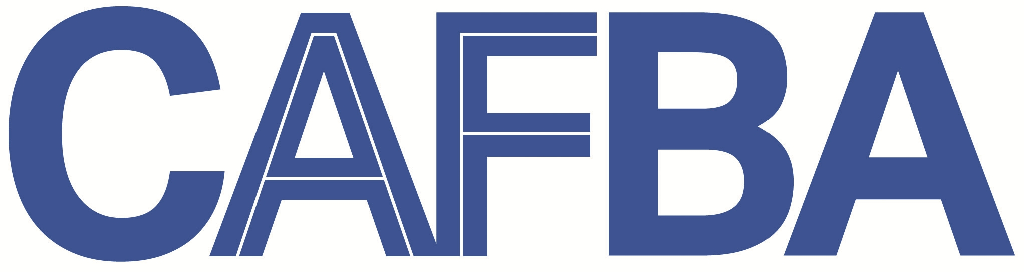 | Commercial Asset Finance Brokers Association of Australia Limited
 | ABN 32 129 490 133
National Professional Body of the Equipment Finance Industry

Small Business Study 15th March, 2013
Productivity Commission
GPO Box 1428
Canberra City ACT 2601

RE: Submission to the Productivity Commission on Regulator Engagement to Small Business

Introduction

The Commercial Asset Finance Brokers Association of Australia Limited (CAFBA) welcomes the opportunity to comment on the study of regulator engagement with small business.

Our submission specifically concentrates on the recent release of the National Consumer Credit Protection Act Phase 2 Credit Bill – Lending to Small Business – the process and consequences of proper regulatory engagement.

About CAFBA

CAFBA is the only professional body in Australia exclusively representing Commercial Equipment Finance Brokers.

The principal activity of our members is securing commercial credit for the acquisition of equipment to be used in a business to earn assessable income.

The majority of our members are small businesses in their own right (under any definition used) and predominantly arrange equipment finance for small business – their clients.

What is the Issue

The introduction of regulations for lending to small business has been mooted since the introduction of NCCP Phase 1, where regulations were introduced in respect to lending to consumers, which CAFBA was generally supportive.

To adopt these rules and regulations for small business owners is however totally unnecessary.

For new regulations to be introduced there should be a valid economic and social justification – in this instance there was not. There was no demonstrated market failure to justify such burdensome regulations on small business. The Governments Regulatory Impact Statement (RIS) stated:

- It is difficult to quantify the cost to industry and the benefit to borrowers
- Not possible to state whether it has a net benefit in monetary terms
- It quite possibly could increase the cost of credit
- Credit may be more difficult to obtain
- There is a risk some lenders may exit the market

The draft legislation required permits to be issued to those arranging (not advising) loans on behalf of small business.

Whilst Treasury was working on NCCP Phase 2, Discussion Groups were held and always attended by CAFBA, however it was felt many of the points raised above and the consequences to small business finance were not being heeded.

Regulators, when engaging in discussions with industry groups should take more notice of the expertise offered and understanding of the issues faced. However subsequent discussion papers seemed to ignore previous concerns – in other words there appeared an agenda to be achieved without listening to advice.

The Issuing of Draft Legislation (Regulations)

It was CAFBA’s understanding the RIS was completed in July, 2012 which signalled draft legislation was imminent. The RIS is meant to set out the rationale for why a piece of legislation is necessary, but in this instance Treasury decided the RIS would not yet be released for consultation. This is disappointing as proper engagement with stakeholders by regulators can not only enhance the final outcome but also give small business confidence in the process.

On the 21st December 2012 the Draft Bill was released (4 days prior to Christmas) with responses due 15th February 2013. This was despite

- Treasury not adhering to the Best Practice Regulation Handbook (page 52 para 13) giving small business sufficient time to respond, and not during recognised holiday periods
- Treasury not following its own protocol by taking the RIS to the Small Business Advisory Committee (SBAC).

Small business requires proper consultation when such far reaching regulations are proposed – as stated The Productivity Commission assists governments make better policies for the long term interest of the Australian Community. This can only be done by following proper procedures that give small business confidence in the processes when new regulation is proposed.

Where are we now

On 13th February Minister Bill Shorten announced the deferral of this legislation for this term of parliament.

It has always been CAFBA’s view that the legislation is unnecessary, will add to the regulatory burden of small business, and make credit to small business both more difficult to obtain and more expensive.

Conclusion

CAFBA has used our recent experience in dealing with the new regulations of the proposed NCCP Phase 2 to highlight the need to have better engagement with small business when implementing regulations that will have far reaching and in some instances unintended consequences (eg this draft legislation would have abolished the hire purchase product to small business for loans under $5mil, which we don’t believe was the intention).

A sensible and workable definition for small business is required for business to understand their compliance obligations.

CAFBA appreciates the opportunity to respond to this submission, and would welcome the opportunity to discuss further on behalf of its small business members.

Yours Faithfully

David Gill
Chief Executive Officer

