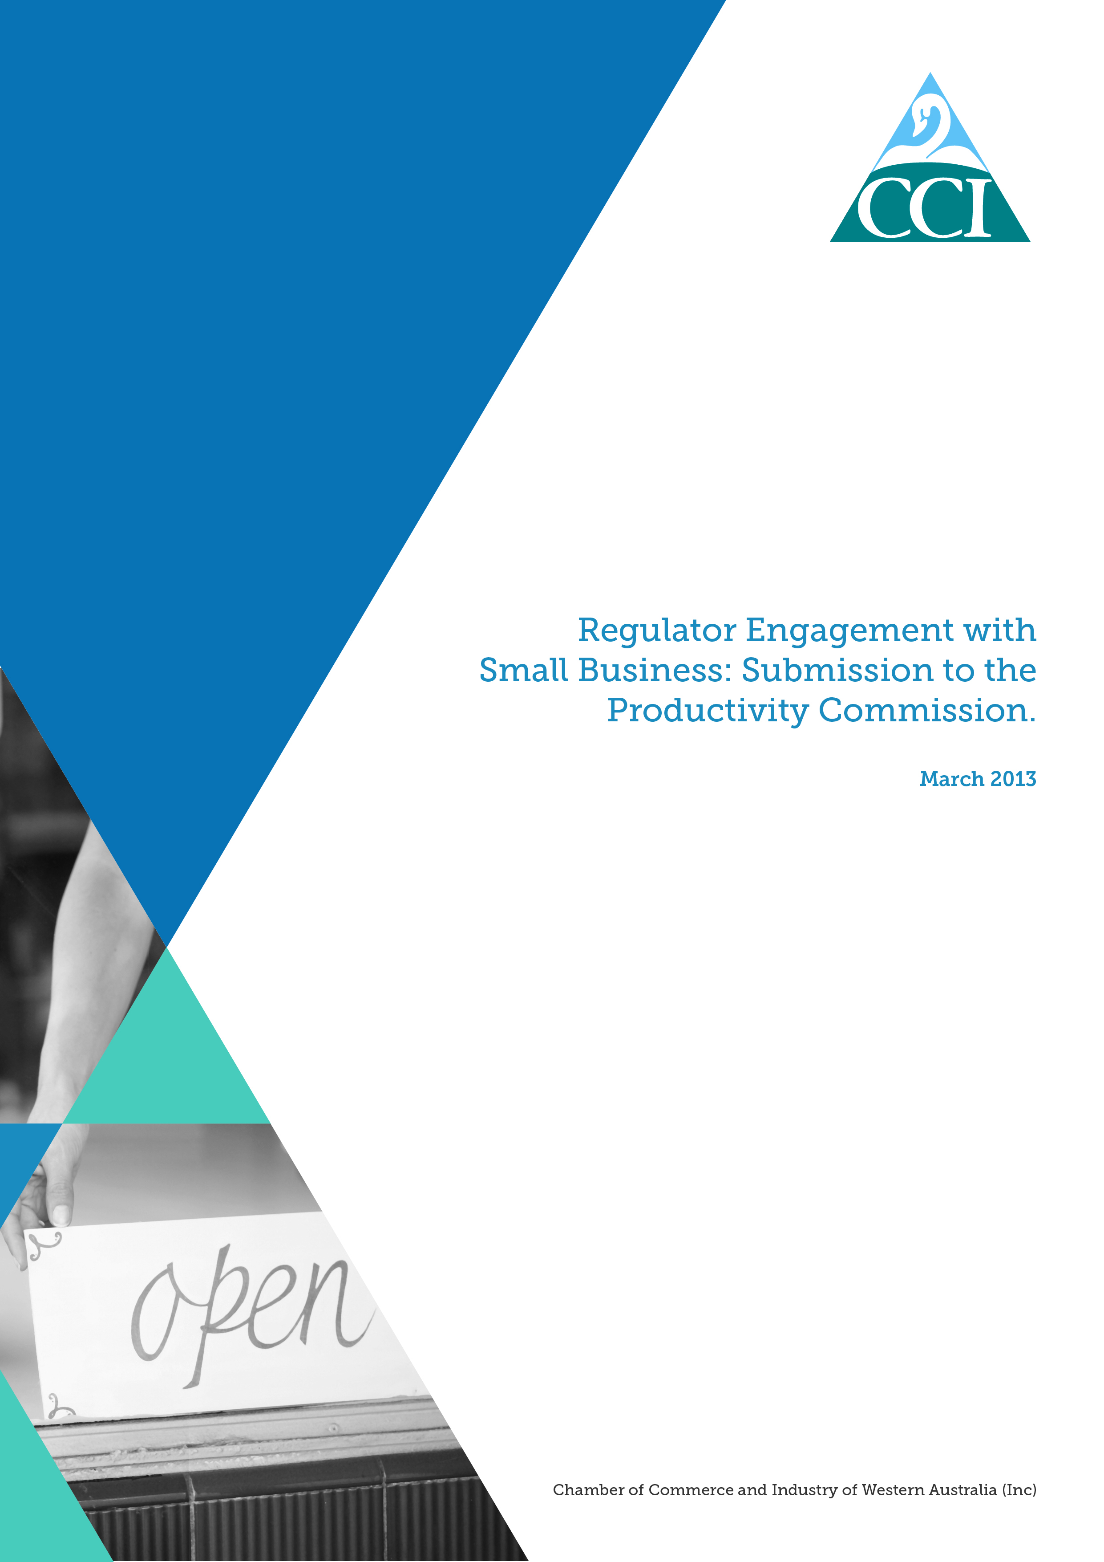

About CCI
CCI is the leading business association in Western Australia and the second largest organisation of its kind in Australia. CCI has a membership of just under 8,000 organisations in all sectors of the economy. About 85 per cent of members are small businesses, and members are located in all geographical regions of Western Australia.

The Small Enterprise Network (SEN) Advisory Panel is made up of CCI’s small business members. The SEN Advisory Panel provides CCI with vital information about the concerns facing small business and has been instrumental in providing feedback on the issues raised in this study.

Introduction
CCI welcomes the opportunity to respond to what is an important study into the way regulators engage with small businesses. Small businesses are a key contributor to the Western Australian economy. There are over 70,000 employing small businesses in Western Australia, which represents 87% of employing businesses in the state.

Regulation is necessary to achieve Government’s social and environmental goals, but poorly designed or excessive regulation can stifle the business community’s ability to adapt to a changing environment, remain competitive and innovative. Understanding how regulation is implemented, enforced, and the subsequent costs on business are an important aspect of reducing the red tape burden and ensuring businesses can continue to grow.

Over recent years there have been a significant number of studies undertaken at the Federal and State level investigating the impact of regulatory structures on business. More recently, CCI released Boosting Australia’s Productivity which identifies a number of reforms to address the regulatory burden on business. Amongst other things, these studies have recognised that whilst there are measures in place to identify areas of regulatory reform, there is still room for improvement.

Regulation is consistently identified by CCI members as having a major impact on their business, particularly among small businesses. Often small businesses will not have the same capacity and resources as large businesses to manage the administrative burden that compliance requires, an issue that has been recognised in some part in the issues paper.

“… Not only that [a clear definition] but a clear understanding of the finite capabilities of these small enterprises by most of the regulators. […] too often the definition causes a misconception of the capacity of a small business to cope with red tape or regulation required to carry out normal business function. Larger businesses have the capacity to carry this cost burden. – Small business owner.

CCI small business members have advised that establishing the necessary administrative processes to manage compliance is most significant, particularly in the time it takes and the monetary cost that goes with it. It is imperative for regulators to understand this issue to ensure that when developing new regulations or amending existing regulations effort is placed on reducing the administrative burden.

The impact of regulation on business has been reflected in a number of studies. Most recently, in a study undertaken by the Australian Chamber of Commerce and Industry (ACCI), some of the key regulatory issues facing business included:
- the time spent complying with regulatory requirements;
- the duplication of information and business reporting requirements;
- the lack of sharing of information between agencies to remove this duplication;
- a lack of consultation with business on regulatory changes; and
- the negative impact compliance is having on the businesses ability to grow.

This submission focuses on three key areas of the issues paper: on the merits of defining small business for the purpose of consistency amongst regulators; how regulator practices can affect small business; and the key cost impositions of regulation on small business.

CCI calls on all parts of government and regulatory agencies to work together to improve the level of engagement with small business, as a means to start removing some of the administrative burden which small businesses face. CCI would welcome the opportunity to work with governments to address this issue.

Regulator practices which affect small business and the cost implications
Defining small business
A common issue which all small businesses face is the inconsistent approach by regulators in the definition of a small business. As Table 2 of the issues paper highlights, there is currently a disjointed approach to defining small business, due in part to the varying regulatory purposes and the differing approaches taken by the three levels of government.

The different approaches to defining small business can increase administration costs for small business by creating duplication, confusion, and limiting the ability to establish streamlined administrative processes. CCI members have indicated that the lack of a consistent definition demonstrates a misunderstanding by regulatory bodies on the way a small business operates particularly in terms of small business’ ability to manage the administrative burden.

“… No real definition creates ambiguity. When regulators become involved they typically set one rule for all, and not all small business/enterprises are the same, nor do they have the same forward outlook. One may be to sustain a suitable and steady income another might be to innovate and grow.” – Small business owner

Examples of some of the issues surrounding the complexity and inconsistent definitions of small business and the impact of this are outlined below.

The main regulator for us is the Australian Tax Office (ATO). Their definition of small business is a 'small business entity', which is an individual, partnership, trust or company with aggregated turnover of less than $2 million. Aggregated turnover is your annual turnover plus the annual turnovers of any business entities you are connected with or are your affiliate. These are referred to as relevant business entities. Your annual turnover includes all ordinary income you earned in the ordinary course of business for the income year. The ATO has in recent years provided consistency around the definition of small business across all areas of tax. This has removed much confusion. – Small business owner

Our main area of contention though is in determining if businesses qualify or not as a small business. Qualifying for Government grants seems to have a whole array of eligibility criteria e.g. Enterprise Connect is only available to businesses with turnover greater than $1.5m (recently reduced from $2m). – Small business owner

Feedback from the SEN Advisory Panel suggests that a consistent approach and interpretation of a definition of small business would be beneficial to small business owners. It would assist in managing the business reporting requirements placed on small business by creating a streamlined approach and it would remove confusion that exists from the differing definitions currently used.

Feedback from CCI members suggests a combined approach, using both turnover and number of employees, for example less than 20 full time equivalent staff and turnover of less than $5 million would be the most appropriate measure.

The role of advice and guidance
An important part of regulator engagement and the experience small business has with regulators is their ability to provide advice and guidance readily and easily. For small business, access to information assists them in their ability to meet regulatory requirements and provides some assurance that they are doing the ‘right thing’.

CCI small business members have indicated that it is often difficult to know where to find relevant information let alone navigate regulator websites to answer their questions or concerns. Feedback from CCI members suggests that members did not receive regular advice or guidance from regulators.

More than half the members of the SEN Advisory Panel indicated that they did not receive guidance or advice from regulators on how to comply with regulations, and a similar proportion felt that this was inadequate. This suggests an environment exists where small business owners are not satisfied with the level of advice or guidance they receive in order to ensure they comply with the relevant regulations.

“AQIS refuses to give advice on how to interpret their regulations. We just have to guess, and wait to see if they allow the shipment or block it.” – Small business owner

In terms of the method of communication, the SEN Advisory Panel indicated that the most common methods of engagement with regulators occurred either; online (61%), phone (61%) or email (53%), and only 23% was face to face. This explains some of the difficulties small business faces in accessing advice from regulators that is specific to their business needs.

“… Pretty much all engagement is through written correspondence with a small percentage of engagement through phone contact.” – Small business owner.
“We have little, if any face to face contact (in fact this can be very difficult to arrange e.g. the ATO as expertise is spread across Australia).” – Small business owner.

CCI believes more can be done in the provision of advice and guidance to small business than currently stands. Using different channels of communication more effectively would go some way to addressing this issue. One way is for regulators to use the networks of the newly created Federal and State Small Business Commissioners as well as the channels which industry associations can provide to make available greater levels of information, and advice for small businesses on regulation issues. It is also important that any information is provided in a way that is simple and easy for small businesses for access. For example, the ACCI Red Tape Survey results showed that 43% of responding businesses want to receive emails directly from regulators on these types of issues.

Business reporting requirements
Business reporting requirements on small business is an area of regulator engagement which can be particularly burdensome and costly. Whilst being a necessary part of compliance with regulations, business reporting requirements can be viewed as cumbersome, often duplicative and unnecessary. Part of the issue was addressed under the need for a consistent definition of small business. A key issue is that business reporting requirements are different across regulators and the inconsistent approach can lead to additional reporting requirements and an increase in the administrative burden. Removing any duplication would assist to alleviate the administrative burden on small business.

“The major difficulty for our business is coping with the additional burden of compliance and reporting the same information … on an ongoing basis.” Small business owner

The ACCI Red Tape Survey identifies some examples where duplication exists for businesses in Western Australia:
- Payroll tax – when operating in more than one Australian jurisdiction information is repeated;
- Planning applications – where State and Local government authorities seek similar information; and
- Environmental regulations – both Federal and State Environment Protection Authorities collect similar information.

There are opportunities for regulators to reduce the burden of business reporting requirements on small business. CCI would welcome an approach in which regulators can share information which small businesses already provide to meet their regulatory requirements. The ACCI Red Tape Survey found 44% of those who responded would support an agreement that allowed all levels of government to share their business information with each other to remove unnecessary duplication. Only 19% did not support this proposal.

A good approach demonstrating how Western Australian state government agencies can share information and work together is the recently released Environmental Assessment and Regulatory System (EARS). This system is being rolled out across a number of agencies involved in the approvals process and forms part of the lead agency framework. It is used for submitting and tracking environmental applications and compliance reporting for project approvals. This means that businesses only need to provide information on their approval to one agency as this is then shared across a number of agencies required to approve the application. In addition, this system allows businesses to see at what stage of the approval process their documentation is and at which agency.

CCI believes that there is scope for agencies and regulators at all levels of Government to look for further options to share small business information as a way to reduce the administrative burden of business reporting.

Cost of compliance
There will always be costs to business when complying with regulation. Importantly, where possible those costs should be avoided or lessened to ensure the burden on business is not such that growth is stifled.

Costs to small business are more common in the form of time than money. The SEN Advisory Panel identified administration as most time consuming and diverting them from their everyday business needs.

This was also reflected in the 2012 ACCI Red Tape Survey, which found that of those which responded 41% of businesses spent one to five hours per week complying with regulations and in the past two years the time it takes to comply has increased. 40% of respondents said complying with government regulatory requirements impact negatively on their business and interestingly the most costly part of compliance is in implementing the compliance obligations and practising these in their business (35%). The survey also found that in the past two years the overall cost of compliance had increased (81% of respondents) and the estimate of this overall cost was between $10,001 - $50,000 (31% of respondents).

CCI has long advocated for the need to reduce the regulatory burden on business, both large and small. Costs of red tape reduce the ability of businesses, particularly small businesses to grow and respond to the changing business environment. CCI supports working with regulators to identify ways in which to reduce the regulatory burden on small business, and has set out a number of key reform priorities for all levels of government in its Boosting Australia’s Productivity and the State Election Blueprint.

Consultation on changes to existing or new regulations
Another area which can impact small business greatly is when changes are made to existing regulations or new regulations are proposed. Regulators need to ensure businesses are consulted to ensure the full costs of new regulation are taken into account. All too often, small businesses are not aware of regulatory changes which can have a direct and in some cases serious effect on the operation of their business.

When the SEN Advisory Panel was consulted, it was clear that consultation by regulators created concern and frustration. The majority of Panel members felt they were not adequately informed or consulted on regulatory changes. These views are backed up by findings from the ACCI Red Tape Survey, where Western Australian businesses which responded to the question ‘how do you find out about changes in regulation that affects your business’ reported 54% received information from their local/state chamber of commerce, 54% directly from the regulator/agency and 53% sought our information themselves. When asked a follow up question about their preferred method of finding out information, 43% of respondents said ‘receiving emails from the regulator/agency directly’, 39% said ‘receiving emails from the local/state chamber of commerce/industry association’.

These results suggest a more coordinated and concerted effort to provide advice, guidance and information about regulatory changes need to be made to ensure that small businesses are able to respond to the changing environment.

CCI believes there are opportunities for regulators to improve consultation with business on changes to existing regulation or developing new regulations. One option may be to further use industry association channels and the newly created Federal and State Small Business Commissioners to engage with small businesses on these issues. .

Australian Bureau of Statistics, catalogue no. 8165.
Productivity Commission, 2012, Regulator Engagement with Small Business Issues Paper, p. 11.
ACCI Red Tape Survey 2012.
Will not add up to 100% as more than one option could be selected.
ACCI Red Tape Survey 2012.
ACCI Red Tape Survey 2012.
ibid.
Ibid.
ACCI Red Tape Survey 2012.

