Superannuation Efficiency and Competitiveness
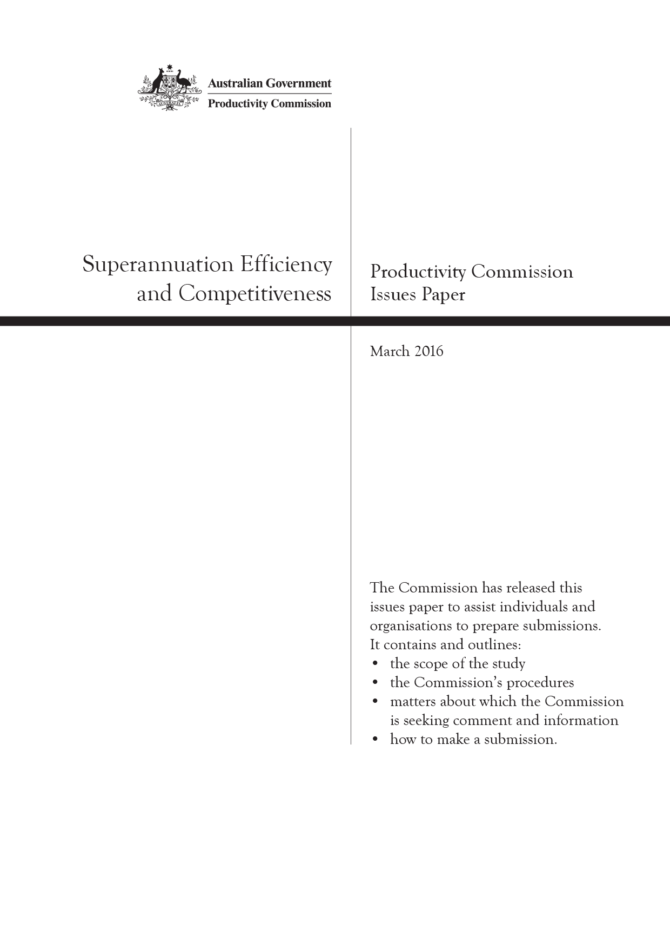
Productivity Commission Issues Paper, March 2016

The Issues Paper
The Commission has released this issues paper to assist individuals and organisations to prepare submissions to the study. It contains and outlines:
- the scope of the study
- the Commission’s procedures
- matters about which the Commission is seeking comment and information
- how to make a submission.
Participants should not feel that they are restricted to comment only on matters raised in the issues paper. The Commission wishes to receive information and comment on issues which participants consider relevant to the study’s terms of reference.
Key study dates
Receipt of terms of reference | 17 February 2016
Due date for submissions | 20 April 2016
Release of draft report | August 2016
Final report to Government | November 2016
Submissions can be lodged
Online: | www.pc.gov.au/inquiries/current/superannuation/competitiveness-efficiency
By post: | Superannuation  Productivity Commission  Locked Bag 2, Collins St East  Melbourne VIC 8003
Contacts
Administrative matters: | Yvette Goss | Ph: 03 9653 2253
Other matters: | Mary Cavar | Ph: 03 9653 2187
Freecall number for regional areas: | 1800 020 083
Email: | super@pc.gov.au
Website: | www.pc.gov.au

The Productivity Commission
The Productivity Commission is the Australian Government’s independent research and advisory body on a range of economic, social and environmental issues affecting the welfare of Australians. Its role, expressed most simply, is to help governments make better policies, in the long term interest of the Australian community.
The Commission’s independence is underpinned by an Act of Parliament. Its processes and outputs are open to public scrutiny and are driven by concern for the wellbeing of the community as a whole.
Further information on the Productivity Commission can be obtained from the Commission’s website (www.pc.gov.au).

Terms of reference
EFFICIENCY AND COMPETITIVENESS OF THE SUPERANNUATION SYSTEM
I, Scott Morrison, Treasurer, pursuant to Parts 2, 3 and 4 of the Productivity Commission Act 1998, hereby request that the Productivity Commission conduct: a study to develop criteria to assess the efficiency and competitiveness of the superannuation system; and an inquiry to develop alternative models for a formal competitive process for allocating default fund members to products.

Background
An efficient superannuation system is critical to help Australia meet the economic and fiscal challenges of an ageing population. The superannuation system has accumulated over $2 trillion in assets. Given the system’s size and growth, the system is of central importance to funding the economy and delivering retirement incomes.
MySuper has been a strong step in the right direction but more needs to be done to reduce fees and improve after-fee returns for fund members. The Financial System Inquiry noted that fees have not fallen by as much as would be expected given the substantial increase in the scale of the superannuation system, a major reason for this being the absence of consumer-driven competition, particularly in the default fund market.
These Terms of Reference follow from the Government’s response to Financial System Inquiry Recommendation 10 on efficiency in superannuation. The Government committed to tasking the Productivity Commission to develop and release criteria to assess the efficiency and competitiveness of the superannuation system, including the choice and default markets and to develop alternative models for allocating default fund members to products.
This work will inform a review of the efficiency and competitiveness of the superannuation system, which the Productivity Commission will be asked to undertake following the full implementation of the MySuper reforms (after 1 July 2017).

Process
The Productivity Commission is to develop criteria to assess the efficiency and competitiveness of the superannuation system and release the criteria within nine months of receiving these Terms of Reference. The release of these criteria is intended to provide transparency and certainty to the superannuation industry about how it will be assessed ahead of the full implementation of MySuper.
The Productivity Commission is to develop alternative models for a formal competitive process for allocating default fund members to products. In developing alternative models, the Productivity Commission should be informed by the criteria it develops to assess the efficiency and competitiveness of the superannuation system. The Productivity Commission should report on alternative models within 18 months of receiving these Terms of Reference.
For both elements, the Productivity Commission should consult widely and undertake appropriate public consultation processes, including inviting public submissions and conducting industry roundtables. The Productivity Commission is to provide both draft and final reports and the reports will be published.

Scope of study: development of criteria to assess efficiency of super system
The Productivity Commission should develop criteria to assess whether and the extent to which the superannuation system is efficient and competitive and delivers the best outcomes for members and retirees, including optimising risk-adjusted after fee returns. In determining the criteria to assess the efficiency and competitiveness of the superannuation system, the Productivity Commission may have regard to:
- operational efficiency, where products and services are delivered in a way that minimises costs and maximises value, which can be enhanced by competition and innovation from new entrants and incumbents;
- allocative efficiency, where the system allocates resources to the most productive use and optimally allocates risks;
- dynamic efficiency, including services to members, where the system induces the optimal balance between consumption and saving over time; and
- the extent to which the system encourages optimal behaviour on the part of consumers, including consideration of the learnings from behavioural finance.
The Productivity Commission should consider the nature of competition in the superannuation industry, the effect of government policy and regulation on the competitiveness and efficiency of the system and relevant international experience.

Scope of inquiry: development of alternative models
The Productivity Commission is to examine alternative models for a formal competitive process for allocating default fund members in the superannuation system to products and to develop a workable model, or models, that could be implemented by Government if a new model for allocating default fund members to products is desirable. These model(s) would provide viable alternatives for the Government’s consideration, depending on the outcomes of the review of the efficiency and competitiveness of the superannuation system, which the Productivity Commission will be asked to undertake following the full implementation of the MySuper reforms.
The developed model(s) should enhance efficiency in the superannuation system in order to improve retirement incomes, including through optimising long-term net returns to members, and build trust and confidence in funds regulated by the Australian Prudential Regulation Authority (APRA). The models developed should consider default fund selection across the superannuation system as a whole.
The Productivity Commission may consider auction, tender and other types of competitive processes. The Productivity Commission should consider the merits of different approaches, the metrics for conducting them and their frequency. This should include consideration of:
- the strengths and weaknesses of competitive processes used internationally, such as Chile, New Zealand and Sweden, as well as those used in large corporate tenders by the Northern Territory Government and in other jurisdictions;
- the costs and benefits of different mechanisms, including:
- optimising long-term after fee returns;
- the administrative, fiscal, individual and complexity costs;
- and in examining different processes, consider:
- the robustness of the process, including against gaming and collusion;
- whether the structure achieves efficient outcomes and facilitates ongoing innovation over the long run;
- the effect on system stability and market concentration;
- who should run the process; and
- the extent to which the process promotes the interests of consumers.
- regulatory impediments to optimal competition under the preferred model(s).
Principles for designing a model for a competitive process should include:
- Best interests: ensure incentive compatibility with meeting the best interests of members, encourage long-term investing, and encourage a focus on expected after-fee returns based on asset allocation and investment strategy.
- Competition: drive pressure on funds to be innovative and efficient, diversify asset allocation and optimise long-term after-fee returns by rewarding best performers. Facilitate new superannuation fund entrants to the market.
- Feasibility: ensure the process is low-cost and easy to administer and minimises regulatory costs on industry, including business and employers.
- Credibility and transparency: make relevant information public; avoid room for gaming the process; and ensure metrics are clear, simple, difficult to dispute and difficult to manipulate.
- Regular assessment and accountability: regularly conduct a repeat process that requires default funds to earn their right to receive new default members, and ensure funds are accountable for the outcomes they deliver members.
- Fiscal implications: the extent to which the process can reduce reliance on the Age Pension and/or give rise to other risks or costs to Government.
The Productivity Commission should draw on expertise in the field of competitive models.
S. MORRISON
Treasurer
[Received 17 February 2016]

Contents
Terms of reference iii
1 What is this study about? 1
2 Superannuation in Australia 3
3 What is the Commission’s approach to assessment? 8
4 Assessing competitiveness 15
5 Assessing efficiency of the superannuation system 19
References 29
Attachment A: How to make a submission 31

1 What is this study about?

Background
This study stems from the Australian Government’s response to the recommendations of the 2014 Financial System Inquiry (the FSI). The FSI found that the superannuation system was not operationally efficient due to a lack of price-based competition in the sector, with the result that potential benefits of scale were not being realised (despite the introduction of MySuper). The FSI recommended a review of the competitiveness and efficiency of the superannuation system by the Productivity Commission (the Commission), to be undertaken in three stages.
The Australian Government, in its response to the FSI, committed to tasking the Commission to review the efficiency and competitiveness of the superannuation system following the full implementation of the MySuper reforms (that is, after 1 July 2017). In the interim, and to inform the review and provide transparency and certainty to stakeholders, the Commission has been tasked to develop the criteria to assess the efficiency and competitiveness of the superannuation system (stage 1 — the study).
The Australian Government has also tasked the Commission with examining alternative models for a formal competitive process for allocating default fund members to products (stage 2). The stage 2 inquiry will involve a separate process and will commence in the second half of 2016. Indicative timelines for the three tasks are shown in figure 1. Both stages 1 and 2 will inform the Commission’s inquiry to review the efficiency and competitiveness of the superannuation system (stage 3).

Figure 1 Indicative timelines for Commission superannuation projects
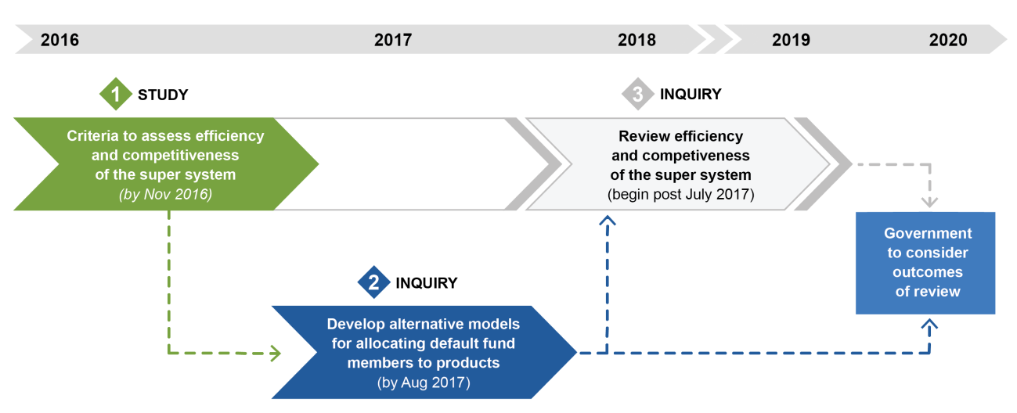

What has the Commission been asked to do?
In this study, the Commission has been asked to develop criteria to assess whether, and the extent to which, the superannuation system is efficient and competitive and delivers the best outcomes for members and retirees, including whether it optimises risk-adjusted after-fee returns. In determining the criteria to assess the efficiency and competitiveness of the superannuation system, the Productivity Commission may have regard to:
- operational efficiency, allocative efficiency and dynamic efficiency
- the extent to which the system encourages optimal behaviour on the part of consumers
- the nature of competition in the superannuation industry
- the effect of government policy and regulation on the competitiveness and efficiency of the system.

The Commission’s approach
This study will develop criteria for a future assessment of the efficiency and competitiveness of the superannuation system. The study will not evaluate the current performance of the superannuation system.
As required by the terms of reference, the study will focus on assessment criteria for the ‘superannuation system’, rather than just for the superannuation industry. The superannuation system is a broader concept than conventional definitions of the superannuation industry, encompassing many horizontal and vertical relationships on the supply side. It includes the demand side — the decisions of users of the system — and is also affected by the overarching government policy affecting both supply and demand.
The study will develop the assessment framework to ultimately (in stage 3) assess the competitiveness and efficiency of the superannuation system. In developing the assessment criteria the Commission will consider how current policy settings impede or constrain the competitiveness and efficiency of the system, and may take this into account in calibrating the criteria where relevant.

How you can contribute to this study
The Commission will consult through stakeholder visits, issue-based roundtables and accepting submissions from all interested parties.
The Commission encourages submissions on issues relevant to the study’s terms of reference. As a guide to participants in preparing submissions, this issues paper provides background material and information on relevant issues that the Commission has identified, and a number of questions. It is not a requirement that participants answer all the questions, restrict their submissions to the questions identified, or present their submissions in a question and answer format. However, the Commission strongly requests that submissions focus on the terms of reference for this study. There will be opportunities to make further submissions following the release of the draft report, and for the second and third stages of the superannuation references once they have commenced.
Submissions should be provided to the Commission by Wednesday 20 April 2016. Attachment A provides further details on how to make a submission.

2 Superannuation in Australia

Three pillar system
Australia has a three-pillar retirement income system consisting of a government-funded and means-tested age pension, compulsory saving through the superannuation guarantee and voluntary saving (including voluntary superannuation contributions). The policy settings across the retirement income system impact the equity and efficiency outcomes of the retirement income system.
The superannuation guarantee was introduced in 1992 and has progressively increased from the original 3 per cent of employee earnings to its current rate of 9.5 per cent (ATO 2015a). In addition to compulsion, there are tax concessions to encourage voluntary contributions.

Objectives of the superannuation system
The Australian superannuation system lacks a set of clearly articulated policy objectives. The FSI recommended that the Australian Government seek broad agreement and articulate in legislation a high-level objective of the system ‘to provide income in retirement to substitute or supplement the Age Pension’ (Murray et al. 2014, p. 95). The FSI also listed several subsidiary objectives. In its response, the Australian Government (2015, p. 5) committed to ‘enshrine the objective of the superannuation system in legislation. This will help align policy settings, industry initiative and community expectations.’ The Government has initiated a separate process to consult on the objectives of superannuation (Australian Government 2016). These policy objectives pertain to the role of superannuation as a part of the broader retirement income system and related policies. The outcome of this process may inform the Commission’s future work.
This Productivity Commission study will develop criteria to ultimately assess (in stage 3) the efficiency and competitiveness of the superannuation system. In doing so, the study will consider the effect of current policy settings on the competitiveness and efficiency of the superannuation system. What is efficient ultimately depends on what you are trying to achieve: the system objective(s). Clear objectives are essential for the development of assessment criteria. For the purposes of this study, the Commission has defined the objective of the superannuation system as delivering the best outcomes for members and retirees (figure 2). In subsequent sections, the Commission has given examples of, and sought feedback on, some more granular system-level objectives and how they inform the development of assessment criteria.

Question on system EFFICIENCY Objectives
Within the current policy settings, what are the objectives against which the efficiency and competitiveness of the superannuation system should be assessed? How prescriptively should the objectives be expressed?

Figure 2 The superannuation system — a hierarchy of objectives
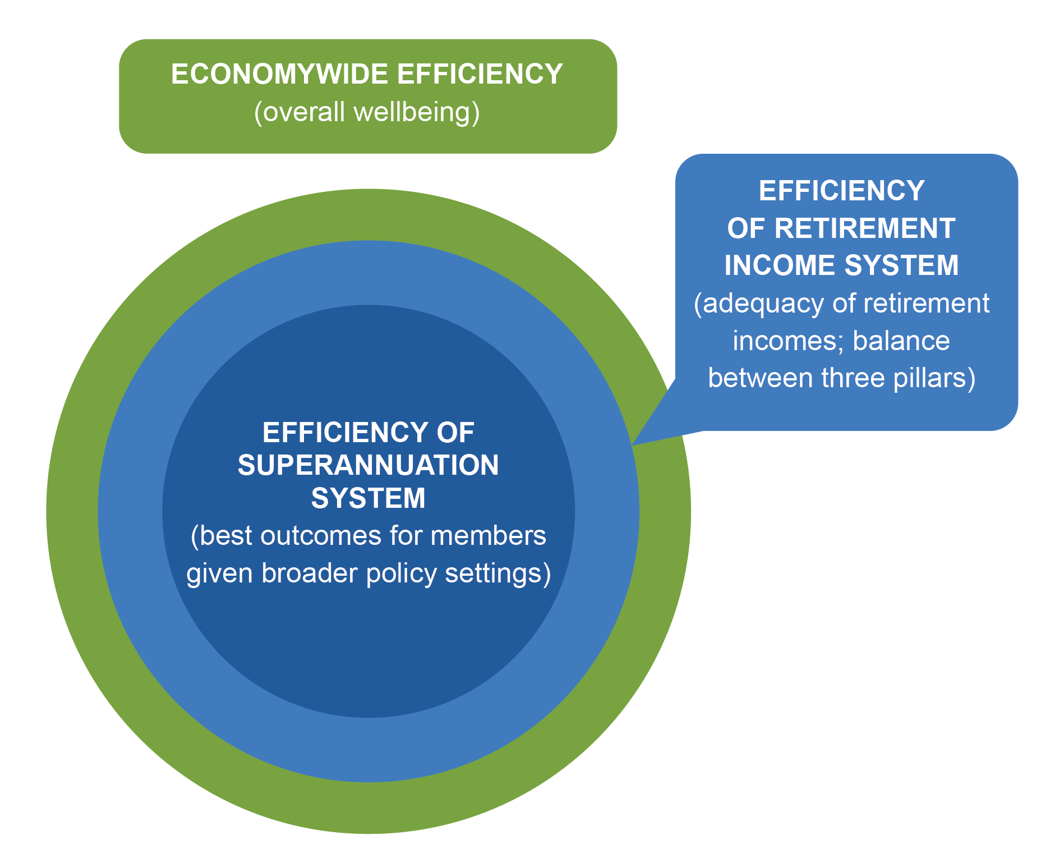

Superannuation — not a standard market
The superannuation system is complex, involving a diverse mix of participants and encompassing many horizontal and vertical relationships (figure 3). This paper will raise issues with respect to the system as a whole. However, the Commission welcomes input on efficiency and competitiveness criteria that may apply specifically to particular segments of the system.

Figure 3 A map of the superannuation system
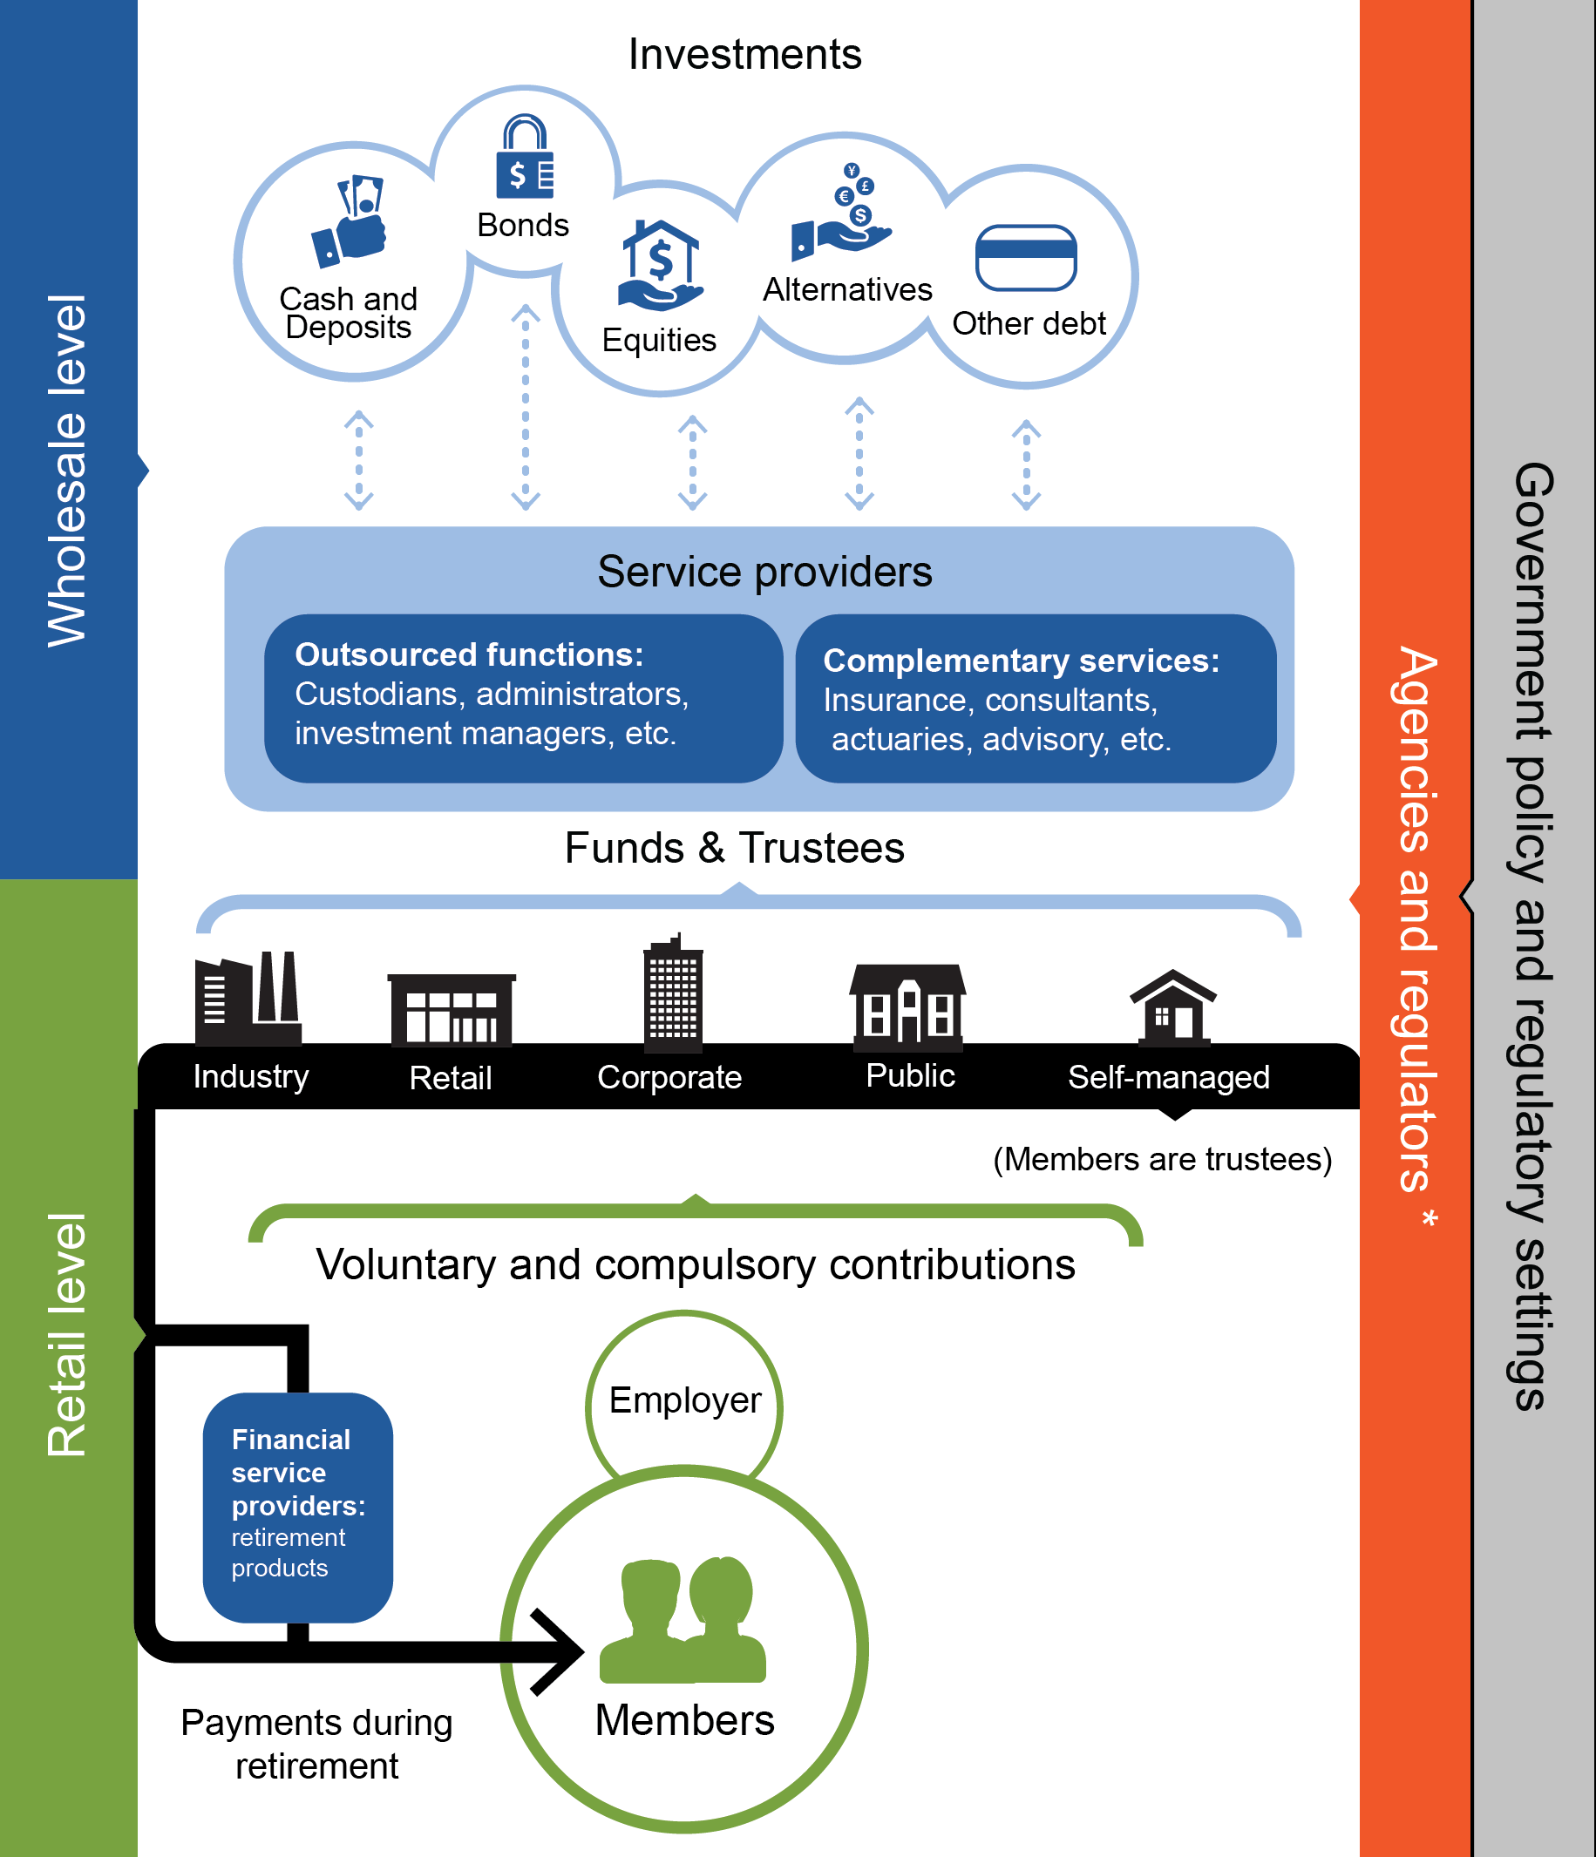

* APRA, ASIC, ATO, ACCC, RBA
Any assessment of the superannuation system needs to be cognisant of the many unique features of the market on both the demand and the supply sides. Those factors materially affect the nature of competition and the drivers of efficiency within the system.

Policy-driven demand and disengaged consumers
The demand for superannuation services is, in large part, driven by government policy. The Superannuation Guarantee mandates a minimum level of saving. Other policies — in particular the Age Pension and welfare safety nets — affect the incentives of members to be engaged and make sound and well-informed decisions.
There are other impediments to optimal decision making. Many of the decisions are inherently complex, particularly during the accumulation stage, and there is also evidence of various behavioural biases and constraints, such as a lack of financial literacy, myopia, loss aversion, reliance on mental shortcuts, a tendency to procrastinate and even general apathy (Gerrans and Yap 2013; PC 2012, 2015).
The net result is strong growth in superannuation funds under management but disengaged members diluting competitive pressure on superannuation funds to reduce costs or improve their service offerings, especially in the accumulation stage. The general disinterest of many members (Murray et al. 2014) is also reflected in high reliance on various default options in the superannuation system, where a choice is made for someone in the absence of an active decision. Default options cover decisions on the choice of fund and product, as well as the bundling of various ancillary services, such as insurance.
That said, there is a cohort of people who are engaged in superannuation decisions, for example by managing their own superannuation fund, or by actively managing their investments in the choice segment of the superannuation market. Thus, the nature and levels of competition may differ in different segments of the market.

Supply side — a complex regulatory landscape
On the supply side, there is a range of fund types. Most superannuation assets are held in accounts with ‘large’ funds, consisting of industry, public sector, corporate and retail funds, with differences in how these funds operate and are governed. A separate regulatory regime applies to the growing number of Australians that have opted to manage their own superannuation through self-managed super funds (SMSFs) and who undertake many administrative and investment functions more directly.
Outside of the SMSF sector, it can be difficult for new funds to enter the market. Among other things, this is because a large amount of funds under management may be needed to compete with incumbent funds in terms of costs, and funds may need to establish a reputation to attract members and employers. Regulatory requirements, particularly those governing capital holdings, may also play a role. Combined with the disengagement of many members, ‘default’ status in existing employment arrangements may also be a factor discouraging new competition.

Principal–agent relationships abound
Both the supply and demand sides of the superannuation system contain many ‘principal–agent’ relationships. For example, employers often select a default fund on behalf of their employees, and many funds outsource administrative functions and investment decisions to a number of specialist providers. Such relationships can give rise to problems if the agent does not have an incentive to act in the best interests of the principal (PC 2012). A lack of transparency can compound this.

The system is dynamic
The superannuation system has undergone significant change over the last decade (figure 4), and will continue to develop and evolve. The system is not expected to reach maturity until the late 2030s, when workers retire after a full working life of superannuation contributions. This has implications for the efficiency and competitiveness of the system.
- Average balances are expected to continue growing, as workers spend longer periods of time accumulating superannuation before drawing upon it. This will affect the role of superannuation in funding the retirement of older Australians and could have broader behavioural implications for people’s life-cycle financial planning.
- The total size of superannuation balances will also continue to grow as the system matures, with broader implications for the financial sector and further elevation of superannuation’s relative importance in the financial system.
- Several trends point to growing scope to realise economies of scale, including through the growth of total funds under management, and the development and growth of platform investment services that enable smaller funds to access such economies.
- As more people reach retirement and draw upon their funds, the range of retirement products offered by funds should increase to meet demand.
- As the SMSF sector continues to grow, there could be further implications for the superannuation system overall, including a possible change in the nature and extent of competitive pressures within the system.
- Policy changes (including tax changes) are frequently considered by government, making it likely that architectural features of the system will continue to change.
- The MySuper reforms are still being implemented, and are expected to reduce costs (and fees) in the market for default superannuation.

Figure 4 Key developments in the superannuation systema
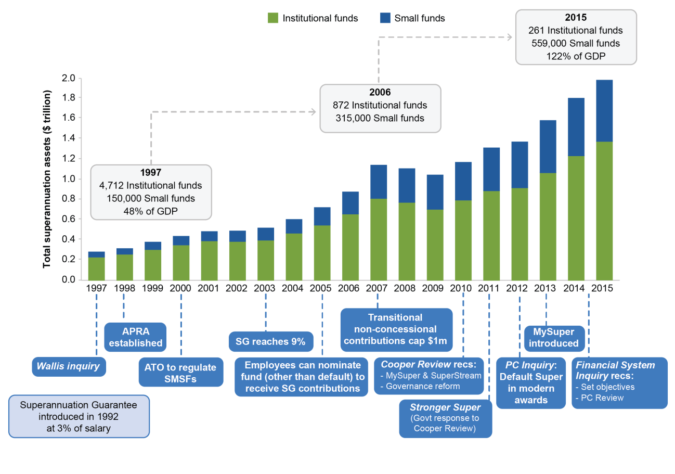

a ’Institutional funds’ comprise corporate, industry, public sector and retail funds. ‘Small funds’ comprise small APRA funds, single-member approved deposit funds and SMSFs.
Data sources: APRA (2007, 2014, 2016).

3 What is the Commission’s approach to assessment?
The Commission’s approach involves three steps:
- imputing objectives for the superannuation system — these are framed in the context of system competitiveness and efficiency
- formulating assessment criteria — these are performance standards by which we assess if the objectives have been achieved
- identifying indicators and other evidence to facilitate assessment (figure 5).
As noted earlier, when calibrating assessment criteria, the Commission may consider how current policy settings impede or constrain the competitiveness and efficiency of the system. For example, the adequacy of total saving rates may be considered beyond the influence of the superannuation system, but the adequacy of voluntary superannuation contributions would be considered more tractable. This approach focuses the current study on developing criteria that are within the influence of the system, without precluding the Commission from assessing the effect of policy on competitiveness and efficiency of the system in the stage 3 inquiry.

Figure 5 A broad schema of the Commission’s approach
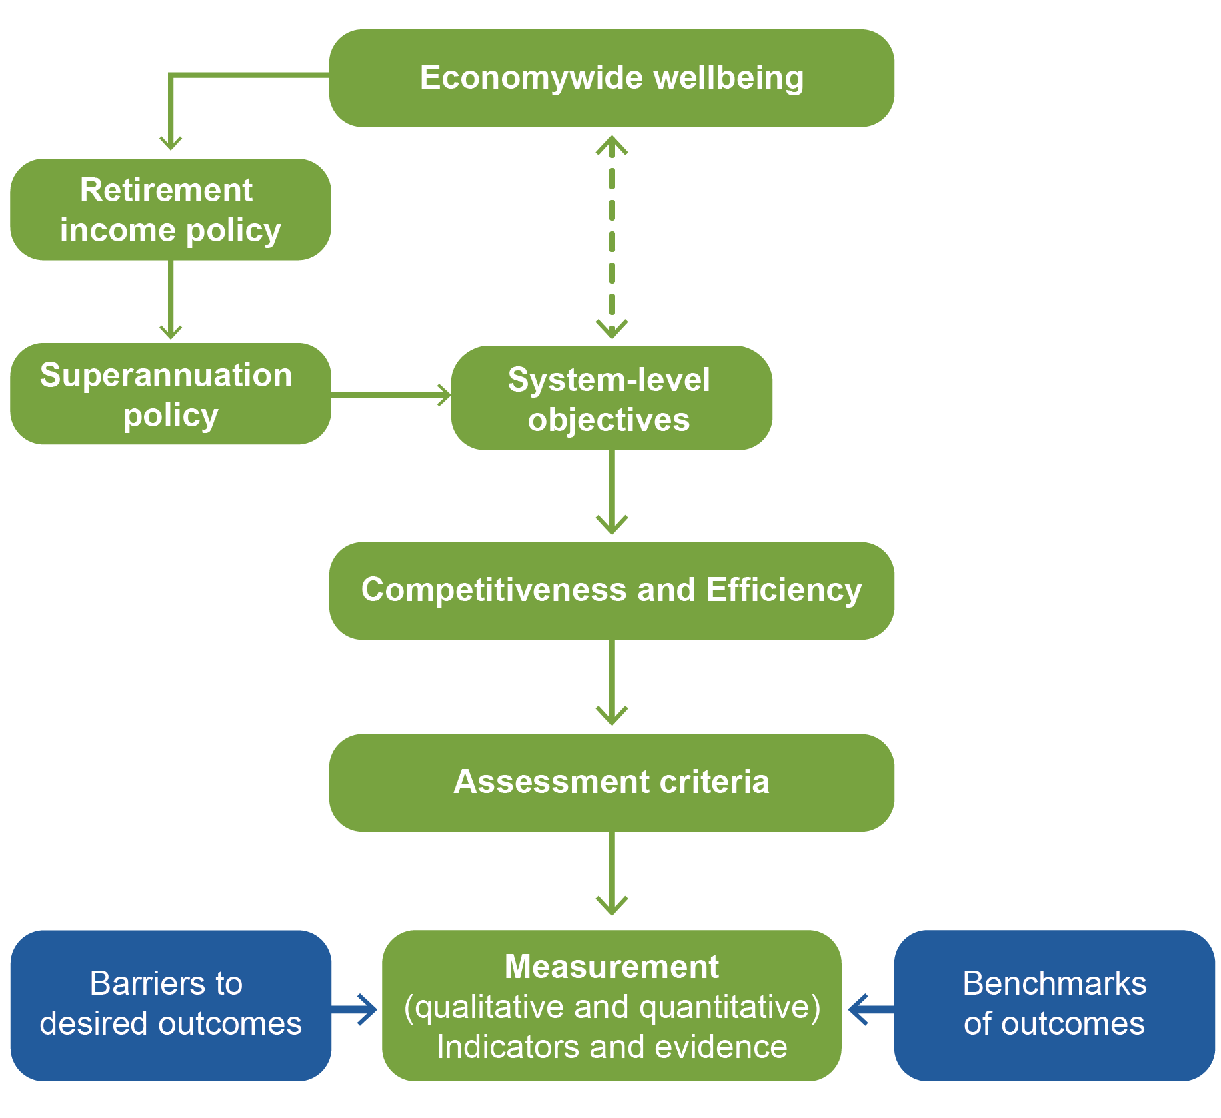

There are two complementary approaches to performance assessment: an analysis of the system’s actual performance against a set of benchmarks, and an assessment of barriers to better outcomes or causes of poor outcomes.

Benchmarking
Benchmarking is a commonly used assessment tool aimed at identifying and encouraging best practice with respect to particular performance criteria (SCRGSP 2016). The benchmarks could be drawn from a number of sources, including, for example:
- particular segments of the superannuation industry (panel or cross-sectional data)
- comparable industries in Australia or overseas (panel or cross-sectional data)
- a time series comparison of outcomes within the Australian superannuation system
- performance of the superannuation system against its own objectives.
The benchmarking methodology could range from a simple comparison of particular indicators to more sophisticated modelling techniques that incorporate multiple factors, such as data envelopment analysis or stochastic frontier analysis.
Benchmarking could offer a number of advantages, in particular by providing objective, transparent results that are relatively simple to interpret. However, this approach also has implementation challenges, and in some circumstances may not be appropriate. There can be problems with data availability or reliability, and it may be impossible to represent some aspects of the superannuation system’s performance (for example, the degree to which the industry’s services and outputs reflect member preferences) through simple quantitative metrics.

Assessing the barriers to competition and efficiency
A complement to benchmarking involves an assessment of the policy and market barriers to competition and efficient outcomes. This approach, described by the Treasury (2014, p. 50) as the ‘negative test’, is largely qualitative and may not generate definitive conclusions on its own. However, it can allow an examination of inefficiencies that are difficult to assess using benchmarking and, by looking at the source of those inefficiencies, would provide policy-relevant results. This approach is also consistent with how competition analysis is typically conducted (discussed below).
The Commission proposes to use both approaches in framing its assessment criteria. However, the relative importance of each may differ depending on which aspect of competitiveness or efficiency is being assessed.

Choosing assessment criteria and indicators
The Commission is seeking participant input on the choice, formulation and application of assessment criteria and indicators. The indicators could be based on a combination of inputs, outputs and outcomes of the superannuation system (box 1).

Box 1 Performance indicators — inputs, outputs and outcomes
Performance indicators can be expressed as outcomes that are linked to the overall objectives of the system. These range from indicators that effectively replicate the system objectives, to subordinate indicators, such as behavioural outcomes that affect the ultimate outcome. An example of an outcome-based indicator is a measure of the extent to which the superannuation system contributes to a person’s financial security over their life cycle. An example of a behavioural outcome is the level of consumer engagement with the superannuation system. While there are benefits in closely linking the assessment to the system objectives, there may also be challenges in measuring outcomes formulated at a very high level. Furthermore, outcomes can be influenced by other factors outside of the superannuation system, so the assessment may not directly reflect the performance of the system.
An alternative approach is to express indicators as more specific outputs of the superannuation system. One example is the risk-adjusted rate of return on investment. Using such proxies for outcomes could make assessment more tractable and focused on the superannuation system, as well as improve overall transparency and certainty for the superannuation sector. However, there are also risks that outputs are less reflective of the system objective, and some outputs (such as the risk-adjusted rate of return) may be difficult to measure.
At the other end of the spectrum, indicators can be expressed as processes or inputs into the superannuation system. For example, particular governance rules are an input into the operation of the system and outcomes for members. Using inputs as indicators could simplify assessment and bring it further within the scope of what can be influenced by system participants. However, it would also distance the subsequent assessment from the end goal of the system.
Trade-offs in the choice of indicators
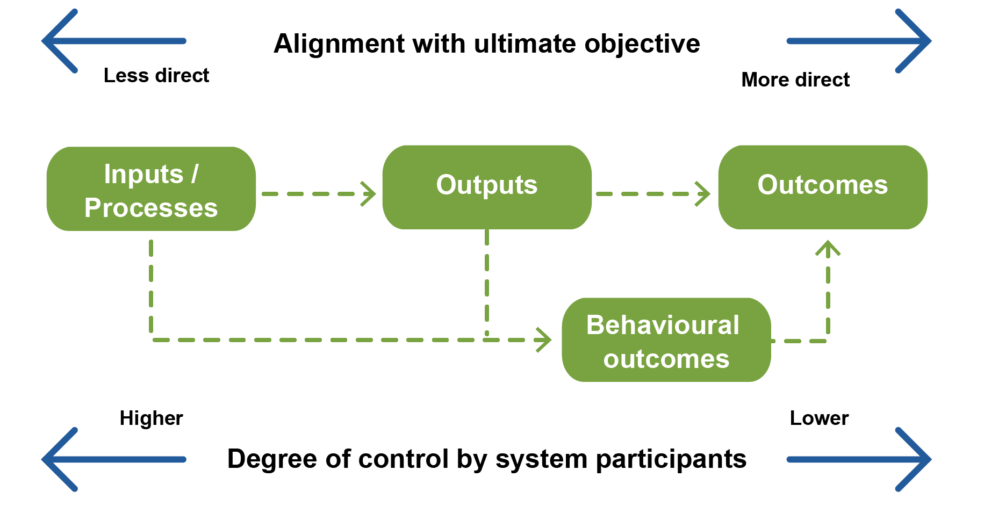
The Commission will likely draw on multiple indicators, some of which will be quantitative while others will be qualitative. The assessment would also need to assign weights or priorities to particular indicators on the basis of their relevance to objectives and evidentiary value. There are a number of methodologies that the Commission may draw on, including the Sparrow Tiered Performance Framework (Sparrow 2000) and multi-criteria analysis (Argyrous 2010; Dodgson et al. 2009).
Whatever indicators are selected, their interpretation is of fundamental importance. For some indicators, there would be ambiguity, and using a single indicator could lead to misleading conclusions. For example, low member switching between products and funds could indicate either member satisfaction (a positive outcome) or disengagement (a potential problem).
The availability of evidence is a key consideration both in the choice and subsequent application of the performance indicators. Past work by other researchers (Chant, Mohankumar and Warren 2014; SuperRatings 2015) and the Commission’s preliminary research indicate that there might be gaps and reliability issues with the evidence in some areas, such as the levels and composition of member fees and comparability across different investment options. There may also be issues with the comparability of data. One example is the comparability of data relating to SMSF and institutional funds due to differences in regulatory regimes and reporting requirements.
One of the objectives of this study is to identify the current gaps and other issues with the evidence so that they can be addressed to the greatest possible extent in advance of the Commission’s foreshadowed inquiry to review the system’s competitiveness and efficiency after July 2017.
The Commission may draw on other reviews for guidance on potential assessment criteria and indicators. There are several composite indexes comparing pension system performance across countries, published by the industry and other bodies (box 2). While such indexes may contain some relevant information, there are also challenges in applying them to the Commission’s task. In particular, the Commission has not identified any indexes that apply an efficiency and competitiveness framework to the assessment. Furthermore, the indexes generally focus on the performance and retirement adequacy of pension arrangements generally, rather than the performance of the system itself.
There are also a number of ratings services that seek to assess and compare the performance of Australian superannuation funds and/or products. Those tools have a narrower focus than this study (as they do not have a system-wide perspective), but the Commission may draw on particular elements in developing its criteria and indicators.

Box 2 Some composite measures of pension system performance
Melbourne Mercer Global Pension Index
The Melbourne Mercer Global Pension Index (MMGPI) has been produced annually since 2009.
In 2015, the MMGPI measured 25 retirement income systems against more than 40 indicators. These comprise a collection of ‘yes’ or ‘no’ questions, percentages, and other values, which are transformed and aggregated into scores out of 100 for three sub-indexes, comprising:
- adequacy (40%) — the capacity of the system to generate adequate retirement incomes (indicators include the minimum and average pension relative to wages, and whether contributions are taxed concessionally)
- sustainability (35%) — the long-term viability of the system in the face of fiscal and demographic considerations (indicators include the proportion of the working age population that are members of private pension plans, overall pension assets as a percentage of GDP, and current and projected life expectancy relative to the state pension age)
- integrity (25%) — whether the system is operating primarily for members’ benefit (indicators include whether private pensions need regulatory approval and supervision, and whether or not industry data are publicly available).
Allianz Pension Sustainability Index
The Allianz Pension Sustainability Index (PSI) was created in 2004 and has been produced sporadically in various forms since. The latest release was in 2014, which was an update on the 2011 release. The PSI differs from the MMGPI in that it does not address adequacy or integrity. However, it uses similar indicators to assess sustainability, separating them into three sub-indexes: demographics, pension system, and public finances. Indicators are transformed into scores out of 10, which are used to give each country an overall score out of 10.
OECD publications
The OECD Pension Markets in Focus publication is up to its twelfth edition. It assesses pension funds’ wealth and performance across OECD and non-OECD countries. The publication does not include an index for direct comparison, but rather contains a comprehensive set of indicators for current performance, as well as modelled predictions for indicators in 2061.
Sources: Allianz (2014); Mercer and Australian Centre For Financial Studies (2015); OECD (2015a, 2015b).

Questions on the Commission’s approach to assessment
Do you agree with the broad approach of combining performance benchmarks with a test of barriers to efficient or competitive outcomes in the superannuation system?
How should the unique features of the superannuation system (identified in section 2) be taken into account in developing criteria and indicators for assessing its competitiveness and efficiency? Are there other possible approaches?
To what extent do different data reporting formats make it difficult to compare SMSFs and APRA-regulated funds, and hence to assess the performance of the superannuation system as a whole?
Which of the existing cross-country composite measures of pension system performance would be most relevant to this study and why? What are the challenges in using those measures to assess the efficiency and competitiveness of Australia’s superannuation system? What measures and criteria are comparable across different countries?
Which of the existing composite measures of Australian superannuation fund and/or product performance would be relevant to this study and why?

Further guidance for participant feedback
When suggesting possible assessment criteria, the Commission requests that participants identify how those criteria are influenced by current policy settings.
The Commission requests that when participants propose particular criteria and indicators, they also indicate how those should be interpreted and why, as well as any additional information that could complement the assessment.
The Commission requests that (where relevant in their responses to the questions that follow) participants indicate any current issues with the evidence and/or data, as well as the feasibility and cost of addressing them by the time of the formal review of the system (stage 3). In looking at the gaps in the evidence, the Commission is interested in:
- whether the evidence gap is due to the data not being collected or not being in the public domain
- who is best placed to collect the data that have not been previously collected, and why.

4 Assessing competitiveness
Competition plays an important role in promoting economic efficiency and enhancing community wellbeing. It can drive the incentives of providers to innovate, reduce costs and improve the quality of their service. Competition is particularly important in superannuation, where there is a strong focus on maximising outcomes for members rather than on the outcomes for both consumers and providers (and their shareholders), as is the case in most markets.
Nevertheless, the relationship between competition and efficiency is not always straightforward. For example, there is a complex interface between competition in financial markets and the broader stability of the financial system (Allen and Gale 2004; IMF 2013). The FSI found that fund portability rules (which would be expected to facilitate competition) may distort asset allocation within the system in favour of greater than optimal levels of liquidity (Murray et al. 2014).
If fund members are not well informed or engaged or have limited influence on fund governance and direction, providers may also compete on irrelevant product features that add little value to the end user. Ensuring competition acts in a manner consistent with members’ interests has an additional layer of complexity, compared to other sectors, given the unique features of the superannuation system mentioned in section 2.
Ultimately, competition is not an end objective in and of itself, but more a means to an end of greater efficiency and thus superior consumer choice and outcomes in superannuation. The assessment of competition in the superannuation system, and the adequacy of regulatory arrangements to promote it, need to be contextualised to that end goal.

Questions on the role of competition in superannuation
What are the key ways in which competition can improve efficiency in the superannuation system?
Is there sufficient emphasis on competition in the regulation of superannuation?
Are there any current circumstances where competition is not delivering efficient outcomes and why?
What are the key sources of economies of scale? What are the ways of realising economies of scale, in addition to fund mergers? Are there any parts of the system that may be operating with diseconomies of scale? What are the best indicators for measuring the current realisation of scale economies, and the scope for future increases?

Assessing competition in the superannuation system
There is no simple definition of what constitutes a competitive market. Many markets fail the textbook test of ‘perfect competition’, but still exhibit ‘effective’ or ‘workable’ competition. Furthermore, a competitive superannuation market can have many or few providers, a high or low level of vertical integration and a high or low level of member switching. For example, some commentators have suggested that there are substantial economies of scale in the provision of superannuation services and that a smaller number of large providers may lead to lower costs (Minifie, Cameron and Savage 2015; Murray et al. 2014). If this is correct, having many providers could be evidence against effective competition, because larger more efficient providers would otherwise be driving out the smaller inefficient ones.
The ultimate outcome-based indicators of competition are efficiency-enhancing innovation that leads to improvements in service quality, downward pressure on member fees and increasing net returns for members.
Member fees are of particular importance. Not only are fees a key determinant of final outcomes for members, they are an objective measure over which the industry has a greater degree of control than net returns, which could be influenced by many external factors. However, there is much diversity in the types and levels of fees charged across funds, and simple conclusions can be misleading (discussed in section 5).
Beyond outcome-based measures, any assessment of competition needs to be fit for purpose, given the unique features of the superannuation market. This includes examining what, if any, are the impediments to more competitive outcomes. In superannuation there is a wide acknowledgment that demand-side pressures for competition are muted due to the mandatory nature of contributions and disengaged consumers (although there are segments of the market with more engaged members).
Some impediments or barriers to competition may be influenced by policy settings which govern the system, whereas others may be inherent to the underlying characteristics of the market, such as the existence of economies of scale.
Furthermore, because of the large number of steps along the vertical supply chain, it is important to understand where the sources of competitive pressure are on the supply side, as well as where the greatest benefits (or costs) from increased competition would arise. For example, in recent years, smaller funds have been increasingly outsourcing various investment, administrative and custodial functions to larger investment platforms. This could have positive implications for efficiency (such as greater economies of scale) without seeing a reduction in the number of funds, but would also require an assessment of competition in that upstream market.
There are well-established frameworks for assessing competition (ACCC 2008; OECD 2011). Competition analysis is typically a two-step process. The first step involves defining the boundaries and characteristics of the superannuation market(s). The second involves applying a set of threshold questions to determine the potential sources of, and barriers to, efficiency-enhancing competitive pressures.

Potential criteria and indicators
The threshold questions to assess the level of competition involve using a mix of qualitative and quantitative indicators. At a high level, this involves looking at two interrelated factors — the characteristics of the supply side and the extent of competitive pressure from the demand side. Table 1 provides some illustrative examples of assessment criteria and indicators. The Commission stresses that no single indicator would lead to a definitive finding, and that any assessment would involve consideration of a number of complementary measures across a suite of criteria.

Table 1 Some illustrative criteria for a competition assessment
 | Assessment criterion | Indicators
Supply side conditions | Barriers to entry and exit | - Regulatory barriers  - Economies of scale  - New entrants
 | Competition between providers | - Economies of scale being achieved  - Downward pressure on fees over time
Demand side pressures | Member engagement and understanding | - Availability and cost of information on key decision factors for members  - Surveys of member awareness of key features of the service and of the availability and nature of substitutes
 | Member switching behaviour | - Costs of switching funds and products  - Surveys of motivation for switching

qUESTIONS ON ASSESSING COMPETITION IN THE SUPERANNUATION SYSTEM
What are the key outcome-based indicators of competition in the superannuation system?
Market definition
For each of the levels in the vertical supply chain (figure 3), who are the relevant consumers, and which market participants within or outside of the superannuation system are the most likely source of competitive pressure?
For each of the levels in the vertical supply chain, is there evidence of competition on factors other than price, and if so what are they (for example, performance, investment options, any additional features)? What drives this choice?
On what factors and features do default funds compete in corporate tenders? What factors are relevant for the assessment and selection of platform service providers by funds?
What is the degree of substitutability between different types of superannuation funds and products? How can this be evaluated or measured?
What is the relative contribution to member fees from the various participants through the vertical value chain?
Criteria and indicators
What are the most reliable and relevant assessment criteria and indicators for measuring the competitiveness of the superannuation system?
What are the barriers to efficiency-enhancing competition in the superannuation system? In particular, what are the policy impediments to competition? How can the impacts of these barriers be measured?
How would you measure the effectiveness of regulation in promoting competition within the superannuation system?
How would you measure the extent of competitive pressure from the SMSF segment on the rest of the superannuation system?
Can levels of transparency on aspects such as conflicts of interest and details of reporting to members (for example, as income stream equivalents) be used as a measure of competition?

5 Assessing efficiency of the superannuation system
Efficiency is typically discussed in the context of three interrelated concepts: operational, allocative and dynamic efficiency. The following sections operationalise those concepts to the assessment of the superannuation system.

Assessing operational efficiency
Operational or productive efficiency refers to producing the maximum value of output for a given level of costs. Alternatively, it can be defined as minimising the costs of producing a given value of output.
The Commission is seeking feedback on the following objectives for operational efficiency:
- maximised net risk adjusted return on member contributions during the accumulation stage, taking into account other features of the services provided to the member
- maximised value of retirement income for a given level of superannuation savings, taking into account risk and other features of the retirement product
- minimised cost of ancillary services, such as insurance and financial advice, taking into account the level and quality of those services.

Benchmarking operational efficiency
Assessment of operational efficiency could lend itself to a benchmarking approach, because most aspects of performance are observable and quantifiable. Several Australian studies have benchmarked the performance of the superannuation industry against ‘productive’ superannuation industry segments or particular funds (box 3). A similar benchmarking approach could apply in assessing the efficiency of provision of ancillary services, in particular insurance.

Box 3 Recent Australian studies of the operational efficiency of superannuation
Grattan Institute researchers have estimated that Australians pay around three times more in superannuation fees on average — around 1.2 per cent of balances — compared to the majority of OECD countries (Minifie, Cameron and Savage 2014). They later expanded on this analysis by benchmarking funds with respect to administration and investment fees (Minifie, Cameron and Savage 2015).
- The study suggested that a benchmark ‘lean fund’ could charge $100 per account in administration fees, compared to a system average of $230, largely by spending less on both core and discretionary services.
- The study also benchmarked investment fees and performance by comparing the average investment fees of default MySuper products (0.64 per cent of account balance), public sector funds (0.52), and large corporate tenders (0.45) to ‘lean funds’ (0.43) — made up of a group of low-fee, high performing funds.
In work commissioned by the Financial System Inquiry, Rice Warner (2014) estimated the contribution of various factors to overall changes in fees. It found that while fees fell only slightly in the decade to 2013, there were more substantial changes in some underlying components. For example, higher average account balances and greater fund scale acted to reduce expenses, while at the same time there were increases in investment management and marketing expenses.
Several recent studies have used a more sophisticated technique — data envelopment analysis — to assess the productive efficiency of Australia’s superannuation funds. Qu (2014, p. 1) estimated an ‘efficient frontier’ for Australian superannuation funds and found that, overall, the industry ‘has relatively high technical and scale efficiency’. By contrast, Bui (2013, p. 1) used a similar approach and found that ‘most Australian superannuation funds are inefficient relative to the efficiency frontier’. In analysing retail funds in particular, Saythe (2011, p. 21) concluded that ‘overall, the efficiency of Australia’s retail funds was found to be low’ and there is scope to achieve significant economies of scale through rationalisation of the sector.
Nevertheless, there are some challenges both in identifying and measuring the relevant inputs and outputs of the system. There could be issues with the availability and comparability of data on fees (box 4). Furthermore, any analysis of fees needs to be in the context of outcomes or outputs for members, such as investment returns and service quality, to draw conclusions about efficiency.

Box 4 Super fees come in many shapes and sizes
Superannuation funds charge a diversity of fees to their members. These can include:
- administration fees, covering costs such as member services, offices and staffing, technology, marketing, communications, regulatory compliance, and actuarial and auditing services
- investment fees, covering the direct and indirect costs of managing investments, as well as fund managers, asset consultants and commissions
- specific service fees, reflecting the costs of providing insurance or financial advice, or of members changing how their account balances are allocated across investments.
There is significant dispersion in fees across individual funds — for example, the Financial System Inquiry cited data showing that total fees range from close to zero to nearly four per cent of account balances each year among large superannuation funds, and these fees are only weakly correlated with fund size.
Moreover, comparing fees can be fraught with difficulty. Some types of fees can be less transparent than others, such as fees that are embedded in asset values (thereby detracting from investment returns) rather than being directly charged to fund members. There are also differences in how funds calculate fees (for example, a flat amount or as a percentage of account balances) and report their fee levels.
Sources: Cooper et al. (2010); Minifie, Cameron and Savage (2014, 2015); Murray et al. (2014); RBA (2014); Rice Warner (2014).
There are also challenges in specifying the outputs of the system, particularly during the accumulation stage. While there appears to be broad acceptance that the focus should be on post-fee risk adjusted rates of return, there is a variety of indicators that have been proposed in the literature to measure those.
Table 2 provides some examples of assessment criteria for examining the operational efficiency of the superannuation system. These are illustrative and are provided as guidance on the nature and type of participant input the Commission is seeking.

Table 2 Some illustrative criteria for benchmarking operational efficiency
Life stage | Objective | Assessment criterion | Indicators
Accumulation | Maximised investment return | Maximised net (post-fee) risk adjusted return on contributions | - Sharpe ratio and variants  - Value at risk  - Risk-adjusted value added
Decumulation | Maximised value of retirement income | Maximised net present value (post-fee) for given levels of savings | - Income efficiency of the retirement product
All | Maximised cost effectiveness of ancillary services | Cost effectiveness of ancillary services | - Ratio of user costs to claims for bundled insurance  - Advice fees

Assessing barriers to operational efficiency
There are several potential sources of operational inefficiency in superannuation. At a high level, inefficiency could arise due to market characteristics and the conduct of participants. It could also stem from the various prudential and consumer regulations that govern the industry.

Questions on assessing operational efficiency of the system
Do you agree with the proposed objectives for operational efficiency? If not, what should they be?
Benchmarking
What are the most reliable and relevant assessment criteria and indicators for benchmarking operational efficiency of the superannuation system? What are the evidence requirements and current gaps in using your proposed criteria and indicators?
What are the appropriate benchmarks against which the operational efficiency of Australia’s superannuation system should be measured? Are there countries that have superannuation systems that could provide an appropriate benchmark?
What types of fees are relevant to assessing the competitiveness and efficiency of the superannuation system? How should these fees be measured? What data sources are available and to what extent are these comparable with one another?
What are the best measure(s) of (post-fee) risk adjusted rates of return? How comparable are these measures?
What aspects of operational efficiency cannot be reliably measured using a benchmarking approach? How could this assessment incorporate aspects such as service quality?
What are the advantages and disadvantages of using techniques such as data envelopment analysis over conventional approaches such as simple benchmarking of a single criterion?
Barriers to operational efficiency
What elements of regulation have the greatest effect on the operational efficiency of the system and which aspects of operations are affected? How could those impacts be measured?

Assessing allocative efficiency
Allocative efficiency refers to the allocation of resources to their highest value uses. Ultimately, the objective is to achieve optimal behaviour on the part of members and to ensure that the outcomes of the superannuation system align with the preferences of members and maximise their wellbeing to the greatest possible extent. In this way, allocative efficiency is also aligned with equity objectives.
The goal of allocative efficiency can be specified as a set of objectives, including achieving optimal (subject to current policy constraints):
- size and timing of superannuation saving
- asset allocation of invested funds
- timing, rate and manner of withdrawals
- consumption of any ancillary services, including financial advice and insurance.
Importantly, the goal is not simply to maximise the outputs of the superannuation system, such as a retirement balance. There are various costs and trade-offs involved in making particular choices that need to be taken into account (box 5).

Box 5 Key trade-offs in maximising the value of superannuation to the users
In making decisions about their superannuation, members have to make various trade-offs. The right balance depends on the individual’s preferences and what is optimal for one person may be less so for another. Some of the main trade-offs include:
- Lifetime saving and years of work — with everything else equal, a lower level of saving can mean that a person has to work longer and/or retire later to be able to achieve a target income in retirement. This trade-off involves finding the right balance between the benefits from consumption and the benefits of having more leisure time.
- Current and future consumption — for a given income, the greater a person’s level of consumption today, the lower the savings to fund consumption in the future. This trade-off involves maximising the benefit from consumption over a person’s life cycle. This consideration is important both during the accumulation stage of superannuation, when the decision is how much to contribute voluntarily, and in retirement, when the question is how quickly to draw down the savings.
- Risk and return — this is the principle that to achieve a higher level of return the investor must accept a greater level of risk. This trade-off involves finding the right balance between the desire to achieve a high return and a desire to minimise risk, including the need to manage sequencing risk in the transition to retirement and any lump sum decumulation.
- Consumption and longevity risk — one of the issues in achieving the ‘right level’ of consumption in retirement is managing longevity risk. This trade-off involves balancing the level of consumption in retirement against the risk of outliving savings, or of consuming too little and leaving an unintended bequest.

Challenges and potential applications of a benchmarking approach
Assessing whether particular outcomes are allocatively efficient requires information about the preferences of users of the system (or knowledge of what outcomes would maximise their wellbeing, if preferences are sub-optimal). There are many challenges. It is difficult to reveal members’ preferences about some of the key decisions, such as their tolerance for investment risk at different stages of the life cycle, and their demand for ancillary services, such as financial advice and insurance. There is also significant heterogeneity of individual circumstances and preferences, and a ‘median’ user of the system will not necessarily reflect what is allocatively efficient for all or even most members.
Nevertheless, some assessment criteria could support an assessment. Table 3 provides some examples of potential criteria and indicators.

Table 3 Some illustrative criteria for benchmarking allocative efficiency
Life stage | Objective | Assessment criterion | Indicators
Accumulation | Optimal investment allocation | Optimal life cycle risk-return trade-off | - Sequencing risk  - Life-cycle reflective asset allocation
Decumulation | Optimal withdrawal | Adequacy of retirement incomes for given levels of superannuation savings | - Post-retirement incomes across retirement stages, benchmarked against particular income standards
All | Optimal product choice and provision | User satisfaction with product choice and quality | - Responses to user satisfaction surveys

Given the information demands of benchmarking, an assessment of barriers to efficient outcomes will also be important. There are several potential sources of inefficiency:
- principal–agent problems
- cognitive constraints affecting choices
- taxation distortions
- barriers to choice of superannuation fund.

Principal–agent problems and governance issues
As noted earlier, there are many principal–agent relationships in superannuation, which can lead to suboptimal outcomes given the complexity of decisions, particularly during the accumulation stage. A related concern is the adequacy of governance arrangements to address principal–agent problems.
An assessment of the impacts of those issues on efficiency could draw either on outcome, output or input-based indicators. An example of an output-based indicator is enforcement activity by regulators, such as APRA or ASIC. An input-based indicator could reflect governance regulation or actual practices and be compared to particular ‘best practice’ principles, such as transparency about any conflicts of interest.

Behavioural biases and cognitive constraints of users
As noted earlier, individuals face many challenges when making long-term saving, investment and consumption decisions. These stem from a combination of behavioural biases, cognitive and informational constraints, and the fact current policies may suppress the incentives for users to become engaged. Assessing the effect of those factors on efficiency is challenging. However, there may be merit in looking at the effectiveness of how the system addresses some of those issues, such as member education and industry disclosure standards.

Taxation treatment of superannuation
The taxation arrangements that apply to superannuation are complex and involve many variables including caps, income level variations, age limits, fund types, investment structures within funds and tax planning approaches. However, at its simplest, superannuation is concessionally taxed (ATO 2015b, 2015c).
In this study, the Commission is not seeking to develop criteria to assess the overall efficiency of the superannuation tax concessions, as this would require examining broader retirement income policy. Nevertheless, from a narrower user perspective, the taxation arrangements affect what members ultimately receive when they draw on their superannuation savings, for a given reduction in their consumption during the accumulation and transitional stages. Maximising this ratio involves ensuring that the performance objectives of the industry incorporate tax considerations, and that the members are informed about the tax implications of particular decisions.

Questions on assessing allocative efficiency
Do you agree with the proposed objectives for allocative efficiency? If not, what should they be?
Benchmarking
What are the advantages and disadvantages of using benchmarking to assess the allocative efficiency of the superannuation system? Which aspects of the system most lend themselves to such assessment?
Which criteria and measures are most relevant to assessing the allocative efficiency of the system, and how should they be interpreted? What are the evidence requirements and current gaps in using your proposed criteria and indicators?
Barriers to allocative efficiency
How can the magnitude and cost of principal–agent problems be assessed?
Should the criteria and indicators for assessing the extent and magnitude of principal–agent and governance problems focus on outcomes or inputs and process, such as best practice governance principles, or a combination of both? What existing measures of governance could the Commission draw on, and what are their strengths and weaknesses?
What are the most important behavioural biases and cognitive constraints affecting the key superannuation saving, investment and withdrawal decisions of users? What are the best assessment criteria and indicators for examining the magnitude and effect of those biases and constraints? What are the key gaps in the evidence to enable such assessment?
What are the best assessment criteria and indicators for examining the extent to which the outcomes for users are optimal with respect to the current taxation settings?

Assessing dynamic efficiency
Dynamic efficiency involves improving productive and allocative efficiency over time. Superannuation decisions span long time horizons, so the line between dynamic efficiency and allocative and productive efficiency can become blurred and the assessments can often overlap. However, dynamic efficiency goes beyond ensuring that the system is achieving optimal outcomes for members under current technological and other constraints. It also means innovation and technological change that relax those constraints, and increase the overall benefits that could be achieved in a competitive and efficient system. As noted earlier, a key force behind dynamic efficiency (particularly its operational dimension) is competition, which can drive product and service innovation, and lead to a more efficient structure and composition of the market.
Dynamic efficiency can manifest in various ways.
- For those involved in the supply chain — sustained improvement in operational efficiency over time, through a high degree of innovation, cost reduction and improvements in service quality.
- For system users — achieving allocative efficiency over time through optimal management of the balance between important trade-offs over the life cycle. This includes life cycle management of investment risks and the balance between current and future consumption.
- For the system as a whole — a stable and predictable policy and market environment that does not impede long-term improvements in operational and allocative efficiency:
- stability and certainty of the regulatory and policy environment to accommodate long-term decisions
- financial stability of the system — in particular, the vulnerability of the superannuation sector to contagion from external and internal shocks, and the role of a stable superannuation system in the overall stability of the Australian financial system and the economy.

Benchmarking dynamic efficiency
Some of the assessment criteria used for operational and allocative efficiency assessment could be adapted to the assessment of dynamic efficiency, by examining how the indicators change over time. Table 4 lists some illustrative examples.

Table 4 Some illustrative criteria for benchmarking dynamic efficiency
Objective | Assessment criterion | Indicators
Operational efficiency over time | High degree of innovation, cost reduction and quality improvement | - Changes in fees  - Rate of introduction of new products and services
Allocative efficiency over time | Alignment of investments with risk–return preferences over time | - Life-cycle reflective asset allocation  - Changes in system-wide asset allocations relative to broader demographic change

Beyond that, assessment criteria can also focus on barriers to, or conditions for, facilitating improved dynamic efficiency.

Assessing barriers to dynamic efficiency
An important focus of the assessment will be on the barriers to the dynamic efficiency of the system. This analysis is likely to be largely qualitative. The Commission has identified several potential sources of inefficiency, some of which have been raised earlier:
- lack of engagement by members
- the potential for policy uncertainty and instability to affect long-term decisions by members and the industry
- financial system stability and systemic risks for superannuation from internal and external shocks
- regulatory barriers to efficient allocation of investments — for example, the scope for fund portability rules to lead to excess liquidity in the system
- potential regulatory barriers to product development — the FSI identified several barriers to the development of retirement income products (Murray et al. 2014). These include the product standards in the Superannuation Industry (Supervision) Regulations 1994, and the need for multiple approvals to comply with tax and social security requirements
- lack of and barriers to competition (discussed earlier).

Questions on assessing dynamic efficiency
Do you agree with the proposed objectives for dynamic efficiency? If not, what should they be?
Benchmarking
What are the most reliable and relevant assessment criteria and indicators for measuring the dynamic efficiency of the superannuation system? What are the evidence requirements and current gaps in using your proposed criteria and indicators?
Barriers to dynamic efficiency
What are the key impediments to dynamic efficiency and how could they be measured?

References
ACCC (Australian Competition and Consumer Commission) 2008, Merger Guidelines, Canberra.
Allen, F. and Gale, D. 2004, ‘Competition and Financial Stability’, Journal of Money, Credit, and Banking, vol. 36, no. 3.
Allianz 2014, Allianz Pension Sustainability Index, Sydney
APRA (Australian Prudential Regulation Authority) 2007, Insight: Celebrating 10 years of superannuation data collection 1996 - 2006, http://www.apra.gov.au/Insight/
Documents/07-Insight-issue-2.pdf (accessed 12 January 2016).
—— 2014, Annual Superannuation Bulletin June 2013, Sydney.
—— 2016, Annual Superannuation Bulletin June 2015, Sydney.
Argyrous, D.G. 2010, Cost-benefit analysis and multi-criteria analysis: Competing or complementary approaches?, The Australia and New Zealand School of Government.
ATO (Australian Taxation Office) 2015a, How much to pay, https://www.ato.gov.au/Business/Super-for-employers/How-much-to-pay/ (accessed 23 February 2016).
—— 2015b, Tax on contributions, https://www.ato.gov.au/Individuals/Super/Super-and-tax/Tax-on-contributions/ (accessed 20 January 2016).
—— 2015c, Withdrawing your super and paying tax, https://www.ato.gov.au/Individuals/
Super/In-detail/Withdrawing-and-paying-tax/Withdrawing-your-super-and-paying-tax/?page=3#How_tax_applies_to_your_super (accessed 20 January 2016).
Australian Government 2015, Improving Australia’s Financial System: Government Response to the Financial System Inquiry, Canberra.
—— 2016, Objective of Superannuation, Discussion Paper, Canberra.
Bui, Y. 2013, ‘Measuring efficiency of Australian superannuation funds using data envelopment analysis’, Flinders University.
Chant, W., Mohankumar, M. and Warren, G. 2014, MySuper: A New Landscape for Default Superannuation Funds, Research Report, Centre for International Finance and Regulation, Sydney.
Cooper, J., Casey, K., Evans, G., Grant, S., Gruen, D., Heffron, M., Martin, I. and Wilson, B. 2010, Super System Review Final Report - Part One: Overview and Recommendations, Final Report, 30 June.
Dodgson, J., Spackman, M., Pearman, A. and Phillips, L. 2009, Multi-criteria analysis: a manual, Department for Communities and Local Government, London.
Gerrans, P. and Yap, G. 2013, Sophistication in retirement savings investment choices, Working Paper, Australian Centre for Financial Studies, Melbourne.
IMF (International Monetary Fund) 2013, Key Aspects of Macroprudential Policy.
Mercer and Australian Centre for Financial Studies 2015, Melbourne Mercer Global Pension Index.
Minifie, J., Cameron, T. and Savage, J. 2014, Super Sting: How to Stop Australians Paying Too Much for Superannuation, Grattan Institute, Melbourne.
——, —— and —— 2015, Super Savings, Grattan Institute, Melbourne.
Murray, D., Davis, K., Dunn, C., Hewson, C. and McNamee, B. 2014, Financial System Inquiry Final Report, Final Report, November, http://fsi.gov.au/files/2014/12/
FSI_Final_Report_Consolidated20141210.pdf (accessed 7 December 2015).
OECD (Organisation for Economic Co-operation and Development) 2011, Competition Assessment Toolkit - Part 1 Principles.
—— 2015a, Pension Markets in Focus No. 12, 2015, Statistical Tables, Paris.
—— 2015b, Pensions at a Glance 2015, OECD Pensions at a Glance, OECD Publishing, http://www.keepeek.com/Digital-Asset-Management/oecd/social-issues-migration-health/pensions-at-a-glance-2015_pension_glance-2015-en#page1 (accessed 18 February 2016).
PC (Productivity Commission) 2012, Default Superannuation Funds in Modern Awards, Report no. 60, Canberra.
—— 2015, Superannuation Policy for Post-Retirement, Final Report, July, Volume 1, Productivity Commission, http://www.pc.gov.au/research/completed/superannuation-post-retirement/super-post-retirement-volume1.pdf (accessed 18 December 2015).
Qu, J.Z. 2014, ‘An efficiency study of the Australian superannuation industry’, http://www.apra.gov.au/AboutAPRA/WorkingAtAPRA/Documents/Zhiwei-Qu-2013.pdf (accessed 15 March 2016).
RBA (Reserve Bank of Australia) 2014, Submission to the Financial System Inquiry, Sydney.
Rice Warner 2014, Superannuation Fees: Financial System Inquiry, Sydney.
Sathye, M. 2011, ‘The impact of financial crisis on the efficiency of superannuation funds: Evidence from Australia’, Journal of Law and Financial Management, vol. 10, no. 2, pp. 16–27.
SCRGSP (Steering Committee for the Review of Government Service Provision) 2016, Report on Government Services 2016, Productivity Commission, Canberra.
Sparrow, M. 2000, The Regulatory Craft, Brookings Institution Press, Washington D.C.
SuperRatings 2015, Fee and Performance Analysis, report to the Australian Institute of Superannuation Trustees, Sydney.
Treasury 2014, The Department of the Treasury’s Submission to the Financial System Inquiry, Canberra.

Attachment A: How to make a submission
This Commission invites interested people and organisations to make a written submission.

How to prepare a submission
Submissions may range from a short letter outlining your views on a particular topic to a much more substantial document covering a range of issues. Where possible, you should provide evidence, such as relevant data and documentation, to support your views.

Generally
- Each submission, except for any attachment supplied in confidence , will be published on the Commission’s website shortly after receipt, and will remain there indefinitely as a public document.
- The Commission reserves the right to not publish material on its website that is offensive, potentially defamatory, or clearly out of scope for the inquiry or study in question.

Copyright
- Copyright in submissions sent to the Commission resides with the author(s), not with the Commission.
- Do not send us material for which you are not the copyright owner - such as newspaper articles - you should just reference or link to this material in your submission.

In confidence material
- This is a public review and all submissions should be provided as public documents that can be placed on the Commission’s website for others to read and comment on. However, information which is of a confidential nature or which is submitted in confidence can be treated as such by the Commission, provided the cause for such treatment is shown.
- The Commission may also request a non-confidential summary of the confidential material it is given, or the reasons why a summary cannot be provided.
- Material supplied in confidence should be clearly marked ‘IN CONFIDENCE’ and be in a separate attachment to non-confidential material.
- You are encouraged to contact the Commission for further information and advice before submitting such material.

Privacy
- For privacy reasons, all personal details (e.g. home and email address, signatures, phone, mobile and fax numbers) will be removed before they are published on the website. Please do not provide a these details unless necessary.
- You may wish to remain anonymous or use a pseudonym. Please note that, if you choose to remain anonymous or use a pseudonym, the Commission may place less weight on your submission.

Technical tips
- The Commission prefers to receive submissions as a Microsoft Word (.docx) files. PDF files are acceptable if produced from a Word document or similar text based software. You may wish to research the Internet on how to make your documents more accessible or for the more technical, follow advice from Web Content Accessibility Guidelines (WCAG) 2.0<http://www.w3.org/TR/WCAG20/>.
- Do not send password protected files.
- Track changes, editing marks, hidden text and internal links should be removed from submissions.
- To minimise linking problems, type the full web address (for example, http://www.referred-website.com/folder/file-name.html).

How to lodge a submission
Submissions should be lodged using the online form on the Commission’s website. Submissions lodged by post should be accompanied by a submission cover sheet.
Online* | http://www.pc.gov.au/inquiries/current/superannuation/competitiveness-efficiency
Post* | Superannuation  Productivity Commission  Locked Bag 2, Collins St East  Melbourne VIC 8003
* If you do not receive notification of receipt of your submission to the Commission, please contact the Administrative Officer.

Due date for submissions
Please send submissions to the Commission by Wednesday 20 April 2016.

Investment platforms are services that allow smaller wholesale and/or retail investors to pool funds to access a wider range of assets and take advantage of scale economies in investment.

