Brussels, 17 July 2013
TO/2013/020

SUBJECT: Safeguard investigation – Australia – Canned tomatoes

Written submission of the European Organisation of Tomato Industries (OEIT)

Dear Madam, Dear Sir,

OEIT would like to thank you for the opportunity to submit comments on the Australian request for safeguard measures for canned tomatoes.

We understand that safeguard investigations and measures must comply with rules and criteria established under the WTO Agreement on Safeguards (1994), the GATT Article XIX on emergency action (GATT 1994), and a number of subsequent WTO panel and appellate body decisions interpreting those requirements.

The adoption of safeguard measures, based on the WTO requirements for taking safeguard action, should cover all products within a given tariff classification. In this case, however, the Australian government has decided to start an investigation only on the tomatoes preserved whole and or in pieces, in packages not exceeding 1.14 l. This does not seem correct, since both tomatoes in containers exceeding 1.14 l and those weighing less, contain the exact same product transformed in the same way. Probably the differentiation was necessary in order to "highlight" an increase in imports. We therefore request clarification on the reasons why the tariff classification in larger packaging has not been included, as the nature of the product is the same.

In fact, when we look to imports of preserved tomatoes whole and in pieces - regardless of weight (commodity 200210), the last year imports has actually declined by about 3% by volume and about 5% in value (according to data of the Australian Bureau of Statistics), and approximately 6% in volume and 5% in value (source: UN).

TAB.1
TAB. 2

I. Increase in imports?

Under WTO provisions, there must be evidence that the quantity of imports of relevant processed tomato products has increased either in absolute terms or relative to domestic production.

While a timeframe for the increase in imports is not specified in the Agreement on Safeguards, a rule of thumb is to focus on the last 5 years for which data are available. In addition, a WTO appellate body has ruled that ‘the increase in imports also must be recent enough, sudden enough, sharp enough and significant enough’ (Argentina – Footwear (EC), (DS121), in WTO 2012).

In this case, even when taking into account the data provided by Australia (referring to the financial year) you will not find any of the features you need.

The alleged increase in imports are NOT RECENT ENOUGH because Australian has reported, as evidence of increased imports, the data for Australia’s Financial Year (1 July / 30 June), not reporting, then, the latest data available. (see the data above)

The alleged increase is NOT SUDDEN ENOUGH because Australia must take into account the appreciation of the Australian dollar that would necessarily have led to an increase in imports. It is obvious, that with the revaluation of the currency, the foreign purchases would have been cheaper than the national production.

GRAPH 1
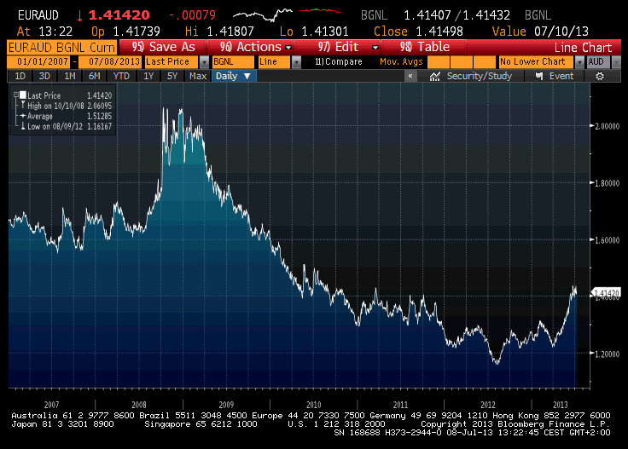
The alleged increase is NOT SHARP AND SIGNIFICANT ENOUGH because we do not see, taking into account the data provided by the Australia, an increase of + 12.15% such as to be sharp enough and significant enough, taking into account that in previous years there was also a decrease in the same imports.

Finally, it needs to be taken into account that the preserved tomato production in Australia, in recent years, has been extremely fluctuating and, in 2011, did not arrive to 90,000 tons (representing 0,23% of world production of tomato for processing).

The drop in production is certainly to be traced to the bad weather conditions that the country has suffered: in fact, in the last 10 years, there has been a period of severe drought, followed by severe flooding. It is evident that these weather conditions affect domestic production and that with a reduction in the domestic production, imports are necessary to meet the demand of the domestic market.

TAB. 3

GRAPH 2
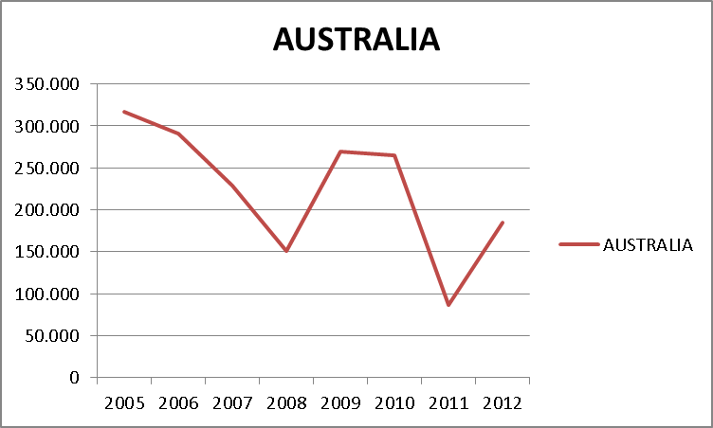

The foregoing is endorsed by the case law which provides that the adoption of safeguard measures is subject to emergency situations created as a result of unforeseen developments.

Due to the drop in Australian production and the appreciation of the Australian currency, it is normal to see an increase in imports. We therefore contradict that this is an unforeseen development.

II. Injury?

We would point out that Article 6 of the Agreement on Safeguards states that a provisional safeguard measure may only be imposed where there are 'critical circumstances where delay would cause damage which would be difficult to repair'.
According to Article 4 (2) (b) of the Agreement on Safeguards, the Commission is obliged to evaluate all relevant factors of an objective and quantifiable nature having a bearing on the situation of that industry. If the national authority has identified factors other than increased imports which have caused injury to the domestic industry, it shall ensure that any injury caused by such factors is not considered to have been caused by the increased imports.

We do not believe, at present, that critical circumstances have occurred, produced by increased imports which would justify a determination of provisional safeguards.
The information provided by Australia is insufficient to draw any conclusions on injury and in addition it is clear that other factors have affected the performance of the industry, therefore putting into question a causal link.

Among other factors affecting the Australian industry there are:
• exchange rate changes (see graph 1)
• weather conditions, such as droughts or flood (as described above, these conditions have occurred in Australia over the last 10 years)
• changes in productivity (see Tab.3 And Graph 2)

Where several factors are causing injury simultaneously, ‘a final determination about the injurious effects caused by increased imports can only be made if the injurious effects caused by all the causal factors are distinguished and separated’ (US-Lamb (DS 177, 178), in WTO 2012).

III. Additional Comments

Finally, we would like to point out that the Italian production of preserved tomatoes, and consequently exports, largely concerns the whole peeled tomatoes processed by long tomato. Italy is the only manufacturer in the world. The whole peeled tomato is a symbol of Made in Italy and one of the most popular products abroad. Therefore, the increase in imports might concern this particular product that Australian companies do not produce. This information cannot be supported by statistical data as the Customs Code does not provide for such a distinction.

Conclusion

On the basis of the above points we see no justification for the application of safeguard measures.

We remain at your disposal for any other question.

Kind regards,

Aline Rutsaert


