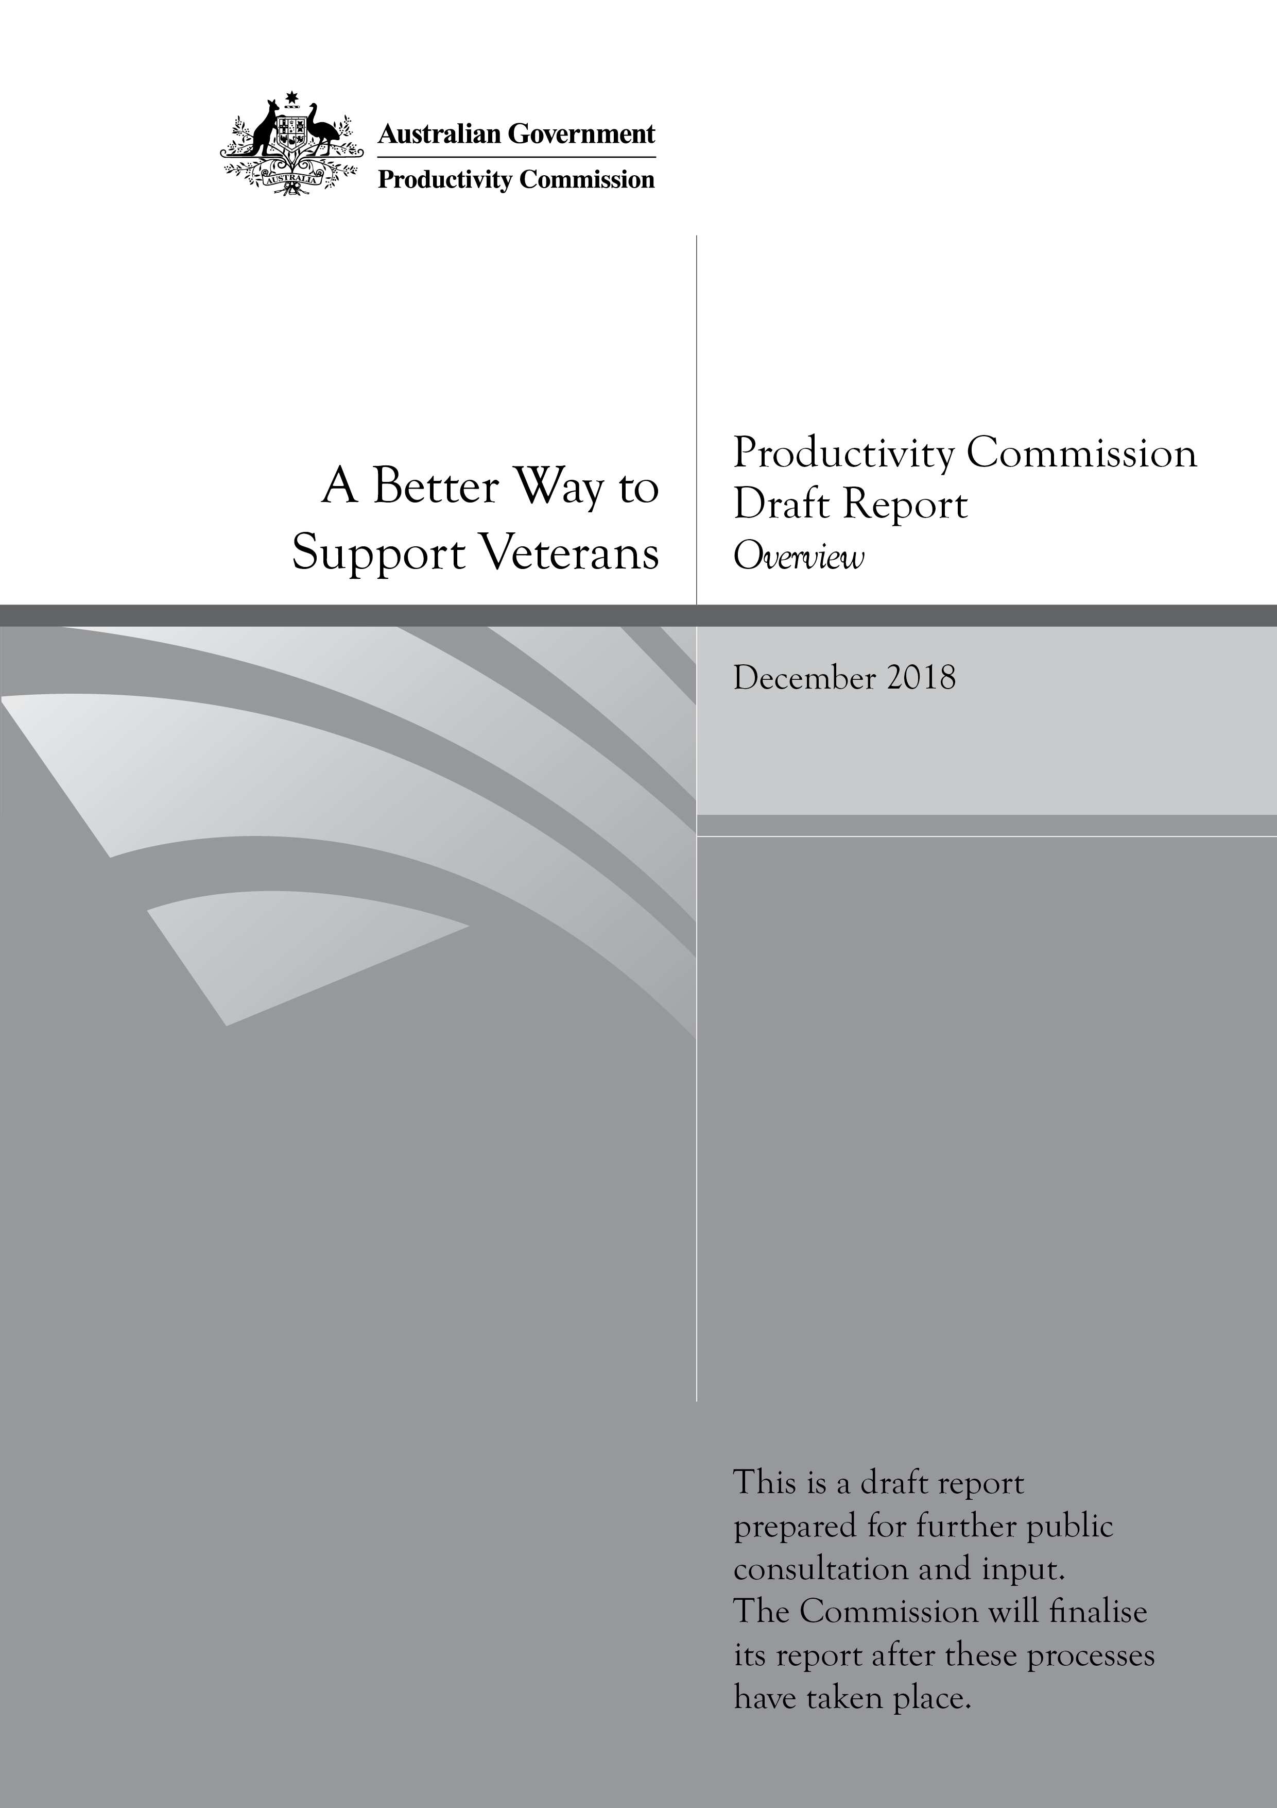
A Better Way to Support Veterans, Productivity Commission Draft Report

Commonwealth of Australia 2018

Except for the Commonwealth Coat of Arms and content supplied by third parties, this copyright work is licensed under a Creative Commons Attribution 3.0 Australia licence. To view a copy of this licence, visit http://creativecommons.org/licenses/by/3.0/au. In essence, you are free to copy, communicate and adapt the work, as long as you attribute the work to the Productivity Commission (but not in any way that suggests the Commission endorses you or your use) and abide by the other licence terms.
Use of the Commonwealth Coat of Arms
Terms of use for the Coat of Arms are available from the Department of the Prime Minister and Cabinet’s website: https://www.pmc.gov.au/government/commonwealth-coat-arms
Third party copyright
Wherever a third party holds copyright in this material, the copyright remains with that party. Their permission may be required to use the material, please contact them directly.
Attribution
This work should be attributed as follows, Source: Productivity Commission, A Better Way to Support Veterans, Draft Report.
If you have adapted, modified or transformed this work in anyway, please use the following, Source: based on Productivity Commission data, A Better Way to Support Veterans, Draft Report.
An appropriate reference for this publication is:
Productivity Commission 2018, A Better Way to Support Veterans, Draft Report, Canberra.
Publications enquiries
Media, Publications and Web, phone: (03) 9653 2244 or email: mpw@pc.gov.au

The Productivity Commission
The Productivity Commission is the Australian Government’s independent research and advisory body on a range of economic, social and environmental issues affecting the welfare of Australians. Its role, expressed most simply, is to help governments make better policies, in the long term interest of the Australian community.
The Commission’s independence is underpinned by an Act of Parliament. Its processes and outputs are open to public scrutiny and are driven by concern for the wellbeing of the community as a whole.
Further information on the Productivity Commission can be obtained from the Commission’s website (www.pc.gov.au).

Opportunity for further comment
You are invited to examine this draft and comment on it by written submission to the Productivity Commission, preferably in electronic format, by Monday 11 February 2019. Further information on how to provide a submission is included on the inquiry website: www.pc.gov.au/inquiries/current/veterans/make-submission#lodge. You may also attend a public hearing or submit a short comment on the inquiry website: www.pc.gov.au/inquiries/current/veterans/assessment#draft.
The final report will be prepared after further submissions have been received and public hearings have been held, and will be forwarded to the Australian Government in June 2019.

Public hearing dates and venues
Location | Date | Venue
Adelaide, SA | 4 February 2019 | Hotel Grand Chancellor  65 Hindley Street, Adelaide
Perth, WA | 5 February 2019 | Mantra on Murray  305 Murray Street, Perth
Darwin, NT | 7 February 2019 | Hilton Darwin  32 Mitchell Street, Darwin
Wagga, NSW | 11 February 2019 | Mercure Wagga Wagga  1 Morgan Street, Wagga Wagga
Canberra, ACT | 12 February 2019 | Productivity Commission  Level 2, 4 National Circuit, Barton
Melbourne, Vic | 13 February 2019 | Productivity Commission  Level 12, 530 Collins St, Melbourne
Hobart, TAS | 15 February 2019 | The Old Woolstore  1 Macquarie Street, Hobart
Sydney, NSW | 26 February 2019 | Adina Apartment Hotel  359 Crown Street, Surry Hills
Brisbane, QLD | 27 February 2019 | Mercure Brisbane  85-87 North Quay, Brisbane
Townsville, QLD | 1 March 2019 | Hotel Grand Chancellor  334 Flinders Street, Townsville

Contents
Opportunity for further comment iii
Overview 1
Key points 2
1 About the veteran support system 5
2 What we have been asked to do and our approach 11
3 What objectives for a veteran support system? 12
4 Why reform is needed 16
5 A better way to support veterans and their families 26
Draft recommendations, findings and information requests 43
For the full report go to the website: www.pc.gov.au

Overview

Key points
- The veterans’ compensation and rehabilitation system is not fit-for-purpose — it requires fundamental reform. It is out-of-date and is not working in the interests of veterans and their families or the Australian community.
- The system fails to focus on the lifetime wellbeing of veterans. It is complex (legislatively and administratively), difficult to navigate, inequitable, and it is poorly administered (and has been for decades), which places unwarranted stress on claimants. Some supports are not wellness focused, some are not well targeted and others are archaic, dating back to the 1920s.
- In 2017-18, the Department of Veterans’ Affairs (DVA) spent $13.2 billion supporting about 166 000 veterans and 117 000 dependants (about $47 000 per client). And while the veteran support system is more generous overall than workers’ compensation schemes for civilians, money alone does not mean it is an effective scheme.
- The system needs to focus on the wellbeing of veterans over their lifetime. This means more attention to prevention, rehabilitation and transition support, which in turn will produce better outcomes for veterans, their families and the Australian community.
- To achieve this focus, the system needs to be redesigned based on the best practice features of workers’ compensation and contemporary social insurance schemes.
- This will require new governance and funding arrangements.
- A single Ministry for Defence Personnel and Veterans should be established.
- A new independent statutory agency — the Veteran Services Commission — should be created to administer and oversee the performance of the veteran support system.
- DVA’s policy responsibility should be transferred to the Department of Defence within a new Veterans Policy Group.
- An annual premium to fund the expected costs of future claims should be levied on Defence.
- Responsibility for preparing serving veterans for, and assisting them with, their transition to civilian life should be centralised in a new Joint Transition Command within Defence.
- DVA’s recent Veteran Centric Reform transformation program is showing early signs of success. It should continue to be rolled out to mid 2021 as planned, but adjusted where necessary to accommodate the proposed reforms.
- The current system should be simplified by: continuing to make the system easier for clients to access (a complex system does not need to be complex for users), rationalising benefits, harmonising across the Acts (including a single pathway for reviews of decisions, a single test for liability and common assessment processes), and moving to two compensation and rehabilitation schemes by July 2025.
- Scheme 1 should largely cover an older cohort of veterans with operational service and injuries that occurred before 2004, based on a modified Veterans’ Entitlements Act 1986 (VEA). Scheme 2 should cover all other veterans, based on a modified Military Rehabilitation and Compensation Act 2004 (MRCA), and over time will become the dominant scheme.
- The way treatments and supports are commissioned and provided to veterans and their families also needs to change. There needs to be more proactive engagement with clients and providers and better oversight of outcomes.
- The recent decision to expand non-liability coverage to mental health care was a positive one, however, the Veteran Mental Health Strategy needs to be updated urgently with specific attention to suicide prevention and access to supports for veterans.

Overview
An implicit principle underpinning the current veterans’ compensation and rehabilitation system is that military service is a unique occupation. Military service involves a requirement to follow orders, frequent relocations (both for military personnel and their families) and long and irregular hours. Military personnel are also frequently placed in high-risk environments, including in war or operational service and while in training or on peacetime service. As the Department of Defence put it:
Australians join the Defence Force for a variety of reasons, but collectively they accept the forfeiture of certain freedoms enjoyed, and taken for granted, by all others in Australian society. Almost every aspect of uniformed life comes with a risk or cost to the member and/or to their families.
Support for members and their families in the event that these risks materialise is widely regarded as a condition of military service. The Australian Government is also committed (and has been since World War I) to supporting, and reintegrating into society, those who are affected by their service in the Australian Defence Force (ADF). And many ex-service organisations provide support to current and former ADF members and their dependants.
While most ADF members successfully transition and quickly re-establish civilian lives, some struggle to address the challenges they experience when they leave the military. Those discharged involuntarily can be deeply impacted. And sometimes the impacts of service do not become apparent until many years after discharge. The health and wellbeing of family members can also be affected by a veteran’s military service, especially the dependants of veterans who have died as a consequence of service.

Australia’s response
Australia has a comprehensive system of support for veterans which includes income support, compensation, health care, rehabilitation and other services. Access to some of the supports and services is contingent on a veteran having suffered an injury or illness (or death) related to their military service. Other supports are available irrespective of whether they incurred an injury or illness.
Australia’s veterans’ compensation and rehabilitation system is separate from, and more generous overall than, the system of workers’ compensation and support generally available to civilian workers. It is described as ‘beneficial’ in nature.
The current veterans’ compensation and rehabilitation system is, in the Department of Veterans’ Affairs’ (DVA’s) words ‘steeped in history, stemming back to World War I’. But the environment in which the system is operating has changed. The nature and tenure of military service has changed, as have approaches to social insurance and the availability of mainstream health and community services. The community of Australian veterans and their families is also changing and the new generation of veterans have different needs and expectations.
The key message of this draft report is that the current veterans’ compensation and rehabilitation system is not ‘fit for purpose’ — it requires fundamental reform.
- It is not working in the interest of veterans and their families or the Australian community.
- It is not meeting the needs of contemporary veterans and will struggle to meet the needs of future generations of veterans.
- It needs to be brought more in line with contemporary workers’ compensation schemes and modern person-centred approaches to rehabilitation, health care and disability support.
- It needs to place veterans at the heart of the system and take a more holistic, flexible and individualised approach to supporting them.
- It needs new governance and administrative systems best suited to meeting the future challenges and emerging needs of veterans while operating in a modern, efficient and effective way.

A lifetime approach
Australians are willing to support veterans who are affected by their service, but they also want to know that the system designed to support them improves, and does not harm, their lives. The veteran support system is, and must be, about more than compensation and rehabilitation. It must take a lifetime approach to supporting veterans and their families and be more focused on wellness and ability (not illness and disability) and minimising harm from service. It needs to be more responsive to the changing needs and circumstances of veterans, which will require more flexibility and adaptability in supports and in the way services are provided.
Recognising that mainstream services are a necessary complement to veteran-specific services is one element of a new approach. Changes also need to be made to the way treatments and supports are commissioned and provided to veterans and their families. There needs to be more proactive engagement with rehabilitation, transition, health and mental health care providers (including requiring an evidence-based approach to treatment and supports) and better oversight of outcomes from treatment and support.

Wide-ranging reforms
Many of the changes we are recommending are about minimising the harm from service-related injury and illness and investing in veterans so that when they leave the ADF they are likely to go on to enjoy fulfilling and productive lives. A focus on the wellbeing of veterans over their lifetime will not only result in better outcomes for veterans and their families but also for the Australian community.
Some of the benefits from the proposed recommendations include:
- a set of principles and objectives to drive the system
- a greater focus on prevention of injury, rehabilitation and transition support
- improved continuity of care in rehabilitation
- better coordinated and more responsive transition support
- a simpler and easier system for veterans and their families to navigate
- better targeted and more equitable compensation
- better governance arrangements, more efficient processes and improved commissioning of services
- a greater focus on outcomes for veterans and their families and the Australian community.
Our proposed reforms are wide ranging and will take time to implement. Their staged implementation will minimise disruption costs, allow current worthwhile initiatives to be rolled out and provide adequate time for legislative and administrative adjustment.
Importantly, no veteran or dependant of a deceased veteran who currently receives a benefit or entitlement will be worse off under our proposals. Veterans and their families will be better served by a reformed veteran-focused support system, and the community will be able to have confidence that the system is delivering supports in an efficient and effective way.

1 About the veteran support system
DVA provides various forms of support to current and former ADF members and their families. The supports include:
- income support and compensation
- health care
- rehabilitation, transition support and other services to support wellbeing.
In 2017-18, DVA reported spending $13.2 billion on the veterans’ rehabilitation and compensation system (or about $47 000 per client). Of this, about $7.4 billion was spent on compensation and support, $5.3 billion on health care and wellbeing, and $437 million on enabling services such as workplace training, financial management and information technology. DVA also spent $60 million on commemorative activities and facilities, such as war graves and memorials.
A further $800 million was provided to veterans and their families by the Commonwealth Superannuation Corporation (CSC) through invalidity and dependant pensions and Defence spent about $437 million on rehabilitation and health care of serving members.
DVA currently supports about 166 000 veterans and about 117 000 dependants (mainly widows or spouses). The exact number of living Australian veterans is not known (box 1). This is just one indication of the lack of information about Australian veterans.

Box 1 Some facts about serving and ex-serving personnel
Who is a veteran?
Traditionally, the term ‘veteran’ described former Australian Defence Force (ADF) members who were deployed to serve in operational conflict environments. However, in 2017, a Roundtable of Australian Veterans’ Ministers agreed that a veteran would be defined as anyone who has served at least one day in the ADF. As such, for this inquiry we have used the term ‘veteran’ to cover all current and former serving ADF personnel, whether they were deployed to active conflict or peacekeeping operations or served without being deployed. The veteran community also covers family members.
About the ADF and veteran population
- ADF members are professionals who have volunteered to serve in the military. About 5200 recruits join the ADF each year.
- In 2017-18, there were about 58 000 permanent members of the ADF and about 20 000 reservists. The Army accounts for about half of ADF personnel and the Navy and Air Force for a quarter each.
- More than two million Australians have served in the ADF since federation.
- The size and tempo of military engagements (previously falling) has increased since the early 2000s, with little sign of that trend ending.
- Personnel returning from deployment can be returning with injuries that, in prior conflicts, might have resulted in death (for example, traumatic brain injuries).
- About 18 per cent of those of who leave the ADF do so for medical reasons.
Little is known about Australia’s total veteran population. The Department of Veterans’ Affairs recently estimated that there are about 640 000 living veterans (including reservists).
DVA clients span all generations and life stages — there are veterans and war widows aged over 100 and children of veterans as young as one year. However, the majority of DVA clients are in the older age groups — about 194 000 are 65 years or older and of these 98 000 are aged over 79 (figure 1).

Figure 1 DVA clients by age, December 2017
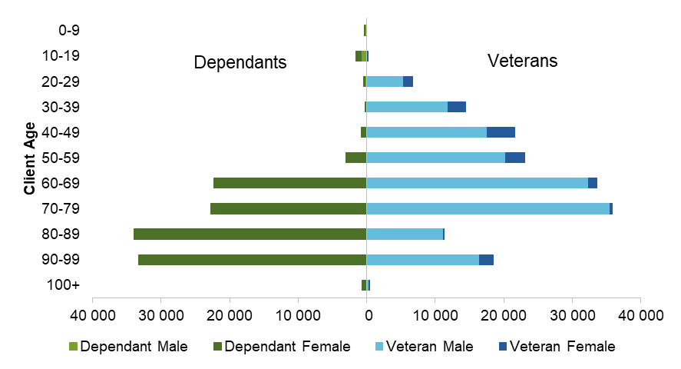
The number of DVA clients is declining, and has fallen from about 540 000 clients in 2000 to 291 000 in 2017, reflecting the deaths of the World War II and the Korean War veteran groups (figure 2).

Figure 2 DVA clients — veterans and dependants
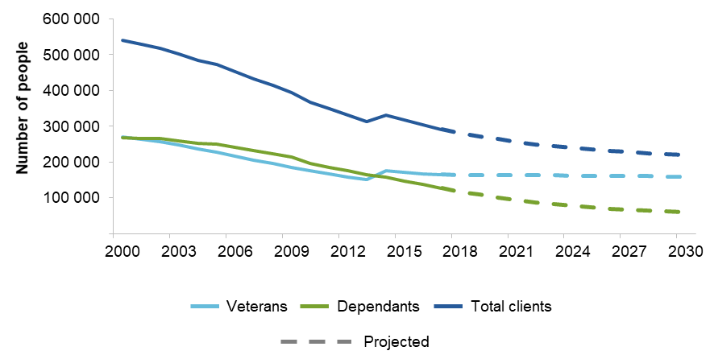

The profile and needs of veterans are also changing. This is driven by the nature of recent and current military conflicts and declining numbers of older veterans.
Older veterans are more likely to require independent living assistance, aged care and health services, while the needs of contemporary veterans are focused on rehabilitation, wellness and returning to work. Contemporary veterans are more likely (than older veterans) to:
- be women (often with dependent children) — the proportion of female members in the ADF increased from 13 per cent in 2000 to around 18 per cent in 2018
- have been on multiple deployments — 38 per cent of permanent ADF members had been deployed more than once
- need to prepare for a working life after service — the median length of time in the military is seven years for members of the Navy and Army, and 10 years for members of the Air Force.
As the Minister for Veterans’ Affairs, Darren Chester, recently said:
… when we think of the word veteran, we tend to think of someone in their sixties or seventies. But from an ADF perspective, our veterans are often in their late twenties or early thirties, so they have another career after they’ve been in the military.

The legislative framework
The current system has three main Acts.
- The Veterans’ Entitlements Act 1986 (VEA).
- The Safety, Rehabilitation and Compensation (Defence-related Claims) Act 1988 (DRCA).
- The Military Rehabilitation and Compensation Act 2004 (MRCA).
The Acts have different eligibility requirements and provide different levels of support to veterans through different claims and appeals processes (figure 3). The timing and type of the relevant service determines which Act covers the veterans’ impairment and veterans with multiple impairments can have different impairments covered under different Acts.
Under current arrangements, DVA determines if a veteran’s condition is service-related under one or more of the Acts. It then identifies the payments and their amounts under separate elements of the claims process.

Figure 3 Veteran supports are provided under three main Acts
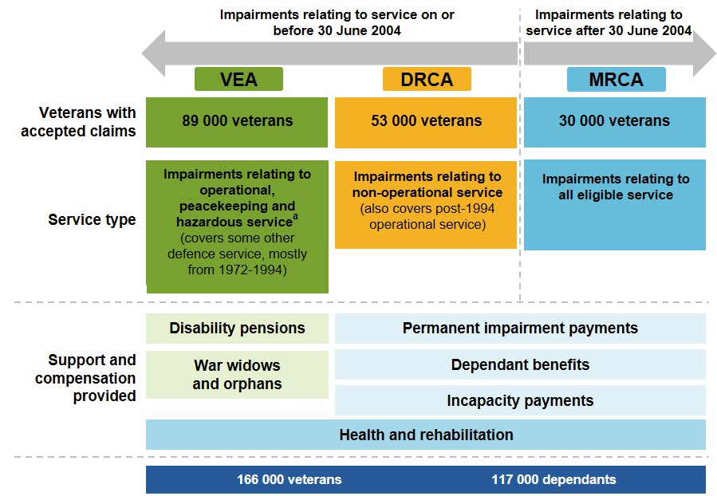

Many of the compensation payments for veterans align with payments in mainstream workers’ compensation schemes. However, there are additional payments and allowances that are unique to the veteran support system (figure 4). Veterans are also eligible for superannuation invalidity payments, and for the age service pension, which cuts in earlier (at 60 years for those with qualifying service) than the equivalent age pension for other Australians.
When considered as a package, compensation for veterans and their families is relatively beneficial compared to other workers’ compensation schemes. For example:
- a veteran with warlike service and an impairment rated at about 20 impairment points would receive lifetime compensation of about $100 000 under the MRCA. This is about double what a civilian worker with a similar impairment point rating would receive under the Safety, Rehabilitation and Compensation Act 1988 (SRCA)
- a veteran who is totally and permanently incapacitated would receive lifetime compensation of between $1.5 and $3.9 million under the MRCA, depending on their age and need for services such as attendant care. The same person would receive between $1.2 and $2.8 million under the SRCA.
The beneficial nature of the supports for veterans was noted by many participants to this inquiry, with one describing the benefits to Australian veterans as ‘well resourced and largely generous’.

Figure 4 Veteran compensation — the range of payments
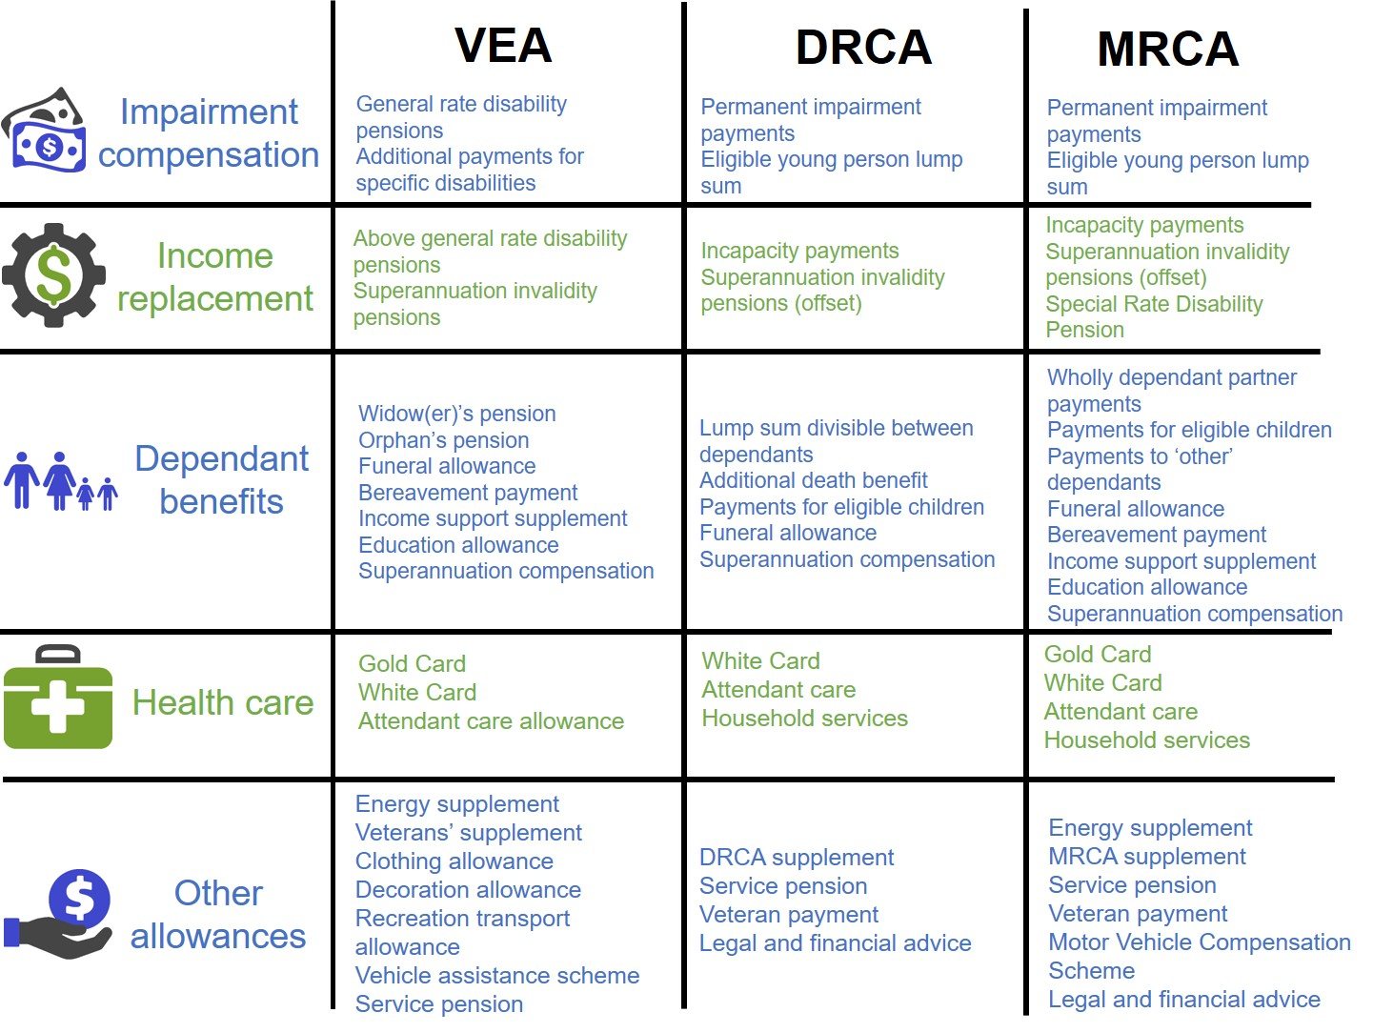

History provides insights into why the system is as it is
History explains, in part, why we have the system we have today (box 2). Some features of the system can be traced back to World War I and its after effects — a time when life expectancy, the economic position of women, the nature of warfare, service members’ pay and motivations for enlisting, and the extent of the mainstream health and welfare system, were very different to what they are today. Since then, new features have been added, often in an ad hoc manner and/or in response to particular incidents or pressure from veterans’ groups. While a number of the original rationales for elements of the scheme have faded, a political desire to avoid reducing entitlements has meant that governments have not seized opportunities to remove duplication and redundancy.
In DVA’s words, the three Acts ‘collectively incorporate almost all of the benefits available to successive generations of veterans over the last 100 years’.

Box 2 The veteran support system: a brief history
The Australian Government first established a military compensation system in 1914 with the introduction of the War Pensions Act 1914. The Government also sought to re-establish returned soldiers without war injuries, creating a Repatriation Department overseen by a Minister and a Repatriation Commission. Some of the repatriation benefits at the time included: assistance for veterans to find employment and ‘sustenance’ payments until they did; loans to veterans to start businesses; and rental assistance.
The original veteran support legislation referred only to veterans of World War I, so subsequent conflicts required either amending the legislation (the Repatriation Act 1920) or creating derivative Acts. The outcome was a number of similar Acts and amended sections.
By the 1970s, there were calls to consolidate the various pieces of legislation into a single Act with a common system for wartime and peacetime veterans. As an interim measure, eligibility under the Repatriation Act was allowed for peacetime veterans. However, because of concerns about potentially disadvantaging some veterans, those with peacetime service could continue to make claims under the Commonwealth workers’ compensation scheme. The Veterans’ Entitlements Act 1986 (VEA) simplified the system by repealing the previous Acts, but the distinction between different kinds of service, and dual eligibility with Commonwealth workers’ compensation for peacetime service, remained.
The 1996 Black Hawk disaster revealed to the public different compensation outcomes for families depending on the date of enlistment and the superannuation scheme choices of the deceased veteran. A subsequent review recommended a new military compensation scheme and changes to address inequities and anomalies caused by the interaction of VEA and the Commonwealth workers’ compensation scheme (as embodied in the Safety, Rehabilitation and Compensation Act 1988 (SRCA)). Most of the recommendations were implemented with determinations under the Defence Act 1903 that supplemented the SRCA benefits for Australian Defence Force personnel.
Following a further review of the military compensation scheme in 1999 (the Tanzer Review), a new scheme for all military personnel with a ‘renewed emphasis’ on rehabilitation was established with the Military Rehabilitation and Compensation Act 2004. However, the new Act did not repeal the VEA or the SRCA, and did not close them off for new claims relating to service before July 2004. The outcome is a highly complex system (with three Acts). The Safety, Rehabilitation and Compensation (Defence-related Claims) Act 1988, introduced in 2017, largely mirrors the SRCA.
There has also been a steady accretion of the entitlements provided under the different Acts over time — in the health area, this culminated, between 1999 and 2002, in the granting of Gold Cards (treatment for all conditions) to veterans over 70 with qualifying services (regardless of whether they had service-related conditions).

2 What we have been asked to do and our approach
This inquiry came about following a recommendation made by the Senate Foreign Affairs, Defence and Trade References Committee in its report titled The Constant Battle: Suicide by Veterans. The Committee found the legislative framework for the veterans’ compensation system to be complex and difficult to navigate. The Committee was concerned that inconsistent treatment of claims for compensation and lengthy delays in the processing of claims were key stressors for veterans and their families, and said it was time for a ‘comprehensive rethink of how the system operates’.
The Commission has been asked to comprehensively examine how the current compensation and rehabilitation system for veterans operates, how it should operate into the future, and whether it is ‘fit for purpose’ (the full terms of reference are at the beginning of this report).
We used a wellbeing approach and assessed the benefits and impacts of the system on the lives of veterans, and Australians more generally, in light of the costs of the system. We also looked at best practice workers’ compensation and contemporary social insurance schemes for insights on system design and principles.
Our focus was on reforming the current system so it can meet the needs of future generations of veterans and their families, while also improving outcomes for veterans and their families who are currently supported by the system.

3 What objectives for a veteran support system?
The overarching objective of the veteran support system should be to improve the lives or wellbeing of veterans and their families (this aligns with what participants told the Commission the objectives of the system should be, box 3). This has at its core minimising the harm from service to veterans and their families. This should be achieved by:
- preventing and minimising injury and illness
- restoring injured and ill veterans by providing timely and effective rehabilitation and health care so they can participate in employment and life
- providing effective transition support for veterans and their families
- enabling opportunities for social integration
- providing adequate and appropriate compensation for veterans (or, if the veteran dies, their family) for pain and suffering and lost income from service-related harm.

Box 3 A focus on wellbeing and rebuilding lives
The Department of Defence said that the priority objectives for veterans’ support should be:
… to ensure the long-term wellbeing, successful rehabilitation and transition for veterans into civilian life.
The Air Force Association:
Any compensation and rehabilitation system for veterans and their families must be ‘fit for purpose’, recognising the unique nature of military service. Its principal aim is to return the veteran who has suffered injury or illness due to service duty to his/her former physical and/or mental health state and when this is not possible provide life-long treatment and financial support.
The Defence Force Welfare Association:
If the member was broken due to military service to the Nation, then the Nation has a moral obligation to restore and financially support the person to an ‘as new’ condition as possible.
RSL Australia National Office:
The primary objective for an ADF member who has suffered an injury or disease should always be a return to health and a return to work, as this is the best outcome for the member’s physical and mental health, their family, the ADF and any future employers.
Stephan Rudzki:
… soldiers wish to be rehabilitated and return to some form of productive work. Having a job is a very important component of overall health and mental well-being.
Mates4Mates:
It is important that veterans, their families and the whole community understand that despite a physical or psychological injury, veterans have the capacity to lead very active, purposeful and fulfilling lives … Research indicates that employment can be a restorative psychological process. There is no substitute for what employment offers in the way of structure, support and meaning. Positive and meaningful employment experiences are linked to improved self-esteem, self-efficacy and high levels of personal empowerment — all of which have a positive effect on mental health and wellbeing.
And as with all other government programs, the objective should be achieved while ensuring value for money for the Australian community while providing supports in the most effective and efficient way. Australians are willing to support veterans and their families, but they also want to know that the money they spend is:
- providing the support that covers the needs of injured or ill veterans
- providing a veteran support system that is run efficiently and effectively, and does not cause unnecessary stress to veterans and their families
- resulting in better lives for veterans and their families.
Best practice workers’ compensation schemes also focus on returning people back to work and health at an affordable and sustainable cost. And contemporary approaches to disability place an emphasis on people’s ability and potential, take an active rather than a passive approach to meeting client’s needs, and focus on long-term costs. The veteran support system should also take a long-term or lifetime approach to improving veterans’ lives. This will not only get the best outcomes for veterans and their families — because such an approach will drive a focus on early intervention and supports that maximise veterans’ independence and economic and social participation — it will also ensure a more affordable and sustainable system by reducing long-term support requirements.
In the context of military personnel, a lifetime approach involves taking into account each of the life stages — recruitment, in-service, transition and ex-service (figure 5).
- When members are serving, preventing injury or illness is critical to minimising the harm to veterans and their families from service.
- In all the life stages, timely, appropriate and effective health care and rehabilitation is important for minimising harm (or costs) to veterans and their families.
- The way in which members make the transition from military to civilian life can be an important determinant of their long-term wellbeing (for example, if veterans are poorly prepared for transition they can experience poor mental health and long periods of unemployment). Timely and effective transition services that are available from early in a veteran’s career, during transition and post-service are therefore important.
- Post-service, some veterans may develop service-related health conditions and need timely access to supports to minimise harm — this points to the importance of a sustainable system so that veterans can be assured that supports will be available if, and when, they need them.
Using a wellbeing approach to supporting veterans and their families, together with insights from best-practice workers’ compensation and contemporary social insurance schemes, the Commission considers that the veteran support system should be:
- wellness focused (ability not disability)
- equitable
- veteran centric (including recognising the unique needs of veterans resulting from military service)
- needs based
- evidence based
- administratively efficient (easy to navigate and achieves timely and consistent assessments and decision making)
- financially sustainable and affordable.
These principles should underpin the future system (figure 6).

Figure 5 Life stages of full-time military personnel
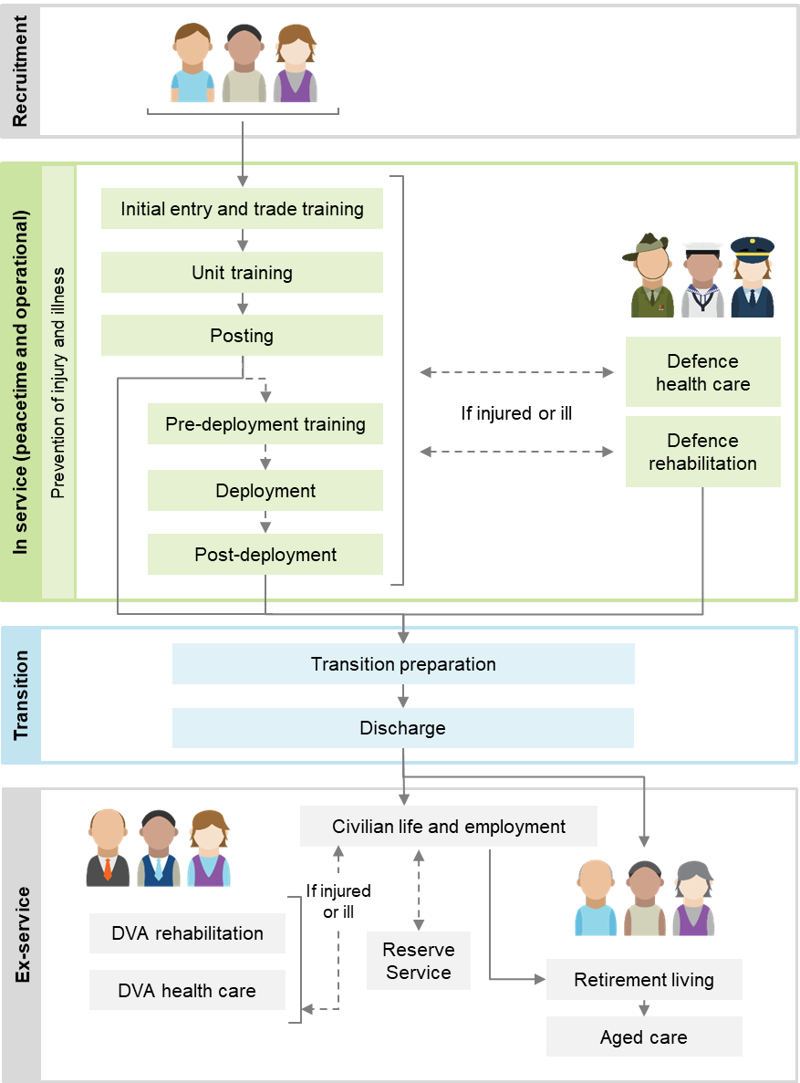

Figure 6 A system that is about better lives for veterans and their families
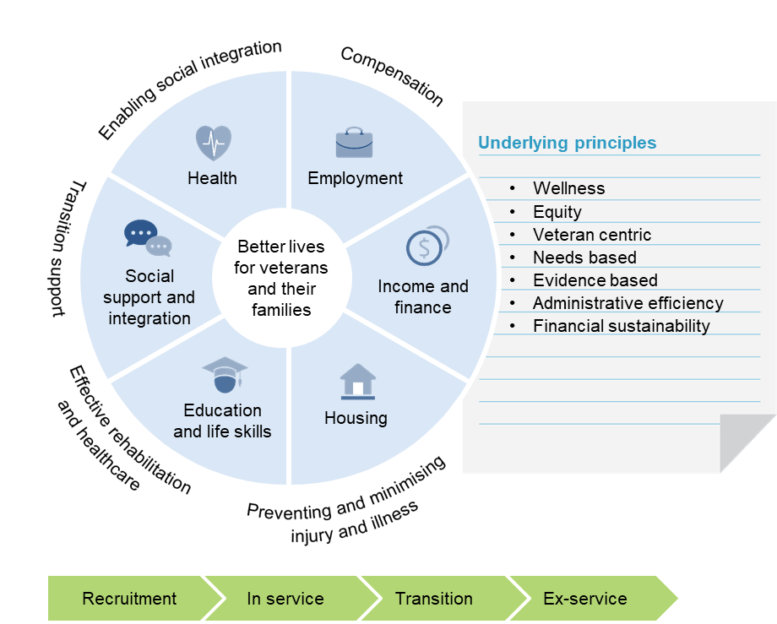

4 Why reform is needed
The current veterans’ compensation and rehabilitation system is not performing well. Veterans and their families could be getting better outcomes from the resources the Australian community is spending to improve their lives.

The system is complex and difficult to navigate …
The veterans’ compensation and rehabilitation system is complex. It is difficult for veterans and their families to navigate and for DVA to administer. Claimants often require help from advocates to navigate the system.
Multiple Acts are one source of complexity. Veterans can be eligible for compensation under more than one Act. This can be confusing for veterans and as one participant put it ‘daunting, even insurmountable’. Almost 30 000 veterans have had liability accepted under more than one of the three Acts.
One of the consequences of multiple Acts is the need for offsetting of compensation between Acts (to ensure veterans are not over or under compensated). Again, this is confusing for veterans and a source of many complaints to the Commonwealth Ombudsman. Offsetting can also lead to errors in compensation estimates which can have serious consequences for veterans. Superannuation invalidity pensions alongside the support system means further offsetting and additional complexity.
The individual Acts are also complex. There are many additional payments (over and above those typically provided by workers’ compensation schemes, for example, there are payments for damaged clothing, vehicle allowances and education payments). There are at least 40 different payments or benefits that veterans and their dependants may be eligible for, depending on the Act they are covered by and the impairment the veteran has suffered.
Eligibility for these payments can vary depending on whether the impairment is related to operational service or not. Some payments are lump sum, some are weekly; some are taxed, some are untaxed. Some benefits are in the form of health care. RSL Queensland said ‘the range of benefits is extensive and not necessarily well understood … it remains difficult for a veteran or his family to feel confident that they have accessed all of their entitlements’.
As discussed earlier, the complexity of the veteran support system is a symptom of reactive policy making and a reluctance to take entitlements away from veterans or even rationalise them when their original rationale no longer exists. DVA highlighted this very problem and explained why, if not addressed, the system will continue to become more complex.
Implementing policy responses to specific ad-hoc requests this way adds to complexity and can ignore the needs of the whole veteran community … such changes can also introduce relatively minor but nevertheless compounding amendments to legislation, adding to an already complex system.

… and there is inconsistent treatment of claims
Veterans with the same injury or illness can receive different levels of support because the amount of compensation payable, and how the compensation is calculated or paid, varies depending on which legislation applies. Box 4 provides an example of the different amounts of compensation that could be provided under the different Acts.

Box 4 Different Acts, different amounts of compensation for the same impairment
The amount of compensation payable, and how the compensation is calculated or paid, varies depending on which Act applies. As an example, Jane is a 30 year old veteran who has suffered a shoulder impairment graded at about 20 impairment points. While the amount and type of compensation will vary based on which Act she is covered by and the type of service under which the impairment was suffered, she will be entitled to:
- either a permanent impairment payment or a pension to compensate for the pain and suffering from the impairment. (Because Jane’s ability to work is not affected by her impairment, she will not be entitled to an income replacement payment.)
- various supplements.
Jane could expect to receive between $56 000 and $140 000 in lifetime financial compensation (with the VEA being the most generous Act).
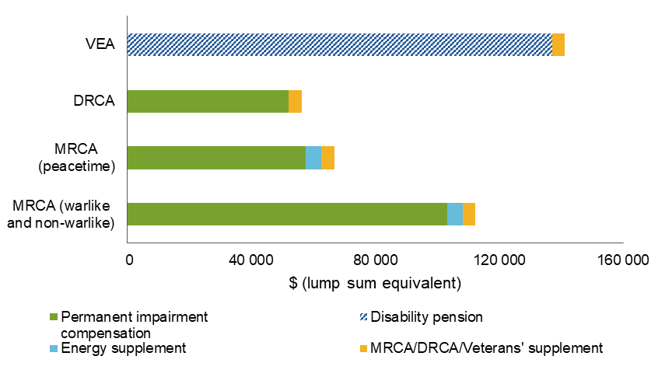
Jane would also receive treatment for the shoulder impairment through the White Card, and, if she has qualifying service, will receive the Gold Card at age 70 and the service pension.
Source: PC estimates based on entitlements under VEA, MRCA and DRCA.
Veterans can receive different levels of support based on the type of service they were undertaking (warlike and non-warlike or peacetime) when an injury or illness occurred (box 4). Under the MRCA, the rates for warlike and non-warlike service are higher than those for peacetime service up to 80 impairment points (there is no difference between the rates for veterans with impairments above 80 points). The difference can be over $100 000.
The difference between compensation for warlike and non-warlike service, and peacetime service adds complexity and requires veterans to demonstrate whether their injury was suffered as a result of warlike or non-warlike service. It also creates inequities between different groups of veterans.

Some supports are poorly targeted…
Some supports available to veterans and their families are poorly targeted. In the area of transition support, for example, veterans who are younger, served in lower ranks, and have skills that are not easily transferable to the civilian labour market tend to be most at risk when transitioning. But transition services are not targeted to this group (in fact, this group can receive the least support of any in transition).
Another example of a poorly targeted support is the Gold Card which covers the cost of a range of public and private health care services, irrespective of whether the impairment is service related (box 5). Veterans with high levels of service-related impairments who are entitled to the Gold Card, for example, have very different health needs to dependants of veterans who have died from service-related causes and are eligible for the Gold Card as part of their compensation package.

… some discourage wellness
Some of the supports available to veterans and their families discourage wellness. The Gold Card, for example, can work against the principle of ‘wellness’ by providing an incentive for veterans and their families to seek to qualify for higher levels of support. RSL NSW said DVA’s health card system ‘encourages a view of the system as a contest to be won, with the Gold Card as the prize’.
… The outcome sought for veterans should be rehabilitation, not monetary settlement. The ‘gold card’ nomenclature utilised by DVA reinforces a negative entitlement culture where success for veterans is the extraction of cash from the government, not their rehabilitation and return to being a productive member of civilian society.
Another example is the Special Rate Disability Pension under the MRCA. It provides little incentive for veterans to rehabilitate and return to work because veterans lose access to their payment entirely if they return to work for more than 10 hours per week.
And the VEA is compensation, not wellness focused (it is based on lifetime pensions and health care — this does not align with contemporary workers’ compensation schemes). As DVA said:
It is notable that the older VEA, under which nearly 16 000 primary claims were made in 2017-18, has a focus on illness and lifetime compensation payments, which is not conducive to a ‘wellness’ model.
There are also a number of outdated payments (dating back to the 1920s) under the VEA that no longer have a clear rationale.

Box 5 Who is entitled to the Gold Card and what does it provide?
The holder of a Department of Veterans’ Affairs (DVA) Gold Card is entitled to treatment and care for all health conditions. About 130 000 DVA clients have a Gold Card. Gold Cards are issued to:
- veterans aged over 70 years with qualifying service (about 7000 cardholders)
- veterans receiving the service pension who satisfy a means test (about 11 000 cardholders)
- veterans above a specific level of impairment or incapacity under the VEA (about 49 000 cardholders) or MRCA (about 1500 cardholders)
- dependants of deceased veterans who qualify for a war widow(er)s’ pension or wholly dependent partner or child payment (about 62 000 cardholders)
- ex-prisoners or war (140 cardholders), British nuclear test participants and members of the British Commonwealth Occupation Force (650 cardholders).
The range of entitlements covered by the Gold Card goes well beyond those covered by the public health system and includes private hospital visits, private specialist appointments, dental services aged care services and travel for treatment. Gold Card holders are also exempt from paying the Medicare levy.

Inefficient processes that can place unnecessary stress on veterans
DVA’s processes for administering claims are also unnecessarily complicated and processing times can be lengthy (the time taken to process claims is typically many months, however some claims can take over a year to process, box 8). This can place unnecessary stress on claimants. One participant said that DVA’s claims process (and the processing delays) caused as much damage as the initial injury. Many ex-service organisations and other government agencies (including the Australian National Audit Office and the Commonwealth Ombudsman) highlighted problems with the administration of the system and the way DVA interacts with clients (box 6).

Box 6 Some comments on DVA’s administration of the system
The Commonwealth Ombudsman, commenting on a complaint against the Department of Veterans’ Affairs (DVA), said:
… more work is needed to assure the public, serving personnel and veterans that processes, policies and guidance are robust and rigorous. In this case, DVA failed to ensure timely record keeping and adequate quality assurance and internal review processes were in place. Simple additional checks from the very earliest of DVA’s dealings with this veteran may have prevented the snowballing of events that led to years of suffering to one man. While cases involving this level of accumulated administrative errors are rare, the individual errors are not isolated incidents.
The Australian National Audit Office:
The majority of DVA Rehabilitation & Compensation (R&C) services are being delivered to veterans and their dependents within DVA’s time based performance targets, however a minority of claims take an excessively long period to process due to inefficient handling. These delays can have significant impacts for these veterans.
Employer Mutual Limited:
DVA’s relationship with veterans and their families errs towards being ‘transactional’ rather than personalised, focused on passing them through procedures and administering payments … In comparison to other compensation schemes, the benefit structures available to Australian veterans are well resourced and largely generous. However, one side effect observed in our review is that DVA can at times operate as a ‘passive payer’ rather than an ‘active manager’ of cases.
Mates4Mates:
We hear time and time again from veterans who are going through a claims process that much of their time and energy, for prolonged periods (sometimes due to claims rejections and subsequent appeals processes), is focused on attesting to their limitations to meet criteria for obtaining and maintaining certain incapacity payments. … if the initial claims process occurred faster … we could prevent people from being immersed for so long in a ‘limitations’ mindset so they can quickly move to a strengths-based mindset.
Other concerns expressed about the way DVA administers claims include:
- it is difficult for claimants to find information on supports
- claims assessors do not communicate well with veterans and their families
- the focus is on processes rather than veterans
- there are high error rates.
Some of the factors contributing to these concerns are a general lack of training and guidance for assessment staff (including on how to effectively deal with trauma-affected clients), high staff turnover and (until recently) outdated information and communication technology (ICT) systems.
While DVA approves most claims submitted by veterans and their families (box 8), many concerns were raised about DVA’s adversarial approach to claims. However, this is inconsistent with the mindset and attitude of most staff (as was apparent to the Commission in its dealings with DVA staff on this inquiry) who seek to operate in the interests of veterans within a complex environment.
DVA’s transformation program, launched in 2016 and known as Veteran Centric Reform (VCR), is demonstrating early signs of success. The VCR program aims to improve the administration of the veteran support system by modernising DVA’s ICT systems and making service delivery consistent with whole-of-government service delivery principles. Longer term, the objective of the VCR program is to create an agency focused on policy, stakeholder relationships and commissioning services.
Positive developments from the VCR program include:
- ‘straight-through’ processing (which permits the use of Defence data to immediately satisfy the service-related requirements of claims)
- the digitisation of records
- the roll out of ‘MyService’, which allows veterans to lodge an initial liability compensation claim online.
MyService is also showing early positive results (box 7). For example:
- the average time taken to process a MyService initial liability claim is 33 days, this compares to an average across all MRCA initial liability claims of 84 days
- on accuracy, although MyService is yet to be subject to a formal quality assurance assessment, informal analysis by DVA showed assessment error rates well within the Department’s internal targets.
When fully rolled out across the claims process, MyService, together with Defence’s Early Engagement Model (which is designed to facilitate the automatic flow of service and medical information about ADF members to DVA throughout their careers), has the potential to completely automate the claims process for most veterans. Some veterans and their families, however, will continue to need engagement with advocates and staff to manage the process and this assistance should be readily available.

Box 7 MyService: some early signs of success
MyService is providing veterans with a simple and convenient way to lodge an initial liability compensation claim online. It also allows claims for non-liability mental health treatment, needs assessments and access to an electronic version of health cards. At the end of June 2018 over 5000 users had lodged claims through MyService, while a link to MyGov (the whole-of-government online platform) from 30 July 2018 enables access by many more.
Recent figures show that around 10 000 claims, around half of all MRCA claims, have been lodged so far through MyService and feedback from users is positive.
Myservice and culture change are ongoing improvements that have been particularly effective. (Alliance of Defence Service Organisations)
The ease of operation for veterans both current and former, to access the data base and lodge a claim is on any view, the most important groundbreaking achievement by DVA in the veterans’ claims and support continuum to date. The ease of using an online claim form that is applied across all three Acts administered by DVA is simply astounding. This [is] important, because in enabling veterans to be able to complete an online claim form in the safety, security and comfort of their own home, is a hugely pleasing aspect of this process. (Royal Australian Armoured Corps Corporation)
MyService minimises the amount of data that a claimant must source by ‘pulling’ information automatically from existing government databases (for example, Defence PmKeys) including for identity checks and determining periods of service. And by using a rules-based approach, MyService asks the right questions to arrive at a lawful determination. In this way it effectively acts as a guide for both claimants and assessors and is a highly effective way of dealing with the complexity of the Acts.

Also inefficiencies in the review process
A common concern raised about how DVA initially assesses claims is that there is a culture of DVA denying claims. In the words of one participant:
... the approach seems to be one of finding every possible way to deny a claim, which results in further expense in appeals that should have been determined very much earlier and in a far more timely manner.
Internal review processes are not as effective as they might be at identifying errors in DVA’s decision making. The majority of cases that reach the Veterans’ Review Board (VRB) lead to changes to DVA’s decision — the VRB appears to be acting as a ‘backstop’ relied on by DVA to correct decisions rather than being more thorough and accurate in their initial decision-making processes.
There are also unjustified differences in the review process between the various Acts. And there are too many decision-making bodies and review pathways. The review process needs to be consistent across all Acts, simplified and set up to support DVA to make accurate decisions in the first instance.

Incentives for strong performance and good outcomes are missing …
The prevention of injury and illness is paramount to any workers’ compensation scheme and a healthy, safe workplace. This is because the cost of injuries and illness to individuals, employers and the community is high. A unique aspect of the current veteran support system is that Defence (the employer) bears no financial responsibility for the cost of compensation, rehabilitation, transition services or medical treatment for service-related injuries and illnesses once a member leaves the service — DVA picks up the tab. A visible insurance premium would provide an additional incentive for injury prevention. The incentive is in part monetary, but also in part because the publicly available figure crystallises the extent to which the employer is acting responsibly.
Best practice workers’ compensation systems also place a strong emphasis on scheme sustainability, which in turn means that they focus on reducing clients’ reliance on supports (and the cost of compensation) through early intervention and building clients’ skills and capabilities for independence. Under current arrangements, little (if any) attention is given to the performance and long-term sustainability of the veteran support system. This is in part because a real budget constraint is missing (the veteran support system is demand driven) and there is little accountability or incentives for DVA to operate the system efficiently and effectively. And because the system does not focus on lifetime costs, the consequence is that too little attention is placed on prevention, early intervention, rehabilitation and transition support (or ‘capacity’).
Responsibility for the long-term wellbeing of military personnel is also not well defined under current governance arrangements. Defence and DVA have very different and often competing objectives.
- Defence has responsibility for training and equipping current serving members to maintain the capability to defend Australia’s interests around the world. Defence also has responsibility for medical treatment and rehabilitation for serving members.
- DVA has responsibility for assisting those members who have an accepted liability for a service-related condition accepted. This includes providing them with rehabilitation, treatment and compensation (consistent with the veterans’ legislation).
A shared purpose could unify and help coordinate action across these responsibilities and work to promote the long-term wellbeing of veterans. Instead, we have a set of somewhat arbitrary (from the point of view of the serving and ex-serving member) functional splits and institutional separation between Defence and DVA. And the functional splits result in:
- incentives for Defence to shift costs and responsibility for some members’ rehabilitation and support onto DVA (which can mean poorer outcomes for injured and ill personnel, and for the broader community)
- policy and implementation gaps. There is a lack of continuity of rehabilitation and transition support (the baton change could be much smoother). Delays in having compensation claims accepted can mean that access to rehabilitation is difficult over the period from claim lodgment to determination. While Defence provides most of the transition support, neither Defence nor DVA has clear responsibility for preparing members for transition or post-discharge support, with the outcome that many members and their families miss out on effective transition support.
- duplicated services and inefficient administration, including around the exchange of information for the processing of claims, noting that Defence and DVA have in place a number of initiatives that may in time address this issue.

… as are outcome measures
Assessing how the veteran support system is performing is not straightforward. This is because there are almost no data on which to assess the effectiveness of the supports funded or provided by Defence or DVA (box 8). The few metrics that DVA does track are on processes. Outcome measures are missing from the picture — there is very little to demonstrate to Australian taxpayers that what they are spending on the veteran support system each year is resulting in good outcomes for veterans.
Little is known, for example, about which rehabilitation and transition services provided by Defence and DVA work well (or not), and where extra supports should be targeted. It is a similar case in the area of health services for veterans. The National Mental Health Commission, for example, commenting on mental health services said:
There are no direct measures of effectiveness (i.e. achievement of outcomes) for the mental health services provided by the ADF and DVA. The only data that is available relates to outputs (e.g. the number of services provided, and the number of people attending training), which does not provide meaningful information about whether a service has achieved its intended outcome for its client (e.g. higher resilience) or client group (e.g. lower rates of mental illness or suicide attempts).
There is also limited management, coordination and oversight of client supports and treatment. DVA takes a passive and transactional approach (rather than an active manager role) to rehabilitation and health services. And the focus of the veterans’ health care system is on providing free and beneficial access to health care for DVA clients, rather than achieving good health outcomes for veterans.

Box 8 A few insights into how the system is performing
Client satisfaction: In late 2016, more than 3000 Department of Veterans’ Affairs (DVA) clients were surveyed about their interactions with DVA over the previous 12 months. The overall satisfaction rating was 83 per cent, however clients over 65 years were more satisfied (92 per cent) than those under the age of 45 (49 per cent). Other results included:
- 73 per cent agreed that DVA is client focused and thinks about clients’ individual circumstances
- 83 per cent agreed that DVA is honest and ethical in its interactions
- 60 per cent of claimants rated the time taken for DVA to process their claim or application as having met or exceeded their expectations.
Claims assessment and management: The latest DVA data shows that the time taken to process claims is typically many months (for example, the median time taken to process permanent impairment claims in 2017-18 was 155 days), while critical error rates in claims processing and compensation determinations range from 4 to 10 per cent.
Most claimants are able to successfully establish liability. Since the MRCA began, the probability of having at least one successful claim within an application exceeds 90 per cent. The overall acceptance rate in 2017-18 for individual conditions is around 56-79 per cent, depending on the Act.
Around 3-4 per cent of primary determinations are appealed, and around 50 per cent of those lead to a determination being varied or set aside. This compares to a set-aside rate of around 20 per cent in comparable civilian workplace health and safety systems.
Rehabilitation services: DVA poorly measures direct outcomes of rehabilitation. Indirect measures, such as return to work rates, are much lower than those of comparable workers’ compensation schemes.
Transition support services are not highly rated by participants — 81 per cent of those who responded to a survey conducted for RSL Queensland said that they did not find ADF transition programs useful.

5 A better way to support veterans and their families
While the VCR program is showing some early signs of success, even when fully implemented, it will not address the fundamental problems of: the lack of focus on the lifetime wellbeing of veterans, the poor oversight of client supports, and the disjointed structure of the veteran support system. More fundamental reform is required if the system is to be fit-for-purpose for the future — with a strong weight on a client-centred approach, outcomes, best practice features of workers’ compensation and contemporary social insurance schemes, and good governance.

New governance arrangements for a lifetime wellbeing focus
New governance arrangements are needed if the objective of the veteran support system — to improve the wellbeing of veterans and their families — is to be achieved over the longer term.
The governance arrangements required to run an effective veteran support system need to incorporate the best features of contemporary workers’ compensation and social insurance schemes. A department structure is not suited to operating a contemporary workers’ compensation scheme. What is required is a corporate model of governance with an independent board, operational independence from government, and a focus on managing the lifetime costs of supporting veterans. Such a model will better facilitate a focus on achieving outcomes for veterans (including achieving veterans’ potential and reducing dependence), and uncovering cost-effective rehabilitation, transition support and health care.
In the interest of getting better outcomes for veterans, and in line with the way contemporary workers’ compensation schemes operate, the Commission is recommending a new independent statutory agency within the Defence portfolio — the Veteran Services Commission (VSC) — to administer the veteran support system. Reportable to the Minister for Defence Personnel and Veterans, the VSC would:
- have an independent Board of Commissioners (part time) who will operate as a normal board of directors
- appoint a Chief Executive Officer
- oversee the performance of, and have autonomous responsibility for, administering the support system. The VSC would operate the veteran support system supported by data collection, analysis and feedback loops, liability estimation and management.
The VSC’s legislated functions would be to:
- achieve the objectives of the veteran support system, including making claim determinations under all Acts
- manage, advise and report publicly on the outcomes of the system, including its financial sustainability (supported by actuarial analysis)
- fund, commission or provide services to eligible veterans, including health, mental health and community services
- enable social integration, including through ex-service organisations
- collect, analyse and exchange data about veterans and veteran supports (including early intervention)
- conduct or commission research into veteran issues.
Responsibility for strategic policy and planning for support for veterans and their families would reside within a new ‘Veteran Policy Group’ in the Department of Defence. The Veteran Policy Group will better align Defence’s ‘duty to prepare’ with the Australian Government’s broader ‘duty of care’ for service personnel and bring the long-term wellbeing of serving and ex-serving members into consideration of broader Defence policy (figure 7). Put simply, there needs to be a much better alignment across policies that affect serving, transitioning and ex-serving personnel.

Figure 7 Current and proposed new governance arrangements
The Commission is also recommending:
- a single Ministry for Defence Personnel and Veterans
- an independent Veterans’ Advisory Council to provide advice to the relevant Minister
- the Australian War Memorial take responsibility for all commemoration functions and the Office of War Graves.
Under the new governance arrangements, the Repatriation Commission, the Military Rehabilitation and Compensation Commission, and DVA would cease to exist upon the establishment of the VSC.

A premium to provide an additional incentive for prevention of injury …
Defence faces a range of incentives to prevent service-related injuries and illnesses — to maximise its operational capability, to look after members of its service ‘family’, to protect its reputation as an employer of choice, and to meet its obligations under work health and safety legislation. These incentives have resulted in a genuine commitment within Defence to improve work health and safety and have delivered a commendable reduction in serious injuries and illness over the past seven years.
However, a change to who pays for veterans’ compensation and rehabilitation (by levying a premium on Defence for uniformed ADF personnel) would provide an additional incentive. A premium is, in effect, a price signal about the real costs (lifetime not short-term costs) of service-related harm. It would complement existing incentives to prevent injury and illness.

… and to fund the veteran support system
A premium levied on Defence could also be used to fund compensation and rehabilitation in the future. The premium would be paid to the VSC and pooled and invested using standard approaches of workers’ compensation schemes. This approach would make transparent the lifetime costs of changes to veterans’ policy and broader Defence policies at the time policy decisions are made. This information is missing under current institutional arrangements, obscuring policy costs to Defence, the Australian Government and the community.
With the above recommended governance changes, almost all veteran support system policy levers will be with Defence which means it will have an incentive to make changes that reduce the premium (including changes to improve veterans’ wellbeing, such as ensuring rehabilitation and transition supports are effective).
To avoid undermining the incentives that a premium creates, any supplementation to cover premium increases would need to be carefully designed and considered as part of the normal Budget process and in line with existing Budget rules.

Improving veterans’ transition experience
Between 5500 and 6000 members of the ADF transition to civilian life each year (box 9). Many are relatively young — they are typically in their mid-20s, having served for almost 9 years.

Box 9 Who is leaving the ADF?
Of the 21 000 people who left the permanent Australian Defence Force (ADF) over the period 2012–2016:
- about 62 per cent had served in the Army
- 21 per cent in the Navy
- 17 per cent in the Air Force.
Just over two thirds of those leaving full time service were serving in the ‘Other Ranks’ (Private Proficient to Lance Corporal) at the time of discharge, and less than 15 per cent were officers.
Of those ADF members who transitioned in 2015, 45 per cent had served four years or less. The median length of service of permanent ADF members is currently 8.7 years.
About one quarter of those leaving the ADF continue to serve in the Reserves.
Leaving the military can be challenging and the challenges can be easily underestimated. They typically include simultaneously finding a new job, house (sometimes involving an interstate move), health care and social networks, as well as psychological changes in an individual’s self-image. Despite these challenges, most veterans make a smooth and successful transition to civilian life, but not all do. As one veteran told the Commission, ‘on discharge I was lost, you need to belong’.
To equip more veterans and their families for the challenges of military-to-civilian transition, effective preparation and transition support are essential. Good transition support is particularly important for young service leavers as they potentially have decades of working life ahead of them. There is also a sound economic case for good transition support, as smooth transitions contribute to the wellbeing of veterans and their families, and could potentially reduce reliance on other forms of government support.
While both Defence and DVA provide support to help smooth the transition process, the rhetoric around the importance of transition is not matched by effective action. Current transition processes were described as routine administrative ‘tick and flick’ exercises. One veteran said ‘they paid a million dollars to train me, and 20 cents to discharge me’.
The number of Defence and DVA processes, requirements and programs can also be confusing for veterans transitioning. A further problem is that neither Defence nor DVA has clear responsibility for all aspects of veterans transition. Transition should be the responsibility of Defence.
Changes need to be made to deliver better transition outcomes for veterans and their families (figure 8). Responsibility for transition should be centralised within Defence (modelled on the existing Joint Health Command) by establishing a Joint Transition Command. This will improve coordination of transition (and continuity of rehabilitation) services and give greater prominence to transition, both among serving members and within the ADF hierarchy.
The new Joint Transition Command should be responsible for all aspects of transition preparation and support, including reporting on transition outcomes to drive further improvement. It should:
- begin to engage with veterans early in their careers by helping them to plan for their service and post-service career. As members get closer to transition, it will provide more, and better tailored, information and support to veterans and reach out to families, so that they can engage more actively in the process of transition. It will assist and facilitate access to DVA claims processes or supports, including referrals to advocacy supports, where requested
- offer continued support to those who require it for a defined period after discharge — for up to 6 months or until the end of an agreed rehabilitation plan where requested by the transitioning member. Some veterans will require no support after discharge
- engage staff, including from the ADF and DVA, with the skills to advise veterans and families on both the practical and psychological aspects of transition
- work closely with the Joint Health Command in the areas of rehabilitation support, medical examinations and medical records and DVA to facilitate access to claims processes and supports if needed.
However, there remain some issues around who should be responsible for what.
Some aspects of eligibility (post-service access to funded rehabilitation is consequent upon DVA accepting liability for a condition) and delays in having compensation claims accepted can mean veterans are not entitled to rehabilitation in the period from lodgment to determination. One option is for DVA to continue any rehabilitation programs for service-related injuries and illness set up by Defence (on the basis that lifetime costs of support could be higher if a rehabilitation program is disrupted). Because rehabilitation programs are for limited periods of time, DVA could then reassess the need for rehabilitation once the program has run its course. The Commission is seeking views on whether this approach is feasible.
The way in which Defence and DVA provide and procure rehabilitation (and health) services should also be brought more in line with the approach used by workers’ compensation schemes, including more proactive engagement with providers and better oversight of outcomes. The Commission is also seeking views on models for providing rehabilitation that are more person-centred and tailored to the needs of individuals.
The enhanced transition package should also include support for veterans to gain skills and qualifications once they leave the ADF, in the form of a trial of a veterans education allowance for those undertaking full-time study.

Figure 8 Military-to-civilian transition: a system that works for veterans and their families
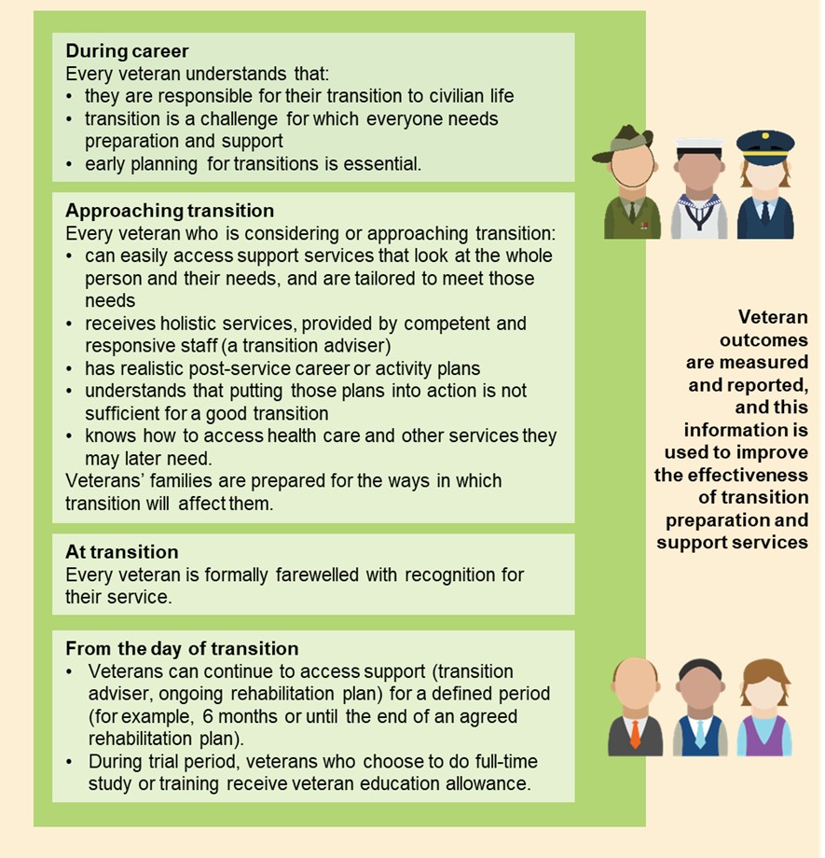

Better health outcomes for veterans
The White Card, which funds treatment for service-connected conditions (as well as treatment for mental health problems, cancer and tuberculosis, without needing to prove a link to service), is generally well-targeted and an appropriate vehicle for funding veterans’ health care. Around 61 000 DVA clients have a White Card.
The Gold Card, however, does not sit well with the key underlying principles for a future scheme. It is not targeted to service-related health needs. It is not wellness-focused or efficient (it can encourage over-servicing). And whether the ‘compensation’ feature of this card for dependants is equitable is also questionable.
Given the Gold Card runs counter to a number of the key design principles that should underpin the future veteran support system, feedback is sought on whether a future system should have a coloured health card system. It is the Commission’s view that eligibility for the Gold Card should not be expanded to any new categories of veterans or dependants that are not currently eligible for such a card. We are seeking feedback on the benefits and costs of possible alternatives to providing the Gold Card to dependants, service pensioners and veterans with qualifying service at age 70.

Improving mental health care access and services
Mental health care is a key area of need for veterans (box 10). As DVA said:
The mental health of veterans has presented as a significant issue for the veteran community in recent years, particularly as younger veterans with recent engagements have faced circumstances — both as part of service, and in returning to Australia — unlike other previous engagements. These circumstances have contributed to many veterans suffering poor mental health.
There has been a heightened focus on veterans’ mental health and suicide in recent years and a range of new policies, programs and research. The recent decision to expand non-liability coverage to mental health care was a positive step. Many participants supported the decision — some describing it as ‘life-saving’.
A number of recent initiatives are also promising — including a suicide prevention pilot in Townsville and a pilot for GP-led coordinated care. However, it is too early to evaluate these, and other, initiatives. DVA has also commissioned a number of research studies that will, in the future, inform policy (but again it is too early to draw any conclusions).
Mental health and suicide prevention is an evolving policy space. DVA’s current mental health strategy is not adequate (it does not contain any tangible goals, commitments or indicators to measure progress) and needs urgent updating. DVA needs to focus more on demonstrable outcomes. The strategy should promote access to high-quality mental health care, and facilitate coordinated care for veterans with complex needs (and where relevant, their families). It should also identify the needs of family members and appropriate responses.

Box 10 Veteran’s mental health
Those who serve in the Australian Defence Force (ADF) are recruited and trained to be physically and mentally resilient, and to display strength and perseverance in the face of adversity.
While veterans are serving, there are a range of protective factors that are likely to reduce the risk of mental ill health compared with the general population. They include a strong sense of purpose, camaraderie and easy access to health care.
But they are also exposed to particular mental health risks, including exposure to trauma and time away from family and frequent relocations. And once veterans leave the ADF, they no longer benefit from the protective factors that supported them while serving and are at greater risk of poor mental health. Transition to civilian life can also be a risk factor in itself, as recent research into veterans’ transition and wellbeing highlighted.
Changes brought about by the transition process can lead to the development and/or exacerbation of existing service related mental and physical symptoms resulting in psycho-social adjustment issues ranging from employment difficulties and family/relationship conflict, to mental health and substance abuse problems.
Rates of mental illness among ex-serving veterans are high. For example, the suicide rate for ex-serving men aged under 30 is 2.2 times that for Australian men the same age. And about one third of those who left the ADF in the past 5 years report high to very high levels of psychological distress.
DVA should also evaluate the effectiveness of its own mental health service — Open Arms (formerly the Veterans and Veterans Families Counselling Service) — to ensure that services are adequate, accessible and of high-quality. Ensuring that the veteran community is better aware of the services available is an important initial step.

Data and evidence could be improved in every area of the system
As with any workers’ compensation scheme, data and evidence are critical to achieving good outcomes for veterans, uncovering better interventions, and managing emerging risks and long-term scheme costs. The VSC will place greater reliance on data and analysis and practices of continuous improvement as it will be required to compare actuarial forecasts of costs and veteran outcomes with the actual experiences of veterans. However, DVA can start work on developing performance and outcomes frameworks immediately.
The evidence base on veterans and their families would also be strengthened by:
- improving the use of the rehabilitation data and reporting on outcomes
- conducting more high-quality reviews and evaluations. DVA has a number of projects that are aimed at improving veteran wellbeing, but there is little evidence on the effectiveness of some of these services
- taking a strategic approach to research by setting out priorities in a research plan (including leveraging off the priorities of the Repatriation Medical Authority, under its new powers to fund and guide medical and epidemiological research).

The role of ex-service organisations
Ex-service organisations (ESOs) play an important role in the veteran support system. They support the broad veteran community, including dependants of deceased veterans. Thousands of hours are volunteered each year to help veterans in all aspects of their post-service lives. They undertake a wide range of activities including:
- welfare and mentoring services for veterans and their families
- commemoration and recognition activities and other social events
- transition support for members leaving the ADF
- employment services
- education and training services
- advocacy services
- assistance with filing and presenting legal or administrative challenges/appeals to DVA decisions.
There are estimated to be several thousand ESOs — and very few have a national footprint or provide the full gamut of services. There is also no peak ESO body. This lack of coordination among ESOs may be diluting their effectiveness.
Community veteran service hubs could aid better social integration, peer-to-peer support and access to advice and information for veterans and their families. The Commission heard about a number of innovative models of collaboration between relevant ESOs and the Australian, state and local governments, including multi-purpose hubs. Such hubs would not replicate existing ESOs, but would provide referral services connecting veterans and their families with relevant ESOs, supports and services, and provide a veteran and family friendly community space. The Commission will say more on the role of ESOs (and advocacy) in the final report after it has considered the recommendations of the Veterans’ Advocacy and Support Services Scoping Study.

A simpler system for veterans and their families
The current system can be simplified in a number of ways.
The front end of the system should be made simpler for clients (a complex system does not need to be complex for veterans and their families). Veterans and their families should be able to understand the system, including the claims process, why claims are accepted or rejected, and what package of supports they may be entitled to.
Simplifying the system is a key component of the VCR program and initiatives such as MyService should continue to be built on. DVA has advised that the VCR program will be fully rolled out by mid-2021.
There are also a number of areas where there is scope to rationalise supports and harmonise the three Acts. Two areas where the three Acts should be harmonised are:
- the initial liability process — moving to a single standard of proof for all types of service (the Commission is seeking feedback on which standard) and adopting the use of Statements of Principles (SoPs) in the DRCA would simplify the initial liability process and ensure a single consistent decision-making process across all three Acts
- the review process — there should be a single review pathway for all veterans’ compensation and rehabilitation decisions (the VEA and MRCA review pathway would apply for the DRCA, box 11) comprising reconsideration, review and resolution by the VRB, formal merits review by the AAT and judicial reviews. The role of the VRB should be modified to provide enhanced dispute resolution processes. It should no longer be a determinative body.

Box 11 The review process could be simpler and more efficient
There are unjustified differences in the review process between the three Acts. There should be a single pathway for all veterans’ compensation and rehabilitation decisions. The single pathway should include:
- internal reconsideration, where a different Department of Veterans’ Affairs (DVA) officer makes a new decision based on all the information available, including additional information that was not available at the initial stage of decision
- review and resolution by the Veterans’ Review Board (VRB). The VRB’s role should be modified to only use alternative dispute resolution processes to resolve claims by consent between the applicant and DVA. This will allow claims to be resolved in a more timely manner. Any matters that cannot be resolved could go to the Administrative Appeals Tribunal (AAT).
- formal merits review by the AAT
- on matters of law, judicial review.
Some payments should be removed, simplified or rolled into the underlying payment. These include:
- the MRCA special rate disability pension (a payment that has rarely been used)
- education payments for dependants over 16 years (which simply mirror youth allowance payments, but without an income test)
- energy and veterans’ supplements (which can be removed or rolled into the underlying payments).
In other areas of compensation, more substantial reforms are warranted.
- Compensation under the MRCA varies depending on whether the impairment was suffered as a result of warlike or non-warlike, or peacetime service. On the basis that ‘an injury is an injury’ irrespective of the type of service, injuries, illness or deaths due to service should be treated in the same way. One rate of compensation should cover all types of service.
- The compensation system includes a system of income replacement administered through DVA, and free invalidity and death insurance provided through the Commonwealth Superannuation Corporation. These payments are offset against each other in most cases, but clients’ needs are assessed by two organisations. There is scope to simplify the administrative arrangements for these schemes.
- Under the MRCA and VEA, dependants can receive benefits (including pensions, lump-sum payments and the Gold Card) if a veteran dies and:
- their death was related to service, or
- the veteran had a certain level of service-related impairment prior to their death, irrespective of the cause of death (that is, the veteran could die in a car crash, or of old age, and their dependants may receive benefits).
- There is little rationale for the second of these eligibility criteria. Going forward, under the MRCA, future eligibility for dependant benefits should be restricted to dependants of veterans who died as a result of service. The effect of this change is likely to be minimal in the near term, as most MRCA dependant benefits are currently due to service-related deaths. However, it will have an effect in the long run, as the MRCA population ages.

Two compensation and rehabilitation schemes
Moving to one Act covering all veterans is the ultimate objective of simplification (many participants called for a single Act). Ultimately the MRCA should be the predominant piece of veterans’ compensation and rehabilitation legislation. This is because the VEA has significant shortcomings with its focus on providing set rate pensions for life which is inconsistent with the goals of rehabilitation and person-centred wellness. Nor are the pensions necessarily reflective of the loss faced by individual veterans.
However, moving to one Act is not possible at this stage. There are many veterans on the VEA (either with current benefits or likely future claims). And many of these are older, which means that the rehabilitation and return to work focus of the more contemporary Act is less relevant.
The Commission is recommending a two scheme approach (figure 9). Scheme 1 covers veterans under a modified VEA. While there will be some modifications to the existing VEA, it will continue until natural attrition removes the need for the scheme. It is largely an older cohort of veterans with operational service who have injuries before 2004 — although any veteran who does not have a current VEA liability claim by 1 July 2025 will no longer be eligible to make claims under this scheme.
Scheme 2 is for all other veterans underpinned by a modified MRCA (incorporating the DRCA). Over time this will become the dominant scheme.
Eligibility should be based on the following principles:
- veterans should only be eligible to make claims under one scheme — that is, all future claims for each individual veteran would be processed under either scheme 1 or scheme 2
- veterans should not have their current benefits affected, however some veterans in scheme 1 should be given a one off opportunity to switch their current and future benefits to scheme 2 (figure 10).

Figure 9 Compensation available under the schemes
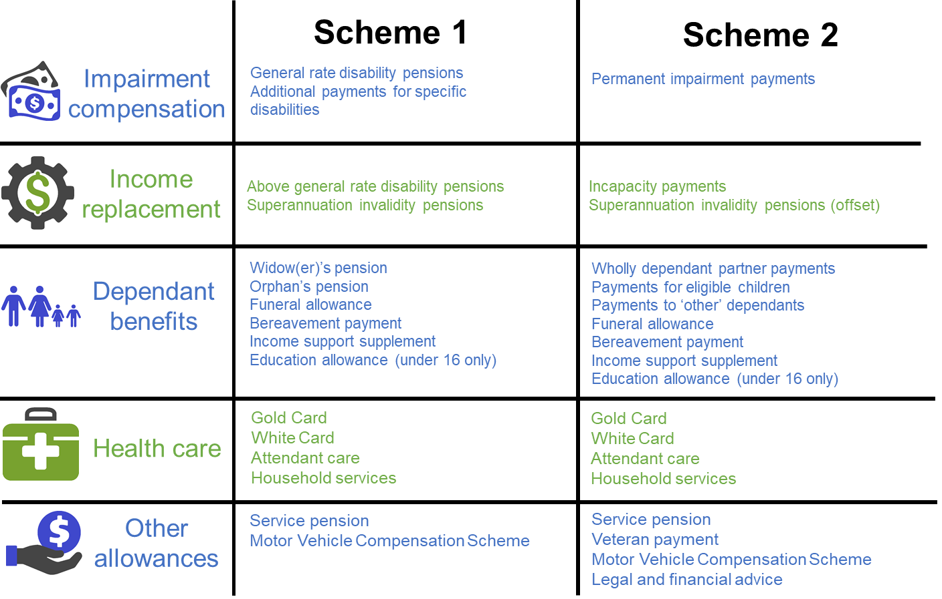

Figure 10 Eligibility under the two schemes
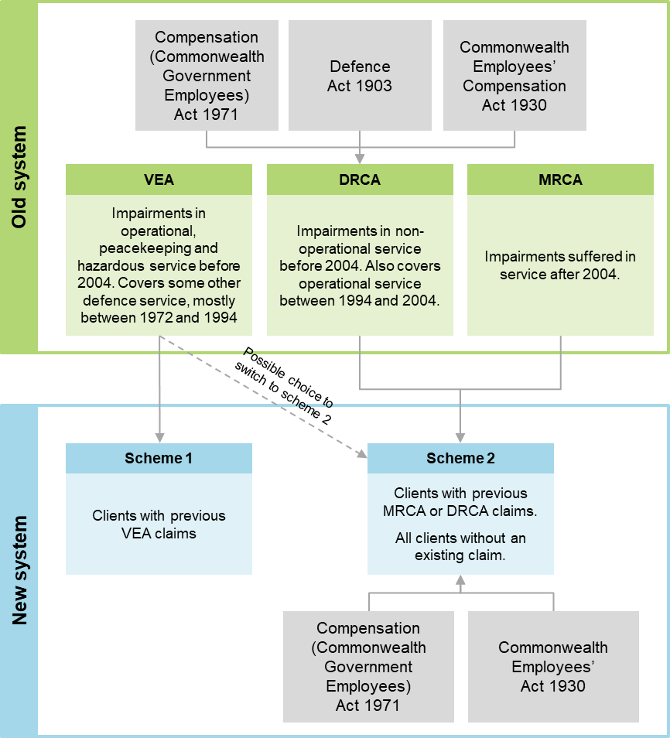

Applying these principles will reduce the need for compensation offsetting, reduce complexity and speed up the transition towards scheme 2.
Veterans with impairments for which DVA has accepted liability under the VEA would remain on scheme 1 with all their future claims processed under this scheme (regardless of their current eligibility for other Acts). However, younger veterans are likely to benefit from the rehabilitation and income replacement focus of scheme 2. Veterans 55 years of age or younger as at 1 July 2025 would be given the option of switching their current benefits and future entitlements to scheme 2, and would receive financial advice to make this decision.
Other veterans — including those currently covered by the MRCA or DRCA, and those without a current or successful VEA claim as at 1 July 2025 — would be covered by scheme 2 for all future claims.
The design of the schemes is complicated by the fact that some veterans have current claims under multiple Acts. The Commission is proposing to set eligibility for this group on both their age and the current benefits they are receiving, but is seeking further input on this issue.
When a veteran that already has an accepted liability claim dies, the dependants would receive compensation based on the scheme that applied to the veteran. If the veteran did not have an existing or accepted liability claim as at 1 July 2025, dependants would receive compensation through scheme 2.

An indicative timeline for reform
Some of the proposed changes to the governance arrangements in the veteran support system, such as the creation of the Veterans’ Advisory Council, can be implemented quickly. Establishing the Joint Transition Command should be a priority — it should be in place by mid-2020.
However, the more foundational changes (including moving DVA’s policy responsibility into Defence, creating the independent VSC and levying a premium on Defence) will be more disruptive. Work to establish the VSC should commence as soon as possible, having regard to the rollout of the VCR reforms that are due to be completed by mid 2021. Based on an indicative timetable, the VSC should begin operating on or before 1 July 2022.
The legislative reform process should be phased over time, with the process culminating in the adoption of the two scheme approach. The starting point for reform should be simplifying and streamlining the Acts themselves. At the same time, some simple harmonisation between the DRCA and the MRCA could be achieved, such as aligning the incapacity payments between the Acts, and using SoPs in the DRCA. These reforms would set the framework for the eventual merging of the Acts.
By mid 2025 the two scheme approach should be implemented. This would involve merging the DRCA into the MRCA, and having in place mechanisms to allow veterans to be assigned to schemes or exercise options for switching (where permitted). This time frame will allow time for the governance reforms to be implemented, as well as allow veterans time to adjust to the new approach and consider their options.

What are the benefits from the proposed reforms?
While the Commission has not quantified the benefits of its reforms, they are likely to be significant and cross multiple domains, including:
- better lives or wellbeing gains, improved work health and safety and injury prevention (fewer veterans and their families having to deal with injury, illness or death)
- improved and more continuous rehabilitation and transition supports (veterans and their families will be better prepared for the challenges of transition)
- a simpler, fairer and more accessible system of compensation
- more consistent assessment of claims easing pressures for claimants
- a quicker and simpler review process to resolve issues in a timely way
- a better evidence base to inform the design and delivery of services, programs and policies which should lead to improved outcomes for clients.
There will also be efficiency gains from the proposed changes (including those that place a greater focus on accountability and lifetime costs of support and reduce duplication). A greater focus on wellness and lifetime costs should also translate into increased economic and social participation of veterans and reduced use of income support. While we have not at this stage costed many of the proposed changes (in large part because of a lack of data), we will seek to do this in consultation with Defence and DVA between the draft and the final report.

Draft recommendations, findings and information requests
Understanding the objectives of the veterans’ compensation and rehabilitation system is important for assessing how well the current system is performing and what an improved system would look like.

Objectives and principles

DRAFT Recommendation 4.1
The overarching objective of the veteran support system should be to improve the wellbeing of veterans and their families (including by minimising the physical, psychological and social harm from service) taking a whole-of-life approach. This should be achieved by:
- preventing or minimising injury and illness
- restoring injured and ill veterans by providing timely and effective rehabilitation and health care so they can participate in work and life
- providing effective transition support as members leave the Australian Defence Force
- enabling opportunities for social integration
- providing adequate and appropriate compensation for veterans (or if the veteran dies, their family) for pain and suffering, and lost income from service-related injury and illness.
The principles that should underpin a future system are:
- wellness focused (ability not disability)
- equity
- veteran centric (including recognising the unique needs of veterans resulting from military service)
- needs based
- evidence based
- administrative efficiency (easy to navigate and achieves timely and consistent assessments and decision making)
- financial sustainability and affordability.
The objectives and underlying principles of the veteran support system should be set out in the relevant legislation.

Prevention
The Australian Defence Force (ADF) is committed to providing a safe and healthy working environment for its members and it has achieved commendable reductions in serious injuries and illnesses over the past seven years. Nonetheless, more can be done to give the ADF better tools to help it achieve its commitment to improved work health and safety.

Draft Finding 5.1
There are no compelling grounds to change the current arrangements where Australian Defence Force (ADF) members are subject to Commonwealth work health and safety legislation. In fact, the introduction of the Work Health and Safety Act 2011 has been instrumental in helping to improve work health and safety outcomes in the ADF.

Draft Finding 5.2
Since Defence introduced Sentinel (a work health and safety incident reporting system) in 2014, it has expanded its coverage (there is now service-wide access), improved the ease of use of the system for serving personnel and put in place processes to ensure that reported incidents are acted on.
However, despite these efforts, underreporting of work health and safety incidents on Sentinel (other than for serious, defined events that must be notified to Comcare) continues to be an issue.

Information request 5.1
The Commission was told that the data recorded on Sentinel significantly understates the true incidence of most types of work health and safety incidents. What aspects of Sentinel contribute to this and what might be done to improve reporting rates?

Draft Recommendation 5.1
Defence should investigate the feasibility and cost of augmenting the Sentinel database with information from the Defence eHealth System. In the longer term, when Defence commissions the next generation of the Defence eHealth System, it should include in the system requirements ways to facilitate the capture of work health and safety data.
The Departments of Defence and Veterans’ Affairs should investigate the feasibility and cost of augmenting the Sentinel database with information from the Department of Veterans’ Affairs’ datasets, which would provide insights into the cost of particular injuries and illnesses.

Draft Recommendation 5.2
Defence should use the injury prevention programs being trialled at Lavarack and Holsworthy Barracks as pilots to test the merit of a new approach to injury prevention to apply across the Australian Defence Force (ADF).
Defence should adequately fund and support these programs, and ensure that there is a comprehensive and robust cost–benefit assessment of their outcomes.
If the cost–benefit assessments are substantially positive, injury prevention programs based on the new approach should be rolled out across the ADF by Defence.

Draft Recommendation 5.3
Beginning in 2019, the Australian Government should publish the full annual actuarial report that estimates notional workers’ compensation premiums for Australian Defence Force members (currently produced by the Australian Government Actuary).

Rehabilitation and wellness services
Significant reform is required to the way Defence and the Department of Veterans’ Affairs (DVA) procures, organises and monitors rehabilitation services. Changes are also required to rehabilitation arrangements in the transition period to ensure continuity of care.
Given that the Veteran Services Commission (VSC) (draft recommendation 11.2) will replace DVA, recommendations in this and subsequent chapters directed at DVA should also be read as referring to the VSC.

Draft Finding 6.1
Defence has a strong incentive to provide rehabilitation services to Australian Defence Force (ADF) members who have a high probability of redeployment or return to duty, but a weaker incentive to rehabilitate members who are likely to be transitioning out of the ADF. This is because ex-serving members become the responsibility of the Department of Veterans’ Affairs (DVA) and Defence does not pay a premium to cover liabilities. Access to rehabilitation supports can also be disrupted during the transition period.
DVA pays limited attention to the long-term sustainability of the veteran support system (in part because the system is demand driven) and this reduces its focus on the lifetime costs of support, early intervention and effective rehabilitation.

draft Recommendation 6.1
The Australian Defence Force Joint Health Command should report more extensively on outcomes from the Australian Defence Force Rehabilitation Program in its Annual Review publication.

Information request 6.1
The Commission is seeking information (both quantitative and qualitative) on return-to-work outcomes from Australian Defence Force and Department of Veterans’ Affairs rehabilitation programs. Areas of particular interest include the appropriateness of comparing return-to-work outcome measures in military and civilian contexts, and what approaches to return to work are effective both in-service and post-service.

draft Recommendation 6.2
The Department of Veterans’ Affairs should make greater use of the rehabilitation data that it collects and of its reporting and evaluation framework for rehabilitation services. It should:
- evaluate the efficacy of its rehabilitation and medical services in improving client outcomes
- compare its rehabilitation service outcomes with other workers’ compensation schemes (adjusting for variables such as degree of impairment, age, gender and difference in time between point of injury and commencement of rehabilitation) and other international military schemes.

draft Recommendation 6.3
Defence and the Department of Veterans’ Affairs need to engage more with rehabilitation providers, including requiring them to provide evidence-based approaches to rehabilitation, and to monitor and report on treatment costs and client outcomes.
Changes are also required to the arrangements for providing and coordinating rehabilitation immediately prior to, and immediately post, discharge from the Australian Defence Force (ADF). Rehabilitation services for transitioning personnel across this interval should be coordinated by Joint Transition Command (draft recommendation 7.1). Consideration should also be given to providing rehabilitation on a non-liability basis across the interval from ADF service to determination of claims post-service.

Information request 6.2
The Commission is seeking further views on the potential use of consumer-directed care for the rehabilitation services provided to veterans, or on alternatives for providing more tailored, person-centred rehabilitation services.

Transition to civilian life after military service
While most veterans make a relatively smooth and successful transition to civilian life, some find transition a difficult and stressful time. Neither Defence nor DVA has clear responsibility for all aspects of veterans’ transition, and services are not targeted to those most at risk. To improve military-to-civilian transition, and to clarify roles and responsibilities, the Commission is recommending creating a new command responsible for transition preparation and support.

DRAFT Finding 7.1
The Departments of Defence and Veterans’ Affairs offer a range of programs and services to support veterans with their transition to civilian life. Despite some improvements in recent years, these efforts remain fragmented and poorly targeted, with few demonstrated results. While many discharging members require only modest assistance, some require extensive support especially those who are younger, served in lower ranks, are being involuntarily discharged for medical or other reasons or who have skills that are not easily transferable to the civilian labour market.

DRAFT Recommendation 7.1
The Australian Government should recognise that Defence has primary responsibility for the wellbeing of discharging Australian Defence Force members, and this responsibility may extend beyond the date of discharge. It should formalise this recognition by creating a ‘Joint Transition Command’ within Defence. Joint Transition Command would consolidate existing transition services in one body, with responsibility for preparing members for, and assisting them with, their transition to civilian life. Functions of Joint Transition Command should include:
- preparing serving members and their families for the transition from military to civilian life
- providing individual support and advice to veterans as they approach transition
- ensuring that transitioning veterans receive holistic services that meet their individual needs, including information about, and access to, Department of Veterans’ Affairs’ processes and services, and maintaining continuity of rehabilitation supports
- remaining an accessible source of support for a defined period after discharge
- reporting on transition outcomes to drive further improvement.

Information request 7.1
The Commission is seeking feedback on the period of time that Joint Transition Command should have responsibility for providing support to members and former members of the Australian Defence Force who require that support.

Draft Recommendation 7.2
Defence, through Joint Transition Command (draft recommendation 7.1), should:
- require Australian Defence Force members to prepare a career plan that covers both their service and post-service career, and to update that plan at least every two years
- prepare members for other aspects of civilian life, including the social and psychological aspects of transition
- reach out to families, so that they can engage more actively in the process of transition.

draft Recommendation 7.3
The Department of Veterans’ Affairs should support veterans to participate in education and vocational training once they leave the Australian Defence Force. It should trial a veteran education allowance for veterans undertaking full-time education or training.

Information request 7.2
The Commission is seeking information to inform the design of the proposed veteran education allowance. In particular:
- at what rate should the veteran education allowance be paid?
- should eligibility for the veteran education allowance be contingent on having completed a minimum period of service? If so, what should that minimum period be?
- should any other conditions be put on eligibility for the veteran education allowance?

Information request 7.3
The Commission is seeking further information on the transition needs of members when they leave the Reserves.

Initial liability assessment
Having liability accepted for an injury, illness or death is the first step in most claims for compensation, treatment and rehabilitation in the veteran support system. The way initial liability is assessed varies by Act and by type of service. These variations are no longer justified and should be reduced or eliminated where feasible.

Draft Recommendation 8.1
The Australian Government should harmonise the initial liability process across the three veteran support Acts. The amendments should include:
- making the heads of liability and the broader liability provisions identical under the Veterans’ Entitlements Act 1986 (VEA), the Safety, Rehabilitation and Compensation (Defence-related Claims) Act 1988 (DRCA) and the Military Rehabilitation and Compensation Act 2004 (MRCA)
- applying the Statements of Principles to all DRCA claims and making them binding, as under the MRCA and VEA
- adopting a single standard of proof for determining causality between a veteran’s condition and their service under the VEA, DRCA and MRCA.

Information request 8.1
The Statements of Principles are created on two different standards of proof for the underlying medical-scientific evidence — a ‘reasonable hypothesis standard’ and a ‘balance of probabilities’ standard.
The Commission is seeking participants’ views on which standard of proof the veteran support system should use going forward. What would be the impacts of that choice on future claims and government expenditure, and how could they be quantified?

draft Recommendation 8.2
The Australian Government should amend the Veterans’ Entitlements Act 1986 (VEA) to allow the Repatriation Medical Authority (RMA) the legal and financial capacity to fund and guide medical and epidemiological research into unique veteran health issues, such as through a research trust fund.
Following any investigation, the RMA should be required to publish the list of peer-reviewed literature or other sound medical-scientific evidence used, as well as outline how different pieces of evidence were assessed and weighed against each other. This may require legislative amendments to the VEA.
Additional resources should also be given to the RMA, so that the time taken to conduct reviews and investigations can be reduced to around six months.

Information request 8.2
The Commission is seeking participants’ views on whether there is merit in the Specialist Medical Review Council remaining as a standalone organisation, or whether its role should be folded into an augmented Repatriation Medical Authority review process that brings in additional medical specialists.

Claims administration and processing
There are significant and ongoing problems with the way DVA administers claims. DVA is attempting to fix these problems under its Veteran Centric Reform (VCR) program, which began in 2016. VCR has had some successes, most notably the introduction of an online claims system, but issues including slow and poor quality claims assessments remain. Close monitoring of the effective roll out of the VCR, both in terms of timeliness and outcomes is required.

draft Recommendation 9.1
The Department of Veterans’ Affairs should report publicly on its progress in implementing recommendations from recent reviews (including the 2018 reports by the Australian National Audit Office and the Commonwealth Ombudsman) by December 2019.

DRAFT Finding 9.1
MyService, in combination with a completed Early Engagement Model, has the potential to radically simplify the way Australian Defence Force members, veterans and their families interact with the Department of Veterans’ Affairs (DVA), particularly by automating the claims process.
But achieving such an outcome will be a complex, multi-year process. To maximise the probability of success, Defence, DVA and the Department of Human Services will need to:
- continue to work closely in a collegiate and coordinated fashion
- retain experienced personnel
- allocate sufficient funding commensurate with the potential long-term benefits.

DRAFT Recommendation 9.2
The Department of Veterans’ Affairs should ensure that staff, who are required to interact with veterans and their families, undertake specific training to deal with vulnerable people and in particular those experiencing the impacts of trauma.

Draft Finding 9.2
The Department of Veterans’ Affairs needs to negotiate a sustainable and predictable funding model with the Department of Finance based on expected claims and existing clients.
This should incorporate the likely efficiency savings from the Veteran Centric Reform program via initiatives such as MyService.

Draft Finding 9.3
The Commission does not support deeming initial liability claims at this stage. Progress on the Veteran Centric Reform program in the Department of Veterans’ Affairs should continue to significantly improve the efficiency of claims processing and management. Should these reforms fail to deliver further significant improvements in the timely handling of claims, then the need for statutory time limits should be reconsidered.

DRAFT Recommendation 9.3
If the Department of Veterans’ Affairs’ quality assurance process identifies excessive error rates (for example, greater than the Department’s internal targets), all claims in the batch from which the sample was obtained should be recalled for reassessment.

draft Finding 9.4
External medical assessors provide useful diagnostic information about veterans’ conditions and are a necessary part of the claims process for the veteran support system. However, they should only be called upon when strictly necessary and staff should be provided with clear guidance to that effect.
The Department of Veterans’ Affairs needs to ensure that the current review into external medical assessors fully considers all aspects of Recommendation 10 of the Senate committee inquiry into veteran suicide.

Draft Finding 9.5
Under the Department of Veterans’ Affairs’ (DVA’s) stewardship, the Veteran Centric Reform (VCR) program has produced a number of early successes. However, given DVA’s poor history of change management, close supervision and guidance will be required to ensure VCR continues to be successfully rolled out. Regular progress reporting and ongoing assurance reviews will facilitate this outcome.

draft Finding 9.6
Ex-service organisations play an important role in the veteran support system. However, the lack of coordination among them may be diluting their effectiveness.

Reviews
Most decisions made by DVA to provide (or not provide) compensation or support to veterans can be challenged through administrative review processes. However, there are a number of issues with the existing processes which warrant reform and a common approach is required for all claims.

Draft Finding 10.1
Current review processes are ensuring that many veterans receive the compensation or support that they are entitled to under the law, albeit sometimes with significant delays. The majority of cases that are reviewed externally result in a change to the original decision made by the Department of Veterans’ Affairs.

Draft Finding 10.2
The Veterans’ Review Board and Administrative Appeals Tribunal are not providing sufficient feedback from their review processes to the Department of Veterans’ Affairs to better inform decision-making practice. Further, the Department is not incorporating the limited available feedback into its decision-making processes. This means that opportunities for process improvement are being missed.

draft Recommendation 10.1
The Department of Veterans’ Affairs (DVA) should ensure that successful reviews of veteran support decisions are brought to the attention of senior management for compensation and rehabilitation claims assessors, and that accuracy of decision making is a focus for senior management in reviewing the performance of staff.
Where the Veterans’ Review Board (VRB) identifies an error in the original decision of DVA, it should clearly state that error in its reasons for varying or setting aside the decision on review.
The Australian Government should amend the Veterans’ Entitlements Act 1986 to require the VRB to report aggregated statistical and thematic information on claims where DVA’s decisions are varied through hearings or alternative dispute resolution processes. This reporting should cover decisions of the Board, as well as variations made with the consent of the parties through an alternative dispute resolution process. This should be collected and provided to DVA on a quarterly basis and published in the VRB’s annual report.
DVA should consider this reporting and respond by making appropriate changes to its decision-making processes.

Draft Finding 10.3
While many veterans are managing to negotiate the current pathways for reviews of decisions made under the various veteran support Acts, there are unjustified differences and complexities in the rights of review available to claimants under each Act.

Draft finding 10.4
The Veterans’ Review Board, while highly regarded by veterans, has functions that overlap with those of the Administrative Appeals Tribunal. Rather than being used occasionally to resolve difficult or exceptionally difficult cases, the Department of Veterans’ Affairs is relying on the Board’s external merits review as a standard part of the process for addressing many claims.

draft Recommendation 10.2
The Australian Government should introduce a single review pathway for all veterans compensation and rehabilitation decisions. The pathway should include:
- internal reconsideration by the Department of Veterans’ Affairs. In this process, a different and more senior officer would clarify the reasons why a claim was not accepted (partially or fully); request any further information the applicant could provide to fix deficiencies in the claim, then make a new decision with all of the available information
- review and resolution by the Veterans’ Review Board, in a modified role providing alternative dispute resolution services only (draft recommendation 10.3)
- merits review by the Administrative Appeals Tribunal
- judicial review in the Federal Court of Australia and High Court of Australia.

draft Recommendation 10.3
The Australian Government should amend the role and procedures of the Veterans’ Review Board (VRB).
Rather than making decisions under the legislation, it would serve as a review and resolution body to resolve claims for veterans. All current VRB alternative dispute resolution processes would be available (including party conferencing, case appraisal, neutral evaluation and information-gathering processes) together with other mediation and conciliation processes. A single board member could recommend the correct and preferable decision to be made under the legislation, and the Department of Veterans’ Affairs and the claimant could consent to that decision being applied in law.
Cases that would require a full board hearing under the current process, or where parties fail to agree on an appropriate alternative dispute resolution process or its outcomes, could be referred to the Administrative Appeals Tribunal.
Parties to the VRB resolution processes should be required to act in good faith.

dRAFT Recommendation 10.4
The Australian Government should conduct a further review in 2025 on the value of the continuing role of the Veterans’ Review Board, once significant reforms to the initial claim process for veterans are established. In particular, the review should consider whether reforms have reduced the rate at which initial decisions in the veteran support system are varied on review. If the review finds that the Board is no longer playing a substantial role in the claims process, the Australian Government should bring the alternative dispute resolution functions of the Board into the Department of Veterans’ Affairs or its successor agency.

Information request 10.1
The Commission is seeking further information on whether there are any decisions that are not reviewable, that should be reviewable.

Governance and funding
Under the current governance arrangements, no single agency has responsibility for the lifetime wellbeing of veterans. Strategic policy in the veteran support system appears to be largely reactive, with changes often making the system more complex and expensive. Also, the veteran support system, which has large contingent liabilities, is funded on a short-term basis, and long-term costs are poorly understood. New governance and funding arrangements are required to develop and administer a new veteran support system for future generations of veterans and their families.

Draft Recommendation 11.1
A new ‘Veteran Policy Group’, headed by a Deputy Secretary, should be created in Defence with responsibility for veteran support policies and strategic planning.
Ministerial responsibility for veterans’ affairs should be vested in a single Minister for Defence Personnel and Veterans within the Defence portfolio.

Draft Recommendation 11.2
The Australian Government should establish a new independent Commonwealth statutory authority, the Veteran Services Commission (VSC), to administer the veteran support system. It should report to the Minister for Defence Personnel and Veterans and sit within the Defence portfolio (but not within the Department of Defence).
An independent board should oversee the VSC. The board should be made up of part-time Commissioners appointed by the Minister who have a mixture of skills in relevant civilian fields, such as insurance, civilian workers’ compensation and project management, as well as some with an understanding of military life and veteran issues. The board should have the power to appoint the Chief Executive Officer (responsible for the day-to-day administration).
The functions of the VSC should be to:
- achieve the objectives of the veteran support system (draft recommendation 4.1) through the efficient and effective administration of all aspects of that system
- manage, advise and report on outcomes and the financial sustainability of the system, in particular, the compensation and rehabilitation schemes
- make claims determinations under all veteran support legislation
- enable opportunities for social integration
- fund, commission or provide services to veterans and their families.
The Australian Government should amend the Veterans’ Entitlements Act 1986 and the Military Rehabilitation and Compensation Act 2004 to abolish the Repatriation Commission and Military Rehabilitation and Compensation Commission upon the commencement of the VSC.

DRAFT Recommendation 11.3
The Australian Government should establish a Veterans’ Advisory Council to advise the Minister for Defence Personnel and Veterans on veteran issues, including the veteran support system.
The Council should consist of part-time members from a diverse range of experiences, including civilians and veterans with experience in insurance, workers’ compensation, public policy and legal fields.

Draft Recommendation 11.4
The Australian War Memorial (AWM) already plays a significant and successful role in commemoration activities. As a consequence of the proposed governance and administrative reforms, the Australian Government should transfer primary responsibility for all commemoration functions to the AWM, including responsibility for the Office of Australian War Graves.

Draft Recommendation 11.5
Once the new governance arrangements in draft recommendations 11.1 and 11.2 have commenced, the Australian Government should make the veteran support system a fully-funded compensation system going forward. This would involve levying an annual premium on Defence to enable the Veteran Services Commission to fund the expected future costs of the veteran support system due to service-related injuries and illnesses incurred during the year.

Information request 11.1
The Commission is seeking feedback on the extent and design of the veteran support system funding model, particularly whether the fully-funded system should cover future liabilities only, or whether existing liabilities (including the Veterans’ Entitlements Act 1986) should be capitalised into the insurance pool.

The compensation package
The compensation package is complex — with offsetting provisions applying between the three main compensation Acts, and a system of superannuation invalidity and life insurance operating alongside the compensation system. Reform is needed to simplify the system, and improve equality between veterans.

DRAFT Recommendation 12.1
The Australian Government should harmonise the compensation available through the Safety, Rehabilitation and Compensation (Defence-related Claims) Act 1988 (DRCA) with that available through the Military Rehabilitation and Compensation Act 2004. This would include harmonising the processes for assessing permanent impairment, incapacity and dependant benefits, as well as the range of allowances and supplements.
Existing recipients of DRCA permanent impairment compensation and dependant benefits should not have their permanent impairment entitlements recalculated. Access to the Gold Card should not be extended to those eligible for benefits under the DRCA.

draft Finding 12.1
The principle of not providing two sources of income replacement to the same veteran is sound. There is no case for changing the current offsetting arrangements between government-funded superannuation payments and incapacity payments.

Draft Recommendation 12.2
The Department of Veterans’ Affairs (DVA) and the Commonwealth Superannuation Corporation (CSC) should work together to streamline the administration of superannuation invalidity pensions and veteran compensation, including by:
- moving to a single ‘front door’ for invalidity pensions and veteran compensation
- moving to a single medical assessment process for invalidity pensions and veteran compensation
- developing information technology systems to facilitate more automatic sharing of information between DVA and CSC.
With the establishment of the proposed Veteran Services Commission (draft recommendation 11.2), consideration should be given to whether it should administer the CSC invalidity pensions.

Information request 12.1
What are the costs and benefits of further integration between superannuation insurance benefits and the veteran compensation scheme, and how might this integration be achieved?

Compensation for an impairment
There are a number of changes that could be made to permanent impairment payments under the Military Rehabilitation and Compensation Act 2004 that would simplify the payments, improve access and equity.
The veteran permanent impairment and incapacity payments, and dependant benefits include many provisions that are unique to the veteran compensation system — they do not have parallels in other workers’ compensation schemes. And there is little rationale for a number of these payments. They also add complexity, lead to inequities and can hinder the rehabilitation focus of the veteran support system. Most of these provisions do not lead to large increases in compensation — removing or improving these provisions is unlikely to have a substantial effect on the compensation received by veterans.

DRAFT Recommendation 13.1
The Australian Government should amend the Military Rehabilitation and Compensation Act 2004 to remove the requirement that veterans with impairments relating to warlike and non-warlike service receive different rates of permanent impairment compensation from those with peacetime service.
The Department of Veterans’ Affairs should amend tables 23.1 and 23.2 of the Guide to Determining Impairment and Compensation to specify one rate of compensation to apply to veterans with warlike, non-warlike and peacetime service.

Information request 13.1
The Commission is seeking information on the new level of permanent impairment compensation that would be reasonable, taking into account the costs, benefits and equity implications to veterans, governments and the broader community.

draft finding 13.1
The requirements that a condition be permanent and stable before final permanent impairment compensation is granted, under the Military Rehabilitation and Compensation Act 2004, are needed to prevent veterans from being overcompensated for impairments that are likely to improve.

Draft RECOMMENDATION 13.2
The Australian Government should amend the Military Rehabilitation and Compensation Act 2004 to remove the option of taking interim permanent impairment compensation as a lump-sum payment. The Act should be amended to allow interim compensation to be adjusted if the impairment stabilises at a lower or higher level of impairment than what is expected within the determination period.

draft Recommendation 13.3
The Australian Government should amend the Military Rehabilitation and Compensation Act 2004 to allow the Department of Veterans’ Affairs the discretion to offer veterans final permanent impairment compensation if two years have passed since the date of the permanent impairment claim, but the impairment is expected to lead to a permanent effect, even if the impairment is considered unstable at that time. This should be subject to the veteran undertaking all reasonable rehabilitation and treatment for the impairment.

DRAFT Finding 13.2
There is little rationale for providing additional non-economic loss compensation to veterans for having children, and the current payment leads to inequities and complexities. This payment is unique to the veteran compensation system.

DRAFT Recommendation 13.4
The Australian Government should amend the Military Rehabilitation and Compensation Act 2004 to remove the permanent impairment lump-sum payments to the veteran for dependent children and other eligible young persons.

DRAFT Recommendation 13.5
The Department of Veterans’ Affairs should review its administration of lifestyle ratings in the Military Rehabilitation and Compensation Act 2004 (MRCA), to assess whether the use of lifestyle ratings could be improved.
If the use of lifestyle ratings cannot be improved, the Australian Government should amend the MRCA and the Guide to Determining Impairment and Compensation to remove the use of lifestyle ratings and provide veterans permanent impairment compensation consistent with the lifestyle ratings that are currently usually assigned for a given level of impairment. Existing recipients of permanent impairment compensation should not have their compensation reassessed.

Information request 13.2
The Commission is seeking further information on the costs and benefits of removing the remuneration loading and replacing it with superannuation contributions for veterans with long-term incapacity. What are the barriers to providing superannuation to veterans on incapacity payments, and how could these be overcome?

draft Recommendation 13.6
The Australian Government should amend the Military Rehabilitation and Compensation Act 2004 to remove the option of taking the special rate disability pension. Veterans that have already elected to receive the special rate disability pension should continue to receive the payment.

draft Finding 13.3
Changes to eligibility for the service pension and other welfare payments means that the package of compensation received by veterans on the special rate of disability pension is reasonable. Despite strong veterans’ representation on this issue, there is no compelling case for increasing the rate of the pension.

draft Recommendation 13.7
The Australian Government should amend the Military Rehabilitation and Compensation Act 2004 (MRCA) to remove automatic eligibility for benefits for those dependants whose partner died while they had permanent impairments of more than 80 points or who were eligible for the MRCA Special Rate Disability Pension.

draft Recommendation 13.8
The Australian Government should amend the Military Rehabilitation and Compensation Act 2004 to remove the additional lump sum payable to wholly dependent partners of veterans who died as a result of their service. The Australian Government should increase the wholly dependent partner compensation by the equivalent value of the lump-sum payment (currently about $115 per week) for partners of veterans where the Department of Veterans’ Affairs has accepted liability for the veteran’s death.

Streamlining and simplifying additional payments
Many of the payments available to veterans are outdated (some have not changed since the 1920s), do not meet their intended objectives and result in another layer of complexity in the veteran compensation system. The additional payments are mostly small and the benefits do not always outweigh the costs of the added complexity. The following recommendations are about simplifying, streamlining or updating additional payments so they better meet their objectives.

draft Recommendation 14.1
The Australian Government should amend the Social Security Act 1991 and relevant arrangements to exempt Department of Veterans’ Affairs adjusted disability pensions from income tests for income-support payments that are currently covered by the Defence Force Income Support Allowance (DFISA), DFISA Bonus and DFISA-like payments. The Australian Government should remove the DFISA, DFISA Bonus and DFISA-like payments from the Veterans’ Entitlements Act 1986.

draft Recommendation 14.2
To align education payments across the veteran support system, the Australian Government should amend the Veterans’ Entitlements Act 1986 and the Military Rehabilitation and Compensation Act 2004 to remove education payments for those older than 16 years of age. Those who pass a means test will still be eligible for the same payment rates under the Youth Allowance.
To extend education payments for those under 16 years of age, the Australian Government should amend the Safety, Rehabilitation and Compensation (Defence-related Claims) Act 1988 to adopt the Military Rehabilitation and Compensation Act Education and Training Scheme.

draft Recommendation 14.3
To help simplify the system, smaller payments should be consolidated where possible or removed where there is no clear rationale.
The Australian Government should remove the DRCA Supplement, MRCA Supplement and Veteran Supplement, and increase clients’ payments by the equivalent amount of the supplement.
The Australian Government should remove the Energy Supplement attached to Department of Veterans’ Affairs’ impairment compensation, but other payments should remain consistent with broader Energy Supplement eligibility.

DRAFT Recommendation 14.4
To streamline and simplify outdated payments made to only a few clients, they should be paid out and removed. The Australian Government should amend the Veterans’ Entitlements Act 1986 to remove the recreation transport allowance, the clothing allowance and the decoration allowance and pay out those currently on the allowances with an age-adjusted lump sum.

draft Recommendation 14.5
The Australian Government should amend the Veterans’ Entitlements Act 1986 (VEA) to remove the attendant allowance and provide the same household and attendant services that are available under the Military Rehabilitation and Compensation Act 2004 (MRCA).
Current recipients of the VEA allowance should be automatically put on the same rate under the new attendant services program. Any further changes or claims would follow the same needs-based assessment and review as under the MRCA.

draft Recommendation 14.6
The Australian Government should amend the Veterans’ Entitlements Act 1986 Vehicle Assistance Scheme and section 39(1)(d) (the relevant vehicle modification section) in the Safety, Rehabilitation and Compensation (Defence-related Claims) Act 1988 so that they reflect the Military Rehabilitation and Compensation Act 2004 Motor Vehicle Compensation Scheme.

Health care
An efficient and effective veteran health system needs to target the right services to the right people in terms of need (financially or in terms of health requirements). Some of the eligibility criteria for the veteran health system potentially needs to be re-targeted towards ensuring that those in most need receive the most care. DVA also needs to improve its monitoring of client outcomes and service providers’ effectiveness.

draft Finding 15.1
Funding the treatment of service-related conditions, as is done through the White Card, is well-justified — it appropriately targets veterans with health needs and is similar to workers’ compensation healthcare entitlements.
The Gold Card, however, runs counter to a number of the key principles that should underlie a future scheme — it is not needs based (because it is not targeted to service-related health needs), wellness focused (there can be an incentive to remain unwell), or efficient (by potentially encouraging over-servicing).

draft Recommendation 15.1
Eligibility for the Gold Card should not be extended to any new categories of veterans or dependants that are not currently eligible for such a card. No current Gold Card holder or person who is entitled to a Gold Card under current legislation would be affected.

Information request 15.1
Given the Gold Card runs counter to a number of key design principles, the Commission is seeking feedback on whether a future system should have a coloured health card system. If not, what are the other options?
In particular, the Commission is seeking feedback on the benefits and costs of providing the Gold Card to dependants, service pensioners and veterans with qualifying service at age 70.

Draft Recommendation 15.2
The Department of Veterans’ Affairs should amend the payments for the Coordinated Veterans’ Care program so that they reflect the risk rating of the patient that they are paid for — higher payments for higher risk patients and lower payments for lower risk patients. Doctors should be able to request a review of a patient’s risk rating, based on clinical evidence.

draft Recommendation 15.3
The current (2013–2023) Veteran Mental Health Strategy has not been very effective and should be updated in light of recent policy changes (such as non-liability access) and research findings on emerging needs.
The Department of Veterans’ Affairs (DVA) (in consultation with the Departments of Health and Defence) should urgently update the Veteran Mental Health Strategy, so that it guides policy development and implementation over the medium term. It should:
- be evidence-based, including outcomes from policy trials and other research on veterans’ mental health needs
- set out clear priorities, actions and ways to measure progress
- commit DVA to publicly report on its progress.
The Strategy should include ways to promote access to high-quality mental health care, and to facilitate coordinated care for veterans with complex needs. It should also have suicide prevention as a focus area and explicitly take into account the mental health impacts of military life on veterans’ families.

Draft Recommendation 15.4
The Department of Veterans’ Affairs (DVA) should monitor and routinely report on Open Arms’ outcomes and develop outcome measures that can be compared with other mental health services.
Once outcome measures are established, DVA should review Open Arms’ performance, including whether it is providing adequate, accessible and high-quality services to families of veterans.

Information request 15.2
The Commission is seeking participants’ views on fee-setting arrangements for veterans’ health care that would promote accessible services while maintaining a cost-effective system.
What would be the benefits and costs of separate fee-setting arrangements for Gold Card and White Card holders? To allow cardholders more choice of provider, should providers be allowed to charge co-payments? Should co-payments, if permitted, be restricted to treatment of non-service related conditions?

Information request 15.3
The Commission is seeking participants’ views on the desirability of subsidising private health insurance for veterans and dependants in place of other forms of healthcare assistance.

Data and evidence
The gaps in information about veterans are significant and there is limited evidence on the effectiveness of services provided to veterans. This inquiry was limited by the lack of data and the poor linking of data. Reform is needed to improve data held on veterans and build an evidence base on what does and does not work.

DRAFT Finding 16.1
There is a lack of robust data and evidence on many crucial aspects of the veteran support system. This impedes the design and delivery of effective supports for veterans and their families.

draft Recommendation 16.1
The Department of Veterans’ Affairs should develop outcomes and performance frameworks that provide robust measures of the effectiveness of services. This should include:
- identifying data needs and gaps
- setting up processes to collect data where not already in place (while also seeking to minimise the costs of data collection)
- using data dictionaries to improve the consistency and reliability of data
- analysing the data and using this analysis to improve service performance.

draft Recommendation 16.2
The Department of Veterans’ Affairs should conduct more high-quality trials and reviews of its services and policies for veterans and their families by:
- evaluating services and programs (in ways that are commensurate with their size and complexity)
- publishing reviews, evaluations and policy trials, or lessons learned
- incorporating findings into future service design and delivery.

DRAFT Recommendation 16.3
The Department of Veterans’ Affairs should set research priorities, publish the priorities in a research plan and update the research plan annually.

Bringing it all together
One of the key drivers for this inquiry was the complex legislative framework underpinning the veteran compensation system. The Commission is proposing simplifying the system by moving to two schemes, while minimising disruption to existing claimants. Importantly, our proposed changes will mean there will be one scheme and one Act in the long term. Although legislative simplification is not a solution for all the issues facing the veteran support system, and some complexity will remain, this approach sets up Australia to have much better, fit-for-purpose compensation and rehabilitation arrangements for the future.

draft Recommendation 17.1
By 2025, the Australian Government should create two schemes for veteran support — the current Veterans’ Entitlements Act 1986 (VEA) with some modifications (‘scheme 1’) and a modified Military Rehabilitation and Compensation Act 2004 (MRCA) that incorporates the Safety, Rehabilitation and Compensation (Defence-related Claims) Act 1988 (DRCA) (‘scheme 2’).
Eligibility for the schemes should be modified so that:
- veterans who only have a current or accepted VEA claim for liability at the implementation date will have all their future claims processed under scheme 1. Veterans on the VEA Special Rate of Disability Pension would also have their future claims covered by scheme 1. Veterans under 55 years of age as at the implementation date should be given the option to switch their current benefits and future claims to scheme 2
- veterans who only have a current or accepted MRCA and/or DRCA claim, (or who do not have a current or accepted liability claim under VEA) as at the implementation date will have their future claims covered under scheme 2. Other veterans on MRCA or DRCA incapacity payments would have their future claims covered by scheme 2
- remaining veterans with benefits under the VEA and one (or two) of the other Acts would have their coverage determined by the scheme which is the predominant source of their current benefits, or their age, at the implementation date.
Dependants of deceased veterans would receive benefits under the scheme in which the relevant veteran was covered by. If the veteran did not have an existing or successful claim under VEA as at the implementation date, the dependants would be covered by scheme 2.
Veterans who would currently have their claims covered by the pre-1988 Commonwealth workers’ compensation schemes should remain covered by those arrangements through the modified MRCA legislation.

Information request 17.1
The Commission is seeking feedback from participants on how the two scheme approach would work for veterans who currently have claims under multiple Acts. What factors should determine which scheme these veterans are covered by for their future claims? Should these veterans be given a choice of which scheme would cover them going forward?

There are the three main veteran support Acts, two older pieces of Commonwealth workers’ compensation legislation that are included in the DRCA and the Defence Act 1903 that supplements some DRCA claims.

