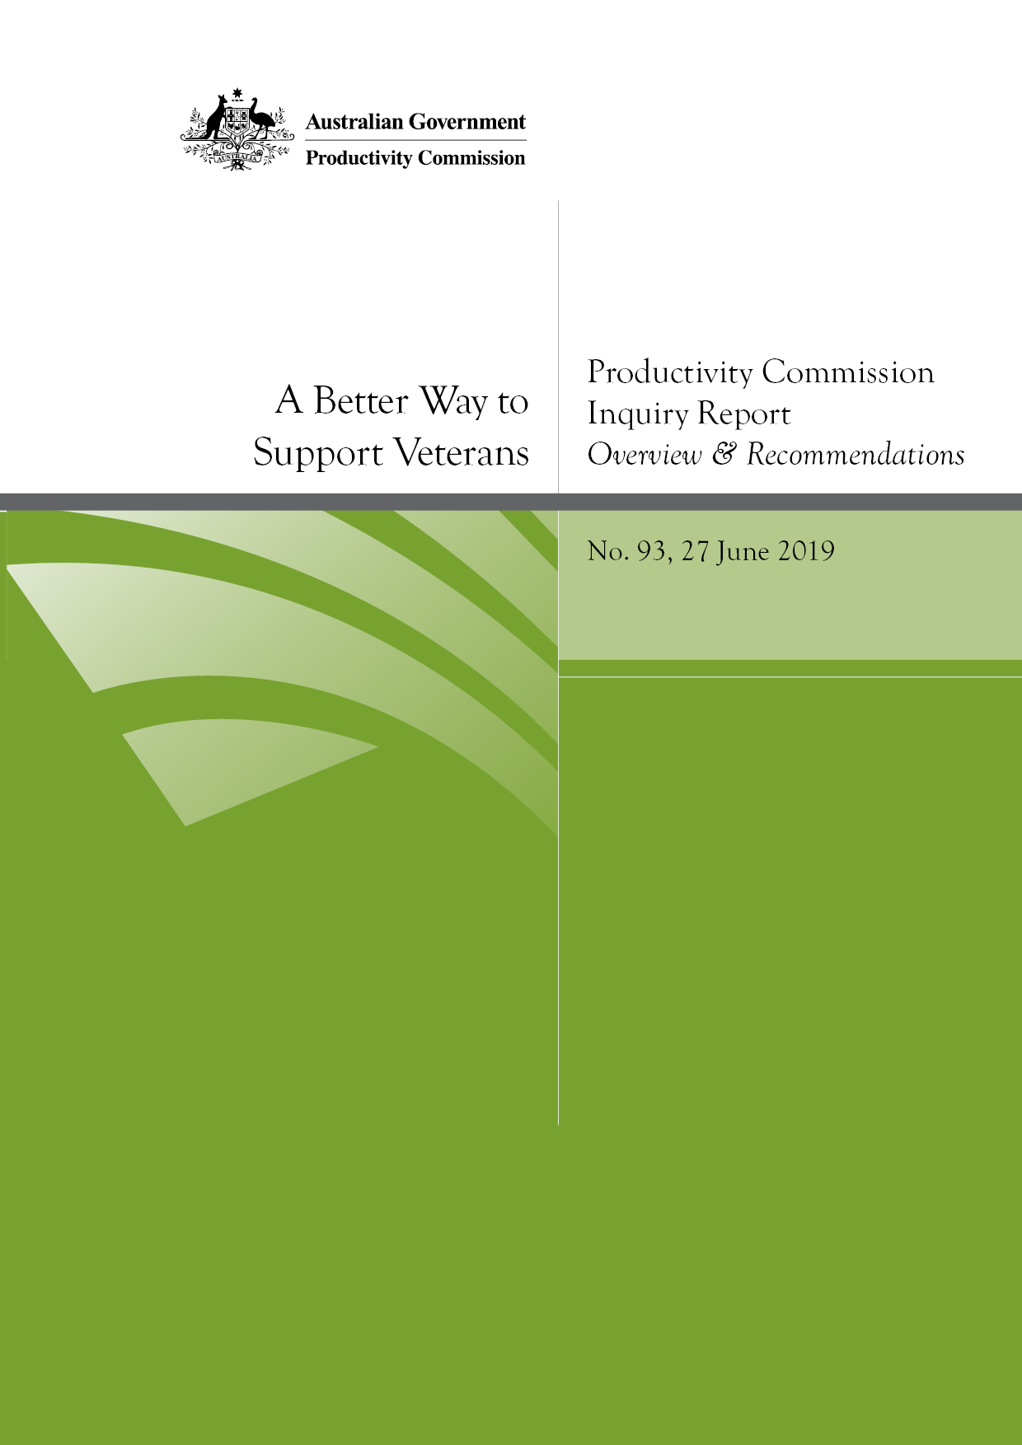
A Better Way to Support Veterans
Productivity Commission Inquiry Report no. 93, 27 June 2019.

Commonwealth of Australia 2019

Except for the Commonwealth Coat of Arms and content supplied by third parties, this copyright work is licensed under a Creative Commons Attribution 3.0 Australia licence. To view a copy of this licence, visit http://creativecommons.org/licenses/by/3.0/au. In essence, you are free to copy, communicate and adapt the work, as long as you attribute the work to the Productivity Commission (but not in any way that suggests the Commission endorses you or your use) and abide by the other licence terms.
Use of the Commonwealth Coat of Arms
Terms of use for the Coat of Arms are available from the Department of the Prime Minister and Cabinet’s website.
Third party copyright
Wherever a third party holds copyright in this material, the copyright remains with that party. Their permission may be required to use the material, please contact them directly.
Attribution
This work should be attributed as follows, Source: Productivity Commission, A Better Way to Support Veterans, Report no. 93.
If you have adapted, modified or transformed this work in anyway, please use the following, Source: based on Productivity Commission data, A Better Way to Support Veterans, Report no. 93.
An appropriate reference for this publication is:
Productivity Commission 2019, A Better Way to Support Veterans, Overview and Recommendations, Report no. 93, Canberra.
Publications enquiries
Media, Publications and Web, phone: (03) 9653 2244 or email: mpw@pc.gov.au

Contents
Overview 1
Key points 2
1 About the veteran support system 6
2 What we were asked to do and our approach 12
3 What objectives for a veteran support system? 13
4 Why reform is needed 17
5 A better way to support veterans and their families 25
Recommendations and findings 45
The full report is available at www.pc.gov.au

Overview

Key points
- Despite some recent improvements to the veterans’ compensation and rehabilitation system, it is not fit-for-purpose — it requires fundamental reform. It is out-of-date and is not working in the best interest of veterans and their families, or the Australian community.
- In 2017-18, the Department of Veterans’ Affairs (DVA) spent $13.2 billion supporting about 166 000 veterans and 117 000 dependants (about $47 000 per client). And while the veteran support system is more generous overall than other workers’ compensation schemes, this does not mean it is an effective system.
- The system fails to focus on the lifetime wellbeing of veterans. It is overly complex (legislatively and administratively), difficult to navigate, inequitable, and it is poorly administered (which places unwarranted stress on claimants). Some supports are not wellness-focused, some are not well targeted and others are archaic, dating back to the 1920s.
- The institutional and policy split between Defence and DVA also embeds perverse incentives, inefficient administration and poor accountability, and results in policy and implementation gaps.
- A future veteran support system needs to have a focus on the lifetime wellbeing of veterans. It should be redesigned based on the best practice features of contemporary workers’ compensation and social insurance schemes, while recognising the special characteristics of military service. This will change the incentives in the system so more attention is paid to the prevention of injury and illness, to rehabilitation and to transition support.
- The split in responsibility between Defence and DVA for the lifetime wellbeing of veterans also needs to be addressed. While the first-best option is for responsibility for veteran policy to be transferred to the Department of Defence, given a lack of trust and confidence by veterans in Defence to exercise this policy role, and strong opposition to the change, this is not realistic or feasible at this stage.
- New governance, funding and cross-agency arrangements are required to address the problems with the current system.
- A single Minister responsible for Defence Personnel and Veterans is needed to ensure policy making for serving and ex-serving personnel is integrated.
- An advisory council to the Minister should be established to provide advice on the lifetime wellbeing of veterans.
- A new independent statutory agency — the Veteran Services Commission (VSC) — should be created to administer and oversee the performance of the veteran support system.
- An annual premium to fund the expected costs of future claims should be levied on Defence.
- A ‘whole-of-life’ veteran policy under the direction of the Minister for Defence Personnel and Veterans needs to be developed by DVA, Defence and the VSC. This should include more rigorous cross-agency planning processes (including external expertise).
- Responsibility for preparing serving veterans for, and assisting them with, their transition to civilian life should be centralised in a new Joint Transition Authority within Defence.
(continued next page)

Key points (continued)
- DVA’s Veteran Centric Reform program has some good objectives and is showing some signs of success. It should be closely monitored to ensure it is rolled out successfully and adjustments should be made, where necessary, to accommodate the proposed reforms.
- The current system should be simplified by: continuing to make it easier for clients to access; rationalising benefits; harmonising across the Acts (including a single pathway for reviews of decisions, a single test for liability and common assessment processes); and moving to two compensation and rehabilitation schemes by July 2025.
- Scheme 1 should largely cover an older cohort of veterans with operational service, based on a modified Veterans’ Entitlements Act 1986. Scheme 2 should cover all other veterans, based on a modified Military Rehabilitation and Compensation Act 2004, and over time will become the dominant scheme.
- Veterans’ organisations play an important role in the system. DVA could better leverage this support network by commissioning services from them, including for veterans’ hubs. Engaging with these organisations when there is no peak body is not easy for government. Should a national peak body be established that represents the broad interests of veterans, the Australian Government should consider funding it.
- The Gold Card runs counter to a number of the key principles that should underlie a future scheme — it is not wellness-focused or needs based. It can also be inefficient (by encouraging over-servicing). It should be more tightly targeted and not be extended to any new categories of recipients. An independent review of DVA’s fee-setting arrangements for health services is also required.
- The way treatments and supports are commissioned and provided to veterans and their families also needs to change. The VSC would more proactively engage with veterans and their families (taking a person-centred approach, tailoring treatments and supports) and have greater oversight of providers than under current arrangements. This approach will require more extensive use of data and a greater focus on outcomes.
- Expanding non-liability coverage to mental health care was a positive step. However, a new Veteran Mental Health Strategy that takes a lifetime approach is urgently needed. Suicide prevention should be a focus of the Strategy, informed by ongoing research and evaluation.
- Families of veterans have access to a number of support services provided by DVA, including access to Open Arms counselling services, respite care, and the Family Support Package. Eligibility for the Family Support Package should be extended. The VSC would have close engagement with families, providing them with more individualised support. Further research is needed to better understand the mental health impacts of service life on families and how they can be best supported.

Overview
An implicit principle underpinning the current veterans’ compensation and rehabilitation system is that military service is a unique occupation. There are a number of features that distinguish military service from other occupations, including that members:
- are required to follow orders — members are subject to military law and discipline and are not as free as other Australians to make independent decisions or to choose to avoid personal injury in armed conflict
- have authority to apply lethal force against enemy forces
- are frequently placed in high-risk environments, including in war or operational service and while in training or on peacetime service.
As the Department of Defence put it:
Australians join the Defence Force for a variety of reasons, but collectively they accept the forfeiture of certain freedoms enjoyed, and taken for granted, by all others in Australian society. Almost every aspect of uniformed life comes with a risk or cost to the member and/or to their families.
Support for members and their families in the event that these risks materialise is widely regarded as a condition of military service. The Australian Government is also committed (and has been since World War I) to supporting, and reintegrating into society, those who are affected by their service in the Australian Defence Force (ADF). And many ex-service organisations provide support to current and former ADF members and their dependants.
While most ADF members successfully transition and quickly re-establish civilian lives, some struggle to address the challenges they experience when they leave the military. Those discharged involuntarily can be deeply affected. And sometimes the impacts of service do not become apparent until many years after discharge. The health and wellbeing of family members of serving and ex-serving veterans can also be harmed by a veteran’s military service, especially the families of veterans who died as a consequence of service and families living with veterans with physical injuries, disease or a mental illness.

Australia supports veterans with a separate and beneficial system
Australia has a comprehensive system of support for veterans, which includes income support, compensation, health care, rehabilitation and other services. Access to some of the supports and services is contingent on a veteran having suffered an injury or illness (or death) related to their military service. Other supports are available regardless of whether they incurred a service-related injury or illness.
Australia’s veterans’ compensation and rehabilitation system is separate from, and more generous overall than, the system of workers’ compensation and support generally available to civilian workers. The ‘beneficial’ nature of the compensation recognises that there can be both anticipated impacts of military service but also unanticipated and unknown potentially harmful exposures.
The current veterans’ compensation and rehabilitation system is, in the Department of Veterans’ Affairs’ (DVA’s) words, ‘steeped in history, stemming back to World War I’. But the environment in which the system is operating has changed. The nature and tenure of military service has changed, as have approaches to social insurance and the availability of mainstream health and community services. The community of Australian veterans and their families is also changing and the new generation of veterans have different needs and expectations.
The key message of this report is that despite recent improvements to the system, the current veterans’ compensation and rehabilitation system requires fundamental reform.
- It is not working in the best interests of veterans and their families or the Australian community.
- It is not set up in a way that minimises harm from service-related injury and illness.
- It is not meeting the needs of contemporary veterans and will struggle to meet the needs of future generations of veterans.
- It needs to be brought more in line with contemporary workers’ compensation schemes and modern person-centred approaches to rehabilitation, health care and disability support. This includes placing veterans and their families at the heart of the system and taking a more holistic, flexible and individualised approach to supporting them.
- It needs efficient and effective governance and administrative arrangements that are suited to meeting the future challenges and emerging needs of veterans.

A lifetime approach
Australians are willing to support veterans who are affected by their service, but they also want to know that the system designed to support them improves, and does not harm, their lives. The veteran support system should be about more than compensation and rehabilitation. It must take a lifetime approach to supporting veterans and their families and be more focused on wellness and ability (not illness and disability) and minimising harm from service. It needs to be more responsive to the changing needs and circumstances of veterans, which will require more flexibility in supports and the way they are provided.
Recognising that mainstream services are a complement to veteran-specific services is one element of a new approach. Changes also need to be made to the way treatments and supports are commissioned and provided to veterans and their families. There needs to be more proactive engagement with rehabilitation, transition, health and mental healthcare providers (including requiring an evidence-based approach to treatment and supports) and better oversight of outcomes from treatment and support.

Wide-ranging reforms
Many of the changes we are recommending are about minimising the harm from service-related injury and illness and investing in veterans so that when they leave the ADF, they are more likely to enjoy fulfilling and productive lives. A lifetime focus will result in better outcomes for veterans, their families and the Australian community.
Some of the benefits from the proposed recommendations include:
- a set of principles and objectives to guide the system
- a greater focus on prevention of injury and illness, on rehabilitation and on transition support
- improved continuity-of-care in rehabilitation
- better coordinated and more responsive transition support
- a simpler and easier system for veterans and their families to navigate
- better targeted and more equitable compensation
- better governance arrangements, more efficient processes and improved commissioning of services
- a greater focus on outcomes for veterans and their families and the Australian community.
We are proposing a comprehensive, coordinated and sequenced package of reforms. The reforms will take time to implement, but they are vital for a better future system of support for veterans and their families. A staged approach will minimise disruption costs, allow current worthwhile initiatives to be rolled out and provide time for legislative and administrative adjustments. It will also allow time for veterans and their families to see the benefits of the reforms and be assured that the changed approach is a better system of support. It is hard to achieve institutional change without trust, and trust is won slowly (particularly given many of the problems that historically have beset veterans’ support). In part, this why the Commission has focused on long-term changes to the veteran support system, in order to build confidence in those changes over time.

1 About the veteran support system
DVA provides various forms of support to current and former ADF members and their families. These include:
- income support and compensation
- health care
- rehabilitation, transition support and other services to support wellbeing.
In 2017-18, DVA spent $13.2 billion on the veterans’ rehabilitation and compensation system (or about $47 000 per client). Of this, about $7.4 billion was spent on compensation and support, $5.3 billion on health care and wellbeing, and about $440 million on enabling services such as workplace training, financial management and information technology. DVA also spent $60 million on commemorative activities and facilities, such as war graves and memorials.
The Commonwealth Superannuation Corporation provided a further $800 million to veterans and their families through invalidity and dependant pensions and Defence spent about $437 million on rehabilitation and health care of serving members.
DVA currently supports about 166 000 veterans and about 117 000 dependants (mainly widows or spouses). The exact number of living Australian veterans is not known (box 1). This is just one indication of the lack of information about Australian veterans.

Box 1 Some facts about serving and ex-serving ADF personnel
Who is a veteran?
Traditionally, the term ‘veteran’ described former Australian Defence Force (ADF) members who were deployed to serve in operational conflict environments. However, in 2017, a Roundtable of Australian Veterans’ Ministers agreed that a veteran would be defined as anyone who has served at least one day in the ADF. As such, for this inquiry we have used the term ‘veteran’ to cover all current and former serving ADF personnel, whether they were deployed to active conflict or peacekeeping operations or served without being deployed. The ‘veteran community’ also covers family members of both living and deceased veterans.
About the ADF and veteran population
- ADF members are professionals who have volunteered to serve in the military. About 5200 recruits join the ADF each year.
- In 2017-18, there were about 58 000 permanent members of the ADF and about 20 000 reservists. The Army accounts for about half of ADF personnel and the Navy and Air Force for a quarter each.
- More than two million Australians have served in the ADF since Federation.
- The extent and tempo of military engagements has increased since the early 2000s.
- Contemporary veterans have injuries that, in prior conflicts, would have resulted in death (for example, traumatic brain injuries).
- About 18 per cent of those who leave the ADF do so for medical reasons.
Little is known about Australia’s total veteran population. The Department of Veterans’ Affairs recently estimated that there are about 640 000 living veterans (including reservists).
DVA clients span all generations and life stages — there are veterans and widows aged over 100 years and children of veterans as young as one year. However, the majority of DVA clients are in the older age groups — about 194 000 are 65 years or older and of these 98 000 are aged over 79 years (figure 1).

Figure 1 DVA clients by age, December 2018
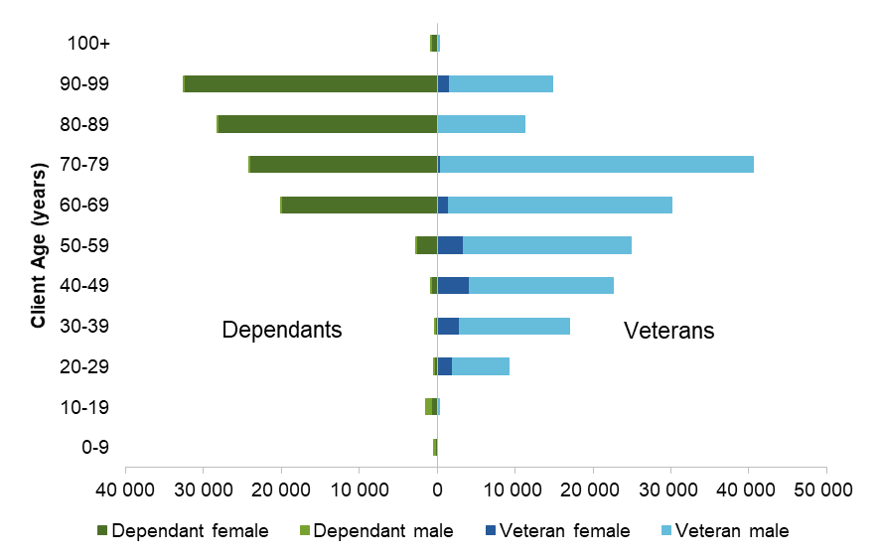
The number of DVA clients is declining, and has fallen from about 540 000 clients in 2000 to 291 000 in 2017, reflecting the deaths of the World War II and the Korean War veteran cohorts (figure 2).

Figure 2 DVA clients — veterans and dependants
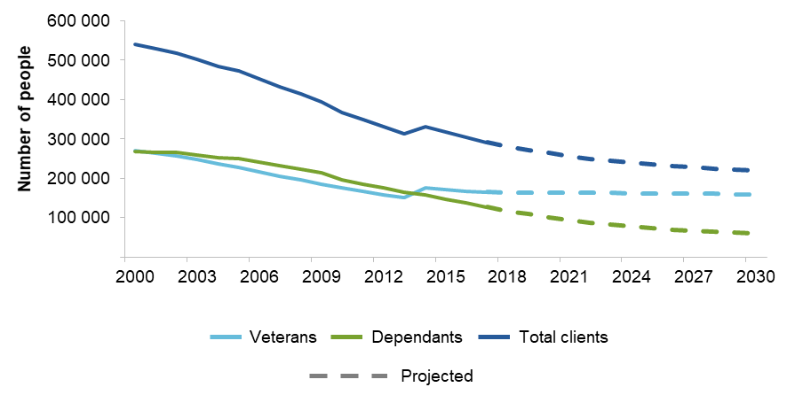

The profile and needs of veterans are changing. This is driven by the nature of recent and current military conflicts and the declining numbers of older veterans.
Older veterans are more likely to require independent living assistance, aged care and health services, while the needs of contemporary veterans are focused on rehabilitation, wellness and returning to work. Contemporary veterans are more likely (than older veterans) to:
- be women (often with dependent children) — the proportion of female members in the ADF increased from 13 per cent in 2000 to about 18 per cent in 2018
- have been on multiple deployments — 38 per cent of permanent ADF members have been deployed more than once
- need to prepare for a working life after service — the median length of time in the military is seven years for members of the Navy and Army, and 10 years for members of the Air Force.
As the Minister for Veterans’ and Defence Personnel, Darren Chester, recently said:
… when we think of the word veteran, we tend to think of someone in their sixties or seventies. But from an ADF perspective, our veterans are often in their late twenties or early thirties, so they have another career after they’ve been in the military.

The legislative framework
The current system has three main Acts.
- The Veterans’ Entitlements Act 1986 (VEA).
- The Safety, Rehabilitation and Compensation (Defence-related Claims) Act 1988 (DRCA).
- The Military Rehabilitation and Compensation Act 2004 (MRCA).
The Acts have different eligibility requirements and provide different levels of support to veterans through different claims and appeals processes (figure 3). The timing and type of the relevant service determines which Act covers the veterans’ impairment. Veterans with multiple impairments can also have different impairments covered under different Acts. Under current arrangements, DVA determines if a veteran’s condition is service-related under one or more of the Acts. It then identifies the payments and their amounts under separate elements of the claims process.

Figure 3 Veteran supports are provided under three main Acts
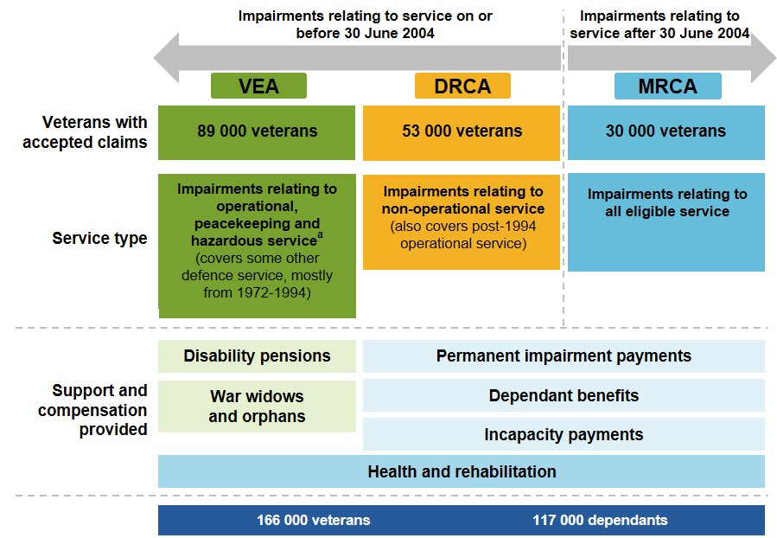

Many of the compensation payments for veterans align with payments in mainstream workers’ compensation schemes, though some are unique (figure 4). Veterans are also eligible for superannuation invalidity payments, and for the age service pension, which cuts in earlier (at 60 years for those with qualifying service) than the equivalent age pension for other Australians.
When considered as a package, compensation for veterans and their families is relatively generous compared to other workers’ compensation schemes. For example:
- a veteran with warlike service and an impairment rated at about 20 impairment points would receive lifetime compensation of about $100 000 under the MRCA. This is about double what a civilian worker with a similar impairment point rating would receive under the Safety, Rehabilitation and Compensation Act 1988 (SRCA)
- a veteran who is totally and permanently incapacitated would receive lifetime compensation of between $1.5 and $3.9 million under the MRCA, depending on their age and need for services such as attendant care. The same person would receive between $1.2 and $2.8 million under the SRCA.

Figure 4 Veteran compensation — the range of payments
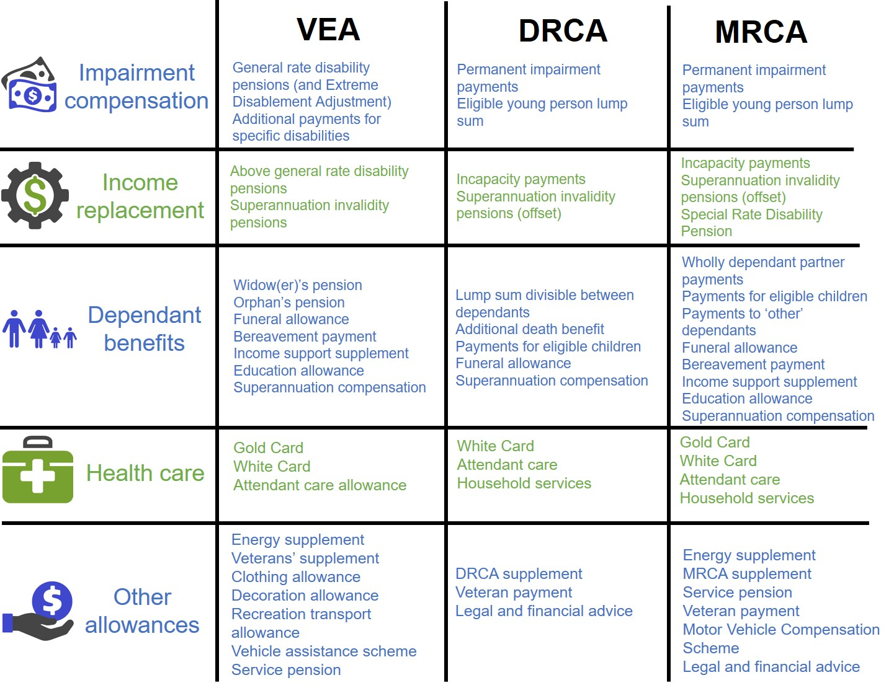

The beneficial nature of the supports for veterans was noted by many participants to this inquiry, with one describing the benefits to Australian veterans as ‘well resourced and largely generous’. However, the important question is not so much the quantum of supports, but their outcomes. Put simply, does this unique system deliver for veterans and the community?

History provides insights into why the system is as it is
History explains, in part, why we have the system we have today. Some features of the system can be traced back to World War I and its after effects — a time when life expectancy, the economic position of women, service members’ pay and motivations for enlisting, and the extent of the mainstream health and welfare system, were very different to what they are today. Since then, governments have added new features, often in an ad hoc manner and/or in response to particular incidents or pressure from veterans’ groups. While a number of the original rationales for elements of the scheme have faded, a political desire to avoid reducing entitlements has meant that governments have not taken opportunities to remove duplication and redundancy.
In DVA’s words, the three Acts ‘collectively incorporate almost all of the benefits available to successive generations of veterans over the last 100 years’.
It almost seems that because Australians value the sacrifices of those who have served, fewer checks and balances are applied to veteran policy (when compared to other areas of policy). While the contribution of our veterans to the nation’s security should be recognised (and there are multiple ways to do this), it is also important that policy makers do not lose sight that the reason for supporting veterans and their families is to improve their lives. More funding for support does not necessarily equate to better outcomes and, in fact, it could undermine the recovery of veterans (for example, by providing a disincentive for veterans to return to work or to work to their potential).
As Gade, a United States veteran who served in Iraq, said:
A fundamental principle of design in any public-policy program can be found in the ancient Hippocratic Oath: ‘First, do no harm.’ This should be especially true of policy toward veterans. Having already taken risks in uniform to protect our society, they should not be exposed to risks from government policy … which could harm them after their service.
There is also only one bucket of taxpayer funds, so it is always important to ask the question ‘how could the money be best spent’?

2 What we were asked to do and our approach
This inquiry came about following a recommendation made by the Senate Foreign Affairs, Defence and Trade References Committee in its report titled The Constant Battle: Suicide by Veterans. The Committee said it chose the title The Constant Battle because it reflected the problematic nature of suicide by veterans and ex-serving personnel, noting that:
For modern veterans, it is likely that suicide and self-harm will cause more deaths and injuries for their contemporaries than overseas operational service.
The Committee found the legislative framework for the veterans’ compensation system to be complex and difficult to navigate. The Committee was concerned that inconsistent treatment of claims for compensation and lengthy delays in the processing of claims were key stressors for veterans and their families, and said it was time for a ‘comprehensive rethink of how the system operates’.
Against this background, the Commission was asked to look at how the current compensation and rehabilitation system for veterans operates, how it should operate into the future, and whether it is ‘fit for purpose’ (the full terms of reference are at the beginning of this report).
We used a wellbeing approach and assessed the benefits and impacts of the system on the lives of veterans, and Australians more generally, in light of the costs of the system. We also looked at best practice workers’ compensation and contemporary social insurance schemes for insights on system design and principles.
Our focus was on providing evidence-based advice about policies that will improve the lives of current and future generations of veterans and their families, while also improving outcomes for the community as a whole.

3 What objectives for a veteran support system?
The overarching objective of the veteran support system should be to improve the lives or wellbeing of veterans and their families (this aligns with what participants told us the objectives of the system should be, box 2). This objective has at its core minimising the harm from service to veterans and their families. This should be achieved by:
- preventing and minimising injury and illness
- restoring injured and ill veterans by providing timely and effective rehabilitation and health care so they can participate in employment and life
- providing effective transition support for veterans and their families
- enabling opportunities for social integration
- providing adequate and appropriate compensation for veterans (or, if the veteran dies, their family) for pain and suffering and lost income from service-related harm.
And as with all other government programs, the objective should be achieved while ensuring value for money for the Australian community. Australians want to know that the money they spend is:
- providing the support that covers the needs of injured or ill veterans
- providing a veteran support system that is run efficiently and effectively, and does not cause unnecessary harm or stress to veterans and their families
- resulting in better lives for veterans and their families.
Best practice workers’ compensation schemes also focus on returning people back to work and health at an affordable and sustainable cost. And contemporary approaches to disability place an emphasis on people’s ability and potential, take an active rather than a passive approach to meeting client’s needs, and focus on long-term costs. The veteran support system, which is unique in its design and purpose, should also take a long-term or lifetime approach to improving veterans’ lives. This will not only get the best outcomes for veterans and their families — because it drives a focus on early intervention and supports that maximise veterans’ independence and economic and social participation — it will also ensure a more affordable and sustainable system by reducing long-term support requirements.

Box 2 A focus on wellbeing and rebuilding lives
The Department of Defence said that the priority objectives for veterans’ support should be:
… to ensure the long-term wellbeing, successful rehabilitation and transition for veterans into civilian life.
The Air Force Association:
Any compensation and rehabilitation system for veterans and their families must be ‘fit for purpose’, recognising the unique nature of military service. Its principal aim is to return the veteran who has suffered injury or illness due to service duty to his/her former physical and/or mental health state and when this is not possible provide life-long treatment and financial support.
The Defence Force Welfare Association:
If the member was broken due to military service to the Nation, then the Nation has a moral obligation to restore and financially support the person to an ‘as new’ condition as possible.
RSL Australia National Office:
The primary objective for an ADF member who has suffered an injury or disease should always be a return to health and a return to work, as this is the best outcome for the member’s physical and mental health, their family, the ADF and any future employers.
Stephan Rudzki:
… soldiers wish to be rehabilitated and return to some form of productive work. Having a job is a very important component of overall health and mental well-being.
Mates4Mates:
It is important that veterans, their families and the whole community understand that despite a physical or psychological injury, veterans have the capacity to lead very active, purposeful and fulfilling lives … Research indicates that employment can be a restorative psychological process. There is no substitute for what employment offers in the way of structure, support and meaning. Positive and meaningful employment experiences are linked to improved self-esteem, self-efficacy and high levels of personal empowerment — all of which have a positive effect on mental health and wellbeing.
In the context of military personnel, a lifetime approach involves taking into account each of the life stages — recruitment, in-service, transition and ex-service (figure 5).
- When members are serving, preventing injury or illness is critical to minimising the harm to veterans and their families from service.
- In all the life stages, timely, appropriate and effective health care and rehabilitation is important for minimising harm (or costs) to veterans and their families.
- The way in which members make the transition from military to civilian life can be an important determinant of their long-term wellbeing (for example, if veterans are poorly prepared for transition they can experience poor mental health and long periods of unemployment). Timely and effective transition services that are available from early in a veteran’s career, during transition and post-service are therefore important.
- Post-service, some veterans develop service-related health conditions and need timely access to supports to minimise harm — this points to the importance of a sustainable system so that veterans can be assured that supports will be available if, and when, they need them.

Figure 5 Life stages of full-time military personnel
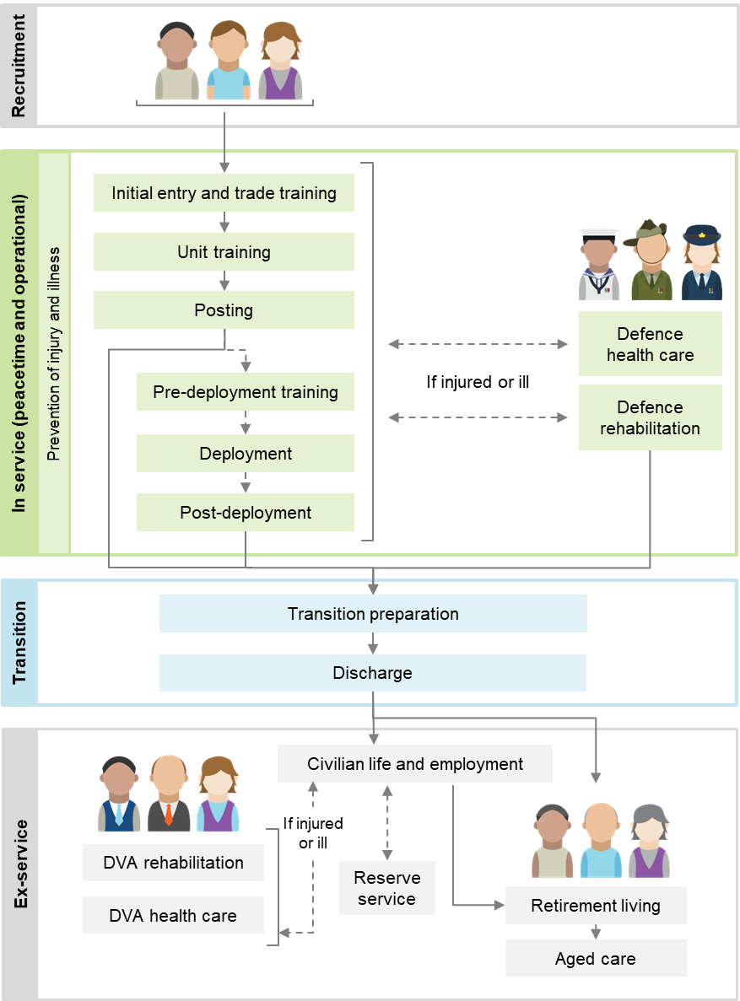

Using a wellbeing approach to support veterans and their families, together with insights from best-practice workers’ compensation and contemporary social insurance schemes, the Commission considers that the veteran support system should be:
- wellness focused (ability not disability)
- equitable
- veteran centric (including recognising the unique needs of veterans and their families resulting from military service)
- needs based
- evidence based
- administratively efficient (easy to navigate and achieves timely and consistent assessments and decision making)
- financially sustainable and affordable.
These principles should underpin the future system (figure 6).

Figure 6 A system that is about better lives for veterans and their families
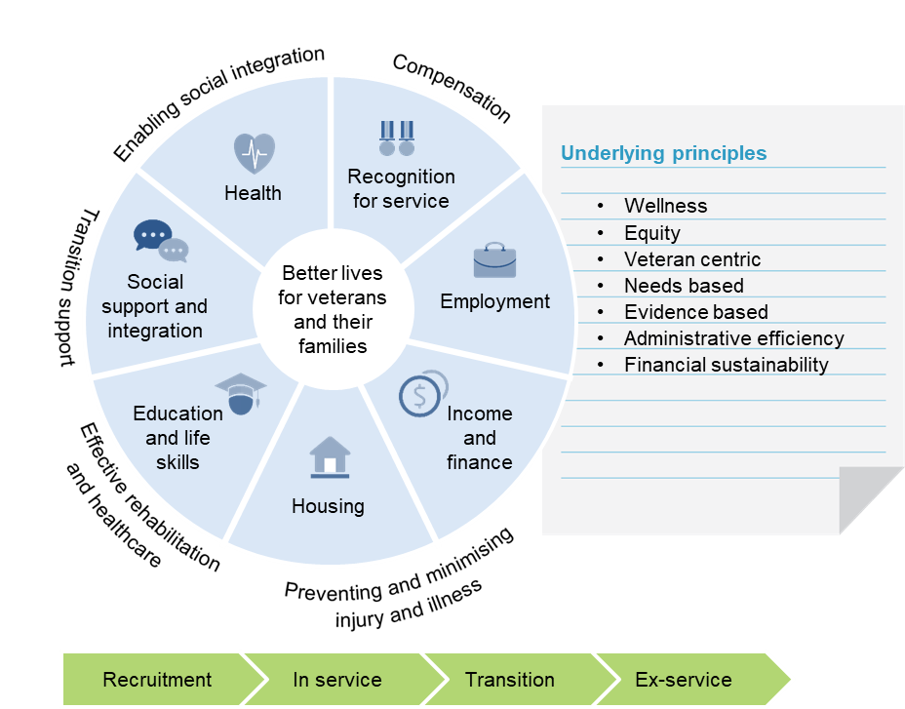

4 Why reform is needed
The current veterans’ compensation and rehabilitation system does not perform well when assessed against the principles that should underpin the future system. This is in part because of the way the system has been added to over time, but also because of the way the system is set up and the incentives it creates for Defence, DVA and veterans. Veterans and their families could be getting far better outcomes from the dollars the Australian community is spending to improve their lives.

The system is overly complex and difficult to navigate …
The veterans’ compensation and rehabilitation system is complex. It is difficult for veterans and their families to navigate and for DVA to administer. It is so complex that claimants often require help from advocates to navigate the system.
Multiple Acts are one source of complexity. Veterans can be eligible for compensation under more than one Act. This can be confusing for veterans and as one participant put it ‘daunting, even insurmountable’. Almost 30 000 veterans have had liability accepted under more than one of the three Acts.
One of the consequences of multiple Acts is the need for offsetting of compensation between Acts (to ensure veterans are not over or under compensated). Again, this is confusing for veterans and a source of many complaints to the Commonwealth Ombudsman. Offsetting can also lead to errors in compensation estimates, which can have serious consequences for veterans. Superannuation invalidity pensions operating alongside the support system means further offsetting and additional complexity.
The individual Acts are also complex. There are many additional payments beyond those typically provided by workers’ compensation schemes (such as payments for damaged clothing, vehicle allowances and education payments). Veterans and their dependants can be eligible for at least 40 different payments or benefits, depending on the Act they are covered by and the impairment the veteran has suffered.
Eligibility for these payments can vary depending on whether the impairment is related to operational service or not. Some payments are lump sum, some are weekly, some are taxed, and others are not. Some benefits are in the form of health care. RSL Queensland said ‘the range of benefits is extensive and not necessarily well understood … it remains difficult for a veteran or his family to feel confident that they have accessed all of their entitlements’.
As discussed earlier, the complexity of the veteran support system is a symptom of reactive and ad hoc policy making and a reluctance to take entitlements away from veterans or even rationalise them when their original rationale no longer exists — problems that DVA itself has highlighted.

… and there is inconsistent treatment of claims
Veterans with the same injury or illness can receive different levels of support because the amount of compensation paid, and how the compensation is calculated or paid, varies depending on which legislation applies. As RSL NSW said ‘veterans can seem to be effectively rewarded or punished for the timing of their service’.
Box 3 provides an example of the different amounts of compensation that a veteran could receive under the different Acts. There are differences based on the type of service they were undertaking (warlike and non-warlike or peacetime) when an injury or illness occurred. Under the MRCA, the rates for warlike and non-warlike service are higher than those for peacetime service up to 80 impairment points (there is no difference between the rates for veterans with impairments above 80 points). The difference can be over $100 000.
Different compensation for warlike and non-warlike service, and peacetime service adds complexity and veterans are required to demonstrate whether their injury was suffered as a result of warlike or non-warlike service. It also means there are inequities between different groups of veterans.

Some supports are poorly targeted …
Some supports are poorly targeted, exemplified by the Gold Card. It covers the cost of a range of public and private health care services, irrespective of whether the impairment is service related (box 4). Most Gold Card holders (about 60 per cent) are dependants or veterans without severe service related disabilities (who qualify because of age or because they are receiving the service pension). The way the healthcare cards operate also means that cardholders are unlikely to be receiving co-ordinated person-centred health care.

… some discourage wellness
And some of the supports discourage wellness. One example is the Special Rate Disability Pension under the MRCA. It provides little incentive for veterans to rehabilitate and return to work because veterans lose access to their payment entirely if they return to work for more than 10 hours per week.

Box 3 Different Acts, different amounts of compensation for the same impairment
The amount of compensation payable, and how the compensation is calculated or paid, varies depending on which Act applies. As an example, Jane is a 30 year old veteran who suffered a shoulder impairment graded at about 20 impairment points. While the amount and type of compensation will vary based on which Act she is covered by and the type of service under which the impairment was suffered, she will be entitled to:
- either a permanent impairment payment or a pension to compensate for the pain and suffering from the impairment. (Because Jane’s ability to work is not affected by her impairment, she will not be entitled to an income replacement payment.)
- various supplements.
Jane could expect to receive between $56 000 and $140 000 in lifetime financial compensation (with the VEA being the most generous Act).
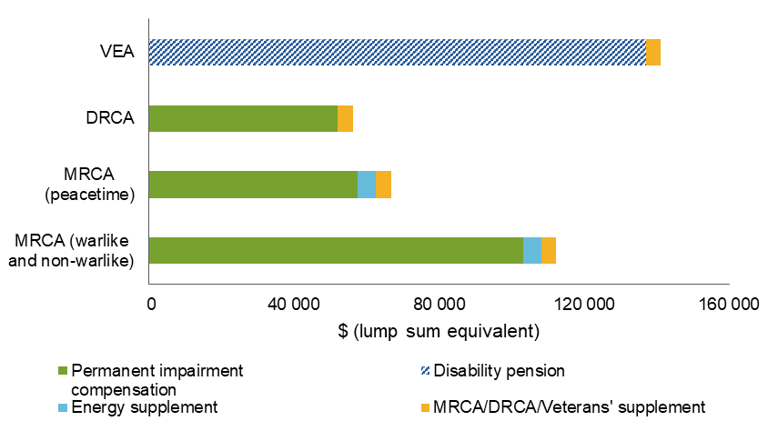
Jane would also receive treatment for the shoulder impairment through the White Card, and, if she has qualifying service, will receive the Gold Card at 70 years of age and the service pension.
The Gold Card can also work against the principle of ‘wellness’ by providing an incentive for veterans to seek to qualify for higher levels of support. A veteran with service-related impairments can substantially increase their compensation package by reaching the Gold Card eligibility. As RSL NSW said, DVA’s health card system ‘encourages a view of the system as a contest to be won, with the Gold Card as the prize’.
… The outcome sought for veterans should be rehabilitation, not monetary settlement. The ‘gold card’ nomenclature utilised by DVA reinforces a negative entitlement culture where success for veterans is the extraction of cash from the government, not their rehabilitation and return to being a productive member of civilian society.

Box 4 Who is entitled to the Gold Card and what does it provide?
The holder of a Gold Card is entitled to treatment and care for all health conditions. About 127 000 DVA clients have a Gold Card. Gold Cards are issued to:
- veterans aged over 70 years with qualifying service (about 7000 cardholders)
- veterans receiving the service pension who satisfy a means test (about 11 000 cardholders)
- veterans above a specific level of impairment or incapacity under the VEA (about 49 000 cardholders) or MRCA (about 1500 cardholders)
- dependants of deceased veterans who qualify for a war widow(er)s’ pension or wholly dependent partner or child payment (about 62 000 cardholders)
- ex-prisoners of war (140 cardholders), British nuclear test participants and members of the British Commonwealth Occupation Force (650 cardholders).
The range of entitlements covered by the Gold Card goes well beyond those covered by the public health system and includes private hospital visits, private specialist appointments, dental services, aged care services and travel for treatment. Gold Card holders are also exempt from paying the Medicare levy.
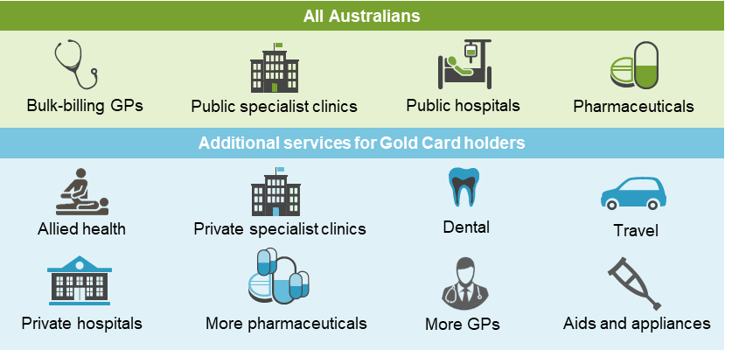
Veterans can also be discouraged from seeking early intervention (which can lead to higher use of more expensive treatments) so they can maintain access to the Gold Card. As the National Mental Health Commission said:
A person eligible for the Gold Card on the basis of total and permanent incapacity, due to a mental health condition for instance, can lose eligibility if their condition improves or other circumstances change. The possibility of losing eligibility can therefore discourage people from seeking early intervention for mental health concerns and — in some cases — lead to higher use of expensive or unnecessary treatments.
There is strong support for the Gold Card from the veteran community — this is of no surprise — as it is, as the National Mental Health Commission said ‘a substitute for private health insurance’ (box 4). Gold Card holders are high users of healthcare services. In 2017-18, DVA funded 220 health services per Gold Card holder (by comparison, Medicare funded about 17 services per person and 44 services for each person aged 85 years and over).
The VEA is compensation, not wellness, focused (it is based on lifetime pensions and health care — this does not align with contemporary workers’ compensation schemes). As DVA said:
It is notable that the older VEA, under which nearly 16 000 primary claims were made in 2017-18, has a focus on illness and lifetime compensation payments, which is not conducive to a ‘wellness’ model.
There are also a number of outdated payments (dating back to the 1920s) under the VEA that no longer have a clear rationale.

Inefficient processes that can place unnecessary stress on veterans
DVA’s processes for administering claims are unnecessarily complicated and processing times can be lengthy. The time taken to process claims is typically many months, and some claims can take over a year to process (box 6). This can place unnecessary stress on claimants. One participant said that DVA’s claims process (and the processing delays) caused as much damage as the initial injury. The Australian National Audit Office, the Commonwealth Ombudsman and many ex-service organisations also highlighted problems with the administration of the system and the way DVA interacts with clients.
Other concerns expressed about the way DVA administers claims include:
- it is difficult for claimants to find information on supports
- claims assessors do not communicate well with veterans and their families
- the focus is on processes rather than veterans
- high error rates.
Some of the factors contributing to these concerns are a lack of adherence by DVA staff to their own internal guidelines (particularly about how to communicate with clients), lack of training and guidance for assessment staff (including on how to effectively deal with trauma-affected clients), high staff turnover and (until recently) outdated information and communication technology systems.
While DVA approves most claims submitted by veterans and their families (box 6), many concerns were raised about DVA’s adversarial approach to claims. However, the Commission’s dealings with DVA staff during this inquiry indicated that most seek to operate in the interests of veterans.
DVA’s transformation program, launched in 2016 and known as Veteran Centric Reform (VCR), is demonstrating early signs of success. The VCR program aims to improve the administration of the veteran support system by modernising DVA’s outdated information and communication technology systems and making service delivery consistent with whole-of-government service delivery principles. Longer term, the objective of the VCR program is to create an agency focused on policy, stakeholder relationships and commissioning services.
Some early, positive developments from the VCR program include:
- ‘straight-through’ processing, which permits the use of Defence data to immediately satisfy the service-related requirements of claims
- the digitisation of records
- quicker and easier initial liability assessments via the rollout of the online claims system ‘MyService’.
MyService is showing early positive results (box 5). For example, the average time taken to process a MyService initial liability claim is 33 days, this compares to an average across all MRCA initial liability claims of 84 days. Informal analysis by DVA showed assessment error rates well within the Department’s internal targets.
When fully rolled out across the claims process, MyService, together with Defence’s Early Engagement Model (which is designed to facilitate the automatic flow of service and medical information about ADF members to DVA throughout their careers), has the potential to automate much of the claims process.
However, MyService is a complement to effective client management and not a substitute for human-to-human engagement with veterans and their families. Some clients need a higher level of support from DVA staff to help them manage the claims process.

Box 5 MyService: some early signs of success
MyService is providing veterans with a simple and convenient way to lodge an initial liability compensation claim online. It also allows claims for non-liability mental health treatment, needs assessments and access to an electronic version of health cards. By June 2019 over 75 000 users had lodged nearly 50 000 claims through MyService, and feedback from users is positive.
MyService and culture change are ongoing improvements that have been particularly effective. (Alliance of Defence Service Organisations)
The ease of operation for veterans both current and former, to access the data base and lodge a claim is on any view, the most important groundbreaking achievement by DVA in the veterans’ claims and support continuum to date. The ease of using an online claim form that is applied across all three Acts administered by DVA is simply astounding. This [is] important, because in enabling veterans to be able to complete an online claim form in the safety, security and comfort of their own home, is a hugely pleasing aspect of this process. (Royal Australian Armoured Corps Corporation)
By using a rules-based approach, MyService asks the right questions to arrive at a lawful determination. In this way it effectively acts as a guide for both claimants and assessors and is a highly effective way of dealing with the complexity of the Acts.

Also inefficiencies in the review process
Internal review processes fail to efficiently identify decision-making errors, with the majority of cases that reach the Veterans’ Review Board (VRB) leading to changes to DVA’s decision — the VRB appears to be acting as a ‘backstop’ relied on by DVA to correct decisions rather than being more thorough and accurate in its initial decision-making processes.
There are also unjustified differences in the review process between the various Acts and too many decision-making bodies and review pathways. The review process should be consistent across all Acts, simplified and set up to support DVA to make accurate decisions in the first instance.

Incentives for strong performance and good outcomes are missing
Best practice workers’ compensation systems place a strong emphasis on scheme sustainability, which in turn means that they focus on reducing clients’ reliance on supports (and the cost of compensation) through early intervention and building clients’ skills and capabilities for independence. Under current arrangements, little (if any) attention is given to the performance and long-term sustainability of the veteran support system. This is in part because DVA is funded on a demand-driven, pay-as-you-go basis, without a real budget constraint, which creates little accountability or incentives to operate the system efficiently and effectively.
For decades DVA has taken a passive welfare approach to providing support, with little focus on lifetime costs or outcomes. The consequence is that too little attention is placed on early intervention, rehabilitation and transition support.
DVA, with responsibility for both designing and implementing policy, has given most of its attention to the demands of the day-to-day administration of the veteran support system leaving long-term strategic thinking underdeveloped. The result is veterans’ affairs policy that tends to be reactive, rather than a proactive, coherent approach with careful design and planning to avoid issues before they arise.
Responsibility for the wellbeing of veterans is also split between Defence and DVA. The wellbeing of veterans is mostly the responsibility of Defence while they are in full-time service. When they leave full-time service, veteran wellbeing and the financial costs of long-term, post-service care are mostly the responsibility of DVA (though only if veterans put their hand up for assistance, such as by filing a claim or applying for non-liability support). But most of the complex problems facing veterans originate from when they were serving. This gives Defence a preeminent capacity to reduce problems before (or just after) they arise.
However, the current demarcation of institutional roles between DVA and Defence sees many of the long-term costs of missed opportunities handed onto DVA. This happens because Defence can effectively settle its long-term work health and safety obligations by discharging its members. This is not an option for any other Australian employer because they pay a financial premium (or self-insure to the same effect) that reflects the long-term costs of their employees’ work-related injuries. In effect, what the current system does is it under prices the high long-term costs of supporting veterans compared to the lower short-run costs.
The institutional split between Defence and DVA means goodwill is working against the grain of the current system, and it leads to policy and implementation gaps, duplicated services, communication problems and inefficient administration. As Defence said itself, the system creates ‘confusion, gaps, overlaps and less accessible services, reducing the effectiveness of the system’.
In practice, a split system serves no one well, including Defence, because the feedback loops that could inform change that enhances capability and cost effectiveness are severed. At the same time, accountability, particularly in the context of financial cost, is not sheeted home to those who are most able to do something to fix the problems.
The transition process provides a concrete example of the problems posed by split responsibilities and the absence of feedback loops and accountability:
The problem with transition is no one takes responsibility. Defence think it’s DVA’s responsibility, DVA think it’s Defence’s responsibility and, … no one is actually doing anything. (Paula Dabovich)
Our son’s medical transition in January 2018, following 20 years of service was a disgrace and highlighted the empty promises made by Defence about new and improved transitioning … Changes and improvements need to start at the Defence workplace. Not after they’ve been kicked to the curb or disappeared down a crack in the floor. Those who are charged to deploy them should also be responsible for ensuring they are supported and encouraged in a positive working space when they return injured and ill. (Kathleen Moore)
And while Defence has a strong incentive to provide rehabilitation services to ADF members who have a high probability of redeployment or return to duty, it has a weaker incentive to rehabilitate members who are likely to be transitioning out. In the context of rehabilitation, a participant said ‘once a member becomes injured or ill for a prolonged period they are on a one-way conveyor belt into the community requiring DVA assistance and support’.
It is important to point out that the current governance arrangements and the incentives they create (or do not create) are the problem, not those who work in the system.

Outcome measures are also missing
Assessing the effectiveness of supports provided to veterans is difficult. This is because there is almost no data to objectively assess the effectiveness of the supports funded or provided by Defence or DVA (box 6). The consequence is that outcome measures are missing from the picture. There is very little to demonstrate to Australian taxpayers that what they spend on the veteran support system produces good outcomes for veterans.
Little is known, for example, about which rehabilitation and transition services provided by Defence and DVA work well, and where extra supports should be targeted. It is a similar case in the area of health services for veterans. Beyond measures of services delivered and people attending training, there is also no assessment of the degree to which mental health services reduce mental illness or promote resilience.
More broadly, the focus of the veterans’ health care system is on providing free and favourable access to health care for DVA clients, rather than achieving good health outcomes for veterans.

Box 6 A few insights into how the system is performing
Client satisfaction: In 2018, more than 3000 Department of Veterans’ Affairs (DVA) clients were surveyed about their interactions with DVA over the previous 12 months. The overall satisfaction rating was 81 per cent, however clients over 65 years were more satisfied (89 per cent) than those under the age of 45 years (58 per cent). Other results included:
- 78 per cent agreed that DVA is honest and ethical in its interactions
- 66 per cent agreed that it is client focused and thinks about clients’ individual circumstances.
Claims assessment and management: The latest DVA data shows that the time taken to process claims is typically many months (for example, in 2017-18 the median time taken to process permanent impairment claims under the Military Rehabilitation and Compensation Act 2004 (MRCA) was 78 days), while critical error rates in claims processing and compensation determinations range from 4 to 10 per cent.
Most claimants are able to successfully establish liability. Since the MRCA began, the probability of having at least one successful claim within an application exceeds 90 per cent. The overall acceptance rate in 2017-18 for individual conditions is around 56-79 per cent, depending on the Act.
Around 3-4 per cent of primary determinations are appealed, and about 50 per cent of those lead to a determination being varied or set aside. This compares to a set-aside rate of around 20 per cent in comparable civilian workplace health and safety systems.
Rehabilitation services: DVA poorly measures direct outcomes of rehabilitation. Indirect measures, such as return-to-work rates, are much lower than those of comparable workers’ compensation schemes.
Transition support services are not highly rated — 81 per cent of those who responded to a survey conducted for RSL Queensland said that they did not find ADF transition programs useful.

5 A better way to support veterans and their families
While the VCR program is showing some early signs of success, even when fully implemented, it will not address the fundamental problems of the lack of focus on the lifetime wellbeing of veterans, the poor oversight of client supports, and the disjointed structure of the veteran support system. Fundamental reform is required.

New governance arrangements for a lifetime wellbeing focus
Many participants to this inquiry argued that the problems with the current system could be resolved if DVA and Defence were given more time and money to implement the current suite of reforms, particularly the VCR program. But the current reforms do not address the system’s fundamental governance problems or the perverse incentives in the system, and are insufficient to underpin a contemporary support scheme.
Well-designed workers’ compensation schemes safeguard both the short- and long-term wellbeing of employees. The implication is that Defence as the ‘employer’ would not just attempt to manage the costs associated with short-term injury, but would play a more prominent role in trying to reduce long-term liabilities.
The ideal suite of complementary governance reforms would define roles and align incentives better, including:
- moving the administration of the veteran support system out of DVA into a newly created statutory agency — the Veteran Services Commission (VSC)
- levying an annual premium to fully fund the future veteran support system
- moving veteran support policy into the Department of Defence and creating a new Veteran Policy Group
- maintaining a single Minister for Defence Personnel and Veterans
- moving responsibility for commemorations and the Office of Australian War Graves to the Australian War Memorial
- establishing a new advisory council to the Minister for Defence Personnel and Veterans.
If implemented as a package, these reforms would create a unified veteran support system with aligned accountability and incentive structures. Responsibility for veterans’ affairs would be centralised into a single portfolio department and VSC’s sole focus would be on administering the veteran support system. This would create clear lines of responsibility and improve strategic direction by balancing Defence’s national security objectives with its duty of care to members.
Notwithstanding the benefits of this package of reforms, there was strong opposition to moving policy responsibility for the veteran support system into the Department of Defence.
A key concern was that expanding the remit of an already very large department would mean that veterans’ interests would not get the attention they would in a dedicated department. But it is not obvious why this would be the case in practice.
Others argued that Defence should not have to (or would be unable to) focus on veteran issues because its key role is warfighting, not looking after veterans. This argument ignores the fact that it is possible to set the goal of a workers’ compensation scheme to reduce (not minimise) long-term liabilities subject to the constraint of being able to meet operational requirements. In any case, there is already strong awareness by Defence that its personnel are its warfighting capability, so it needs to reduce injuries and illnesses to maximise the availability of deployable and motivated personnel. The missing ingredient is an incentive to account for long-term costs.
Resistance to the proposed change from veterans seems to stem from a lack of confidence in Defence to exercise such a policy role. RSL Tasmania, for example, said:
Any notion considering the possibility of passing the responsibility of veteran welfare, rehabilitation and/or compensation to the Department of Defence should be strongly resisted. Defence do not appear to have a good record of responsibility of care for members with regard to rehabilitation, either during service, or once the member has transitioned from the military.
However, other changes recommended by the Commission, in particular levying a premium and creating the Joint Transition Authority (discussed below), are likely to change Defence’s capacity and willingness to take on the policy role in the future.
Nevertheless, the Commission acknowledges that without veterans having confidence in Defence’s capacity to take on policy responsibility, and given the strong opposition, this proposal is not realistic or feasible at this stage.
This means responsibility for veteran policy would remain within a retained DVA (figure 7), which also means the issues of cross jurisdictional policy development must be addressed.
There will need to be significant enhancement to the policy and strategic planning capabilities of DVA, with buy-in from Defence to address the most significant problems identified in this inquiry. Defence and the VSC will also need to work closely with DVA to develop an integrated ‘whole of life’ veteran policy. This policy and planning process should formally involve external expertise and the close oversight of the Minister for Defence Personnel and Veterans. This should be underpinned by a premium in order for Defence to accept responsibility for the lifetime impacts of military service on personnel.
The Commission is strongly of the view that a departmental structure is ill-suited to running a contemporary compensation and support scheme. Australian governments have recognised this by progressively moving away from departmental administration of such schemes. As discussed in detail below, shifting to an independent statutory agency — with dedicated expertise in managing service delivery and claims and a corporate governance structure equivalent to other compensation schemes — will be pivotal to much better outcomes. The Repatriation Commission, the Military Rehabilitation and Compensation Commission would cease to exist upon the establishment of the VSC.
Following the establishment of the VSC, DVA’s functions would continue to include: strategic policy and planning in the veteran support system, legislative responsibility for the three main Acts, engagement, coordination and support for ex-service organisations, training and professional development of advocates, major commemorative activities and events, and coordination of research and evaluations (figure 7).

Figure 7 Proposed new governance arrangements

More about the VSC
The VSC’s structure should mirror the best features of existing scheme administrators, while still recognising the unique features of military service. It should have a corporate model of governance with an independent board, be operationally independent from government, and have a focus on managing the lifetime costs of supporting veterans (based on insurance principles).
A lifetime approach encourages early interventions and investments that minimise harm from service, improve veterans’ independence and their ability to work and participate in the community, and takes account of the circumstances of individuals.
Reporting to the Minister for Defence Personnel and Veterans, the VSC would:
- have an independent Board of Commissioners (part time) who will operate as a normal board of directors
- have a Chief Executive Officer appointed by the Board
- administer, and have autonomous responsibility for, the veteran support system.
The VSC’s functions would be to:
- achieve the objectives of the veteran support system, including making claim determinations under all Acts
- calculate, collect and administer a premium on Defence (for ADF members) under a fully-funded system
- manage, advise and report publicly on the outcomes of the system, including its financial sustainability (based on insurance principles and supported by actuarial analysis)
- fund, commission or provide services to eligible veterans, including health, mental health and community services
- encourage social integration, including through ex-service organisations
- collect, analyse and exchange data about veterans and veteran supports (including early intervention)
- contribute to priorities for research into veteran issues.
The VSC should work with the ADF to help optimise operational approaches. For example, over time the VSC would be able to identify long-term health outcomes experienced by veterans and establish links to particular Defence activities. With this information, Defence could better understand the long-term impacts, including health effects and financial cost, of activities on service personnel. This information could then be used by the ADF to help modify training regimes to reduce long-term injuries and increase the in-service longevity of its personnel, at least cost.
Ultimately, this would improve Defence’s treatment of its personnel, which in turn would improve Defence’s warfighting capability. As one participant said, ‘members and their families are capability — without them, the best design, best technology and best equipment means nothing’.

A premium to improve incentives and fund the veteran support system
Defence already faces a range of incentives to prevent short-term injuries and illnesses. It has an incentive to: maximise its operational capability, look after members of the service family, protect its reputation as an employer of choice, and meet its obligations under work health and safety legislation. These incentives have resulted in a genuine commitment within Defence to improve work health and safety and have delivered a significant reduction in serious injuries and illness over the past seven years.
However, changing who pays for veterans’ compensation and rehabilitation — by levying an actual insurance premium on Defence for uniformed ADF personnel — would provide incentives for Defence to improve the long-term wellbeing of its personnel (including through transition and rehabilitation for discharging members), as well as reinforce existing incentives to prevent short-term injury and illness. A premium is, in effect, a price signal about the real costs (lifetime costs not short-term costs) of Defence activities. The incentive is in part financial, but also informational, as the publicly available figure crystallises the extent to which the employer is acting responsibly.
A premium levied on Defence is also a funding source for the veteran support system: a premium is by definition equivalent to all the future costs of the compensation, rehabilitation, treatment and other relevant services for veterans and their families that are expected to be generated as a result of Defence activities during the year the premium is levied. The premium would be paid to the VSC and pooled and invested using standard approaches of workers’ compensation schemes.
A dedicated, but constrained, funding source will provide a strong incentive for the VSC to control system costs and get value for money for veteran services, to ensure that the system is financially sustainable. This includes more efficient claims administration — to minimise time delays and the negative impacts of unsupportive claims handling on veterans and their families — and a greater focus on proactive, early treatment and rehabilitation for veterans.
A premium will be an additional cost to Defence’s budget and a reasonable level of transitional funding from the Government to cover this cost would be justified. Any additional Defence funding to cover subsequent increases in the premium (or to cover capital shortfalls if funding turns out to be inadequate) should then be considered by the Government on a case-by-case basis, as part of the normal Budget process, to avoid undermining the premium’s financial incentives.
This also applies to changes in the premium that are due to the cost of operational deployments (for instance, to war zones).

Improving veterans’ transition experience
About 6000 members of the ADF transition to civilian life each year (box 7). Many are relatively young — they are typically in their mid-20s, and have served for about 8 years.
Leaving the military entails unique challenges and these can be easily underestimated. This is why veterans are supported reintegrating into civilian life by a system of transition support that is rarely required for movements from employer to employer for other Australians.

Box 7 Who is leaving the ADF?
Of the 21 000 people who left the permanent Australian Defence Force (ADF) over the period 2012–2016:
- about 62 per cent had served in the Army
- 21 per cent in the Navy
- 17 per cent in the Air Force.
Just over two thirds of those leaving full time service were serving in the ‘Other Ranks’ (Private Proficient to Lance Corporal) at the time of discharge, and less than 15 per cent were officers.
Of those ADF members who transitioned in 2015, 45 per cent had served four years or less. The median length of service of permanent ADF members is currently 8.7 years, and the mean is less than 8 years.
About one quarter of those leaving the ADF continue to serve in the active Reserves.
Transition challenges result from the change in responsibilities of defence personnel and their disconnect from a supportive social network (the Defence ‘family’). Defence provides a job, dwelling, health care and social networks, whereas in transition, a veteran has to assume responsibility for managing all of these. Despite these challenges, most veterans make a smooth and successful transition to civilian life, but not all do. As one veteran told the Commission, ‘on discharge I was lost, you need to belong’.
To equip more veterans and their families for the challenges of military-to-civilian transition, effective preparation and transition support are essential. Good transition support is particularly important for young service leavers as they potentially have decades of working life ahead of them (and the rate of suicide for ex-serving male veterans under 30 years is twice that for Australian men of the same age, box 8). There is also a sound economic case for good transition support, as smooth transitions contribute to the wellbeing of veterans and their families, potentially increase labour force participation, and reduce reliance on other forms of government support.
As discussed above, while both Defence and DVA provide support to help smooth the transition process, neither has clear responsibility for all aspects of veterans transition and the rhetoric around the importance of transition is not matched by effective action. One veteran said ‘they paid a million dollars to train me, and 20 cents to discharge me’.
To improve military-to-civilian transition, two main changes are needed (figure 8). First, responsibility for assisting members in their transition to civilian life should be centralised in a new body within Defence — the Joint Transition Authority (JTA). The JTA would consolidate transition support currently provided by Defence and DVA, and be staffed by ADF and DVA personnel. Its functions would include:
- engaging every veteran early in their careers, to help prepare them for their inevitable departure from the military and plan for their service and post-service careers
- providing individualised support, advice and referrals to veterans and their families as they approach transition, and continued support after discharge (up to 12 months as needed or until the end of an agreed rehabilitation plan)
- ensuring that veterans have continuity of rehabilitation and other support services
- reporting publicly on transition outcomes.
Longer-term transitional or reintegration supports will be through the VSC.

Figure 8 Transition to civilian life: outcomes for veterans
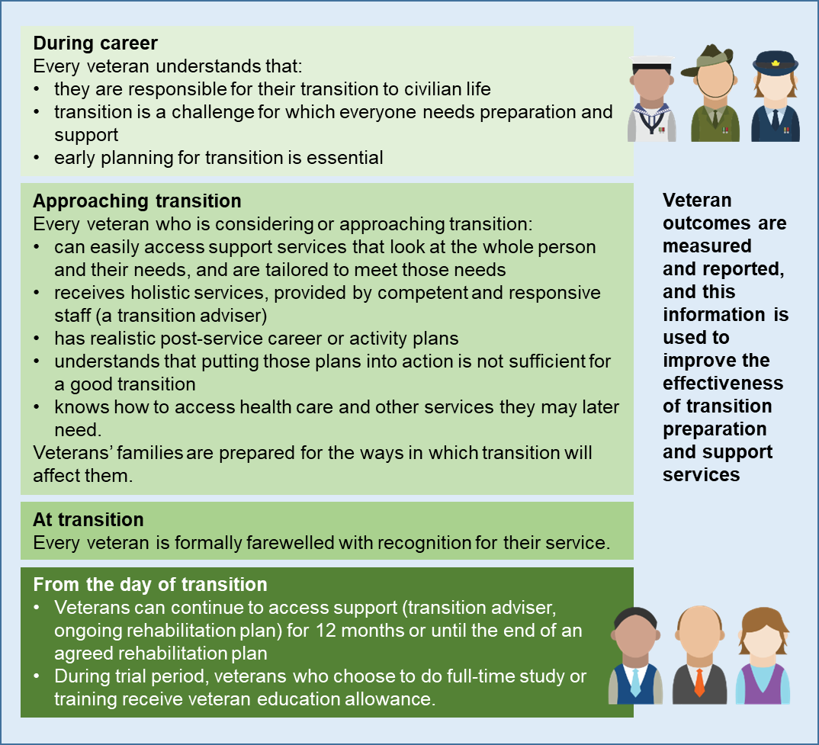

Second, an improved package of transition support is needed. The package should include the enhanced services provided by the JTA, as well as support for veterans to gain skills and qualifications once they leave the ADF, by trialling an education allowance to provide a source of income for veterans undertaking full-time education or vocational training.
Defence has also recently introduced a range of new programs and services to better support veterans and families during transition, and these have many promising features. However, it is unclear how Defence plans to keep track of what services work well (or not), and why and where extra supports should be targeted. The way Defence (and DVA) provide and procure rehabilitation and health services should also be brought more in line with the approach used by workers’ compensation schemes, including more proactive engagement with providers and better oversight of outcomes.

Better health outcomes for veterans
The White Card, which funds treatment for service-connected conditions, is generally well-targeted and a good vehicle for funding veterans’ health care (about 75 000 DVA clients have a White Card). However, the Gold Card has become more about compensation than health care. And it does not sit well with the key underlying principles for a future scheme.
The Gold Card should be more tightly targeted towards highly-impaired veterans (those who are most likely to benefit from comprehensive health care). Eligibility for the Gold Card should also not be extended to any new categories of veterans or dependants that are not currently eligible for such a card. This will not affect any current Gold Card holder or person who is entitled to a Gold Card under current legislation.
The VSC would take a different approach to health care for veterans than the current system. It would provide more proactive individualised health care case management and, like other administrators of workers’ compensation schemes, it would be more actively engaged with health care providers and provide better oversight of outcomes (this will be driven by its focus on lifetime costs and a clear objective of improving the lives of veterans).
DVA has some good health initiatives, including the Coordinated Veterans’ Care program, which funds coordinated care for Gold Card holders at risk of hospitalisation. The program could, however, be improved by better targeting and measuring of outcomes.
DVA’s relatively low fees for some (but not all) health services, may mean that some veterans with service-related conditions have less accessible and lower quality services than people covered by civilian workers’ compensation schemes. An independent review of DVA’s fee-setting arrangements is required.

Improving mental health care access and services
There has been a heightened focus on veterans’ mental health and suicide in recent years and a range of new policies, programs and research (box 8).

Box 8 Veterans’ mental health
Those who serve in the Australian Defence Force are recruited and trained to be physically and mentally resilient, and to display strength and perseverance. While veterans are serving, there are a range of protective factors that are likely to reduce the risk of mental ill-health. A strong sense of purpose, camaraderie and easy access to health care provide some protection against the risk of mental ill-health. Many other aspects of defence life work the other way — veterans can be exposed to trauma, they spend time away from family and can relocate frequently. And once veterans leave the Australian Defence Force, they no longer benefit from the protective factors that supported them while serving and are at greater risk of poor mental health. Transition to civilian life can also be a risk factor in itself.
There is some evidence that mental health disorders are more prevalent for veterans than in the wider population. The latest data also show that the age-adjusted rate of suicide for male ex-serving personnel is significantly higher than the general population. (There is an absence of data on mental health and suicide among female veterans).
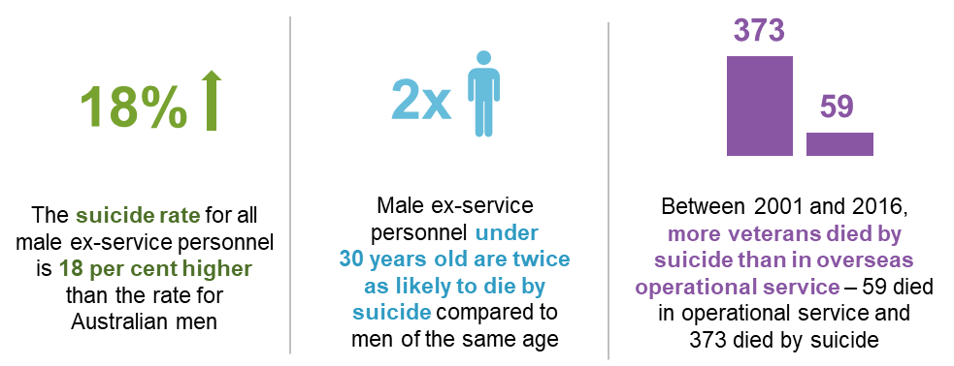
Veterans can access mental health and support services provided to the general population, and additional services through DVA.
- Open Arms is run by DVA, and provides counselling, case coordination and an after-hours telephone counselling service for veterans and their families. Participants had varying views on the Open Arms service, and there is no published outcomes data, so effectiveness of its services is not clear. DVA should develop outcomes measures for Open Arms.
- The recent decision to expand non-liability coverage to include mental health care was about improving access to mental health services for veterans and was described by one participant as ‘lifesaving’. However, DVA cannot demonstrate that the number of veterans accessing treatment has increased, and there is no monitoring of the quality of treatment veterans are receiving.
There are also a number of recent promising initiatives — including a Veteran Suicide Prevention Pilot, an early intervention measure for people in the Coordinated Veterans’ Care program and a suicide prevention trial (Operation Compass) in Townsville. It is important that robust evaluations of these trials are undertaken to build the evidence base about what works (or does not work).
Veterans and their families are not always aware of the mental health services available. DVA should be more proactive in promoting mental health services for veterans.
To build and improve on recent policy changes and trials, a new Veteran Mental Health Strategy is urgently needed. The Strategy should be developed by Defence and DVA, cover each of the life stages of military personnel, and focus on building the evidence base on the causes of, and effectiveness of treatments for, mental ill-health. The National Mental Health Commission should provide oversight of the strategy and report annually on progress towards the goals of the Strategy.

Support for families of veterans
The impacts of military service extend to the families of veterans. While frequent relocations, the veteran’s irregular hours and extended periods away from home can all take a toll, a particularly acute concern is for families that care for a veteran with an injury or disease related to service. The support of families can be important for veterans undertaking rehabilitation and when they are transitioning back into civilian life. And families of deceased veterans can have added pressures and needs.
Families of veterans have access to a number of support services provided by DVA (in addition to supports provided by Defence and those available more generally). These include:
- Open Arms for families of veterans who have a non-liability White Card
- respite care for carers providing ongoing care to veterans who have a White or Gold Card
- the Family Support Package for families of eligible veterans, which includes childcare support and brief intervention counselling. Counselling (provided in addition to Open Arms) can be accessed from any appropriately qualified professional and includes drug and alcohol counselling, resilience training, parenting skills and personal relationship counselling.
Supports for families are also provided by veterans’ organisations, including counselling services, claims advocacy and wellbeing support.
The Family Support Package should be extended to:
- families of veterans without warlike service and families of veterans receiving the veteran payment
- give parents and eligible young children of veterans who have suffered a service death or a suicide related to their service, and families of veterans not under a rehabilitation plan, access to counselling services
- cover all counselling services for partners, widows and widowers, eligible young children and parents. For these family members, session limits and the requirement for an identified need should be removed and replaced with an appropriate cap on total payment.
The VSC would have close engagement with families (including providing them with support) as this can be important for supporting veterans on a more individualised basis. Further research is needed to better understand the mental health impacts of military service on families and how they can be best supported.

Data and evidence could be improved in every part of the system
As with any workers’ compensation scheme, data and evidence are critical to achieving good outcomes for veterans, uncovering better interventions, and managing emerging risks and long-term scheme costs. The VSC would place greater reliance on data and analysis and practices of continuous improvement as it would be required to compare actuarial forecasts of costs and veteran outcomes with the actual experiences of veterans. However, DVA should start work on developing performance and outcomes frameworks immediately.
The evidence base on veterans and their families would also be strengthened by:
- linking and analysing data held by DVA and reporting on outcomes
- conducting more high-quality reviews and evaluations. DVA has several projects aimed at improving veteran wellbeing, but there is little evidence on the effectiveness of some of these services
- taking a more strategic approach to research. Defence and DVA should set research priorities on issues affecting the health and wellbeing of veterans. The priorities should be published in a research plan and the plan published annually. The research plan and its implementation should be overseen by an Expert Committee on Veteran Research.

The role of veterans’ organisations
Veterans’ organisations play an important role in the veteran support system. They include ex-service organisations as well as organisations that assist current ADF personnel and the families of veterans. Each year, thousands of people volunteer to help veterans and their families in all aspects of their post-service lives.
Veterans’ organisations undertake a wide range of activities, including:
- claims advocacy — assisting veterans and their families to prepare and lodge claims to DVA, as well as putting the veteran’s case to DVA, the VRB and the Administrative Appeals Tribunal (AAT)
- wellbeing supports — assisting veterans and their families with transition, rehabilitation and social engagement
- policy input and influence — informing government about the practical experience of accessing the veteran support system and recognising veterans’ interests in government policy.
Claims advocacy has traditionally been the focus of veterans’ organisations, but the needs and expectations of younger veterans require a stronger focus on wellbeing supports. DVA (and in future, the VSC) should take on a greater role assisting people to put in claims. With many existing volunteer advocates nearing retirement, DVA could start contracting veterans’ and other organisations to provide claims advocacy where there is identified unmet need. Claimants who want the services of an advocate should be able to access one.
DVA gives grants to assist veterans’ organisations to provide wellbeing supports. DVA should better leverage this support network by developing a strategy for commissioning wellbeing supports provided by veterans’ or other organisations. In particular, there is an opportunity for DVA to design and fund services through veterans’ hubs.
Veterans’ organisations — acting as representatives of veterans and their families — are highly influential in policymaking, but have no unified position. Despite being well placed to see the shortcomings in the system and to provide feedback about how the system is functioning, engaging meaningfully with thousands of veterans’ organisations with no peak body is difficult for government. If a single peak body is formed within the Australian veteran community, and represents the broad interests of veterans, then the Australian Government should consider funding it. Such a body could engage more transparently and effectively with DVA and the Minister and replace the existing consultation framework.

A simpler system for veterans and their families
The current system can be simplified in a number of ways.
The front end of the system should be made simpler for clients (a complex system does not need to be complex for veterans and their families). Veterans and their families should be able to understand the system, including the claims process, why claims are accepted or rejected, and the package of supports they may be entitled to.
Simplifying the system is a key component of the VCR program and initiatives such as MyService should continue to be built on. DVA has advised that the VCR program will be fully rolled out by mid-2021.
There are also a number of areas where there is scope to rationalise supports and harmonise the three Acts. Two areas where the three Acts should be harmonised are:
- the initial liability process — adopting the use of Statements of Principles (SoPs) in the DRCA would simplify the initial liability process and make it more consistent across all three Acts. Moving to the ‘reasonable hypothesis’ as a single standard of proof for all types of service under the MRCA would also simplify the system going forward
- the review process — there should be a single review pathway for all veterans’ compensation and rehabilitation decisions (the VEA and MRCA review pathway would apply for the DRCA, box 9) comprising reconsideration, review and resolution by the VRB, formal merits review by the AAT and judicial reviews. The role of the VRB should be modified to provide enhanced dispute resolution processes, and over time, should transition to exclusively helping veterans and their families to resolve their cases collaboratively with the VSC. The VRB should also provide more useful feedback on the types of cases where the original decision is most likely to be changed on review.

Box 9 The review process could be simpler and more efficient
There are unjustified differences in the review process between the three Acts. There should be a single pathway for all veterans’ compensation and rehabilitation decisions. The single pathway should include:
- internal reconsideration, where a different Department of Veterans’ Affairs officer makes a new decision based on all the information available, including additional information that was not available at the initial stage of decision
- review and resolution by the Veterans’ Review Board (VRB). The VRB’s role should be modified to only use alternative dispute resolution processes to allow claimants to resolve their cases with the Department of Veterans’ Affairs. The VRB should retain its decision-making powers for some time, but the establishment of an independent Veteran Services Commission could allow it to take a role of solely aiming to resolve cases (rather than remaking the decision). This will allow claims to be resolved in a more timely manner. Any matters that cannot be resolved could go to the Administrative Appeals Tribunal.
- formal merits review by the AAT
- on matters of law, judicial review.
Some payments should be removed, simplified or rolled into the underlying payment. These include:
- the MRCA Special Rate Disability Pension (a payment that has rarely been used)
- education payments for dependants over 16 years (which simply mirror youth allowance payments, but without an income test)
- energy and veterans’ supplements (which can be removed or rolled into the underlying payments).
More substantial reforms are warranted in other areas of compensation.
- Compensation under the MRCA varies depending on whether the impairment was suffered as a result of warlike or non-warlike, or peacetime service. As ‘an injury is an injury’ irrespective of the type of service, injuries, illness or deaths due to service should be treated in the same way. Moving to a single rate of compensation would increase equity between veterans and reduce complexity. A transition path is needed to ensure that veterans who have already lodged claims are not disadvantaged.
- The compensation system includes income replacement administered through DVA, and invalidity and death insurance provided through the Commonwealth Superannuation Corporation. These payments are offset against each other in most cases, but clients’ needs are assessed by two organisations. There is scope to simplify the administrative arrangements for these schemes.
- Under the MRCA and VEA, dependants can receive benefits (including pensions, lump-sum payments and the Gold Card) if a veteran dies and:
- their death was related to service, or
- the veteran had a certain level of service-related impairment prior to their death, irrespective of the cause of death (that is, the veteran could die in a car crash, or of old age, and their dependants may receive benefits).
There is little rationale for the second of these eligibility criteria. Under the MRCA, future eligibility for dependant benefits should be restricted to dependants of veterans who died as a result of service. The effect of this change is likely to be minimal in the near term, as most MRCA dependant benefits are currently due to service-related deaths. However, it will have an effect in the long run, as the MRCA population ages.
- The funeral allowance available under the VEA should be aligned with the MRCA funeral allowance for veterans whose dependants would receive a funeral allowance under the MRCA.

Two compensation and rehabilitation schemes
Moving to one Act covering all veterans is the ultimate objective of simplification (many participants called for a single Act). The MRCA should be the predominant piece of veterans’ compensation and rehabilitation legislation. This is because the VEA has significant shortcomings with its focus on providing set rate pensions for life which is inconsistent with the goals of rehabilitation and person-centred wellness. Nor are the pensions necessarily reflective of the loss faced by individual veterans.
However, moving to one Act is not possible at this stage. There are many veterans on the VEA (either with current benefits or likely future claims). And many of them are older, which means that the rehabilitation and return to work focus of the more contemporary Act is less relevant.
In this context, a two-scheme approach (figure 9) is warranted. Scheme 1 covers veterans under a modified VEA. While there will be some modifications to the existing VEA, it will continue until natural attrition removes the need for the scheme. It is largely an older cohort of veterans with operational service who have injuries before 2004 — although any veteran who does not have a current VEA liability claim by 1 July 2025 will no longer be eligible to make claims under this scheme.

Figure 9 Compensation available under the schemes
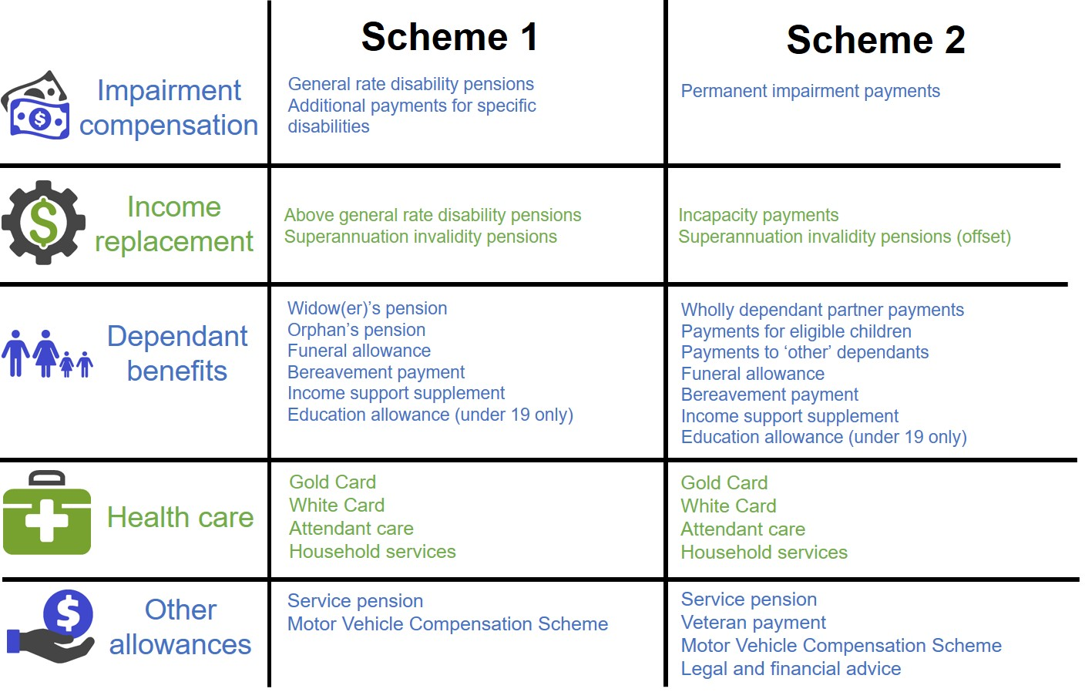
Scheme 2 is for all other veterans underpinned by a modified MRCA (incorporating the DRCA). Over time this will become the dominant scheme.
Eligibility should be based on the following principles:
- veterans should only be eligible to make claims under one scheme — that is, all future claims for each individual veteran would be processed under either scheme 1 or scheme 2
- veterans should not have their current benefits affected, however some veterans in scheme 1 should be given a one-off opportunity to switch their current and future benefits to scheme 2 (figure 10).
Applying these principles will reduce the need for compensation offsetting, reduce complexity and speed up the transition towards scheme 2.
Veterans with impairments for which DVA has accepted liability under the VEA would remain on scheme 1 with all their future claims processed under this scheme (regardless of their current eligibility for other Acts). However, younger veterans are likely to benefit from the rehabilitation and income replacement focus of scheme 2. Veterans 55 years of age or younger as at 1 July 2025 would be given the option of switching their current benefits and future entitlements to scheme 2, and would receive financial advice before making this decision.

Figure 10 Eligibility under the two schemes
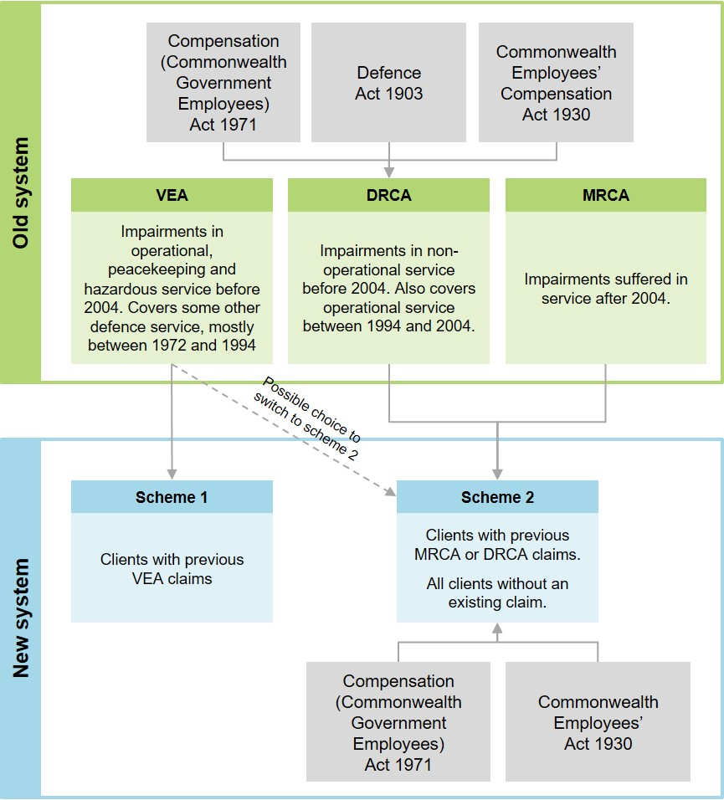

Other veterans — including those currently covered by the MRCA or DRCA, and those without a current or successful VEA claim as at 1 July 2025 — would be covered by scheme 2 for all future claims.
The design of the schemes is complicated by the fact that some veterans have current claims under multiple Acts. Eligibility for this group should be based on both their age and the current benefits they are receiving.
When a veteran that already has an accepted liability claim dies, the dependants would receive compensation based on the scheme that applied to the veteran. If the veteran did not have an existing or accepted liability claim as at 1 July 2025, dependants would receive compensation through scheme 2.

A pathway for reform
Some of the proposed changes to the veteran support system, including improving both data and evidence and service delivery and support, could begin immediately. The new advisory council could also be put in place relatively quickly. Establishing the Joint Transition Authority should be a priority — it should be in place by mid-2020 (figure 11).

Figure 11 Reform timeline
However, some of the more foundational changes (including creating the independent VSC and levying a premium on Defence) will be more disruptive. Work to establish the VSC should commence as soon as possible, taking into account the rollout of the VCR reforms that are due to be completed by mid-2021. Based on an indicative timetable, the VSC should begin operating on or before 1 July 2022.
The legislative reform process should be phased over time, with the process culminating in the adoption of the two-scheme approach. The starting point for reform should be simplifying and streamlining the Acts themselves. At the same time, some simple harmonisation between the DRCA and the MRCA could be achieved, such as aligning the incapacity payments between the Acts, and using SoPs in the DRCA. These reforms would set the framework for the eventual merging of the Acts.
By mid-2025 the two-scheme approach should be implemented. This would involve merging the DRCA into the MRCA, and having in place mechanisms to allow veterans to be assigned to schemes or exercise options for switching (where permitted). This schedule will allow time for the governance reforms to be implemented, as well as allow veterans time to adjust to the new approach and consider their options.

What are the benefits from the proposed reforms?
While the Commission has not quantified the benefits of its reforms, they are likely to be significant and cross multiple domains, and include:
- better lives or wellbeing gains, improved work health and safety and injury prevention (fewer veterans and their families having to deal with injury, illness or death)
- improved and more continuous rehabilitation and transition supports (veterans and their families will be better prepared for the challenges of transition)
- a simpler, fairer and more accessible system of compensation
- more consistent assessment of claims easing pressures for claimants
- a quicker and simpler review process
- a better evidence base to inform the design and delivery of services, programs and policies which should lead to improved outcomes for clients.
There will also be efficiency gains from the proposed changes (including those that place a greater focus on accountability and lifetime costs of support and reduce duplication). A greater focus on wellness and lifetime costs should also translate into increased economic and social participation of veterans and reduced use of income support.
While we have not provided an estimate of aggregate costs for the reforms, there are cost estimates (including in some cases cost ranges) for some reforms throughout the report. The focus of this report was not on saving dollars, rather it was about finding ways to achieve better outcomes for veterans. And in fact, if fully implemented, our proposed future veteran support system would cost more in the short term, but with a focus on wellness and independence, less in the longer term.

Recommendations and findings

Objectives and principles
Understanding the objectives of the veterans’ compensation and rehabilitation system is important for assessing how well the current system is performing and what an improved system would look like. A robust set of objectives and principles are needed to underpin a contemporary system to meet the needs of tomorrow’s veterans.

Recommendation 4.1 Objectives and PRINCIPLES for the Veteran SUPPORT system
The overarching objective of the veteran support system should be to improve the wellbeing of veterans and their families (including by minimising the physical, psychological and social harm from service) taking a whole-of-life approach. This should be achieved by:
- preventing or minimising injury and illness
- restoring injured and ill veterans by providing timely and effective rehabilitation and health care so they can participate in work and life
- providing effective transition support as members leave the Australian Defence Force
- enabling opportunities for social integration
- providing adequate and appropriate compensation for veterans (or if the veteran dies, their family) for pain and suffering, and lost income from service-related injury and illness.
The principles that should underpin a future system are:
- wellness focused (ability not disability)
- equity
- veteran centric (including recognising the unique needs of veterans and their families resulting from military service)
- needs based
- evidence based
- administrative efficiency (easy to navigate and achieves timely and consistent assessments and decision making)
- financial sustainability and affordability.
The objectives and underlying principles of the veteran support system should be set out in the relevant legislation.

Finding 4.1
The Commission acknowledges that there are different risks, hardships and requirements of operational and peacetime service, and these are recognised in remuneration, allowances and honours. However, in principle, the basis for providing support should be need, not how or when an injury or illness was acquired. For compensation and support, the distinction between different types of military service should be removed where it is both practicable and cost-effective to do so.

Prevention
The Australian Defence Force (ADF) is committed to providing a safe and healthy working environment for its members and it has achieved significant reductions in serious injuries and illnesses since 2011-12. Nonetheless, more can be done to give the ADF better tools to help it achieve its commitment to improved work health and safety.

Finding 5.1
There are no compelling grounds to change the current arrangements under which Australian Defence Force members are subject to Commonwealth work health and safety legislation. In fact, the introduction of the Work Health and Safety Act 2011 (which took effect on 1 January 2012) has been instrumental in helping to significantly improve work health and safety outcomes in the Australian Defence Force.

Finding 5.2
Since Defence introduced Sentinel (a work health and safety incident reporting system) in 2014, it has expanded its coverage, improved the ease of use of the system for serving personnel and put in place processes to ensure that reported incidents are acted on.
However, despite these efforts, underreporting of work health and safety incidents in Sentinel (other than for serious, defined events that must be notified to Comcare) continues to be an issue.

Recommendation 5.1 IMPROVE REPORTING OF WORK HEALTH AND SAFETY INCIDENTS
Defence should assess the feasibility and cost of incorporating the information on the Sentinel database with information from the Defence eHealth System. In the longer term, when Defence commissions the next generation of the Defence eHealth System, it should include the capture of work health and safety data as a system requirement.
The Department of Defence and Department of Veterans’ Affairs should assess the feasibility and cost of incorporating information from the Sentinel database with information from the Department of Veterans’ Affairs’ datasets, which would provide insights into the cost of particular injuries and illnesses.

Recommendation 5.2 SUPPORTING A NEW APPROACH TO INJURY PREVENTION
Defence should use the injury prevention programs being trialled at Lavarack and Holsworthy Barracks as pilots to test the merit of a new approach to injury prevention to apply across the Australian Defence Force (ADF).
Defence should adequately fund and support these programs, and ensure that there is a comprehensive and robust cost–benefit assessment of their outcomes.
If the cost–benefit assessments are substantially positive, injury prevention programs based on the new approach should be rolled out across the ADF by Defence.

Recommendation 5.3 PUBLISH ANNUAL NOTIONAL PREMIUM ESTIMATES
Beginning in 2019, the Australian Government should publish the full annual actuarial report that estimates notional workers’ compensation premiums for Australian Defence Force members (currently produced by the Australian Government Actuary).

Recommendation 5.4 FORMALISE DEFENCE responsibility to SUPPORT ADF MEMBERS
In line with the proposed Australian Defence Veterans’ Covenant, the Australian Government should amend Defence’s outcomes to include an additional objective, explicitly acknowledging that — due to the unique nature of military service — Defence has a responsibility to respect and support members of the Australian Defence Force having regard to their lifetime wellbeing.

Rehabilitation
Significant reform is required to the way Defence and the Department of Veterans’ Affairs (DVA) procures, organises and monitors rehabilitation services. Changes are also required to rehabilitation arrangements in the transition period to ensure continuity of care.

Finding 6.1
Defence has a strong incentive to provide rehabilitation services to Australian Defence Force (ADF) members who have a high probability of redeployment or return to duty, but a weaker incentive to rehabilitate members who are likely to be transitioning out of the ADF. This is because ex-serving members become the responsibility of the Department of Veterans’ Affairs (DVA) and Defence does not pay a premium to cover liabilities. Access to rehabilitation supports can also be disrupted during the transition period.
DVA pays limited attention to the long-term sustainability of the veteran support system (in part because the system is demand driven) and this reduces its focus on the lifetime costs of support, early intervention and effective rehabilitation.

Recommendation 6.1 public reporting on ADf rehabiliTation
The Australian Defence Force Joint Health Command should report more extensively on outcomes from the Australian Defence Force Rehabilitation Program in its Annual Review publication.

Recommendation 6.2 Evaluation and reporting of DVA rehabiliTation
The Department of Veterans’ Affairs should make greater use of its rehabilitation data and of its reporting and evaluation framework for rehabilitation services. It should:
- evaluate the efficacy of its rehabilitation and medical services in improving client outcomes
- compare its rehabilitation service outcomes with other workers’ compensation schemes (adjusting for variables such as degree of impairment, age, gender and difference in time between point of injury and commencement of rehabilitation) and other international military schemes.

Recommendation 6.3 Commissioning and INTEGRATION of REHABILITAtion services
Defence and the Department of Veterans’ Affairs should engage more with rehabilitation providers, including requiring them to provide evidence-based approaches to rehabilitation, and to monitor and report on treatment costs and client outcomes.
Changes are also required to the arrangements for providing and coordinating rehabilitation immediately prior to, and immediately post, discharge from the Australian Defence Force (ADF). Rehabilitation services for transitioning personnel across this interval should be coordinated by the Joint Transition Authority (recommendation 7.1). Consideration should also be given to providing rehabilitation on a non-liability basis across the interval from ADF service to determination of claims post-service.

Transition to civilian life after military service
While most veterans make a relatively smooth and successful transition to civilian life, some find transition a difficult and stressful time. Neither Defence nor DVA has clear responsibility for all aspects of veterans’ transition and services. To improve military-to-civilian transition, and to clarify roles and responsibilities, the Commission is recommending creating a new authority responsible for transition preparation and support.

Finding 7.1
The Departments of Defence and Veterans’ Affairs offer a range of programs and services to support veterans with their transition to civilian life. While many discharging members require only modest assistance, some require extensive support — especially those who are younger, served in lower ranks, are being involuntarily discharged for medical or other reasons, and those who have skills that are not easily transferable to the civilian labour market. Despite considerable change in recent years, stewardship of transition remains poor and supports have not improved in ways that are tangible to veterans.

Recommendation 7.1 Establish a Joint Transition Authority
The Australian Government should recognise that Defence has primary responsibility for the wellbeing of discharging Australian Defence Force members, and that this responsibility may extend beyond the date of discharge. It should formalise this recognition by creating a ‘Joint Transition Authority’ within Defence.
Functions of the Joint Transition Authority should include:
- preparing serving members and their families for the transition from military to civilian life
- providing individual support and advice to veterans as they approach transition
- ensuring that transitioning veterans receive services that meet their individual needs, including information about, and access to, Department of Veterans’ Affairs’ processes and services, and maintaining continuity of rehabilitation supports
- remaining an accessible source of support for 12 months after discharge
- reporting publicly on transition outcomes to drive further improvement.

Recommendation 7.2 Career planning and family engagement for TRANSITION
Defence, through the Joint Transition Authority (recommendation 7.1), should:
- ensure that Australian Defence Force members prepare a career plan that covers both their service and post-service career, and update that plan at least every two years
- prepare members for other aspects of civilian life, including the social and psychological aspects of transition
- reach out to veterans’ families, so that they can engage more actively in the process of transition.

Recommendation 7.3 Trial a veteran EDUCATION allowance
The Department of Veterans’ Affairs should support veterans to participate in education and vocational training once they leave the Australian Defence Force. It should trial a veteran education allowance to provide a source of income for veterans who, after completing their initial minimum period of service or having been medically discharged, wish to undertake full-time education or vocational training.

Initial liability assessment
Having liability accepted for an injury, illness or death is the first step in most claims for compensation, treatment and rehabilitation in the veteran support system. The way initial liability is assessed varies by Act and by type of service. These variations are no longer justified and should be reduced or eliminated where feasible.

Recommendation 8.1 Harmonise the Initial Liability process
The Australian Government should harmonise the initial liability process across the three veteran support Acts. The amendments should include:
- making the heads of liability and the broader liability provisions identical under the Veterans’ Entitlements Act 1986 (VEA), the Safety, Rehabilitation and Compensation (Defence-related Claims) Act 1988 (DRCA) and the Military Rehabilitation and Compensation Act 2004 (MRCA)
- applying the Statements of Principles to all DRCA claims and making them binding, as under the MRCA and VEA.

Finding 8.1
Allowing accrued rights for repealed versions of the Statements of Principles (SoPs) under the Veterans’ Entitlements Act 1986 is contrary to the purpose of the SoP system, which is to reflect the latest sound medical-scientific evidence.

Recommendation 8.2 Improve the RMA’s resourcing and transparency
The Australian Government should provide additional resources to the Repatriation Medical Authority (RMA) so that the time taken to conduct reviews and investigations can be reduced to closer to six months.
Following any investigation, the RMA should routinely publish a full bibliography of the peer-reviewed literature or other sound medical-scientific evidence used to create or update the relevant Statement of Principles. Stakeholders interested in how different pieces of evidence were assessed and weighed can continue to request the RMA’s briefing papers under s.196I of the Veterans’ Entitlements Act 1986.

Recommendation 8.3 Abolish the Specialist Medical Review Council
The Australian Government should abolish the Specialist Medical Review Council. The process for reviewing Repatriation Medical Authority decisions on Statements of Principles should instead be expanded to incorporate independent external medical specialists, where necessary.

Recommendation 8.4 Move MRCA to a single standard of proof
The Australian Government should remove the distinction between types of service when determining causality between a veteran’s condition and their service under the Military Rehabilitation and Compensation Act 2004 (MRCA). This should include:
- amending the MRCA to adopt the reasonable hypothesis Statement of Principles for all initial liability claims
- requesting that the Australian Law Reform Commission conduct a review into simplifying the legislation and moving to a single decision-making process for all MRCA claims, preferably based on the reasonable hypothesis process.

Claims management and processing
There are significant and ongoing problems with the way DVA administers claims. DVA is attempting to fix these problems under its Veteran Centric Reform (VCR) program, which began in 2016. VCR has had some successes, most notably the introduction of an online claims system, but issues including slow and poor-quality claims assessments remain. Close monitoring of the effective rollout of the VCR, both in terms of timeliness and outcomes is required.

Recommendation 9.1 public PROGRESS reports on recent reviews
The Department of Veterans’ Affairs should report publicly by December 2019 on its progress implementing recommendations from recent reviews (including the 2018 reports by the Australian National Audit Office and the Commonwealth Ombudsman).

Finding 9.1
MyService, in combination with a completed Early Engagement Model, has the potential to radically simplify the way Australian Defence Force members, veterans and their families interact with the Department of Veterans’ Affairs (DVA), particularly by automating many aspects of the claims process.
But achieving such an outcome will be a complex, multi-year process. To maximise the probability of success, Defence, DVA and Services Australia will need to:
- continue to work closely in a collegiate and coordinated fashion
- retain experienced personnel
- allocate sufficient funding commensurate with the potential long-term benefits.

Finding 9.2
The Department of Veterans’ Affairs is failing to ensure that its staff consistently apply its own internal guidelines for communicating with clients. This leads to poor outcomes for clients and undermines confidence in the Department.

Recommendation 9.2 APPROPRIATELY train staff
The Department of Veterans’ Affairs should ensure that staff who are required to interact with veterans and their families undertake specific training to deal with vulnerable people and in particular those experiencing the impacts of trauma.

Finding 9.3
The Department of Veterans’ Affairs needs to negotiate a sustainable and predictable departmental funding model with the Department of Finance based on expected claims and existing clients.
This should incorporate the likely efficiency savings from the Veteran Centric Reform program via initiatives such as MyService.

Finding 9.4
The Productivity Commission does not, at this stage, support automatically deeming initial liability claims at the end of a fixed period. Progress on the Veteran Centric Reform program in the Department of Veterans’ Affairs should continue to significantly improve the efficiency of claims processing and management. Should these reforms fail to deliver further significant improvements in the timely handling of claims, then the need for statutory time limits should be reconsidered.

Recommendation 9.3 ensure quality of claims processing
If the Department of Veterans’ Affairs’ quality assurance process identifies excessive error rates (for example, greater than the Department’s internal targets), all claims in the batch from which the sample was obtained should be recalled for reassessment.

Finding 9.5
External medical assessors provide useful diagnostic information about veterans’ conditions and are a necessary part of the claims process for the veteran support system. However, they should only be called upon when strictly necessary and staff should be provided with clear guidance to that effect.

Finding 9.6
Under the Department of Veterans’ Affairs’ stewardship, the Veteran Centric Reform (VCR) program has some good objectives and has produced some early successes. However close supervision and guidance will be required to ensure VCR is rolled out successfully. Regular progress reporting and ongoing assurance reviews will facilitate this outcome.

Reviews of claims
Most decisions made by DVA to provide (or not provide) compensation or support to veterans can be challenged through administrative review processes. However, there are a number of issues with the existing processes which warrant reform and a common approach is required for all claims.

Finding 10.1
Current review processes are ensuring that many veterans receive the compensation or support that they are entitled to under the law, albeit sometimes with significant delays. The majority of cases that are reviewed externally result in a change to the original decision made by the Department of Veterans’ Affairs.

Finding 10.2
The Veterans’ Review Board and Administrative Appeals Tribunal are not providing sufficient feedback from their review processes to the Department of Veterans’ Affairs (DVA) to better inform decision-making practices. Further, DVA is not incorporating the limited available feedback into its decision-making processes. This means that opportunities for process improvement are being missed.

Recommendation 10.1 IMPROVE AND USE FEEDBACK FROM ADMINISTRATIVE REVIEWS
The Department of Veterans’ Affairs (DVA) should ensure that successful reviews of veteran support decisions are brought to the attention of senior management for claims assessors, and that accurate decision making is a focus for senior management in reviewing the performance of staff.
Where the Veterans’ Review Board (VRB) identifies an error in the original decision of DVA, it should state the cause for varying or setting aside the decision on review (including whether new information was provided by the applicant or if DVA’s original decision misapplied the law).
DVA and the VRB should establish a memorandum of understanding to report aggregated statistical and thematic information on claims where DVA’s decisions are varied through hearings or alternative dispute resolution processes. This reporting should cover VRB decisions, as well as variations made with the consent of the parties through an alternative dispute resolution process. This information should be collected and provided to DVA on a quarterly basis and published in the VRB’s annual report.
DVA should respond by making appropriate changes to its decision-making processes to improve accuracy.

Finding 10.3
While many veterans are managing to negotiate the current pathways for reviews of decisions made under the various veteran support Acts, there are unjustified differences and complexities in the rights of review available to claimants under each Act.

finding 10.4
The Veterans’ Review Board has functions that overlap with those of the Administrative Appeals Tribunal. The Department of Veterans’ Affairs is relying on the Board’s external merits review as a standard part of the process for addressing many claims, rather than using it occasionally to resolve difficult cases.

Recommendation 10.2 SINGLE REVIEW PATHWAY
The Australian Government should introduce a single review pathway for all veterans’ compensation and rehabilitation decisions (including decisions under the Safety, Rehabilitation and Compensation (Defence-related Claims) Act 1988). The pathway should include:
- internal reconsideration by the Department of Veterans’ Affairs. In this process, a different and more senior officer should clarify the reasons why a claim was not accepted (partially or fully); request any further information the applicant could provide to fix deficiencies in the claim, then make a new decision with all of the available information
- review and resolution by the Veterans’ Review Board, in a modified role providing alternative dispute resolution services only (recommendation 10.3)
- merits review by the Administrative Appeals Tribunal
- judicial review in the Federal Court of Australia and High Court of Australia.

Recommendation 10.3 VETERANS’ REVIEW BOARD AS A REVIEW AND RESOLUTION BODY
The Australian Government should amend the role and procedures of the Veterans’ Review Board (VRB), so that:
- it would serve as a review and resolution body to resolve claims for veterans
- all current VRB alternative dispute resolution processes would be available (including party conferencing, case appraisal, neutral evaluation and information-gathering processes) together with other mediation and conciliation processes.
Where an agreement cannot be reached, a single board member should determine the correct and preferable decision to be made under the legislation and implement that decision.
When the Veteran Centric Reform program is complete and the Veteran Services Commission is established, this determinative power should be removed.
Cases that would require a full board hearing under the current process, or where parties fail to agree on an appropriate alternative dispute resolution process or its outcomes, could be referred to the Administrative Appeals Tribunal.
Parties to the VRB resolution processes should be required to act in good faith.

Recommendation 10.4 REVIEW OF ONGOING ROLE OF VETERANS’ REVIEW BOARD
The Australian Government should conduct a further evaluation in 2025 of the performance of the Veterans’ Review Board in its new role. In particular, the evaluation should consider whether reforms have reduced the rate at which initial decisions in the veteran support system are subsequently varied on appeal. If the evaluation finds that the Board is no longer playing a substantial role in the claims process, the Australian Government should abolish the Board and bring its alternative dispute resolution functions into the Department of Veterans’ Affairs or its successor agency.

Governance and funding
Under the current governance arrangements, no single agency has responsibility for the lifetime wellbeing of veterans. Strategic policy in the veteran support system appears to be largely reactive, with changes often making the system more complex and expensive. Also, the veteran support system, which has large contingent liabilities, is funded on a short-term basis, and long-term costs are not taken into account when policy decisions are made. New governance and funding arrangements are required for the veteran support system for future generations of veterans and their families.

Recommendation 11.1 Establish a Veteran Services Commission
The Australian Government should establish a new independent statutory authority — the Veteran Services Commission (VSC) — to administer the veteran support system by July 2022. It should report to the Minister for Defence Personnel and Veterans, but be a stand-alone agency for veteran services (that is, separate from any department of state).
The functions of the VSC should be to:
- achieve the objectives of the veteran support system (recommendation 4.1) through the efficient and effective administration of all aspects of that system
- make all claims determinations under the veteran support legislation
- calculate, collect and administer a premium on Defence (recommendation 11.2)
- manage, advise and report on outcomes and the financial sustainability of the system, in particular, the compensation and rehabilitation schemes
- enable opportunities for social integration
- fund, commission or provide services to veterans and their families.
An independent board should oversee the VSC. The board should be made up of part-time Commissioners appointed by the Minister. Board members should have a mix of skills in relevant fields (such as other compensation schemes, project management or providing services to veterans), and some members should have experience in the military and veterans’ affairs. The board should have the power to appoint the Chief Executive Officer (who should be responsible for the day-to-day administration of the VSC).
The Australian Government should amend the Veterans’ Entitlements Act 1986 and the Military Rehabilitation and Compensation Act 2004 to abolish the Repatriation Commission and Military Rehabilitation and Compensation Commission upon the commencement of the VSC.

Recommendation 11.2 Levy a premium on Defence
The Australian Government should move towards a fully-funded system for veteran supports. This would involve the Veteran Services Commission levying an annual premium on Defence to fund the expected future costs of the veteran support system entitlements that were generated during the year. The premium should cover the costs of all compensation, rehabilitation and treatment benefits available to veterans or their families, as well as covering the cost associated with operational deployments.
The Australian Government should provide a level of funding to Defence to cover the reasonable costs of the premium. Any funding above the initial level should be considered on a case-by-case basis by the Government, in line with existing Budget rules, to avoid undermining the premium’s financial incentives.
As the Military Rehabilitation and Compensation Act 2004 (MRCA) will form the basis of the future veteran support system, the Government should also fully capitalise all existing MRCA liabilities (that is, back to 1 July 2004). Existing liabilities under the Veterans’ Entitlements Act 1986 and the Safety, Rehabilitation and Compensation (Defence-related Claims) Act 1988 should be calculated and regularly reported as separate notional line items, acknowledging their implied call on future Budgets.

Finding 11.1
Moving responsibility for veteran support policies and strategic planning into the Department of Defence is, in the Commission’s view, the best option for improving the lives of veterans and their families, as it aligns incentives and accountability structures and gives Defence an ‘enlistment-to-the-grave’ responsibility for the wellbeing of Australian Defence Force personnel. Nevertheless, given the strong opposition and lack of trust and confidence by veterans in Defence’s capacity to take on such a policy role, the Commission acknowledges that this proposal is not realistic or feasible at this stage.

Recommendation 11.3 Improving POLICY OUTCOMES
Ministerial responsibility for veterans’ affairs should be permanently vested in a single Minister for Defence Personnel and Veterans.
In the absence of veterans policy being placed in the Department of Defence (finding 11.1), the Department of Veterans’ Affairs (DVA) should focus on building its capacity for independent strategic policy advice in the veteran support system. DVA should commence this process immediately.
Following the establishment of the Veteran Services Commission (recommendation 11.1), the functions of a retained DVA could include:
- strategic policy and planning for the veteran support system
- legislative responsibility for the three main Acts
- engagement, coordination and support for ex-service organisations
- training and professional development of advocates
- major commemorative activities and events (in line with recommendation 11.5)
- coordination of research and evaluations
- some secretariat functions for small portfolio agencies.
In addition, DVA should work with Defence and the Veteran Services Commission to create a robust process for the development of integrated ‘whole of life’ policy, under the direction and close oversight of the Minister for Defence Personnel and Veterans. Defence, DVA and ultimately the VSC should establish inter-departmental steering committees and policy taskforces to further strengthen cross-agency cooperation and coordination, and use experts from appropriate disciplines to provide multidisciplinary advice.

Recommendation 11.4 Create a ministerial advisory council
The Australian Government should establish an advisory council to the Minister for Defence Personnel and Veterans, to provide advice on the lifetime wellbeing of veterans and the best-practice design, administration and stewardship of services provided to current and ex-serving members and their families.
The advisory council should consist of part-time members with diverse capabilities, including individuals with experience in military or veterans’ affairs, health care, rehabilitation, aged care, social services and other compensation schemes.

Recommendation 11.5 Move war grave functions into the War Memorial
To consolidate the agencies maintaining Australia’s memorials to its veterans, the Australian Government should transfer primary responsibility for the Office of Australian War Graves to the Australian War Memorial.
Responsibility for major commemoration activities and ceremonies should remain with the Department of Veterans’ Affairs.

Advocacy, wellbeing supports and policy input
Veterans’ organisations play an important role in the veteran support system. However, there is scope for the Australian Government to better leverage this support to make it more effective and relevant to the veteran community. To achieve this there needs to be much greater clarity around why government funds advocacy and wellbeing supports provided through veterans’ organisations.

Recommendation 12.1 REFRAME SUPPORT FOR VETERANS’ ORGANISATIONS
The Department of Veterans’ Affairs should reframe its support for organisations that provide services for veterans by clearly differentiating between:
- claims advocacy — the delivery of advocacy on behalf of claimants by accredited advocates
- wellbeing supports — the commissioning of a broad set of welfare supports or services delivered by and on behalf of the veterans’ community (replacing the notion of welfare advocacy)
- policy input and influence — the provision of support to assist veterans’ organisations to engage meaningfully in policy considerations.
- grant funding — for the general support of innovative programs and significantly worthwhile community initiatives for the veterans community.

Recommendation 12.2 dva SHOULD PROVIDE ASSISTANCE WITH PRIMARY CLAIMS
One of the core functions of the Department of Veterans’ Affairs, and when established, the Veteran Services Commission, should be to assist veterans and their families to lodge primary claims.
Claims advocacy assistance from veterans’ organisations should remain available to any veteran who seeks it.

Recommendation 12.3 FUND A CLAIMS ADVOCACY PROGRAM
The Department of Veterans’ Affairs (DVA) should fund professional claims advocacy services in areas where it identifies unmet need. Services should be delivered through ex-service and other organisations in a contestable manner similar to the National Disability Insurance Scheme Appeals Program and the National Disability Advocacy Program. DVA should also take a more active role in the stewardship of these services.

Recommendation 12.4 ACCREDITATION OF ADVOCATES
The Department of Veterans’ Affairs (DVA) should ensure that all claims advocates who act on behalf of a claimant in primary claims or appeals are accredited under the Advocacy Training and Development Program (ATDP).
DVA should monitor and adjust the delivery of the ATDP in response to stakeholder feedback, including by providing more flexible training programs.

Recommendation 12.5 FUND LEGAL ASSISTANCE AT THE AAT
The Department of Veterans’ Affairs (DVA) should fund legal advice and representation for claimants in the veteran support system on a means-tested and merits-tested basis.
The Attorney-General’s Department should alter the Administrative Appeals Tribunal (AAT) Costs Procedures such that, if a veteran succeeds on appeal in the AAT for cases under the Military Rehabilitation and Compensation Act 2004 and the Safety, Rehabilitation and Compensation (Defence-related Claims) Act 1988, a presumption is created that 100 per cent of the veteran’s party-party costs (measured using the Federal Court Scale of Costs) are paid by DVA. Scope should remain to:
- reduce this costs order to account for unsuccessful grounds of appeal
- increase this costs order to one of indemnity if DVA has unreasonably rejected earlier offers to compromise or otherwise unduly delayed proceedings.
In line with the beneficial intent of the veteran support legislation, and in line with the current legislation, there should be no power for the AAT to award costs against a plaintiff.
The Veterans’ Entitlements Act 1986 should be amended to permit costs awards for cases that reach the AAT.

Recommendation 12.6 program for funding wellbeing supports
The Department of Veterans’ Affairs should develop a funding framework for commissioning of wellbeing supports through veterans’ and other organisations. In particular, this should include guidelines for funding services and supports delivered by volunteers and paid staff in veterans’ hubs. The funding could cover information and training programs for volunteers and paid staff.

Recommendation 12.7 FUNDING POLICY ADVICE FROM VETERANS’ ORGANISATIONS
In addition to the ministerial advisory council proposed in recommendation 11.4 the Australian Government should consider:
- a funding contribution for a national peak body of veterans’ organisations, which could provide advice on veterans’ policy issues
- the establishment of appropriate reference groups to advise on mental health, rehabilitation, transition, supports for families and lifelong wellbeing issues, including in relation to the varying needs of veterans of different ages and circumstances
- reviewing the role or necessity for the Ex-Service Organisation Round Table in light of alternative, more targeted, approaches.

The compensation package
The compensation package is complex — with offsetting provisions applying between the three main compensation Acts, and a system of superannuation invalidity and life insurance operating alongside the compensation system. Reform is needed to simplify the system and improve equality between veterans.

Recommendation 13.1 Harmonise the DRCA with the MRCA
The Australian Government should harmonise the compensation available through the Safety, Rehabilitation and Compensation (Defence-related Claims) Act 1988 (DRCA) with that available through the Military Rehabilitation and Compensation Act 2004. This should include harmonising the processes for assessing permanent impairment, incapacity and benefits for dependants, as well as the range of allowances and supplements.
Existing recipients of DRCA permanent impairment compensation and benefits for dependants should not have their permanent impairment entitlements recalculated. Access to the Gold Card should not be extended to those eligible for benefits under the DRCA.

Finding 13.1
The principle of not providing two sources of income replacement to the same veteran is sound. There is no case for changing the current offsetting arrangements between government-funded superannuation payments and incapacity payments.

Recommendation 13.2 Simplify the administration of Invalidity pensions
The Department of Veterans’ Affairs (DVA) should work closely with the Commonwealth Superannuation Corporation (CSC) to streamline the administration of superannuation invalidity pensions, including by:
- moving to a single ‘front door’ for invalidity pensions and veteran compensation
- moving to a single medical assessment process for invalidity pensions and veteran compensation
- developing information technology systems to facilitate more automatic sharing of information between DVA and CSC.
To give DVA the necessary legal authority to participate in a single ‘front door’, the Australian Government should amend section 36 of the Governance of Australian Government Superannuation Schemes Act 2011 to allow the CSC to delegate authority to DVA (or the Veteran Services Commission (VSC)).
These reforms should be undertaken immediately and incorporated into the operational design of the VSC.
If by 2025 the interface between the VSC and CSC has not improved significantly, the VSC should be given the function of processing claims and administering payments for superannuation invalidity pensions under the Defence Forces Retirement Benefits Act 1948, the Military Superannuation and Benefits Act 1991 and the Australian Defence Force Cover Act 2015.

Recommendation 13.3 replace invalidity pensions with incapacity payments
The Australian Government should close off access to invalidity pensions under the Australian Defence Force Cover Act 2015 (ADF Cover Act) for new applicants (existing pensioners would not be affected). Medically discharged veterans (who joined on or after 2016) should have access to incapacity payments under the Military Rehabilitation and Compensation Act 2004 if the condition leading to their medical discharge causes them incapacity.
The death benefits for dependants under ADF Cover should remain the same but the Australian Government should amend the eligibility for reversionary pensions so that dependants of medically discharged veterans who were in receipt of incapacity payments are now also eligible for a reversionary incapacity payment.
These reforms would not affect current recipients of invalidity pensions.

Recommendation 13.4 Rehabilitation for invalidity payment recipients
The Australian Government should amend the provisions for invalidity pensions under the Military Superannuation and Benefits Act 1991 to include a requirement for veterans to, if deemed appropriate after an assessment of the veteran, attend rehabilitation to obtain invalidity pensions. This would align with the approach taken to incapacity payments under the Military Rehabilitation and Compensation Act 2004 (MRCA). Invalidity pensions should be made available during the rehabilitation process.
This would not affect those who are already receiving invalidity pensions.
Optional rehabilitation should also be offered to those claiming for invalidity pensions under the Defence Force Retirement and Death Benefits Act 1973.
The rehabilitation services should be administered by the Department of Veterans’ Affairs (and then the Veteran Services Commission) as part of the rehabilitation that is offered to those under the Safety, Rehabilitation and Compensation (Defence-related Claims) Act 1988 and the MRCA.

Compensation for an impairment
There are a number of changes that could be made to permanent impairment payments under the Military Rehabilitation and Compensation Act 2004 that would simplify the payments, improve access and equity.
The veteran permanent impairment and incapacity payments, and dependant benefits include many provisions that are unique to the veteran compensation system — they do not have parallels in other workers’ compensation schemes. And there is little rationale for a number of these payments. They also add complexity, lead to inequities and can hinder the rehabilitation focus of the veteran support system. Subject to final determination by the Australian Government, most of these provisions do not lead to large increases in compensation — removing or improving these provisions is unlikely to have a substantial effect on the compensation received by veterans.

Recommendation 14.1 A single rate of permanent impairment compensation
The Australian Government should amend the Military Rehabilitation and Compensation Act 2004 to remove the requirement that veterans with impairments relating to warlike and non-warlike service receive different rates of permanent impairment compensation from those with peacetime service.
The Department of Veterans’ Affairs should amend tables 23.1 and 23.2 of the Guide to Determining Impairment and Compensation to specify one rate of compensation to apply to veterans with warlike, non-warlike and peacetime service. This should be achieved via a transition path, with the compensation factors merging to a single rate over the course of about 10 years.
Prior to setting the single rate the Australian Government will need to balance the lifetime fiscal implications of the change with the benefits needed by veterans, as well as the transitional arrangements that will be necessary to implement a single rate.

finding 14.1
The requirements that a condition be permanent and stable before final permanent impairment compensation is granted, under the Military Rehabilitation and Compensation Act 2004, are needed to prevent veterans from being overcompensated for impairments that are likely to improve.

RECOMMENDATION 14.2 Interim Compensation to be taken as a periodic payment
The Australian Government should amend the Military Rehabilitation and Compensation Act 2004 to remove the option of taking interim permanent impairment compensation as a lump-sum payment. The Act should be amended to allow interim compensation to be adjusted if the impairment stabilises at a lower or higher level of impairment than what is expected within the determination period.
The Department of Veterans’ Affairs should adjust its policy on assessing lifestyle ratings for interim permanent impairment to more closely reflect the lifestyle rating a veteran would expect to receive once the condition has stabilised.

Recommendation 14.3 Interim compensation to be finalised after two years
The Australian Government should amend the Military Rehabilitation and Compensation Act 2004 to allow the Department of Veterans’ Affairs the discretion to offer veterans final permanent impairment compensation if two years have passed since the date of the permanent impairment claim, but the impairment is expected to lead to a permanent effect, even if the impairment is considered unstable at that time. This should be subject to the veteran undertaking all reasonable rehabilitation and treatment for the impairment.

Finding 14.2
There is little rationale for providing additional non-economic loss compensation to veterans for having children. The current payment is unique to the veteran compensation system, and leads to inequities and complexities.

Recommendation 14.4 eligible young person permanent impairment payment
The Australian Government should amend the Military Rehabilitation and Compensation Act 2004 to:
- remove the permanent impairment lump-sum payments made to the veteran for dependent children and other eligible young persons
- increase the rate of permanent impairment compensation by about $37 per week for veterans with more than 80 impairment points. This should taper to $0 by 70 impairment points.

Recommendation 14.5 Improve Lifestyle ratings
The Department of Veterans’ Affairs should review its administration of lifestyle ratings in the Military Rehabilitation and Compensation Act 2004 to assess whether the use of lifestyle ratings could be improved to more closely reflect the effect of an impairment on a veteran’s lifestyle, rather than being a ‘tick and flick’ exercise.

Recommendation 14.6 Target incapacity payments at economic loss
The Australian Government should amend the Military Rehabilitation and Compensation Act 2004 to:
- remove the remuneration loading added to normal earnings for future claimants of incapacity payments
- provide the superannuation guarantee to veterans on incapacity payments who:
- were members of the ADF Super or Military Superannuation and Benefits Scheme when they were in the military
- are not receiving an invalidity pension through their superannuation
- have been on incapacity payments for at least 45 weeks
- are not receiving the remuneration loading.

Recommendation 14.7 Remove the MRCA Special Rate disability pension
The Australian Government should amend the Military Rehabilitation and Compensation Act 2004 to remove the option of taking the special rate disability pension. Veterans who have already elected to receive the special rate disability pension should continue to receive the payment.

Finding 14.3
Changes to eligibility for the service pension and other welfare payments mean that the package of compensation received by veterans on the special rate of disability pension is reasonable. Despite strong veterans’ representation on this issue, there is no compelling case for increasing the rate of the pension.

Recommendation 14.8 remove automatic ELIGIBILITY for MRCA dependant benefits
The Australian Government should amend the Military Rehabilitation and Compensation Act 2004 (MRCA) to remove automatic eligibility for benefits for those dependants whose partner died while they had permanent impairments of more than 80 points or who were eligible for the MRCA Special Rate Disability Pension.

Recommendation 14.9 Combine MRCA Dependant benefits into one payment
The Australian Government should amend the Military Rehabilitation and Compensation Act 2004 to:
- remove the additional lump sum payable to wholly dependent partners of veterans who died as a result of their service
- increase the wholly dependent partner compensation by the equivalent value of the lump-sum payment (currently about $115 per week) for partners of veterans where the Department of Veterans’ Affairs has accepted liability for the veteran’s death.

Recommendation 14.10 Harmonise the funeral allowance
The Australian Government should amend the Veterans’ Entitlements Act 1986 (VEA) to align its funeral allowance with the Military Rehabilitation and Compensation Act 2004 funeral expenses benefit for veterans who:
- were receiving the special rate of disability pension
- were receiving the extreme disablement adjustment pension
- were receiving an allowance for being a multiple amputee
- were a former prisoner of war
- died of service-related causes.
Other groups eligible for the VEA funeral allowance should remain on the existing benefit.

Streamlining and simplifying additional payments
Many of the payments available to veterans are outdated (some have not changed since the 1920s), do not meet their intended objectives and result in another layer of complexity in the veteran compensation system. The additional payments are mostly small and the benefits do not always outweigh the costs of the added complexity. The following recommendations are about simplifying, streamlining or updating additional payments so they better meet their objectives.

Recommendation 15.1 simplify DFISA
The Australian Government should amend the Social Security Act 1991 and relevant arrangements to exempt Department of Veterans’ Affairs adjusted disability pensions from income tests for income-support payments that are currently covered by the Defence Force Income Support Allowance (DFISA), DFISA Bonus and DFISA-like payments. The Australian Government should remove the DFISA, DFISA Bonus and DFISA-like payments from the Veterans’ Entitlements Act 1986.

Recommendation 15.2 Simplify and harmonise education payments
To align education payments across the veteran support system, the Australian Government should:
- amend the Veterans’ Entitlements Act 1986, the Military Rehabilitation and Compensation Act 2004 and the Social Security Act 1991 to extend the education payments available for those under 16 years of age to those between 16 and 19 years of age and in secondary school — including allowing people to receive Family Tax Benefit while receiving this payment
- amend the Veterans’ Entitlements Act 1986 and the Military Rehabilitation and Compensation Act 2004 to remove education payments for those older than 19 years of age (or older than 16 and not in secondary school). Those who pass a means test will still be eligible for the same payment rates under the Youth Allowance
- amend the Safety, Rehabilitation and Compensation (Defence-related Claims) Act 1988 to adopt the Military Rehabilitation and Compensation Act Education and Training Scheme.

Recommendation 15.3 consolidate supplements into underlying payments
To help simplify the system, smaller payments should be consolidated where possible or removed where there is no clear rationale for them.
The Australian Government should remove the DRCA Supplement, MRCA Supplement and Veteran Supplement, and increase clients’ payments by an amount equivalent to the removed supplement.
The Australian Government should remove the Energy Supplement attached to Department of Veterans’ Affairs’ impairment compensation, but other payments should remain consistent with broader Energy Supplement eligibility.

Recommendation 15.4 remove and pay out smaller payments
To streamline and simplify outdated payments made to only a few clients, they should be paid out and removed. The Australian Government should amend the Veterans’ Entitlements Act 1986 to remove the recreation transport allowance, the clothing allowance and the decoration allowance and pay out those currently receiving the allowances with an age-adjusted lump sum.

Recommendation 15.5 Harmonise attendant and household services
The Australian Government should amend the Veterans’ Entitlements Act 1986 (VEA) to remove the attendant allowance and provide the same household and attendant services that are available under the Military Rehabilitation and Compensation Act 2004 (MRCA).
Current recipients of the VEA allowance should be automatically put on the same rate under the new attendant services program. Any further changes or claims would follow the same needs-based assessment and review as under the MRCA.

Recommendation 15.6 harmonise vehicle assistance
The Australian Government should amend the Veterans’ Entitlements Act 1986 Vehicle Assistance Scheme and section 39(1)(d) (the relevant vehicle modification section) in the Safety, Rehabilitation and Compensation (Defence-related Claims) Act 1988 so that they reflect the Military Rehabilitation and Compensation Act 2004 Motor Vehicle Compensation Scheme.

Health care
An efficient and effective veteran health system needs to target the right services to the right people in terms of need (financially or in terms of health requirements). Some of the eligibility criteria for the veteran health system need to be re-targeted so that those in most need receive the most care. DVA also needs to improve its monitoring of client outcomes and service providers’ effectiveness.

Finding 16.1
The veteran health system, as currently administered by the Department of Veterans’ Affairs (DVA), is largely about funding health care — DVA has little visibility of health outcomes for veterans.
- Funding the treatment of service-related conditions, as is done through the White Card, is well-justified — it appropriately targets veterans with health needs and is similar to workers’ compensation healthcare entitlements.
- The Gold Card, however, runs counter to a number of the key principles that should underlie a future scheme. It is not needs based (because it is not targeted to service-related health needs), wellness focused (there can be an incentive to remain unwell), or financially sustainable (by potentially encouraging over-servicing).
- DVA has some good initiatives that are more focused on improving the wellness of veterans, such as Coordinated Veterans Care — although the targeting of this program could be improved (recommendation 16.1).

Finding 16.2
The Veteran Services Commission, in line with other workers’ compensation scheme administrators, would take a lifetime, person-centred, evidence-based approach to health care. It would also proactively manage health care providers and be focused on health outcomes.

Recommendation 16.1 Eligibility for Coordinated Veterans’ Care
The Department of Veterans’ Affairs should amend the payments for the Coordinated Veterans’ Care program so that they reflect the risk rating of the patient — higher payments for higher risk patients and lower payments for lower-risk patients. Doctors should be able to request a review of a patient’s risk rating, based on clinical evidence.

Recommendation 16.2 Public reporting on accessibility of health services
The Department of Veterans’ Affairs (DVA) should improve its public reporting on accessibility of health services. It should report:
- accessibility complaints data in more detail, including the number of complaints (so as to develop a time series to monitor the trend), and complaints by service and location
- the use of contingency arrangements, including requests for, and approval of, prior approval by providers to charge higher fees
- the number of providers who have indicated to DVA that they will no longer accept cardholders as clients.

Recommendation 16.3 Independent review of fee-setting arrangements
The Department of Veterans’ Affairs should commission an independent review into its health fee-setting arrangements. This review should look at the merits of adopting workers’ compensation-style fee arrangements, including the use of co-payments and options for monitoring fees over the longer term. The review should also consider and advise on future governance arrangements for the ongoing setting of fees.

Recommendation 16.4 BETTER targeted ELIGIBILITY for the GOLD card
The Australian Government should amend the Veterans’ Entitlements Act 1986 to remove eligibility for the Gold Card for anyone other than veterans with severe service-related impairments.
Unless they qualify through having severe service-related impairments, this would remove eligibility from:
- all dependants
- veterans over 70 years old with qualifying service
- veterans on the service pension who meet the means test
- veterans on the service pension who are also receiving a disability pension above the general rate, or who have between 30 and 60 MRCA impairment points.
The Australian Government should provide financial compensation to dependants who lose eligibility for the Gold Card.
All current Gold Card holders should retain their eligibility.

Recommendation 16.5 No further EXTENSIONS of gold card eligibility
Eligibility for the Gold Card should not be extended to any new categories of veterans, dependants or other civilians who are not currently eligible for such a card. All current Gold Card holders should retain their eligibility.

Mental health and suicide prevention
Timely access to effective mental health information and services can be critical to improving the mental health and wellbeing of veterans and their families. There has been a heightened focus on veterans’ mental health and suicide in recent years and a range of new policies, programs and research, but little is known about outcomes.

Finding 17.1
The Departments of Defence and Veterans’ Affairs offer a range of programs and services to support serving personnel, ex-serving personnel and their families with their mental health. There have also been a number of reviews and inquiries into the mental health of serving and ex-serving personnel.
Despite this, the suicide rate for veterans is higher than the general population. Suicide has caused more deaths for contemporary Australian Defence Force (ADF) personnel than overseas operational service — between 2001 and 2016, there were 59 deaths of ADF personnel on deployment and 373 suicides in serving, reserve and ex-serving ADF personnel.
Veteran mental ill-health can also have flow-on adverse effects on family members, friends, colleagues and others.

Recommendation 17.1 improve awareness of dva mental health services
To ensure that veterans and their families are aware of the services that the Department of Veterans’ Affairs (DVA) provides (including Open Arms and counselling through the White Card), DVA should develop relationships with, and advertise its services through, mainstream mental health service providers (such as Beyond Blue, the Black Dog Institute and Lifeline).

Finding 17.2
All veterans are entitled to mental health care funded by the Department of Veterans’ Affairs through a non-liability White Card. However, the extent to which the non-liability White Card has, in practice, increased the number of veterans who are able to access mental health treatment, and the appropriateness of the treatment they receive, is unclear.

Recommendation 17.2 monitor and report on open arms’ outcomes
The Department of Veterans’ Affairs (DVA) should monitor and routinely report on Open Arms’ outcomes.
- It should first develop outcomes measures that can be compared with other mental health services.
- Once outcomes measures are established, DVA should review Open Arms’ performance, including whether it is providing accessible and high-quality services to veterans and their families, and publish all such reviews.

Recommendation 17.3 evidence-based treatment for veterans mental health
It is important that veterans who seek mental health care can access the right (evidence-based) care. The Department of Veterans’ Affairs should:
- publish a list of practitioners who have completed Phoenix Australia’s trauma-focussed therapy and cognitive processing therapy training
- make mental health a priority area within the veteran research plan (recommendation 18.3).

Finding 17.3
The current (2013–2023) Veteran Mental Health Strategy has not been very effective and has been superseded by recent policy changes (notably the introduction of non-liability access to mental health care for veterans). Defence also has its own Mental Health and Wellbeing Strategy. A single Strategy would facilitate an integrated approach to veteran mental health and wellbeing across their lifetime.

Recommendation 17.4 a new veteran mental health strategy
The Departments of Defence and Veterans’ Affairs, with input from the Prime Ministerial Advisory Council on Veterans’ Mental Health, should urgently develop a new single strategy for veterans’ lifetime mental health. The new Strategy should:
- cover mental health activities in each of the life stages of military personnel — recruitment, in-service, transition and ex-service
- ensure there are activities in each life stage that address the needs of those who are mentally healthy (promotion and prevention activities), at-risk (early intervention) and have a mental illness (treatment)
- ensure systems are in place to identify and support at-risk individuals and that there is an identified focus on the prevention on suicide
- ensure the needs of family members of veterans, including those of deceased veterans, are appropriately identified
- be evidence based, incorporating outcomes from trials and research on veterans’ mental health needs
- set out priorities, actions, timelines and ways to measure progress
- commit the Departments of Defence and Veterans’ Affairs to publicly report on the progress towards the goals of the Strategy.
The National Mental Health Commission should have oversight of the new Strategy and publicly report on its implementation and outcomes.

Data and evidence
The gaps in information about veterans are significant and there is limited evidence on the effectiveness of services provided to veterans. This inquiry was hampered by the lack of data and the poor linking of data. Reform is needed to improve data held on veterans and to build an evidence base on what does and does not work.

Finding 18.1
There is a lack of robust data, evidence and research on many crucial aspects of the veteran support system. This impedes the design and delivery of effective supports for veterans and their families.

Recommendation 18.1 OUTCOMES AND PERFORMANCE FRAMEWORKS
The Department of Veterans’ Affairs should develop outcomes and performance frameworks that provide robust measures of the effectiveness of services. This should include:
- identifying data needs and gaps
- setting up processes to collect data where not already in place (while also seeking to minimise the costs of data collection)
- using data dictionaries to improve the consistency and reliability of data
- analysing the data and using this analysis to improve service performance.

Recommendation 18.2 more high-quality trials and reviews
The Department of Veterans’ Affairs should conduct more high-quality trials and reviews of its services and policies for veterans and their families by:
- evaluating services and programs (in ways that are commensurate with their size and complexity)
- publishing reviews, evaluations and policy trials, or lessons learned
- incorporating findings into future service design and delivery.

Recommendation 18.3 Develop and publish a veteran research plan
The Departments of Defence and Veterans’ Affairs should set research priorities on issues affecting the health and wellbeing of veterans, publish the priorities in a research plan and update the research plan annually.

Recommendation 18.4 EXPERT COMMITTEE ON VETERAN RESEARCH
The Departments of Defence and Veterans’ Affairs should establish an Expert Committee on Veteran Research. The Committee should have part-time members appointed on the basis of skills and experience. Members should have a mixture of skills in relevant fields, such as military and veterans’ affairs, health care, rehabilitation, aged care, family support and other compensation systems.
The functions of the Expert Committee on Veteran Research should include:
- providing input into the development of the research priorities and research plan
- monitoring the outcomes of the research plan
- promoting the use of research in the veteran support system
- ensuring the Departments of Defence and Veterans’ Affairs publicly report on research outcomes and progress towards the goals outlined in the research plan.

Bringing it all together
One of the key drivers for this inquiry was the complex legislative framework underpinning the veteran compensation system. The Commission is proposing simplifying the system by moving to two schemes, while minimising disruption to existing claimants. Importantly, our proposed changes will mean there will be one scheme and one Act in the long term. Although legislative simplification is not a solution for all the issues facing the veteran support system, and some complexity will remain, this approach sets up Australia to have much better, fit-for-purpose compensation and rehabilitation arrangements for the future.
An expanded range of supports for family members of veterans, including for those of deceased veterans, is required. The needs of family members should be better assessed and the responses more targeted to those specific needs. A more individualised approach is likely to achieve better outcomes.

Recommendation 19.1 two schemes for veteran support
By 2025, the Australian Government should create two schemes for veteran support — the current Veterans’ Entitlements Act 1986 (VEA) with some modifications (‘scheme 1’) and a modified Military Rehabilitation and Compensation Act 2004 (MRCA) that incorporates the Safety, Rehabilitation and Compensation (Defence-related Claims) Act 1988 (DRCA) (‘scheme 2’).
Eligibility for the schemes should be modified so that:
- veterans who only have a current or accepted VEA claim for liability at the implementation date will have all their future claims processed under scheme 1. Veterans on the VEA special rate of disability pension would also have their future claims covered by scheme 1
- veterans who only have a current or accepted MRCA and/or DRCA claim (or who do not have a current or accepted liability claim under the VEA) at the implementation date will have their future claims covered under scheme 2. Other veterans on MRCA or DRCA incapacity payments would have their future claims covered by scheme 2
- remaining veterans with benefits under the VEA and one (or two) of the other Acts would have their coverage determined by the scheme that is the predominant source of their current benefits at the implementation date. If this is unclear, the veteran would be able to choose which scheme they would be covered by at the time of their next claim.
Veterans who would be covered under scheme 1 and are under 55 years of age at the implementation date should be given the option to switch their current benefits and future claims to scheme 2.
Dependants of deceased veterans would receive benefits under the scheme that the relevant veteran was covered by. If the veteran did not have an existing or successful claim under the VEA at the implementation date, the dependants would be covered by scheme 2.
Veterans who would currently have their claims covered by the pre-1988 Commonwealth workers’ compensation schemes should remain covered by those arrangements through the modified MRCA legislation.

Recommendation 19.2 An expanded Family Support Package
The Australian Government should:
- amend the family support provisions in the Military Rehabilitation and Compensation Act 2004 (MRCA) to remove the requirement for veterans to have undertaken warlike service
- amend the Veterans’ Entitlements Act 1986 and the Safety, Rehabilitation and Compensation (Defence-related Claims) Act 1988 to provide the same (or equivalent) family support provisions as the MRCA.
The Department of Veterans’ Affairs should amend the Family Support Package to extend:
- eligibility to families of veterans without warlike service and families of veterans receiving the veteran payment
- eligibility for counselling services to parents and eligible children of veterans who have suffered a service death or a suicide related to their service, and families of veterans not under a rehabilitation plan
- the range of supports to cover all counselling services for partners, widow(er)s, eligible children and parents. For these family members, session limits and the requirement for an identified need should be removed and replaced with an appropriate cap on total payment.

There are the three main veteran support Acts, two older pieces of Commonwealth workers’ compensation legislation that are included in the DRCA and the Defence Act 1903 that supplements some DRCA claims.

