Workplace Relations Framework: Employee Protections, Productivity Commission, Issues Paper 4, January 2015

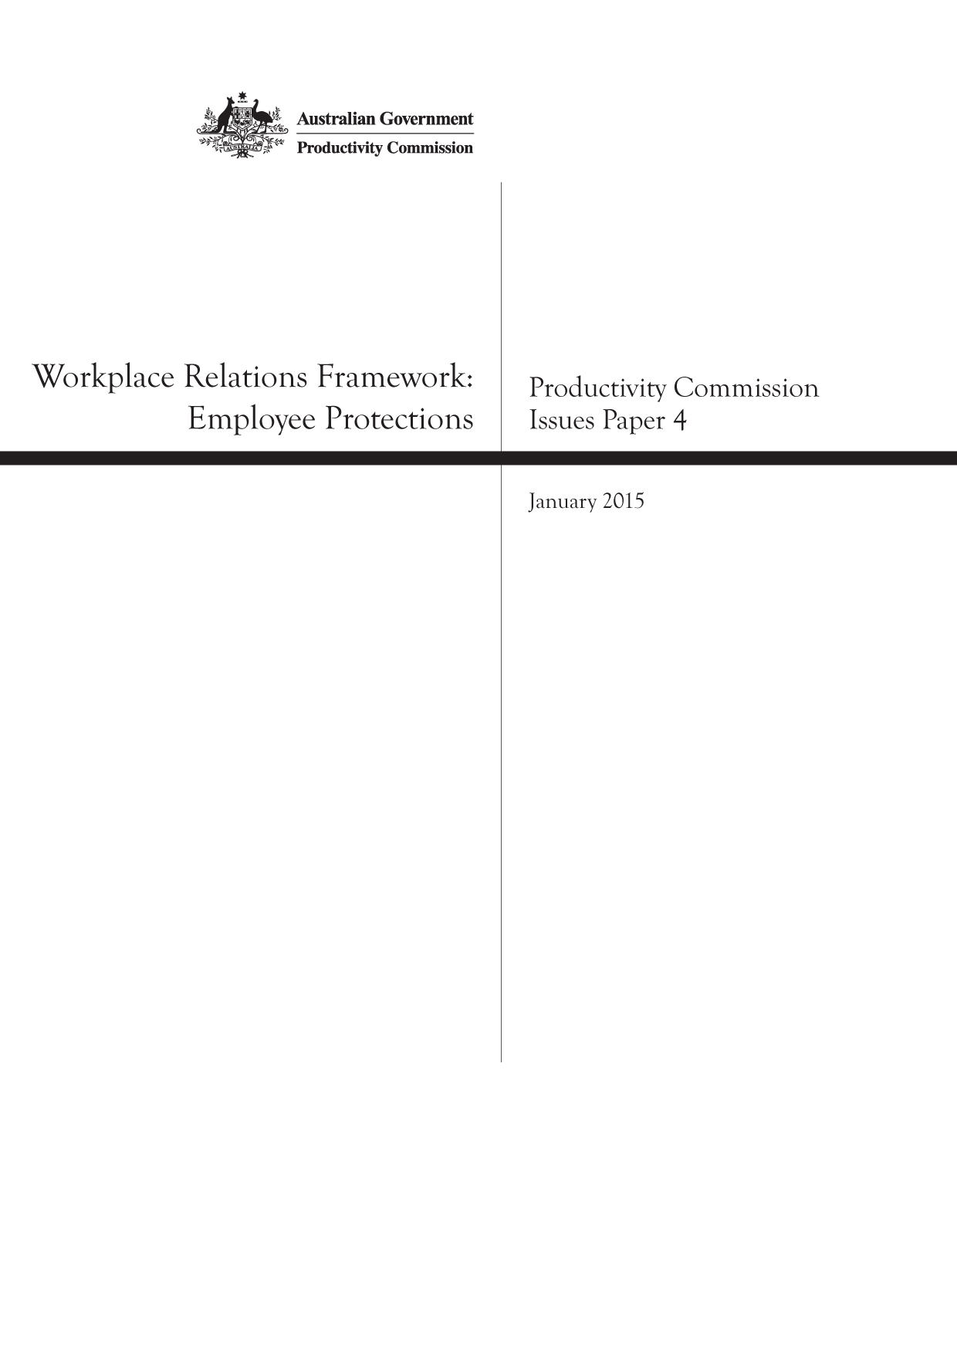

|  |
| --- |
| The Issues Paper |
| The Commission has released this issues paper to assist individuals and organisations to prepare submissions on matters relating to various employee protections.  There are four other issues papers related to the inquiry that may also be of interest.  Information about the terms of reference, the key dates, how to make a submission, the processes used by the Commission and our contact details are in Issues Paper No. 1, and are also available on the Commission’s website:  http://www.pc.gov.au/inquiries/current/workplace-relations |
|  |

|  |
| --- |
| The Productivity Commission |
| The Productivity Commission is the Australian Government’s independent research and advisory body on a range of economic, social and environmental issues affecting the welfare of Australians. Its role, expressed most simply, is to help governments make better policies, in the long term interest of the Australian community.  The Commission’s independence is underpinned by an Act of Parliament. Its processes and outputs are open to public scrutiny and are driven by concern for the wellbeing of the community as a whole.  Further information on the Productivity Commission can be obtained from the Commission’s website (www.pc.gov.au). |
|  |

Contents

4.1 Protections in workplace relations systems 1

4.2 Unfair dismissal 1

4.3 Anti‑bullying laws — a new addition to the WR framework 4

4.4 General protections and ‘adverse action’ 5

References 8

## 4.1 Protections in workplace relations systems

Workplace relations (WR) systems throughout the world legislate some protections for employees, employee representatives and, in some circumstances, employers. Central to these are various arrangements that address the unfair dismissal of employees and that allow employees to organise collectively. The avoidance of racial and sexual discrimination are also key protections for people in workplaces, though these are often outside the WR system itself.

## 4.2 Unfair dismissal

Australia’s workplace relations (WR) system provides remedies for workers who are dismissed in a ‘harsh, unjust or unreasonable’ manner. The Fair Work Commission (FWC) may order the unfairly dismissed employee to be reinstated, or paid compensation where reinstatement is inappropriate.

Unfair dismissal arrangements reflect that employees and employers are not always angels. Employees may underperform, be disruptive or behave inappropriately. Firms and labour markets can only function efficiently if managers have the power to demand behavioural change by poorly performing employees and, absent that, to dismiss or otherwise penalise them. On the other hand, employers may bully workers, make unreasonable demands (such as working longer without pay or overlooking safety issues) or may dismiss people based on prejudice, whimsy or without due process. Accordingly, there is a need for some balance between the prerogative of businesses to manage and the rights of employees to fair treatment.

There are different views about where the balance lies. Some of the important factors will be the impacts of alternative systems on productivity, worker turnover, wages, the propensity to hire and fire vulnerable workers, the compliance costs faced by the relevant stakeholders and fairness to people (both employees and employers). While much of the evidence is international,[1] there is emerging empirical analysis in Australia that unfair dismissal provisions have imposed modest, but not trivial, costs on employment and businesses, but had uncertain impacts on productivity (Freyens and Oslington 2007, 2013).

It is important to consider the potential for unintended impacts, strategic behaviour and compliance costs of different systems. For example:

* if the processes for dismissing an underperforming employee are excessive, employers may be reluctant to hire people with a higher perceived risk of underperformance, use less open processes to recruit staff such as using only known contacts and not advertise the job more broadly (to the potential disadvantage of some vulnerable groups) or use more costly recruitment screening processes (a hidden form of compliance cost)
* the higher costs of employment may be reflected in terms of employment (for instance, casual work only) or wages that are lower than otherwise
* exemptions from, or reduced requirements under, unfair dismissal provisions based on headcounts may distort the choice of full‑time versus part‑time workers, or may create business growth traps (akin to payroll tax exemptions)
* if some forms of employment termination lie outside the unfair dismissal system, businesses have incentives to re‑categorise dismissals to avoid coverage by unfair dismissal laws
* protracted unfair dismissal proceedings might generally increase workplace tensions among all the employees of an enterprise
* firms facing the procedural requirements of unfair dismissal laws may improve their personnel management systems (a benefit were this to occur)
* a reduction in the capacity for workers to initiate unfair dismissal proceedings might lead to greater use of alternative legal remedies — anti‑discrimination laws, anti‑bullying laws, Workplace Health and Safety (WHS) regulations and common law actions — which would still involve costs (and sometimes potentially greater ones). That raises the issue of whether changes to one form of employment protection might require changes to others, or whether some form of consolidation might be feasible
* the compliance costs associated with unfair dismissal, uncertainty about how to avoid disputes, and the process for resolving disputes may loom strongly in the minds of employers (and would‑be employers). Businesses may pay ‘go away money’ to quickly settle unjustified cases of unfair dismissal, rather than resolve the matter at the FWC. The issue of compliance costs in general are raised in Issues Paper No. 5.

Perceptions can still influence people’s behaviour. Business perceptions about the prevalence of unfair dismissals and ‘go away’ money, and reported instances of the apparent misuse of the provisions may affect their hiring practices, even if the reality does not match the perceptions. Similarly, employees’ perceptions about their workplaces and relationships with their employers may be conditioned by particular instances of unfair dismissal highlighted in the media. One of the roles of this inquiry will be to use evidence to assess the validity of people’s perceptions.

The design of any employment protection system needs to be informed by the likely responses by all parties. There are examples where the design of the arrangements at least reflect a *desire* to reduce the costs of the arrangements:

* current unfair dismissal arrangements make it relatively easy for an employer to dismiss an employee who has worked for six months or less with the business (12 months for small businesses). This may partly address concerns about the recruitment of new workers whose performance has not been tested in the job. However, employers must still observe some requirements for dismissing employees with short lengths of service, and failure to do so would expose the employer to action
* in recognition of the compliance costs of unfair dismissal provisions for the smallest businesses, the Australian Government developed the Small Business Fair Dismissal Code for businesses employing less than 15 employees on a headcount basis. If a small business follows the code, then the dismissal will be deemed to be fair.

Whether these arrangements are justified or function well is unclear.

Do Australia’s unfair dismissal processes achieve their purpose, and if not, what reforms should be adopted, including alternatives (or complements) to unfair dismissal provisions?

Are the tests used by the FWC appropriate for determining whether conduct is unfair, and if not, what would be a workable test? Are the exemptions to unfair dismissal appropriate, and if not, how should they be adapted?

What are the strengths and weaknesses of the Small Business Fair Dismissal Code, and how, if at all, should the Australian Government amend it? Should the employment threshold be maintained, raised or lowered?

In cases where employers are required to pay compensation in lieu of reinstatement, are the current arrangements for a cap on these payments suitable?

What are the effects of unfair dismissal arrangements on firm costs, productivity, recruitment processes, employment, and employment structures?

What are the impacts on employees of unfair dismissal, both personally and in terms of altered behaviours in workplaces?

What are the main sources of costs (including indirect costs), and how could these be reduced without undermining the fundamental goals of unfair dismissal legislation?

Under current or previous arrangements, what evidence is there of the practice of ‘go away money’? Have recent changes, such as those that provide the FWC with expanded powers in relation to costs orders and dismissing applications based on unreasonable behaviour, improved matters?

Do unfair dismissal actions disproportionately affect any particular group of employees (for example, by gender, ethnicity, geographical location, industry, union affiliation, occupation or business size)?

What are the main grounds on which people assert unfair dismissal, and what types of claims are most likely to succeed?

How does Australia compare internationally with regard to the unfair dismissal protections? Are there elements of overseas approaches and frameworks that could usefully by applied to Australia?

## 4.3 Anti‑bullying laws — a new addition to the WR framework

The WR system also protects employees from workplace bullying. Broad anti‑bullying provisions were introduced under the *Fair Work Act 2009* (Cth) (FWA) in January 2014. Bullying is defined as behaviour towards another person that is unreasonable, repeated, and creates a risk to health and safety (s. 789FD). As is the case for unfair dismissal, the FWC is the mediator, conciliator and, as a last resort, adjudicator.

The anti‑bullying provisions are available to employees of all ‘constitutional businesses’, but also to contractors, hire‑workers, apprentices, trainees, work experience students and volunteers. They do not relate to employees of unincorporated enterprises or state government agencies (though such parties could use one of various avenues outside the FWA for redress). Nor do they relate to people who have been bullied in the past, but have since left the employer. However, the provisions may apply to bullying occurring at times prior to the commencement of the new regime, so long as the person is still employed by the same employer, and where there is a concern that absent action, bullying might re‑occur (Murphy 2014).

There are no differences in the applicability of the measures by the size of the business, or the salary or tenure of the worker (unlike unfair dismissal). The bully may be a supervisor, subordinate or colleague. Anti‑bullying laws could apply to intimidation by, or of, union officials.

No compensation is payable under the FWA for a proven case (though compensation could be sought through other means). The usual goal is to prevent future bullying. However, failure to comply with FWC orders would expose the employer and/or the relevant bullying party to civil penalties.

Initially it was anticipated that many thousands of claims would be lodged annually. However, since the commencement of the jurisdiction in January 2014, there have been 343 applications for an order to stop bullying (Fair Work Commission 2014), with 197 finalised in that period. Only 21 of these involved a formal decision by the FWC (with one application granted). Claims may increase as people become aware of the legislation. On the other hand, the absence of compensation and the fact that any redress only applies to people who have continued their employment in the relevant business may limit the use of the provisions (Caponecchia 2014).

Some stakeholders have argued that the existing arrangements are confusing and complex for employees and employers alike. This reflects that the anti‑bullying provisions of the FWA coexist with other, partly overlapping, measures that target bullying, including:

* WHS legislation (and an associated anti‑bullying code) outside the WR system
* where discrimination is the basis for bullying, more general anti‑discrimination laws both in the FWA and other legislation (Andrades 2009)
* an additional anti‑bullying provision exclusive to Victoria, which makes serious bullying a criminal offence (the *Crimes Amendment (Bullying) Act 2011* (Vic) or ‘Brodie’s Law’, named after a victim of bullying)
* the potential for parties to take actions under the common law.

Sometimes parties could simultaneously use several of these avenues for the same incident.

Some stakeholders have argued that the WHS system rather than WR law is the appropriate avenue for pursuing bullying, given that the main concern is harm to people in the workplace (for example, ACCI 2011, p. 5). While recognising some of the overlaps, others see the FWA provisions as largely complementary.

Regardless, there are issues about the effects and the design of the present arrangements.

What are the likely utilisation rates of the anti‑bullying provisions, and what factors are most likely to affect these rates?

What are the impacts, disadvantages and advantages of the anti‑bullying provisions of the FWA for employers and workers?

Are there any unintended consequences of the anti‑bullying provisions?

To what extent are the anti‑bullying provisions of the FWA substitutes for, or complements to, state and federal WHS laws and other provisions of the FWA? What implications do overlaps have for the current arrangements?

How effective has the FWC been in assessing applications for orders to stop workplace bullying?

What, if any changes, should occur to the anti‑bullying provisions of the FWA or in the processes used to address claims and to communicate with businesses and employees about the measures?

## 4.4 General protections and ‘adverse action’

The WR system aims for fairness and representation in the workplace by recognising and protecting the right to freedom of association, preventing discrimination, and preventing other unfair conduct. Part 3‑1 of the FWA sets out a framework for achieving this. It contains general protections against ‘adverse action’ in connection with exercising workplace rights and engaging in industrial activity. The complex scope of protections provided by this part of the Act is indicated by the array of actions that are defined as ‘adverse’. These include doing, threatening, or organising any of the following:

* an employer dismissing an employee, injuring them in their employment, altering their position to their detriment, or discriminating between them and other employees
* an employer refusing on discriminatory grounds to employ a prospective employee or discriminating against them in the terms and conditions the employer offers
* a principal terminating a contract with an independent contractor, injuring them or altering their position to their detriment, refusing to use their services or to supply goods and services to them, or discriminating against them in the terms and conditions the principal offers to engage them on
* an employee or independent contractor taking industrial action against their employer or principal
* an industrial association, or an officer or member of an industrial association, organising or taking industrial action against a person, or taking action that is detrimental to an employee or independent contractor
* an industrial association imposing a penalty of any kind on a member.

Some recent decisions on, and modifications to, select provisions appear to have served to clarify and possibly improve the operation of the general protections. [2] The Commission is therefore seeking views on the operation of the general protections as they are now configured, and their implications for the conduct of employees, unions, employers and customers, and their overall impacts on the operation of workplaces and labour markets.

The coherence of the general protections, both as a discrete segment of the FWA and in relation to other key segments and protections within and additional to the Act, is a further point of interest to the Commission.

Do the general protections within the Fair Work Act 2009, and particularly the ‘adverse action’ provisions, afford adequate protections while also providing certainty and clarity to all parties?

What economic impacts do these protections have?

To what extent has the removal of the ‘sole or dominant’ test that existed in previous legislation shifted the balance between employee protections and employer rights?

Is there scope or argument for consolidating or clearly separating the mechanisms by which employees can seek redress for unfair conduct by others in the workplace?

Are the discrimination provisions within the general protections effective, and are they consistent with other anti‑discrimination regulations that currently apply in Australia?

In regard to the dismissal‑related general protections, to what extent do the current arrangements for the awarding of costs and convening of conferences produce outcomes that are problematic?

To what extent has the recent harmonisation of the time limits for lodgments of general protection dismissal disputes and unfair dismissal claims increased certainty for all parties involved and reduced the ‘gaming’ of such processes?

### Employee protections outside the WR system

People in workplaces can also seek protection from discrimination and harassment within workplaces under federal human rights and anti‑discrimination laws[3], as well as various equal opportunity and anti‑discrimination acts at the state and territory level. Within the federal anti‑discrimination system, an employee can bring a complaint to the Australian Human Rights Commission, which can investigate complaints and facilitate resolution through conciliation between the employee and their employer. If the employee is not satisfied with the outcome of this process, they can choose to bring the matter before the Federal Court.

While the existing human rights and anti‑discrimination legislation partially overlaps with other WR protections, it also serves a broader purpose for the community in preventing discrimination outside of workplaces. As such, the Commission considers Australia’s broader human rights framework to be distinct from the WR system and only considers any tensions between the two frameworks.

## References

ACCI (Australian Chamber of Commerce and Industry) 2011, *ACCI Submission to the Inquiry into the Fair Work Act 2009*, February, Canberra.

Andrades, C. 2009, *Intersections between ‘General Protections’ under the Fair Work Act 2009 (Cth) and anti-discrimination law: questions, quirks and quandaries*, Working Paper No. 47, December, Centre for Employment and Labour Relations Law, University of Melbourne, Melbourne.

Autor, D., Kerr, W. and Kugler, A. 2007, ‘Does employment protection reduce productivity? Evidence from US states’, *The Economic Journal*, vol. 117, June, pp. F189–F217.

Bassanini, A., Nunziata, L. and Venn, D. 2008, *Job Protection Legislation and Productivity Growth in OECD Countries*, Discussion Paper, IZA DP No. 3555, IZA (Forschungsinstitut zur Zukunft der Arbeit), Germany, June.

Bjuggren, C. 2014, ‘The Eﬀect of Employment Protection Rules on Labor Productivity’, Conference Paper.

Calcagnini, G., Ferrando, A. and Giombini, G. 2014, ‘Does employment protection legislation affect ﬁrm investment? The European case’, *Economic Modelling*, vol. 36, January, pp. 658–665.

Caponecchia, C. 2014, ‘Changing workplace bullying laws will not open floodgates’, *The Conversation*, 9 January.

Cingano, F., Leonardi, M., Messina, J. and Pica, G. 2014, *Employment Protection Legislation, Capital Investment and Access to Credit: Evidence from Italy*, Seminar Report, 27 April, University of Milan, Naples.

Fair Work Commission 2014, *Annual Report 2013-14*, 15 October.

Freyens, B. and Oslington, P. 2007, ‘Dismissal costs and their impact on employment: evidence from Australian small and medium enterprises’, *The Economic Record*, vol. 83, no. 260, pp. 1–15.

—— 2013, ‘A first look at incidence and outcomes of unfair dismissal claims under Fair Work, WorkChoices and the Workplace Relations Act’, *Australian Journal of Labour Economics*, vol. 16, no. 2, pp. 295–306.

Gianfreda, G. and Vallanti, G. 2013, *Courts’ Inefficiency and Irregular Workers: identifying the Impact of Real EPL*, 104, January, LLEE Working Paper Series, Luiss Lab of European Economics, Department of Economics and Business,, Rome.

Ichino, A. and Riphahn, R. 2005, ‘The Effect of Employment Protection on Worker Effort: Absenteeism During and After Probation’, *Journal of the European Economic Association*, vol. 3, pp. 120–143.

Laporsek, S. and Stubelj, I. 2012, ‘Employment Protection Legislation and Profits: Evidence from European Countries’, *Transylvanian Review of Administrative Sciences*, vol. E/2012, no. 35, pp. 138–152.

Micco, A. and Pages, C. 2006, *The economic effects of employment protection legislation: Evidence from international industry-level data*, Discussion Paper No. 2433, IZA (Forschungsinstitut zur Zukunft der Arbeit), Germany, November, http://papers.ssrn.com/sol3/papers.cfm?abstract_id=944137 (accessed 11 July 2014).

Murphy, J. 2014, *Fair Work Commission hands down landmark ruling on anti-bullying regime*, FlagPost, Parliamentary Library, Canberra, 7 March.

Trentinaglia De Daverio, M. 2014, ‘Excess of capacity and Employment protection: evidence from the European manufacturing industry’, presented at 13th GEP Annual Postgraduate Conference, Nottingham Centre for Research on Globalisation and Economic Policy, 1-2 May, Nottingham, Nottingham University.

1. There is an extensive literature on effects, such as on absenteeism (Ichino and Riphahn 2005), productivity (Autor, Kerr and Kugler 2007; Bassanini, Nunziata and Venn 2008; Bjuggren 2014; Cingano et al. 2014; Gianfreda and Vallanti 2013; Laporsek and Stubelj 2012; Trentinaglia De Daverio 2014), employment (Micco and Pages 2006); and investment (Calcagnini, Ferrando and Giombini 2014). However, it is an open question whether these findings are relevant to Australia.
2. Recent High Court decisions of note include *Board of Bendigo Regional Institute of Technical and Further Education v. Barclay and Anor* (M128/2011, October 2012) and *Construction, Forestry, Mining and Energy Union v. BHP Coal Pty Ltd* (B23/2014, October 2014). Modification of the time limit for the lodgment of general protections claims involving dismissal set out in s. 366 took effect from 1 January 2013.
3. Including the *Racial Discrimination Act 1975* (Cth), *Sex Discrimination Act 1984* (Cth), *Disability Discrimination Act 1992* (Cth) and the *Age Discrimination Act 2004* (Cth).