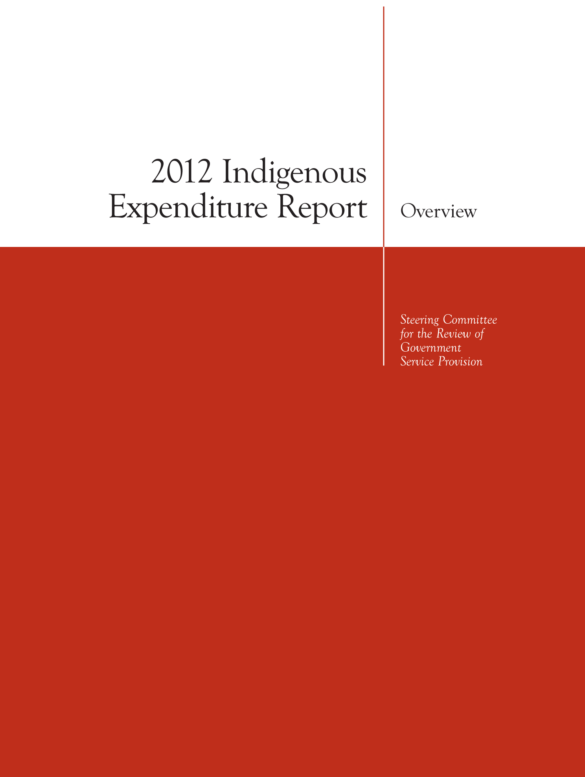
© Commonwealth of Australia 2012
ISSN 1838-2444
ISBN 978-1-74037-411-8
This work is copyright. It has been produced by the Steering Committee for the Review of Government Service Provision (SCRGSP). Apart from any use as permitted under the Copyright Act 1968, the work may be reproduced in whole or in part for study or training purposes, subject to the inclusion of an acknowledgment of the source. Reproduction for commercial use or sale requires prior written permission from the Productivity Commission. Requests and inquiries concerning reproduction and rights should be addressed to the Indigenous Expenditure Report Secretariat (see below).
This publication is available from the Productivity Commission website at www.pc.gov.au. If you require part or all of this publication in a different format, please contact the Secretariat.
The Productivity Commission acts as the Secretariat for the Steering Committee for the Review of Government Service Provision.
Secretariat
Steering Committee for the Review of Government Service Provision
Productivity Commission
LB 2 Collins Street East Post Office
Melbourne VIC 8003
Level 12
530 Collins Street
Melbourne VIC 3000
Tel: (03) 9653 2100 or Freecall 1800 020 083
Fax: (03) 9653 2359
Email: gsp.ier@pc.gov.au
website: http://www.pc.gov.au/ier
Suggestions:
The Steering Committee welcomes suggestions on the information contained in this report. Please direct your suggestions to the Secretariat at the above address.
An appropriate citation for this report is:
SCRGSP (Steering Committee for the Review of Government Service Provision) 2012, 2012 Indigenous Expenditure Report: Overview, Productivity Commission, Canberra.

Foreword
The 2012 Indigenous Expenditure Report is the second in a series of biennial reports first commissioned by the Council of Australian Governments (COAG) in December 2007.
The Report presents estimates of expenditure by all governments on both Indigenous specific and mainstream services to Aboriginal and Torres Strait Islander people. The estimates are broadly aligned to the COAG Closing the Gap building blocks.
The Report can contribute to better policy making and thus improved outcomes for Indigenous Australians by providing information on the levels, patterns and drivers of government expenditure on the services they receive. When combined with other data, the estimates provide the basis for acquiring a better understanding of the adequacy, effectiveness and efficiency of such government expenditure. The Report also helps governments identify areas where improved data or more detailed investigations are required to address key questions about services to Indigenous Australians.
While the estimates in this report represent the best collective effort of the jurisdictions, they should be interpreted with due consideration to the caveats expressed. Identifying the Indigenous component of expenditure is not straightforward, with a number of data and methodological challenges yet to be resolved.
On behalf of the Steering Committee, thanks are extended to all those who contributed to this report. Special thanks are due to members of the Indigenous Expenditure Report Working Group and its Convenor, Commissioner Robert Fitzgerald. I am also very grateful for the efforts and commitment of Secretariat staff at the Productivity Commission.
Gary Banks AO
Chair, Steering Committee
September 2012

Steering Committee
This Report was produced under the direction of the Steering Committee for the Review of Government Service Provision. At 4 September 2012, the Steering Committee comprises the following current members:
Mr Gary Banks Chairman Productivity Commission
Mr Ron Perry Aust. Govt. Department of Prime Minister and Cabinet
Mr Peter Robinson Aust. Govt. Department of the Treasury
Mr Mark Thomman Aust. Govt. Department of Finance and Deregulation
Dr Meg Montgomery NSW Department of Premier and Cabinet
Mr Kevin Cosgriff NSW NSW Treasury
Mr Simon Kent Vic Department of Premier and Cabinet
Mr Jeremy Nott Vic Department of Treasury and Finance
Ms Nicole Tabb Qld Department of the Premier and Cabinet
Ms Janelle Thurlby Qld Queensland Treasury
Mr Warren Hill WA Department of the Premier and Cabinet
Mr David Christmas WA Department of Treasury
Mr Chris McGowan SA Department of the Premier and Cabinet
Mr David Reynolds SA Department of Treasury and Finance
Ms Rebekah Burton Tas Department of Premier and Cabinet
Ms Pam Davoren ACT Chief Minister’s Department
Ms Jenny Coccetti NT Department of the Chief Minister
Mr Craig Graham NT NT Treasury
Mr Peter Harper Australian Bureau of Statistics
Mr David Kalisch Australian Institute of Health and Welfare

Contents
Foreword iii
Steering Committee iv
Contents v
Terms of reference vi
Key Points x
Overview
Key Points 1
How does this report contribute to public policy? 3
What do the terms of reference require? 5
How will this report contribute to the Indigenous reform agenda? 5
How does the Report estimate Indigenous expenditure? 6
Interpreting the estimates in this report 7
How reliable are the estimates? 8
Service delivery context 10
Comparing expenditure over time 11
Expenditure estimates 11
How much did governments spend on services to Indigenous Australians in 2010-11? 12
Why is Indigenous expenditure per capita different? 20
What other information is available? 22
The printed report 22
Documentation of the method and data sources 23
Additional estimates in web-attachments 23
References 25

Terms of reference
The following terms of reference were endorsed by the Council of Australian Governments at its 2 July 2009 meeting in Darwin.
The Indigenous Expenditure Report aims to contribute to better policy making and improved outcomes for Indigenous Australians, by:
- reporting on expenditure on services which support Indigenous Australians, including in a manner consistent with the COAG Working Group on Indigenous Reform statement of objectives, outcomes and measures and the COAG Overcoming Indigenous Disadvantage report framework.
- promoting the collection and reporting of robust Indigenous expenditure data through:
- determining and applying consistent methodology to the collection and reporting of data
- identifying necessary improvements to the collection and availability of relevant data
- developing and implementing strategies to address data deficiencies.
The Indigenous Expenditure Report will:
- include expenditure by both Commonwealth and State/Territory governments (and local government if possible), and over time will:
- allow reporting on Indigenous and non-Indigenous social status and economic status
- include expenditure on Indigenous-specific and key mainstream programs
- be reconcilable with published government financial statistics.
- focus on on-the-ground services in areas such as: education; justice; health; housing; community services; employment; and other significant expenditure.
- report on a regular basis, including:
- completion of an initial ‘stocktake’ report for the first COAG meeting in 2009, setting out the reporting framework, principles, methodology, and survey of available data and strategies for data development
- staged reporting against the framework (having regard to considerations such as data availability, implementation requirements and costs of reporting)
- report on both Indigenous and non-Indigenous expenditure.
- provide governments with a better understanding of the level and patterns of expenditure on services which support Indigenous Australians, and provide policy makers with an additional tool to target policies to Close the Gap in Indigenous Disadvantage.
The Indigenous Expenditure Report Steering Committee will:
- provide regular updates to Heads of Treasuries on progress in developing the expenditure framework and to the Working Group on Indigenous Reform on progress on data issues
- recommend to Heads of Treasuries appropriate institutional arrangements for annual reporting on Indigenous expenditure once the framework for reporting has been developed.

Overview

Key points
- The 2012 Report is the second in a series that provides estimates of expenditure on services to Indigenous Australians. It contributes to the information available to policy makers to address the gap between outcomes for Indigenous and other Australians.
- It provides information on the levels and patterns of expenditure on targeted and mainstream services for Indigenous Australians across 86 expenditure categories, mapped to the COAG National Indigenous Reform Agreement building blocks.
- When combined with other information, the estimates in the Report can contribute to a better understanding of the adequacy, effectiveness and efficiency of government expenditure on services to Indigenous Australians.
- Some national level data are summarised below. There were significant variations in the levels and patterns of expenditure across service categories, and across states and territories — more information is available in the Report and from the project website (www.pc.gov.au/gsp/ier).
- Total direct Indigenous expenditure in 2010-11 was estimated to be $25.4 billion, accounting for 5.6 per cent of total direct general government expenditure. Indigenous Australians make up 2.6 per cent of the population.
- The Australian Government accounted for $11.5 billion (45 per cent) of direct Indigenous expenditure, with the remaining $13.9 billion (55 per cent) provided by State and Territory governments.
- Mainstream services accounted for $19.9 billion (78 per cent) of direct Indigenous expenditure, with the remaining $5.5 billion (22 per cent) provided through Indigenous specific (targeted) services.
- Estimated expenditure per head of population was $44 128 for Indigenous Australians, compared with $19 589 for other Australians (a ratio of 2.25 to 1). The $24 538 per person difference reflected the combined effects of:
- greater intensity of service use ($16 109 or 66 per cent) — Indigenous Australians use more services per capita because of greater need, and because of population characteristics such as the younger age profile of the Indigenous population
- additional cost of providing services ($8429 or 34 per cent) — it can cost more to provide services to Indigenous Australians if mainstream services are more expensive to provide (for example, because of location), or if Indigenous Australians receive targeted services (for example, Indigenous liaison officers in hospitals) in addition to mainstream services.
- The Report includes a number of focus areas of expenditure. In selected areas, the ratio of Indigenous to non-Indigenous expenditure per head of population was:
- school education — 2.99:1 ($5359 per Indigenous Australian compared with $1792 per non-Indigenous Australian), mainly reflecting higher per capita use of school services, driven by the younger age profile of the Indigenous population
- public and community health services — 4.89:1 ($3152 per Indigenous Australian compared with $644 per non-Indigenous Australian), mainly reflecting higher per capita use of health services, driven by the poorer health status of Indigenous Australians
- housing — 4.85:1 ($1708 per Indigenous Australian compared with $352 per non-Indigenous Australian), mainly reflecting higher per capita use of social housing by Indigenous Australians, driven by socio-economic disadvantage.

Overview
The 2012 Indigenous Expenditure Report is the second in a series, prepared by the Steering Committee for the Review of Government Service Provision under the auspice of the Council of Australian Governments (COAG). It provides estimates of expenditure on services provided to Aboriginal and Torres Strait Islander people by the Australian Government, and State and Territory governments. Estimates are provided for each level of government, Australia as a whole, and by state and territory geographical basis, for 2008-09 and 2010-11. These estimates provide one element of the evidence base that policy makers need to gain a clearer picture of the efficiency of government services provided to Indigenous Australians.
Estimating the Indigenous component of expenditure — especially for mainstream services — is a complex exercise. The 2010 Indigenous Expenditure Report (IERSC 2010) and supplement (SCRGSP 2011a) were important first steps toward a reliable method for estimating this expenditure. This report builds on that work with a number of important improvements (box 1). However, many data quality and methodological challenges are yet to be resolved, and the interpretation of these estimates requires an understanding of the strengths and limitations of the data and method, as well as the context within which Indigenous services are provided.

How does this report contribute to public policy?
The disparity between outcomes for Indigenous and other Australians has been an ongoing policy concern for governments at all levels. The Overcoming Indigenous Disadvantage: Key Indicators 2011 report noted:
Across virtually all the indicators in this report, there are wide gaps in outcomes between Indigenous and other Australians. The report shows that the challenge is not impossible — in a few areas, the gaps are narrowing. However, many indicators show that outcomes are not improving, or are even deteriorating. There is still a considerable way to go to achieve COAG’s commitment to close the gap in Indigenous disadvantage. (SCRGSP 2011b, p. 3)

Box 1 Key improvements for the 2012 Report
The Steering Committee is committed to ongoing improvement of the data and method employed for the Indigenous Expenditure Report estimates. Key improvements for the 2012 Report include:
- new method for allocating Australian Government expenditure by state and territory — at the time of the 2010 Report publication, it was not possible to allocate Australian Government direct expenditure across states and territories. As a result, ‘total government’ expenditure in each state and territory could not be estimated. A method was subsequently developed for the 2010 Report Supplement. This method has been fully implemented in the 2012 Report
- improvements to data and quality — a number of improvements have been made to the sources and quality of the service use data that underpin the estimates in this report. These are detailed in the 2012 Report Service Use Measure Definitions Manual (SCRGSP 2012b), which is available from the project website
- improved mapping of expenditure to policy priorities — for example:
- housing — a revised structure for the collection and reporting of housing expenditure has improved the accuracy of Indigenous housing expenditure estimates and better aligned with the National Affordable Housing Agreement objectives (chapter 7)
- health — a revised structure for health services expenditure has improved alignment with health outcome areas and other health expenditure reporting. It has also allowed the separate reporting of primary health and secondary health management services (chapter 5)
- access to justice — a revised structure for law courts and legal services expenditure categories has allowed the separate reporting of expenditure on services promoting Indigenous access to justice (chapter 8).
The reasons for these persistent gaps in outcomes are complex, arising from a mix of historical, social and economic causes. Yet there has been limited information with which to assess the adequacy, effectiveness and efficiency of expenditure on programs aimed at improving outcomes for Indigenous Australians.
At its December 2007 meeting, COAG committed to transparent reporting on government expenditure on services related to Indigenous Australians. The Ministerial Council for Federal Financial Relations progressed this commitment by establishing the Indigenous Expenditure Report Steering Committee to develop a national framework for collecting and reporting government expenditure on services related to Indigenous and other Australians.
After the release of the 2010 Report, COAG transferred responsibility for developing and producing the Indigenous Expenditure Report to the Steering Committee for the Review of Government Service Provision, which also oversees the production of the Report on Government Services and the Overcoming Indigenous Disadvantage report, and the collation of National Agreement data for the COAG Reform Council.

What do the terms of reference require?
The COAG-endorsed terms of reference (p. vi) require that the Indigenous Expenditure Report contribute to governments’ understanding of the levels and patterns of expenditure on services that relate to Indigenous Australians, and provide policy makers with an additional tool for targeting policies to Close the Gap in Indigenous disadvantage, by:
- reporting regularly on a broad range of government expenditure — including Australian Government, and State and Territory Government expenditure on Indigenous specific and mainstream services used by Indigenous and non-Indigenous Australians
- emphasising policy relevant expenditure — focusing on on-the-ground services (such as education, justice, health, housing, community services, and employment) that can be related to National Indigenous Reform Agreement and Overcoming Indigenous Disadvantage reporting frameworks.

How will this report contribute to the Indigenous reform agenda?
The estimates in this report contribute to an understanding of the levels and patterns of government expenditure on services that support Indigenous Australians. Estimates are provided for 86 separate expenditure categories, mapped to six broad service areas — early child development, and education and training; healthy lives; economic participation; home environment; safe and supportive communities; and other government expenditure — that are aligned, at a high level, to the seven National Indigenous Reform Agreement Closing the Gap building blocks.
The estimates in this report can inform key questions such as:
- How much did government spend on key services?
- How much was spent on Indigenous Australians and how does this compare with expenditure on other Australians?
- What were the patterns of service use by Indigenous Australians and how do these compare with service use by other Australians?
- What drove the differences in expenditure between Indigenous and other Australians?
When combined with other data, the estimates in this report can contribute to a better understanding of the adequacy, effectiveness and efficiency of government expenditure on services for Indigenous Australians.

How does the Report estimate Indigenous expenditure?
Figure 1 illustrates the Report’s approach to estimating Indigenous expenditure. Government services for Indigenous Australians are provided through a combination of Indigenous specific (targeted) and mainstream (available to all Australians) services. For this report:
- expenditure on Indigenous specific services is assumed to relate exclusively to Indigenous Australians
Figure 1 Estimating Indigenous expenditurea
a More information on the Report method is provided in the 2012 Report Expenditure Data Manual (SCRGSP 2012a) and 2012 Report Service Use Measure Definitions Manual (SCRGSP 2012b) which are available from the project website.
- the Indigenous share of expenditure on mainstream services has been estimated using the best available proxies for the impact of Indigenous Australians on expenditure on those services — referred to as ‘service use measures’. Service use measures vary depending on the nature of a particular service:
- where individuals have a direct impact on expenditure, an individual service use measure is used; for example, the proportion of mainstream school students who are Indigenous is used to estimate the Indigenous share of expenditure on school services
- where individuals have little impact on expenditure, a population based service use measure is used; for example, the proportion of the population who are Indigenous is used to estimate the Indigenous share of expenditure on defence
- where relevant, mainstream service use measures are adjusted for: Indigenous under-identification (where service use measures are known to underestimate the number of Indigenous service users); the cost of service provision (where it costs more (or less) to provide a mainstream service to an Indigenous Australian); and for substitute Indigenous specific services (where Indigenous Australians are provided with targeted services and programs as an alternative to mainstream programs).

Interpreting the estimates in this report
The 2012 Indigenous Expenditure Report provides estimates of expenditure on Indigenous and non-Indigenous Australians for 2008-09 and 2010-11 (box 2). Estimates are provided for 86 expenditure categories, based on the ABS Government Purpose Classification (ABS 2011), which have been mapped to the National Indigenous Reform Agreement building blocks. For each expenditure category, estimates are available for:
- direct expenditure — expenditure on services and payments provided directly to individuals, non-government service providers, or local governments. Estimates are available for:
- Australian Government direct expenditure by state and territory
- State and Territory Government direct expenditure
- total (Australian Government plus State and Territory Government) direct expenditure by state and territory.

Box 2 What is expenditure?
The Indigenous Expenditure Report defines expenditure as all expense transactions undertaken by the general government sector of the Australian, State and Territory governments, following the ABS Government Finance Statistics framework (ABS 2005).
This definition excludes capital expenditure but includes expenses related to ‘depreciation’ and maintenance of assets, and ‘capital grants’ made outside the general government sector, or indirect expenditure to other governments.
The estimates in this report are reconcilable to expenditure reported under the Uniform Presentation Framework in jurisdictions’ end-of-year financial reports.
Source: SCRGSP 2012a and ABS 2011.
- indirect expenditure — Australian Government expenditure ‘to’ and ‘through’ other governments, such as Specific Purpose Payments and Goods and Services Tax payments, by state and territoryError: Reference source not found
- total expenditure — direct plus indirect expenditure estimates (which are reconcilable to end-of-year financial reports) are available for all of the Australian Government, and State and Territory governments. Australian Government total expenditure estimates are also available by state and territory.
The printed report summarises one subset of the available estimates — direct expenditure for 2010-11. These are considered robust estimates of the amounts directly spent by the Australian Government, and State and Territory governments on services in 2010-11. More detailed information, including additional expenditure categories, estimates for 2008-09 and estimates of Australian Government total (direct plus indirect) expenditure are available from the project website.

How reliable are the estimates?
The estimates of Indigenous expenditure are based on three components that combine to make up total Indigenous expenditure (figure 2):
- directly identified Indigenous expenditure — where expenditure on Indigenous specific (targeted) services and programs can be directly identified, it does not need to be estimated. This component of total Indigenous expenditure is highly reliable (although jurisdictions may not have been able to identify all targeted services)
Figure 2 Components of 2010-11 Indigenous expenditure estimatesa
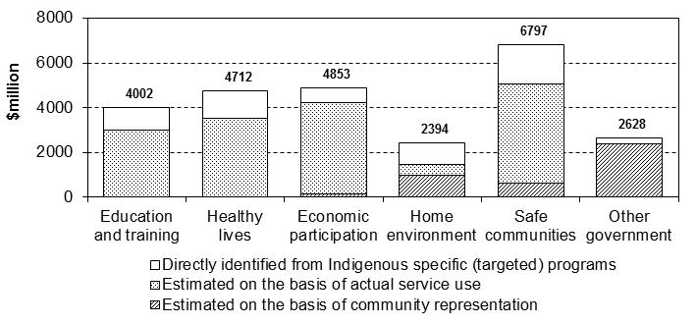
a As a general guide, expenditure directly identified from Indigenous specific (targeted) programs is considered highly reliable; expenditure estimated from actual service use is considered to be conceptually reliable, but is subject to the limitations of data quality; and expenditure estimated on the basis of the Indigenous representation in the community is considered less likely to closely reflect the relationship between individual Indigenous Australians and the expenditure.
Source: overview table 1.
- Indigenous share of mainstream expenditure estimated on the basis of actual service use — where the Indigenous share of mainstream expenditure is estimated on the basis of actual service use, there is likely to be a closer relationship between Indigenous Australians (as service users) and the cost of providing services. These estimates are conceptually robust, but can have limitations where data quality is low
- Indigenous share of mainstream expenditure estimated on the basis of share of population — where the Indigenous share of mainstream expenditure is estimated on the basis of the Indigenous share of the Australian population, there is not likely to be a direct relationship between individual Indigenous Australians and the cost of providing services. These estimates are still conceptually robust, but the services are less likely to have ‘on-the-ground’ significance to Indigenous Australians or communities.
The reliability of these three components can be influenced by factors such as:
- data availability and quality — the quality of expenditure estimates is dependent on the availability and quality of the service use measure data and adjustments used in the estimation process. In some cases, the required data are not available or are of relatively poor quality
- conceptual precision of service use measures and adjustment factors — how well a service use measure represents the link between the service use and costs will affect the quality of expenditure estimates. For example, estimates are likely to be more robust where services:
- are more homogeneous — because it is easier to identify a robust service use measure. For example, all eligible recipients of the Australian Government Baby Bonus receive the same payments, whereas health services are generally provided through a complex case-mix approach
- are closely aligned with cost centres and administrative portfolios — because it is easier for jurisdictions to allocate expenditure. For example, education services are generally associated with an education department, whereas juvenile justice services involve initiatives from a broad range of agencies and portfolios
- have direct interaction with individuals — because the link between individuals and service costs is more strongly defined. For example, school students have strong links with education costs, whereas environment and community services provide infrastructure which people may or may not use.
A subjective assessment of the appropriateness and quality of the data underpinning the estimates in this report is provided in overview table 1. Comprehensive data quality statements are provided in the 2012 Report Service Use Measure Definitions Manual (SCRGSP 2012b), available from the project website.

Service delivery context
The service delivery context influences the levels and patterns of expenditure on Indigenous and non-Indigenous Australians across jurisdictions. In particular, the service delivery context can affect both demand for services and the cost of providing services. The factors influencing demand and cost are complex and inter-related:
- the demand for services — demand for services can be influenced by a range of demographic and socio-economic factors, such as the size and age of the population and the incidence of disadvantage. Indigenous Australians use some services more intensively than non-Indigenous Australians (that is, Indigenous Australians use some services more per head of population than non-Indigenous Australians)
- the cost of service provision — the cost of providing services to Indigenous Australians can be higher (or lower) than the cost of providing similar services to non-Indigenous Australians, for reasons such as location, complexities related to culture and the compounding effects of multiple disadvantage.

Comparing expenditure over time
This report presents 2010-11 data in the printed report, and 2008-09 and 2010-11 data in the web-based tables. The data for these two periods are not intended to represent particular benchmarks against which future expenditure should be compared. Caution should be exercised when comparing differences between these two points in time because government expenditure, particularly for more disaggregated expenditure categories, can change over time for a number of reasons, including:
- increase in demand for government services — generally, increases in the level of demand for particular services will increase expenditure, particularly where expenditure based on meeting eligibility criteria is uncapped. For example, expenditure on unemployment benefits or Medicare
- the effects of inflation — to determine actual movement in expenditure, the effect of inflation needs to be removed. However, it is difficult to distinguish changes in price from changes in the level of services government provide, particularly at an aggregate level. This report does not remove the effect of inflation from time series data, and caution should be taken when comparing data for 2008-09 with data for 2010-11
- new policies and changes to existing entitlements — changes in government policies over time can cause significant movements in expenditure. For example, significant ‘one-off’ global financial crisis stimulus expenditures influenced the 2008-09 estimates. On the other hand, expenditure on many Closing the Gap initiatives did not commence until after 2008-09
- changes to the allocation of expenditure — the 2012 Report Expenditure Data Manual (2012a) provides guidelines for allocating outlays to the appropriate expenditure categories. However, changes in the machinery of government, information systems and accounting policies can result in different allocations of expenditure over time (particularly for detailed levels of disaggregation).
Future Indigenous Expenditure Reports are expected to provide more robust information about trends in expenditure over time, as more years of data become available and the quality of data improves.

Expenditure estimates
The printed Report presents an overview of estimates of Australian Government, and State and Territory Government ‘direct’ expenditure on Indigenous and non-Indigenous Australians, across six broad areas of expenditure that relate to the National Indigenous Reform Agreement and Overcoming Indigenous Disadvantage report building blocks:
- early child development, and education and training (chapter 4) — expenditure related to the educational aspects of early child development, and education and training
- healthy lives (chapter 5) — expenditure related to health services
- economic participation (chapter 6) — expenditure related to programs, services and support that allow people to participate in the economy (including labour and employment services, and social security)
- home environment (chapter 7) — expenditure related to services and programs that provide people with a safe, healthy and secure place to live (including housing, community and environment, and transport and communication services)
- safe and supportive communities (chapter 8) — expenditure related to services and programs that contribute to safe and supportive communities. This includes public order and safety, community support and welfare, and recreation and culture
- other government services (chapter 9) — government services that can not be easily allocated to any of the building blocks.

How much did governments spend on services to Indigenous Australians in 2010-11?
Nationally, Australian Government plus State and Territory Government direct expenditure on services for Indigenous Australians was $25.4 billion or 5.6 per cent of all government direct expenditure in 2010-11 (overview table 2). Indigenous Australians made up 2.6 per cent of the Australian population in June 2011 (chapter 3). Across the six building blocks (figure 3):
- similar proportions of Indigenous and non-Indigenous expenditure were devoted to education and training, healthy lives, economic participation and home environment
- a greater proportion of Indigenous expenditure (27 per cent) than non-Indigenous expenditure (13 per cent) was devoted to safe and supportive communities. This mainly related to expenditure on:
- public order and safety — which accounted for 13 per cent of direct Indigenous safe and supportive communities expenditure, compared with 4.9 per cent of direct non-Indigenous safe and supportive communities expenditure
- community support and welfare — which accounted for 12 per cent of total direct Indigenous safe and supportive communities expenditure compared with 6.8 per cent of direct non-Indigenous safe and supportive communities expenditure.
- a much lower proportion of Indigenous expenditure (10 per cent) than non-Indigenous expenditure (20 per cent) was devoted to other government services, which mainly related to services estimated on a per capita basis.
Figure 3 Australian Government plus State and Territory Government direct expenditure on services for Indigenous and non-Indigenous Australians, 2010-11a, b
(a) Indigenous expenditure | (b) Non-Indigenous expenditure
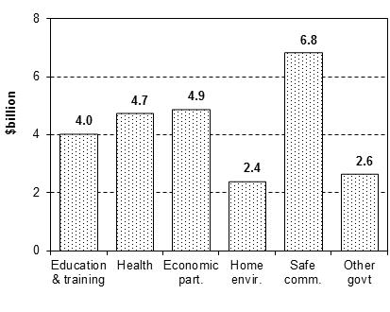 | 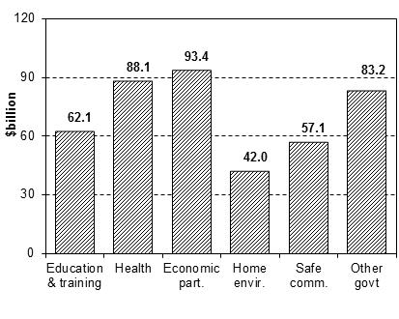
a Direct expenditure includes government outlays on services and programs (including income support) that are paid directly to individuals, non-government service providers, or local governments. b Education & training — early child development and education (chapter 4); health — healthy lives (chapter 5); economic part. — economic participation (chapter 6); home envir. — home environment (chapter 7); safe comm. — safe and supportive communities (chapter 8); and other govt — other government services (chapter 9).
Source: overview table 2.

How do Indigenous and non-Indigenous expenditure per person compare?
Throughout this report, estimated expenditure is presented on an expenditure per head of population basis (that is, expenditure per person). This allows the comparison of the relative level of expenditure between Indigenous and non-Indigenous Australians, and across jurisdictions of different sizes. It also allows expenditure in different service areas to be aggregated and compared on a consistent basis. However, expenditure per person is not the same as expenditure per user and must not be interpreted as a proxy for unit cost, or the amount that individuals receive from government (box 3).

Box 3 Interpreting estimated expenditure per person
Throughout this report, estimated expenditure is presented on an expenditure per head of population basis (that is, expenditure per capita). This allows the comparison of the relative size of expenditure between Indigenous and non-Indigenous Australians, and across jurisdictions of different sizes. It also allows expenditure in different service areas to be aggregated and compared on a consistent basis.
Expenditure per head of population is not a unit cost measure
Expenditure per head of population is not the same as expenditure per user, and must not be interpreted as a proxy for unit cost:
- expenditure per head of population — is estimated expenditure divided by the total population
- expenditure per user (unit cost) — is estimated expenditure divided by the total number of service users.
Expenditure per user will always be higher than expenditure per head of population, because services are generally provided to a subset of the entire population (for example, school education is only provided to school aged children).
Estimated direct government expenditure per person on all services was $44 128 per Indigenous person and $19 589 per non-Indigenous person in 2010-11. That is, an estimated $2.25 was spent per Indigenous person for every dollar spent per non-Indigenous person in the population in 2010-11 (overview table 2). By broad area of expenditure:
- early child development, and education and training (chapter 4) — $2.44 was spent per Indigenous person in the population for every dollar spent per non-Indigenous person. The largest area of difference in expenditure per head of population was:
- school education (a ratio of $2.99 to 1) — which reflects the younger age profile of the Indigenous population (figure 4a).
- healthy lives (chapter 5) — $2.02 was spent per Indigenous person in the population for every dollar spent per non-Indigenous person. Indigenous expenditure per person was:
- higher for public and community health services (a ratio of $4.89 to 1) — which includes expenditure on Aboriginal Community Controlled Health Organisation services
- lower for health care subsidies and support (a ratio of $0.66 to 1) — which includes expenditure on Medicare rebates, pharmaceutical benefits subsidies (such as the PBS) and private health insurance rebates (figure 4b).
Figure 4 Australian Government plus State and Territory Government direct expenditure per person by service area, Australia, 2010-11a, b
(a) Early child development, and  Education and training (chapter 4)  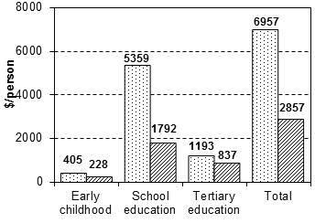 | (b) Healthy lives  (chapter 5)  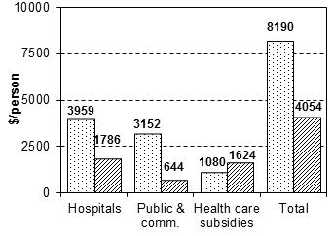
(c) Economic participation  (chapter 6)  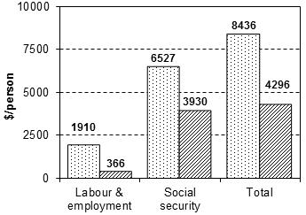 | (d) Home environment  (chapter 7)  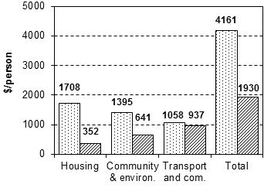
(e) Safe and supportive  communities (chapter 8)  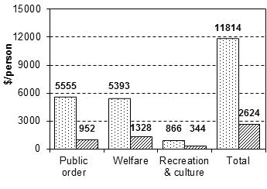 | (f) Other government  services (chapter 9)  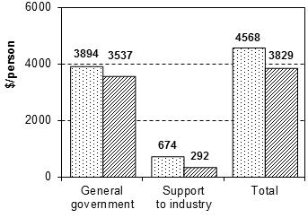
a Direct expenditure includes government outlays on services and programs (including income support) that are paid directly to individuals, non-government service providers, or local governments. b Per head of population expenditure is not the same as expenditure per user, and should not be interpreted as a proxy for unit cost. The population data used for these calculations are provided in appendix C, table C.1.
Source: overview table 2.
- economic participation (chapter 6) — $1.96 was spent per Indigenous person in the population for every dollar spent per non-Indigenous person. The largest area of difference in expenditure per person was:
- labour and employment programs (a ratio of $5.22 to 1) — which was mainly related to Indigenous specific employment programs such as the Australian Government Indigenous Employment Program and Community Development Employment Projects (figure 4c).
- home environment (chapter 7) — $2.16 was spent per Indigenous person in the population for every dollar spent per non-Indigenous person. The largest area of difference in expenditure per head of population was:
- housing (a ratio of 4.85 to 1) — which reflects the higher per capita use by Indigenous Australians of social housing and rental market assistance (figure 4d).
- safe and supportive communities (chapter 8) — $4.50 was spent per Indigenous person in the population for every dollar spent per non-Indigenous person. The difference in expenditure per person was larger for Indigenous Australians for both:
- public order and safety (a ratio of $5.83 to 1) — which related to the overrepresentation of the Indigenous population in the justice system. However, care should be exercised in this area because of the relative poor quality of the data and limited information on per-incident costs
- community welfare and support (a ratio of $4.06 to 1) — which mainly related to the greater per capita use of welfare services, such as support for people with a disability and support for families and children (figure 4e).
- other government services (chapter 9) — $1.19 was spent per Indigenous person in the population for every dollar spent per non-Indigenous person. The largest area of difference in expenditure per head of population was:
- support to industry (a ratio of $2.31 to 1) — which mainly related to the distribution of royalties generated from mining on Aboriginal land in the Northern Territory to the Aboriginals Benefit Account (figure 4f).

How much do the different levels of government contribute to direct expenditure?
Overall, the Australian Government, and State and Territory governments accounted for similar proportions of total direct expenditure in 2010-11:
- the Australian Government accounted for $11.5 billion or 45 per cent of direct Indigenous expenditure and $246 billion or 58 per cent of direct non-Indigenous expenditure
- State and Territory governments accounted for $13.9 billion (55 per cent) of direct Indigenous expenditure and $180 billion (42 per cent) of direct non-Indigenous expenditure in 2010-11 (overview table 3).
However, the proportion of direct expenditure accounted for by the Australian Government, and State and Territory governments varied across states and territories (figure 5).
Figure 5 Australian Government and State and Territory Government direct expenditure per person by state and territory, 2010-11a
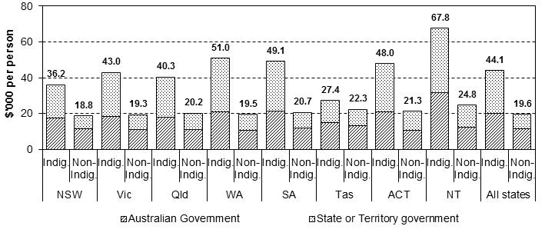
a Per head of population expenditure is not the same as expenditure per user, and should not be interpreted as a proxy for unit cost. The population data used for these calculations are provided in appendix C, table C.1.
Source: web-table W-K.1.
The proportions of direct expenditure accounted for by the Australian Government, and State and Territory governments also varied across areas of expenditure. State and Territory governments accounted for the majority of expenditure on:
- early child development, and education and training — $3.2 billion (80 per cent) of direct Indigenous early child education and education and training expenditure and $44.6 billion (72 per cent) of direct non-Indigenous early child education and education and training expenditure
- healthy lives — $3.1 billion (66 per cent) of direct Indigenous healthy lives expenditure and $47.7 billion (54 per cent) of direct non-Indigenous healthy lives expenditure
- home environment — $1.8 billion (76 per cent) of direct Indigenous home environment expenditure and $30.3 billion (72 per cent) of direct non-Indigenous home environment expenditure
- safe and supportive communities — $4.8 billion (71 per cent) of direct Indigenous safe and supportive communities expenditure and $34.1 billion (60 per cent) of direct non-Indigenous safe and supportive communities expenditure.
The Australian Government accounted for the majority of expenditure on:
- economic participation — $4.7 billion (96 per cent) of direct Indigenous economic participation expenditure and $90.6 billion (97 per cent) of direct non-Indigenous economic participation expenditure
- other government services — $1.9 billion (71 per cent) of direct Indigenous other government expenditure and $62.8 billion (75 per cent) of direct non-Indigenous other government expenditure.
The Australian Government also contributed significant indirect expenditure ‘to’ and ‘through’ State and Territory governments (box 4).

Box 4 Australian Government indirect expenditure
Australian Government indirect expenditure ‘to’ and ‘through’ State and Territory governments are reflected in State and Territory Government direct expenditure when the relevant services are provided. Australian Government indirect expenditure in 2010-11 related to:
- National Specific Purpose Payments (SPP) ($26.2 billion) — payments to State and Territory governments to deliver services, including the National Healthcare SPP, National Schools SPP, National Skills and Workforce Development SPP, National Disability Services SPP and National Affordable Housing SPP
- National Partnership Agreement payments ($25.3 billion) — payments to State and Territory governments to deliver specific projects and undertake national reforms, and as rewards for delivering reforms or service delivery improvements
- Goods and Services Tax and general revenue assistance — payments provided to State and Territory governments without conditions, to spend according to their own priorities.
In 2010-11, the Australian Government provided $47.0 billion in general revenue assistance, nearly all ($45.9 billion) in Goods and Services Tax payments.
Source: Aus Gov (2011).

How significant is expenditure on Indigenous specific services?
Government services are provided to Indigenous Australians through a combination of mainstream and Indigenous specific (targeted) services. Mainstream services accounted for $19.9 billion (78 per cent) of direct Indigenous expenditure in 2010-11 (overview table 4). By broad area of expenditure:
- early child development, and education and training — mainstream services accounted for $3.0 billion (74 per cent) of direct Indigenous early child development, and education and training expenditure
- healthy lives — mainstream services accounted for $3.5 billion (74 per cent) of direct Indigenous health expenditure
- economic participation — mainstream services accounted for $4.2 billion (87 per cent) of direct Indigenous economic participation expenditure
- home environment — mainstream services accounted for $1.5 billion (61 per cent) of direct Indigenous home environment expenditure
- safe and supportive communities — mainstream services accounted for $5.4 billion (79 per cent) of direct Indigenous safe and supportive communities expenditure
- other government services — mainstream services accounted for $2.4 billion (89 per cent) of direct Indigenous other government services expenditure (figure 6).
Figure 6 Australian Government plus State and Territory Government direct expenditure on services to Indigenous Australians by type of expenditure, 2010-11a, b, c
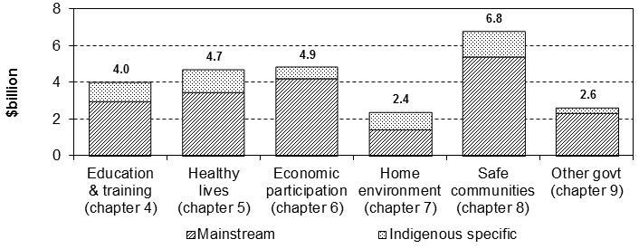
a Direct expenditure includes government outlays on services and programs (including income support) that are paid directly to individuals, non-government service providers, or local governments. b Mainstream expenditure includes outlays on programs, services and payments that are available to both Indigenous and non-Indigenous Australians on either a targeted or universal basis. Indigenous mainstream expenditure comprises a component estimated on the basis of service use and a component estimated on the basis of the difference in the cost of providing these services to Indigenous and non-Indigenous people. c Indigenous specific expenditure includes outlays on programs, services and payments that are explicitly targeted to Indigenous Australians. These programs, services and payments can be either complementary (additional) to, or be substitutes (alternatives) for, mainstream services.
Source: overview table 4.
Indigenous specific services accounted for $5.5 billion (22 per cent) of direct Indigenous expenditure in 2010-11 (overview table 4). Indigenous specific services can either substitute for, or be complements to, mainstream services:
- substitute Indigenous specific services — are alternatives to mainstream services (for example, ABSTUDY). These services are an alternate way of meeting the service needs of Indigenous Australians. Substitute services accounted for $1.5 billion (28 per cent) of Indigenous specific services in 2010-11
- complementary Indigenous specific services — are provided in addition to mainstream services (for example, Indigenous student counsellors in schools). These services add to the cost of providing mainstream services to Indigenous Australians. Complementary services accounted for $4.0 billion (72 per cent) of Indigenous specific expenditure in 2010-11 (web-table W-I.1).

Why is Indigenous expenditure per capita different?
Expenditure on Indigenous Australians varied across jurisdictions and when compared with expenditure on non-Indigenous Australians. The Report method identifies several factors that drove these variations.

What can the method explain about differences in expenditure?
This report estimates direct expenditure on Indigenous Australians based on:
- intensity of service use — expenditure driven by the use of services. Intensity of service use has two sub-components:
- Indigenous use of mainstream services — the estimated Indigenous share of mainstream expenditure is proportional to Indigenous use of mainstream services.
The per capita intensity of service use is higher if, on average, Indigenous Australians tend to use more services than non-Indigenous Australians — either because of greater individual need, or because a higher proportion of the Indigenous population belongs to the age group likely to use those services
- Indigenous specific services that substitute for mainstream services — these are services that Indigenous Australians use instead of a similar mainstream service.
- additional cost of service provision — expenditure driven by the additional cost of providing services to Indigenous Australians, compared with the cost of providing similar services to non-Indigenous Australians. (This figure can be negative if it costs less to provide services to Indigenous Australians; for example, if Indigenous Australians use less expensive services.) The additional cost of service provision has two sub-components:
- mainstream service cost differential — any additional cost of providing mainstream services to Indigenous Australians, for reasons such as location, culture and language. For social security payments, mainstream services cost differentials reflect differences in the average payment to Indigenous and non-Indigenous recipients when assessed against eligibility criteria
- Indigenous specific services that complement mainstream services — these are services that Indigenous Australians use in addition to a mainstream service.

Variations in expenditure between Indigenous and other Australians
The variation in expenditure per person between Indigenous and non-Indigenous Australians can be explained by differences in the intensity of service use, plus any additional cost of providing services to Indigenous Australians (figure 7).
Figure 7 Australian Government plus State and Territory Government direct expenditure per person by driver of expenditure, 2010-11a, b, c, d
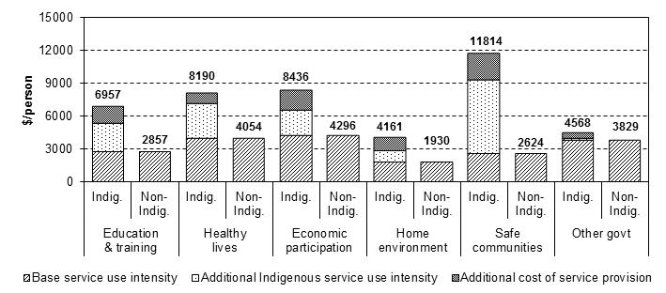
a Direct expenditure includes government outlays on services and programs (including income support) that are paid directly to individuals, non-government service providers, or local governments. b Per head of population expenditure is not the same as expenditure per user, and should not be interpreted as a proxy for unit cost. The population data used for these calculations are provided in appendix C, table C.1.c Additional cost of service provision includes additional cost of providing mainstream services to Indigenous Australians plus complementary Indigenous specific services (those provided in addition to mainstream services). d Total Indigenous intensity of service use includes the use of mainstream services plus substitute Indigenous specific services (those provided as an alternative to mainstream services). The base service use intensity is the service use intensity of non-Indigenous Australians. The additional Indigenous intensity of service use is total Indigenous intensity of service use less base service use intensity.
Source: overview table 5.
Estimated total direct expenditure per Indigenous Australian ($44 128) was $24 538 higher than direct expenditure per non-Indigenous Australian in 2010-11. The majority of the difference $16 109 (66 per cent) was attributable to greater intensity of service use, with the remaining $8429 (34 per cent) attributable to additional cost of service provision (overview table 5). The majority of additional cost of service provision ($6948 or 82 per cent) related to complementary Indigenous specific services that were used in addition to mainstream services (web-table W-I.16).
By broad area of expenditure:
- early child development, and education and training — expenditure per Indigenous person was $4101 higher than per non-Indigenous person, with the majority ($2562 or 62 per cent) attributable to greater intensity of service use
- healthy lives — expenditure per Indigenous person was $4136 higher than per non-Indigenous person, with the majority ($3147 or 76 per cent) attributable to greater intensity of service use
- economic participation — expenditure per Indigenous person was $4141 higher than per non-Indigenous person, with the majority ($2346 or 57 per cent) attributable to greater intensity of service use
- home environment — expenditure per Indigenous person was $2231 higher than per non-Indigenous person, with the majority ($1196 or 54 per cent) attributable to additional cost of service provision
- safe and supportive communities — expenditure per Indigenous person was $9190 higher than per non-Indigenous person, with the majority ($6773 or 74 per cent) attributable to greater intensity of service use
- other government services — expenditure per Indigenous person was $739 higher than per non-Indigenous person, with the majority ($493 or 67 per cent) attributable to additional cost of service provision (overview table 5).

What other information is available?

The printed report
The printed report comprises three key elements:
- background and guidelines for interpretation — information on the background and purpose of the Report (chapter 1), and guidelines on how the report estimates should be interpreted within the context of the method and data (chapter 2) and service delivery context (chapter 3)
- overview of expenditure — separate chapters provide a high level overview of expenditure mapped to the COAG building blocks: early child development, and education and training (chapter 4), healthy lives (chapter 5); economic participation (chapter 6); home environment (chapter 7); safe and supportive communities (chapter 8); and other government services (chapter 9)
- focus areas of expenditure — each of the expenditure area chapters includes a detailed examination of a focus area of expenditure. These were selected as guides to the more detailed estimates available online, because of their importance for Indigenous outcomes. The focus areas of expenditure for the 2012 Report are: school education (chapter 4); public and community health (chapter 5); social security support (chapter 6); housing (chapter 7); and law courts and legal services (including access to justice) (chapter 8). There is no focus area of expenditure for chapter 9.

Documentation of the method and data sources
Detailed documentation of the method is provided in two manuals, available from the project website:
- Expenditure Data Manual — provides a set of agreed counting rules (definitions, methods and guidelines) for jurisdictions to follow when providing expenditure data (SCRGSP 2012a)
- Service Use Measure Definitions Manual — documents the agreed measures used to prorate mainstream expenditure between Indigenous and non-Indigenous Australians (SCRGSP 2012b).

Additional estimates in web-attachments
The printed report should be viewed as an introduction and guide to the full suite of information available in the 2012 Indigenous Expenditure Report. The Steering Committee has prepared extensive web-based tables to meet the anticipated needs of users. A full list of the web-based tables and their content is provided in appendix D of the printed report.

References
ABS (Australian Bureau of Statistics) 2005, Australian System of Government Finance Statistics Concepts, Sources and Methods 2005, Cat. no. 5514.0, Canberra.
—— 2011, Amendments to Australian System of Government Finance Statistics Concepts, Sources and Methods 2005, Information Paper, Cat. no. 5514.0, Canberra.
Aus Gov (Australian Government) 2011, Final Budget Outcome 2010-11, Australian Government Department of the Treasury, www.budget.gov.au/
2010-11/content/fbo/html/index.htm (accessed 27 June 2012).
IERSC (Indigenous Expenditure Report Steering Committee) 2010, 2010 Indigenous Expenditure Report, Productivity Commission, Canberra.
SCRGSP (Steering Committee for the Review of Government Service Provision) 2011a, Australian Government Expenditure by State and Territory, 2010 Indigenous Expenditure Report Supplement, Productivity Commission, Canberra.
—— 2011b, Overcoming Indigenous Disadvantage: Key Indicators 2011, Productivity Commission, Canberra.
—— 2012a, Expenditure Data Manual, 2012 Indigenous Expenditure Report, Productivity Commission, Canberra.
—— 2012b, Service Use Measure Definitions Manual, 2012 Indigenous Expenditure Report, Productivity Commission, Canberra.

Table 1 Reliability of model parameters, 2010-11 estimates
 | Estimated |  |  |  |  |  | Information qualitya
 |  | Directly  identifiedb |  | Service  usec | Comm.  repd | Total  exp | Appr.e | Qual.f | Cost  diff.g
 | % |  |  | % | % | $m
Early child development, and Education and training (chapter 4)
Early childhood |  |  | 33.5 | 66.5 | – | 5 191 | A | B | C
School education |  |  | 22.9 | 75.1 | 2.0 | 42 041 | A | B | B
Tertiary education |  |  | 35.7 | 62.5 | 1.9 | 18 878 | A | B | C
Total |  |  | 25.7 | 72.4 | 1.9 | 66 109 | A | B | C
Healthy lives (chapter 5)
Hospital servicesh |  |  | 6.3 | 93.7 | – | 41 101 | A | A | A
Public and community health |  |  | 60.9 | 39.1 | – | 15 820 | A | A | B
Health care subsidies & support |  |  | 12.7 | 87.3 | – | 35 928 | A | A | B
Total |  |  | 27.0 | 73.0 | – | 92 849 | A | A | B
Economic participation (chapter 6)
Labour and employment |  |  | 59.2 | 29.0 | 11.9 | 9 054 | B | B | C
Social security support |  |  | – | 100.0 | – | 89 193 | A | A | B
Total |  |  | 13.4 | 83.9 | 2.7 | 98 247 | A | A | B
Home environment (chapter 7)
Housing |  |  | 51.0 | 49.0 | – | 8 637 | A | B | C
Community and environment |  |  | 52.2 | – | 47.8 | 14 739 | A | A | C
Transport and communications |  |  | 5.0 | – | 95.0 | 20 978 | A | A | C
Total |  |  | 39.7 | 20.1 | 40.2 | 44 354 | A | A | C
Safe and supportive communities (chapter 8)
Public order and safety |  |  | 13.6 | 76.4 | 10.0 | 23 899 | C | B | C
Community support and welfare |  |  | 34.1 | 64.6 | 1.4 | 31 973 | B | A | C
Recreation and culture |  |  | 52.0 | – | 48.0 | 7 979 | A | A | C
Total |  |  | 25.8 | 65.4 | 8.8 | 63 851 | B | B | C
Other government services (chapter 9)
General government and defence |  |  | 4.4 | – | 95.6 | 79 141 | A | A | C
Support to industry |  |  | 46.3 | – | 53.7 | 6 736 | A | A | C
Total |  |  | 10.6 | – | 89.4 | 85 877 | A | A | C
TOTAL EXPENDITURE |  |  | 23.2 | 60.6 | 16.2 | 451 287 | B | B | C
a A subjective assessment of the reliability of service use measure and data: ‘A’ implies good; ‘B’ implies fair; ‘C’ implies poor and ‘D’ implies very poor. b Expenditure directly identified as Indigenous specific (targeted) programs. c Expenditure estimated on the basis of actual service use. d Expenditure estimated on the basis of community representation (comm. rep). e Appropriateness (appr.) — a subjective assessment of how well the service use measure represents the link between service use and cost. f Quality (qual.) — a subjective assessment of the reliability of the service use measure data, including Indigenous identification. g Cost differential (cost diff.) — a subjective assessment of the reliability of the information on the difference in the cost of providing the same service to Indigenous and non-Indigenous Australians. h Expenditure estimates on ‘Hospital services’ for Indigenous Australians in some jurisdictions should be interpreted with care; in Tas, due to concerns regarding recording of Indigenous status in Tasmanian hospitals, and in ACT and NSW, on account of cross border flows between these two states. – Zero or rounded to zero.
Source: Steering Committee for the Review of Government Service Provision analysis.
Table 2 Australian Government plus State and Territory Government direct expenditure, Australia, 2010-11a, b, c
 | Total  expenditure |  |  |  |  |  |  | Expenditure per head  of populationd
 | Indig. |  |  | Non-Indig. | Total | Indig.  share |  | Indig. | Non-Indig. | Ratioe
 | $m |  |  | $m | $m | % |  | $/pers | $/pers | ratio
Early child development, and Education and training (chapter 4)
Early childhood | 233 |  |  | 4 958 | 5 191 | 4.5 |  | 405 | 228 | 1.78
School education | 3 083 |  |  | 38 958 | 42 041 | 7.3 |  | 5 359 | 1 792 | 2.99
Tertiary education | 686 |  |  | 18 192 | 18 878 | 3.6 |  | 1 193 | 837 | 1.43
Total | 4 002 |  |  | 62 107 | 66 109 | 6.1 |  | 6 957 | 2 857 | 2.44
Healthy lives (chapter 5)
Hospital services | 2 278 |  |  | 38 823 | 41 101 | 5.5 |  | 3 959 | 1 786 | 2.22
Public & community health | 1 813 |  |  | 14 007 | 15 820 | 11.5 |  | 3 152 | 644 | 4.89
Health care subsidies & support |  |  | 621 | 35 307 | 35 928 | 1.7 |  | 1 080 | 1 624 | 0.66
Total | 4 712 |  |  | 88 137 | 92 849 | 5.1 |  | 8 190 | 4 054 | 2.02
Economic participation (chapter 6)
Labour & employment | 1 099 |  |  | 7 955 | 9 054 | 12.1 |  | 1 910 | 366 | 5.22
Social security support | 3 755 |  |  | 85 438 | 89 193 | 4.2 |  | 6 527 | 3 930 | 1.66
Total | 4 853 |  |  | 93 393 | 98 247 | 4.9 |  | 8 436 | 4 296 | 1.96
Home environment (chapter 7)
Housing | 982 |  |  | 7 655 | 8 637 | 11.4 |  | 1 708 | 352 | 4.85
Community & environment | 803 |  |  | 13 936 | 14 739 | 5.4 |  | 1 395 | 641 | 2.18
Transport & communications |  |  | 609 | 20 369 | 20 978 | 2.9 |  | 1 058 | 937 | 1.13
Total | 2 394 |  |  | 41 960 | 44 354 | 5.4 |  | 4 161 | 1 930 | 2.16
Safe and supportive communities (chapter 8)
Public order & safety | 3 196 |  |  | 20 703 | 23 899 | 13.4 |  | 5 555 | 952 | 5.83
Community support & welfare |  | 3 102 |  | 28 870 | 31 973 | 9.7 |  | 5 393 | 1 328 | 4.06
Recreation & culture | 498 |  |  | 7 481 | 7 979 | 6.2 |  | 866 | 344 | 2.52
Total | 6 797 |  |  | 57 054 | 63 851 | 10.6 |  | 11 814 | 2 624 | 4.50
Other government services (chapter 9)
General govt & defence | 2 240 |  |  | 76 901 | 79 141 | 2.8 |  | 3 894 | 3 537 | 1.10
Support to industry | 388 |  |  | 6 348 | 6 736 | 5.8 |  | 674 | 292 | 2.31
Total | 2 628 |  |  | 83 249 | 85 877 | 3.1 |  | 4 568 | 3 829 | 1.19
TOTAL EXPENDITURE | 25 387 |  |  | 425 900 | 451 287 | 5.6 |  | 44 128 | 19 589 | 2.25
a Direct expenditure includes government outlays on services and programs (including income support) that are paid directly to individuals, non-government service providers, or local governments. b Refer to relevant chapters for more detail on the estimates and specific guidelines for the use and interpretation of these data. c Totals may not add due to rounding. d Per head of population expenditure is not the same as expenditure per user, and should not be interpreted as a proxy for unit cost. The population data used for these calculations are provided in appendix C, table C.1. e The ratio of total Indigenous expenditure per person to total non-Indigenous expenditure per person.
Source: web-tables W-I.1 and W-I.2.
Table 3 Australian Government plus State and Territory Government direct expenditure by state and territory, 2010-11a
 | NSW | Vic | Qld | WA | SA | Tas | ACT | NT | All  states
Early child development, and Education and training (chapter 4)
Indigenous ($million)
Aust Govt | 242 | 59 | 207 | 101 | 53 | 25 | 9 | 108 | 803
State Govt | 818 | 211 | 793 | 505 | 242 | 89 | 29 | 512 | 3 199
Non-Indigenous ($million)
Aust Govt | 5 645 | 4 608 | 3 473 | 1 580 | 1 318 | 409 | 393 | 105 | 17 530
State Govt | 11 793 | 11 898 | 9 283 | 5 451 | 3 613 | 1 195 | 853 | 490 | 44 576
Total | 18 498 | 16 776 | 13 756 | 7 637 | 5 226 | 1 719 | 1 283 | 1 215 | 66 109
Healthy lives (chapter 5)
Indigenous ($million)
Aust Govt | 337 | 100 | 317 | 212 | 65 | 41 | 12 | 518 | 1 603
State Govt | 623 | 188 | 883 | 518 | 218 | 37 | 35 | 607 | 3 109
Non-Indigenous ($million)
Aust Govt | 13 707 | 9 248 | 7 884 | 4 579 | 2 541 | 1 039 | 666 | 818 | 40 482
State Govt | 14 293 | 11 488 | 9 946 | 4 921 | 4 337 | 1 252 | 988 | 430 | 47 655
Total | 28 960 | 21 024 | 19 030 | 10 231 | 7 161 | 2 369 | 1 702 | 2 373 | 92 849
Economic participation (chapter 6)
Indigenous ($million)
Aust Govt | 1 213 | 252 | 1 290 | 777 | 285 | 112 | 31 | 723 | 4 683
State Govt | 30 | 9 | 79 | 16 | 7 | 3 | – | 27 | 170
Non-Indigenous ($million)
Aust Govt | 29 383 | 22 989 | 18 375 | 7 753 | 7 779 | 2 662 | 1 235 | 444 | 90 620
State Govt | 1 116 | 494 | 448 | 275 | 298 | 83 | 19 | 41 | 2 774
Total | 31 742 | 23 743 | 20 192 | 8 821 | 8 368 | 2 861 | 1 285 | 1 234 | 98 247
Home environment (chapter 7)
Indigenous ($million)
Aust Govt | 153 | 34 | 157 | 60 | 28 | 17 | 4 | 129 | 583
State Govt | 318 | 96 | 492 | 232 | 73 | 25 | 12 | 564 | 1 811
Non-Indigenous ($million)
Aust Govt | 3 758 | 2 815 | 2 529 | 1 141 | 893 | 286 | 160 | 82 | 11 663
State Govt | 8 460 | 8 034 | 6 951 | 3 578 | 2 052 | 443 | 456 | 323 | 30 297
Total | 12 689 | 10 979 | 10 129 | 5 010 | 3 046 | 771 | 632 | 1 098 | 44 354
(Continued next page)
Table 3 (continued)
 | NSW | Vic | Qld | WA | SA | Tas | ACT | NT | All  states
Safe and supportive communities (chapter 8)
Indigenous ($million)
Aust Govt | 490 | 130 | 510 | 247 | 139 | 48 | 30 | 376 | 1 970
State Govt | 1 246 | 409 | 1 138 | 991 | 295 | 78 | 44 | 626 | 4 827
Non-Indigenous ($million)
Aust Govt | 7 470 | 5 916 | 4 472 | 1 924 | 2 201 | 586 | 303 | 109 | 22 979
State Govt | 10 469 | 8 977 | 6 484 | 3 964 | 2 359 | 895 | 601 | 329 | 34 076
Total | 19 674 | 15 432 | 12 603 | 7 125 | 4 993 | 1 607 | 977 | 1 439 | 63 851
Other government services (chapter 9)
Indigenous ($million)
Aust Govt | 493 | 110 | 485 | 227 | 93 | 60 | 14 | 374 | 1 855
State Govt | 144 | 23 | 295 | 75 | 29 | 27 | 11 | 169 | 773
Non-Indigenous ($million)
Aust Govt | 20 318 | 15 826 | 12 704 | 6 397 | 4 675 | 1 410 | 1 015 | 465 | 62 810
State Govt | 5 939 | 3 319 | 6 263 | 1 644 | 1 497 | 617 | 801 | 359 | 20 439
Total | 26 893 | 19 278 | 19 746 | 8 343 | 6 295 | 2 114 | 1 841 | 1 367 | 85 877
TOTAL EXPENDITURE
Indigenous ($million)
Aust Govt | 2 927 | 686 | 2 966 | 1 624 | 662 | 304 | 100 | 2 229 | 11 498
State Govt | 3 178 | 935 | 3 680 | 2 337 | 863 | 260 | 131 | 2 504 | 13 889
Non-Indigenous ($million)
Aust Govt | 80 280 | 61 403 | 49 435 | 23 374 | 19 406 | 6 392 | 3 772 | 2 021 | 246 083
State Govt | 52 070 | 44 209 | 39 375 | 19 833 | 14 156 | 4 485 | 3 717 | 1 972 | 179 817
Total | 138 455 | 107 233 | 95 455 | 47 167 | 35 088 | 11 441 | 7 720 | 8 727 | 451 287
a Direct expenditure includes government outlays on services and programs (including income support) that are paid directly to individuals, non-government service providers, or local governments.
Source: web-table W-J.1.
Table 4 Australian Government plus State and Territory direct expenditure on Indigenous Australians, Australia, 2010-11a
 | Indigenous expenditure |  |  |  |  |  | Indig.  specific  shareb | Service area sharec
 | Mainstream |  | Indig.  specific | Total |  |  | Indig.  specific  shareb | Service area sharec
 | $m |  | $m | $m |  | % |  | %
Early child development, and Education and training (chapter 4)
Early childhood |  | 155 | 78 | 233 |  | 33.5 |  | 0.9
School education |  | 2 378 | 705 | 3 083 |  | 22.9 |  | 12.1
Tertiary education |  | 441 | 245 | 686 |  | 35.7 |  | 2.7
Total |  | 2 974 | 1 028 | 4 002 |  | 25.7 |  | 15.8
Healthy lives (chapter 5)
Hospital services |  | 2 135 | 143 | 2 278 |  | 6.3 |  | 9.0
Public & community health |  | 803 | 1 010 | 1 813 |  | 55.7 |  | 7.1
Health care subsidies & support |  | 542 | 79 | 621 |  | 12.7 |  | 2.4
Total |  | 3 480 | 1 232 | 4 712 |  | 26.1 |  | 18.6
Economic participation (chapter 6)
Labour & employment |  | 449 | 650 | 1 099 |  | 59.2 |  | 4.3
Social security support |  | 3 755 | – | 3 755 |  | – |  | 14.8
Total |  | 4 203 | 650 | 4 853 |  | 13.4 |  | 19.1
Home environment (chapter 7)
Housing |  | 481 | 501 | 982 |  | 51.0 |  | 3.9
Community & environment |  | 384 | 419 | 803 |  | 52.2 |  | 3.2
Transport & communications |  | 594 | 15 | 609 |  | 2.5 |  | 2.4
Total |  | 1 458 | 936 | 2 394 |  | 39.1 |  | 9.4
Safe and supportive communities (chapter 8)
Public order & safety |  | 2 760 | 436 | 3 196 |  | 13.6 |  | 12.6
Community support & welfare |  | 2 395 | 707 | 3 102 |  | 22.8 |  | 12.2
Recreation & culture |  | 239 | 259 | 498 |  | 52.0 |  | 2.0
Total |  | 5 394 | 1 402 | 6 797 |  | 20.6 |  | 26.8
Other government services (chapter 9)
General govt & defence |  | 2 142 | 98 | 2 240 |  | 4.4 |  | 8.8
Support to industry |  | 208 | 180 | 388 |  | 46.3 |  | 1.5
Total |  | 2 350 | 278 | 2 628 |  | 10.6 |  | 10.4
Total expenditure |  | 19 861 | 5 526 | 25 387 |  | 21.8 |  | 100.0
a Direct expenditure includes government outlays on services and programs (including income support) that are paid directly to individuals, non-government service providers, or local governments. b Indigenous specific expenditure as a proportion of total Indigenous expenditure. c Indigenous expenditure in the service area as a proportion of total direct Indigenous expenditure. – Zero or rounded to zero.
Source: web-table W-I.1.

Table 5 Australian Government plus State and Territory direct expenditure per person on Indigenous and non-Indigenous Australians by source of difference, Australia, 2010-11a, b
 | Indigenous expenditure |  |  |  |  |  |  | Source of differencec
 | Service  used |  | Cost of prov.e | Total |  | Non-  Indig |  | Service  used | Cost of prov.e | Total
 | $/pers |  | $/pers | $/pers |  | $/pers |  | $/pers | $/pers | $/pers
Early child development, and Education and training (chapter 4)
Early childhood | 267 |  | 138 | 405 |  | 228 |  | 39 | 138 | 177
School education | 4 203 |  | 1 157 | 5 359 |  | 1 792 |  | 2 411 | 1 157 | 3 567
Tertiary education | 948 |  | 244 | 1 193 |  | 837 |  | 112 | 244 | 356
Total | 5 418 |  | 1 539 | 6 957 |  | 2 857 |  | 2 562 | 1 539 | 4 101
Healthy lives (chapter 5)
Hospital services | 3 676 |  | 283 | 3 959 |  | 1 786 |  | 1 891 | 283 | 2 173
Public & community health | 2 587 |  | 565 | 3 152 |  | 644 |  | 1 943 | 565 | 2 507
Health care subsidies & support |  | 938 | 142 | 1 080 |  | 1 624 |  | -686f | 142 | -544f
Total | 7 201 |  | 989 | 8 190 |  | 4 054 |  | 3 147 | 989 | 4 136
Economic participation (chapter 6)
Labour & employment | 769 |  | 1 140 | 1 910 |  | 366 |  | 404 | 1 140 | 1 544
Social security support | 5 873 |  | 654 | 6 527 |  | 3 930 |  | 1 943 | 654 | 2 597
Total | 6 642 |  | 1 794 | 8 436 |  | 4 296 |  | 2 346 | 1 794 | 4 141
Home environment (chapter 7)
Housing | 1 260 |  | 447 | 1 708 |  | 352 |  | 908 | 447 | 1 356
Community & environment | 719 |  | 676 | 1 395 |  | 641 |  | 78 | 676 | 754
Transport & communications |  | 986 | 72 | 1 058 |  | 937 |  | 49 | 72 | 122
Total | 2 965 |  | 1 196 | 4 161 |  | 1 930 |  | 1 035 | 1 196 | 2 231
Safe and supportive communities (chapter 8)
Public order and safety | 4 802 |  | 753 | 5 555 |  | 952 |  | 3 850 | 753 | 4 603
Community support & welfare | 4 175 |  | 1 218 | 5 393 |  | 1 328 |  | 2 847 | 1 218 | 4 065
Recreation & culture | 420 |  | 447 | 866 |  | 344 |  | 76 | 447 | 522
Total | 9 397 |  | 2 417 | 11 814 |  | 2 624 |  | 6 773 | 2 417 | 9 190
Other government services (chapter 9)
General govt & defence | 3 713 |  | 181 | 3 894 |  | 3 537 |  | 176 | 181 | 357
Support to industry | 362 |  | 312 | 674 |  | 292 |  | 70 | 312 | 382
Total | 4 075 |  | 493 | 4 568 |  | 3 829 |  | 246 | 493 | 739
Total expenditure | 35 699 |  | 8 429 | 44 128 |  | 19 589 |  | 16 109 | 8 429 | 24 538
a Direct expenditure includes government outlays on services and programs (including income support) that are paid directly to individuals, non-government service providers, or local governments. b Per head of population expenditure is not the same as expenditure per user, and should not be interpreted as a proxy for unit cost. The population data used for these calculations are provided in appendix C, table C.1. c The source of the difference between Indigenous and non-Indigenous expenditure per person. d Service use — ‘intensity of service use’. e Cost of prov — ‘cost of service provision’. f The difference between Indigenous and non-Indigenous expenditure per person is negative because Indigenous Australians have a lower intensity of service use than non-Indigenous Australians.
Source: web-table W-I.16.

In this report lower case state and territory refers to the geographical boundaries of jurisdictions, and upper case State and Territory refers to the jurisdictional governments.
State and Territory Government indirect expenditure amounted to less than $1.6 billion, compared with $98.5 billion for the Australian Government in 2010-11 (web-attachments W-N to W-V).

