A Population characteristics of Aboriginal and Torres Strait Islander people and their language use
This appendix provides contextual data on the population characteristics of Aboriginal and Torres Strait Islander and non-Indigenous people from the 2016 Census, to aid interpretation of data elsewhere in the Report. Also provided are 2016 Census data on the use of Aboriginal and Torres Strait Islander languages.

Aboriginal and Torres Strait Islander people account for about three per cent of the Australian population
There were an estimated 798 400 Aboriginal and Torres Strait Islander people in Australia at June 2016, accounting for 3.3 per cent of the total Australian population at that time (ABS 2018). The majority of Aboriginal and Torres Strait Islander people lived on the Eastern seaboard of Australia in 2016 (figure A.1).

Figure A.1 Aboriginal and Torres Strait Islander people, by Indigenous region, June 2016a,b
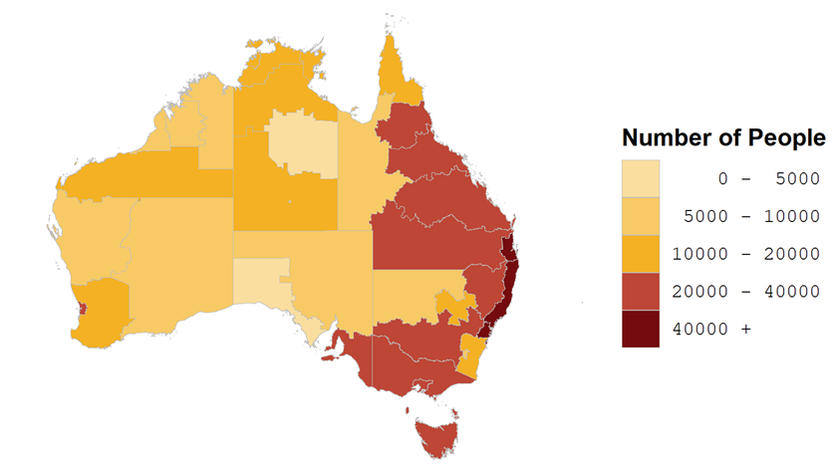
a The estimated number of Aboriginal and Torres Strait Islander Australians in the 37 ABS Indigenous regions as at June 2016. b See table A.2 for detailed definitions, footnotes and caveats.
Source: ABS (2019) Estimates and Projections, Aboriginal and Torres Strait Islander Australians, 2006 to 2031, Cat. no. 3238.0, Canberra; table A.2.
Nationally as at June 2016, around three in five Aboriginal and Torres Strait Islander people lived in either NSW (33 per cent) or Queensland (28 per cent). The proportions across other jurisdictions ranged from 1 per cent in the ACT to 13 per cent in WA (table A.3).

The majority of Aboriginal and Torres Strait Islander people live in major cities and regional areas — but a much higher proportion live in remote and very remote areas compared with non-Indigenous people
Like all Australians, the majority of Aboriginal and Torres Strait Islander people live in major cities and regional areas (figure A.2). Even so, a much higher proportion of Aboriginal and Torres Strait Islander people lived in remote and very remote areas (19 per cent, compared with 2 per cent of non-Indigenous people), and were spread more evenly across all remoteness areas than non-Indigenous people (figure A.2).

Figure A.2 Proportion of the population, by remoteness area and Indigenous status, June 2016a
a See table A.3 for detailed definitions, footnotes and caveats.
Source: ABS (2018) Estimates of Aboriginal and Torres Strait Islander Australians, June 2016, Cat. no. 3238.0.55.001; table A.3.
Aboriginal and Torres Strait Islander people as a proportion of the population differed across states and territories. The NT had the highest proportion (30 per cent) while Victoria had the lowest (1 per cent) (figure A.3).

Figure A.3 Aboriginal and Torres Strait Islander people as a proportion of the population in each State and Territory, June 2016a
a See table A.3 for detailed definitions, footnotes and caveats.
Source: ABS (2019) Estimates of Aboriginal and Torres Strait Islander Australians, Cat. no. 3238.0.55.001; table A.3.

The Aboriginal and Torres Strait Islander population is younger than the non-Indigenous population
The Aboriginal and Torres Strait Islander population has a younger age structure than the non-Indigenous population in Australia. As at June 2016:
- 34 per cent of Aboriginal and Torres Strait Islander people were under 15 years old, compared with 18 per cent of non-Indigenous people (figure A.4)
- about 1 per cent of Aboriginal and Torres Strait Islander people were aged 75 years or over, compared with 7 per cent of non-Indigenous people (figure A.4)
- the median age (midpoint) of Aboriginal and Torres Strait Islander people was 23 years, compared with 38 years for non-Indigenous people (table A.1).

Figure A.4 Proportion of the population, by age group and Indigenous status, June 2016a
a See table A.1 for detailed definitions, footnotes and caveats.
Source: ABS (2018) Estimates of Aboriginal and Torres Strait Islander Australians, June 2016, Cat. no. 3238.0.55.001; table A.1.

At the time of the 2016 Census, one in ten Aboriginal and Torres Strait Islander people spoke an Aboriginal and Torres Strait Islander language at home
More than 250 Aboriginal and Torres Strait Islander languages, including 800 dialects, existed at the time of European settlement — but today only about 120 languages are still spoken (AIATSIS nd; DITRDC, AIATSIS and ANU 2020, 2020; Marmion, Obata and Troy 2014).
Languages are much more than a communication tool and are integral to maintaining the identity and strength of people and culture. When a language is no longer spoken it disconnects people from their past, and knowledge, traditions and cultures become harder to express and pass on (DITRDC, AIATSIS and ANU 2020). Aboriginal and Torres Strait Islander languages are no exception. The revitalisation and maintenance of Aboriginal and Torres Strait Islander languages is crucial to preserving and strengthening Aboriginal and Torres Strait Islander cultures, which is ultimately linked to the wellbeing of Aboriginal and Torres Strait Islander people (see section 5.5 Indigenous language revitalisation and maintenance).
According to the 2016 Census of Population and Housing, 10 per cent of Aboriginal and Torres Strait Islander people spoke an Aboriginal and Torres Strait Islander language at home (figure A.5). This proportion varied across states and territories. The NT had the highest proportion (66 per cent), while Tasmania had the lowest (less than 1 per cent) (figure A.5).

Figure A.5 Language spoken at home by Aboriginal and Torres Strait Islander people, 2016a
a See table A.5 for detailed definitions, footnotes and caveats.
Source: ABS (unpublished) Census of Population and Housing 2016; table A.5.
The proportion of Aboriginal and Torres Strait Islander people who spoke an Aboriginal and Torres Strait Islander language at home also differed across remoteness areas and age groups. Very remote areas had the highest proportion of Indigenous language speakers (63 per cent), followed by remote areas (21 per cent), while less than 2 per cent of Aboriginal and Torres Strait Islander people in major cities or regional areas spoke an Indigenous language at home (figure A.6).
The majority of Aboriginal and Torres Strait Islander people who spoke an Indigenous language at home also spoke English well or very well (85 per cent). However, 11 per cent of Indigenous language speakers said they did not speak English well or at all — ranging from about 3–4 per cent in major cities and inner regional areas, to 13 per cent in very remote areas (figure A.7).

Figure A.6 Proportion of Aboriginal and Torres Strait Islander people who spoke an Indigenous language at home, by remoteness area and age, 2016a
a See table A.8 for detailed definitions, footnotes and caveats.
Source: ABS (unpublished) 2016 Census of Population and Housing; table A.8.

Figure A.7 Aboriginal and Torres Strait Islander people who spoke an Indigenous language at home, by remoteness area and English proficiency, 2016a
a See table A.8 for detailed definitions, footnotes and caveats.
Source: ABS (unpublished) 2016 Census of Population and Housing; table A.8.

Improving quality of, and access to, data for assessing local needs and planning local solutions is a key future development for data on Aboriginal and Torres Strait Islander people
Like all Australians, the needs of Aboriginal and Torres Strait Islander people are diverse, differing across communities and regions. Access to reliable data is vital for shared decision-making. Reliable data that are easily accessed and understood empower communities to advocate for their needs, and assist governments and others to make more informed decisions and improve efficiency and accountability (PC 2017, p. 61).
Initiatives to provide Aboriginal and Torres Strait Islander people with improved access to, use of and oversight of, databases containing information about themselves and their ancestors contribute to addressing this need (section 5.4 Case studies in governance).
However, existing data sets are limited in their effectiveness for smaller regions in several ways. For example, large data sets can:
- under-identify Aboriginal and Torres Strait Islander people and capture only relatively homogenous information
- provide information that is reliable only at higher levels of aggregation and not necessarily relevant for particular communities or regions, even where the data are specific to Aboriginal and Torres Strait Islander people.
Furthermore, large data sets are not always easily accessible in formats that can be readily understood, while data for small areas are often subject to confidentiality requirements which limits the available data.
Shared access to data and information at a regional level is one of the priority reform areas in the National Agreement on Closing the Gap. This includes shared access to location-specific data and information, recognising that disaggregated data and information is most useful to Aboriginal and Torres Strait Islander organisations and communities for local decision-making (Australian Government and Coalition of Peaks 2020).

Attachment tables
Attachment tables are identified in references throughout this appendix by an ‘A’ prefix (for example, ‘table A.2’). These tables can be found on the web page (www.pc.gov.au/oid2020).

References
ABS (Australian Bureau of Statistics) 2018, Estimates of Aboriginal and Torres Strait Islander Australians, June 2016, 31 August, Cat. no. 3238.0.55.001, Canberra.
AIATSIS (Australian Institute of Aboriginal and Torres Strait Islander Studies) nd, Indigenous Australian Languages - Celebrating 2019 International Year of Indigenous Languages, Indigenous Australian Languages, https://aiatsis.gov.au/explore/articles/indigenous-australian-languages (accessed 20 July 2020).
Australian Government and Coalition of Peaks 2020, National Agreement on Closing the Gap, Canberra.
DITRDC, AIATSIS and ANU (Department of Infrastructure, Transport, Regional Development and Communications, Australian Institute of Aboriginal and Torres Strait Islander Studies and Australian National University) 2020, National Indigenous Languages Report 2020, Australian Government, Canberra, ACT.
Marmion, D., Obata, K. and Troy, J. 2014, Community, Identity and Wellbeing: The Report of the Second National Indigenous Languages Survey, Australian Institute of Aboriginal and Torres Strait Islander Studies, Canberra.
PC (Productivity Commission) 2017, Data Availability and Use, Report No. 82, Canberra.

Population estimates for Aboriginal and Torres Strait Islander people in this Report are based on 2016 Census of Population and Housing counts, adjusted for net undercount as measured by the ABS Post Enumeration Survey (ABS 2018).
Measures to confidentialise data, such as perturbation or not publishing small cells, can lead to data that is difficult to understand or use at the local level.

