2 The framework
This chapter explains the Overcoming Indigenous Disadvantage: Key Indicators report framework. Section 2.1 describes how the key elements of the framework fit together. Section 2.2 discusses how the outcomes and strategic actions across the framework interrelate and interact.

2.1 The focus of the framework is on outcomes
The framework in this Report focuses on outcomes — that is, the actual lived experiences of Aboriginal and Torres Strait Islander people. While there are many reports on Aboriginal and Torres Strait Islander people, reports about the performance of governments often focus on specific programs or policies. They may take a ‘silo’ approach — with education reported by education departments, and health by health departments — and they tend to focus on service inputs (how budgets are spent) and outputs (the actual services delivered), rather than on the outcomes achieved. While information on inputs and outputs is valuable, particularly when evaluating the efficiency of a specific program or service, information on outcomes is crucial to measure whether progress is being made in improving the wellbeing of Aboriginal and Torres Strait Islander people and whether the Closing the Gap policy objectives are being achieved.

The framework has evolved over time with an increasing emphasis on the importance of governance, leadership and culture in improving wellbeing
At the time when the framework was developed, and in early editions of this Report, the focus of the framework was on understanding the disadvantage experienced by Aboriginal and Torres Strait Islander people, with an emphasis on the ‘gap’ with non-Indigenous people. The framework made use of the best available evidence about the underlying reasons disadvantage is experienced so that policy attention could be directed to prevention, as well as responding to the existing disadvantage experienced. This focus on disadvantage was reflected in the terms of reference (as updated in 2009), which noted the report’s significance as:
… a source of high quality information on the progress being made in addressing Indigenous disadvantage across a range of key indicators. The OID report has been used by governments and the broader community to understand the nature of Indigenous disadvantage and, as a result, has helped inform the development of policies to address Indigenous disadvantage. (p. iv)
As the framework has evolved over time, greater prominence has been given to governance, leadership and culture as key building blocks for improving the wellbeing of Aboriginal and Torres Strait Islander people. From the 2014 edition, the framework was further enhanced by:
- renaming the ‘Governance and Leadership’ strategic area ‘Governance, leadership and culture’, in recognition that the most significant positive influences on the wellbeing of Aboriginal and Torres Strait Islander people are to do with ‘culture’
- grouping the ‘cultural’ indicators together under this strategic area, to increase their prominence and allow for a discussion about the connections between culture and other outcomes.
The key elements of the framework are shown in a simplified form in figure 2.1. Each of the framework elements is discussed briefly below.

Figure 2.1 Framework elements

Three aspirational priority outcomes sit at the top of the framework
Three interlinked priority outcomes sit at the top of the framework; no single aspect of the priority outcomes can be achieved in isolation. The priority outcomes are:
- safe, healthy and supportive family environments with strong communities and cultural identity
- positive child development and prevention of violence, crime and self-harm
- improved wealth creation and economic sustainability for individuals, families and communities.
These outcomes reflect the vision for Aboriginal and Torres Strait Islander people to have the same life opportunities as other Australians.
It is extremely difficult to measure progress in achieving such broadly stated, aspirational outcomes, and to hold governments and service providers accountable. Therefore, the framework includes two layers of quantifiable indicators. The logic of the framework is that, over time, measurable improvement in these indicators will mean progress toward achieving the priority outcomes.

The first layer of the framework contains the COAG targets and headline indicators
The first layer of indicators is made up of targets set by COAG for ‘Closing the Gap’ between outcomes for Aboriginal and Torres Strait Islander people and non-Indigenous people, along with a further six headline indicators selected by the Steering Committee to represent significant, high-level outcomes.
At the time of preparing this report the COAG targets were those that were part of the National Indigenous Reform Agreement (NIRA). The NIRA has now been replaced by a new National Agreement on Closing the Gap (the Agreement) that came into effect from 27 July 2020. The Agreement was developed in partnership between Australian governments, the Coalition of Aboriginal and Torres Strait Islander Peak Organisations and the Australian Local Government Authority. A number of targets from the NIRA have been retained in the Agreement, while others have been retained as indicators supporting targets.
The COAG-agreed Closing the Gap targets forming part of the NIRA are listed below, with details in square brackets if they continue to be a target under the Agreement:
- life expectancy — close the life expectancy gap within a generation, by 2031 [this target has been retained]
- young child mortality — halve the gap in mortality rates for Indigenous children under five within a decade, by 2018 [this target has not been retained]
- early childhood education — 95 per cent of all Indigenous four-year-olds enrolled in early childhood education, by 2025 [this target has been retained]
- reading, writing and numeracy — halve the gap for Indigenous students in reading, writing and numeracy within a decade, by 2018 [this target has not been retained]
- Year 1 to 10 attendance — close the gap between Indigenous and non-Indigenous school attendance within five years, by 2018 [this target has not been retained]
- Year 12 attainment — halve the gap for Indigenous 20–24 year olds in Year 12 or equivalent attainment rates, by 2020 [a modified version of this target has been retained]
- employment — halve the gap in employment outcomes between Indigenous and non-Indigenous Australians within a decade, by 2018 [a modified version of this target has been retained].
These targets highlight specific outcomes in areas that are either significant in their own right (life expectancy and early childhood mortality) or important preconditions or preventative factors for addressing long term disadvantage (access to preschool, learning outcomes, school attainment and attendance, and employment).
The Steering Committee has selected six headline indicators that sit alongside the COAG targets in the first layer of indicators. These headline indicators are all important outcomes in their own right, and require whole-of-government action over the long term before significant progress will be seen. Under the new Agreement, a number of these (or similar) indicators now have targets. The headline indicators, with details in square brackets if they are related to a target in the new Agreement, are:
- post-secondary education [this indicator is related to a target]
- disability and chronic disease [this indicator is not related to a target]
- household and individual income [this indicator is not related to a target]
- substantiated child abuse and neglect [this indicator is related to a target]
- family and community violence [this indicator is related to a target]
- imprisonment and youth detention [this indicator is related to a target].
Together, the COAG targets and headline indicators provide an overview of progress in overcoming the disadvantage experienced by many Aboriginal and Torres Strait Islander people, and act as proxy measures for the priority outcomes.
Chapter 4 includes information on the evidence base supporting the selection of indicators, the definitions of the specific measures used to report against them, and available data.

The second layer of the framework identifies ‘strategic areas for action’ and related ‘strategic change indicators’
The COAG targets and headline indicators, by their very nature, are extremely important — but their whole-of-government, long-term nature can make it difficult to hold specific governments or agencies accountable for short- to medium-term outcomes. The second layer of the framework seeks to overcome this limitation by identifying ‘strategic areas for action’: specific areas of policy where immediate action is needed to drive improvement in these targets and headline indicators. Each strategic area for action has a small number of ‘strategic change indicators’ that measure short-term progress. The full framework is shown in figure 2.2.
Chapters 5 to 11 include the evidence base supporting the selection of each strategic area for action and its associated indicators, the definitions of the specific measures used to report against each indicator, and the available data.

The strategic areas for action have the potential to drive improvement in the headline indicators and progress toward the COAG targets
The seven strategic areas for action were chosen for their potential to have a significant and lasting impact on improving the wellbeing of Aboriginal and Torres Strait Islander people and in reducing the experience of disadvantage. Each strategic area represents a set of related activities that evidence suggests have the potential to drive improvement in the headline indicators and progress toward the COAG targets.
The strategic areas do not match typical government service silos. Improving the wellbeing of Aboriginal and Torres Strait Islander people will require the combined efforts of governments, Aboriginal and Torres Strait Islander people and the broader community. In some cases, a specific service area will play a major role — but in all strategic areas, more than one government agency will have to take action in order to achieve better outcomes. For example, in the area of education and training, the school system has an important role to play, but so do agencies dealing with housing and health (other strategic areas within the framework). Section 2.2 provides further detail on these interactions.

Figure 2.2 Multi-level indicator framework
Priority outcomes
COAG targets and headline indicators
COAG targets | Headline indicators
4.1 Life expectancy | 4.8 Post-secondary education — participation and attainment
4.2 Young child mortality | 4.9 Disability and chronic disease
4.3 Early childhood education | 4.10 Household and individual income
4.4 Reading, writing and numeracy | 4.11 Substantiated child abuse and neglect
4.5 Year 1 to 10 attendance | 4.12 Family and community violence
4.6 Year 12 attainment | 4.13 Imprisonment and youth detention
4.7 Employment
Strategic areas for action
Governance, leadership and culture |  |  |  |  | Early child development |  |  |  |  | Education and training |  |  |  |  | Healthy lives |  |  |  |  | Economic participation |  |  |  |  |  | Home environment |  |  |  |  | Safe and supportive communities
5.1 Valuing Aboriginal and Torres Strait Islander people and their cultures  5.2 Participation in decision making  5.3 Engagement of services  5.4 Case studies in governance  5.5 Indigenous language revitalisation and maintenance  5.6 Indigenous cultural studies  5.7 Participation in community activities  5.8 Access to traditional lands and waters |  |  |  |  | 6.1 Antenatal care  6.2 Health behaviours during pregnancy  6.3 Teenage birth rate  6.4 Birthweight  6.5 Early childhood hospitalisations  6.6 Injury and preventable disease  6.7 Ear health  6.8 Basic skills for life and learning |  |  |  |  | 7.1 Teacher quality  7.2 School engagement  7.3 Transition from school to work |  |  |  |  | 8.1 Access to primary health care  8.2 Potentially preventable hospitalisations  8.3 Potentially avoidable deaths  8.4 Tobacco consumption and harm  8.5 Obesity and nutrition  8.6 Oral health  8.7 Mental health  8.8 Suicide and self-harm |  |  |  |  | 9.1 Employment by full time/part time status, sector and occupation  9.2 Indigenous owned or controlled land and business  9.3 Home ownership  9.4 Income support |  |  |  |  |  | 10.1 Overcrowding in housing  10.2 Rates of disease associated with poor environmental health  10.3 Access to clean water and functional sewerage and electricity services |  |  |  |  | 11.1 Alcohol consumption and harm  11.2 Drug and other substance use and harm  11.3 Youth diversions  11.4 Repeat offending  11.5 Community functioning

Note: Numbers beside indicator names refer to section numbers in the Report.

The strategic change indicators measure progress in each strategic area for action
A small number of targeted, shorter term ‘strategic change indicators’ measure progress in each strategic area for action. These indicators make it easier to track short-term progress, and improve accountability for outcomes. (The term ‘indicator’ has a particular meaning in this Report, and is distinguished from the term ‘measure’ — see box 2.1).

Box 2.1 Indicators and measures
In this Report, the term ‘indicator’ refers to a broad statement of the concept to be measured. Indicators are usually described in general terms, to allow for developments in the evidence base and changes in data sets over time.
In this Report, the term ‘measure’ refers to how an indicator will be measured. Data limitations mean that, sometimes, proxy measures must be used to report against indicators, and multiple measures may be required to illustrate a single indicator. Information on the measures reported for each indicator is provided at the beginning of each indicator section.
Linkages across the framework mean that some indicators could potentially be placed in more than one strategic area for action. Indicators have been placed in the strategic area where the evidence base suggests they will have greatest effect, but their potential to influence other outcomes is acknowledged by cross-references in the text.
Many other indicators could have been included in this Report. Potential strategic change indicators were assessed against the criteria listed in box 2.2 before they were added to the framework. Most of the indicators in the Report meet all the criteria — but a few indicators are regarded as so important that they are included even though they do not meet some criteria.

Box 2.2 Criteria used to select strategic change indicators
- Required by alignment with NIRA indicators (as the NIRA was still in effect at the time of preparing this report).
- Measures an outcome (rather than an input or output) or a close proxy for an outcome — the focus is on measurable impacts on individuals or communities rather than resources spent or services provided. Where outcomes are not available and there is strong evidence that certain inputs or outputs are closely linked to an outcome, these may be included as proxy indicators.
- Relevance to priority outcomes — the whole framework is geared toward measuring progress toward the priority outcomes.
- Improvement in the strategic change indicator results in improvement over time in the COAG targets and headline indicators — the report draws its strength from the evidence base or underlying theory of causality that links improvement in a strategic change indicator to improvement in the COAG targets and headline indicators, and therefore to progress toward the priority outcomes.
- Supported by logic or empirical evidence — for most indicators, empirical evidence provides the causal link. For some indicators, where there is limited empirical evidence, other supporting information or logic may provide the link.
- Sensitive to policy interventions and changes in policy settings — the terms of reference for the Report require it to inform Australian governments about the impact of policies and programs. Therefore, the indicators need to be sensitive to policy interventions and settings.
- Meaningful to stakeholders — furthermore, the terms of reference for the Report require it to be meaningful to Aboriginal and Torres Strait Islander people and governments.
- Unambiguous and clear in meaning and interpretation — an indicator should be clear, unambiguous and easy to understand, and should make it obvious whether or not progress is being made. Where results may be ambiguous the Report includes explanatory text to assist interpretation.
- The existence, or ease, of developing supporting data sets — there is a practical need for data to report against an indicator. In some cases, proxy measures are reported — and in a few cases, important indicators are included even though data are substantially qualified, not available for all jurisdictions or not available at all (and other information is reported instead). Some of these indicators (for example, ‘teacher quality’ and ‘school engagement’) do not have data but are considered as high priorities.

2.2 Interactions across the framework
There are many interactions across this Report’s framework, that link strategic change indicators with the COAG targets and headline indicators, and therefore, with the priority outcomes.
Understanding that multiple causes may contribute to a single measured outcome, and that some actions can affect multiple outcomes, is important for understanding the framework.

A single outcome may have multiple causes, and may therefore require multiple actions
Prevention and early intervention lie at the heart of the Report’s framework. The focus is on encouraging action in the strategic areas that, over time, will lead to improvements in the COAG targets and headline indicators, and progress toward the priority outcomes.
In many cases, coordinated action is required across multiple areas if high-level outcomes are to improve. Two examples, one for educational success and one for health, illustrate just some of the many linked factors that can affect outcomes.
The COAG targets of Employment (section 4.7), Year 12 attainment (section 4.6), School attendance (section 4.5) and Reading, writing and numeracy (section 4.4), plus the headline indicator of Post-secondary education — participation and attainment (section 4.8), are influenced by outcomes across the framework (figure 2.3). It is obvious that educational success will depend on outcomes in the ‘Education and training’ strategic area, which in turn depend on the achievement of outcomes in the ‘Early child development’ strategic area. However, social and cultural factors, such as those in the ‘Home environment’ and ‘Governance, leadership and culture’ strategic areas also affect these outcomes. Of course, these are not the only factors at work — employment and education outcomes can also be influenced by the intergenerational effects of parental income, employment and education levels. The message from the framework is that, although educational services are important in achieving these COAG targets and headline indicators, many other services and supports also play a part.
Similarly, the COAG targets of Life expectancy (section 4.1) and Young child mortality (section 4.2) are clearly linked, and are closely related to the headline indicator of Disability and chronic disease (section 4.9) (figure 2.4). In turn, these outcomes will be influenced by outcomes in the ‘Early child development’ and ‘Healthy lives’ strategic areas. But actions in these areas must be supported by actions to address outcomes in the ‘Economic participation’ and ‘Governance, leadership and culture’ strategic areas. Actions must also address other social determinants of health in the education and employment areas.

A single, well-targeted action can affect multiple outcomes
Although some high level outcomes may require actions across a range of areas, sometimes a single, well-targeted action can influence a range of outcomes. Interactions like this emphasise the need for a whole-of-government approach to assessing the costs and benefits of actions.
Figure 2.3 Multiple causes — employment and education
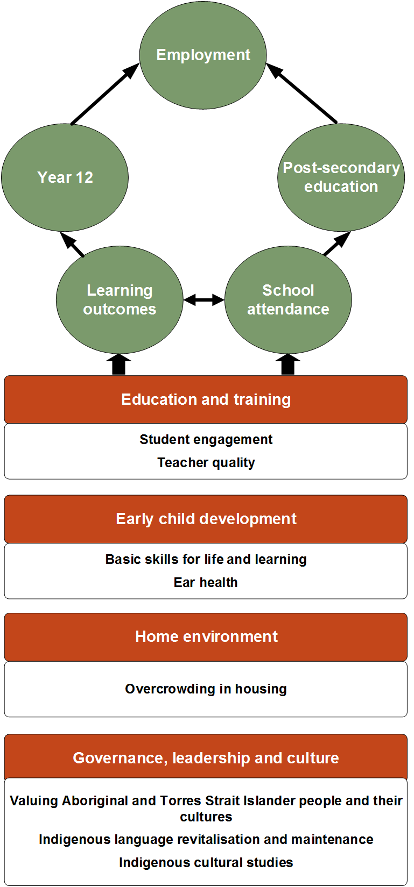

Figure 2.4 Multiple causes — health
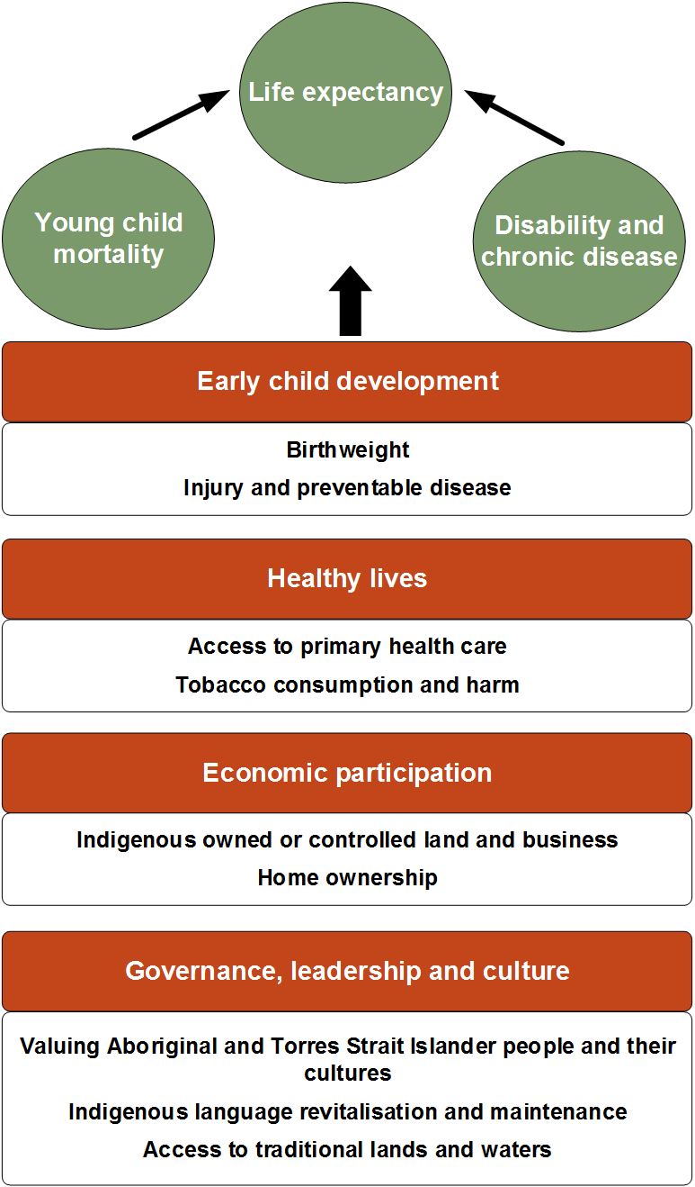

For example, Valuing Aboriginal and Torres Strait Islander people and their cultures (section 5.1) can affect the COAG target of Reading, writing and numeracy (section 4.4) and the headline indicators of Disability and chronic disease (section 4.9) and Family and community violence (section 4.12), as well as outcomes in the ‘Education and training’, ‘Healthy lives’, ‘Home environment’ and ‘Safe and supportive communities’ strategic areas (figure 2.5). Although other influences are also important in each of these areas, there is sufficient evidence throughout this Report to promote concern about the impact on multiple outcomes of not addressing cultural issues.

Figure 2.5 Multiple effects — valuing Aboriginal and Torres Strait Islander people and their cultures
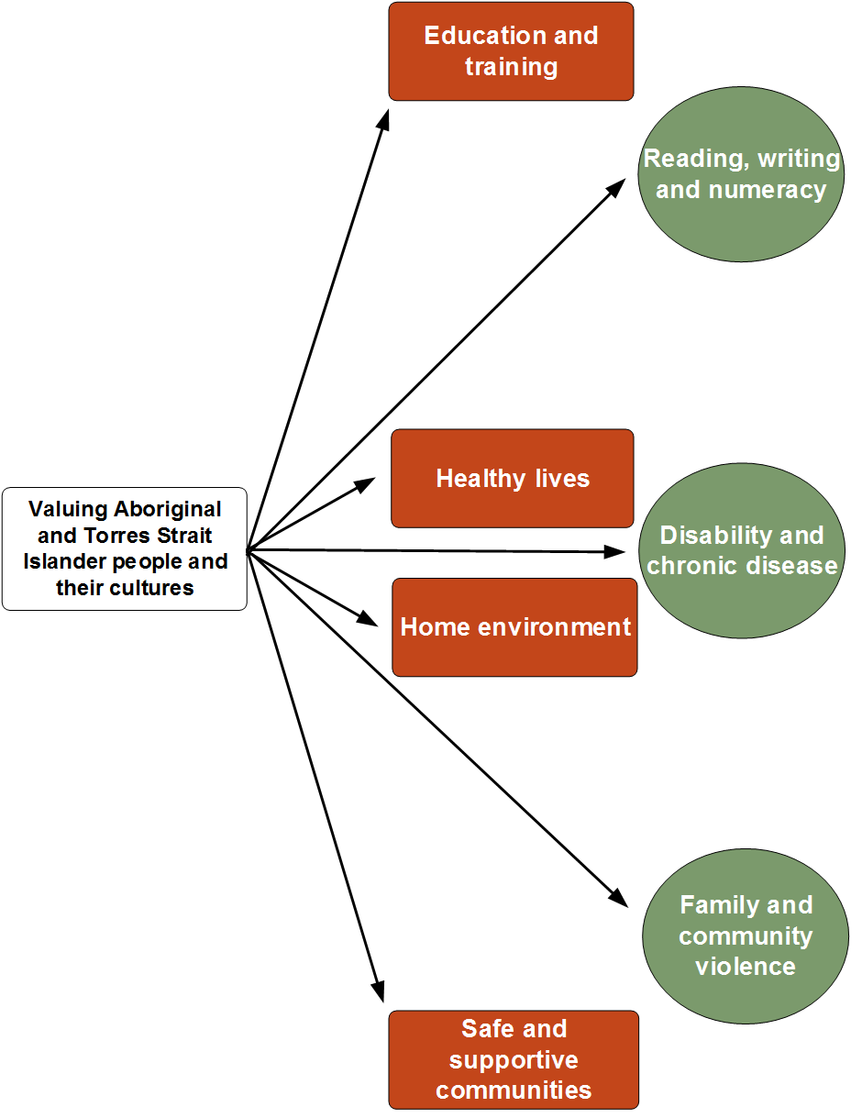

Similarly, actions designed to assist in Indigenous language revitalisation and maintenance (section 5.5) can have impacts on multiple outcomes (figure 2.6). Aboriginal and Torres Strait Islander languages are closely linked to cultures, lands, laws, and ultimately wellbeing; they can contribute to the COAG target of Employment (section 4.7) and the headline indicators of Disability and chronic disease (section 4.9) and Family and community violence (section 4.12), and can also affect outcomes in the ‘Early child development’, ‘Healthy lives’, ‘Economic participation’, and ‘Safe and supportive communities’ strategic areas. Although Indigenous language revitalisation and maintenance (section 5.5) is not the only influence in these areas, there is sufficient evidence to promote concern about cultural issues and their impact on outcomes related to wellbeing.

Figure 2.6 Multiple effects — Indigenous language revitalisation and maintenance
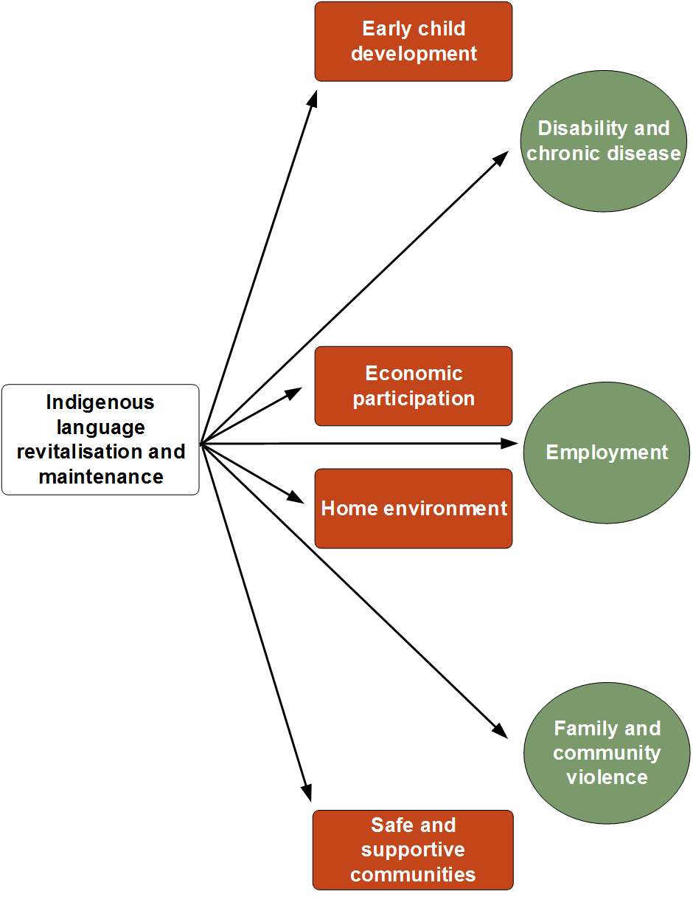

References
COAG 2020, Meeting outcomes, Council of Australian Governments, https://www.coag.gov.au/ meeting-outcomes (accessed 9 October 2020).

See chapter 3 Understanding the outcomes and how they can be improved for more information about personal risk factors, structural barriers and institutional racism experienced by Aboriginal and Torres Strait Islander people.
COAG was disbanded on 29 May 2020 and replaced by a National Federation Reform Council (COAG 2020).

