Overview

Key points
- This report measures the wellbeing of Aboriginal and Torres Strait Islander people. It provides comprehensive data across a range of outcome areas, along with supporting material on the strengths of Aboriginal and Torres Strait Islander people, and the structural and systemic barriers that need to be addressed if outcomes are to further improve.
- In many areas outcomes have improved for Aboriginal and Torres Strait Islander people.
- Mortality rates for children improved between 1998 and 2018, particularly for 0<1 year olds, whose mortality rates more than halved (from 13 to 5 deaths per 1000 live births).
- Education improvements included increases in the proportion of 20–24 year olds completing year 12 or above (from 2008 to 2018-19) and the proportion of 20–64 year olds with or working towards post-school qualifications (almost doubling from 2002 to 2018-19).
- From 2014 to 2018, more people in the general community felt it was important to know about Aboriginal and Torres Strait Islander histories and cultures and more people rated their level of knowledge of both as high.
- But in some areas outcomes have not improved for Aboriginal and Torres Strait Islander people.
- Rates of children in out-of-home care have almost tripled in the past 15 years (60 per 1000 children in 2018-19).
- The proportion of adults reporting high levels of psychological distress increased from 27 per cent in 2004-05 to 31 per cent in 2018-19, and the rate of deaths from suicide and self-harm increased by 40 per cent over the decade to 2018.
- The adult imprisonment rate increased 72 per cent between 2000 and 2019, and whilst the youth detention rate has decreased it is still 22 times the rate for non-Indigenous youth.
- When outcomes have not improved they need to be understood with reference to the personal challenges and systemic and structural barriers that many Aboriginal and Torres Strait Islander people have experienced and continue to face.
- Aboriginal and Torres Strait Islander people have a higher prevalence of the personal risk factors associated with poorer outcomes and are more likely to have multiple risk factors.
- Aboriginal and Torres Strait Islander people are often disproportionally affected by structural barriers due to their particular circumstances or the disadvantage they experience.
- Connection to culture is a key to many Aboriginal and Torres Strait Islander people’s identity and strength. These cultures are a foundation on which wellbeing can continue to be built.
- Common characteristics of approaches that appear to be successful in improving outcomes for Aboriginal and Torres Strait Islander people include:
- Addressing racism and discrimination in the Australian community, through structural changes, and building knowledge and education.
- Enabling Aboriginal and Torres Strait Islander people to share in decision-making on things that affect them.
- Addressing laws, policies, and practices that operate to the detriment of Aboriginal and Torres Strait Islander people.
- Ongoing government investment, collaboration and coordination.
- Ensuring access to effective culturally safe services, at the right time and suited to the local context.

What is the Overcoming Indigenous Disadvantage report?
The Overcoming Indigenous Disadvantage (OID) report measures the wellbeing of Aboriginal and Torres Strait Islander people. It is the eighth report in a series commissioned by all Australian governments, designed to measure progress in improving the wellbeing of Aboriginal and Torres Strait Islander people. It identifies where progress is being made and draws attention to where more action is needed.
The information in the OID report can be used to examine the existing strengths of Aboriginal and Torres Strait Islander people and the nature of disadvantage they experience and can help inform the design of policies. However, the Report is not designed to evaluate specific policies or programs and, except for the COAG targets in the National Indigenous Reform Agreement (which was in effect at the time of preparing this Report), the Report does not include targets. (The National Agreement on Closing the Gap came into effect too late for the associated targets to be included in this edition of the Report).
The OID report has several elements:
- this overview, which summarises the Report’s key messages
- the main Report (available electronically), which provides the evidence base supporting the Report’s framework, and more detailed information on outcomes
- attachment tables (available electronically), which expand on the data used in the Report.
The OID report is produced by the intergovernmental Steering Committee for the Review of Government Service Provision (Steering Committee) (see page iv for a list of members). The Steering Committee is advised by the OID working group (see page v for a list of members).

Understanding the outcomes for Aboriginal and Torres Strait Islander people requires an understanding of our shared history
Before colonisation, Aboriginal and Torres Strait Islander people thrived and their cultures were strong and well developed.
The history of Aboriginal and Torres Strait Islander people since colonisation, and the intergenerational and ongoing effects on Aboriginal and Torres Strait Islander people, need to be acknowledged and understood when considering the outcomes in this Report.
Many readers will be familiar with much of this history, but others will not and are encouraged to become familiar with this history so they are able to better understand this Report. The main Report includes a brief summary of the historical context (chapter 1, section 1.2), and an extensive list of additional sources providing a range of views on how historical policies and events affected, and continue to affect, the lives of Aboriginal and Torres Strait Islander people today.

Understanding the outcomes also requires a knowledge of where Aboriginal and Torres Strait Islander people live and their diversity
Based on the most recent available national Census data, the final estimated resident Aboriginal and Torres Strait Islander population of Australia as at 30 June 2016 was 798 400 people, or 3.3 per cent of the total Australian population.

Aboriginal and Torres Strait Islander people by Indigenous region, 2016a
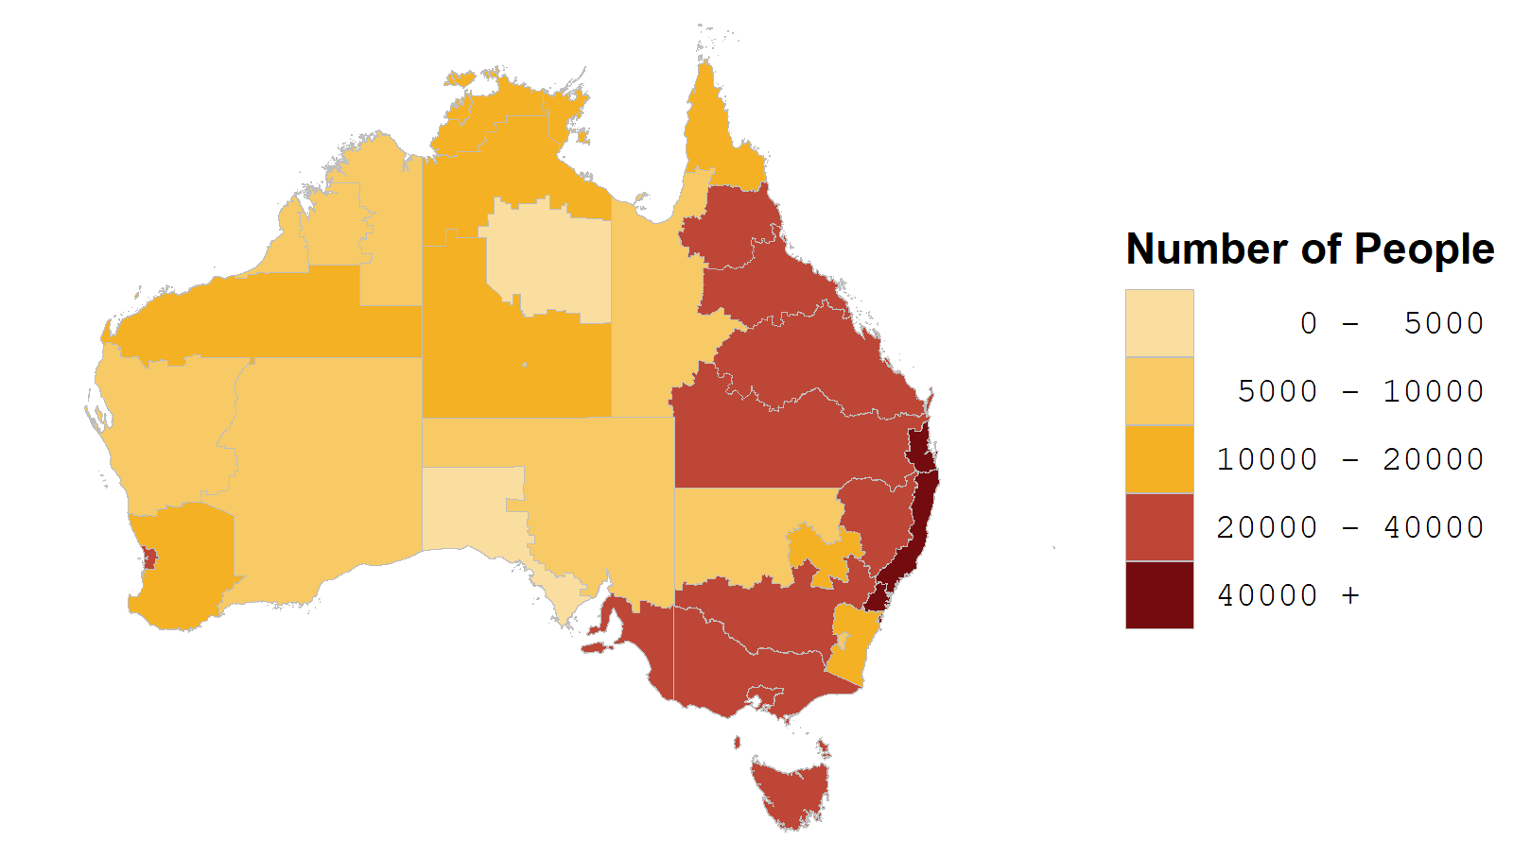
a The estimated resident number of Aboriginal and Torres Strait Islander people in the 37 ABS Indigenous regions as at 30 June 2016. Source(s): Author (year); Author (year, year).
Source: ABS 2019, Estimates and Projections, Aboriginal and Torres Strait Islander Australians, 2006 to 2031, Cat. no. 3238.0, Canberra; ABS 2018, Australian Demographic Statistics, June 2018, Cat. no. 3101.0, Canberra; Appendix A, table A.2.
Three in five Aboriginal and Torres Strait Islander people live in NSW or Queensland. However, the NT has the largest proportion of their population who identify as Aboriginal and Torres Strait Islander.

Aboriginal and Torres Strait Islander people, by State or Territory, 2016
Proportion of Aboriginal and Torres Strait Islander population in each State or Territory | Proportion of population in State or Territory who are Aboriginal and Torres Strait Islander people
Source: ABS 2019, Estimates and Projections, Aboriginal and Torres Strait Islander Australians, 2006 to 2031, Cat. no. 3238.0, Canberra; ABS 2018, Australian Demographic Statistics, June 2018, Cat. no. 3101.0, Canberra; Appendix A, table A.1.
Most Aboriginal and Torres Strait Islander people live in major cities or regional areas. However, they are significantly overrepresented in the population who live in remote and very remote areas (30 per cent in these areas, compared to 3.3 per cent in the total population).

Aboriginal and Torres Strait Islander population, by remoteness area, 2016
Proportion of Aboriginal and Torres Strait Islander people, in each area | Proportion of people in each area who are of Aboriginal and Torres Strait Islander origin
Source: ABS 2019, Estimates and Projections, Aboriginal and Torres Strait Islander Australians, 2006 to 2031, Cat. no. 3238.0, Canberra; ABS 2017, Regional Population Growth, Australia, Population Estimates by Remoteness Area, 2006 to 2016, Cat. no. 3218.0; Appendix A, table A.3.

How have trends in outcomes over time been assessed?
The figure on the next page summarises changes in outcomes over time. The following approach was taken to assessing change over time:
- The key consideration was change over time in outcomes for Aboriginal and Torres Strait Islander people NOT the gap to non-Indigenous people. It is important to acknowledge improvements in outcomes for Aboriginal and Torres Strait Islander people, even if improvements for non-Indigenous people mean that the gap has not narrowed and/or the outcomes for non-Indigenous people are significantly better.
- Change has been assessed by comparing the latest available data to the earliest available data for each indicator in this Report. Therefore, the time period may be different for different indicators.
- If apparent change was not statistically significant this was recorded as no significant change.
- The focus has been on the main measure/s identified for each indicator. Supplementary measures for some indicators may show different trends.
- No trend has been identified where it is not clear whether an observed change in the main measure is positive or negative, or where improvements to data collections have created a break in series.
Results have been summarised into the following five categories:
- progress — where the main measure for an indicator shows outcomes for Aboriginal and Torres Strait Islander people improving over time
- no significant change — where the main measure for an indicator shows no meaningful change in outcomes for Aboriginal and Torres Strait Islander people
- regress — where the main measure for an indicator shows a decline in outcomes for Aboriginal and Torres Strait Islander people
- data gap — where no suitable trend data are available (this does not include indicators where improvements to data collections have created a break in series, which are labelled ‘unclear’)
- unclear — where it is not clear whether an observed change in the main measure is positive or negative, or where improvements to data collections have created a break in series. Results should be considered in the light of the contextual material in the relevant section of the Report.
There are 52 indicators in this Report. However, one indicator (5.4 Case studies in governance) is not designed to include quantitative measures.

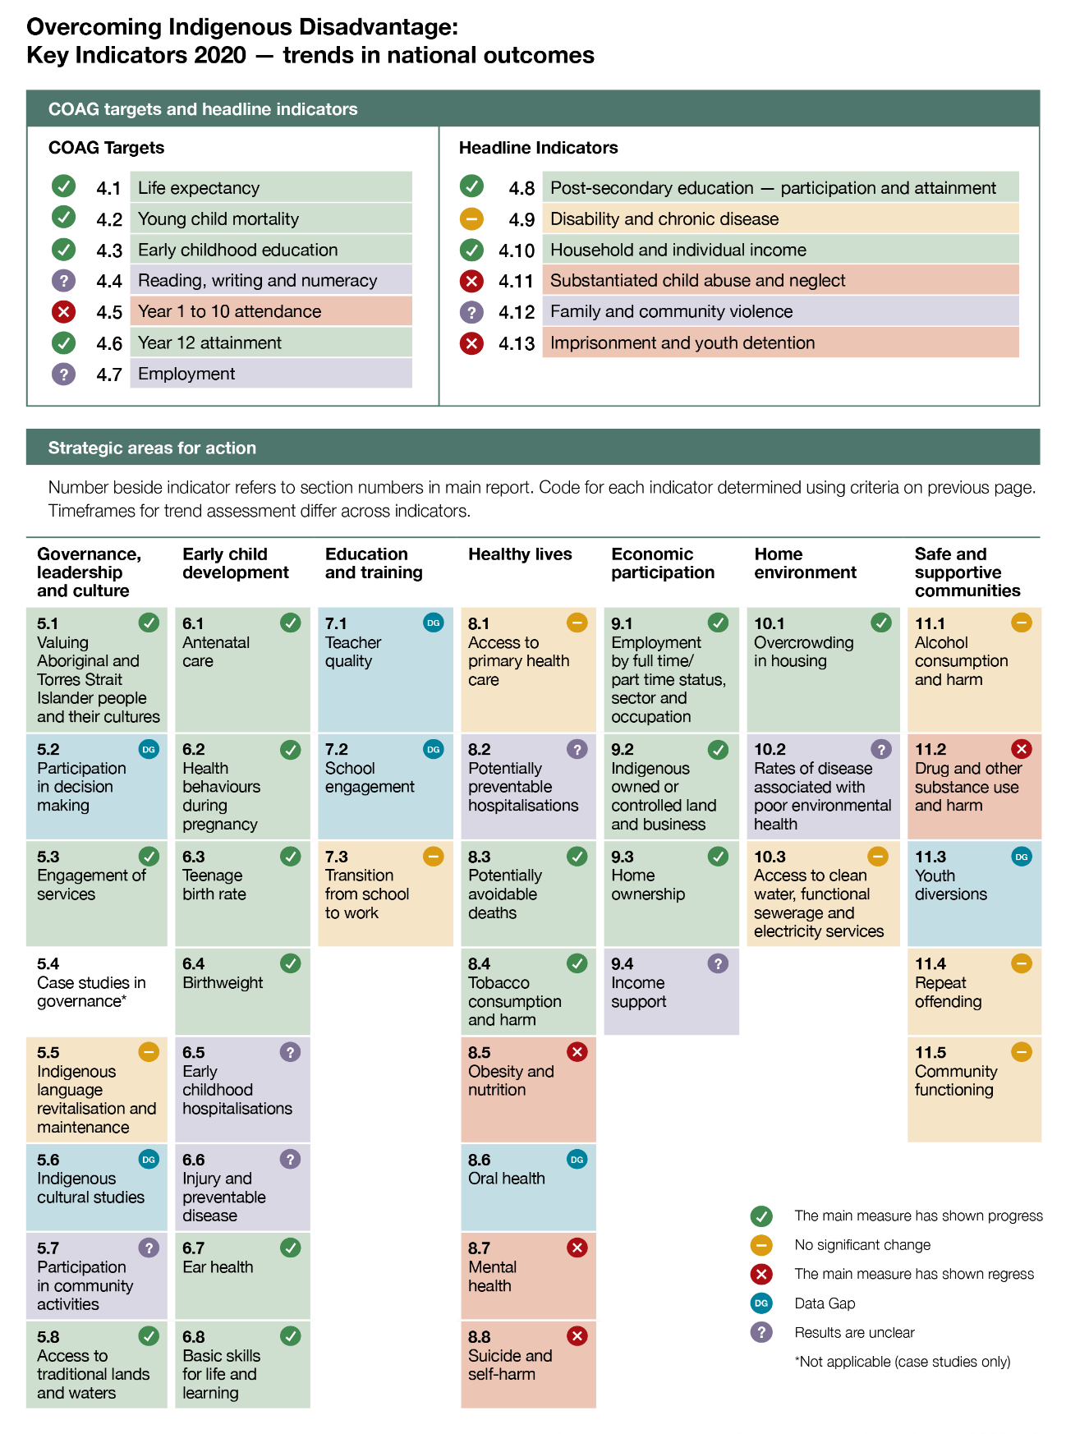

Why is so much of the information reported at the national level?
This report measures outcomes for Aboriginal and Torres Strait Islander people, often at the aggregate (national and State and Territory) level. It is important to have an aggregate picture of outcomes, because Aboriginal and Torres Strait Islander people are over-represented among Australians facing disadvantage, and this disadvantage appears more persistent over time and across generations. The indigenous peoples of countries with similar colonial histories to Australia, such as Canada, the United States of America and New Zealand, also experience high rates of disadvantage. A focus on what is happening at the aggregate level is important, to help ensure the underlying causes of disadvantage are being addressed.
However, the Steering Committee acknowledges that Aboriginal and Torres Strait Islander people, cultures and experiences are diverse and outcomes can vary markedly by readily measured factors such as geography, age, sex, employment and other factors, and other less easily measured factors such as connection to Country. Throughout the Report and in the attachment tables, outcomes are presented by remoteness and other relevant characteristics wherever possible.
The strengths and needs of the Aboriginal and Torres Strait Islander population differ across groups and regions. The relatively small number of Torres Strait Islander people makes reporting difficult, but available data are presented in chapter 12 of the main Report and summarised in this Overview in the section on ‘Outcomes for Torres Strait Islander people’.
Given these limitations, access to reliable data at local levels is needed to ensure good decisions can be made across regions and local communities. Reliable data that are easy to access and understand can empower Aboriginal and Torres Strait Islander people and communities to advocate for the local needs of their communities and assist governments to make more informed decisions and improve its efficiency and accountability. Developing data sets that can be used by regions and local communities to identify local needs and improve decision-making is a key future development for reporting on what contributes to the wellbeing of Aboriginal and Torres Strait Islander people.

The OID indicator framework logic
The Report is based on a framework of indicators that aim to measure the wellbeing of Aboriginal and Torres Strait Islander people (see chapter 2 in the main Report for the details on the complete framework). The framework is based on evidence about the underlying causes of disadvantage, and the positive factors that contribute to wellbeing.
At the top of the framework, three closely linked priority outcomes reflect the vision for Aboriginal and Torres Strait Islander people to have the same life opportunities as other Australians.
It is difficult to measure progress against such broadly stated outcomes. So, the framework includes two layers of measurable indicators.
- The first layer of indicators is made up of the seven Closing the Gap targets (in the National Indigenous Reform Agreement agreed by COAG, which was in effect at the time of preparing this Report), and six headline indicators developed by the Steering Committee. These indicators measure important high-level outcomes, which typically require coordinated, long-term action to achieve significant progress.
- The second layer of indicators measure shorter-term outcomes in seven strategic areas. Evidence shows that targeted action in these areas is needed in order to achieve the COAG targets and headline indicators.
The logic behind the framework is that, over time, improvements in the strategic change indicators will lead to changes in the COAG targets and headline indicators, demonstrating progress toward the priority outcomes.
As illustrated in the diagrams below, coordinated action across strategic areas is usually required to achieve better outcomes. Conversely, sometimes a single, well-targeted action can lead to improvements across many strategic areas.

Wellbeing is supported by multiple actions…
The COAG targets of ‘Life expectancy’ and ‘Young child mortality’ are clearly linked, and closely related to the ‘Disability and chronic disease’ headline indicator. In turn, these outcomes are influenced by outcomes in the ‘Early child development’ and ‘Healthy lives’ strategic areas for action. But actions in these areas must be supported by actions to address outcomes in the ‘Economic participation’ and ‘Governance, leadership and culture’ strategic areas. Other social determinants of health in the education and employment areas must also be addressed.
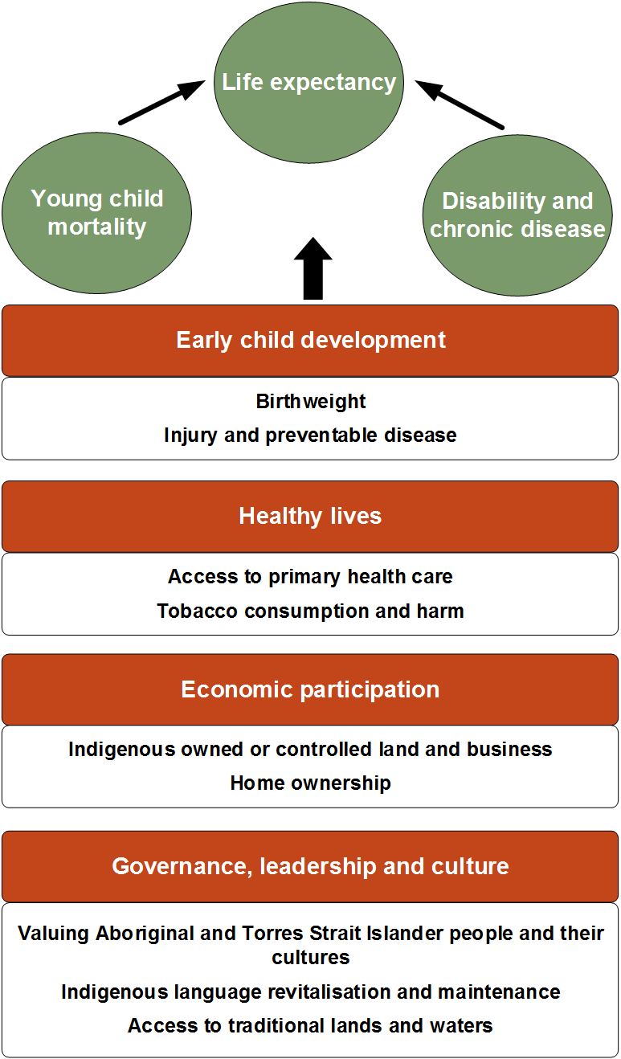

…and a single, well targeted action can have multiple effects
‘Valuing Aboriginal and Torres Strait Islander people and their cultures’ can affect the COAG target of ‘Reading, writing and numeracy’, and headline indicators of ‘Disability and chronic disease’ and ‘Family and community violence’ as well as outcomes in the ‘Education and training’, ‘Healthy lives’, ‘Home environment’ and ‘Safe and supportive communities’ strategic areas. Although other influences are also important in each of these areas, there is sufficient evidence throughout this Report to be concerned about the negative impact of not addressing cultural matters on multiple outcomes.
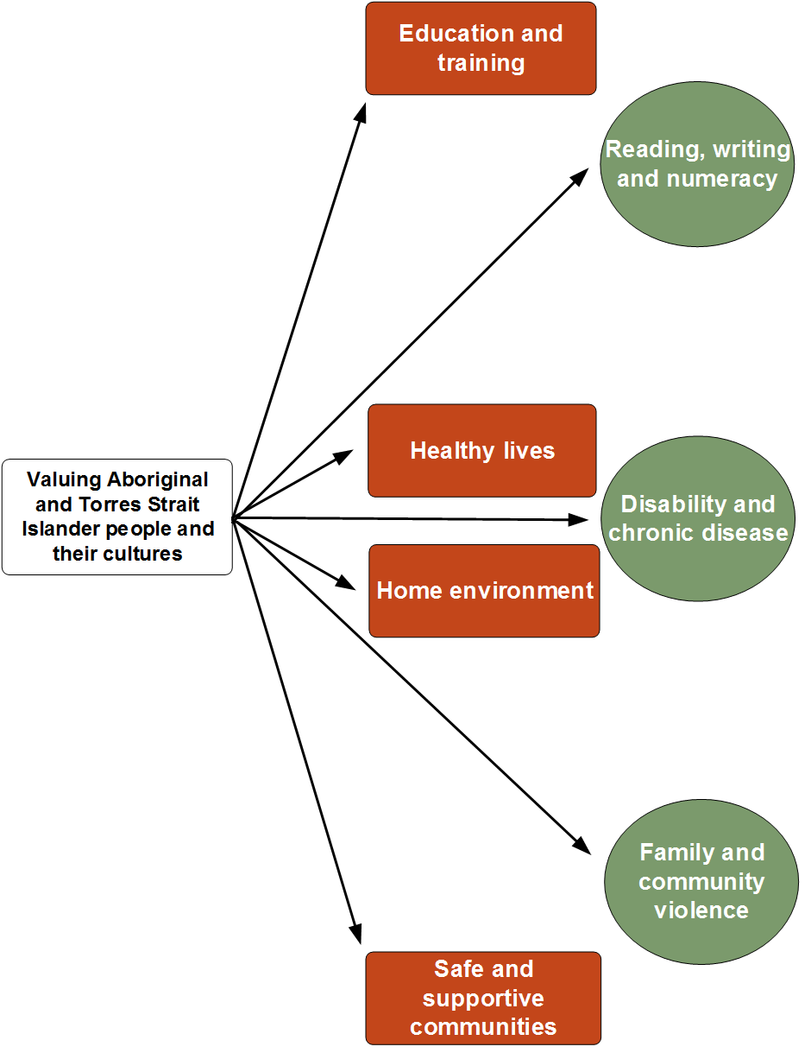

In addition to reporting on the framework, this edition identifies approaches that may help to improve outcomes
In addition to reporting on the outcomes experienced by Aboriginal and Torres Strait Islander people, this edition of the Report seeks to:
- identify the significant strengths of, and sources of wellbeing for, Aboriginal and Torres Strait Islander people
- focus on the key structural and systemic barriers that contribute to these outcomes
- identify approaches that the research tells us might help improve these outcomes.
This material supports the existing quantitative reporting for the OID indicator framework.
A significant source of strength and the foundation for the wellbeing of Aboriginal and Torres Strait Islander people are their cultures. Connection to culture is a key element of many Aboriginal and Torres Strait Islander people’s identity. While cultures are diverse, some of the strengths provided by the cultures of Aboriginal and Torres Strait Islander people include:
- strong connections with family and kin, and the belief that it is the responsibility of family to provide care and support for each other
- respect for the leadership of Elders, their role in decision-making and the value of spending time with them
- connection with, and caring for, Country, which is considered as caring for oneself and one’s community, and is also associated with the management of land and waters.
In contrast, a range of structural barriers and racism can undermine or erode Aboriginal and Torres Strait Islander people’s wellbeing, for example:
- policies, laws and practices that appear neutral, but operate in an uneven or unfair manner that is detrimental to Aboriginal and Torres Strait Islander people because of their particular circumstances, for example in the areas of:
- criminal justice, where laws that declare people with cognitive impairments unfit to plead, and bail laws that favour those with secure accommodation, have a greater negative impact on Aboriginal and Torres Strait Islander people
- child protection, where factors related to decision-making processes compounded by difficulties in getting the support needed to navigate the system, may mean that Aboriginal and Torres Strait Islander children are more vulnerable to entering the child protection system
- many Aboriginal and Torres Strait Islander people experience discrimination and racism, including institutional racism, that can cause both immediate and long-term harm.
Common characteristics of approaches that appear to be successful in improving outcomes for Aboriginal and Torres Strait Islander people include:
- addressing racism and discrimination in the Australian community, through structural changes, and building knowledge and providing education
- enabling Aboriginal and Torres Strait Islander people to share in decision-making about things that affect them
- addressing laws, policies, and practices that operate to the detriment of Aboriginal and Torres Strait Islander people
- ongoing government investment, collaboration and coordination
- ensuring access to effective culturally safe services, at the right time and suited to the local context.
Since the 2005 edition, case studies on ‘Things that work’ have been included in the Report which highlight programs or services that are making a difference. For this edition, the case studies are focussed on governance, with a specific focus on arrangements that support shared decision-making between Aboriginal and Torres Strait Islander people and governments (see section 5.4 of the main Report). This focus on shared decision-making recognises that it is a critical component underpinning improved outcomes for Aboriginal and Torres Strait Islander people.

COAG targets and headline indicators
The seven COAG targets and six headline indicators are high level social and economic outcomes that must improve in order to achieve the priority outcomes. Numbers beside each indicator refer to section numbers in the main Report.
COAG targets are covered in sections 4.1 to 4.7. Headlines indicators are covered in sections 4.8 to 4.13.
These indicators are often closely inter-related and positive change will generally require action across a range of areas. In addition, most of these high-level indicators are likely to take some time to improve, even if effective policies are implemented.

4.1 Life expectancy
Life expectancy is a widely used measure of population health measuring the length but not the quality of life. It is a limited measure for Aboriginal and Torres Strait Islander people whose understanding of health is holistic; to be healthy is to be well physically, spiritually and emotionally and connected with family, community, culture, language, and Country. |  | Aboriginal and Torres Strait Islander boys born in 2015–2017 are expected to live to 71.6 years and girls to 75.6 years. This is 4.1 years longer than for boys and 2.5 years longer for girls born 10 years earlier (20052007), but changes were not statistically significant for girls.

4.2 Young child mortality
Young child mortality (particularly infant mortality) is a long-established indicator of child health and the physical and social environment.  The vast majority of babies of Aboriginal and Torres Strait Islander mothers (about 97 per cent) are born healthy. |  | From 1998 to 2018, there was a significant decline in mortality rates for Aboriginal and Torres Strait Islander children aged 0–4 years (from 217 to 141 deaths per 100 000 population), with the greatest decrease in the infant (0–<1 year) mortality rate (from 13 to 5 deaths per 1000 live births).
Aboriginal and Torres Strait Islander young child mortality rates, 1998 to 2018a,b
a Small numbers of Aboriginal and Torres Strait Islander infant (0<1 year old) deaths contribute to variability in the reported rates. b Totals here include NSW, Queensland, WA, SA and the NT. These five jurisdictions have sufficient levels of Aboriginal and Torres Strait Islander identification and numbers of deaths for reporting purposes.
Source: Figure 4.2.2 in the main Report.

4.3 Early childhood education
Participating in early childhood education (through a preschool program) is important for all children to further build their cognitive and non-cognitive skills, which also assists in preparing them for the formal school system. |  | In 2019, for Aboriginal and Torres Strait Islander children in the year before full time schooling:  - 92 per cent were enrolled in preschool, an increase since 2016  - 94 per cent were attending preschool, similar to 2016.
Children enrolled in a preschool program in the year before full time schooling, by Indigenous status
Source: Figure 4.3.1 in the main Report.

4.4 Reading, writing and numeracy
Developing a strong grounding in reading, writing and numeracy is a key part of a quality education and important for all children. | ? | Comparing 2008 and 2019, the proportion of Aboriginal and Torres Strait Islander students achieving national minimum standards increased for Years 3 and 5 for reading, and for Years 5 and 9 for numeracy. However, volatility in the data means conclusions drawn from comparisons should not be interpreted as consistent improvement over time.
Results for this indicator have fluctuated over time with no clear trend.

4.5 Year 1 to 10 attendance
Regular attendance at school is an important precursor for all students’ academic achievement, although the relationship between the two is complex and influenced by a variety of factors. |  | In 2019, the overall attendance rate for Aboriginal and Torres Strait Islander students was 82 per cent, a decrease from 84 per cent in 2014.  The attendance rate for non-Indigenous students was 92 per cent in 2019.

4.6 Year 12 attainment
Students who complete year 12 or equivalent are more likely to go on to further education and training, have better employment options, and have improved economic, social and emotional wellbeing. |  | The proportion of Aboriginal and Torres Strait Islander 20–24 year olds completing year 12 or equivalent or above increased from 45 per cent in 2008 to 66 per cent in 2018-19. For non-Indigenous people, the proportion remained relatively unchanged (90 per cent in 2017-18).
4.7 Employment
Aboriginal and Torres Strait Islander people contribute to the economy and community through employment in both general occupations and occupations that benefit from their unique skills and culture. Their employment choices are partly driven by a desire to support their family and community, which is a key part of their cultural identity, and this can influence their occupational choices and how they engage in paid employment. | ? | The employment rate for Aboriginal and Torres Strait Islander 15–64 year olds increased from 38 per cent in 1994 to 54 per cent in 2008, before decreasing to 49 per cent in 2018-19 (similar to 2012-13), partly driven by changes to the CDEP program.
Data for this indicator are difficult to interpret due to a number of changes including to the Community Development Employment Projects (CDEP) program, now the Community Development Program (CDP).
Employment outcomes for Aboriginal and Torres Strait Islander people, 1994 to 2018-19a
a Error bars represent 95 per cent confidence intervals around each estimate.
Source: Figure 4.7.1 in the main Report.

4.8 Post-secondary education — participation and attainment
People with a skilled vocational or higher education qualification are more likely to be employed than those without. Other potential benefits include a positive influence on health and social wellbeing.  Increasingly, job opportunities in Australia require higher level qualifications, with Certificate III level now considered an entry-level qualification in many industries. |  | The proportion of Aboriginal and Torres Strait Islander 20–64 year olds with a Certificate level III or above or studying increased from 26 per cent in 2002 to 50 per cent in 2018-19.  The gap between Aboriginal and Torres Strait Islander people and non-Indigenous people remained steady over the period at about 25 percentage points.

4.9 Disability and chronic disease
Living with disability means that a person is born with, or acquires, an impairment that limits everyday activities or restricts their participation in school or work, without assistance. | _ | In 2015, the rate of disability among Aboriginal and Torres Strait Islander people was 24 per cent, little changed from 21 per cent in 2009.  Chronic diseases can result in disability, and vice versa.

4.10 Household and individual income
For the general population higher income is correlated with improved wellbeing, but the relationship is not straightforward for Aboriginal and Torres Strait Islander people. For example, higher income at the expense of the degradation of Country or not undertaking cultural obligations may decrease wellbeing. |  | The median equivalised gross weekly household (EGWH) income for Aboriginal and Torres Strait Islander people was $553 in 2018-19.  Due to changes in data collection methodologies we cannot compare 2018-19 EGWH income with historical data. However, between 2002 and 2014-15 Aboriginal and Torres Strait Islander people’s real EGWH increased by about 30 per cent.

4.11 Substantiated child abuse and neglect
Acting early to prevent childhood abuse and neglect is important to reduce the likelihood of this leading to numerous issues with health and wellbeing into adulthood.  A significant issue in reporting on child abuse and neglect is the absence of data on prevalence in the community, with data only available once a child comes in contact with child protection services. At this point, differences in representation in the system are unclear (greater exposure to risk factors and/or the structural factors that increase the likelihood of entry to the system). |  | Child protection substantiations for Aboriginal and Torres Strait Islander children increased from 28 per 1000 children in 2009-10 to 42 per 1000 children in 2016-17, before decreasing to 38 per 1000 children in 2018-19.  The rate of Aboriginal and Torres Strait Islander children in out-of-home care increased from 21 to 60 per 1000 children over the 14 years to 2018-19, while the proportion placed in accordance with the Aboriginal Child Placement Principle decreased.
Children aged 0–17 years who were in out-of-home care at 30 June, by Indigenous status
Source: Figure 4.11.3 in the main Report.

4.12 Family and community violence
Although most Australian families are strong and healthy, some are at risk of family and community violence, and the impact can be far reaching. In an Aboriginal and Torres Strait Islander context, the term recognises the broader impacts of violence on extended families, kinship networks and community relationships. | ? | In 2018-19, about 16 per cent of Aboriginal and Torres Strait people aged 15 years or over reported being a victim of physical or threatened harm in the past 12 months.  This proportion is about three times the rate for the total population aged 15 years or over.
The 2018-19 collection was the first time these data were collected as part of the ABS National Aboriginal and Torres Strait Islander Health Survey and are not comparable to data collected in ABS National Aboriginal and Torres Strait Islander Social Surveys.

4.13 Imprisonment and youth detention
Incarceration has serious and long-term effects on people, affecting the health, wellbeing and economic livelihoods of prisoners/detainees and their families. |  | From 2000 to 2019, the imprisonment rate for Aboriginal and Torres Strait Islander adults increased 72 per cent.  The daily average detention rate for Aboriginal and Torres Strait Islander youth decreased from 2007-08 to 2018-19 (from 409 to 336 per 100 000 10–17 year olds), but remains about 22 times the rate for non-Indigenous youth.

Strategic areas for action
The following sections summarise the key messages for each strategic area for action. Much more information can be found in the main Report. The strategic areas deliberately do not mirror typical government service areas. In some cases (such as healthy lives, or education and training), a specific service area can be expected to play a major role but, in all strategic areas, more than one government agency is relevant to achieving better outcomes. Conversely, sometimes a single, well-targeted action by one agency can lead to improvements across many strategic areas.

Governance, leadership and culture
Effective governance and leadership, and recognition of cultures, are essential to the wellbeing of Aboriginal and Torres Strait Islander people. These influence most indicators in the framework that underpin this Report. Governance refers to the way the members of a group or community organise themselves to make decisions that affect themselves and others. Central to the development of strong governance is leadership, and there are specific cultural aspects to Aboriginal and Torres Strait Islander leadership. Cultures include the diverse Aboriginal and Torres Strait Islander nations and peoples, each with distinct cultural norms, laws, languages and identities that are dynamic in nature.

5.1 Valuing Aboriginal and Torres Strait Islander people and their cultures
Building mutual respect and a stronger relationship between Aboriginal and Torres Strait Islander people and other Australians is important for improving the wellbeing of Aboriginal and Torres Strait Islander people. |  | In 2018, more than 8 in 10 people in the general community felt it was important for all Australians to know about Aboriginal and Torres Strait Islander cultures and histories and about two in five rated their level of knowledge of Aboriginal and Torres Strait Islander cultures and histories as high — increases from 2014.  Over this period the proportions of people perceiving levels of trust as high have remained relatively unchanged.
Perceptions of knowledge of Aboriginal and Torres Strait Islander histories and cultures, general community
Source: Figure 5.1.1 in the main Report.

5.2 Participation in decision-making
Participation in decision-making is a key element of self-determination, which in turn is a critical part of governance. Participation includes both wanting to participate, and feeling that one can. | Data gap | Available data on the participation of Aboriginal and Torres Strait Islander people show they remain underrepresented in the Parliament of Australia and in all State and Territory parliaments. As of May 2020, parity across all nine jurisdictions would be achieved with 15 additional Aboriginal and Torres Strait Islander parliamentarians.
There are no data available on Aboriginal and Torres Strait Islander people wanting to, and feeling that they can, participate in decision-making that is important to them.

5.3 Engagement of services
Positive engagement of services is critical to improve outcomes for Aboriginal and Torres Strait Islander people. Engagement covers both access to services and the culturally appropriate delivery of services. |  | The proportion of Aboriginal and Torres Strait Islander people aged 15 years or over who reported problems accessing services in the previous 12 months decreased from 30 per cent in 2008 to 24 per cent in 2014-15. Difficulty with access was higher in remote areas compared to non-remote areas (33 per cent compared to 22 per cent).

5.4 Case studies in governance
Good governance contributes to the success of organisations and of government engagement with Aboriginal and Torres Strait Islander people.  To improve wellbeing for Aboriginal and Torres Strait Islander people, governance arrangements:  - must be effective in both Aboriginal and Torres Strait Islander organisations and governments  - should empower Aboriginal and Torres Strait Islander people to achieve the things that matter to them. |  | Governance arrangements that empower Aboriginal and Torres Strait Islander people to achieve the things that matter to them, ensure they are able to participate in shared decision-making alongside governments. Case studies in this section highlight that this works best when structures, rules and laws:  - provide Aboriginal and Torres Strait Islander people with decision-making authority  - promote Aboriginal and Torres Strait Islander cultural frameworks, processes, context and time frames  - recognise power inequalities, and share power, through mechanisms that are transparent  - ensure Aboriginal and Torres Strait Islander people can choose their representatives, and these representatives have the resources and support that they need  - define desired outcomes, the steps to achieving them and the roles and responsibilities of participants, along with their mutual accountabilities.
There is no trend category for this indicator, which is based on qualitative case studies.
Case studies included in this Report that focus on shared decision-making between Aboriginal and Torres Strait Islander people/groups and governments are listed below.
- Aboriginal Children’s Forum (section 4.11)
- Anindilyakwa Housing Aboriginal Corporation (section 10.1)
- Approaches to land and sea governance (Aboriginal Land Council of Tasmania, Queensland Indigenous Land and Sea Ranger Program and the Aboriginal Lands Trust WA) (section 9.2)
- Buthera Agreement between the Narungga Nation and the SA Government (section 5.4)
- Dampier Peninsula Project (section 9.2)
- Empowered Communities (section 5.4)
- Local decision-making model in NSW (section 5.4)
- Partnership Agreement on Closing the Gap (section 5.4)
- Western Australian Aboriginal Advisory Council and advisory groups (section 5.2).

5.5 Indigenous language revitalisation and maintenance
Languages transmit cultural practices and beliefs, and strengthen a sense of identity and belonging. Aboriginal and Torres Strait Islander languages are closely linked to culture and ultimately wellbeing. | _ | In 2014-15, similar to 2008, for Aboriginal and Torres Strait Islander people aged 3 years or over:  - 11 per cent were learning an Indigenous language, with the proportion highest for the youngest age group (19 per cent for  3–14 year olds)  - 16 per cent spoke an Indigenous language, with the proportion highest in remote areas (50 per cent).

5.6 Indigenous cultural studies
Indigenous cultural studies at school, incorporating Indigenous cultural perspectives, may enhance identity and self-esteem for Aboriginal and Torres Strait Islander students, and can help to promote a greater understanding of, and respect for, Aboriginal and Torres Strait Islander people and their cultures. | Data gap | In 2014-15, consistent with 2008, about 70 per cent of Aboriginal and Torres Strait Islander 5–14 year olds reported being taught about Indigenous cultures at school. (No data are available for non-Indigenous people.)
There is no main measure for this indicator. Data are reported on supplementary measures for students taught about Indigenous cultures as part of their studies and the proportion of Aboriginal and Torres Strait Islander school staff.

5.7 Participation in community activities
Involvement in community activities can lead to improvements in people’s long-term health and physical and mental wellbeing, as well as improved social cohesion in communities. | ? | Between 2002 and 2014-15, the proportion of Aboriginal and Torres Strait Islander people aged 15 years or over attending cultural events in the past 12 months decreased (from 68 to 63 per cent), while the proportion participating in sport and recreational activities increased (from 49 to 59 per cent).
Results for this indicator are unclear as one measure (participation in sport and recreational activities) has shown progress while the other measure (participation in cultural events) has declined.

5.8 Access to traditional lands and waters
Aboriginal and Torres Strait Islander people report that they derive physical, spiritual, emotional and cultural benefits from their connection to Country. Access to traditional lands and waters gives an indication of Aboriginal and Torres Strait Islander people’s connection to Country. |  | In 2018-19, the proportion of Aboriginal and Torres Strait Islander adults that recognised traditional lands was 74 per cent. Recognition was higher in remote areas (90 per cent) compared to non-remote areas (71 per cent).  For Aboriginal and Torres Strait Islander people aged 15 years and over the proportion increased from 2002 (70 per cent) to 2012-13 (74 per cent), where it remained in 2014-15 (data were not available for people aged less than 18 years for 2018-19).
Aboriginal and Torres Strait Islander adults who identified with a clan, tribal or language group, recognised or lived on their traditional lands, by remoteness, 2018-19a
a Error bars represent 95 per cent confidence intervals around each proportion.
Source: Figure 5.8.1 in the main Report.

Early child development
A good start can help children to thrive and lead happy and healthy lives into adulthood. Addressing challenges in early childhood, including before children are born, can reduce the development of problems that would prevent them achieving their full potential. The indicators in this strategic area focus on the early drivers of long-term wellbeing which contribute to overcoming disadvantage.

6.1 Antenatal care
Antenatal care provides expectant mothers with information and screening, prevention and treatment to maximise their health throughout pregnancy, and the health of their babies. |  | The proportion of Aboriginal and Torres Strait Islander women who gave birth and attended at least one antenatal visit in the first trimester of pregnancy, increased from 50 per cent in 2011 to 66 per cent in 2018.

6.2 Health behaviours during pregnancy
The health behaviours of women during pregnancy can be important for the health and wellbeing of women and their children. |  | The proportion of Aboriginal and Torres Strait Islander mothers who smoked during pregnancy decreased from 52 per cent in 2009 to 44 per cent in 2018.

6.3 Teenage birth rate
For some young women, teenage motherhood can be a positive experience. But giving birth as a teenager can pose health risks for both the mother and the baby, and is also associated with socioeconomic disadvantage at the birth of the child which can be lifelong for the mother. |  | The Aboriginal and Torres Strait Islander teenage birth rate is at its lowest level since reporting began in 2004, with a rate of 48 births per 1000 women aged  15–19 years in 2018. The non-Indigenous teenage birth rate is also at its lowest level over this period, with a rate of 7 births per 1000 women of this age in 2018.
Birth rate for Aboriginal and Torres Strait Islander teenage mothers, by age of mother, 2004, 2009 and 2018
Source: Figure 6.3.1 in the main Report.

6.4 Birthweight
Children with a low birthweight have a greater risk of poor health or death at birth, and face a continued risk to their healthy development. |  | Nationally, the proportion of Aboriginal and Torres Strait Islander mothers who had low birthweight babies decreased from 11 per cent in 2007 to 10 per cent in 2018.

6.5 Early childhood hospitalisations
Hospitalisation data provide a broad indicator of the scale of significant health issues. However, a high rate of hospitalisation may also indicate lower access and use of primary health care, as many hospital admissions could be prevented if more effective non-hospital care were available and used. | ? | Nationally in 2018-19, there were about 3 hospitalisations for every 10 Aboriginal and Torres Strait Islander 0–4 year olds. This rate has increased by almost 40 per cent over the past decade.
Results for this indicator are difficult to interpret, as an increase in hospitalisations may indicate improved access to services rather than an increase in prevalence of underlying conditions. It is important to consider the leading causes, duration and frequency of children’s hospitalisations.

6.6 Injury and preventable disease
Many hospital admissions can be prevented if effective non-hospital care is available and appropriate for use. | ? | Between 2010-11 and 2018-19, potentially preventable hospitalisation rates increased 25 per cent for Aboriginal and Torres Strait Islander  0–4 year olds.  From 2009–2013 to 2014–2018 (for NSW, Queensland, WA, SA and the NT combined), the potentially avoidable death rate did not change substantially.
An increase in hospitalisations may indicate improved access to services rather than an increase in injuries and preventable diseases. This combined with no change in the death rate make the results difficult to interpret.

6.7 Ear health
Good hearing is important for a child’s social, emotional, and cognitive development. Poor hearing can impede a child’s development of language and communication skills, cognitive development and subsequent school performance. |  | The proportion of Aboriginal and Torres Strait Islander 0–14 year olds with a self-reported hearing condition decreased from 11 per cent in 2001 to 7 per cent in 2018-19. The rate for non-Indigenous children in 2017-18 was 3 per cent.  In 2018-19, the hospitalisation rate for Aboriginal and Torres Strait Islander  0–14 year olds for ear and hearing problems was 9 per 1000 population, compared to 6 per 1000 population for non-Indigenous children.

6.8 Basic skills for life and learning
Young children who are well nurtured develop the skills that are important for their successful transition to school and for their later academic achievement, mental health and wellbeing. |  | From 2009 to 2018, the proportions of Aboriginal and Torres Strait Islander children classified as developmentally ‘on track’ increased in each domain of the Australian Early Development Census (from between 47–60 to  60–65 per cent). These proportions remain lower than those for non-Indigenous children (between  77–86 per cent) but the gap has narrowed in each domain since 2009.

Education and training
Education is a life-long activity, beginning with learning and development in the home and in communities and continuing through to more formal settings of school education, vocational education and training and higher education. Education and training can help strengthen communities and regions both economically and socially, and there are strong links between higher levels of education and improved health outcomes.

7.1 Teacher quality
Teacher quality is considered the most important ‘in school’ influence on student educational outcomes.  Increasing the number of Aboriginal and Torres Strait Islander teachers could help foster student engagement and improve educational outcomes for Aboriginal and Torres Strait Islander students. | Data gap | There is currently no nationally-agreed measure of teacher quality.  The More Aboriginal and Torres Strait Islander Teachers Initiative (MATSITI) found that there were 3100 Aboriginal and Torres Strait Islander school teachers nationally in 2015, a net increase of 439 teachers from 2012. Of these teachers, 83 per cent were classroom teachers, 7 per cent were deputy principals and 3 per cent were principals.
There is currently no nationally-agreed measure of teacher quality.

7.2 School engagement
School engagement is more than just attendance.  Research suggests that school engagement is made up of three main elements: behavioural, emotional and cognitive engagement. | Data gap | Aspects measured in this Report include attendance (aspect of behavioural engagement) in section 4.5 and sense of belonging (aspect of emotional engagement). Data show that Aboriginal and Torres Strait Islander students’ and non-Indigenous students’ sense of belonging at school has been decreasing since 2003.
There is currently no nationally-agreed definition of school engagement and hence no agreed measure.

7.3 Transition from school to work
The successful transition of young people from school to further education, training and employment is important for establishing and maintaining social connections, and for their economic prospects and health and wellbeing. | _ | The proportion of Aboriginal and Torres Strait Islander 17–24 year olds participating in post-school education, training or employment was 36 per cent in 2018-19, similar to 2002.
Proportion of people aged 17–24 years who are fully engaged in post-school education, training or employment, 2002 to 2017–19a
a Error bars represent 95 per cent confidence intervals around each proportion.
Source: Figure 7.3.1 in the main Report.

Healthy lives
Aboriginal and Torres Strait Islander people’s understanding of health is holistic and encompasses physical, mental, cultural and spiritual health. Good health and wellbeing depends on the network of individuals, family, kin, and community, and it recognises an individual’s connection to land (which is central to wellbeing), culture, spirituality and ancestors. If the harmony of these interrelations is disrupted, it can lead to Aboriginal and Torres Strait Islander people’s ill health.
Health outcomes directly affect the quality and length of people’s lives, including their ability to socialise with family and friends, to participate in the community and to work and earn an income. Physical health outcomes reflect such things as a healthy living environment and access to and use of health and community services. Mental health outcomes are related to a complex range of medical issues, historical and lifestyle factors, and the stressors associated with entrenched disadvantage and drug and substance misuse.

8.1 Access to primary health care
Primary health care is generally the first contact a person has with Australia’s health system.  Access to services is a complex concept, involving sufficient supply of services and the ability and willingness to use them (which may be influenced by affordability, location and the cultural safety of the service). | _ | The proportion of Aboriginal and Torres Strait Islander people 15 years or over reporting their health as excellent or very good in 2018-19 (45 per cent) is largely unchanged from 2002 (44 per cent) following a decrease in 2012-13 (39 per cent).  The proportion of Aboriginal and Torres Strait Islander adults in 2018-19 reporting not seeing a doctor in the previous 12 months when needed (19 per cent) is largely unchanged from 2012-13.

8.2 Potentially preventable hospitalisations
Potentially preventable hospitalisations are an indirect measure of adequate primary health care. In many cases, hospital admissions can be prevented if more effective non-hospital care is available, either at an earlier stage in disease progression or as an alternative to hospital care. | ? | For Aboriginal and Torres Strait Islander people, hospitalisation rates for potentially preventable chronic, acute and vaccine-preventable conditions have increased over time.
Results for this indicator are difficult to interpret. These hospitalisations are a proxy measure as increasing hospitalisations for potentially preventable conditions may represent a lack of access to primary care but could also reflect better access to hospital services.

8.3 Potentially avoidable deaths
Reducing potentially avoidable deaths is a key contributor to increasing life expectancy. |  | Between 1998 and 2018 (for NSW, Queensland, WA, SA and the NT), mortality rates for Aboriginal and Torres Strait Islander people from potentially avoidable deaths declined by 40 per cent.
Avoidable mortality for Aboriginal and Torres Strait Islander people, NSW, Queensland, WA, SA, and the NT combined, by sex, 1998 to 2018 (age-standardised)
Source: Figure 8.3.1 in the main Report.

8.4 Tobacco consumption and harm
Despite considerable progress in reducing smoking rates, tobacco consumption remains the biggest contributor to the burden of preventable ill health and death for Australian adults. |  | Between 2001 and 2018-19, the proportion of Aboriginal and Torres Strait Islander adults who were current daily smokers decreased from 51 per cent to 40 per cent.  Smoking rates have also decreased for non-Indigenous adults at a similar rate, but from a lower base.

8.5 Obesity and nutrition
A healthy weight reduces the risk of heart disease, some cancers and other health conditions, whereas obesity leads to poor health and reduces average life expectancy. |  | The proportion of Aboriginal and Torres Strait Islander adults who were overweight or obese increased from 69 per cent in 2012-13 to 74 per cent in 2018-19.  Supplementary data on children’s fruit and vegetable intake in 2017–19 show that 69 per cent of Aboriginal and Torres Strait Islander children reported adequate daily intake of fruit (76 per cent for non-Indigenous children), and about 6 per cent of all children reported adequate daily vegetable intake.
Overweight and obese adults, by Indigenous status, by age, by sex, 2017–19
Source: Figure 8.5.1 in the main Report.

8.6 Oral health
Good oral health, being able to speak and smile, is important for people’s overall health and wellbeing — and it can prevent the most common chronic oral diseases, such as tooth decay and tooth loss. | Data gap | Accurate data on dental health are relatively old (for children, the most recent data are for 2012-14 and for adults are for 2017-18). Supplementary data for Aboriginal and Torres Strait Islander people aged 15 years or over show that in 2018-19, 51 per cent reported the loss of one or more teeth, similar to 2012-13.
Nationally comparable time series data on tooth decay are not available.

8.7 Mental health
For Aboriginal and Torres Strait Islander people, social and emotional wellbeing is the foundation for both physical and mental health. It is a holistic concept reflecting the interconnectedness of individuals, family, kin and community, and it recognises an individual’s connection to lands, culture, spirituality and ancestors. When the harmony of these interrelations is disrupted, ill health persists. |  | The proportion of Aboriginal and Torres Strait Islander adults who reported high/very high levels of psychological distress increased from 27 per cent in 2004-05 to 33 per cent in 2014-15 and were similar in 2018-19 (31 per cent).  After adjusting for population age structures, the proportion of Aboriginal and Torres Strait Islander adults experiencing high/very high psychological distress in 2018-19 was more than twice the proportion for non-Indigenous adults in 2017-18.

8.8 Suicide and self-harm
Suicide is a serious public health challenge and causes substantial grief, pain and loss within and across communities. |  | After adjusting for population age structures, the suicide death rate for Aboriginal and Torres Strait Islander people increased by about 40 per cent over the decade to 2018, and continues to be about twice the rate for non-Indigenous people.  Rates for Aboriginal and Torres Strait Islander men are about three and half times the rate for women (and rising).
Suicide rates for Aboriginal and Torres Strait Islander people, NSW, Victoria, Queensland, WA, SA and the NT combined, by sex, 2008 to 2018 (age-standardised)
Source: Figure 8.8.1 in the main Report.

Economic participation
Participation in the economy can significantly influence living standards. The extent to which people participate in the economy is closely related to their personal circumstances.

9.1 Employment by full time/part time status, sector and occupation
Understanding the full time/part time status, sector and occupation of people’s employment provides insights into the work people do. Individuals may select their work (for example, part time work may be desirable for those with caring commitments), or it may be all that is available to them. |  | For employed Aboriginal and Torres Strait Islander 18–64 year olds, the proportion who are in full time employment increased from 55 per cent in 2002 to 63 per cent in 2014-15, and remained at this level in 2018-19.
Proportion of employed people aged 18–64 years in full time employment, 2004-05 to 2017-19a,b,c
a Includes CDEP employment up to and including 2011–13. b Data for non-Indigenous people are not available for 2002 (baseline) so data presented in this chart are from 2004-05 onwards. c Error bars represent 95 per cent confidence intervals around each estimate.
Source: Figure 9.1.1 in the main Report.

9.2 Indigenous owned or controlled land and business
Land and waters ownership or rights, self-employment and business ownership can lead to autonomy and economic independence for all people. Control over assets is a means of wealth creation for communities and families, and it can deliver increased income and employment. |  | As at 30 June 2019, native title had been determined to exist in about 40 per cent of Australia (up from 5 per cent in 2004) and registered Indigenous Land Use Agreements covered 33 per cent of Australia.  In May 2020, Aboriginal and Torres Strait Islander people collectively owned or controlled 15 per cent of land in Australia, with most of this land in very remote areas — similar to 2014 and 2016.  In 2018-19, 11 per cent of employed Aboriginal and Torres Strait Islander adults were self-employed — up from 6 per cent in 2011–13, and similar to 2014-15.

9.3 Home ownership
Home ownership, although not an aspiration of all people, is an important indicator of wealth and saving. Home ownership also provides security of tenure and allows control over living arrangements. |  | The proportion of Aboriginal and Torres Strait Islander adults living in a home owned or being purchased by a member of their household increased from 22 per cent in 1994 to 27 per cent in 2002, and has remained at a similar level since (31 per cent in 2018-19). The proportion for non-Indigenous adults decreased from 74 to 68 per cent between 2002 and 2017-18 (earlier data are not available).

9.4 Income support
Income support aims to support people who cannot, or cannot fully, support themselves. Aboriginal and Torres Strait Islander people are more likely to experience barriers that affect earning capacity and financial security, which in turn contributes to their continued over-representation in the income support system. | ? | In 2018-19, government pensions and allowances (45 per cent) and employee income (44 per cent) were jointly the main source of personal cash income for Aboriginal and Torres Strait Islander people aged 18−64 years.
A lack of comparable data has limited analysis of income sources over time.

Home environment
Environmental conditions in the home are key to the wellbeing of Aboriginal and Torres Strait Islander people. Environmental health relates to physical, chemical and biological factors external to a person which potentially affect their health. Better environmental health can have positive outcomes for Aboriginal and Torres Strait Islander people and is especially beneficial for children’s physical and emotional wellbeing.

10.1 Overcrowding in housing
Better, less cramped living conditions are linked to positive effects on health, education and family relationships.  Cultural and social factors influence the way housing is used by different peoples. Overcrowding in Australia is measured using the Canadian National Occupancy Standard, which will reflect the culture and preferences of some, but not all, Aboriginal and Torres Strait Islander people. |  | The proportion of Aboriginal and Torres Strait Islander people living in overcrowded households decreased from 27 per cent in 2004-05 to 18 per cent in 2018-19, including a decrease in overcrowding in all remote areas from 53 to 42 per cent.

10.2 Rates of disease associated with poor environmental health
Good environmental health can help promote a better quality of life and prevent diseases such as scabies and rheumatic heart disease.  Some of the key environmental factors affecting health are poor air quality, lack of safe drinking water and power, inadequate waste and sanitation facilities and poor housing and overcrowding. | ? | For NSW, Victoria, Queensland, WA, SA and the NT combined, from 2010-11 to 2018-19, hospitalisation rates for Aboriginal and Torres Strait Islander people increased for just over half of the selected diseases.  For NSW, Queensland, WA, SA and the NT combined, from 2009–2013 to  2014–2018, the death rate for Aboriginal and Torres Strait Islander people from diseases associated with poor environmental health remained relatively unchanged.
Results for this indicator are difficult to interpret with an increase in the hospitalisation rate but no change in the death rate.

10.3 Access to clean water and functional sewerage and electricity services
Communities need a clean, adequate and reliable supply of water for drinking, cooking and washing; a functional sewerage system to prevent sewerage from contaminating drinking water and food; and access to a reliable electricity (or gas) supply for cooking, refrigeration, and running household appliances. | _ | The proportion of Aboriginal and Torres Strait Islander households living in houses of an acceptable standard (including structural issues and working facilities) was 80 per cent in 2018-19, similar to 2008 (following a decrease to 78 per cent in 2012-13).
Data on access to water, sewerage and electricity services in discrete Aboriginal and Torres Strait Islander communities are relatively old and with limited time series.

Safe and supportive communities
Safe and supportive families and communities provide a resilient, caring and protective environment, promoting a range of positive outcomes. However, the history of colonisation and intergenerational trauma has deeply affected Aboriginal and Torres Strait Islander people as individuals and communities in many ways. This trauma has contributed to family and community disruption, alcohol and drug misuse, violence and harm, and contact with the criminal justice system.

11.1 Alcohol consumption and harm
Drinking alcohol at harmful levels comes with social and financial burden to the drinker, their families, and the people and community around them. Alcohol contributes to disability and death, family violence and the burden of disease. | _ | In 2018-19, 20 per cent of Aboriginal and Torres Strait Islander adults reported exceeding lifetime alcohol risk guidelines, similar to 2012-13.  The proportion who reported exceeding the single occasion risk guidelines at least once in the previous 12 months was 53 per cent, also similar to 2012-13.

11.2 Drug and other substance use and harm
The misuse of legal and illegal substances can negatively affect the lives of individuals, families and communities. Users are more susceptible to illness and accident, and injecting drug users who share needles are at a greater risk of blood‑borne diseases.  Illicit substance use often co-occurs with mental illness and psychological distress. |  | The majority of Aboriginal and Torres Strait Islander adults do not misuse substances. In 2018-19, 70 per cent of Aboriginal and Torres Strait Islander adults reported they had not misused substances in the previous 12 months.  But the proportion who report that they are misusing has increased over time (from 23 per cent in 2002 to 28 per cent in 2018-19, with the increase occurring between 2012-13 and 2014-15).

11.3 Youth diversions
Youth diversion provides an opportunity for the criminal justice system to identify and respond to the complex needs of young people so that they are prevented from entering and re-entering the system, which can fundamentally change their life trajectory. | Data gap | For most jurisdictions the average diversion rate for Aboriginal and Torres Strait Islander and non-Indigenous young people over the last four years (2015-16 to 2018-19) was lower or the same as in the preceding four years (2010-11 to 2014-15), indicating a trend nationally towards less diversion.  In 2018-19, rates of diversions for Aboriginal and Torres Strait Islander young people were between 39 and 88 per cent below the rates for non-Indigenous young people.
Nationally comparable data are not currently available.

11.4 Repeat offending
While most Aboriginal and Torres Strait Islander people do not have contact with the justice system, the higher rates of incarceration among Aboriginal and Torres Strait Islander people compared to non-Indigenous people are strongly linked to higher rates of re-incarceration.  Aboriginal and Torres Strait Islander youth enter the criminal justice system at a younger age than non-Indigenous youth, which is a factor in their rates of return. | _ | On 30 June 2019, 78 per cent of Aboriginal and Torres Strait Islander adult prisoners had a known prior imprisonment, compared with 50 per cent of non-Indigenous prisoners. These proportions have remained relatively unchanged since 2000.  Over the period 2000-01 to 2018-19, 55 per cent of Aboriginal and Torres Strait Islander young people in sentenced supervision had more than one supervised sentence, compared to 34 per cent for non-Indigenous young people.

11.5 Community functioning
For many people, individual wellbeing is closely tied to the wellbeing of their community as a whole. | _ | Whilst there is no overall measure of community functioning, outcomes for 2014-15 are not significantly different to those for 2008, for the six themes that make up community functioning: connectedness to Country; land and history; culture and identity; resilience; leadership; having a role, structure and routine; feeling safe; and vitality.

Outcomes for Torres Strait Islander people
Torres Strait Islander people are ethnically and culturally distinct from Aboriginal people, and there is also great diversity in Torres Strait Islander communities, languages and traditions. The relatively small number of Torres Strait Islander people limits the ability to report comprehensively on outcomes, but Census data are available for some indicators. Census data are used instead of survey data as survey data are subject to sampling error which makes it difficult to detect differences between results for relatively small populations.

Outcomes for Torres Strait Islander people
Torres Strait Islander people are about one in ten of the Aboriginal and Torres Strait Islander population, with the majority living in Queensland.
Torres Strait Islander people have higher levels of year 12 or equivalent attainment and comparable levels of post-secondary attainment to Aboriginal people. For Torres Strait Islander people, rates in very remote areas are comparable to those in regional areas while those for Aboriginal people decrease as remoteness increases.
Rates of year 12 and post-secondary attainment have increased over time for Torres Strait Islander people, with much of the growth in post-secondary qualifications from Certificate III to Diploma level.
Despite this growth in educational attainment, this does not appear to have translated into better employment outcomes for Torres Strait Islander people, and the engagement of Torres Strait Islander people in the workforce is declining. Employment data (particularly in remote areas) is affected by the replacement of CDEP with the CDP, and the associated change in classification of participants from employed to not employed.
For those living in the Torres Strait Region, for selected health indicators, Aboriginal and Torres Strait Islander people appear to have a better quality of life than their peers on the mainland. With lower rates of substance use, long-term health conditions and psychological distress.
People aged 20–64 years with non-school qualifications at Certificate III level or above, by Aboriginal and Torres Strait Islander status, 2011 and 2016
TSR = Torres Strait Region
Source: Figure 12.1 in the main Report.

Future directions in data
All Australian governments have agreed that improvement of data on Aboriginal and Torres Strait Islander people is a high priority, and there have been improvements in many data sources since the first OID report in 2003. However, there are still some key data gaps for individual indicators (details on data issues for all indicators are available at the end of each indicator section in the main Report).

Indicator |  | Data priority
Life expectancy and mortality |  | Continue work to improve Aboriginal and Torres Strait Islander deaths data, to inform estimates of mortality by jurisdiction.
Disability and chronic disease |  | Develop a culturally appropriate measure of disability and more frequent reporting on prevalence.
Household and individual income and Income support |  | Maintain comparability of household and personal income across collections and over time.
Family and community violence |  | Maintain comparability across collections and over time.
Substantiated child  abuse and neglect |  | Collect data on the prevalence of child abuse and neglect.
Participation in  decision-making |  | Collect data on the preferred measure of ‘wanting to, and ability to’ participate in decision-making.
Indigenous cultural  studies |  | Develop a measure and data source.
Teacher quality |  | Develop a measure and data source.
School engagement |  | Develop a nationally agreed definition, to inform selection of measures.
Year 12 attainment |  | Collect data on senior secondary certification.
Access to traditional  lands and waters / Indigenous owned land |  | Collect data on ownership of, and access to, waters and improve reporting of tenure type for Indigenous land.
Oral health |  | Collect nationally comparable data.
Home ownership |  | Collect data on preferences.
Youth diversions |  | Collect nationally comparable data.
Self-employment and Indigenous business |  | Collect data on Indigenous businesses.
Access to clean water  and functional sewerage and electricity services |  | Collect data on essential services in Aboriginal and Torres Strait Islander communities.

