July 2024

Fairly equal? Economic mobility in Australia
  - Research paper
Appendix
A Economic mobility concepts
B Life course mobility
C Intergenerational income mobility
D Analysing poverty in Australia

The Productivity Commission acknowledges the Traditional Owners of
Country throughout Australia and their continuing connection to land,
waters and community. We pay our respects to their Cultures, Country and Elders past and present.

The Productivity Commission
The Productivity Commission is the Australian Government’s independent research and advisory body on a range of economic, social and environmental issues affecting the welfare of Australians. Its role, expressed most simply, is to help governments make better policies, in the long term interest of the Australian community.
The Commission’s independence is underpinned by an Act of Parliament. Its processes and outputs are open to public scrutiny and are driven by concern for the wellbeing of the community as a whole.
Further information on the Productivity Commission can be obtained from the Commission’s website (www.pc.gov.au).

© Commonwealth of Australia 2024

With the exception of the Commonwealth Coat of Arms and content supplied by third parties, this copyright work is licensed under a Creative Commons Attribution 4.0 International licence. In essence, you are free to copy, communicate and adapt the work, as long as you attribute the work to the Productivity Commission (but not in any way that suggests the Commission endorses you or your use) and abide by the other licence terms. The licence can be viewed at: https://creativecommons.org/licenses/by/4.0.
The terms under which the Coat of Arms can be used are detailed at: www.pmc.gov.au/government/commonwealth-coat-arms.
Wherever a third party holds copyright in this material the copyright remains with that party. Their permission may be required to use the material, please contact them directly.
ISBN 978-1-74037-801-7 (online)
ISBN 978-1-74037-800-0 (print)
An appropriate reference for this publication is:
Productivity Commission 2024, Fairly equal? Economic mobility in Australia, Appendix, Research paper, Canberra

Publication enquiries:
Phone 03 9653 2244 | Email publications@pc.gov.au

- Economic mobility concepts
This appendix outlines the Commission’s approach to producing the Great Gatsby Curve in chapter 1, and also provides more detail on the literature about how various factors affect mobility and income persistence.
  - Estimating the Great Gatsby Curve
Early versions of the Great Gatsby Curve (Andrews and Leigh 2009; Corak 2013) relied on estimates of intergenerational elasticity of income (IGE), which tend to be more sensitive to attenuation and lifecycle bias (Chetty et al. 2014). Moreover, these estimates were based on survey data and thus were more likely to be affected by attrition, non-response, measurement errors and differences in imputation methods (Jäntti and Jenkins 2015; Mitnik et al. 2015; Nybom and Stuhler 2017). Early variations of the Great Gatsby Curve also used measures of income elasticity between sons and fathers only, due to a lack of comparable mobility estimates that included the incomes of daughters and mothers.
To ensure mobility estimates are more comparable and reliable, where possible the Great Gatsby Curve in figure 1.2 uses:
- income data from large administrative datasets
- a more stable rank-rank slope (RRS) as the main measure of intergenerational mobility
- income data for all genders
- family or household level income
- multiple years of income data to estimate average parent and child incomes.
Even so, there remain differences in methodologies used that could affect comparability of RRS estimates. Italy, Sweden, Brazil, Switzerland and Uruguay measure child income at the individual rather than family or household level. Estimates for Germany, China and the United Kingdom are based on survey data and estimates for France only use administrative data for children’s incomes (unobserved parental incomes are estimated using limited observations of parental income in the dataset). Estimates for Brazil and Uruguay combine administrative data on formal income with other data sources on informal income.
A large portion of studies use birth cohorts that were born in the late 1970s or early 1980s. Exceptions include estimates from Sweden (1968–1976), Switzerland (1967–1984) , Germany (1957–1976), United Kingdom (1973–1992), Brazil (1988–1990) and China (1973–1997). Studies for France and Italy present alternate estimates that have been adjusted to account for different sources of bias. For these countries, we make use of adjusted estimates rather than baseline estimates.
  - Factors that influence mobility

Intergenerational mobility

Human capital investment
Education, skills and health make up an individual’s human capital, which is an important determinant of income (McLachlan et al. 2013). As such, the resource constraints faced by low-income parents may act as barriers to their children’s mobility.
Low-income parents may have fewer resources to invest in their children’s education, skill development and health (Becker and Tomes 1979; Loury 1981). Parental investments can directly increase access to and quality of skill development opportunities (e.g. paying for tutoring or extracurricular activities). They can also indirectly affect children’s ability to acquire skills by influencing the learning environment and educational resources at home, and health outcomes via the ability to afford healthy food and medical care.

Family characteristics
Parental income may be associated with a range of other family characteristics that influence children’s incomes.
- Education and employment: Parents who are employed or have higher education attainment are more likely to pass on values of education and employment to their children, and spend more time on educational activities with their children, such as reading (Barón et al. 2015, p. 28; Kalil and Ryan 2020). This can help promote children’s educational and employment outcomes in later life.
- Single parent households: Single parents cannot rely on a second co-resident parent to share parenting responsibilities with, which affects their ability to spend time and resources on their children. This could explain relatively poorer outcomes later in their children’s life (McLachlan et al. 2013, pp. 142–143).
- Inherited cognitive ability: Children’s school outcomes may partly be explained by their cognitive abilities, which have an inherited component (Crawford et al. 2011). However, true cognitive abilities are difficult to separate from other environmental factors (Fishkin 2014, pp. 94–99), and targeted intervention programs can alter outcomes for children.
- Racial background: Income inequality between Aboriginal and Torres Strait Islander people and non-Indigenous people is due to inequity and a range of other dimensions of inequality, which have impacts from one generation to the next. Aboriginal and Torres Strait Islander organisations identify the process of colonisation and subsequent policies of dispossession, protectionism and assimilation as the cause of complex disadvantage experienced by Aboriginal and Torres Strait Islander people (NACCHO 2023; VACCA 2023). Among these are disruption and denial of traditional economies, land stewardship and trade practices (QAIHC 2023, p. 7), historical wage theft which removed opportunities for wealth-building for Aboriginal and Torres Strait Islander people (QAIHC 2023, p. 7), and enduring economic exclusion due to racism and discrimination (IBA 2023, p. 7). Barriers to equal opportunities include policies that make it difficult for Aboriginal and Torres Strait Islander people to access the government support payments that they are eligible for (CLC 2023, pp. 10–11) or unfairly target First Nations Australians in the justice system (Yoorrook Justice Commission 2023). Migrants to Australia can also face barriers to equal opportunity such as abuse in the workplace (Kosny et al. 2017).

Location and social connections
Where a child grows up affects their educational attainment, cognitive ability and health outcomes (Deutscher 2020; Edwards and Baxter 2013; Manduca and Sampson 2019; Smith et al. 2019), which in turn influence their income as an adult. Several reasons explain how location can affect child outcomes.
- Disparities in access to and quality of services: Location, especially remoteness, influences access to services that support child development. These include medical and dental care, childcare, education, public transport and financial services (Baum and Gleeson 2010; Doko Tchatoka and Varvaris 2021; McLachlan et al. 2013, p. 13; Treasury 2023).
- Peers and social networks: Location can shape children’s peers and social networks. Peers influence the decision to finish high school (Gaviria and Raphael 2001) and to avoid criminal activity (Billings et al. 2019), which matter for education and employment outcomes in adulthood. Social networks can also act as a source of knowledge and resources. While high-income people who are part of high-income peer networks are able to draw on more resources, low-income people do not derive the same benefits from their peer networks (Letki and Mieriņa 2015; Mani and Riley 2019).

Life course mobility
Events that occur within a person’s lifetime affect their income and mobility over time. Some of these life events may have been influenced by the individual’s parental circumstances and income. These include completing high school or university and getting a job, which can increase an individual’s income, or the onset of illness, which can reduce income (Barón et al. 2015; Kalil and Ryan 2020; McLachlan et al. 2013; Parolin et al. 2023).
While parental income sets the stage for an individual’s economic prospects, a range of other unrelated events can influence their lifetime income trajectory. These include things like experiencing economic booms or busts, or random events like natural disasters and unexpected injury (García-Gómez et al. 2013; McLachlan et al. 2013).

- Life course mobility
This appendix outlines the Commission’s datasets and methodologies for analysing life course mobility in chapter 2.
  - Overall income mobility
Relative measures of income mobility focus on people’s relative position in the income distribution at different points in time. The Commission has examined this by looking at movements between income deciles over a period, using data from the Household, Income and Labour Dynamics in Australia (HILDA) survey. We use cross-sectional data from all available HILDA waves, from 2001 to 2022. For this analysis, the sample is restricted to people aged 25 to 40 years old in the year 2001, to reflect a group that, on average, would be expected to remain within typical ‘working age’ for the duration of the period to 2022. There are around 3,500 people in this HILDA sub-sample.
The Commission’s analysis in section 2.1 measures income deciles for people from this sample over the period 2001 to 2022 using household equivalised disposable income. Figure B.1 summarises the movement of people between income deciles in each year in the period 2001 to 2022. It shows the number of different income deciles that a person spent time in during this two-decade period.
Figure B.1 – Income mobility for people of ‘working age’^{a,b}
Movement of people between income deciles within the 2001 to 2022 period
a. Mobility is measured as the difference between an individual’s income decile in 2001 and 2022. b. This includes people aged between 25 and 40 years of age in 2001.
Source: Commission estimates using Household, Income and Labour Dynamics in Australia survey, release 22.
  - The effect of education on wages

Data and variables
The Commission uses data from the HILDA survey to analyse how education affects wages in section 2.2. It contains wide-ranging information, including variables on economic and personal well-being, and labour market dynamics and other demographic characteristics. We use cross-sectional data from the last five waves available, from years 2018 to 2022. The sample is restricted to people aged 15 to 65. Around 40,600 observations are in the sample, of which 52% are female and 48% are male.
Hourly wage was chosen as the measure of income used for the model’s dependent variable. It reflects the marginal value of labour more accurately than annual income, and better captures differences between full-time, part-time and other work patterns.
Education is indicated by the highest level of education attained by an individual and sorted into four groups (degree or higher, diploma or certificate, year 12 and year 11 or below) based on the Australian Standard Classification of Education (ASCED).

Estimation methodology: Heckman approach
The effects of education on wages were estimated using an adapted model based on Mincer (1974). Wages are observed for people in employment only. People employed, however, tend to have different labour market and demographic characteristics to those without an income or not in the labour force. This might lead to ‘sample selection bias’, where the sample used has systematically different characteristics from the rest of the population.
The Heckman approach is used to address potential sample selection bias in this model. It involves a two-step process. The first estimates the probability an observation should be used in the sample. The second uses the sample to model the effect on the outcome of interest – education on wages. We estimate this model for women and men separately to allow for gender differences.
Step 1:
We estimate the probability that an individual is employed using a probit model with the following selection equation:
$$E_{i}= {γZ}_{i}+u_{i}$$
Where $E_{i}$ represents the propensity an individual is employed, and $Z_{i}$ is a vector of explanatory variables or individual characteristics affecting the likelihood of being employed. These estimates are used to construct the Inverse Mills Ratio (IMR), an expected value of error that is then incorporated as an estimator in the wage equation of the next step to correct for selection bias (Heckman 1976).
Step 2:
Wages are now estimated based on the Mincer model:
$$\ln\left(W_{i}\right)=α+{β_{1}educ+X}^{'}β+λ{IMR}_{i}+ε_{i}$$
Where the natural log of hourly wages, $W_{i}$, is expressed as a function of highest educational attainment and a vector of covariates, $X'$, including year, age, sex, relationship status, occupation type, part-time work, study, long-term health condition, non-English speaking background, state and remoteness area.

Robustness checks
We conducted a range of robustness checks that did not have meaningful or unexpected impacts on the results:
- estimating a single model for men and women using dummy variables and interactions
- expanding the number of years in the dataset and including individual and time fixed effects
- testing explanatory variables for multicollinearity
- testing whether residuals are normally distributed
- removing COVID-19 years and testing on waves 2015 to 2019.
  - The effect of life events on income

Data and variables
We use HILDA survey data from 2002 to 2022. Given the structure of our event study model, we capture people that experienced the event between 2004 and 2017 (inclusive).
We apply a series of filters to the dataset. For those that experience the event (or shock), we need to observe the individual for all leads and lags in the model for them to be included (otherwise they are dropped). We also drop observations for those experiencing the shock outside of the event window. Those that do not experience the event do not require this filtering and so remain as an unbalanced panel. We restrict the sample to individuals between the ages of 15 and 65 and exclude people that did not receive disposable income at any point in the sample.
Income variables
- Most of the event study model analysis uses individual regular disposable income. ‘Regular’ income includes all income after taxes and including government transfers, except for ‘irregular’ sources of income that are typically non-ongoing. ‘Irregular’ sources of income include inheritance, redundancies, workers compensation payouts, irregular payments from parents, and irregular lump sum superannuation income. We focus on regular as opposed to total income so that results are not unnecessarily complicated by one-off payments.
  - For example, when someone is made redundant, they may receive redundancy payments. However, we are more interested in the impact of a particular shock on recurring income and how this recovers over time.
- We mainly focus on individual income so that the impacts of shocks are not masked by income from other members of the household. However, we also explore equivalised household income when looking at separation, given that this change can impact household type.
Event variables
- Job loss: whether the respondent was fired or made redundant by an employer in the past 12 months.
- Health shocks:
  - whether the respondent experienced serious personal injury or illness to self in the past 12 months.
  - whether the respondent began experiencing a long-term health condition.
  - whether the respondent self-reported sharp and negative changes to:
    - bodily pain
    - mental health
    - general health
    - physical functioning
    - vitality.
- Separation: whether the respondent separated from their spouse or long-term partner in the past 12 months.

Estimation methodology: event study model
An event study model estimates how an outcome changes after an event compared to just before the event, and how this impact evolves over time. For section 2.3, we use the following event study regression model (following Miller 2023):
$$Y_{it}= \sum_{j≠-1}{γ_{j}∙D_{i,t-j}+α_{i}+δ_{t}+β∙X_{it}+ε_{it}}$$
where $Y_{it}$ is the outcome of interest (e.g. income), $D_{i,t-j}$ is a vector of lead and lag dummy variables at event time $j$ (excluding the lead variable right before the event: $j=-1$), $α_{i}$ and $δ_{t}$ are individual and time fixed effects, respectively, and $X_{it}$ is an optional vector of control variables.
Our headline results use two leads and five lags, and so capture people that experienced the event between 2004 and 2017 (inclusive).
We run the above regression on income levels and then convert the estimates to percentages using average pre-shock income. We use levels and not logs so that we do not drop individuals with zero income from the sample. One concern with running this model on levels is that the results could be overly impacted by outliers. However, removing high income earners from the sample did not meaningfully change the results.
Event study models can include people who do not experience the shock as a counterfactual group (see Lancaster 2021) or can be filtered to only those who experience the event to focus on variation within an individual or group over time (see Bahar et al. 2023). We focus on the former but explore both to see if different sources of variation produce similar results (as suggested by Miller 2023).
There are many assumptions that underpin event study models (see Miller 2023 for further detail). For example, it is assumed that there are no other shocks that correlate with the event of interest that could also impact the outcome variable. Furthermore, if an event is expected, the results could be impacted by anticipated changes before the shock. Ideally, there should be no clear trend or effects on the outcome of interest prior to the shock.
In addition, event study models can be used to analyse the spillover effects of shocks (for example, by exploring whether an event experienced by one member of the household impacts other people in the same household). Some individuals or communities might provide additional support to close friends or family members who experience a negative life event, such as losing their job or suffering serious personal injury or illness. Identifying spillover effects was beyond the scope of this report.

Robustness checks
For the life events analysis we conducted the following robustness checks that did not have meaningful impacts on the results:
- removing COVID-19 years from the analysis and focusing on waves from 2002 to 2019
- changing the number of leads and lags in the event study model
- removing the top 1% and top 5% of the income distribution
- filtering different age ranges (for example, restricting the sample to people 30–60 years old)
- restricting the ‘counterfactual’ group to only couples for the separation results
- filtering to only those that experienced the shock to exploit only within-person variation

Additional analysis

Impact of other health shocks on income
The main findings in section 2.3 focus on two health shocks: suffering severe personal injury or illness and experiencing a long-term health condition. We also tested the effects of other health shocks, such as a sharp increase in bodily pain or decrease in self-reported measures of mental health (figure B.2). The results for the bodily pain shock are broadly similar to shocks reported in section 2.3, showing negative impacts that worsen over time. For mental health, there is an initial negative impact, but income does recover within five years. However, causality in the relationship between mental health and income can go both ways: experiencing a mental health issue can lead to a reduction in income, or a negative income shock (such as losing your job) may adversely impact mental health. We cannot separate these two effects with this analysis.
We also explored the effect of large negative changes to other self-reported measures including general health, vitality and physical functioning. We did not find any statistically significant results for these health shocks.

Figure B.2 – Impact of significant changes in bodily pain and mental health on individual disposable income^{a,b}
Bodily pain  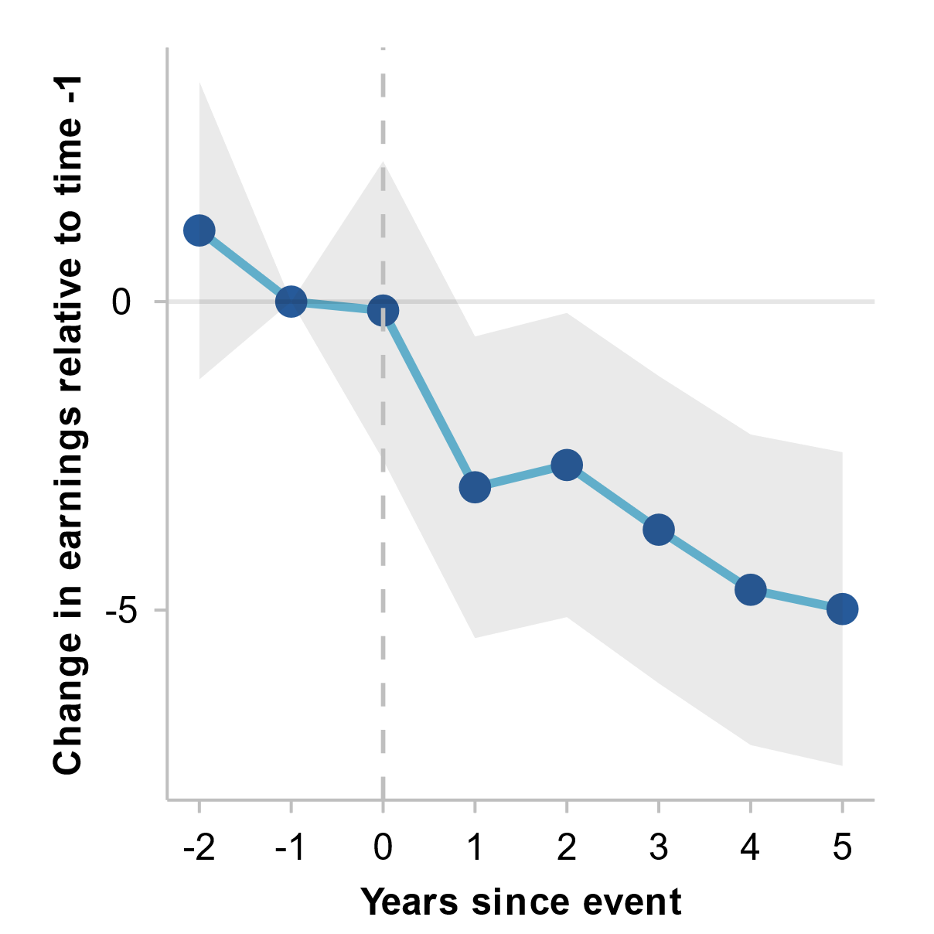 | Mental health  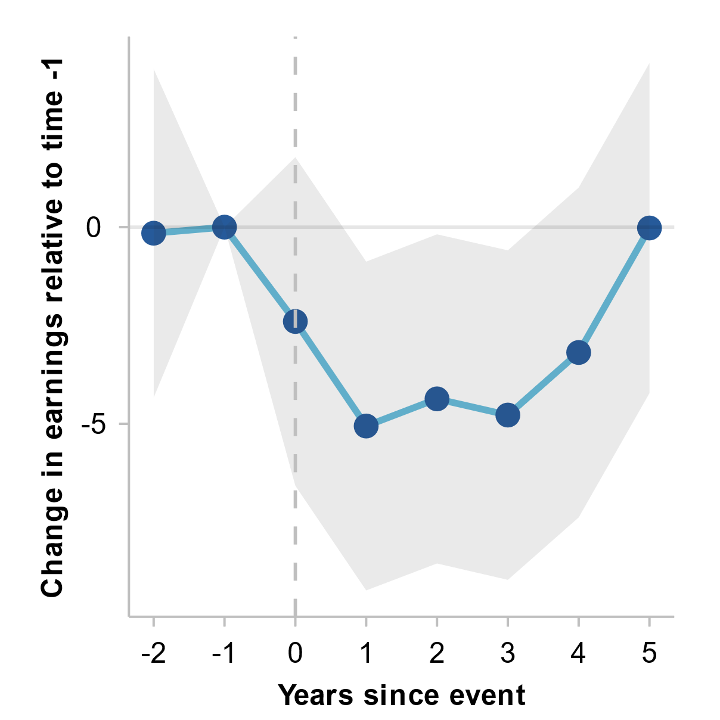
a. Vertical line represents the year of health shock. Shaded area shows 95% confidence intervals. Event study regression coefficients are estimated on income levels and then converted to percentages using average income before shock. Includes data from 2002 to 2022, capturing people experiencing a health shock between 2004 and 2017. b. Both health shocks are measured using a transformed index that is constructed according to the SF-36 Health Survey, an internationally recognised diagnostic tool for assessing functional health status/wellbeing, where zero is the lowest negative score and 100 is the highest positive score (see HILDA User Manual – Release 22, p. 62). The shock to bodily pain and mental health is defined as someone who’s relevant index has dropped by at least 30 points relative to the previous year.
Source: Commission estimates using Household, Income and Labour Dynamics in Australia survey, release 22.

Impact of separation on components and types of income
Following separation, government payments increase sharply for women but not men (figure B.3, panel A), indicating that additional support (for example, parenting payments) play an important role in the recovery of women’s income following separation. Labour income also increases following separation for women, albeit more gradually, suggesting that increases in hours worked and/or increases in pay also have an impact (figure B.3, panel B).
Figure B.3 – Impact of separation on government transfers and wagesª
A. Government transfers  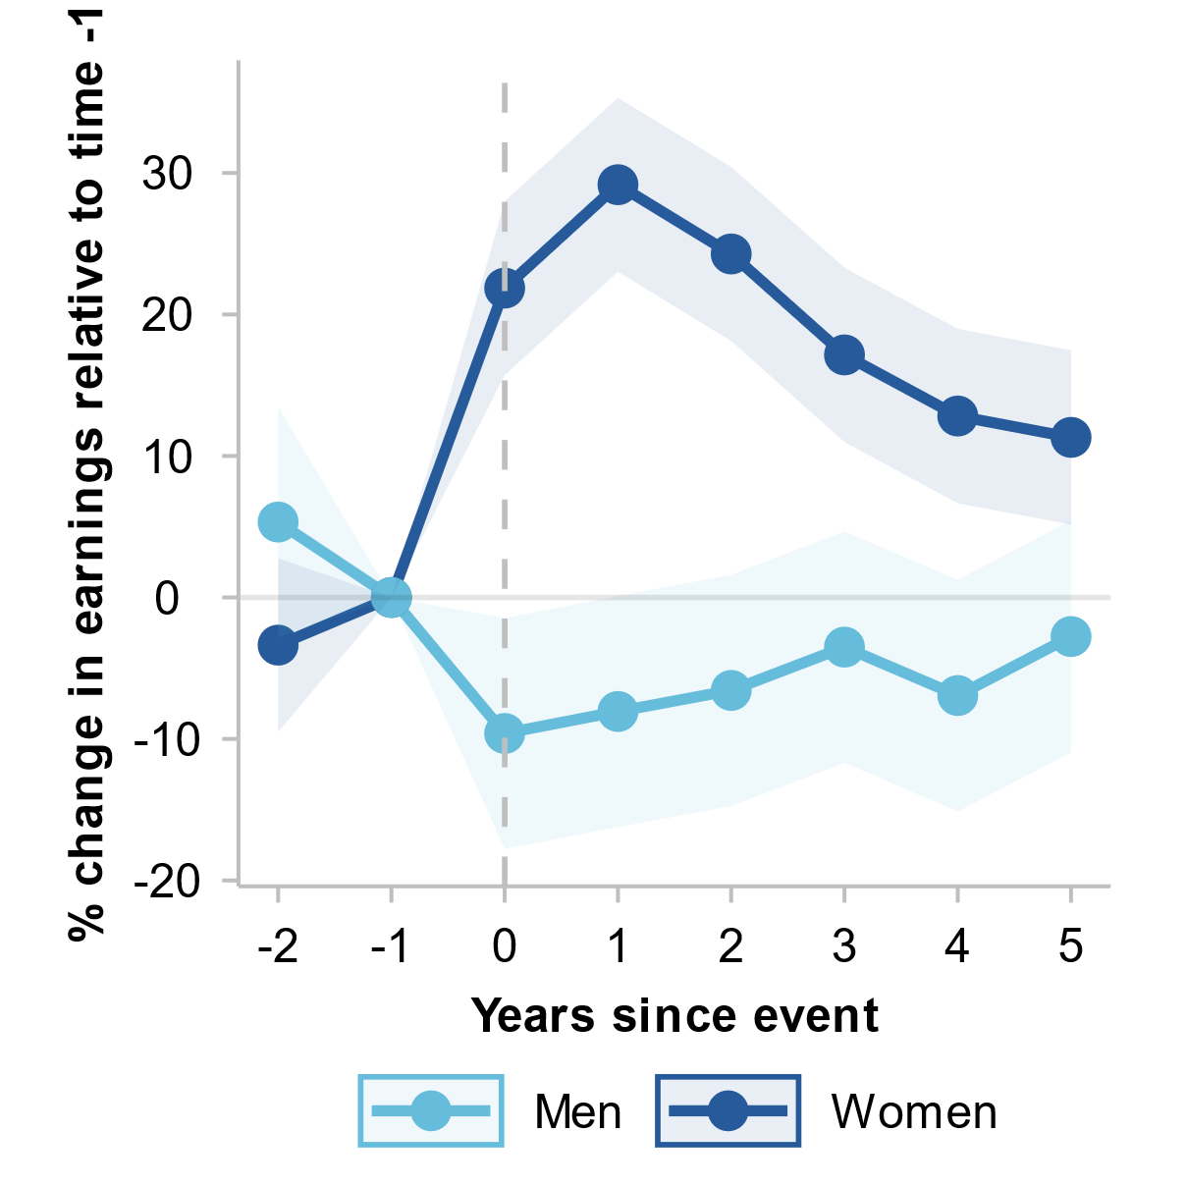 | B. Wages  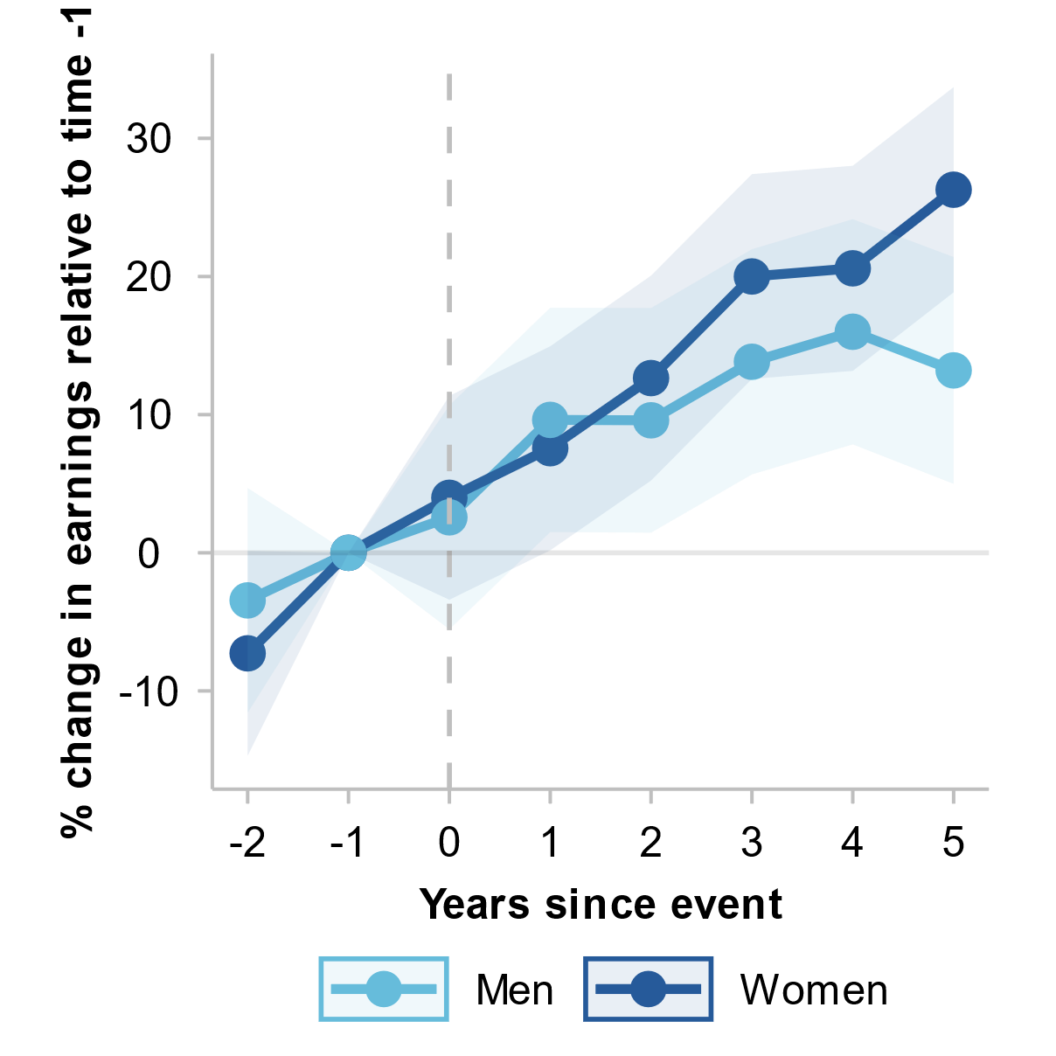
a. Vertical line represents the year of separation. Shaded area shows 95% confidence intervals. Event study regression coefficients are estimated on income levels and then converted to percentages using average pre-separation income. Includes data from 2002 to 2022, capturing people experiencing separation between 2004 and 2017.
Source: Commission estimates using Household, Income and Labour Dynamics in Australia survey, release 22.
The Commission also explored the impact of separation on unequivalised household income to test whether children moving out of home could be driving the recovery in equivalised household income for women (figure 2.10, panel A). A child moving out of home would have a significant effect on equivalised income as it would cause a decrease in the household equivalisation factor (additional resources are assumed to be no longer required for the child). This effect would not occur for unequivalised income.
While unequivalised household income decreases more for women than men following separation, it recovers to a large extent within the first five years, to a similar level to men (figure B.4). This suggests that a decrease in the household equivalisation factor from children moving out of home is not driving the recovery in equivalised household income for women after separation.
Figure B.4 – The impact of separation on unequivalised household incomeª
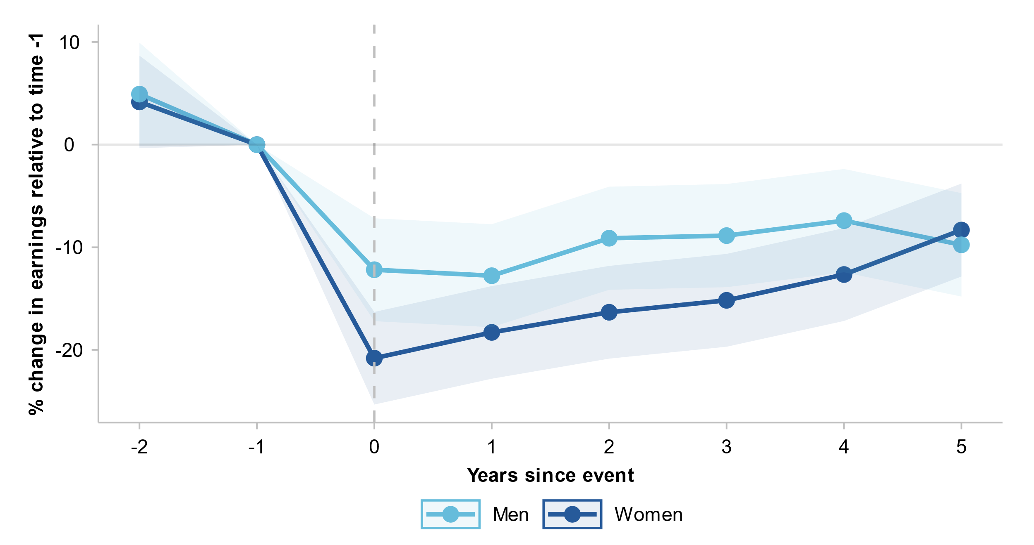
a. Vertical line represents the year of separation. Shaded area shows 95% confidence intervals. Event study regression coefficients are estimated on income levels and then converted to percentages using average income before separation. Includes data from 2002 to 2022, capturing people experiencing separation between 2004 and 2017.
Source: Commission estimates using Household, Income and Labour Dynamics in Australia survey, release 22.

- Intergenerational income mobility
This appendix outlines the Commission’s dataset and methodology for producing its estimates of absolute and relative intergenerational mobility in chapter 3.
  - ALife-Family dataset
The Commission used a preliminary version of the ATO’s ALife-Family dataset, which is a component of the ATO Longitudinal Income Files (ALife). The ALife-Family dataset links individuals with their parents, spouses and siblings using a number of sources, including ATO spouse data and information derived from Medicare enrolment data showing individuals who have shared Medicare cards. The ALife-Family dataset builds on an original dataset used in Deutscher and Mazumder (2020). The ALife-Family dataset has a sample of 10% of taxpayers and has strong coverage of parent links for individuals born between 1969 and 1999.
The tax return data is individual based. Following the international literature, we constructed family incomes using the person-spouse linkage in the ALife-Family dataset. For the parent generation, we used the most recently reported spouse details from the spouse data. For the child generation, reported spouse details in the tax form are used to create family incomes. The parent-child linkage in ALife-Family is used to connect a person with their parents.
Our final sample includes over 200,000 individuals who were born between 1 July 1976 to 30 June 1982; that is, the 1976–82 birth cohort. We measure incomes for people in their 30s and mid-40s, with an average age of 37.5. Using these cohorts allows our results to be comparable to with previous estimates of intergenerational mobility as well as international findings.
  - Absolute intergenerational mobility
Absolute intergenerational mobility measures the share of children who earn more than their parents around a similar age, and thus parents who were born between 1956 and 1962 are included in the analysis, as reported in section 3.1.

Measure of income
We closely follow previous studies on intergenerational income mobility in constructing income variables from administrative tax data (Chetty and Hendren 2018; Deutscher and Mazumder 2020). Throughout the report, unless otherwise indicated, our main measure of income is individual total income (before tax and deductions), which is the total income or loss as reported in the tax return forms.
For individuals who had not filed a tax return in a given year, we use the sum of salary and wages reported by employers, and taxable allowances. We do not include social transfers for those who had not filed a tax return. Data from Centrelink on social transfers is only available from 2002, meaning it is not possible to include it in the incomes of the parent generation. Consequently, we do not include it in the incomes of the child generation. Consistent with the literature, negative incomes are treated as zero, which affected approximately 1% of the parent generation and less than 1% of the child generation’s data.
The Commission used individual incomes as the primary measure of income for analysing absolute intergenerational mobility, rather than family or household incomes, to focus on whether children themselves earn higher incomes relative to their parents. Higher (equivalised) household incomes may reflect higher incomes earned by other household members rather than a person’s own capacity to earn a higher income. Additionally, individual incomes better capture underlying gender differences in the likelihood of a person surpassing their parent’s income, which can be masked when using equivalised household incomes.

Parent-child linkage
In comparing incomes between parents and their children, we use the ALife-Family dataset’s ranking for the parent-child pair relationship. For each child, we report their parent’s income using the child’s ‘primary’ parent, who is the person ranked highest in the parent-child linkage. As a robustness check, we also produce estimates using the income of the child’s ‘secondary parent’ – that is, the parent ranked second in the parent-child linkage. The results are broadly similar for both approaches, for children overall as well as for women and men separately (table C.1).
Table C.1 – Absolute mobility estimates of children earning more than their parentsª
Percent of children who earn more than their parent’s individual income
 | ‘Primary’ parent | ‘Secondary’ parent
Children who earn more than their parents | 67% | 69%
Women who earn more than their parents | 56% | 58%
Men who earn more than their parents | 77% | 79%
a. Primary and secondary parents are based on parent-child linkage as defined above.
Source: Commission estimates using ALife-Family dataset.
  - Relative intergenerational mobility

Measure of income
Consistent with the literature, we used family incomes in the analysis of relative intergenerational mobility because we are interested in examining the connections between the family’s economic resources and the child’s economic outcomes. This also enables our findings to be compared with prior studies on intergenerational mobility.
We calculated family income by combining the total incomes of an individual and their spouse in a given year. If no spousal relationship is reported, the family income is the individual’s personal income. For the parent generation, we followed Deutscher and Mazumder (2020) and averaged the combined income over the period of 1991–2001 to obtain a proxy for lifetime household income.
The measure of total income we use for most people is the total income or loss as reported in the tax return forms. This includes labour income, investment income, income from benefits and pensions, and other income. For individuals who had not filed a tax return in a given year, total income is the sum of salary and wages reported by employers, and taxable allowances, benefits and pensions where available. But as data from Centrelink on government transfers is only available from 2002, benefits and pensions for non-lodgers are only able to be included in the child generation’s income, consistent with the approach used by Deutscher and Mazumder (2020).
Income variables are measured in 2022-23 dollars, adjusted for inflation using the consumer price index by the ABS.
The literature suggests that income is too volatile if it is measured too early or too late in an individual’s lifetime (Lee and Solon 2009). We therefore restrict the year of birth for the parent generation to 1962 and earlier. Using the latest available data, income is averaged between 2011 and 2020 for the child generation, which equates to when they are in their 30s and 40s. This is a longer period of income for the child generation than was used in the previous study by Deutscher and Mazumder (2020), which used incomes between 2011 and 2015.
The average family income for the parent generation is $119,424 in 2001 and is slightly less than the average household income in the Survey of Housing and Income (SIH) in 2003-04, the closest year of survey. For the child generation, the average family income is $132,761 and is comparable to the average household income in the 2019-20 SIH, where the age of the household head is similar to the age of the child generation in our sample.
On average, parents have 9.2 years and children have 8.8 years of income information in our sample.
In addition to the main analysis using family incomes, the Commission has also produced intergenerational mobility estimates for different combinations of parental relationships: father/son, father/daughter, mother/son and mother/daughter. For this, we used the individual parent and child’s total income as reported in the tax data.

Measures of relative mobility
Relative measures of income mobility focus on the relative outcomes of children from different family backgrounds. The most common relative intergenerational income mobility measures are intergenerational income elasticity and rank-rank slope measures, which we report in section 3.2. While there are other measures, such as conditional expected ranks, the Commission has not produced estimates of these measures in this report.

Intergenerational income elasticity
Intergenerational income elasticity (IGE) refers to the degree to which parents’ incomes explain their child’s income. A lower IGE coefficient indicates that parental income matters less in determining their child’s income as an adult. IGE is a well-established measure that allows for findings to be compared across studies and countries, but is highly sensitive to sampling and specification (e.g. using lifetime income rather than income averaged over a specific age range).
The IGE is the estimate of $β$ from the following equation, which is based on Becker and Tomas’ (1979) framework where a child’s income is a linear function of their parents’ income:
$$y_{i,c}=α+βy_{i,p}+ε_{i,c}$$
where $y_{i,c}$ denotes the log income of the child’s generation, and $y_{i,p}$ is the log income of the parents’ generation. $β$ measures the rate of relative mobility; that is, the association between the mean log income of children and their parents’ income. The higher the $β$ is, the lower mobility is.
Ideally, mobility would be measured using the parents’ and child’s lifetime income, but this is not practical due to data limitations. To avoid measurement error and lifecycle biases, Solon (1992) and Zimmerman (1992) noted that averaging a person’s income over at least a five year period is necessary, but Mazumder (2005) suggested averaging incomes over even longer periods are needed to eliminate transitory income fluctuations that are serially correlated. Our data allows us to average incomes at least ten years.
Previous US studies show that lifecycle bias is acute when children’s incomes are measured too early, so estimating IGE for people aged around and over 40 is recommended (Chetty et al. 2014; Mazumder 2016). In our sample, the parent generation’s average age is 46 and the child generation’s average age is 37.
We removed zero incomes from the estimation of IGE due to the log specification. Dropping zero incomes reduces the sample size by less than 1%.

Rank-rank slope
The rank-rank slope measures the association between the parents’ rank in the income distribution and their children’s rank in the income distribution as adults. Compared to the IGE, the rank-rank slope is more robust to different specifications and samples and can account for people with no income. The rank-rank slope is calculated by the following equation, where the child’s income percentile rank is a linear function of their parents’ income percentile rank:
$$r_{i,c}=a+br_{i,p}+ε_{i,c}$$
where $r_{i,c}$ and $r_{i,p}$ are the percentile rank of individual $i$ and their parents in the income distribution in their respective generation. $a$ measures the expected rank of a child with a parent at the bottom of the income distribution ($r_{i,p}=0$). $b$ measures the persistence in rank position, or the association between the child’s and parents’ position in their respective income distributions.
Nybom and Stuhler (2017) find rank-rank mobility measures are reasonably stable from age 30 onwards. Our rank-rank estimates were relatively stable for different specifications, such as estimating the model by restricting the sample to Australia-born individuals only, using the spouse linkage based on the first year of relationship information, and using disposable incomes.
The rank-rank slope allows us to account for people with zero or missing income, so the sample used to produce our estimates is the full sample of 201,226 individuals.

Robustness checks
The Commission’s analysis is broadly comparable with Deutscher and Mazumder’s (2020) previous study of relative intergenerational mobility, though there are some data and methodological differences. Deutscher and Mazumder (2020) only included individuals born in Australia in their analysis, while the ALife-Family data has non-Australian born individuals. As a robustness check, we estimated our model only for people born in Australia using Medicare enrolment details, and the results were broadly similar (table C.2).
Table C.2 – Rank-rank slope and IGE estimates
 | Rank-rank slope | IGE
Full sample | 0.176 | 0.197
Restricted to Australia-born individuals only | 0.175 | 0.202
With spouse linkage connected by first year of relationship | 0.176 | 0.196
Source: Commission estimates using ALife-Family dataset.
As discussed above, parents and children both have approximately nine years of income information in our sample. We performed a robustness check by dropping individuals with more than five years of missing observations. The results do not change the qualitative finding of relative intergenerational mobility.

Regional estimates
There are different ways to produce estimates of IGE and rank-rank slope for different regions. For example, one could reasonably argue either the parents’ or child’s location is more appropriate depending on the question of interest. Additionally, there are other issues that can complicate the analysis, such as how to account for people moving across different regions.
The Commission is interested in the intergenerational income mobility of people based on where they grew up, because where a person grows up has significant implications for the opportunities and services available to them, such as education and labour market opportunities. Accordingly, we undertook the analysis based on our definition of the ‘permanent’ region where a person grew up: income mobility estimates for each region include parents who lived in that region for at least six years (that is, more than 50% of the time that parents’ incomes are averaged).
For rank-rank slope measures, consistent with the literature, we used rankings based on the national income distribution (Chetty et al. 2014; Deutscher and Mazumder 2020). Regional IGE estimates deliver broadly similar findings for regional intergenerational mobility as the rank-rank slope estimates reported in section 3.2 (table C.3).
Table C.3 – IGE estimates by regions
 | IGE
New South Wales | 0.201
Victoria | 0.199
Queensland | 0.207
South Australia | 0.216
Western Australia | 0.196
Tasmania | 0.192
Northern Territory | 0.284
Australian Capital Territory | 0.169
Source: Commission estimates using ALife-Family dataset.

- Analysing poverty in Australia
This appendix outlines the approaches used to analyse poverty and low mobility in chapter 4.
  - Factors affecting likelihood of being in poverty

Person Level Integrated Data Asset (PLIDA)
The Commission’s poverty analysis in section 4.2 (as well as box 4.1 and table 4.3) uses data from the Person Level Integrated Data Asset (PLIDA). PLIDA is a secure data asset combining information on health, education, government payments, income and taxation, employment, and population demographics over time. PLIDA includes data from the ABS, ATO, Department of Health and Aged Care, Department of Social Services (DSS), Services Australia and Department of Home Affairs.
These datasets are integrated using the ABS's linkage spine, an algorithmically derived matching mechanism that allows analysis of individuals across datasets while preserving their anonymity. The spine is designed to encompass all individuals residing in Australia during a specified reference period. More information on PLIDA, including the linkage spine, can be found at ABS (2024).
This report uses a cross-sectional dataset for 2021-22 derived from PLIDA, specifically tailored for this research project. This dataset incorporates several sources of information:
- tax and income data from the ATO, encompassing details from income tax returns and payment summaries
- welfare payment data obtained from DSS
- demographic and location data sourced from the ABS, which is further enriched by additional demographic insights from Census data.
The resultant dataset included the financial and demographic profiles of households with positive income, covering 22.7 million individuals. This represents approximately 87% of the population at the time the data was compiled. As such, the dataset provides comprehensive coverage of a large majority of the population, free from common sampling and survey biases. However, data limitations mean that we are unable to account for:
- individuals who subsist on the income from their cash assets
- those who report income losses on their tax returns
- participants in the cash economy whose income is unrecorded in the tax dataset.
Other limitations associated with using PLIDA data include its relatively recent introduction to economic research, posing potential issues with verification, and the sheer size of the dataset, which poses significant challenges in computational analysis.

Measures of income and poverty
Gross income (income before tax) is taken from tax returns unless income reported in payment summaries is greater. In this case, income from payment summaries is used. Additionally, welfare payments are factored in if they exceed income or welfare payments reported on the tax return.
Taxes are based on the information provided in tax returns. Disposable income (also known as net income) is then calculated by subtracting the tax from the gross income.
Our analysis on poverty includes a measure based on disposable income alone, and a measure that excludes housing costs. For the latter, housing costs are derived from Census data and then subtracted from disposable income. Both pre- and post-housing income are equivalised using methods outlined in the Commission’s earlier research paper, A snapshot of inequality in Australia (2024a).
An individual is considered to be in poverty if their equivalised household income is below the poverty threshold. In chapter 4, this threshold is 50% of the median income, which can be calculated either before or after housing costs are taken into account.

Poisson regression model of poverty risk factors
In section 4.2, we use a Poisson regression model to assess the influence of various factors on the likelihood that an individual is in poverty. The model’s dependant variable was a binary variable to denote poverty status (1 for in poverty, 0 for not). The types of factors that were included as independent variables in the model are given in table D.1 below.
Table D.1 – Types of poverty risk factors modelled
Variable category | Source
Gender | PLIDA spine
Age groups | PLIDA spine
Aboriginal and Torres Strait Islander identification | PLIDA spine
Region groups | PLIDA spine
Family types | Census
Employment | Census
Education groups | Census
Migration status | Census
Language spoken at home | Census
Housing situation | Census
Long term health condition | Census
Disability status | Census
Source: Productivity Commission.
The formal model for an individual $i$ is:
$$\begin{aligned}\operatorname{Log}\left(λ_{i}\right)=β_{0}+β_{1}X_{1i}+β_{2}X_{2i}+...+β_{n}X_{ni}\end{aligned}$$
where:
- $log⁡(λ_{i})$ is the logged probability of being in poverty for individual $i$
- $\begin{aligned}X_{1i}, …, X_{ni}\end{aligned}$ are the values of the $n$ independent variables (poverty risk factors) for individual $i$
- $β_{0}$ is the intercept
- $\begin{aligned}β_{1}\end{aligned},…, \begin{aligned}β_{n}\end{aligned}$ are the coefficients for the $n$ independent variables.
The regression provides insights into the association between various factors and the likelihood of poverty, relative to a baseline scenario. The constant represents the logged likelihood of poverty for a base case, where all variables are set to zero. For instance, in a model considering variables such as 'male' and 'renter', the baseline would reflect the odds of poverty for a female who does not rent.
Factors that exhibit statistically significant coefficients suggest a non-zero association with the likelihood of poverty. However, this does not necessarily imply causation as other unseen factors may be the underlying driver of changes in both variables.
Conversely, factors with statistically insignificant coefficients do not show an association with poverty likelihood, given the other variables in the model. For example, the insignificant coefficient on ‘outer regional’, with ‘major city’ as the baseline, indicates no statistically significant evidence of a difference in poverty risk between the two regions, when controlling for other factors.
The Poisson specification was chosen as the exponentiated coefficients give the incidence rate ratios (IRRs). An IRR greater than 1 indicates an increase in the rate of occurrence of poverty with each unit increase in the independent variable (that is, the poverty risk factor), and an IRR less than 1 indicates a decrease.
For example, the coefficient for renting was 0.48, which has an exponent of 1.62. This means that renters, relative to non-renters, were at 1.62 times the risk of poverty (or a 62% higher risk), holding all other variables constant.
  - Factors affecting time spent in poverty
Measuring poverty at a single point in time does not distinguish between people who are temporarily experiencing low income and those experiencing it over extended periods of time. Looking at factors correlated with the time that people spend in poverty can provide insight into who experiences the consequences of poverty.
‘Survival analysis’ can be used to examine what factors are associated with time spent ‘surviving’ in poverty, and how these factors affect the likelihood of people exiting poverty. Survival analysis involves estimates of the time required for an event to occur – in this case, exit from poverty. It typically uses the ‘hazard’ of an event occurring – the instantaneous risk of the event occurring at a point in time, given that the subject has survived up to that time. In the context of exiting poverty, the hazard rate represents the probability that a person exits poverty at a specific time, provided they remained in poverty up to that time.
This section outlines the data used for the survival analysis included in section 4.3 and the model specification.

Poverty spells in HILDA
The Housing Income and Labour Dynamics in Australia survey is used to analyse factors associated with the length of poverty spells. Using the definition of poverty after housing costs have been taken into account, there are around 33,000 spells of poverty observed in 22 years of HILDA data. A spell of poverty starts in a year when a person is found to be in poverty, and continues until either that person is found not to be in poverty or is last observed in the HILDA data.
Many of the poverty spells in the spell data are incomplete, or ‘censored’. This means that the beginning (‘left censored’) and/or the end (‘right censored’) of the spell is not observed in the data available. A failure to take into account censoring of the data will result in biased estimates. In the HILDA spell data, around 14% of spells are left censored, around 16% are right censored, while around 7% of spells are both left and right censored (figure D.1). The majority of poverty spells (63%) are not censored.
Figure D.1 – Poverty spell lengths by censoring status
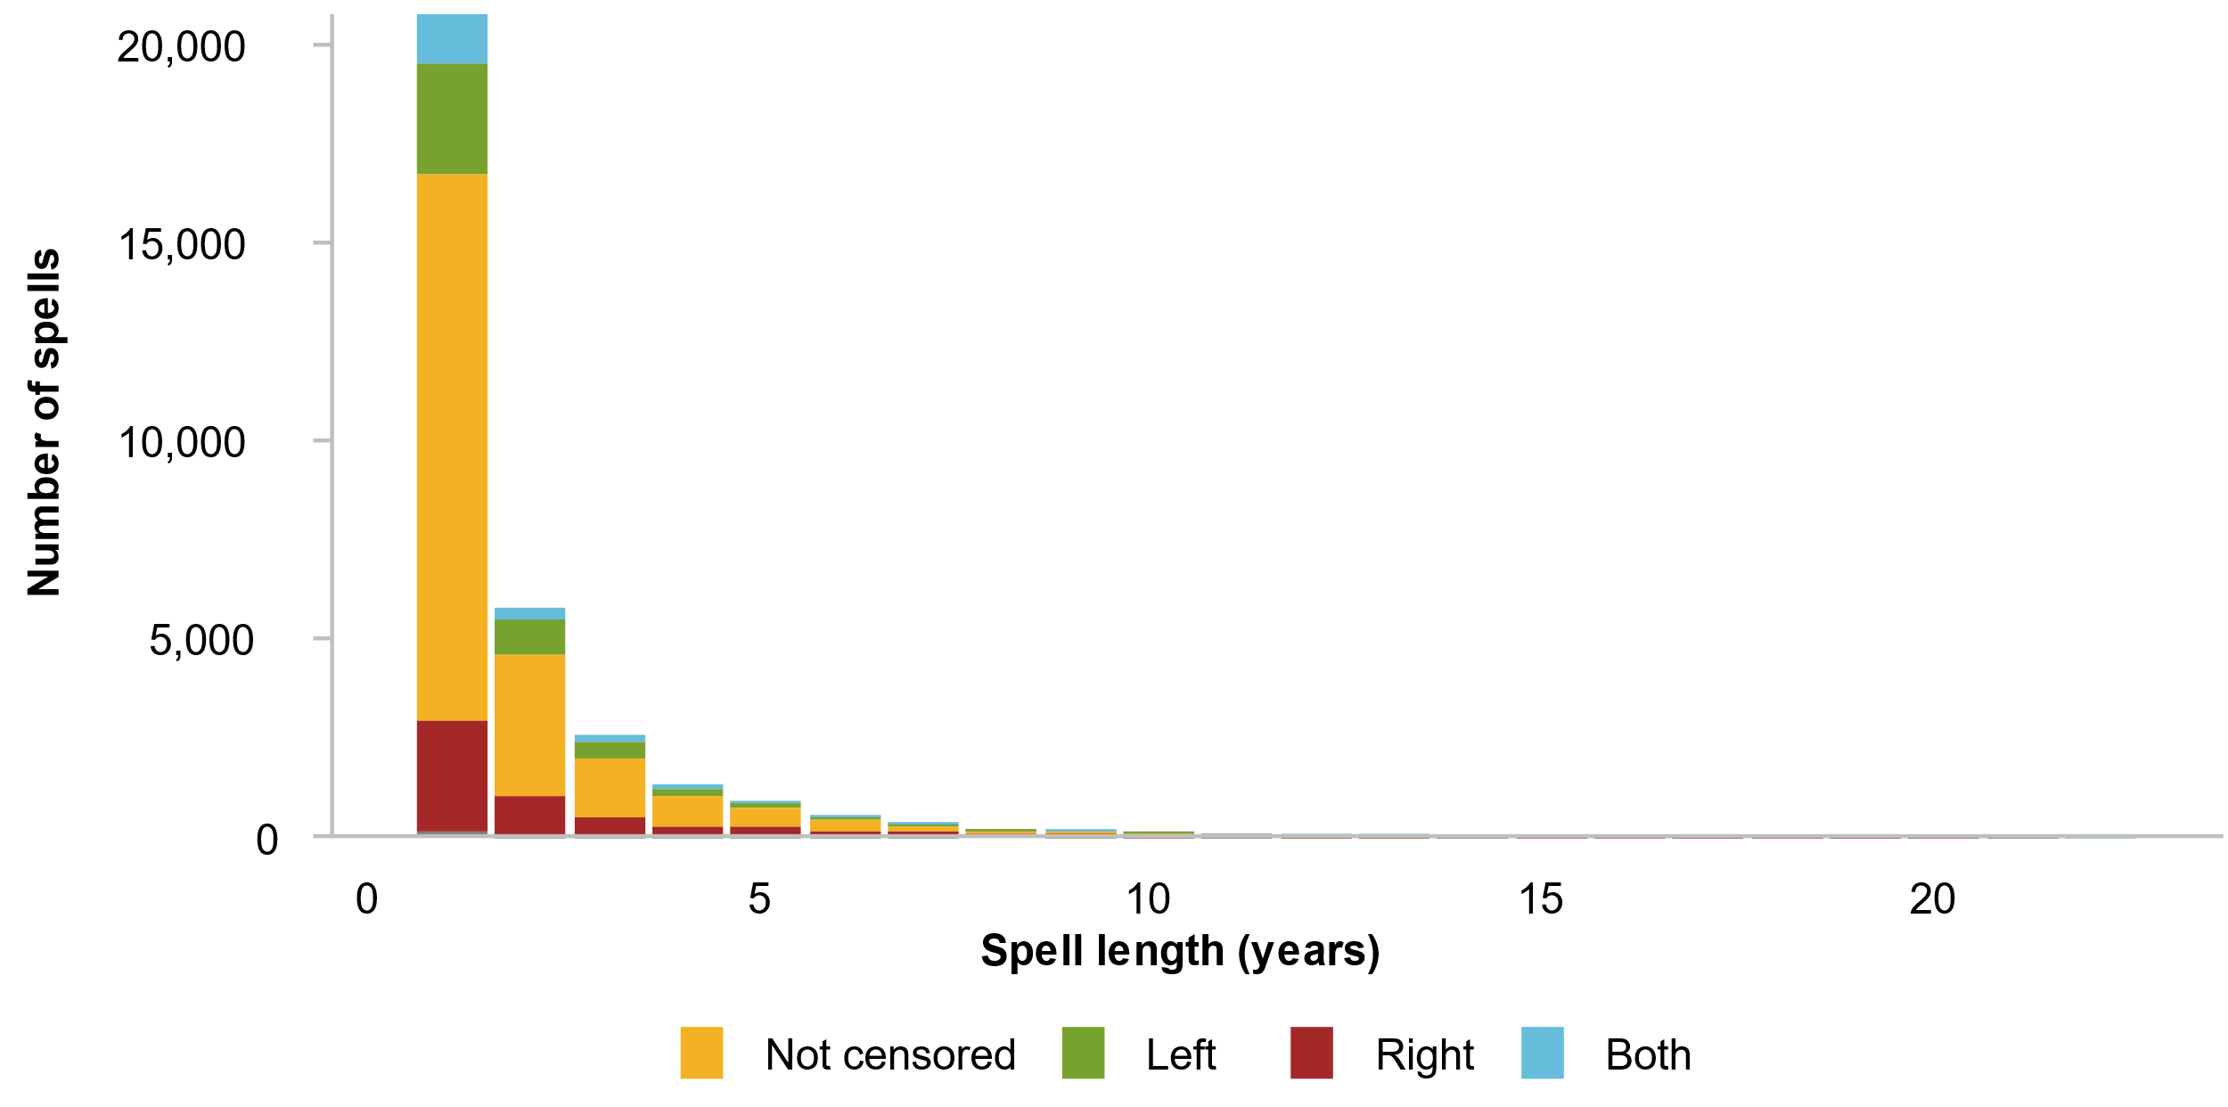
Source: Commission estimates using Household, Income and Labour Dynamics in Australia survey, release 22.

Proportional hazards model
The Cox proportional hazards model allows the consideration of how demographic characteristics predict the likelihood of poverty exit – that is, how likely people are to exit poverty if they have a certain demographic characteristic. The proportional hazards model is a survival analysis technique used to quantify the relationship between ‘survival time’ and other information likely to affect survival. The model is given by the following equation:
$h(t|X$) = $h_{0}\left(t\right)∙e^{(b_{1}X_{1}+b_{1}X_{1}+...+b_{n}X_{n})}$
Here $h(t|X$) represents the hazard function (probability of exiting poverty at time t given covariates X), $h_{0}\left(t\right)$ is the baseline hazard and $b_{1},b_{2}… b_{n}$ are the coefficients of covariates $X_{1},X_{2}… X_{n}$, which are demographic characteristics in our model.
The exponent of each coefficient indicates a hazard ratio: the ratio of the hazard with a given covariate to the baseline hazard rate. It quantifies the effect of a covariate on the hazard or risk of an event occurring. A hazard ratio greater than one indicates that people with that specific demographic characteristic are more likely to exit poverty than the comparison group at any time point. A hazard ratio less than one suggests that people with that characteristic are less likely to exit.
Following Chen et al. (2022), who conduct a similar analysis using data from the United States, adjusted hazard ratios are estimated that control for a range of demographic characteristics. These include gender, age, family structure, highest educational attainment, whether or not people have a long-term health condition, housing type and disadvantage of the area in which people live. Disadvantage is measured by the Socio-Economic Index for Areas quintile for the index of relative socioeconomic, which summarises information about the levels of low income, low educational attainment and high unemployment in a given area. The analysis is restricted to people who are aged between 15 and 64. This is because the poverty status of younger people is strongly associated with that of their parents, while that of older people is closely related to their receipt of the Age Pension and other government payments such as Rent Assistance (box 4.1).
It is important to distinguish between people and spells. Around 8,000 people have multiple spells in the data, and a failure to account for this has the potential to affect findings. Descriptive figures are included in table D.2 that provide demographics characteristics for people who experience a spell of poverty.
Table D.2 – Characteristics of people experiencing a poverty spellª
Variable | % | Variable | %
Gender |  | Highest educational attainment
Female | 53.5 | Degree | 14.3
Male | 46.5 | Diploma/certificate | 24.0
Age |  | Year 11 or below | 38.5
15 to 24 | 36.0 | Year 12 | 23.2
25 to 34 | 20.2 | Long-term health condition
35 to 44 | 16.2 | No | 73.3
45 to 54 | 12.8 | Yes | 26.7
55 to 64 | 14.9 | Housing tenure
Family structure |  | Own/currently paying mortgage | 37.0
Couple | 21.9 | Rent | 60.4
Couple with dependent children | 22.4 | Other | 2.6
Couple with non-dependent children | 5.8 | Socioeconomic Index for Areas (SEIFA) value
Other family | 2.7 | 1st quintile | 28.0
Single parent with dependent children | 10.0 | 2nd quintile | 22.1
Single parent with non-dependent children | 6.3 | 3nd quintile | 17.9
Single person | 30.9 | 4th quintile | 16.8
 |  | 5th quintile | 15.2
a. Figure relates to people who experience at least one spell of poverty.
Source: Commission estimates using Household, Income and Labour Dynamics in Australia survey, release 22.
The proportional hazards model was run for both people’s first spell only, and including all spells with a clustered variance allowing for correlation between observations (which are in this case spells, rather than people) (table D.3). A variable indicating spell number is included in the model that allows for multiple spells. The coefficient on this variable is less than one, indicating that the hazard of exiting poverty goes down with each spell.
Schoenfeld residuals were used to test the proportional hazards assumption in Cox proportional hazards models by examining the correlation between residuals and time. Age varies over time, violating the proportional hazards assumption and requiring the inclusion of time-varying coefficients in the model (Zhang et al. 2018). This effectively allows the effect of age on the hazard of poverty exit to vary with time. The hazard ratios for the time-varying coefficients are statistically significant and above one, indicating that the likelihood of exiting poverty is both greater and increasing over time for people younger than the reference group of people aged 55 to 64.

Table D.3 – Hazard ratios of poverty exit
Proportional hazards model with single or multiple spells
 | Single spells only |  |  |  | Multiple spells
 | HR | SE | p-value |  | HR | SE | p-value
Gender
Male | Reference |  |  |  | Reference
Female | 1.00 | 0.02 | 0.88 |  | 1.00 | 0.02 | 0.86
Age group
15 to 24 | 0.99 | 0.05 | 0.83 |  | 1.06 | 0.04 | 0.13
25 to 34 | 1.13 | 0.06 | 0.01 |  | 1.18 | 0.05 | 0.00
35 to 44 | 1.06 | 0.05 | 0.25 |  | 1.11 | 0.05 | 0.01
45 to 54 | 1.06 | 0.06 | 0.30 |  | 1.09 | 0.04 | 0.03
55 to 64 | Reference |  |  |  | Reference
Family type
Couple | 0.95 | 0.03 | 0.10 |  | 0.99 | 0.02 | 0.65
Couple with dependents | Reference |  |  |  | Reference
Couple with non-dependents | 1.04 | 0.05 | 0.32 |  | 1.04 | 0.03 | 0.24
Single person | 0.87 | 0.03 | 0.00 |  | 0.88 | 0.02 | 0.00
Single parent with dependents | 0.96 | 0.03 | 0.30 |  | 0.97 | 0.02 | 0.22
Single parent with non-dependents | 0.98 | 0.04 | 0.61 |  | 0.94 | 0.03 | 0.05
Other | 0.81 | 0.06 | 0.00 |  | 0.82 | 0.05 | 0.00
Long term health condition
Yes | 0.83 | 0.02 | 0.00 |  | 0.84 | 0.01 | 0.00
No | Reference |  |  |  | Reference
Housing type
Own/currently paying off mortgage | Reference |  |  |  | Reference
Rent (or pay board) | 0.75 | 0.02 | 0.00 |  | 0.77 | 0.01 | 0.00
Other | 0.77 | 0.05 | 0.00 |  | 0.76 | 0.04 | 0.00
Highest educational attainment
Degree | Reference |  |  |  | Reference
Diploma/certificate | 0.98 | 0.03 | 0.50 |  | 0.98 | 0.02 | 0.46
Year 12 | 0.80 | 0.02 | 0.00 |  | 0.95 | 0.02 | 0.04
Year 11 or below | 0.91 | 0.03 | 0.00 |  | 0.85 | 0.02 | 0.00
SEIFA quintile
1st quintile | 0.89 | 0.03 | 0.00 |  | 0.90 | 0.02 | 0.00
2nd quintile | 0.93 | 0.03 | 0.02 |  | 0.93 | 0.02 | 0.00
3rd quintile | Reference |  |  |  | Reference
4th quintile | 0.98 | 0.03 | 0.60 |  | 0.97 | 0.02 | 0.21
5th quintile | 1.04 | 0.03 | 0.17 |  | 1.06 | 0.03 | 0.03
Spell number |  |  |  |  | 0.96 | 0.01 | 0.00
Time varying coefficient
15 to 24 | 1.12 | 0.02 | 0.00 |  | 1.09 | 0.02 | 0.00
25 to 34 | 1.05 | 0.02 | 0.03 |  | 1.04 | 0.02 | 0.02
35 to 44 | 1.05 | 0.02 | 0.03 |  | 1.04 | 0.02 | 0.03
45 to 54 | 1.01 | 0.02 | 0.69 |  | 1.02 | 0.02 | 0.31
55 to 64 | Reference |  |  |  | Reference
Source: Commission estimates using Household, Income and Labour Dynamics in Australia survey, release 22.

References

ABS (Australian Bureau of Statistics) 2023, Births, Australia, 2022, https://www.abs.gov.au/statistics/people/population/births-australia/latest-release (accessed 4 July 2024).
—— 2024, Person Level Integrated Data Asset (PLIDA), https://www.abs.gov.au/about/data-services/data-integration/integrated-data/person-level-integrated-data-asset-plida (accessed 4 July 2024).
Andrews, D. and Leigh, A. 2009, ‘More inequality, less social mobility’, Applied Economics Letters, vol. 16, no. 15, pp. 1489–1492.
Bahar, E., Bradshaw, N., Deutscher, N. and Montaigne, M. 2023, Children and the Gender Earnings Gap: Evidence for Australia, Treasury working paper.
Barón, J.D., Cobb-Clark, D.A. and Erkal, N. 2015, ‘Welfare receipt and the intergenerational transmission of work-welfare norms’, Southern Economic Journal, vol. 82, no. 1, pp. 208–234.
Baum, S. and Gleeson, B. 2010, ‘Space and place: Social exclusion in Australia’s suburban heartlands’, Urban Policy and Research, vol. 28, no. 2, pp. 135–159.
Becker, G.S. and Tomes, N. 1979, ‘An equilibrium theory of the distribution of income and intergenerational mobility’, Journal of Political Economy, vol. 87, no. 6, pp. 1153–1189.
Billings, S.B., Deming, D.J. and Ross, S.L. 2019, ‘Partners in Crime’, American Economic Journal: Applied Economics, vol. 11, no. 1, pp. 126–150.
Chen, J.-H., Wu, C.-F. and Zheng, H. 2022, ‘Who stays poor and who doesn’t? An analysis based on joint assessment of income and assets’, Journal of Social Policy, pp. 1–22.
Chetty, R. and Hendren, N. 2018, ‘The impacts of neighborhoods on intergenerational mobility i: childhood exposure effects’, The Quarterly Journal of Economics, vol. 133, no. 3, pp. 1107–1162.
——, ——, Kline, P. and Saez, E. 2014, ‘Where is the land of opportunity? The geography of intergenerational mobility in the United States’, The Quarterly Journal of Economics, vol. 129, no. 4, pp. 1553–1623.
CLC (Central Land Council) 2023, Submission to the Senate Standing Committee on Community Affairs, Senate Standing Committee on Community Affairs Inquiry into the Extent and Nature of Poverty in Australia.
Corak, M. 2013, ‘Income inequality, equality of opportunity, and intergenerational mobility’, Journal of Economic Perspectives, vol. 27, no. 3, pp. 79–102.
Crawford, C., Goodman, A. and Joyce, R. 2011, ‘Explaining the socio-economic gradient in child outcomes: the inter-generational transmission of cognitive skills’, Longitudinal and Life Course Studies, vol. 2, no. 1, pp. 77–93.
Deutscher, N. 2020, ‘Place, peers, and the teenage years: long-run neighborhood effects in Australia’, American Economic Journal: Applied Economics, vol. 12, no. 2, pp. 220–249.
—— and Mazumder, B. 2020, ‘Intergenerational mobility across Australia and the stability of regional estimates’, Labour Economics, vol. 66, p. 101861.
Doko Tchatoka, F. and Varvaris, V. 2021, ‘Neighbourhood, school zoning and the housing market: Evidence from New South Wales’, Journal of Housing Economics, vol. 54, p. 101790.
Edwards, B. and Baxter, J. 2013, The tyrannies of distance and disadvantage: factors related to children’s development in regional and disadvantaged areas of Australia, Research report no. 25, Growing up in Australia, Australian Institute of Family Studies.
Fishkin, J. 2014, Bottlenecks: A new theory of equal opportunity, Oxford University Press.
García-Gómez, P., Kippersluis, H. van, O’Donnell, O. and Doorslaer, E. van 2013, ‘Long-term and spillover effects of health shocks on employment and income’, Journal of Human Resources, vol. 48, no. 4, pp. 873–909.
Gaviria, A. and Raphael, S. 2001, ‘School-based peer effects and juvenile behaviour’, The Review of Economics and Statistics, vol. 83, no. 2, pp. 257–268.
Heckman, J.J. 1976, ‘The common structure of statistical models of truncation, sample selection and limited dependent variables and a simple estimator for such models’, Annals of Economic and Social Measurement, Volume 5, number 4, NBER, pp.
IBA (Indigenous Business Australia) 2023, Submission to the Senate Standing Committee on Community Affairs, Senate Standing Committee on Community Affairs Inquiry into the Extent and Nature of Poverty in Australia.
Jäntti, M. and Jenkins, S.P. 2015, ‘Income Mobility’, in Atkinson, A. and Bourguignon, F. (eds), Handbook of Income Distribution, vol 2, Elsevier, pp. 807–935.
Kalil, A. and Ryan, R. 2020, ‘Parenting practices and socioeconomic gaps in childhood outcomes’, The Future of Children, vol. 30, no. 1, pp. 29–54.
Kosny, A., Santos, I. and Reid, A. 2017, ‘Employment in a “land of opportunity?” immigrants’ experiences of racism and discrimination in the Australian workplace’, Journal of International Migration and Integration, vol. 18, no. 2, pp. 483–497.
Lancaster, D. 2021, ‘The Financial Cost of Job Loss in Australia’, RBA Bulletin, September.
Lee, C.-I. and Solon, G. 2009, ‘Trends in intergenerational income mobility’, The Review of Economics and Statistics, vol. 91, no. 4, pp. 766–772.
Letki, N. and Mieriņa, I. 2015, ‘Getting support in polarized societies: Income, social networks, and socioeconomic context’, Social Science Research, vol. 49, pp. 217–233.
Loury, G.C. 1981, ‘Intergenerational Transfers and the Distribution of Earnings’, Econometrica, vol. 49, no. 4, pp. 843–867.
Manduca, R. and Sampson, R.J. 2019, ‘Punishing and toxic neighborhood environments independently predict the intergenerational social mobility of black and white children’, Proceedings of the National Academy of Sciences, vol. 116, no. 16, pp. 7772–7777.
Mani, A. and Riley, E. 2019, Social networks, role models, peer effects, and aspirations, WIDER Working Paper 2019/120.
Mazumder, B. 2005, ‘Fortunate sons: new estimates of intergenerational mobility in the united states using social security earnings data’, The Review of Economics and Statistics, vol. 87, no. 2, pp. 235–255.
—— 2016, ‘Estimating the intergenerational elasticity and rank association in the United States: Overcoming the current limitations of tax data’, Inequality: Causes and Consequences, vol 43, Emerald Group Publishing Limited.
McLachlan, R., Gilfillan, G. and Gordon, J. 2013, Deep and Persistent Disadvantage in Australia, Productivity Commission Staff Working Paper, Canberra.
Miller, D.L. 2023, ‘An introductory guide to event study models’, Journal of Economic Perspectives, vol. 37, no. 2, pp. 203–230.
Mincer, J.A. 1974, ‘The Human Capital Earnings Function’, Schooling, Experience, and Earnings, NBER, pp. 83–96.
Mitnik, P., Bryant, V., Weber, M. and Gruski, D. 2015, New estimates of intergenerational mobility using administrative data.
NACCHO (National Aboriginal Community Controlled Health Organisation) 2023, Submission to the Senate Standing Committee on Community Affairs, Senate Standing Committee on Community Affairs Inquiry into the Extent and Nature of Poverty in Australia.
Nybom, M. and Stuhler, J. 2017, ‘Biases in standard measures of intergenerational income dependence’, The Journal of Human Resources, vol. 52, no. 3, pp. 800–825.
Parolin, Z., Schmitt, R., Esping-Andersen, G. and Fallesen, P. 2023, The Intergenerational Persistence of Poverty in High-Income Countries, IZA Discussion Paper No. 16194, Rochester, NY.
PC (Productivity Commission) 2023, Review of the National Agreement on Closing the Gap: Review paper 3: What we have heard to date - first phase of engagement.
—— (Productivity Commission) 2024a, A snapshot of inequality in Australia, Research paper, Canberra.
—— (Productivity Commission) 2024b, Review of the National Agreement on Closing the Gap, Study report, Vol. 1, Canberra.
QAIHC (Queensland Aboriginal and Islander Health Council) 2023, Submission to the Senate Standing Committee on Community Affairs, Senate Standing Committee on Community Affairs Inquiry into the Extent and Nature of Poverty in Australia.
SCRGSP (Steering Committee for the Review of Government Service Provision) 2020, Overcoming Indigenous Disadvantage: Key Indicators 2020, Productivity Commission, Canberra.
Smith, C., Parr, N. and Muhidin, S. 2019, ‘Mapping schools’ NAPLAN results: a spatial inequality of school outcomes in Australia’, Geographical Research, vol. 57, no. 2, pp. 133–150.
Solon, G. 1992, ‘Intergenerational income mobility in the United States’, The American Economic Review, vol. 82, no. 3, pp. 393–408.
Treasury 2023, Working future: The Australian Government’s White Paper on jobs and opportunities, Final Report.
VACCA (Victorian Aboriginal Child Care Agency) 2023, Submission to the Senate Standing Committee on Community Affairs, Senate Standing Committee on Community Affairs Inquiry into the Extent and Nature of Poverty in Australia.
Yoorrook Justice Commission 2023, ‘Yoorrook for justice: Report into Victoria’s child protection and criminal justice systems’, APO: Analysis & Policy Observatory.
Zhang, Z., Reinikainen, J., Adeleke, K.A., Pieterse, M.E. and Groothuis-Oudshoorn, C.G.M. 2018, ‘Time-varying covariates and coefficients in Cox regression models’, Annals of Translational Medicine, vol. 6, no. 7, p. 121.
Zimmerman, D.J. 1992, ‘Regression Toward Mediocrity in Economic Stature’, American Economic Association, The American Economic Review, vol. 82, no. 3, pp. 409–429.

Chetty et al. (2014) finds that using individual income instead of family income leads to a reduction in RRS estimates by 20%.
When child income data is restricted to those born between 1979–1981, the RRS estimate for Switzerland does not change significantly.
Explored further in the Commission’s work on Closing the Gap (PC 2023, 2024b) and Overcoming Indigenous Disadvantage (SCRGSP 2020).
This approach has been taken for some papers that use event study models, for example Bahar et al. (2023)
The ALife-Family dataset consists of two types of individual-spouse linkages: one is reported in the tax return form and the other is identified through other sources with the first year of relationship. Spouse linkages differ between these two approaches in less than 2% of the data sample. Our estimates are based on the first type of linkage. For the parent generation, spouse details were not available in early years; thus we extrapolated the linkage backwards. We used the second type of linkage as a robustness check by extrapolating the spouse details forwards, and the results are broadly similar.
The ALife-Family dataset has a ‘rank’ for the parental relationship for each individual. We used the two top-ranking parents if more than two parents are linked with a child; in such cases, the biological parents are most likely ranked as the top two.
Deutscher and Mazumder (2020) covered the 1978–82 birth cohort in their analysis, and thus people were in their early and mid-30s. Chetty et al. (2014) analysis for the United States had the child generation in their 30s.
We obtained this information from data on non-lodgers provided by the ATO.
The main effect of not being able to include data on non-lodgers’ transfer income for the parent generation is understating the number of low-income people in the income distribution of parents. Analysis on the impacts of including non-lodgers’ data for the child generation suggests minimal differences – incorporating non-lodgers’ data increases the sample size by only 0.5% and changes the average income for the child generation by about $400 a year.
This also ensures the median age of mothers and fathers is consistent with the median parental age reported by Registries of Births, Deaths and Marriages in each state and territory (ABS 2023).
In addition to the variables specified in this equation, many studies also include age or birth year dummy variables as covariates. We used the age of both parents and children averaged over the period in which their incomes are measured. Deutscher and Mazumder (2020) included a dummy variable for the financial year in which a person was born in their estimation.
Including zero incomes by replacing with $1 slightly lowers the estimate (table C.2).
Because of these additional conditions in producing regional estimates, these estimates are not directly comparable with the Australia-wide estimates that do not include such conditions. As a robustness check, we also undertook the analysis with an alternative definition of regions, based on the location where the parents lived in 1991 (that is, the first year we started measuring parents’ income, with their children aged between 9 and 15). This reduces the number of observations significantly, but the results are broadly similar. The Commission’s preferred estimate was with the permanent region definition as reported above.

