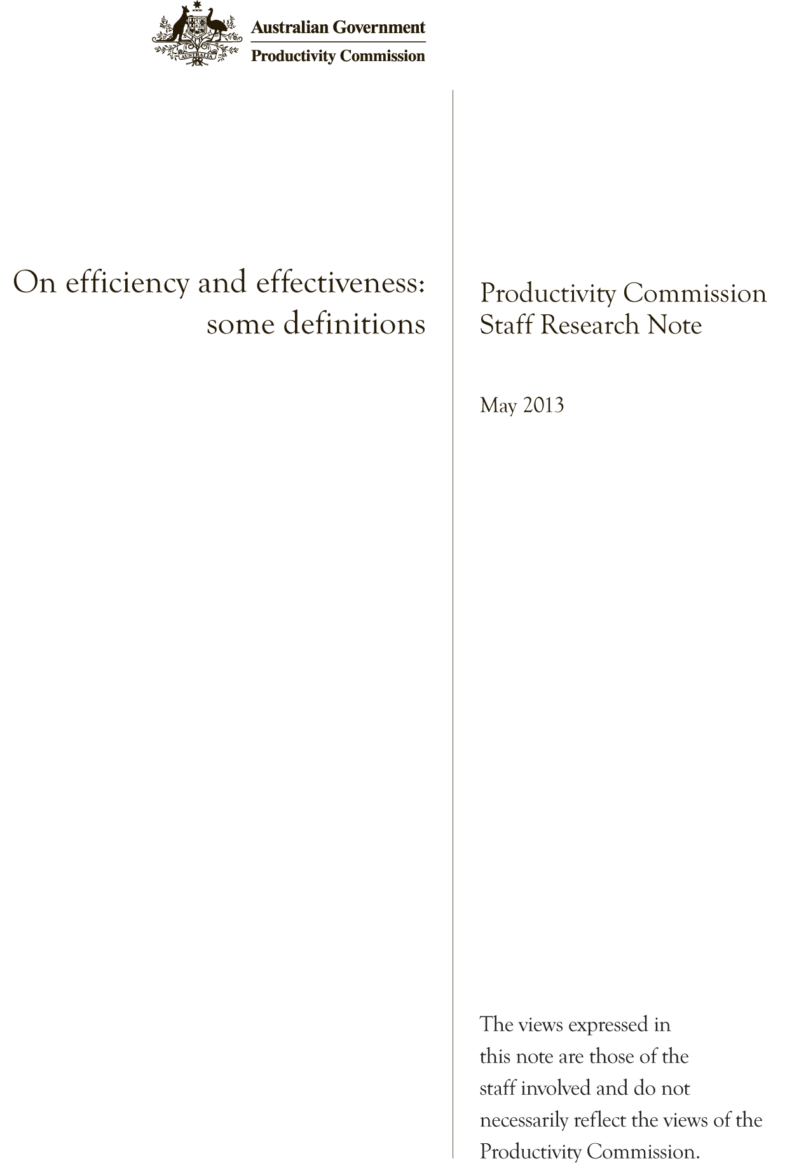
Commonwealth of Australia 2013
ISBN 978-1-74037-438-5
This work is copyright. Apart from any use as permitted under the Copyright Act 1968, the work may be reproduced in whole or in part for study or training purposes, subject to the inclusion of an acknowledgment of the source. Reproduction for commercial use or sale requires prior written permission from the Productivity Commission. Requests and inquiries concerning reproduction and rights should be addressed to Media and Publications (see below).
This publication is available from the Productivity Commission website at www.pc.gov.au. If you require part or all of this publication in a different format, please contact Media and Publications.
Publications enquiries:
Media and Publications
Productivity Commission
Locked Bag 2 Collins Street East
Melbourne VIC 8003
Tel: (03) 9653 2244
Fax: (03) 9653 2303
Email: maps@pc.gov.au
General enquiries:
Tel: (03) 9653 2100 or (02) 6240 3200
An appropriate citation for this paper is:
Productivity Commission 2013 On efficiency and effectiveness: some definitions, Staff Research Note, Canberra.
The Productivity Commission
The Productivity Commission is the Australian Government’s independent research and advisory body on a range of economic, social and environmental issues affecting the welfare of Australians. Its role, expressed most simply, is to help governments make better policies, in the long term interest of the Australian community.
The Commission’s independence is underpinned by an Act of Parliament. Its processes and outputs are open to public scrutiny and are driven by concern for the wellbeing of the community as a whole.
Further information on the Productivity Commission can be obtained from the Commission’s website (www.pc.gov.au) or by contacting Media and Publications on (03) 9653 2244 or email: maps@pc.gov.au

On efficiency and effectiveness: some definitions∗
The terms efficiency and effectiveness are commonly used, yet often are applied in slightly and occasionally widely different ways. This staff research note sets out how the Productivity Commission defines these terms along with related concepts such as cost-effectiveness and productivity.

Introduction
The terms of reference for inquiries and studies undertaken by the Productivity Commission often require the Commission to assess the efficiency and effectiveness of different policies and programs. For example, the terms of reference received on mineral and energy resource exploration asked the Commission to: ‘examine exploration approvals systems and processes, within and across jurisdictions, to assess their effectiveness and efficiency’ (Bradbury, 27 September 2012).
Economics literature uses a variety of terms to express notions of efficiency and effectiveness, as do the literatures of other disciplines. However, these terms are not always defined nor interpreted consistently within and across disciplines. For example, in some dictionaries, ‘efficient’, ‘cost efficient’ and ‘cost effective’ are given as synonyms. While many economists and others would distinguish between these terms their uses do not always align. For example, the term ‘cost effective’ is sometimes used to mean that the outcome of an action was worth more than its cost. Similarly, in everyday language the word ‘efficient’ can meaningfully carry a modifier, like ‘most’ or ‘barely’ or ‘super’. To many economists these terms have very clear and distinct meanings, and such applications are viewed as at best imprecise, and at worst misleading.
So what does the Commission (and most economists) mean when it assesses the efficiency and effectiveness of a policy or program? This research note seeks to provide some clarification.

Economic efficiency
For economists, the critical criterion applied to evaluations of policies and programs is economic efficiency. Essentially, overall economic efficiency is attained when individuals in society maximise their utility, given the resources available in the economy. In other words, an increase in economic efficiency improves the wellbeing of the members of the community — the ultimate goal of most policy or regulatory endeavours.
The concept of efficiency has a number of dimensions. Overall economic efficiency requires satisfaction of productive, allocative and dynamic efficiency (box 1).
- Maximum productive efficiency requires that goods and services be produced at the lowest possible cost. A productively efficient outcome uses the least cost input mix required to produce a given output of any good or service. This concept goes beyond technical efficiency, which is the lowest volume of inputs per unit output for each possible combination of inputs, as it takes into account the prices of the inputs.

Box 1 Components of economic efficiency
Economic efficiency is about maximising the aggregate or collective wellbeing of the members of the community. Economists commonly say that economic efficiency requires satisfaction of three components.
Productive efficiency is achieved when output is produced at minimum cost. This occurs where no more output can be produced given the resources available, that is, the economy is on its production possibility frontier (PPF). In panel I below, a shift from A to B, or to C or to D is an improvement in productive efficiency.
Productive efficiency incorporates technical efficiency, which refers to the extent to which it is technically feasible to reduce any input without decreasing the output, and without increasing any other input. When more than one input is used, or more than one output is produced, the ratio of outputs to inputs can be formed only if inputs and outputs are summed into two scalars. If prices are used for that purpose, then technical efficiency merges into productive efficiency.
Allocative efficiency is about ensuring that the community gets the greatest return (or utility) from its scarce resources. A country’s resources can be used in many different ways. The best or ‘most efficient’ allocation of resources uses them in the way that contributes most to community wellbeing. In panel II below the move from B to C is an improvement in allocative efficiency as a higher level of utility can be achieved by better matching the output mix to preferences.
Dynamic efficiency refers to the allocation of resources over time, including allocations designed to improve economic efficiency and to generate more resources. This can mean finding better products and better ways of producing goods and services. In panel III this is represented as a shift out in the production possibility frontier, with consumption rising as the economy moves from C to E. This shift can arise from innovation (producing more with less) and from growth in resources such as capital and labour. Improvements in dynamic efficiency bring growth in living standards over time.
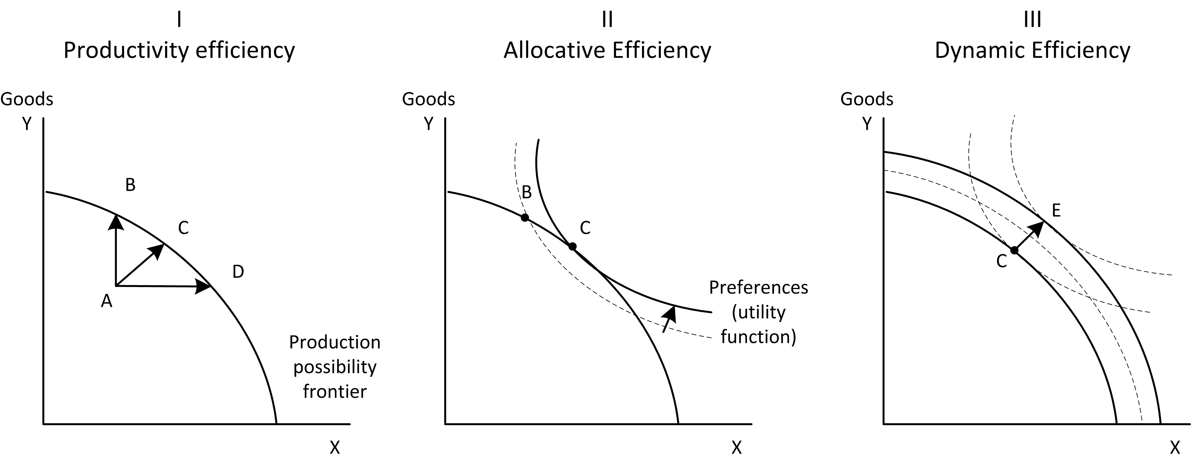
Source: Adapted from PC (1999).
- Maximum allocative efficiency requires the production of the set of goods and services that consumers value most, from a given set of resources. An allocatively efficient outcome is the output mix of the economy that best satisfies preferences. It must pass three tests:
- no good or service is eligible for inclusion in this set unless the value of the benefits that it offers is at least equal to its costs (both broadly conceived)
- the most efficient output level for any good or service is attained, where marginal benefit equals marginal cost
- of the goods and services satisfying these two cost-benefit tests, those with the highest net benefits are included in the economically efficient set.
- Maximum dynamic efficiency is achieved when these tests are met for investments, as well as for production for current consumption.
In brief, an activity is economically efficient if there is no other use of the resources that would yield a higher value or net benefit. Alternatively, an activity is economically inefficient if its costs exceed its benefits; or if it can be shown that the resources could be used to produce something with a higher net benefit.

Efficiency and public policy
These efficiency concepts are as applicable to the activities of the public sector — taxing, spending, regulating, policy making, etc. — as they are to everyday, marketed goods and services. The difference is that for marketed goods and services prices play the allocative role (Adam Smith’s invisible hand). Under specific conditions markets can be shown to allocate resources to the outputs most preferred by people in way that maximises economic efficiency. Economic institutions and policy can assist in improving economic efficiency by, for example, helping align market prices of goods and services to their true economic costs. Beyond this, in response to significant market failure, or for other reasons, such as redistribution or risk management to improve the quality of life, governments make decisions that affect production, consumption and investment. Ensuring that these decisions improve overall wellbeing requires that they satisfy the economic efficiency criterion.
In practice, much of the Commission’s work is focused on achieving gains in efficiency (for the purpose of improving community wellbeing). For example, improving economic efficiency can involve reducing the costs of production per unit of output (improving technical or productive efficiency), matching the supply of goods and services to those most desired by individuals (improving allocative efficiency), and/or removing barriers to innovation and flexibility (improving dynamic efficiency).
The Commission also aims to identify the efficient option — the policy, program or outcome that results in the highest net benefit to the community as a whole (maximises net benefits). A definition that lacks precision would be where an arrangement is considered efficient if resulting benefits outweigh all costs involved, so that a net benefit is generated. While the generation of an extra or additional net benefit (to the community) would result in an efficiency improvement, compared with having no policy or program, there may be an alternative approach that would achieve higher net benefits. The efficient option is that which generates the highest net benefit. That is, benefit greater than cost is a necessary but not a sufficient condition for economic efficiency.
There are times when efficiency can be defined, explicitly or implicitly, to be the narrower concept of technical efficiency. This can be appropriate, for example, when undertaking a program evaluation; and the terms operationally efficient can be used in this context. The question then is ‘Is there a better (more efficient) way of achieving the objectives?’ But generally it is also necessary to ask the broader questions, relating to allocative (and dynamic) efficiency: Are the specified objectives the right ones? Is the program or policy the most appropriate use of resources? And, taking dynamic considerations into account, does the program or policy enhance future outcomes in a way that supports the community’s ongoing wellbeing?

Effectiveness
In general, effectiveness the extent to which stated objectives are met — the policy achieves what it intended to achieve. The goal can be as broad or as narrow as is deemed appropriate — a continuum exists, ranging from achieving very specific outputs (such as ‘increasing the number of solar heating panels installed in new houses’) to very general outcomes (such as ‘improving the environment’ or even ‘improving community living standards or wellbeing’).
The Commission’s framework for measuring the performance of government services in the Report Government Services (ROGS) is set out in figure 1. ROGS defines performance indicators based on the concept of effectiveness at two levels (SCRGSP 2006):
- Cost effectiveness performance indicators are based on what the ROGS defines as ‘technical efficiency’ (which is akin to productive efficiency described above). These indicators estimate the unit costs of producing well- defined outcomes.
- Program effectiveness performance indicators are based on agreed measures of access, appropriateness, and quality. These indicators aim to reflect the extent to which the objectives of government expenditure are achieved.
Using this framework, a service would be judged to be more effective in achieving its objective if, say, it provided better quality services or better access to clients. Service options could then be ranked in terms of their degree of effectiveness.

Effectiveness and causality
Indicators of the effectiveness of programs generally focus on measuring the changes in outcomes that reflect the objectives of the program. Yet, as figure 1 makes clear, outcomes depend not just on the program outputs but also on external influences. Outputs too may depend on other inputs, in addition to program inputs. For example, at the individual level, the outcome of interest might be the days of hospital stay for a particular procedure. The person’s health going into the procedure is an input that is largely out of the control of the hospital, but will affect the cost of undertaking the procedure, and well as the length of the hospital stay. Adjusting for such external influences, or recognising where they differ when making comparisons, is important in interpreting effectiveness measures.
Figure 1 The Report of Government Services framework
Source: SCRGSP (2006)
More broadly, measures of outcomes alone do not provide information about causality — that the program inputs caused the outcome. Economists apply the concept of the counterfactual to determine what would have happened in the absence of the program or policy. The effectiveness of a program should be measured by the change in the outcome relative to this counterfactual. Operationalising this usually requires setting targets that imply an improvement on what would otherwise have happened. Where the counterfactual is an expected deterioration in the outcome, the appropriate target may be no change, or a smaller decline, which can be conceptually hard to explain. As targets should be achievable, this can create a quandary for measuring effectiveness.
The Commission used the term ‘additionality’ in its report on research and development (R&D) and innovation (PC 2007b) to focus attention on whether programs to promote R&D were effective. Program effectiveness was assessed by how much extra R&D was undertaken by firms as a result of the incentives, such as the R&D tax concessions. Working out what is ‘additional’ requires forming a view of the counterfactual — the level of R&D a firm would have undertaken without the incentive. Methods to estimate this counterfactual include modelling, applying historical trends, and comparisons with similar firms which did not access an incentive program.

Cost effectiveness
A common ‘effectiveness concept’ is cost effectiveness. For example, COAG’s Principles and Guidelines for National Standard Setting and Regulatory Action (2004) state that cost effectiveness offers a priority ranking of proposals with the same or similar outputs or benefits, on the basis of comparative ‘cost per unit of effectiveness’ or ‘units of effectiveness per dollar’. Also, the term cost effectiveness is frequently used to cover the case of achieving the maximum level of output for a stated level of inputs or cost. Thus, a method of delivery of a government service could be judged to be more cost effective than another when it produces more of the output for the same cost. The ROGS framework covers both cases — more output, same cost; same output, less cost — in either case the most cost effective option is that which has the lowest unit cost.
The cost effectiveness concept can be very useful where a desired outcome has been agreed, and the main issue is how to achieve this at the lowest cost. For example, it makes sense to take the lowest cost option of achieving an agreed reduction in carbon emissions (PC 2007a). This approach avoids the question of whether such action improves economic efficiency, which depends on the costs relative to the benefits of the emissions reduction.
The question of the economic efficiency of an option aside, cost effectiveness measures work well for identifying a preferred option where there is a single clear measurable outcome. They are more difficult to apply where options differ in both effectiveness and in cost, and not merely in one or the other. This is a particular problem where the outcomes are not directly comparable. For example, in the report on Caring for Older Australians (PC 2011) the Commission had to compare the costs of supporting older people to remain in their home and receive community care, with those of moving to a residential facility. The location at which care was provided affected the outcome, with people expressing a strong preference for home based care. The outcomes of care at home and care in a residential facility are valued differently.
The inputs differ too, as family and friends are likely to provide informal care in the home setting. This illustrates an additional issue with cost-effectiveness measures, which is which costs are taken into account. Cost effectiveness measures in most government programs focus on the direct program costs. In the aged care example, from a public finance perspective the cost effectiveness of home based care programs might be high relative to residential care. But from an economic efficiency perspective all the costs, including to informal carers, need to be taken into account. No easy conclusion can be drawn as to which to prefer, unless appropriate values or prices can be attributed to the various inputs and outcomes. However, if satisfactory estimates of the values generated by the two options are available, then, on efficiency grounds, the option with the larger net benefit is to be preferred.

The relationship between economic efficiency and cost effectiveness
If an option is deemed to be economically efficient, it must also be the most cost effective (using the COAG definition of cost effectiveness). The converse is not always true — cost effective policies and programs need not be economically efficient.
Cost effectiveness analysis is often used as an alternative to cost-benefit analysis where it is easier to estimate the desired outcomes, than it is to value them. Taking carbon mitigation as an example, a cost effectiveness analysis of policy options can identify the lowest cost approach to a particular reduction in carbon emissions. However, a cost effectiveness study cannot by itself demonstrate a conclusive case (on grounds of economic efficiency) for or against the appropriateness of a proposal, because it is concerned only with possible alternative unit costs, and not concerned with whether the total costs exceed or are exceeded by the total of prospective benefits. The beneficial effect, although achieved as cheaply as possible, may not be worth the cost — that is, it may not contribute to economic efficiency.
Going further, even if a particular policy option is the most cost effective available, and even if it does indeed produce more benefits than cost, employing it may not maximise overall economic efficiency. It may be better to abolish the program entirely and use the resources to produce something else. That is, a different use of resources may deliver a more allocatively efficient result, where consumers’ wants and needs are better met. Achieving the best input mix does not guarantee that the output mix will be preferred over feasible alternatives.
The term ‘cost effective’ is, nonetheless, sometimes used as shorthand for asserting that there is a net benefit (that the total benefits of an activity exceed its total costs). There is a danger of an invalid inference being drawn in this usage, namely, that there is no better, feasible alternative — doing something else, or doing nothing. Doing something always has a cost, which is closely related to the counterfactual, as it is what is forgone as a result of undertaking a particular option. The opportunity cost is the value of the best foregone opportunity. For example, a heavy handed approach to regulation to protect consumers may impose compliance costs for the businesses (which are passed on to their customers in higher prices, back to their suppliers in lower prices for inputs, or to their shareholders in lower returns). The opportunity cost of this approach is the difference in these costs compared to an alternative light handed approach which achieves the desired consumer protection at least cost.
It is worth noting that the line between cost effectiveness and economic efficiency becomes more blurred the more broadly the policy objectives (or outcomes) are defined, and the wider the concept of costs adopted. At the limit, determining that a policy has cost effectively improved the wellbeing of society would seem to be equivalent to saying that the policy has improved economic efficiency.

Relationship between efficiency and productivity
In addition to efficiency and effectiveness, the Commission is often asked to consider the impact of a policy on productivity. Indeed, analysis of Australia’s productivity performance and the factors underpinning it is a major area of supporting research undertaken by the Commission. Productivity analysis can be applied to the whole economy, or to parts of it. Usually, two types of productivity are considered: partial factor productivity — that is the productivity of separate productive inputs (like labour, or capital, or electricity); and total factor productivity or multifactor productivity (MFP) — that is, the productivity of the whole mix of inputs engaged in production or in value-adding(box 2).
The Commission generally focuses on measures of MFP. This ratio of a volume index of output to a volume index of inputs is sometimes called ‘technical efficiency’. However, volume indexes do not always have simple physical or ‘technical’ interpretations. As discussed in box 2, adjusting for quality changes can be difficult, and the approach taken to constructing the price index used to adjust value to get a volume measure can affect the estimates.

Box 2 The concept of productivity
Like efficiency, the term productivity can be interpreted in a number of ways. As a general concept, productivity growth is the growth in volume of output relative to growth in the volume of inputs. However, measures of productivity vary in how inputs and outputs are calculated. The Commission’s analysis generally focuses on multifactor productivity, but other productivity measures can also be useful.
Multifactor productivity (MFP) — focuses on the change in the volume of output relative to the volume of primary inputs — labour and capital. The volume of output for an industry is the ‘value-added’ by the industry, that is, the total value of sales less the cost of intermediate inputs. Capital and labour inputs and value added output are measured by ‘volume’ or ‘quantity’ indexes that adjust the total value for changes in prices. Hence MFP does not reflect changes in prices, say due to changes in the terms of trade, or a shift in domestic preferences. Ideally, the volume indexes will be adjusted to reflect changes in the quality of outputs and inputs, which may also be reflected in the price. However, in practice such adjustments are limited to where quality can be measured reliably.
Total factor productivity (TFP) — this concept is very similar to MFP, but it uses volume indexes based on the total value of output and the total cost of labour, capital and intermediate inputs.
Labour productivity (LP) — measures the change in the volume of output relative to the change in the volume of labour inputs. In general labour inputs are measured in terms of total hours worked, but quality adjusted labour input indexes have also been constructed. LP growth estimates using quality adjusted labour inputs will be lower where the quality of labour is growing.
Capital productivity — measures the change in the volume of output relative to the change in the volume of capital inputs. Measuring the volume of capital accurately is challenging as quality changes are not uniform across different types of capital, and utilisation rates and rates of depreciation and obsolesce can vary over time and across industries.
Firm productivity — while this should refer to the change in the firm’s volume of output relative to the volume of inputs used by the firm, it is often (incorrectly) used to refer to a change in the value of the firm’s outputs relative to the cost of its inputs — its profitability.
Volume indexes are constructed by deflating the value measure with a price index. There are a number of ways to construct price and volume indexes which have implications for the productivity measure. It should be noted that there are some forms of calculation of productivity, using Divisia or welfare indexes, that come closer to reflecting changes in overall value, or net benefit to the economy.

More fundamentally, as the Commission’s report on productivity in mining (Topp et al 2008) found, there can be unmeasured inputs that affect the measurement of MFP (or any other productivity measure). For example, the rising prices of minerals have made it economic to mine more marginal deposits, and mining leads eventually to resource depletion. As the quality of the resource being mined is not treated as an input in productivity measurement, productivity estimates reflect both changes in technical efficiency and in the resource input. One option for industries which rely on natural resource inputs is to include them in the input index, which would make MFP a better measure of technical progress. However, this introduces additional complexities into the measurement, and reduces the extent to which growth in MFP is reflective of changes in living standards that can be supported by a country’s economic activity.
Growth in MFP and other productivity measures are, however, only one source of improvement in living standards. In recent years, the strong growth in Australia’s terms of trade — the prices of the things produced relative to the prices of those things consumed — has supported increased income and with it living standards. This is despite a relatively lacklustre productivity growth performance over the last decade (Parham 2012). This illustrates the distinction between productivity and economic efficiency. Allocative efficiency requires that resources move to firms and industries that provide the greatest net benefit – which depends on relative prices as well as productivity. The shift of labour and capital into mining and supporting industries raised Australia’s income, but lowered its productivity growth (PC 2012). Yet, not allowing resources to move would have reduced the growth in income in Australia, making people worse off. This demonstrates that it is economic efficiency rather than productivity that should be the overarching objective of government economic policies. That said, all else equal, growth in MFP unambiguously increases the standard of living that an economy can provide for its population. It is just that an efficient allocation of resources also allows the population to enjoy the greatest possible gains to trade.

Some definitions
- Technical efficiency. A measure of how well an input (such as a pharmaceutical drug) is converted into an output (such as hospital separations). Measured as the ratio of physical output to physical input.
- Productive/production efficiency. A measure of how well a given value of inputs (such as salaries, and the costs of equipment and drugs) is converted into output value (such as the fees paid for surgical procedures and subsequent recovery in hospital). Measured as the ratio of the value of outputs to the value of inputs. Productive efficiency is an element of the usual measurement of total or multifactor productivity.
- Allocative efficiency. A measure of how well the available resources are allocated to production that meets the preferences of the population. Measured as a change in net benefits (broadly defined). The term allocative efficiency is sometimes defined so broadly as to equate it with the concept of overall economic efficiency.
- Dynamic efficiency. A measure of how well resources are allocated over time to meet the current and future preferences of the population.
- Economic efficiency. A measure of the increase in net benefits; encompassing productive, allocative and dynamic efficiency An economically efficient option means that no other option can provide a higher net benefit.
- Effectiveness (of a program or service). A measure of how well the outputs of a program or service achieve the stated objectives (desired outcomes) of that program or service.
- Cost effectiveness. A measure of the extent to which the cost of resources, used to produce a specified output or outcome, has been minimised. Cost effectiveness involves comparisons of the costs of alternative ways of producing the same or very similar effect; or comparisons of the effect produced by alternative ways with the same or very similar cost. An option is cost effective if it has the lowest cost of all the ways of producing the same or very similar effects. This does not mean that the option necessarily has a positive net benefit.

References
Bradbury, D. 2012, Minerals and Energy Resource Exploration: Public Inquiry — Terms of Reference, 27 September.
Council of Australian Governments (COAG) 2004, Principles and Guidelines for National Standard Setting and Regulatory Action.
Parham, D. 2012, Australia’s Productivity Growth Slump: Signs of Crisis, Adjustment or Both?, Visiting Researcher Paper, Productivity Commission, Canberra.
PC (Productivity Commission) 2012, Annual Report 2011-12, ch. 1, Annual Report Series, Canberra.
—— 2011, Caring for Older Australians, Report No. 53, Final Inquiry Report, Canberra.
—— 2007a, Productivity Commission Submission to the Prime Ministerial Task Group on Emissions Trading, March.
—— 2007b, Public Support for Science and Innovation, Research Report, Productivity Commission, Canberra.
—— 1999, Microeconomic Reforms and Australian Productivity: Exploring the Links, Commission Research Paper
SCRGSP (Steering Committee for the Review of Government Service Provision) 2006, Report on Government Services 2006, Productivity Commission, Canberra.
Topp, V., Soames, L., Parham, D. and Bloch, H. 2008, Productivity in the Mining Industry: Measurement and Interpretation, Productivity Commission Staff Working Paper, December.

∗ This Staff Research Note is an updated version of an Internal Research Memorandum produced in February 2006, written by Jonathan Pincus. The original document was motivated by Helen Owens, and drew heavily on the preliminary work of Steven Argy, Sarah Box and Sue Holmes, and from comments from Mike Woods and a number of other Commissioners and staff.
Some dictionary definitions are: Effective: serving to affect the purpose; producing the intended or expected result (Macquarie). Efficient: productive of desired effects; especially: productive without waste (Merriam-Webster); working productively with minimum wasted effort or expense (Compact Oxford). Cost-efficient: productive relative to the cost (RhymeZone). Cost-effective: economical in terms of tangible benefits produced by money spent (Merriam-Webster); effective or productive in relation to its cost (Compact Oxford).
This is called achieving ‘Pareto efficiency,’ or ‘reaching the utility frontier’. With this allocation of resources no one can be made better off without making someone else worse off, nor could the winners from a reallocation compensate the losers (Kaldor’s extension of Pareto efficiency). Note that this criterion takes the initial distribution of resources (and utility) as given, and only considers changes from this state.
Wellbeing includes both the quality of life that people experience as well as their standard of living that comes from the goods and services that they consume. These goods and services are produced in the market and non-market sectors of the economy using human, produced (physical and knowledge), natural and social capital resources. While intrinsic outcomes such as rights, freedoms and relationships are important for the quality of life, and interact in complex ways with production processes and the material standard of living, economic analysis mostly focuses on the allocation of resources for the production of goods and services to meet the preferences of the population. The concept of efficiency relates to this allocation, and hence the standard of living contributions to wellbeing.
In addition to these three components of efficiency, a number of other terms are used in the literature, but for brevity are not discussed here. They include: consumption efficiency; exchange efficiency; administrative efficiency; and inter-temporal efficiency (the last being a version of dynamic efficiency).
This is the first fundamental theorem of welfare economics. The conditions are complete markets (which also requires full information and no externalities) and perfect competition (no producer or consumer has market power). Market failure occurs when one or more of these conditions do not hold. However, markets may still provide the economically efficient outcome where market failures are minor, and/or the resource cost of correcting the failures is high.
If economic efficiency is defined in terms of income rather than utility the connection between community wellbeing and economic efficiency can be less conclusive. For example, if the purpose of policy is to redistribute income, the Hicks-Kaldor criterion defined in terms of income can be violated: the winners could not fully compensate the losers, without themselves becoming losers. If, however, economic efficiency is defined in terms of utility, to the extent that the redistribution reflects the preferences of the people in the community (they care about the income of the less well-off) the Hicks-Kaldor criterion is satisfied. However, in practice measuring such values is difficult and whether the level of redistribution maximises wellbeing is generally left to the political process to determine.
If a number of individual markets fail to meet the requirements for full efficiency, improving the efficiency of one of them is not guaranteed to improve the overall efficiency of the economy. This is referred to as the problem of second best.
Analysts cannot evaluate every counterfactual, every conceivable allocation of economic resources. Therefore, the estimate of opportunity cost is limited to the range of options considered.
They also reflect a capital lag effect as accelerating growth in the capital stock and the time taken to bring mines into production led to capital inputs effectively being over estimated (Topp et al 2008).

