Productivity Commission Submission

September 2019
Senate Select Committee on Jobs for the Future in Regional Areas

Introduction
The Productivity Commission (Commission) is pleased to make this submission to the Senate Select Committee on Jobs for the Future in Regional Areas.
The Commission is the Australian Government’s independent research and advisory body on a range of economic, social and environmental issues affecting the welfare of Australians. We contribute by providing quality, independent advice and information to governments, and on the communication of ideas and analysis.
The core function of the Commission is to conduct public inquiries at the request of the Australian Government on key policy or regulatory issues bearing on Australia’s economic performance and community wellbeing. In addition, we undertake a variety of research at the request of the Government and to support its annual reporting, performance monitoring and other responsibilities.
This submission briefly addresses a number of the matters in the Committee’s terms of reference, drawing on existing work undertaken by the Commission. The submission is organised around the broad themes of the future of work, structural adjustment and change in regional areas and regional development policy.

The future of work
The current Australian economy bears little resemblance to the economy of the early twentieth century. There has been substantial transformation in the nature of businesses and jobs over the past few decades. Technological change and globalisation have driven long-run multifactor productivity growth, while higher incomes have driven demand for services (figure 1).
The Commission has explored the future of work by looking back at how Australia has adopted to the above forces, while also considering circumstances where today may be different.

Figure 1 National trends in employment and value added by industrya
Mining | Agriculture
Manufacturing | Services

a Value added data are up to March quarter 2019.
Sources: ABS (Labour Force, Australia, Detailed, Quarterly, May 2019, Cat. no. 6291.0.55.003); ABS (Australian National Accounts: National Income, Expenditure and Product, Mar 2019, Cat. no. 5206.0).
Labour markets have been reasonably resistant to the large shocks posed by new technologies. Overall employment has grown, and while unemployment rates have fluctuated over the long run, they have not trended up over the long run, as would be expected if new jobs and occupations did not emerge to replace obsolete jobs. Technology can also facilitate workforce participation by making job search easier, and by expanding the scope of work than can be done (remote work, part-time work, freelance work).
Speculation about the effects of technologies often suffer from extreme optimism or pessimism. And some popular impressions about the modern labour market need myth busting. For example, the relative prevalence of casual work and self-employment has not increased significantly, nor has job tenure declined (PC 2015). In reality, change is slow.
The gig economy is still in its infancy, but this may change in the future. A challenge for policy is, on the one hand, to ensure protections for workers while, on the other, not destroying the opportunities for economic growth that rely on new forms of employment. The workplace relations framework will need to consider whether the traditional demarcation between an employee (lots of protections) and a contractor (few protections) is apt for the future (PC 2016).
Automation and machine learning will lead to the creation of new occupations and jobs, while threatening a range of other jobs. It is likely to be tasks rather than jobs per se that will be automated (see box 1). And just because a job can be automated doesn’t mean that it will be. To date, most risk of automation has been experienced by ‘moderately skilled’ jobs. Jobs that require creativity and human empathy are less likely to be automatable. Jobs growth is likely to be strong in areas like disability and aged care.
Some workers will struggle to adjust to changes in demand for their skills and new, more flexible but less reliable, work options. The most vulnerable groups in this regard are likely to be: young people with little experience and low skills; and older people in industries subject to major structural change, and who are unable to acquire new skills readily.
Australia’s social safety net will remain important in mitigating risks for workers. Other policy responses should similarly focus on these at-risk workers who have least prospect of picking up a new job. This includes having access to a high quality education system geared to the needs of students. The Commission’s most recent prognosis is that the school, VET and university systems are not delivering the best student outcomes (PC 2017a). Our education system also needs to shift its emphasis from front-ended study to providing life-long learning, thereby facilitating the inevitable transitions from job to job and occupation to occupation that will occur over people’s lifetimes.
While governments have been encouraging students into STEM degrees, such graduates have faced underemployment and underutilisation of their skills. Rather than trying to pick winners, governments can support students and workers by improving information on the employment outcomes for students across skill sets and educational institutions to better inform student choice (PC 2016).

Box 1 Suitability for Machine Learning
Machine learning does not replace jobs; it replaces tasks within jobs, enabling workers to focus on areas unsuitable for computers. Brynjolfsson and Mitchell (2017) established a methodology evaluating the suitability of machine-learning tools to undertake a range of tasks, and connected those tasks to occupations to create occupation-specific Suitability for Machine Learning (SML) scores. The Commission linked the latest US results and Australian data to create relative SML scores for over 2000 local regions in order to gain insights into the geographic and occupational opportunities faced here.
These data suggest that remote and regional areas are potentially less exposed to the next wave of automation than city and urban areas. This reflects the differences in occupational mixes between regional and urban Australia, and the history of automation in the past. For example, many routine and manual functions in the agricultural, manufacturing and trade occupations have already been automated. Whereas sales and managerial occupations — often concentrated in cities and urban areas — have greater suitability for machine learning and relatively low levels of historical automation.
The flipside of this is that technology-driven opportunities are more limited in regional Australia. The application of automation and machine learning would be accompanied by increased demand for ICT business and systems analysts and software and application developers, occupations highly concentrated in cities.
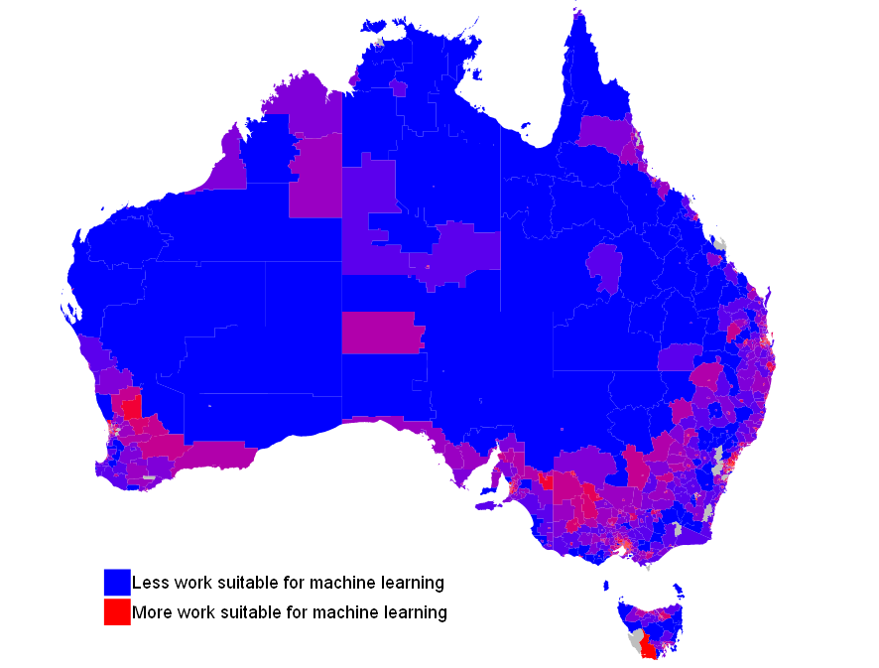
a Results are presented for Statistical Area Level 2s (2310 regions), as defined under the Australian Statistical Geography Standard. Grey areas had insufficient data for scoring. b For each region, a relative SML score was created by linking the Brynjolfsson, Mitchell and Rock (2018) task-to-occupation SML scores (18 156 tasks, linked to the 964 O*NET-SOC occupations), mapped to the 358 ANZSCO occupations in Australia, and then doing a weighted sum based on the share of residents in each occupation.
Sources: Brynjolfsson E. and Mitchell T. 2017 ‘What Can Machine Learning Do? Workforce Implications.’ Science 358 (6370): pp. 1530–34. Brynjolfsson E., Mitchell T. and Rock D. 2018 ‘What Can Machines Learn and What Does It Mean for Occupations and the Economy’, AEA Papers and Proceedings 2018, 108: pp. 43–47, May.

Growth and structural change in regional areas
A range of economic forces have affected the economic and social development of Australia’s regions, including the mining resources boom, productivity in the agriculture industry and structural adjustment in the manufacturing industry. This is in addition to broader developments such as globalisation, population ageing, technological advancements and climate change.
The Commission explored how the regions were adjusting to the resources boom through the lens of geographic labour mobility in 2013-14 (PC 2014) and, more recently, how regions were transition from the resources investment boom to a more sustainable economic base (PC 2017b).
The Commission found that the mining boom has made Australians substantially better off in the short term and over the long term. Adjustment from the mining boom is generally not a source of significant disadvantage and does not justify special intervention from governments (PC 2017b). But not all regional communities have experienced the same resilience (see also box 2 on regional adaptive capacity).
In (PC 2014), the Commission conducted quantitative work on regional migration patterns in order to provide insight into the factors that influence aggregate people movements, and on the factors that influence the decision to move at an individual level.
- Gravity (a region’s size), distance and economic opportunities are the main determinants of whether a region attracts people at an aggregate level. And labour appears to be moving to areas with better job and income opportunities; that is, workers seem to be responding to market signals.
- Young people, single people, recent overseas migrants, unemployed people and more highly educated and skilled people all move between labour markets more than other groups. Life events and family circumstances appear to be the most important factors in decisions to move, but factors related to housing, employment and local infrastructure also play a prominent role.
- Fast growing regions can experience skills shortages alongside high unemployment rates due to skills mismatches. Overseas migration and fly-in-and-fly-out (FIFO) have assisted in addressing skills shortages in hard-to-fill regions and occupations.
Structural adjustment and geographic labour mobility can lead to small regional communities contracting in size and losing key services. In many cases, those who remain in these communities are the most disadvantaged. Governments have attempted to support these communities by putting in place various decentralisation policies and offering incentives for people to work in regional and remote areas. These have had, at best, mixed results (see below).

Box 2 A measure of regional adaptive capacity (PC 2017b)
The Commission developed a single metric of regional adaptive capacity. The metric can be used as a litmus test to identify regions which may find it difficult to adjust to significant economic disruptions.
People-related factors (including education, skills, employment, income and community cohesion) strongly shape adaptive capacity, particularly for communities in urban areas. For communities in remote areas, these and other factors associated with remoteness, such as accessibility to services and infrastructure, have the strongest influence on results.
However, caution is required in interpreting the metric and using it as a basis for policy making. A single metric of relative adaptive capacity cannot fully capture the unique attributes of each regional community. Further, the metric does not predict the likely outcome of a region to a shock, which is based not only on the region’s adaptive capacity but also the nature of shocks it faces, the options available to people affected, and the decisions that they make.
Source: PC 2017b.

Structural change in regions can be exacerbated by poor planning for population growth and inadequate infrastructure. The Commission heard examples of local governments not being consulted on major developments within their area (PC 2014 and 2017c). And local governments themselves may not have the capacity (skills or funding) to carry out their responsibilities effectively. The Commission noted the importance of early local consultation as part of planning and approval processes for major projects and land release and use.

Regional development policy
All levels of government support people living in regions through the provision of services such as health, education, and community services, as well as infrastructure services (including transport and the National Broadband Network). An education and training system that is of high quality, flexible and responsive to the changing needs of individuals is a major enabler of individual and regional opportunity and prosperity.
Australia also has a long history of regional development policies (sometimes intertwined with industry policy and structural adjustment policy) that aim to influence the location of economic activity.
There are no simple levers to affect regional development. Time and again, policies aiming to influence where people live and work, and where businesses operate, have not delivered measurable benefits. In addition, government support always comes at a cost to people in Australia, as taxpayers must find the money.
In its Transitioning Regional Economies report (PC 2017b), the Commission proposed some principles for assessing the scope for economic and social development in regions. These involve:
- incorporating the views and knowledge of regional communities
- identifying and supporting a region’s relative strengths (comparative advantage)
- identifying any unnecessary regulatory impediments to people or businesses taking up economic opportunities, or relocating (either within, or to other regions)
- considering the capabilities of people in regional communities and the region’s connections with other regions and markets
- evaluating whether existing programs and strategies aimed at regional development (or adjustment) are effective and provide value for money
- embedding robust evaluation and transparent processes for policy/project proposals, which include clear objectives, identification and assessment of options, and monitoring and evaluation of outcomes
- considering the scope for private economic activity that is not dependent on ongoing government financial support (other than payments made under general taxation, social security and welfare policies).
Specific adjustment assistance to individual regions should be reserved for extreme events that are likely to result in high levels of permanent disadvantage in a community, and where the general safety net arrangements are demonstrably inadequate. Assistance should focus on securing employment (such as targeted and time-limited training assistance and provision of information on industry needs and employment opportunities).

References and further information
Further information is available on the Commission’s website at www.pc.gov.au
(PC 2014) Geographic labour mobility: research report
(PC 2015) Workplace relations framework: inquiry report (chapter 2)
(PC 2016) Digital disruption: What do governments need to do?
(PC 2017a) Shifting the Dial: 5 year productivity review (chapter 3 and supporting paper 8)
(PC 2017b) Transitioning regional economies: research report

