
March 2022

Head in the cloud: firm performance and cloud service
  - Conference paper
Henry McMillan
Tim Murray
Catherine de Fontenay
Ralph Lattimore

The views expressed in this paper are those of the staff involved and do not necessarily reflect the views of the Productivity Commission.
The Productivity Commission acknowledges the Traditional Owners of
Country throughout Australia and their continuing connection to land,
waters and community. We pay our respects to their Cultures, Country and Elders past and present.

The Productivity Commission
The Productivity Commission is the Australian Government’s independent research and advisory body on a range of economic, social and environmental issues affecting the welfare of Australians. Its role, expressed most simply, is to help governments make better policies, in the long term interest of the Australian community.
The Commission’s independence is underpinned by an Act of Parliament. Its processes and outputs are open to public scrutiny and are driven by concern for the wellbeing of the community as a whole.
Further information on the Productivity Commission can be obtained from the Commission’s website (www.pc.gov.au).

© Commonwealth of Australia 2022

With the exception of the Commonwealth Coat of Arms and content supplied by third parties, this copyright work is licensed under a Creative Commons Attribution 4.0 International licence. In essence, you are free to copy, communicate and adapt the work, as long as you attribute the work to the Productivity Commission (but not in any way that suggests the Commission endorses you or your use) and abide by the other licence terms. The licence can be viewed at: https://creativecommons.org/licenses/by/4.0.
The terms under which the Coat of Arms can be used are detailed at: www.pmc.gov.au/government/commonwealth-coat-arms.
Wherever a third party holds copyright in this material the copyright remains with that party. Their permission may be required to use the material, please contact them directly.
An appropriate reference for this publication is:
McMillan, H, Murray, T., de Fontenay, C., Lattimore, R. 2022, Head in the cloud: firm performance and cloud service, Conference paper, Productivity Commission, Canberra

Publication enquiries:
Media, Publications and Web | phone 03 9653 2244 | email publications@pc.gov.au

Head in the cloud: firm performance and cloud service

Abstract
There is good evidence that cloud services improve productivity. Such services allow businesses to tailor their computing resources more flexibly to their organisational needs, avoiding the large fixed costs of conventional computing solutions, and enable new ways of working. COVID-19 undoubtedly further increased the uptake and application of cloud computing because it suited remote working and the virtual delivery of services.
But there is little empirical evidence about the extent to which cloud services increase firm performance and returns to labour, the types of firms where this occurs or the role of complementary inputs. This paper uses a novel application of machine learning tools (causal forests) to data from the Business Longitudinal Analysis Data Environment (BLADE) to assess the impacts of cloud computing services.
Causal forest results suggest that cloud technology is associated with higher firm turnover per worker and higher wages per worker, taking into account numerous features to proxy management capability and entrepreneurial attitudes within firms. The effects are larger for regional businesses, for which cloud technologies assist in overcoming the tyranny of distance.
An advantage of the machine learning approach is that it can uncover how effect sizes of the uptake of cloud services vary with idiosyncratic features of the firm. Intriguingly, there are a large number of firms that, given their features, appear likely to benefit from cloud services, but have not yet adopted them, and a non-trivial share of firms that have adopted cloud services but have experienced negative impacts on performance. The former likely reflects the historical norm of the gradual diffusion of new technologies. The latter, more beguiling (and more fragile) result suggests that some firms do not have the complementary competencies to benefit from cloud services.

In 2020, Pizza Hut aimed to celebrate its 50th anniversary of activity in the Australian market by giving away 10 000 pizzas in two--hour slots for each of five days. The ordering process was via a cloud--based platform with the assumption that there would be orderly flow of sales over each two -hour window. Instead, all of the initial tranche of 10 000 pizzas were given away in the first 70 seconds, a transaction load that was only feasible because cloud services are so quickly scalable (Cameron 2021). This is an illustration of the profound impacts of the cloud on agility and scalability, but also emblematic that sophisticated IT use can flourish in businesses once characterised as ‘low tech’.
The ‘cloud’ has been characterised as the infrastructure for enhancing the productivity of all forms of information technology, with optimistic views about its long run ‘transformative’ impacts on people’s quality of life and productivity (Mills 2021). It has the potential to have a material effect on productivity given that its functions are relevant to all parts of the economy and as expenditure on cloud services comprise a large share of business IT expenditure in Australia and globally (DeStefano, Kneller and Timmis 2020). The 2021 market for cloud services is expected to be about $330 billion (Gartner 2021).
But systematic evidence about the impacts of the cloud on business performance is scanty globally and even thinner in Australia. This paper explores some of the current impacts on business performance of the cloud in an Australian context, while being mindful that its full potential may be yet to emerge. The novel aspect of the paper is its application of machine learning (ML) techniques (causal forests) to a rich dataset combining administrative data and survey responses on business innovation, IT and management features.

1. What is the Cloud?
The cloud refers to services run over the internet rather than on a local device as for traditional software. The cloud comprises numerous server hosting platforms (datacentres) that provide decentralised services, with minimal infrastructure and software needs at the firm level. The largest players in this space are Amazon Web Services, Microsoft Azure and Google Cloud.
The main categories of cloud services are:
- Software-as-a-Service (SaaS) — An application delivered though the internet (for example, Microsoft Office 365, Zoom)
- Platform-as-a-Service (PaaS) — Provides platforms and tools to make your own software, undertake analytics or perform other business functions. This typically includes operating systems, development tools, gateway software, web portals and databases. For example, PaaS could include an inventory database or Citrix desktop. PaaS reduces the need for buying/modifying in-house software and the building and testing of security. Overall, it increases the speed of deployment of new applications and allows high levels of scalability.
- Infrastructure-as-a-Service (IaaS) — Raw computational power and storage external to the firm that they can use to build any service they may require. For example, a business can avoid setting up and investing in its own data centre, eliminating the costs of maintaining hardware and investment in in-house servers and storage. In-house investments are also built for peak demand where as IaaS is scalable. As an illustration, the Real Estate Institute of Queensland shifted from ageing infrastructure vulnerable to security risks to IaaS (Amazon Web Services) and SaaS (Office 365) (idea 11 2021, p. 11).

2. The potential impacts of cloud technology
Cloud provision is typically structured as a pay-as-you-go service — sometimes supplied through subscription-based pricing — that allows businesses to access scalable services (virtual machines) and avoid the costs of excess capacity and uncertain returns associated with large upfront lumpy investments of software and hardware (Bayrak, Conley and Wilkie 2011; Minifie 2014). These fixed costs are instead met by vendors and efficiently spread across many business customers. Firm-specific spikes in demand for services are effectively smoothed out (so--called ‘shared economies of scale’). And because cloud technology (particularly IaaS) eliminates the need to make lumpy investments, it is particularly beneficial for regional firms forced to operate below efficient scale because demand in their region is low.
Moreover, whereas infrastructure like the poles, wires, towers, trenches and dams that are the fundamental cost drivers for telecommunications, electricity and water services must be provided locally with accompanying risks for quality and adequate supply, cloud infrastructure can be in any low-cost location in the world (unless impeded by data localisation regulations). Thus firms can access more reliable, affordable and scalable services via the cloud.
One aspect of this is the capacity for smaller and younger firms to rapidly access technologies that were previously cost-prohibitive (DeStefano, Kneller and Timmis 2020) or whose sunk nature meant they were subject to credit constraints (DeStefano et al. 2019). More generally, cloud services can lower entry costs into activities requiring large lumpy or specialised IT investments, and thereby stimulate experimentation with IT and innovation generally. There is some evidence of this in Europe (Etro 2009) and the United States (Jin and McElheran 2017).
Innovative cloud applications with significant cost-saving potential are now available to most firms. Digital technology cost savings can be broken down into search, replication, transport, tracking and verification cost savings (Goldfarb and Tucker 2019). Search costs are reduced when common databases are updated and used in real time; replication costs are reduced when employees in different locations can access completed work from other offices; and so on. Verification costs are reduced through identity and credibility assessment tools (like star ratings in eBay, or online security identification processes) administered through centralised databases, that can facilitate trust between customers, employees and firms (Ba and Pavlou 2002) in a way impossible without cloud technology. Indeed, one of the key features of the cloud is that it creates network externalities — one firm’s use of the cloud creates value for other firms, for example, because of the value of cumulative data that multiple users create.
Cloud computing also allows easier business collaboration between geographically separate sites and provides a greater capacity to serve customers in novel ways (Karunagaran, Mathew and Lehner 2019). Cloud technology can also enable innovation, such as through new ways in which businesses organise their workforces (like software-assisted remote working during COVID-19), engage with customers (telehealth) and collect data from diverse sources. In part, these innovations emerge because cloud services are less tied to legacy software and hardware and take advantage of the more rapid development of remotely provided software (with videoconferencing software developments during COVID-19 being an exemplar).
Of relevance to Australian regional economies, cloud technology may thus reduce the ‘tyranny of distance’, increasing the capacity for isolated businesses to link into the national and global economy (Goldfarb and Tucker 2019, p. 4). In 2021, there were 23 so-called ‘edge’ data centres in regional Australia, serving larger regional towns, such as Tamworth, Wagga Wagga, Bendigo, Townsville and Coffs Harbour (Thorpe 2021). Absent IaaS, the costs for a regional business of owning its own infrastructure and obtaining timely maintenance limits its technological sophistication and growth, affecting the types of businesses that can operate in regional Australia and their capacity to serve customers outside their local community. (However, other constraints — such as the availability of skilled labour and broadband access — remain prerequisites for use of cloud services.)
And do firms actually perceive these myriad potential benefits? To the extent that business’s perceptions of the effects of cloud computing are accurate, about 50 per cent of Australian business adopters, regardless of size, benefitted from productivity increases (figure 1). However, contrary to the expectation that small firms might benefit more from cost reductions and scalability, these benefits appear to be more commonly realised in large businesses. This seems likely to reflect the more extensive and sophisticated use of cloud technologies by larger businesses (discussed further below) and their greater management capabilities. A survey of 20 000 business managers in 35 countries found that firms with high-quality management processes and high--intensity cloud technology deployment experienced a productivity improvement of 20 per cent, while comparable investments by firms with low quality management practices led to only a 2 per cent improvement (Grous 2019, p. 17). An analysis of the impacts of cloud computing adoption during the period 2010–2016 on the performance of globally publicly listed firms (typically large enterprises) found significant improvements in profitability (after accounting for reverse causality) (Chen, Guo and Shangguan 2022).
Figure 1 – What Australian businesses say about the benefits
Share of adopters experiencing given benefits
Source: ABS 2015, Business Use of Information Technology, 2013-14, Cat. no. 8129.0.

Beware exuberance
A general deficiency in the analysis of new technologies is the tendency for exuberance about their effects (Mills 2021) of the kind that Robert Solow (1987) and Robert Gordon (2000) have forcefully questioned for the IT ‘revolution’ generally. While the large expansion of cloud services and their uptake points to sizeable benefits for most adopters, some adopters are adversely affected because they do not fully anticipate the costs of moving away from conventional IT arrangements — referred to as the cloud ‘hangover’ (Linthicum 2021; Makhlouf 2020; McCafferty 2015). In one global survey, about one third of IT decisionmakers in firms said cloud technologies have not met expectations (McCafferty 2015). It also found about 80 per cent experienced unplanned costs from adoption, of which the principal form was internal maintenance of software. 63 per cent of the surveyed businesses surveyed struggled with cloud implementation and 72 per cent said cloud use had increased the complexity of their company’s IT infrastructure (despite expectations). A more recent survey of 350 business IT professionals using the cloud found similar results for cost overruns and significant problems in integrating multiple uses of cloud across their enterprises (Virtana 2021). In transitioning to the cloud, businesses often also have to pay for legacy on-premises infrastructure as well as cloud services (Stewart et al. 2021, p. 20). While now a dated statistic, the ABS found that about 15 per cent of businesses using cloud computing did not realise any benefits (figure 1 above).
There has been significant volatility in IaaS prices over the period from 2012 to 2017 (and reasonable stability to 2021), which can have unforeseen financial consequences for adopters, depending on their service supplier (Stephens 2021).There is also evidence that a sizeable share of businesses (globally) are repatriating some of their workload from the cloud back to on-premise data centres, while still using some cloud services (AFCOM 2021). A vivid example is Dropbox, which originally stored all of its 500 petabytes data on Amazon’s servers until it transferred these to its own servers to ensure quality control, customer credibility about secure storage, flexibility, and capturing the margin on costs. In the latter vein, Dropbox’s chief technology officer observed: “Nobody is running a cloud business as a charity. There’s some margin somewhere” (Fulton 2020; Miller 2017; Sverdlik 2018). Some claim imperfect competition between cloud providers by virtue of high entry and exit costs and market structure (Benzina 2019), though domination by a few players does not mean large margins.
Further, ‘pay as you go’ cloud services still retain some lumpiness as investments because the virtual machines underpinning the cloud come in discrete sizes with different charges for each option (akin to broadband plans). So a business will often pay for unused capacity just as they can for on-premise infrastructure (Synytsky 2018). When cloud services were in a rapid growth phase, many businesses purchased too much capacity (40 per cent underutilisation according to one survey), many paid for computing tasks running all the time but not doing anything, and many did not take advantage of large discounts for reserving capacity (Staten 2012).
Accordingly, given unanticipated costs and implementation problems, some businesses may find themselves no better or even worse off as a result of adopting cloud-based services. Efficient technological diffusion does not always involve universal adoption and even for businesses that ultimately benefit, there may be a (prolonged) period during which productivity and cost efficiency may be degraded. The empirical strategy in this paper allows us to investigate the degree to which some businesses may (at least temporarily) be adversely affected by technology adoption.

3. Uptake of the cloud among Australian businesses
There has been a rapid uptake of cloud technologies by Australian firms since consistent data were first collected in 2013-14 (figure 2). Overall, in 2019-20, 55.4 per cent of Australian business used paid computing services (up from 19.4 per cent in 2013-14). Australian spending on cloud services amounted to about $14 billion in 2021 with it expected to grow to about $17 billion in 2022 (Bushell-Embling 2021).
By global standards, Australia has a relatively high level of cloud preparedness and growth in cloud service use (figure 2). However, Australia’s international ranking on digital competitiveness as a whole has fallen from 15th to 20th (IMD 2021).
There is little evidence that COVID-19 accelerated the already high growth rates in adoption rates among businesses as a whole, in part because adoption rates were already high for larger enterprises (figure 3), and diffusion rates of new technology tend to follow an S-shape. However, adoption rates of some applications of cloud computing have been stimulated by COVID-19, driven by the limitations on travel, physical proximity and the expansion of working from home (PC 2021). For example, video conferencing use (ACMA 2021), various within-business applications such as document sharing (Aggarwal 2021) and online retailing have become the day-to-day norm for many firms. Australian online retail sales — often undertaken through cloud services — increased by 94 per cent over the 22 month period from February 2019 to November 2021 compared with 25 per cent over the preceding comparable period (ABS 2022). It is doubtful that this rapid increase could have been achieved without cloud services.
Figure 2 – Cloud preparedness and growth is strong in Australia
Cloud preparedness scores and cloud growth
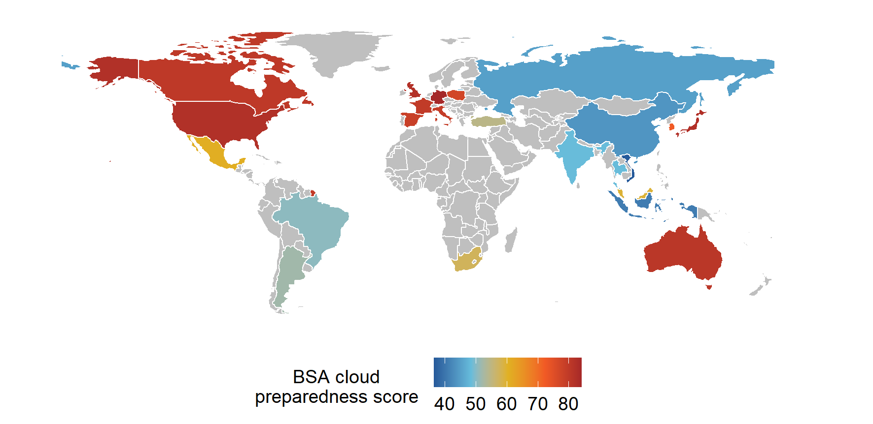
Source: Gartner (2021), BSA and Galexia (2018).
Adoption rates of cloud services depends on their type and the nature of the firm (figure 4). Software-as-a-Service (SaaS) is the most adopted technology by businesses of all sizes, dominated by the use of finance or accounting software. It is possible that some firms might not be aware if they are using cloud software or might mistakenly think that they are using it when in fact they are not. If this hypothesis is true, it would be expected to have the least impacts on firm performance (due to poor reporting). Of the firms using cloud services in 2017-18, 89 per cent said they used these technologies (ABS 2019, table 3).
Figure 3 – Cloud technology growth has been strong, but slowing
Adoption rates by firm employment size, 2013-14 to 2019-20, Australiaª
a. The ABS defines cloud computing as IT services that are used over the internet to access software, computing power or storage capacity.
Source: ABS 2019, Characteristics of Australian Business, 2017-18, Characteristics of Internet Access, Cat. no. 8167.0 and ABS 2021, Characteristics of Australian Business, 2019-20, Characteristics of Internet Access, Cat. no. 8167.0.
Figure 4 – Larger firms make more generalised and sophisticated use of cloud computing
Adoption rates by firm employment size, 2019-20, Australiaª
a. CRM is customer relationship management.
Source: ABS 2019, Characteristics of Australian Business, 2017-18, Cat. no. 8167.0 and ABS 2021, Characteristics of Australian Business, 2019-20, Cat. no. 8167.0.
A much smaller share of firms indicate that they use cloud technologies as IaaS, with larger firms being much more dominant users. Notably, firms employing 200 or more employees had a nearly four times higher rate of using the cloud for its processing power to run software (at 25 per cent) than the smallest firms. Database hosting follows a similar, if slightly less marked, pattern of use by firm size. The firm size dimension reflects the relative sophistication of larger firms in managing ICT, tied to the availability of in-house expertise. About two-thirds of the larger businesses had in-house ICT specialists and 44 per cent had other in-house staff with ICT skills. For the smallest employing enterprises, the comparable estimates were about 11 per cent (ABS 2021b, table 6).

4. Firm heterogeneity and the uptake and impacts of
the cloud
Firms’ decisions to adopt cloud services are ultimately driven by the expected commercial advantages, but as with any emerging technology, the technological, organisational and environmental contexts all play a role in how readily firms can adopt cloud computing, what they do with it, and in turn how much they can benefit from it. Even at the macro geographical level, there can be large differences in the motivation for adoption and the impacts of cloud technologies. For instance, in Europe, Southern European businesses tended to more often adopt cloud technologies to reduce on-premises IT costs, whereas northern European businesses were more motivated by the impacts of the cloud on innovation and collaboration (Loukis, Arvanitis and Kyriakou 2017).
The academic literature (figure 5) suggests that cloud use and adoption depend on any of the factors that are relevant to its net benefits for the business (such as relative costs to on-premises infrastructure and the IT intensity of the business), the organisational capacity to adopt (such as having IT expertise and management buy-in) and environmental factors (such as competitive pressures and availability of appropriate broadband services). High-level technical requirements will tend to favour the uptake of the most advanced cloud services by large firms (Gutierrez, Boukrami and Lumsden 2015).
Figure 5 – Factors driving adoption of cloud computing
What the literature reveals
Source: (Karunagaran, Mathew and Lehner 2019; Oliveira, Thomas and Espadanal 2014; Senarathna et al. 2018; Shuaib et al. 2019; Vu, Hartley and Kankanhalli 2020).
Businesses identify a range of factors that are obstacles to using the cloud (figure 6), with larger businesses tending to report more obstacles — with the exception of the availability of specialist expertise. On face value, this is paradoxical since larger businesses typically have the resources to manage the kind of transaction costs that underpin most of these obstacles, while their overall uptake of cloud technologies is greater than small business. Our interpretation of the results is that larger businesses have more complex IT systems and so the decision about whether to use cloud services at all, or if they do so, the extent of its use and the functionalities that they want, involves more considerations than a small business looking for simple services. While substituting locally installed Microsoft Office with cloud-based Office 365 is straightforward, replacing physical hardware with virtual machines ‘spun up’ on demand requires expertise and changes in ways of working. Some cloud services can require cutting edge/up-to-date local software/hardware, and well-trained IT staff, potentially increasing other costs (Gutierrez, Boukrami and Lumsden 2015).
Notably, concerns about security appear to have reduced cloud use (figure 6 and Alismaili et al. 2020), with this being a greater concern for larger businesses and for firms in industries with higher cloud uptake. (This reinforces the point that diffusion of cloud services is as much about the purposes of cloud technologies as much as their takeup overall — and hence the importance of differentiating between types of cloud use in the analysis of impacts on business performance.)
Though a conjecture, the results showing some adopters do not obtain productivity benefits (figure 1 above) are also consistent with ill-informed assessments of risks by some enterprises — they may adopt cloud technology, foreseeing no problems even if they exist. If these risks crystalise for an overly sanguine adopter of cloud technologies, it may show up as lower performance compared with non-adopters, which may be one reason for the results emerging from the causal forest results discussed below.
Figure 6 – Factors that limited or prevented the use of paid cloud computing by firm size
Adopters and non-adopters, 2019-20ª
a. This question was posed to both non-users and users of the cloud.
Source: ABS 2021, Characteristics of Australian Business, 2019-20, Cat. no. 8167.0.
Notwithstanding these various obstacles, there is no decisive factor that limits cloud technology use and uptake, and indeed, the Agriculture, Forestry and Fishing industry aside, there is little variation at the industry level in overall barriers (figure 7).
An important implication of the above findings on the positive and negative factors affecting adoption is that many of these factors will themselves be affecting business performance. For example, if better managed firms are more likely to adopt the cloud and make effective use of it, the apparent productivity and other aspects of the cloud on firm performance will be conflated with the impact of managerial competence. This indicates that some kind of identification strategy is needed to isolate causal effects of cloud computing on firm performance — as discussed below.
Figure 7 – Share of firms with no limiting factors affecting uptake or extent of use of cloud technologies
By industry, 2019-20ª
a. This question was posed to both non-users and users of the cloud.
Source: ABS 2021, Characteristics of Australian Business, 2019-20, Cat. no. 8167.0.

5. The econometric method
The management and economic literature discussed above suggests that the impact of the cloud varies with the features of the business, its environment and the types of cloud services used. The effects of the cloud may therefore vary with a firm’s age, size, industry, labour skills, ownership status, managerial and innovative capability, and type of cloud service, and do so in complex and non-linear ways. Some of these dependencies can be addressed in standard regression analysis by using interaction terms to capture variation in cloud impacts for each type of firm characteristic (such as that the treatment effect might be higher for larger firms of a certain age for example). However, in any practical application, this leads to an explosion in the number of coefficients and a significant risk of overfitting, while still being unable to consider any complex non-linearities.
Against that background, computer--intensive methods using machine learning have some promising features. Tree -based ML methods require fewer assumptions than regressions, can take into account the interactions between all of a firm’s characteristics with dynamically adapting functional forms (formed by aggregating numerous sub-regression or decision trees) and have the ability to handle missing values in data.
This approach may pick up factors, like entrepreneurship, that are otherwise hard to observe. In this paper, we take advantage of recent developments that have leveraged the power of such tree-based ML tools’ predictive accuracy to create new tools (generalised random forests, of which causal and instrumental forests are special cases) that draw causal inferences (box 1 and Athey, Tibshirani and Wager 2019; Athey and Wager 2019).

Box 1 – Machine learning through generalised random forests
All the forest methods laid out in this paper are generalised variants of random forests (Athey 2019). Random forests are a collection of decision trees created in random subsets of a dataset to solve regression or classification problems. Any given tree branch will split data on observed features to minimise mean squared error of an outcome variable prediction. The following shows an example of what a tree might look like in this analysis.
In the hypothetical mini model above, the trained/fitted model ONLY split on industry when Employees (E)<=12 with the scatter plot showing this. For E<=12 (the left side of the scatter), the arts (light blue) cluster clearly has a lower average effect on the outcome variable (turnover) than the non-arts (dark blue cluster). However, when E>12, there are many arts and non-arts firms with turnover distributed around the same mean.
Once all the trees are ‘grown’, a predicted outcome for a given observation will be the average of outcomes in all trees for that observation. The following diagram demonstrates this process.
Causal forests build on this structure and adapt it to an experimental setup with treatment and control groups. In a causal forest, decision trees split branches in such a way that maximises differences in the relationship between treatment and outcome. For example, small firms may benefit more from cloud, so a tree may split on number of employees >10. When the trees are grown, each endpoint in the tree is split into treatment and control (for this work, whether or not firms use cloud technology). The theory underpinning this formulation is that after controlling for observed characteristics earlier in the tree, the only remaining difference should be treatment effect.
While causal forests account for observed characteristics and how they may influence the treatment effect, it does not adjust for unobserved features (or features not proxied by other included features of firms). To apply a causal forest to non-experimental data, the analyst needs to either assume that the observed characteristics adequately represent and proxy the factors that affect outcomes (as in propensity score matching) or find another identification strategy (through approaches such as instrumental variables). Instrumental forests help resolve the identification of causal relationship using an instrumental variable (if an appropriate instrument is available).
Like propensity score matching, causal forests ML identifies the difference in treatment effects attributable to observables associated with firms. Causal forests compares and groups firms like with like (reflecting all the features included in the model, and their interactions), fits regression trees to the data using the included features, with the final differentiating feature (leaf of the tree) being the treatment (giving firm-specific treatment effects). This can be used for causal inference (Rosenbaum and Rubin 1983; Athey and Wager 2019; Brumback 2021), allowing for the confounding effects of features included in the model.

6. Data and variable choices
The identification of the impact of cloud services on firm performance using the causal forest machine learning methods requires sufficiently large data sets. This reflects that the strength of the approach is to discover ‘treatment’ effects (the causal impacts of adoption of cloud computing) at the firm level, rather than just average treatment effects. Further, ML techniques rely on validation by using only part of the dataset for training. In the Australian context, the best available dataset that can support such analysis is the Business Longitudinal Analysis Data Environment (BLADE).
BLADE is a collection of government administrative data and surveys which provides a near complete financial census of Australian firms over time linked to other surveys (ABS 2021a). The core structure of BLADE is firm-level tax records, such as business income statements and pay-as-you-go personal income tax. These components are combined with the ABS’s business register, which provides information on industry, employment and age. The final components of BLADE are ‘modules’: linkable datasets covering diverse topics, such as intellectual property and environmental surveys. For this study, the key survey module is the Business Characteristics Survey (BCS), which has collected data on cloud use in 2013-14, 2015-16, 2017-18 and (not used in this study) 2019-20 from large random surveys of businesses. As the BCS is the only source of information in BLADE about the adoption of cloud services, their sample sizes therefore determine the size of the dataset available for our analysis.
The BCS distinguishes between several different ways in which businesses use cloud computing, of which this paper concentrates on three — those that use cloud computing at all, those that specify that they use cloud software (an indicator of SaaS) and those using cloud processing power to run their own software (IaaS).
One approach to model specification would be to include the relevant cloud service measures above as inputs in a production function, which would also include other inputs, such as specialist forms of skilled labour, intellectual property, and software investments generally. This would have the advantage of measuring the substitution and complementarities of cloud services with other inputs and in assessing any dynamic links to the absorption or generation of knowledge underpinning technological progress as diffusion occurs. There is an emerging literature using detailed firm level data that probes these issues for other specific technologies, like robots (such as Acemoglu, Lelarge and Restrepo 2020; Dinlersoz and Wolf 2018; Dixon, Hong and Wu 2020; Hirvonen, Stenhammar and Tuhkuri 2022 for France, the United States, Canada and Finland respectively).
Unfortunately, as rich as is BLADE data, its capacity to uncover the production function on which cloud technologies are embedded is limited by data gaps, including the fact that the measure of cloud services is only whether they are used, not a scale measure of their use. Consequently, we have used a simpler framework that considers the impacts of cloud services on various performance metrics after controlling for a range of firm traits.
The available data has shaped our choice of performance metric. It would have been desirable to assess the impact of cloud services using a variety of standard metrics, including:
- productivity, such as value added per hour and, given its potential to substitute for physical assets,
capital productivity
- profitability, given that the diffusion of new technologies provides early adopters with higher returns, which drives out less profitable rivals and serves as a signal to others to adopt the new technology (reinforced by service providers looking to capitalise on growth of cloud services)
- higher returns to labour employed in adopting firms, given the higher bargaining power and scarcity of workers with skills complementary to adoption (Brambilla 2018).
Unfortunately, inadequacies in the data (BLADE) precluded robust conventional measures of productivity and profitability. Nevertheless, wages per full-time equivalent worker (derived from reported wages and hours) serve as a reasonable measure of the returns to labour, while the impacts of cloud services on turnover per employee provides a measure of firm performance.

Causal inference depends on the inclusion of important confounding features of firms
To effectively use causal forests to infer a causal connection between cloud use and firm performance, it is important that firm features included in the model can adequately proxy other important factors that jointly driving firm performance and cloud adoption. The model can then interact those terms with other included features, and jointly consider firms where data are missing/included.
In addition to the variables included in the regressions (such as industry and employment size), several additional firm features were included in the causal forests models. These were taken from the Business Characteristics Survey and included missing values or non-responses for some firms. These additional data were selected to represent attributes of firms that might be jointly associated with strong firm performance and cloud adoption: attributes such as firm dynamism, entrepreneurial/innovative attitudes, management competency, and general attitudes towards use of technology. The additional features taken from the BCS were: expenditure on development or introduction of new goods, services, processes or methods; capital expenditure; expenditure on information technology; share of permanent and temporary employees; the total value of imports and exports for a firm; whether or not the firm has a web presence; whether or not the firm has a social media presence; whether the firm accessed debt finance; whether the firm accessed equity finance; and age of the business. Including all of these confounding variables, their possible interactions, non-linearities in interaction, and missing values, could not realistically have been implemented using traditional regression techniques.

7. Results
It is axiomatic that, on average, adoption of cloud services will benefit business performance since adoption is a choice made by generally optimising businesses. In a stable equilibrium, only firms for which cloud technology was beneficial would adopt it, though the impacts on their performance would vary with their characteristics.
This is borne out by the average treatment effects estimated using causal forest ML, which shows positive impacts for all combinations of cloud services and outcome variables (figure 8). Cloud processing has larger effects than the generalised use of cloud technology. This is an unsurprising result as many applications of cloud services are vanilla substitutes for other technologies and do not strengthen the growth potential or innovative capacity of businesses. This result aligns with the general literature on the effects of specific types of digital technology. For instance, adopters of 3D printing, advanced robotics, the internet of things, AI and big data, augmented/virtual reality, and drones all experience higher labour productivity (Cathles, Nayyar and Rückert 2020, pp. 5–6).
Figure 8 – Cloud services generally improve wages and turnover …
Estimated increase in wages/turnover per FTE from using cloud services ª
a. Wages and turnover measures are per full-time equivalent worker.
Source: Commission estimates using BLADE (based on about 11 989 observations).
These summary results hide a wide distribution of estimated treatment effects across firms. Causal forests estimate the idiosyncratic (firm-specific) ‘treatment effects’ of cloud adoption. Figure 9 shows a summary of the sorted treatment effects estimated for all firms’ turnover and wages to employment, based on any form of cloud computing adoption. The results are mean treatment effects for clusters of 100 firms, a requirement for ABS DataLab/BLADE extraction to meet confidentiality requirements; but these are clusters of firms which are the most similar to each other in terms of the whole range of characteristics. The chart also shows the share of firms in any cluster that did in fact adopt the technologies. Figure 10 represents these data as frequency histograms and suggests a much more nuanced story about the impacts of cloud services, which in part will reflect that at any given time, businesses are in flux and have to adapt to new technologies.
Figure 9 – … but each firm will benefit in different ways, some not at all
Sorted point estimates of treatment effect for any form of cloud adoption ª
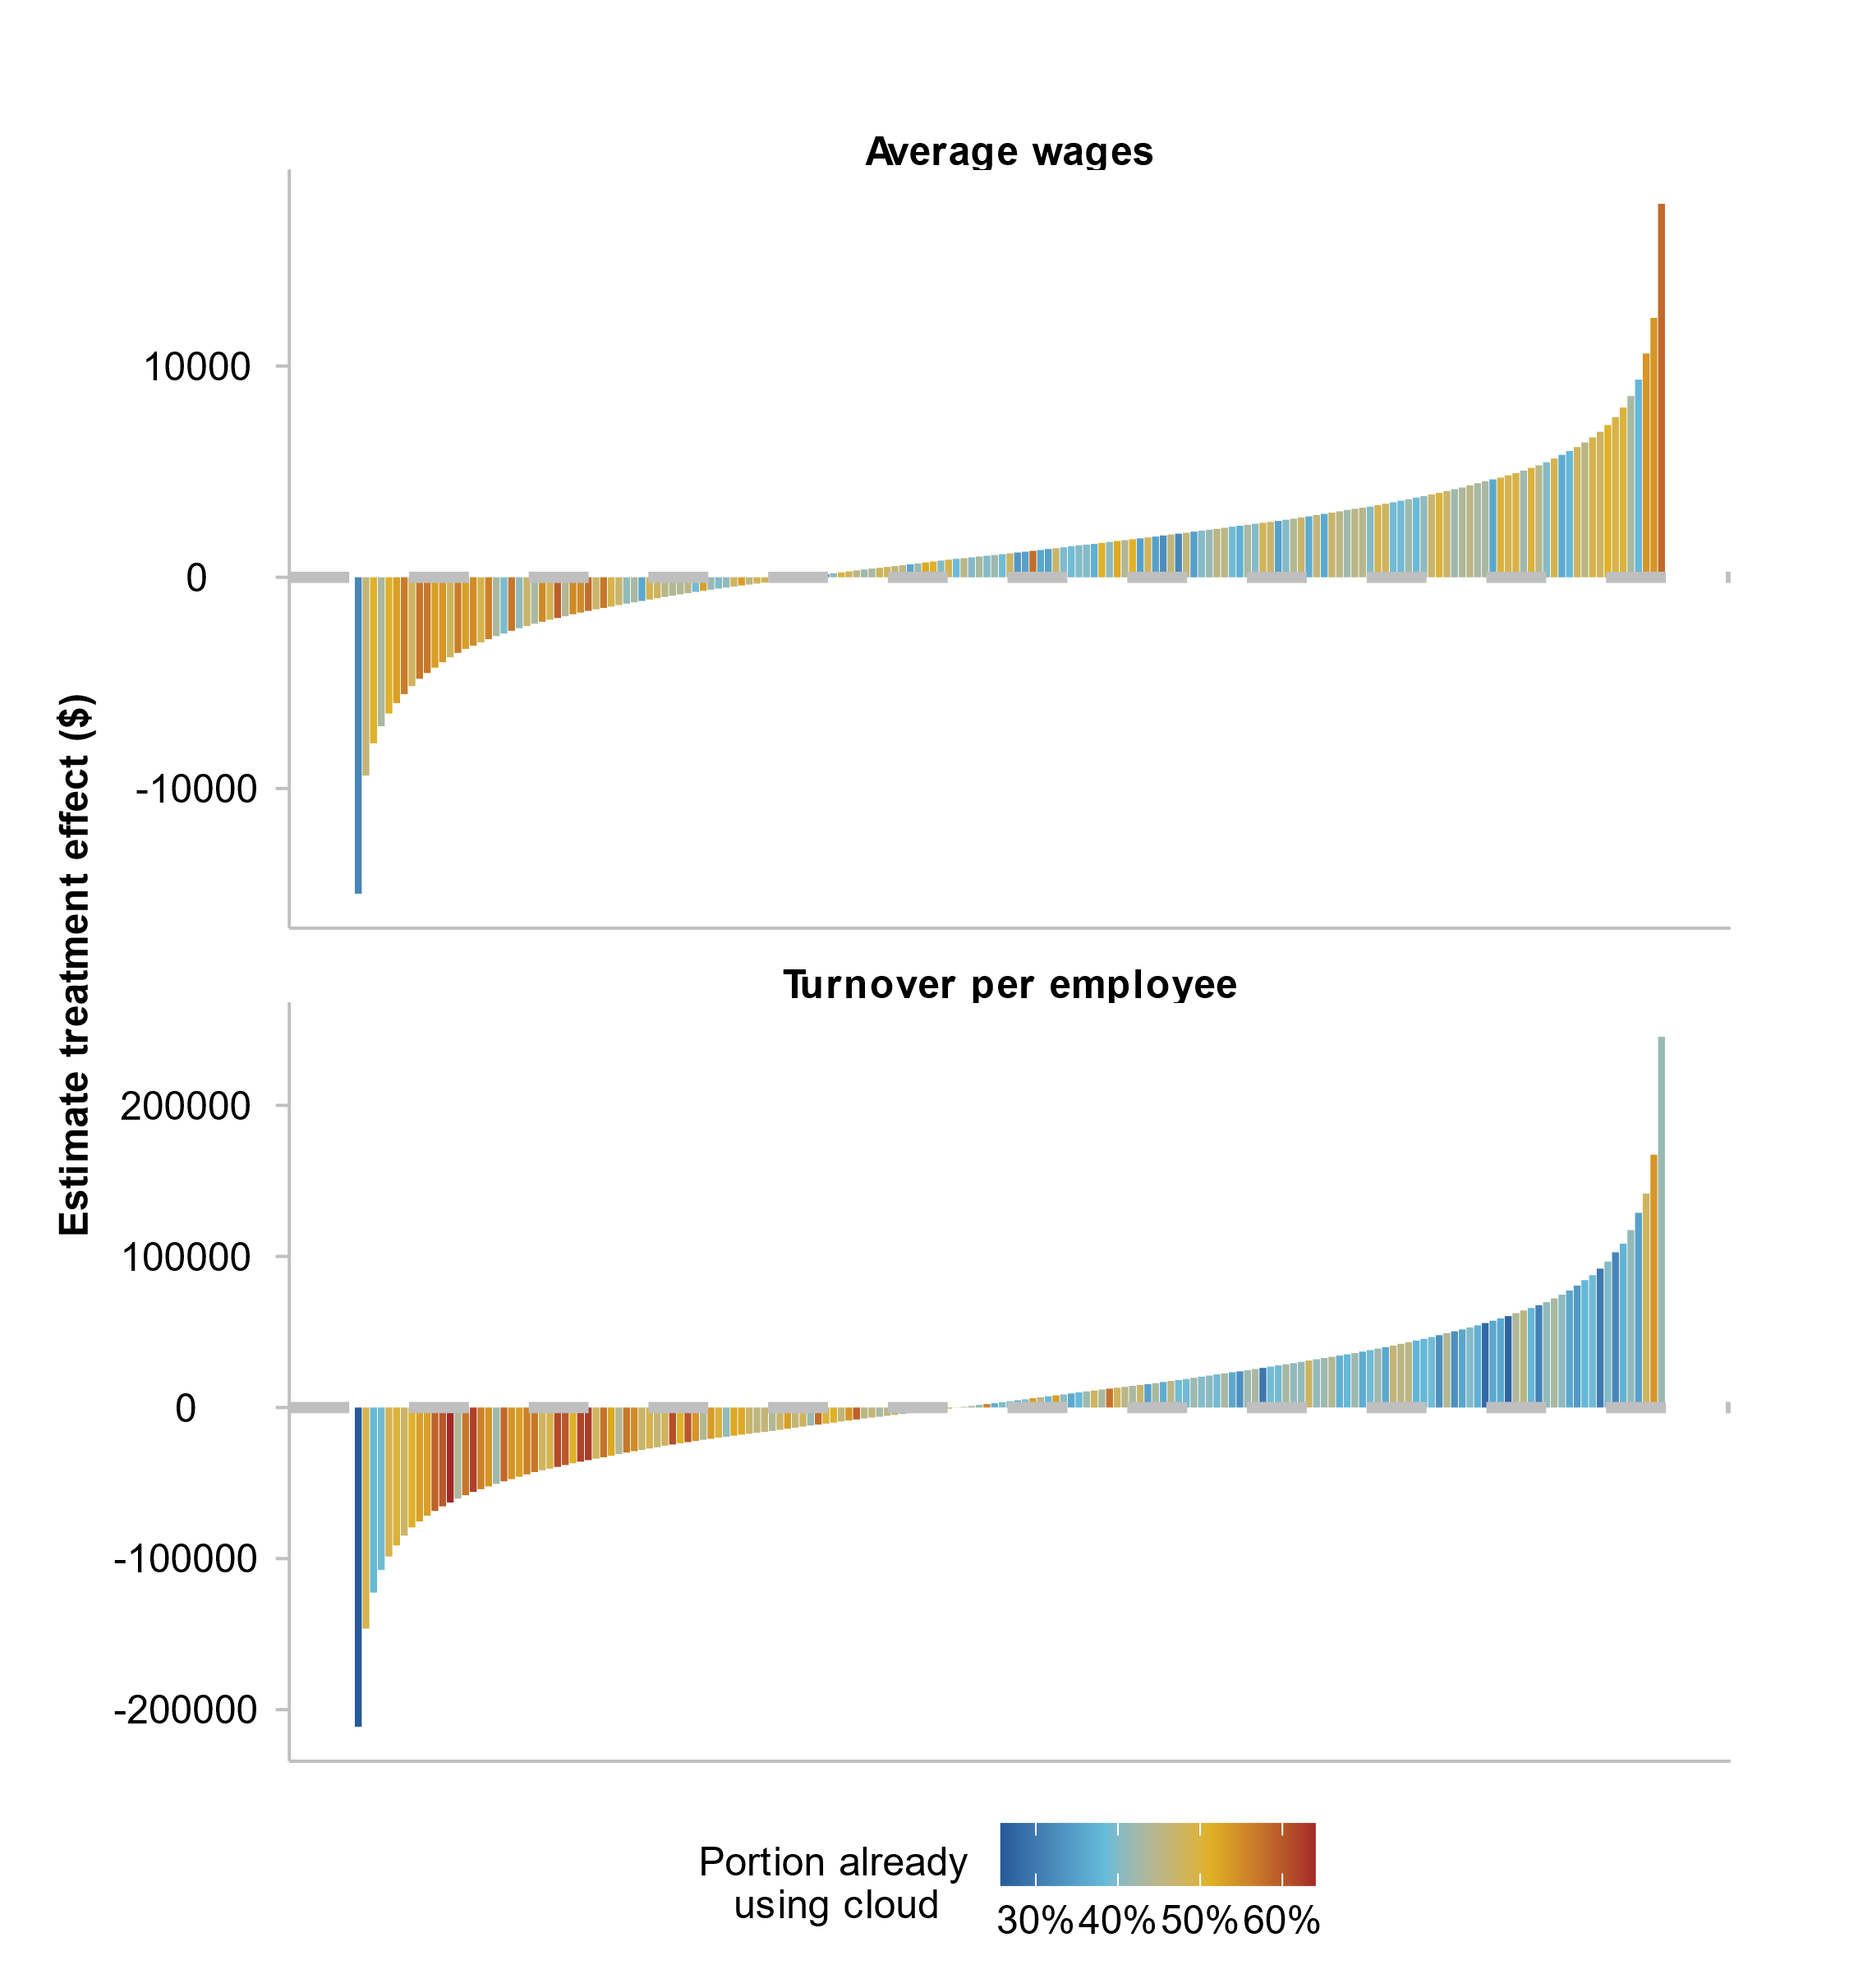
a. Each bar represents approximately 100 individual firm observations..
Source: Commission estimates using BLADE.
Figure 10 – Most firms show a wage effect; fewer have a turnover effect
Histogram of treatment effects for any type of cloud adoptionª
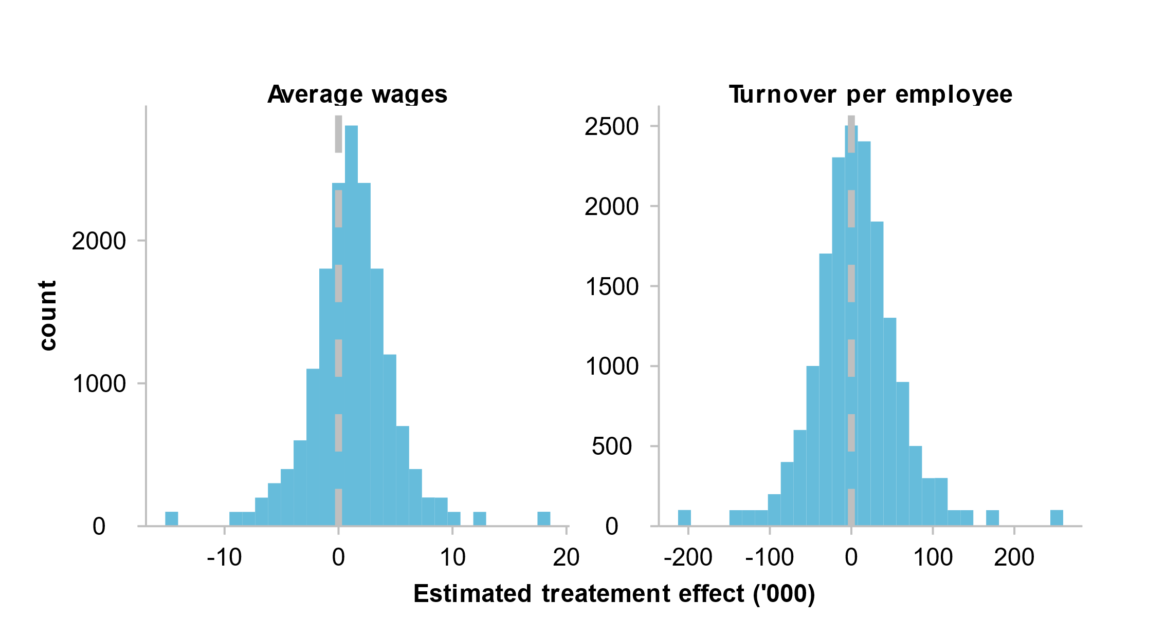
a. Actual treatment effects have been band censored to meet ABS Datalab requirements. Actual results may vary slightly.
Source: Commission estimates using BLADE.
As shown by the work on business dynamism, at any given time, there are leader and laggard businesses:
- In the context of cloud technologies, leaders are those that derive large benefits from the technology and have adopted it. These are the amber to red shaded clusters of firms on the righthand side of figure 9. There is evidence of this pathway in studies of the impact of other digital technologies, with findings that early adopters obtain a performance boost and gain market share (Calvino, Criscuolo and Verlhac 2020; Cathles, Nayyar and Rückert 2020).
- ‘Laggards’ could fall into two categories. One group are firms that would benefit from cloud technologies but have yet to adopt. These are the blue shaded clusters of firms on the righthand side of figure 9. For these firms, cloud technology represents an unexploited opportunity, which raises questions about the factors that have contributed to non-adoption. The second group of productivity laggards are ‘naïve leaders’ — those that have adopted the technology, but for which it has negative impacts on performance, for example, because of wrong vendor choices were made, higher than expected purchasing and implementation costs, security breaches, or lack of complementary skilled labour at the firm level. These are the amber to red shaded clusters of firms on the lefthand side of figure 9. As discussed above, there is a reasonable body of evidence in the literature that a significant group of firms get no beneficial, and sometimes adverse, outcomes from cloud adoption (at least in cross-sectional data).
- Outside the ‘leaders and laggards’ taxonomy, there is another category — non-adopting firms for which adoption would have adverse effects (the blue shaded clusters on the left-and side of figure 9).
The results are only suggestive because of the burden of implausibility — there are so many firms that appear not to have taken advantage of cloud computing though it would seemingly benefit them, and even more beguilingly, so many that have adopted it, but for which its effects are negative. But it is interesting that these results are not driven by ‘pooling’, that is, by firms being lumped into broad categories with firms that are fundamentally dissimilar to them. The power of the causal forest methodology is to identify groups of highly similar firms, and thus that explanation is ruled out.
The results for average wages looks more plausible than for turnover per worker. In the latter instance, it appears that there is weak matching between the take-up of cloud technology and its predicted impacts on turnover. This could be because turnover is a very poor proxy for profitability; we view the results on wages as being more reliable. However, these puzzling results should provide additional pause to any policy measures to stimulate the generalised uptake of cloud technologies.

What type of firms benefit from cloud technologies?
One of the strengths of these machine learning methods is that they can start to pinpoint which types of firms have the most to gain. We have only undertaken some exploratory work in that area, and it would be useful to consider these issues in more detail in subsequent research.
One novel result is that the impacts of cloud adoption on turnover per worker (and to a lesser extent, average wages) for outer regional and remote locales appear to be higher than for inner regional and urban locations (figure 11). One interpretation of this result is that using cloud services (such as teleconferencing or online storefronts) can give regional and remotes businesses access to suppliers and customers that would traditionally only be available with a physical presence in another area. Regardless of the underlying driver of the remote and regional treatment effects, the result indicates that infrastructure that allows businesses in regional and remote Australia to connect to the cloud may benefit business and wages in the regions.
Figure 11 – Cloud technologies appear to have promise for more isolated firms
Sorted point estimates of treatment effects of adoption of any cloud services
Source: Commission estimates using BLADE.

8. Attempting to understand causation with an instrument
The central question of this paper is for a business with a given set of characteristics, what would be the outcome were it to adopt cloud technologies? Causal forests build on the advantages of propensity scoring in trying to isolate such causal impacts. However, there are plausible risks that in nonexperimental settings, effect sizes can still be biased by reverse causation, missing variables that are correlated with cloud technology uptake but that also have independent effects on firm performance, and mismeasurement of explanatory variables. This problem has been identified in other empirical research on the impacts of digital technology on firm performance (Cathles, Nayyar and Rückert 2020; DeStefano, Kneller and Timmis 2020).
An instance of reverse causation may be if at some threshold, increases in turnover per worker in a given industry segment require a business to shift to cloud services (for example, because cloud datacentres are the only reliable way to host their IT infrastructure.) Omitted measures of intangible capital in businesses are also possible confounders. Such intangible capital includes the technical talent of employees, creative managers and good management decision-making processes, which promote adoption of new technologies like cloud computing, but also independently spur innovation, growth and efficiency. The critical point is that uptake of a new technology is not randomly assigned to businesses but reflects their inherent capabilities and business cultures. The competitive environment facing businesses may also be influential as rivalry and cooperation can jointly drive adoption of new technologies and improved performance.
The ensuing identification problem requires some variable that is correlated with cloud adoption but is otherwise uncorrelated with business performance except via its connection to the treatment. As in the case of a study of the impacts of cloud technologies in the United Kingdom (DeStefano, Kneller and Timmis 2020) and fast broadband in New Zealand (Fabling and Grimes 2017), variations across areas in the availability of highspeed internet (fast upload and download) provides a natural experiment. Access to high-speed internet is a prerequisite for adoption of some key cloud computing technologies in any given area. A firm in an area not served by fast broadband has a limited capacity for adoption of cloud computing and is a good control if matched to an otherwise identical set of firms in an area where broadband is available, some of whom will adopt cloud services.
Access to high-speed internet is, on a priori grounds, a reasonable instrument as the choice to deploy fast internet is made by telecommunications providers on a regional basis, and not on the performance of businesses. (The choice that businesses make about what type of connection they seek from available network is, however, less likely to be a good instrument.)
The Commission obtained geographic data on the rollout and use rates of various National Broadband Network (and other) connections from NBN Co. This included seven different types of connections (fibre-to-the-building, fibre-to-the-curb, fibre-to-the-node, fibre-to-the-premises, fixed wireless, hybrid-fibre-coaxial, and satellite), which were also used to impute typical download and upload speeds that might have been accessible to firms by location. Similar variables were taken from the Business Characteristics Survey to consider the type of internet and broadband connection at the firm level (in contrast to the geographic level with the NBN Co data).
This paper tested the potential for broadband network availability as an instrument using standard IV estimation regressions. We also used instrumental forest models to consider causal impacts more closely. The results suggests that broadband network availability is not a good instrument.
Several of broadband access variables appeared to be valid instruments: they were somewhat (though weakly) correlated with cloud use, with correlations as high as 12 to 18 per cent. And broadband access variables were largely uncorrelated with the residuals from the first stage regressions (correlations less than 1 per cent). The most promising instruments were the share of firms in a region using connections with the highest speeds (an aggregation of FTTB, FTTC and FTTB) and the share of firms in a region using connections with the lowest speeds (satellite). Formal testing of instrument overidentification and exogeneity using the Sargan-Hansen and Durbin-Wu-Hausman tests lent credence to the potential usefulness of some of the instruments.
Nonetheless, using IV methods in standard regressions found implausible results. Cloud services continued to have generally positive impacts on firm performance, but the effect sizes were too high to be credible and standard errors were very high. When included in an instrumental forest model, after hyperparameter tuning, the feature importance of the instrument drops to almost zero: effectively, the model collapsed to the previous casual forests model. In effect, the ML technique chose not to include the instrument in its set of explanatory variables, and therefore collapsed to its non--instrumental form. So what? This might reflect that the causal forest had sufficient features in it to proxy the non--directly observed factors (entrepreneurial spirit etc) the instrument was intended to address, such that the instrument (NBN) added nothing. Alternatively, the instrument may simply be too weak. We therefore are left with uncertainty about whether the results are fully causal.

9. Synthesis and conclusions
Cloud adoption is positively associated with firm performance. The benefits appear to be greatest for cloud processing, consistent with the hypothesis that firms using IaaS might be best placed to adopt and leverage the benefits of the technology. The cloud processing results also appear to be concentrated most strongly in some regions and firms, supporting the hypothesis that benefits might accrue particularly to those with expert knowledge.
A unique feature of the results from the machine learning modelling is that there are large numbers of firms that would benefit from cloud technologies but have not adopted them. This is consistent with the historical record of technological diffusion in which it can take many years for businesses to adopt leading edge technologies. There also appear to be a significant rump of firms that have taken up the technology, but where it adversely affects their performance. While there will be unquestionably instances where this occurs (for example due to underestimating the complexity of effectively using complex cloud technologies), the share of businesses affected is implausibly high and should not be interpreted as reliable.
This work has potential broader implications for a post-COVID-19 Australian economy given it has increased the uptake of certain kinds of cloud technologies — particularly those that underpin remote work. While the results from this study are mixed, there should be reasonable optimism that greater uptake associated with the pandemic will generally improve firm performance. Moreover, while adoption may prove adverse for some firms, it is hard to visualise this as anything more than a transitory situation.
This paper’s novelty is its use of machine learning to uncover the idiosyncratic effects of cloud adoption on performance. Subject to data availability, a useful direction for future research would be assessment of the impacts of the expenditure on different forms of cloud computing on productivity, and any links to complementary skills and other digital innovation. Further exploration of natural experiments that could confirm the causal impacts of cloud computing would be fruitful. This paper is also based on cross-sectional data and so cannot explore the dynamics of cloud adoption, and some of the key concerns about whether variable rates of ICT adoption has divided industries into persistent laggards and leaders.

References
ABS (Australian Bureau of Statistics) 2019, Characteristics of Australian Business, 2017-18, Characteristics of Internet Access, Cat. no. 8167.0, Canberra.
—— (Australian Bureau of Statistics) 2021a, Business Longitudinal Analysis Data Environment (BLADE), Canberra.
—— (Australian Bureau of Statistics) 2021b, Characteristics of Australian Business, 2019-20, Characteristics of Internet Access, Cat. no. 8167.0, 4 June, Canberra.
—— (Australian Bureau of Statistics) 2022, Retail Trade, Australia, November 2021, Table 21 Online Retail Turnover, Australia, by type of activity, Cat. no. 8501.0, Canberra.
Acemoglu, D., Lelarge, C. and Restrepo, P. 2020, ‘Competing with Robots: Firm-Level Evidence from France’, AEA Papers and Proceedings, vol. 110, pp. 383–388.
ACMA (Australian Communications and Media Authority) 2021, Telehealth and video conferencing surge during COVID-19, 10 May.
AFCOM (Association for Computer Operations Management) 2021, The 2021 State of the Data Center Report.
Aggarwal, G. 2021, How The Pandemic Has Accelerated Cloud Adoption, 15 January, Forbes.
Alismaili, S.Z., Li, M., Shen, J., Huang, P., He, Q. and Zhan, W. 2020, ‘Organisational-level assessment of cloud computing adoption: evidence from the Australian SMEs’, Journal of Global Information Management (JGIM), vol. 28, no. 2, pp. 73–89.
Athey, S., Tibshirani, J. and Wager, S. 2019, ‘Generalized random forests’, The Annals of Statistics, vol. 47, no. 2, pp. 1148–1178.
—— and Wager, S. 2019, ‘Estimating treatment effects with causal forests: An application’, Observational Studies, vol. 5, no. 2, pp. 37–51.
Ba, S. and Pavlou, P. 2002, ‘Evidence of the effect of trust building technology in electronic markets: price premiums and buyer behavior’, MIS Quarterly, vol. 26, pp. 243–268.
Bayrak, E., Conley, J. and Wilkie, S. 2011, The Economics of Cloud Computing, Working Paper 11-W18, Vanderbilt University, Nashville.
Benzina, K. 2019, ‘Cloud Infrastructure-as-a-Service as an Essential Facility: Market Structure, Competition, and the Need for Industry and Regulatory Solutons’, Berkeley Technology Law Journal, vol. 34, no. 119, pp. 121–142.
Bloom, N. and Pierri, N. 2018, ‘Research: Cloud Computing Is Helping Smaller, Newer Firms Compete’, Harvard Business Review, 31 August, https://hbr.org/2018/08/research-cloud-computing-is-helping-smaller-newer-firms-compete (accessed 21 February 2022).
Brambilla, I. 2018, Digital Technology Adoption and Jobs: A Model of Firm Heterogeneity, World Bank Policy Research Working Paper, 8326, World Bank.
BSA and Galexia 2018, 2018 BSA Global Cloud Computing Scorecard.
Bushell-Embling, D. 2021, ‘Australian cloud spending to reach $13.8bn in 2021’, Technology Decisions, 3 August.
Calvino, F., Criscuolo, C. and Verlhac, R. 2020, Declining business dynamism: Structural and policy determinants, OECD Science, Technology and Industry Policy Papers, No. 94, OECD, Paris.
Cameron, N. 2021, How Pizza Hut gave away 10,000 pizzas in 70 seconds, 8 March, CMO from IDG.
Cathles, A., Nayyar, G. and Rückert, D. 2020, Digital technologies and firm performance: Evidence from Europe, 2020/06, EIB Working Papers, European Investment Bank.
Chen, X., Guo, M. and Shangguan, W. 2022, ‘Estimating the impact of cloud computing on firm performance: an empirical investigation of listed firms’, Information & Management, p. 103603.
DeStefano, T., Johnstone, N., Kneller, R. and Timmis, J. 2019, ‘Do Capital Incentive Policies Distort the Adoption of Cloud Technologies and Big Data?’, presented at Economics of Digitization, 22-23 November, Munich.
——, Kneller, R. and Timmis, J. 2020, Cloud Computing and Firm Growth, SSRN Scholarly Paper, ID 3618829, Social Science Research Network, Rochester, NY.
Dinlersoz, E. and Wolf, Z. 2018, Automation, Labor Share, and Productivity: Plant-Level Evidence from U.S. Manufacturing, CES 18-39, September, Center for Economic Studies.
Dixon, J., Hong, B. and Wu, L. 2020, The Robot Revolution: Managerial and Employment Consequences for Firms, 3 June, NYU Stern School of Business.
Etro, F. 2009, ‘The economic impact of cloud computing on business creation, employment and output in Europe’, Review of Business and Economics, vol. 54, no. 2, pp. 179–208.
Fabling, R. and Grimes, A. 2017, Picking up speed: does ultrafast broadband increase firm productivity?, Motu Working Paper 16-22, Motu Economic and Public Policy Research.
Fulton, S. 2020, Dropbox’s Reverse Migration, From Cloud to Own Data Centers, Five Years On, 26 February, DataCenter Knowledge, https://www.datacenterknowledge.com/manage/dropbox-s-reverse-migration-cloud-own-data-centers-five-years (accessed 21 February 2022).
Gartner 2021, Gartner Forecasts Worldwide Public Cloud End-User Spending to Grow 23% in 2021, Press release, 21 April, Stamford.
Goldfarb, A. and Tucker, C. 2019, ‘Digital economics’, Journal of Economic Literature, vol. 57, no. 1, pp. 3–43.
Gordon, R.J. 2000, Does the ‘New Economy’ measure up to the great inventions of the past?, NBER Working Paper 7833, National Bureau of Economic Research.
Grous, A. 2019, The Transformative Effect of Cloud on Firm Productivity and Performance: Defining the benefits and impact of cloud as a 21st Century digital enabler, March, London School of Economics and Political Science.
Gutierrez, A., Boukrami, E. and Lumsden, R. 2015, ‘Technological, organisational and environmental factors influencing managers’ decision to adopt cloud computing in the UK’, Journal of Enterprise Information Management, vol. 28, no. 6, pp. 788–807.
Hirvonen, J., Stenhammar, A. and Tuhkuri, J. 2022, New Evidence on the Effect of Technology on Employment and Skill Demand, 16 January, MIT Economics.
idea 11 2021, Case Studies, https://www.idea11.com.au/case-study-reiq/ (accessed 21 February 2022).
IMD (International Institute of Management Development) 2021, IMD World Digital Competitiveness Rankings 2021, https://www.imd.org/centers/world-competitiveness-center/rankings/world-digital-competitiveness/ (accessed 1 February 2022).
Jin, W. and McElheran, K. 2017, Economies Before Scale: Survival and Performance of Young Plants in the Age of Cloud Computing, SSRN Scholarly Paper, ID 3112901, Social Science Research Network, Rochester, NY.
Karunagaran, S., Mathew, S.K. and Lehner, F. 2019, ‘Differential cloud adoption: a comparative case study of large enterprises and smes in Germany’, Information Systems Frontiers, vol. 21, no. 4, pp. 861–875.
Linthicum, D. 2021, Why the cloud computing hangover?, 3 December, InfoWorld.
Loukis, E., Arvanitis, S. and Kyriakou, N. 2017, ‘An empirical investigation of the effects of firm characteristics on the propensity to adopt cloud computing’, Information Systems and e-Business Management, vol. 15.
Makhlouf, R. 2020, ‘Cloudy transaction costs: a dive into cloud computing economics’, Journal of Cloud Computing, vol. 9, no. 1, p. 1.
McCafferty, D. 2015, How Unexpected Costs Create a ‘Cloud Hangover’, https://www.cioinsight.com/cloud-virtualization/how-unexpected-costs-create-a-cloud-hangover/ (accessed 31 January 2022).
Miller, R. 2017, Why Dropbox decided to drop AWS and build its own infrastructure and network, 16 September, Techcrunch, https://social.techcrunch.com/2017/09/15/why-dropbox-decided-to-drop-aws-and-build-its-own-infrastructure-and-network/ (accessed 21 February 2022).
Mills, M.P. 2021, The Cloud Revolution: How the Convergence of New Technologies Will Unleash the Next Economic Boom and A Roaring 2020s, Encounter Books, New York.
Minifie, J. 2014, The silver lining: how cloud computing can help small and medium enterprises, Grattan Institute, Melbourne.
Oliveira, T., Thomas, M. and Espadanal, M. 2014, ‘Assessing the determinants of cloud computing adoption: An analysis of the manufacturing and services sectors’, Information and Management, vol. 51, no. 5, pp. 497–510.
PC (Productivity Commission) 2021, Working from home, Commission Research Paper, Canberra.
Senarathna, I., Wilkin, C., Warren, M., Yeoh, W. and Salzman, S. 2018, ‘Factors that influence adoption of cloud computing: an empirical study of Australian SMEs’, Australasian Journal of Information Systems, vol. 22.
Shuaib, M., Samad, A., Alam, S. and Siddiqui, S.T. 2019, ‘Why Adopting Cloud Is Still a Challenge?—A Review on Issues and Challenges for Cloud Migration in Organizations’, in Hu, Y.-C., Tiwari, S., Mishra, K.K. and Trivedi, M.C. (eds), Ambient Communications and Computer Systems, Springer, pp. 387–399.
Solow, R. 1987, ‘We’d better watch out’, New York Times Book Review, p. 36.
Staten, J. 2012, Cloud inefficiency - Bad habits are hard to break, ZDNet.
Stephens, R. 2021, IaaS Pricing Patterns and Trends 2021, 17 December, RedMonk.
Stewart, D., Okubo, N., Jehu, P. and Liu, M. 2021, ‘The cloud migration forecast: cloudy with a chance of clouds’, Deloitte - Technology, Media and Telecommunications Predictions.
Sverdlik, Y. 2018, Here’s How Much Money Dropbox Saved by Moving Out of the Cloud, 1 March, DataCenter Knowledge, https://www.datacenterknowledge.com/cloud/here-s-how-much-money-dropbox-saved-moving-out-cloud (accessed 21 February 2022).
Synytsky, R. 2018, Council Post: Deceptive Cloud Efficiency: Do You Really Pay As You Use?, 28 March, Forbes.
Thorpe, C. 2021, Digital Equity for Regional Australia, Innovation Intelligence International, https://www.innovation-intelligence.com/digital-equity-for-regional-australia (accessed 21 February 2022).
Virtana 2021, Survey Report: The State of Hybrid Cloud and FinOps, September.
Vu, K., Hartley, K. and Kankanhalli, A. 2020, ‘Predictors of cloud computing adoption: A cross-country study’, Telematics and Informatics, vol. 52, p. 101426.

Dr Catherine de Fontenay presented this paper to the Australian Bureau of Statistics and Reserve Bank of Australia joint conference on the ‘Economic implications of the digital economy’ held 9-10 March 2022.
There are ABS data for cloud software use for 2019-20, but this is by software category with no overall measure.
In contrast to the Australian evidence, drawing on a database of the technology use of millions of firms in the United States, it appeared that cloud adoption rates in small firms (0-9 employees) was on a par with the largest (1000+), though this appears to relate to the use of specific cloud-hosting services principally domiciled in the United States, such as AWS and Microsoft Azure (Bloom and Pierri 2018).
In this respect, less than 20 per cent of large businesses do not use paid cloud services, but 39 per cent of large businesses faces obstacles to using the cloud, which demonstrates that a significant share of large businesses using the cloud face obstacles to its full use.
Many regression techniques also have difficulties with missing values (which could require further reduction in the size of the dataset, or imputation of missing or non-response values), limiting the firm characteristics that can be included in a regression (or biasing the result). ML can better address missing values.
One possible concern about using turnover per worker is that it need not be highly correlated with productivity as measured by value-added per worker. For example, businesses with large intermediate input ratios and high turnover will have low value added. However, the changes in turnover per worker associated with cloud service adoption are likely to reflect increases in value added per worker, unless cloud service adoption changed intermediate input ratios.
Decisions about the locations for the NBN rollout was not undertaken on a purely commercial basis (Tasmania being a starting location), which improves the status of the rollout as an instrument. Nonetheless, commercial considerations have not been absent, such that its more attractive to rollout high-cost internet services to areas where the uptake will be highest, which may disproportionately include business hubs with high wage workers. This would weaken the validity of the instrument as the NBN rollout would not be completely separable from the performance metrics used in this paper.
The Business Characteristics Survey has information about the type of broadband connection used (DSL, fibre to the premises, cable, fixed wireless, mobile wireless and satellite). However, since use of such technologies is a choice by businesses, it diminishes its value as an instrument.
There could be several reasons for the limitations in the instrument. One key factor is that the adoption of some cloud computing does not require the high-speed broadband services provided by NBN Co. ADSL 2 sometimes offered speeds comparable to low cost NBN plans, though on average NBN services are much faster.

